AWS CodeDeploy

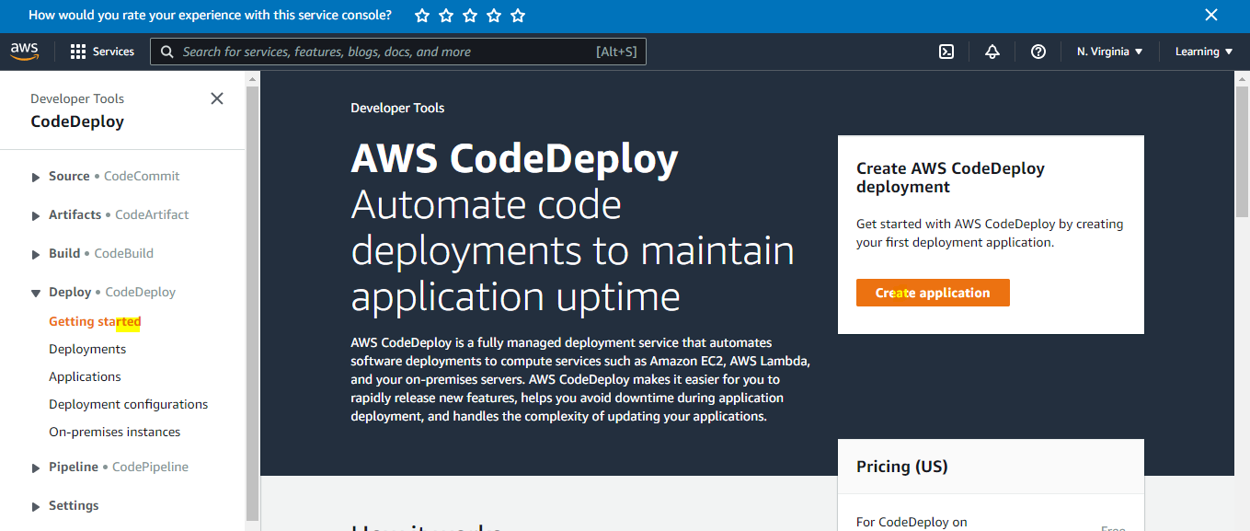
Step1: Create Application
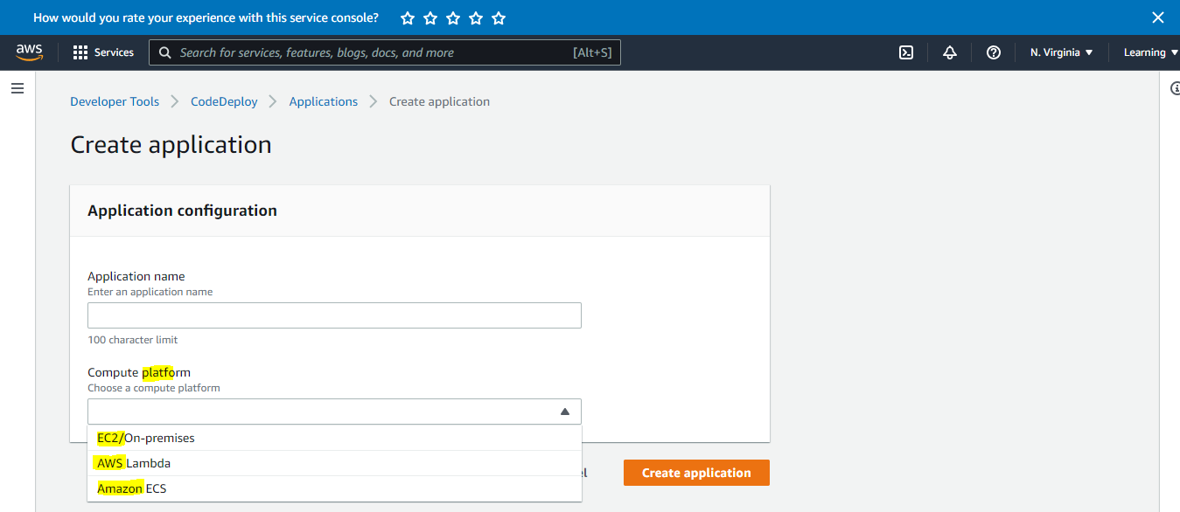
Step2: Create Deployment Group
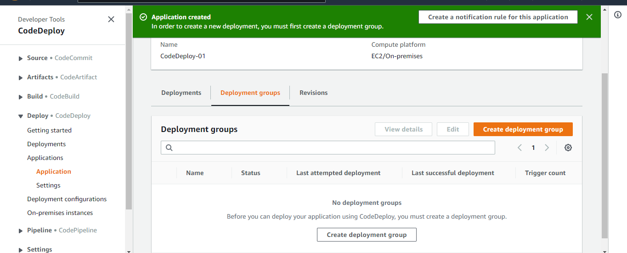
Step2.1:

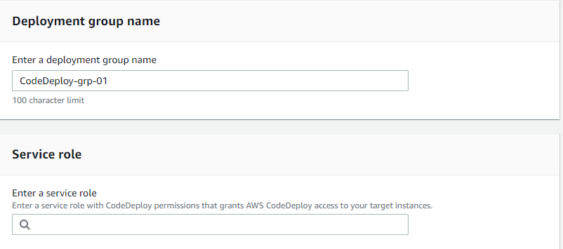
Step2.2:
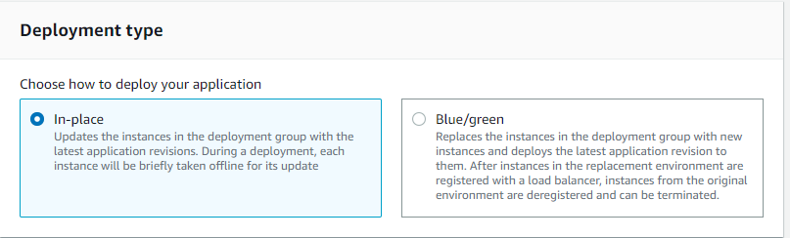
Step2.3:
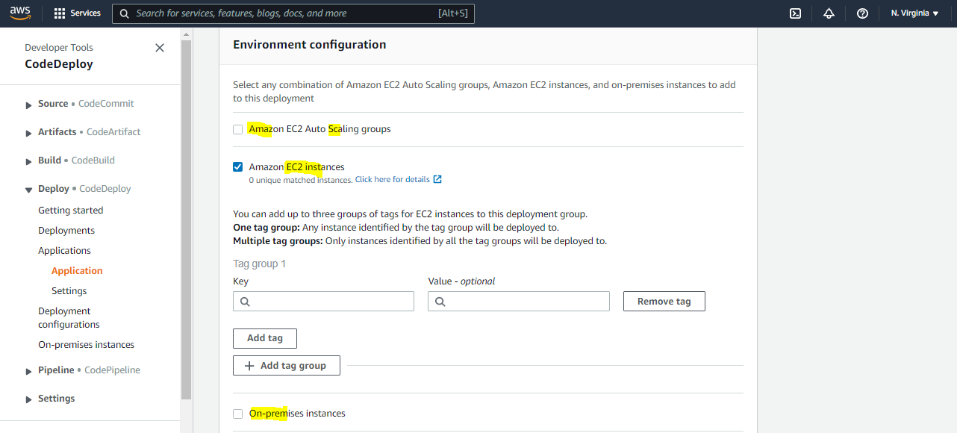

Step2.4:
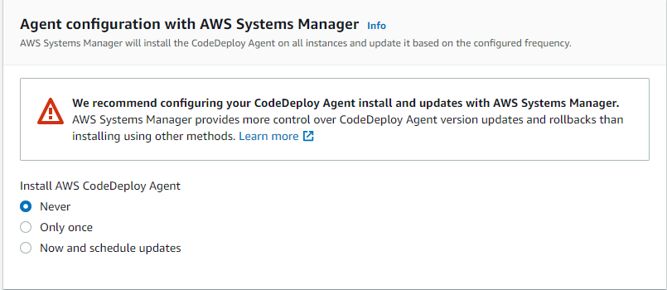
Step2.5:
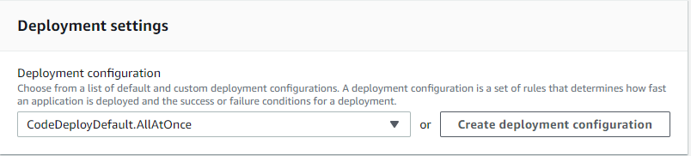
Step2.6:

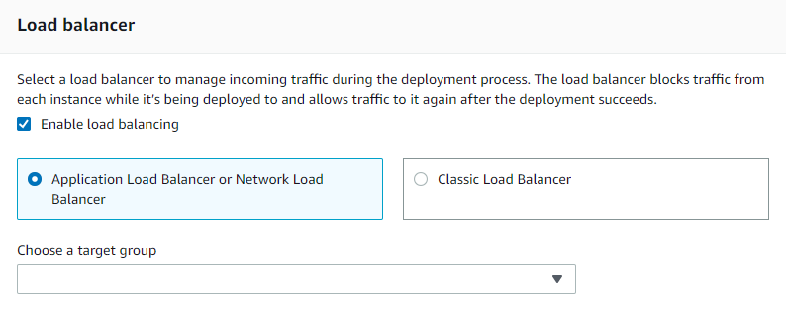

Step3: Create Deployment
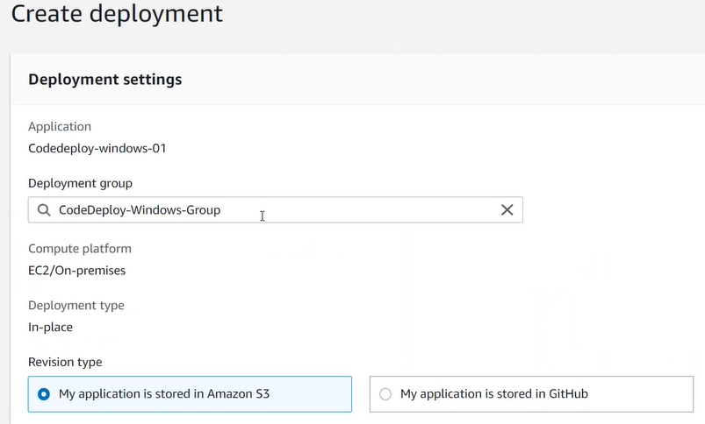
Step3.1:
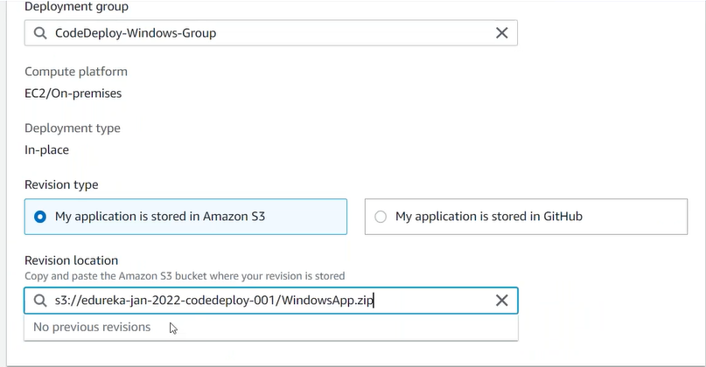
Step3.2:
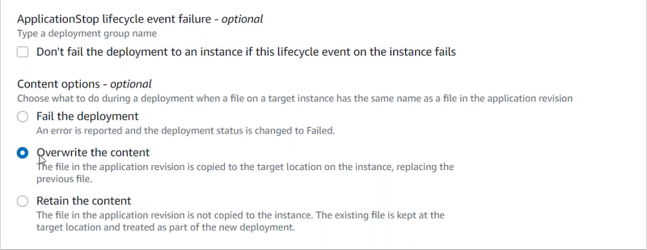
Step4: Monitor Deployment Lifecycle Events

AWS CodeCommit
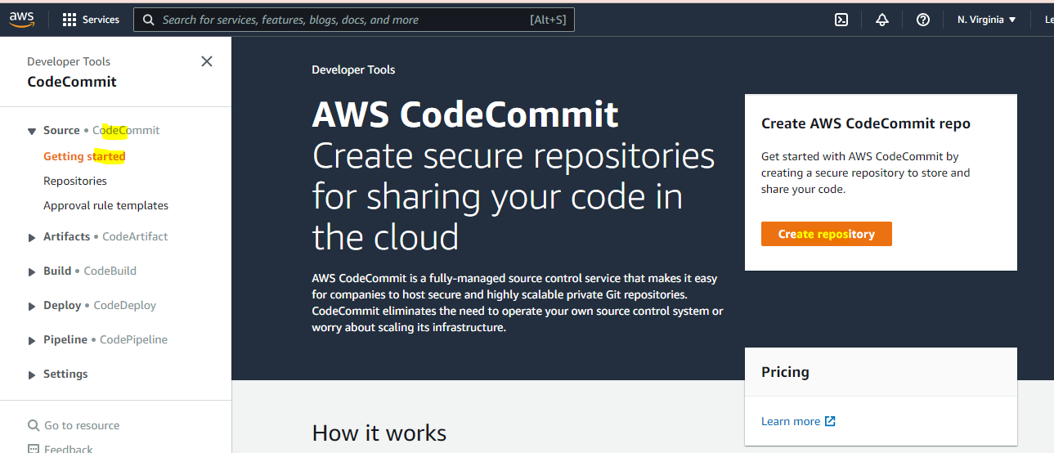

Step1: Create Repository
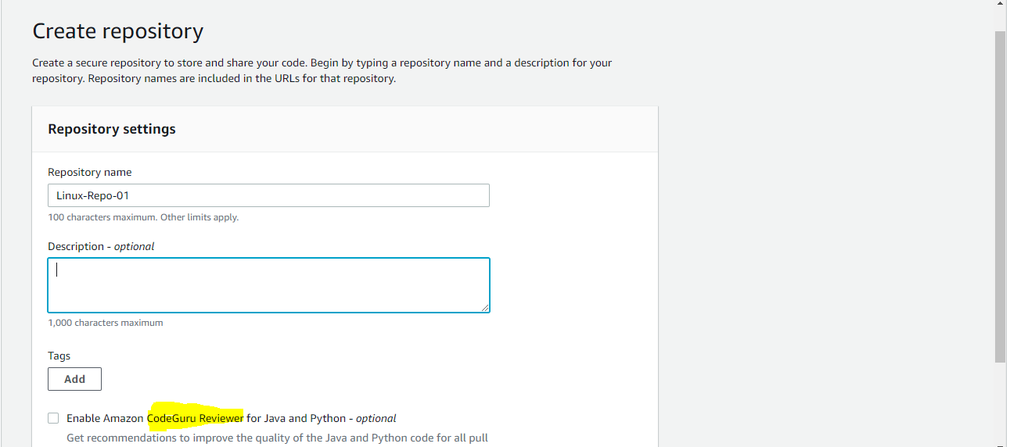
Step1.1:
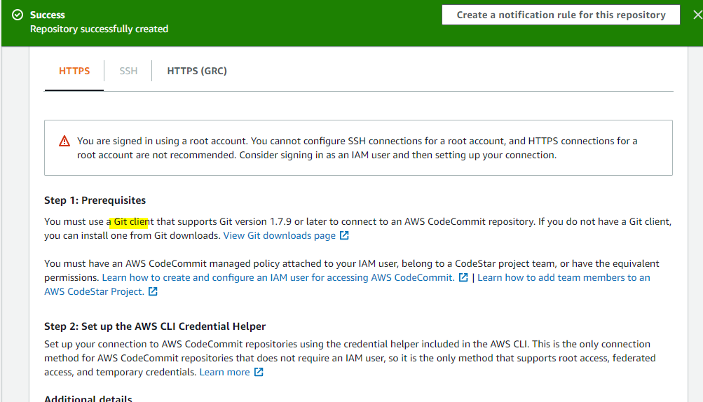
Step1.2:
git clone <URL> ???
Step1.3:
Clone in your local
mkdir CodeCommit
cd CodeCommit
git init
git clone <URL> # AWS CLI (IAM User->Security tab-> HTTPS credentials for AWS CodeCommit, also user must have policy of AWSCodeCommitPowerUser)
aws configure
Resource Group and Tag Editor

Step2
Create Deployment
Step2.1: Create Application
Step2.1: Create Deployment Group
Step3: Code Pipeline
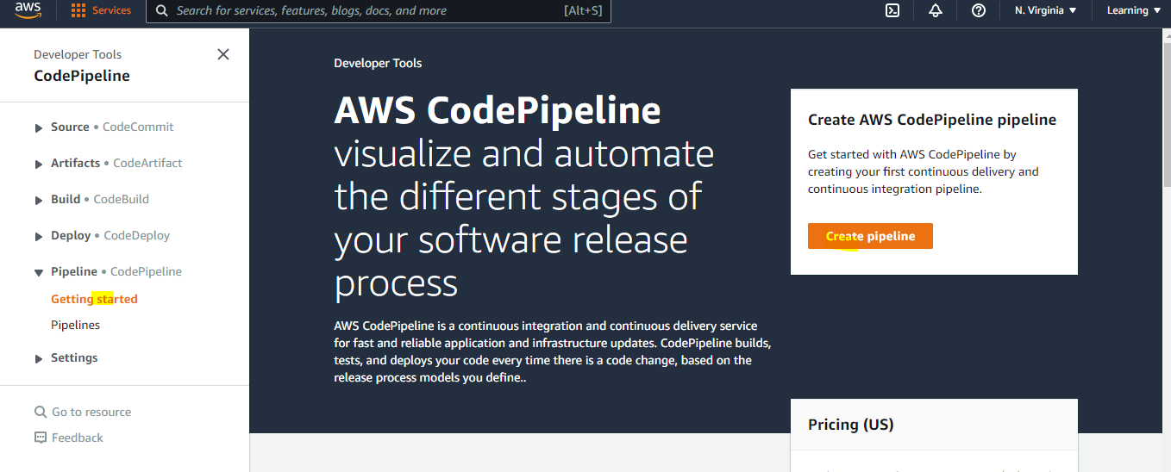
Step3.1: Create Pipeline
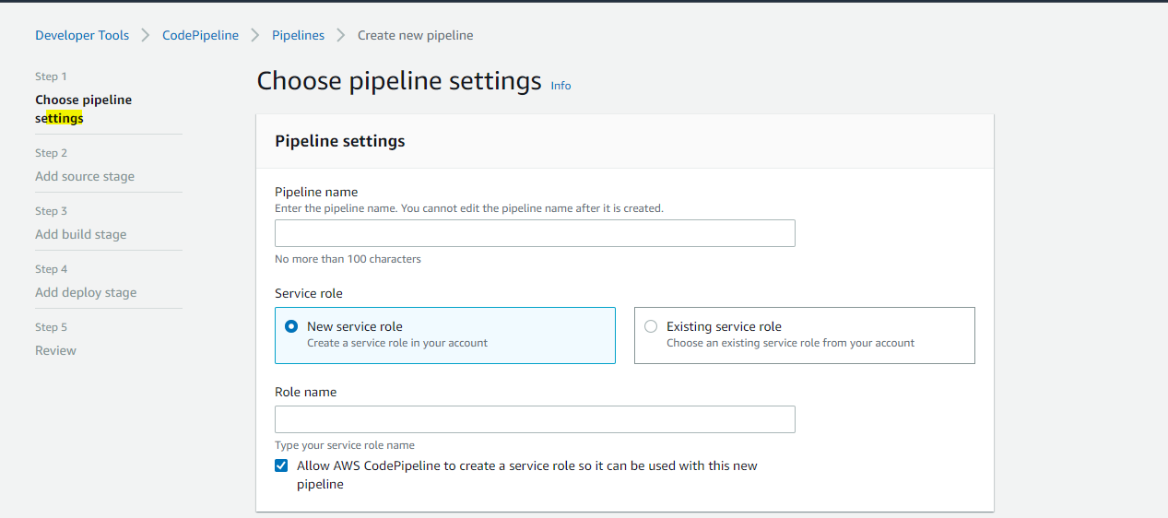
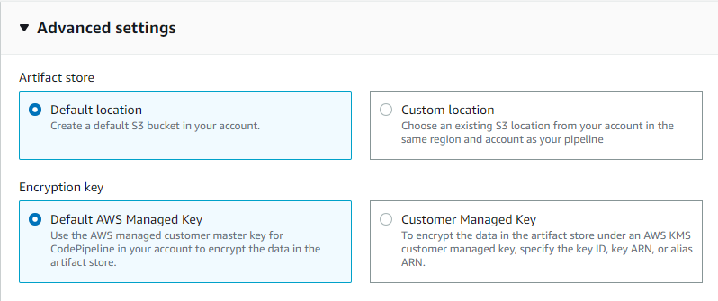
Step3.2
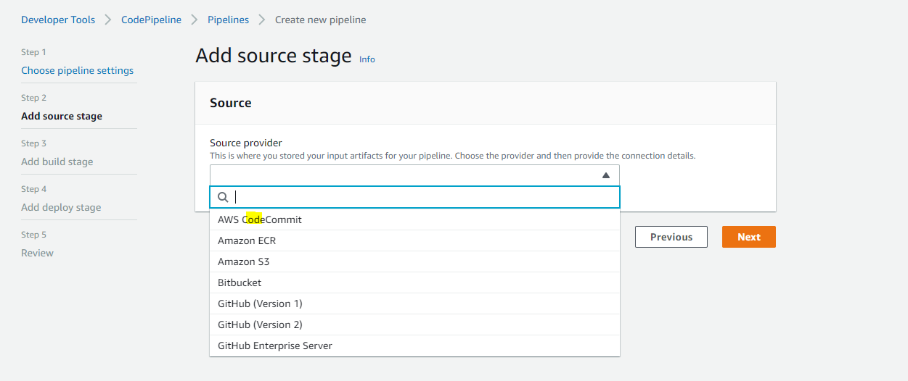
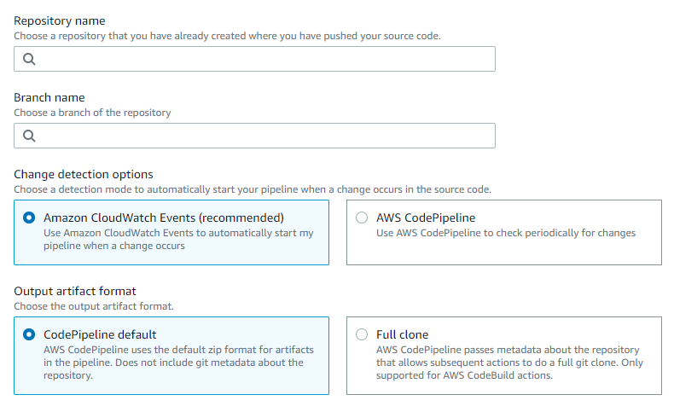
Step3.3
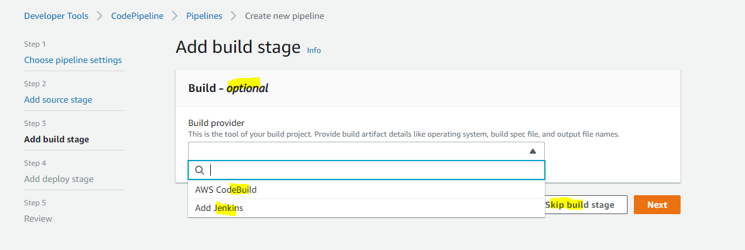
Step3.4
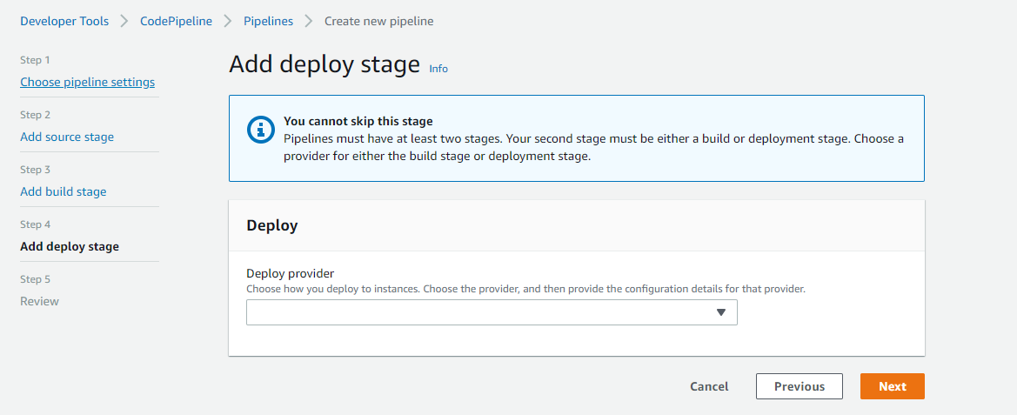
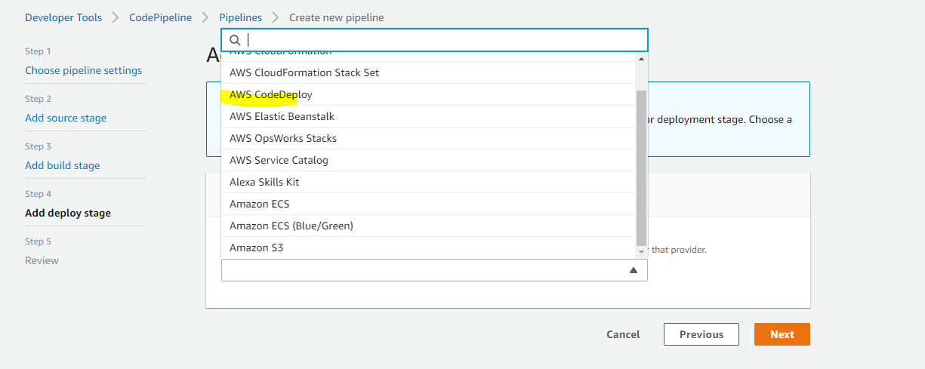

Step3.5 Monitor Pipeline
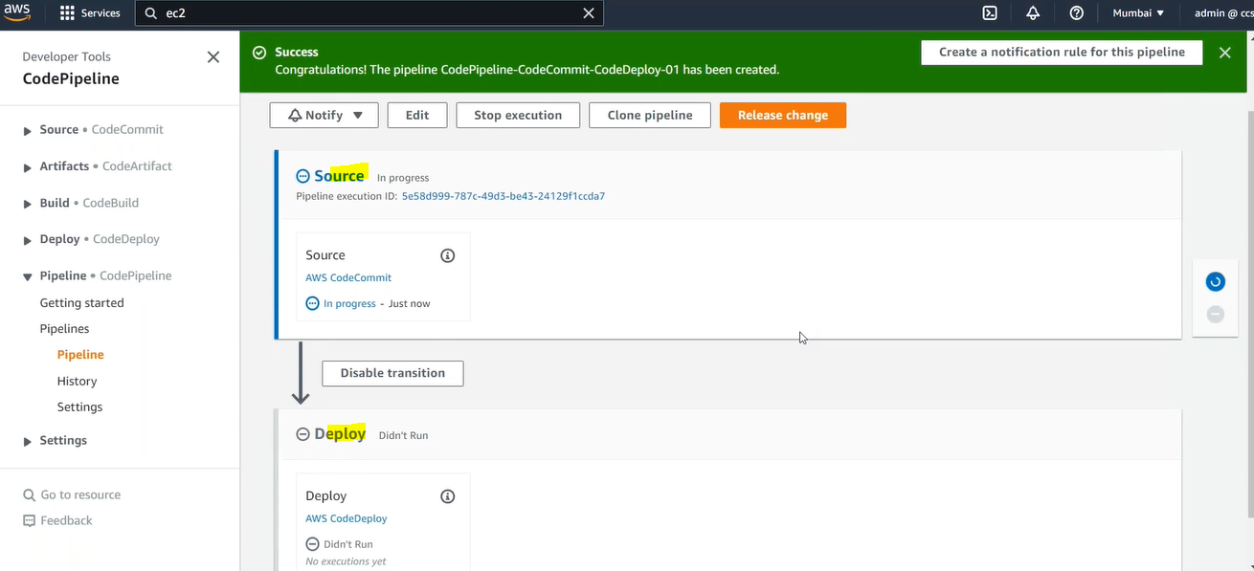

Step4: Code Build (Java, C++ byte code )
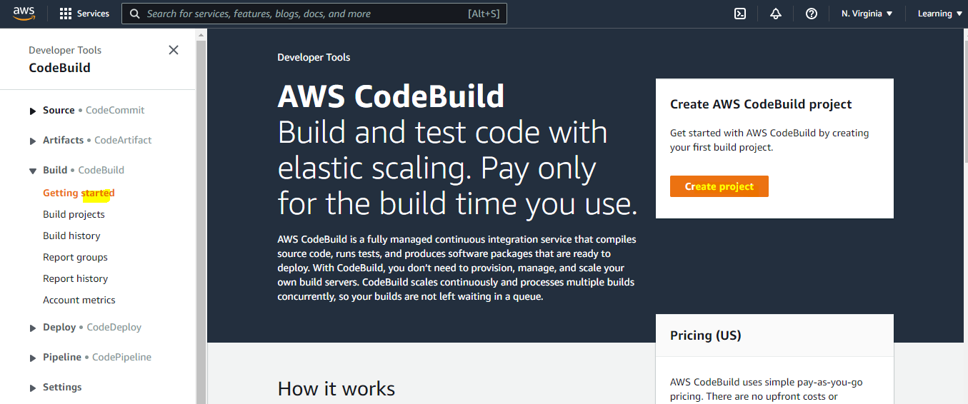

Step4.1: Create Project
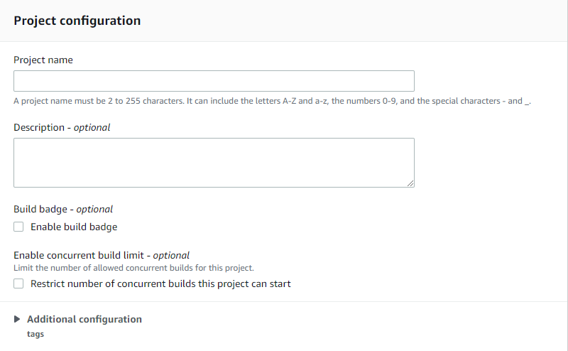
Step4.2
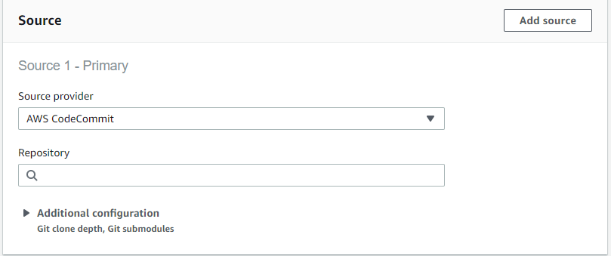
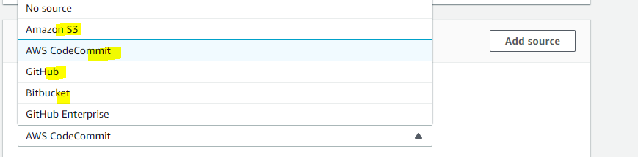
Step4.3
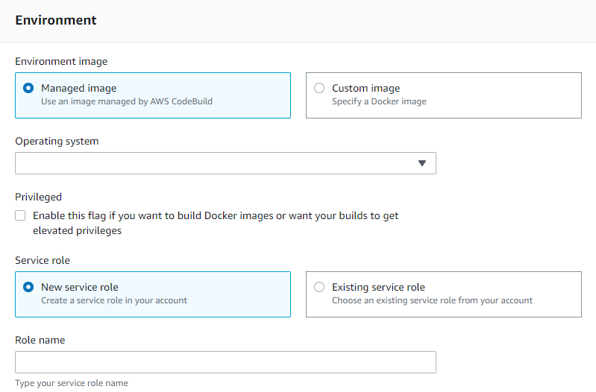

Step5: Code Pipeline
Codebuild-pipeline-demo-01
Step5.3(Step3.3)
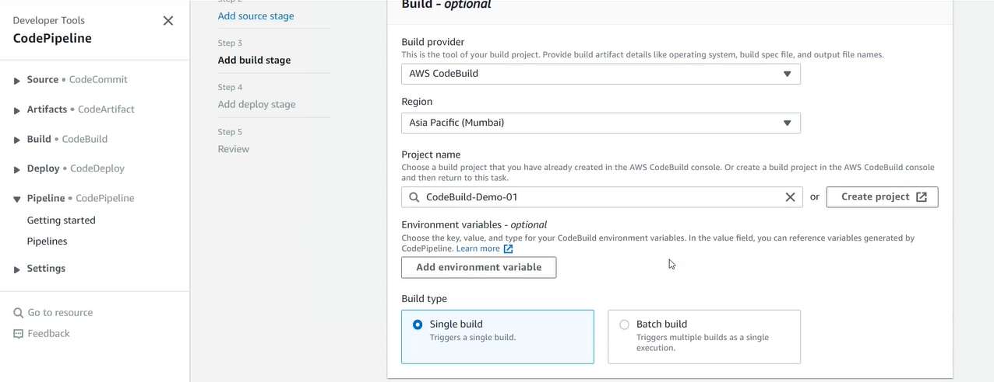
Step5.4 (CodeDeploy)
Step6: GitHub
Step7: Jenkins (Plugin: AWS CodePipeline)
EC2 Role: DemoRoleForJenkinsAccess (AWSCodePipelineCustomActionAccess)

configure
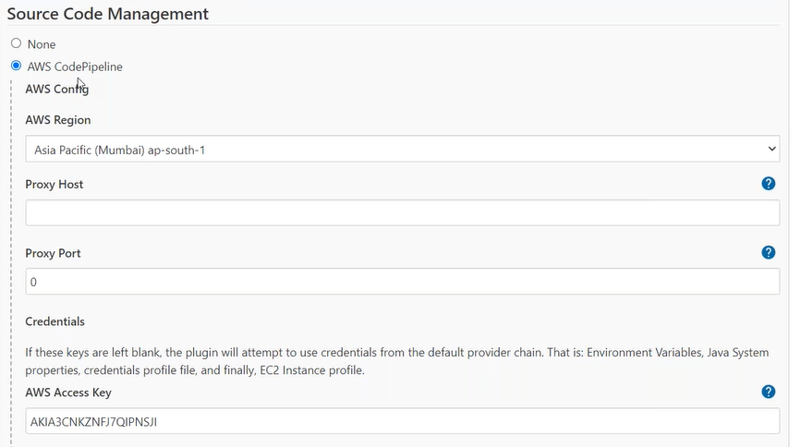
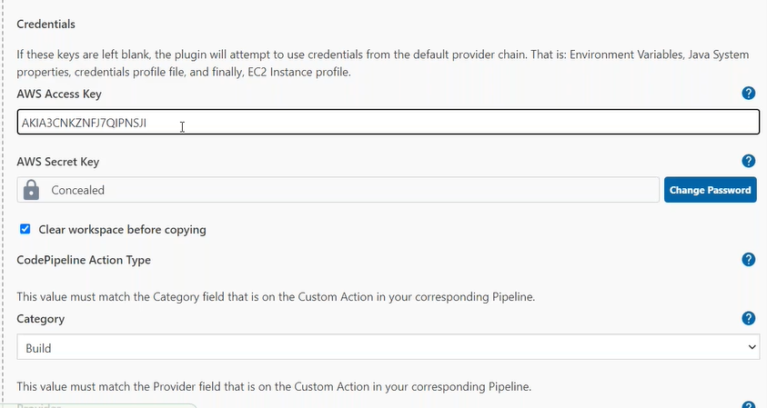
Step8: CodePipeline

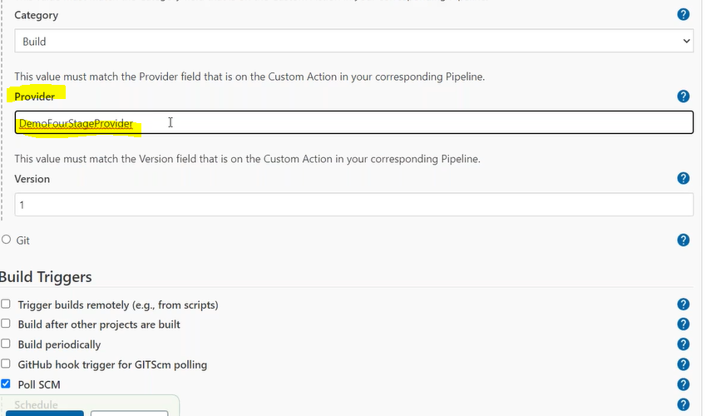
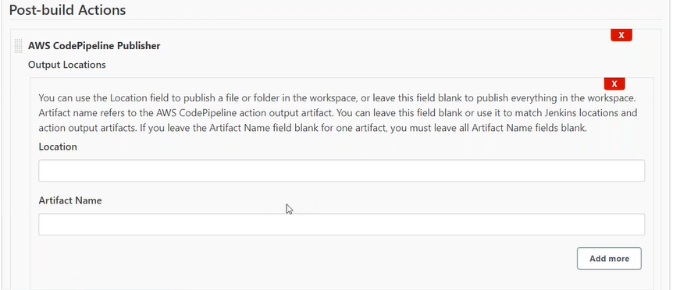
Step8.1: Build Stage
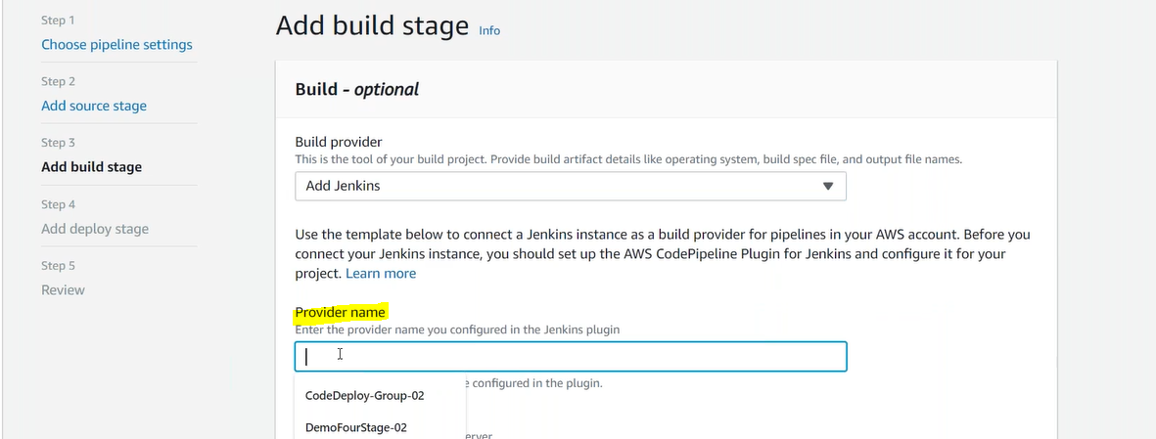
Step8.2
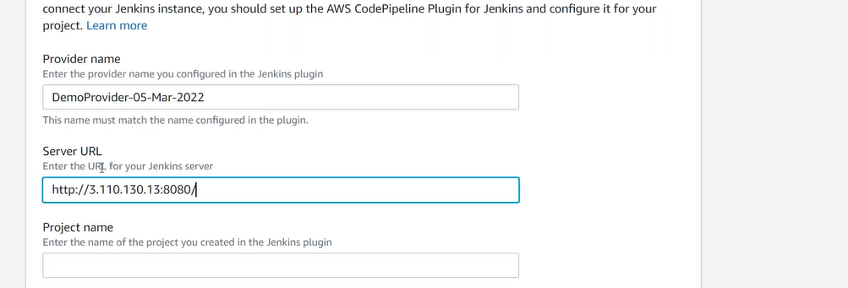

Edit Pipeline: Add Stage (parallel/sequential)
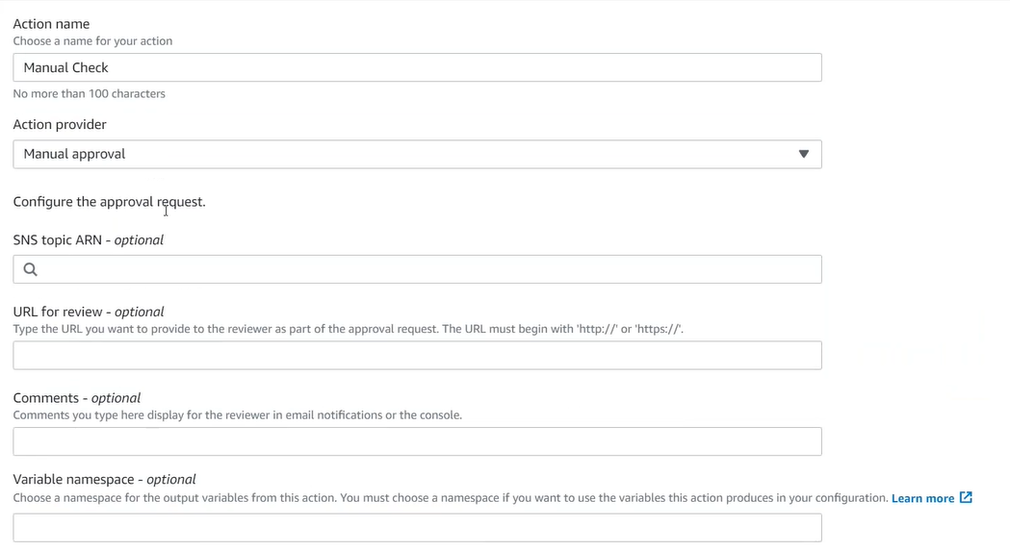

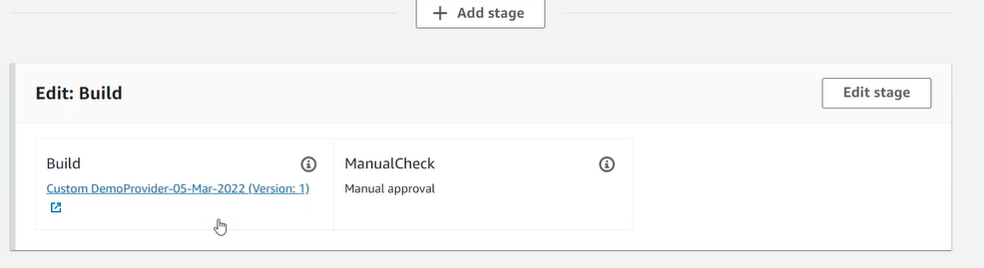
Manual Check On S3

ALB
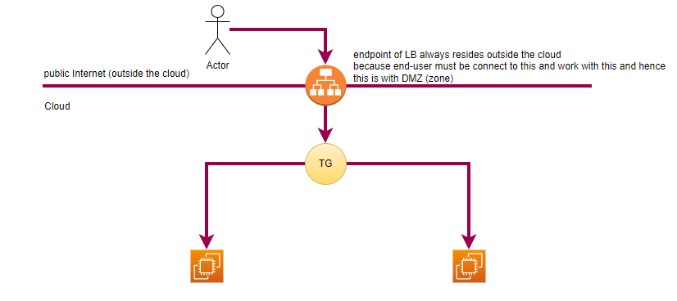
step1: create 2 EC2 Instances
step2: create Target Group
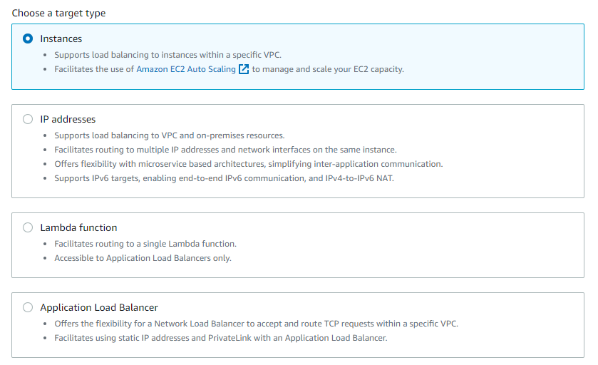
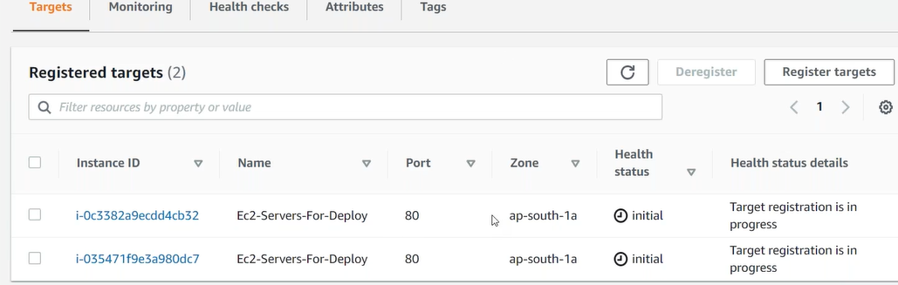
step3: create ELB (ALB)
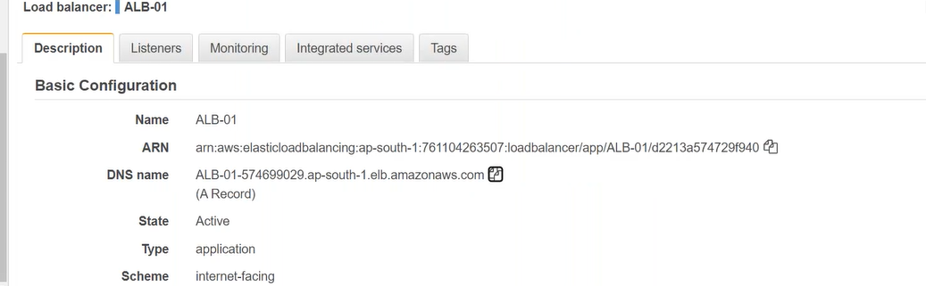
Step4: create CodeDeploy (Application)
Step4.1: Deployment Group
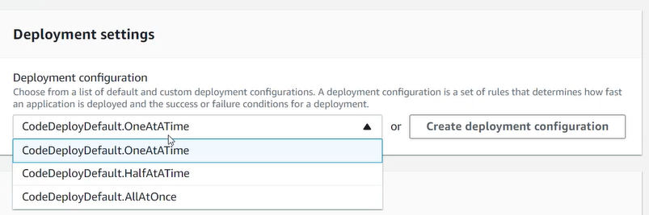
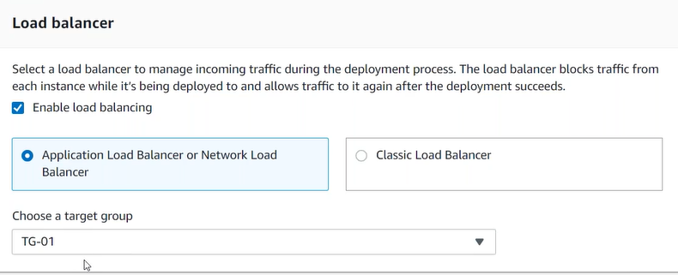
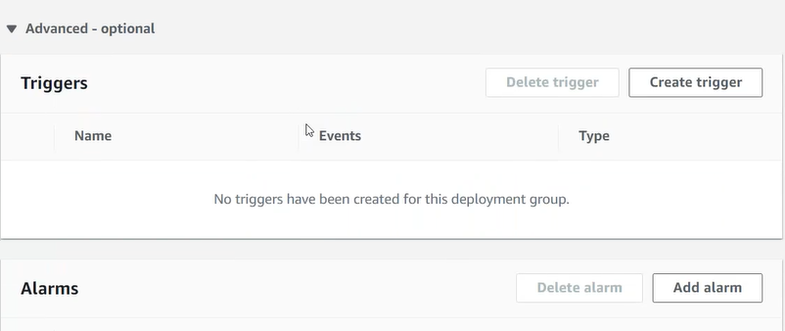
Step4.2: Create Deployment

EC2 Instance Lifecycle hooks
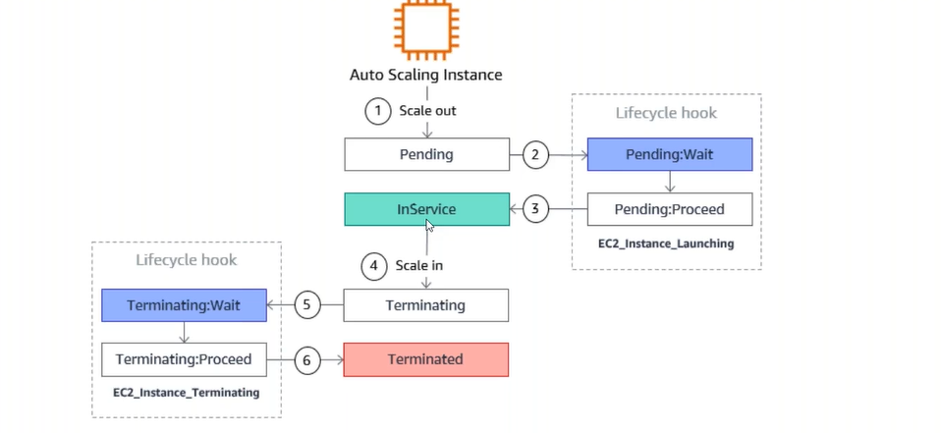
Autoscaling:
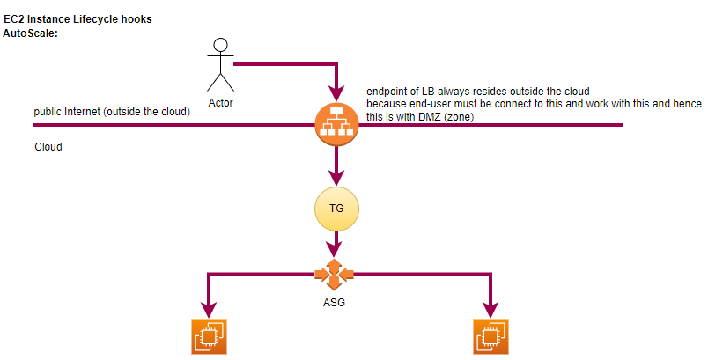
step1: launch template
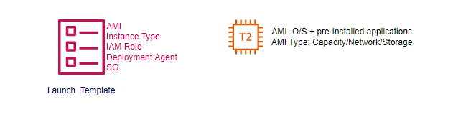
step1: create EC2 template (CodeDeploy Agent)
step2: create AS Group
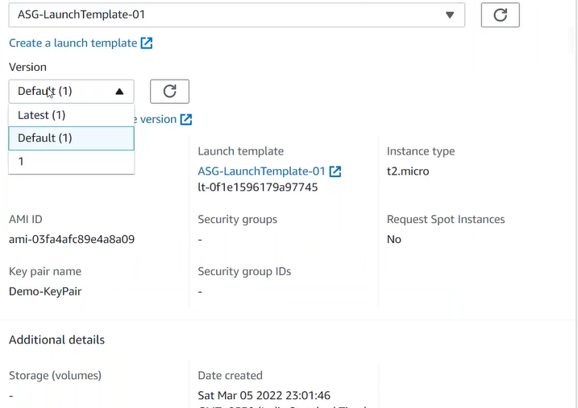
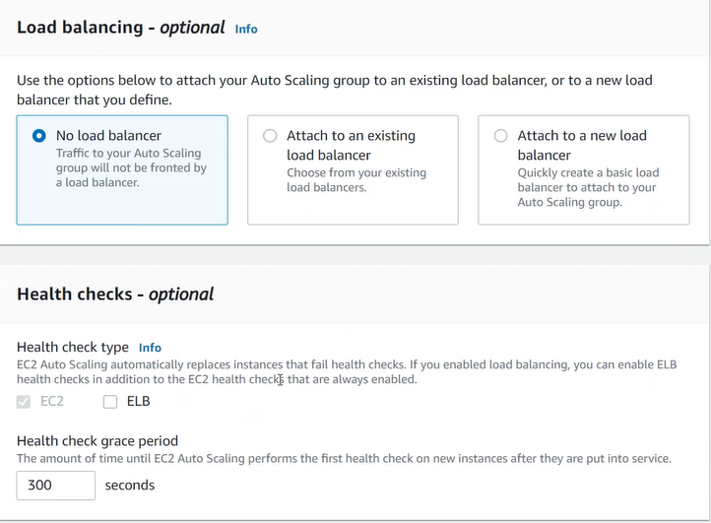
Note: EC2 Instance created by ASG
step3: create Deployment Group
step4: Create Deployment
Day4:
step1: create EC2 instance in 1a
# CodeDeployAgent script, IAM Role AmazonEC2RoleforAWSCodeDeploy+ AWSCodeDeployRole
step2: create EC2 instance in 1b
step3: create Target Group TG-01
step4: Add both Instances to TG
step5: Create ALB
step6: create Template # CodeDeployAgent script, Auto-Assign public Ip (Enable)
step7: create ASG # attach with TG-01

step8: Create CodeDeploy
step8.1: create Application
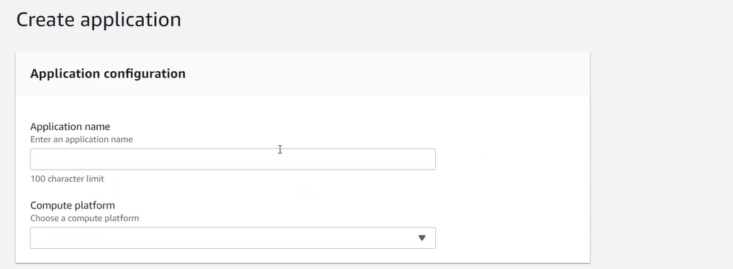
step8.1: create Deployment Group
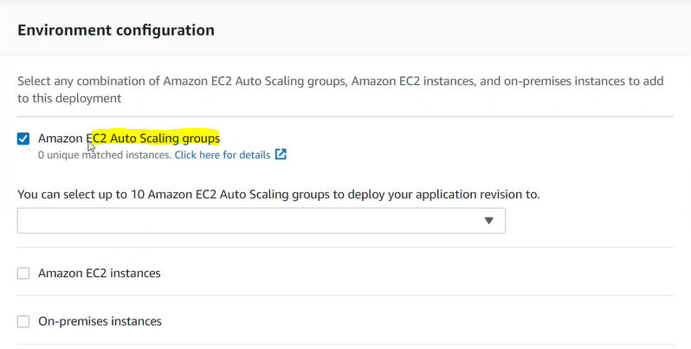
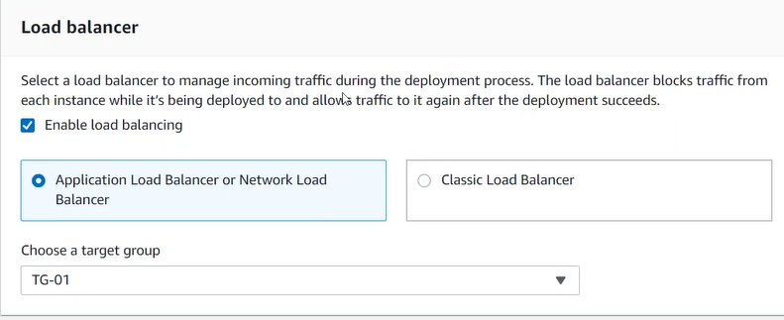

step8.2: create Deployment # upload .zip in S3

Container: (blue/green, Auto scale)
step1: create Dockerfile
step2: create image from Dockerfile
step3: tag the image
step4: push the image in ECR (just like docker hub) # first compress the size then uploads (aws managed)s
step4.1: create repository in ECR
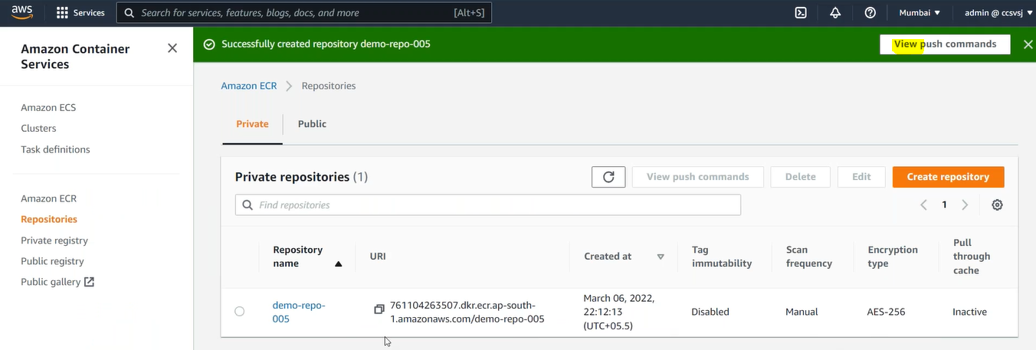
step4.2: push the image in ECR repository

step5: ECS
Cluster
Multiple Servers
Multiple Services
Each service has multiple tasks (task- Image+CPU+Memory…)
Each task has multiple containers (AZ1, AZ2...)
step5.1: Create Cluster (Group of servers spread across multiple AZ) # Fargate
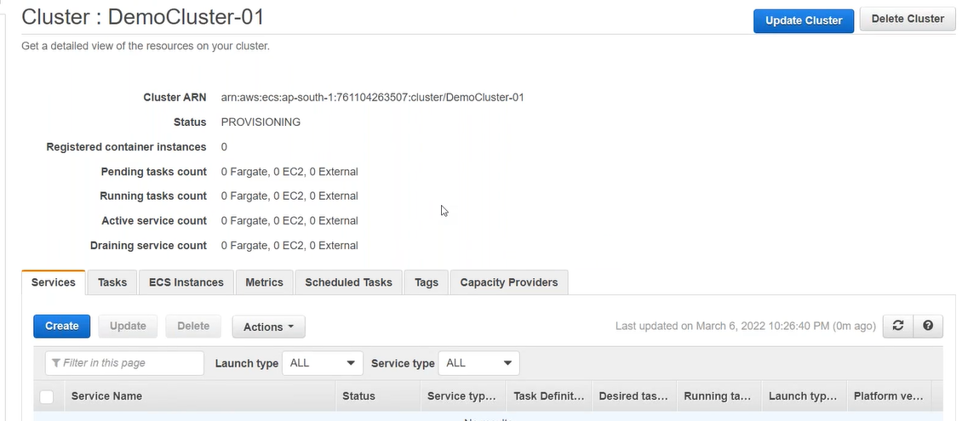
step5.2: Create task definition (just like pod) # image/cpu/memory # Fargate
step5.3: create services (just like controller) #Fargate
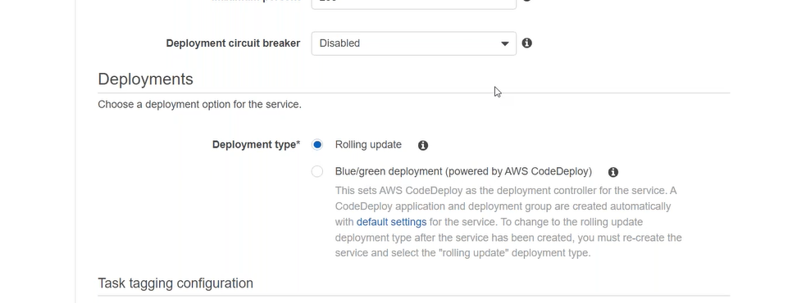

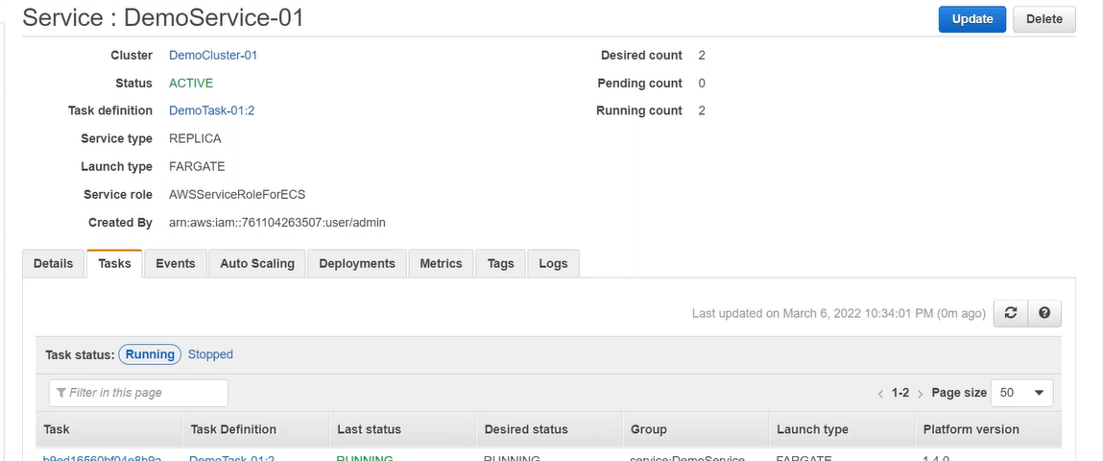

Change the Colour and push latest image
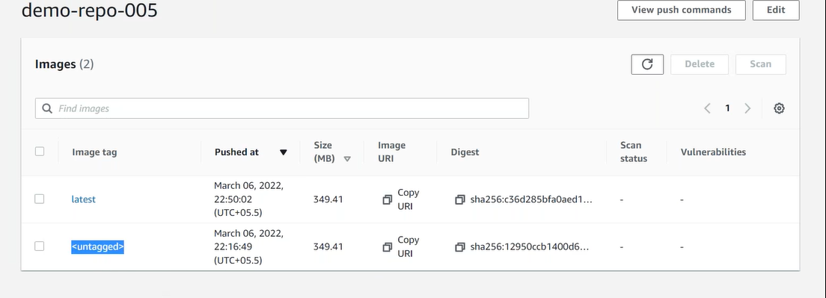

Create latest version of task?
Update the task definition (Update Service)
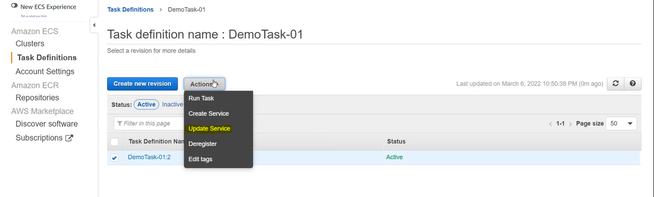
Retain older version for some time
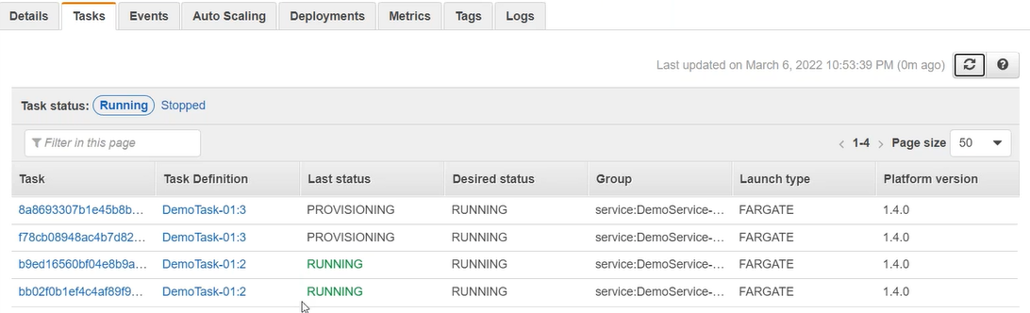

Blue-Green environment only available with ECS environment, not with EC2 environment.
Create TG (IP based)- Without targets
Create ALB
Update the ECS
Create new service ( add LB)
Check the TG to Identify the target

Route53
HostedZone- domain
Create Records
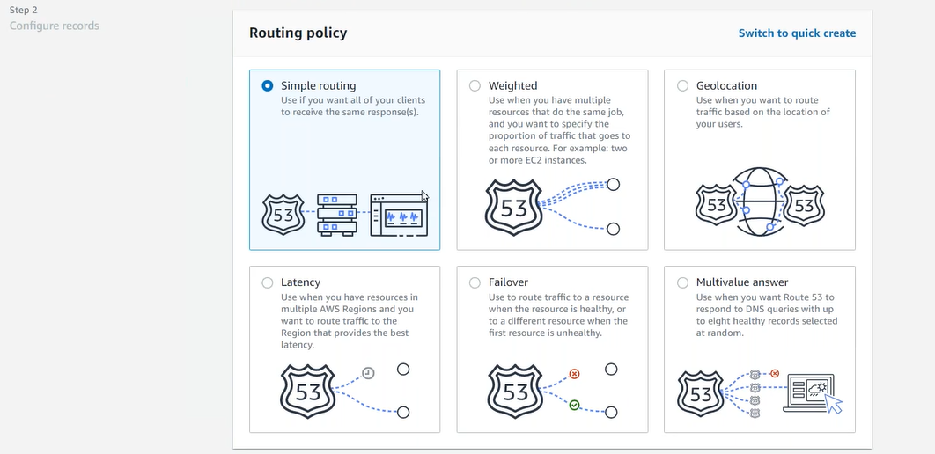
Name Server
Day5
Blue/Green
step1: Create 2 Target Groups (IP based not instance based)
step2: create ALB
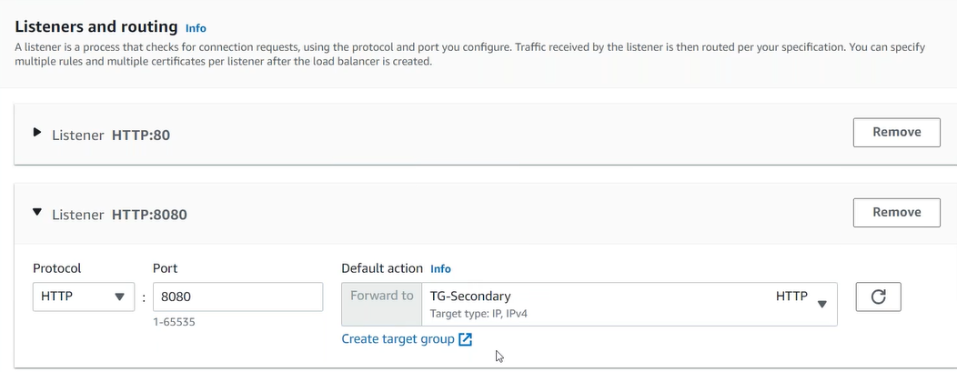
step3: push image in ECR
step4: create cluster (ECS)
step5: task definition
step6: create service (Automatically CodeDeploy will be created)
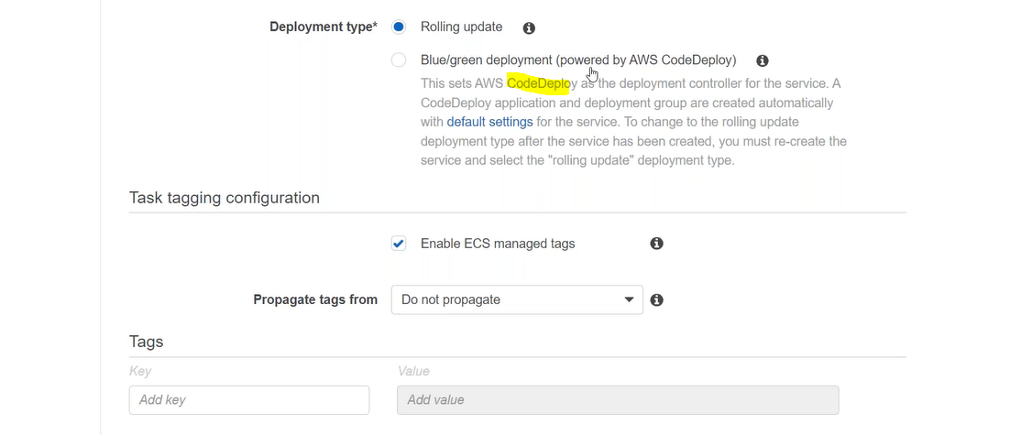

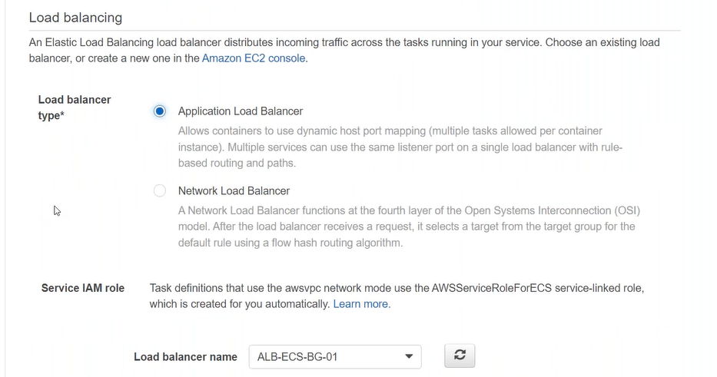
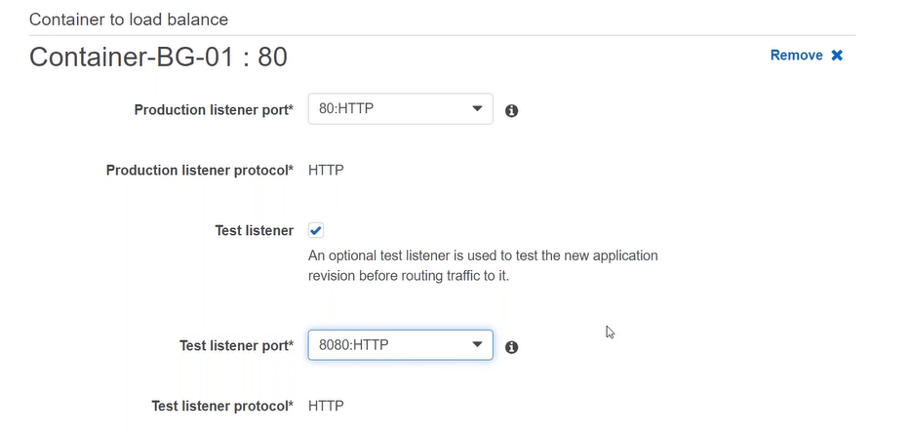
configuration
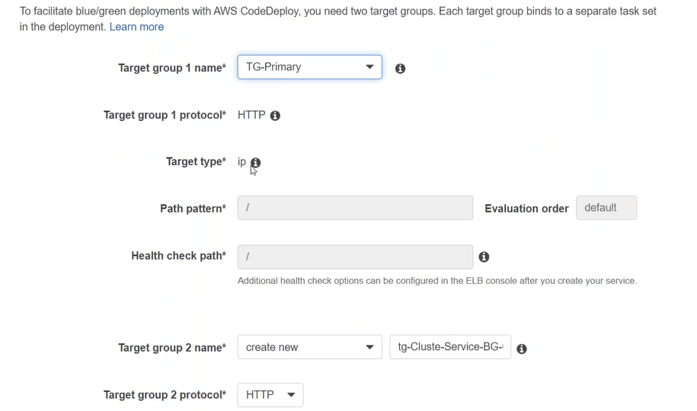

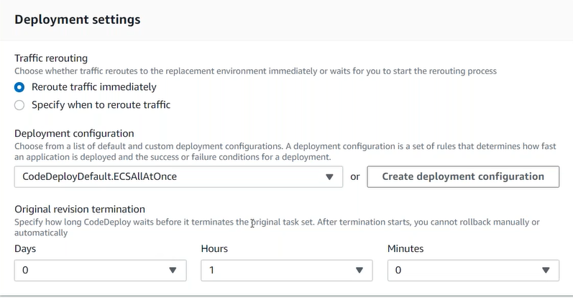

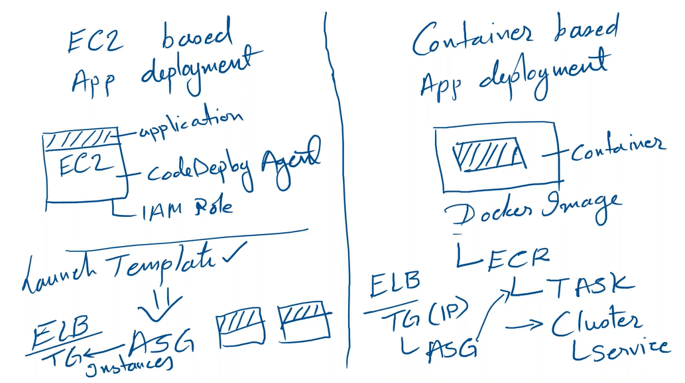
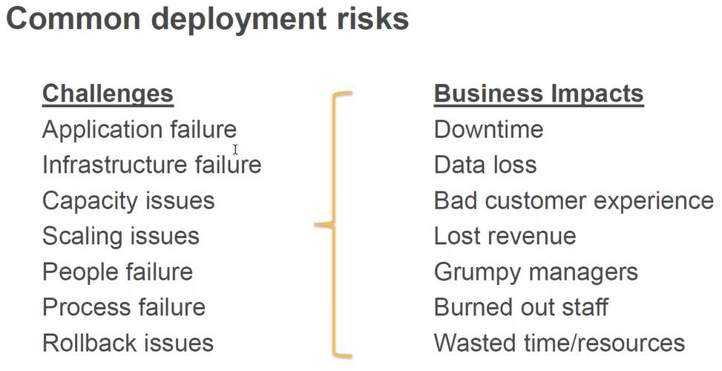

Day6
CloudFormation:
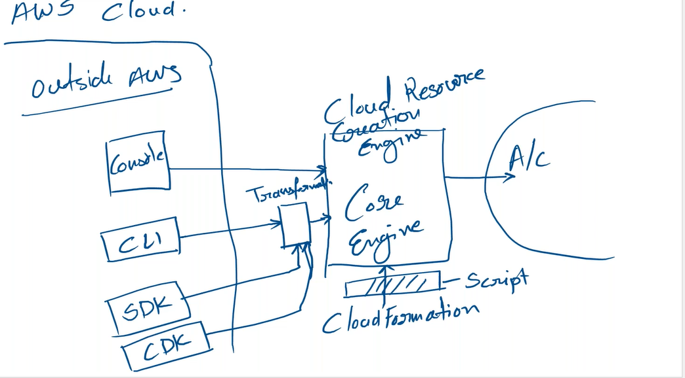
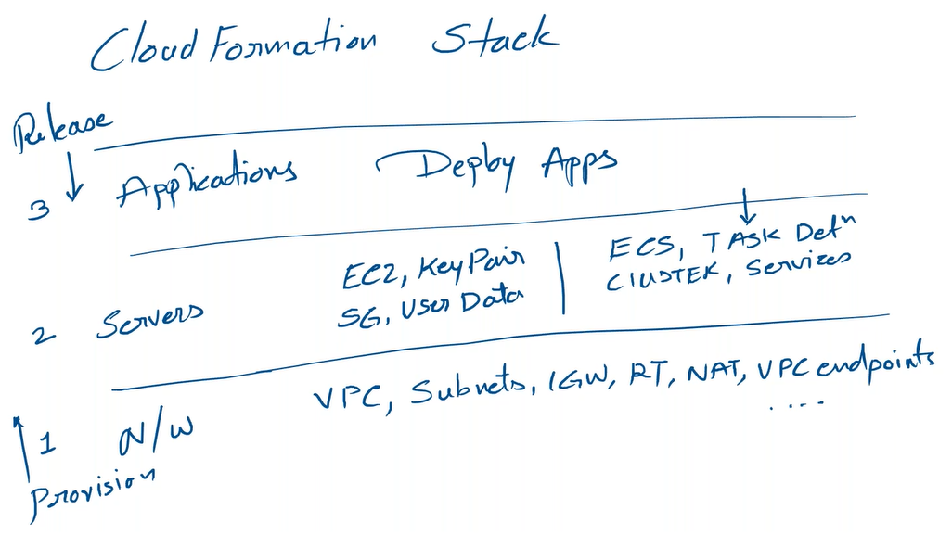

- Parameters (drop down) # Arrays, resource type from account
- Resources
- Outputs
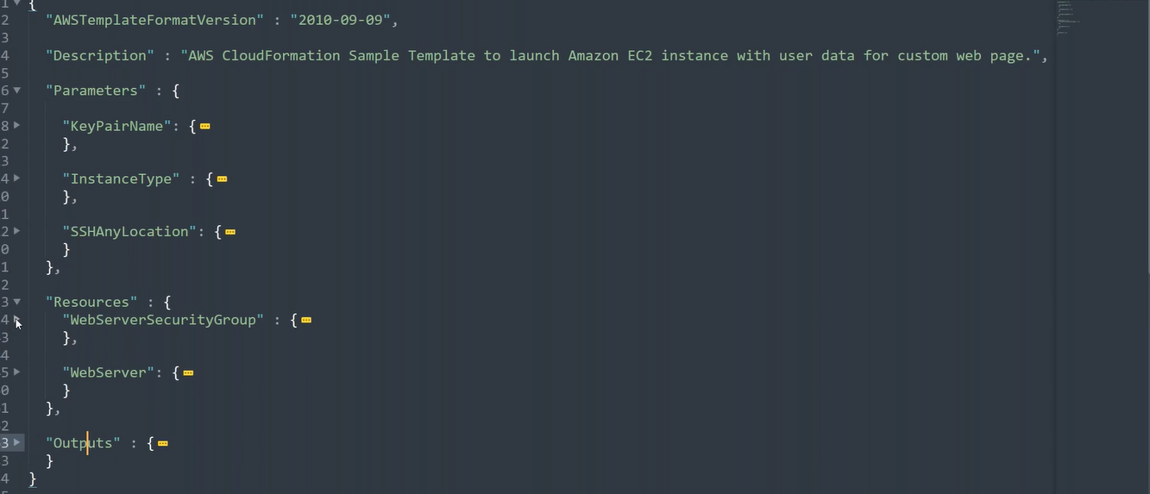
2nd level is always variable name, (Parameters, Resources)
Parameter/Variable names used with in the resources
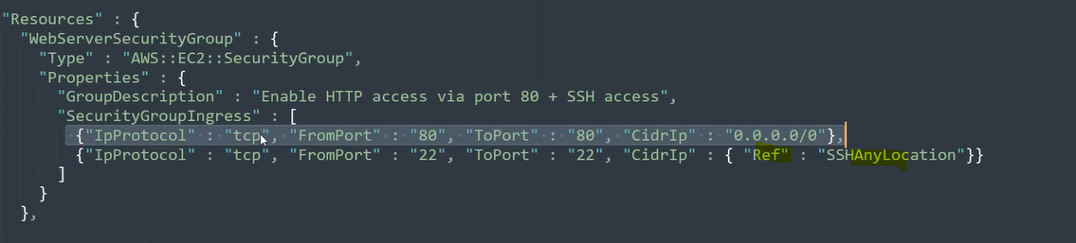
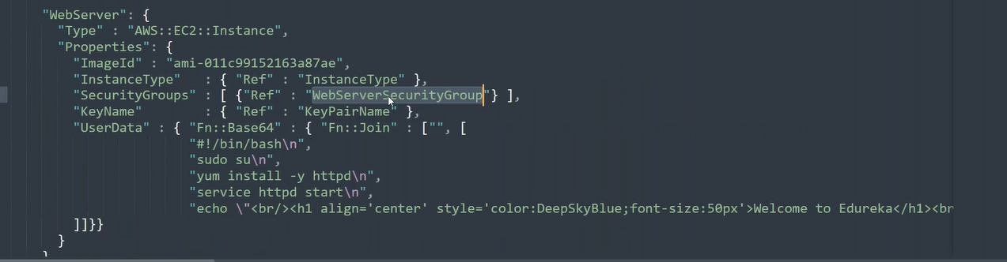
Intrinsic Functions:
Fn:: Base64
Fn:: Join
Fn::getAtt
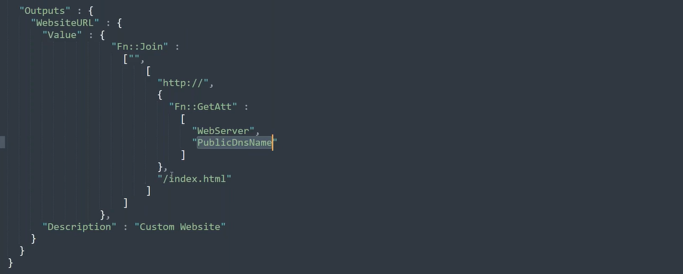

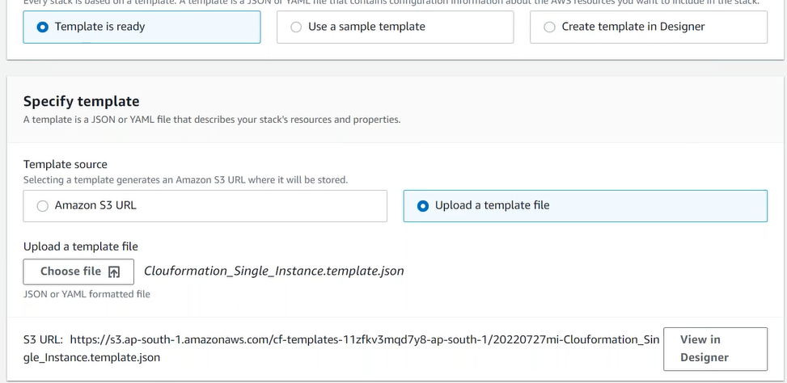
Stack:
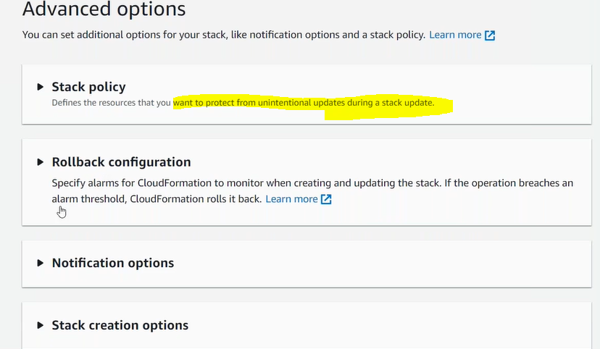
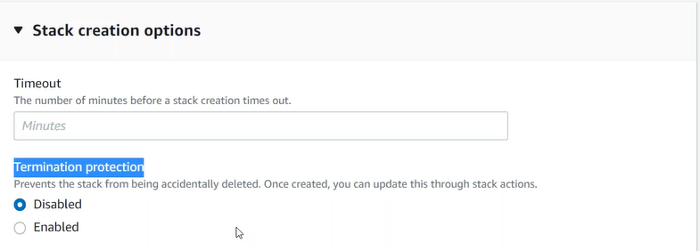
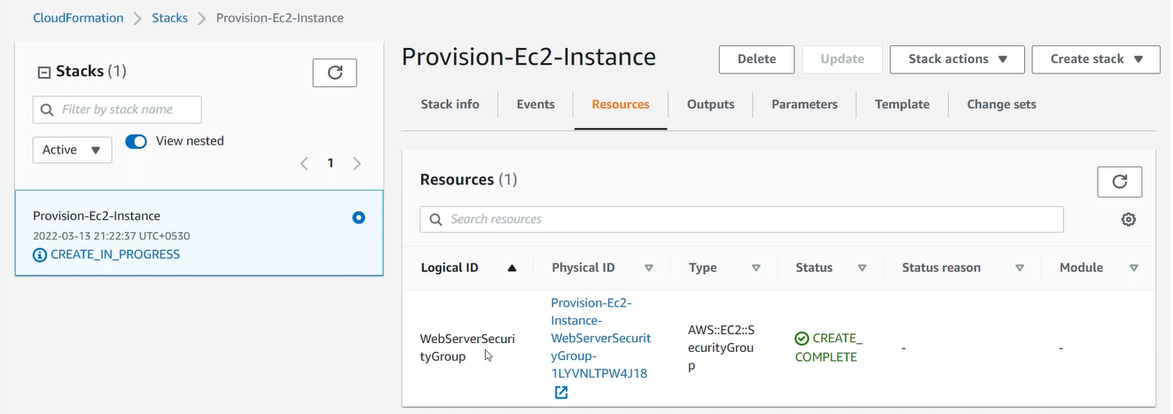
UC: Change the properties of the resource manually e.g. change the SG?
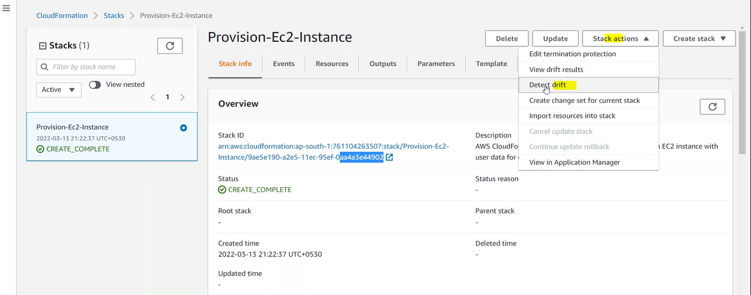
Changeset?
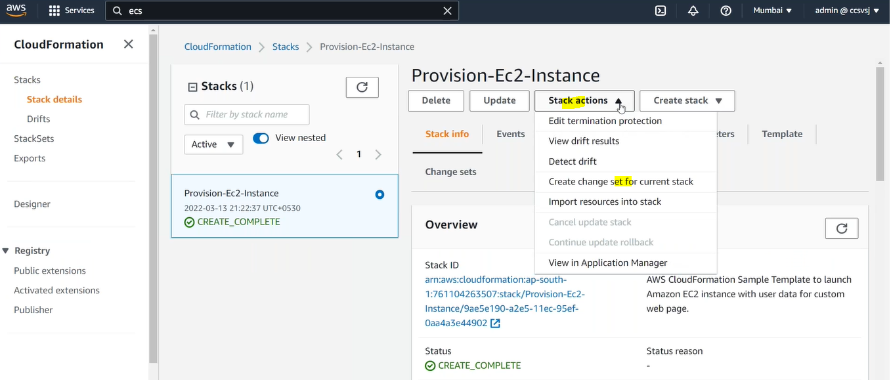

Terraform
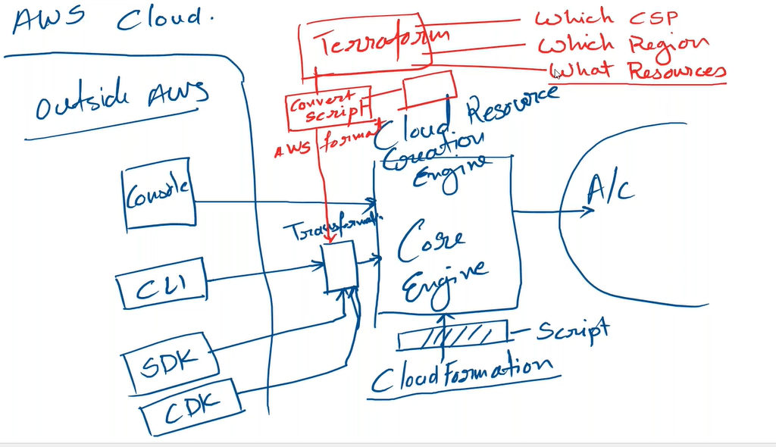
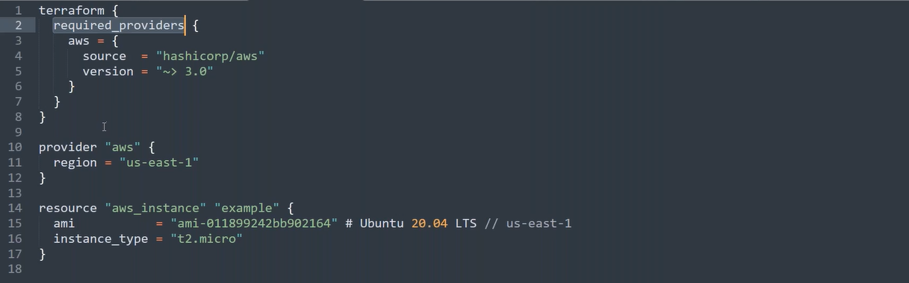
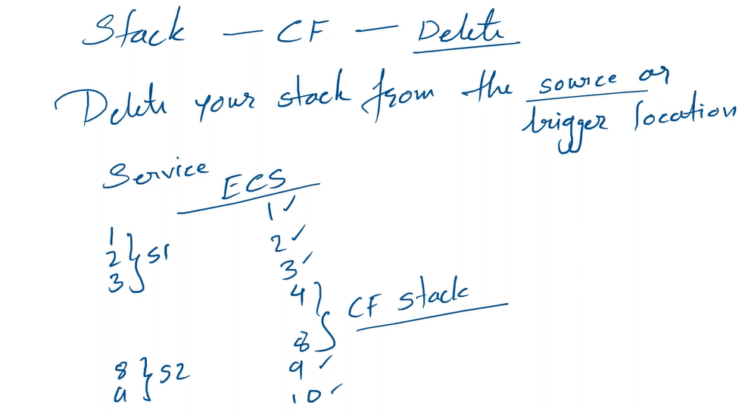

Serverless
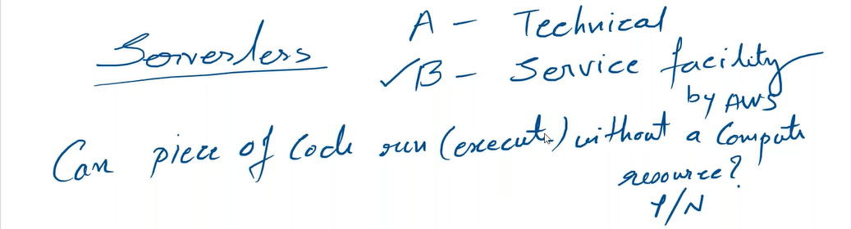

Lambda
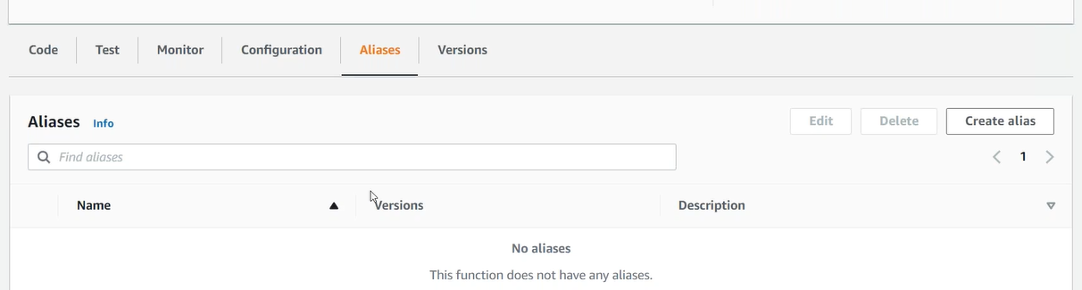
Configuration:
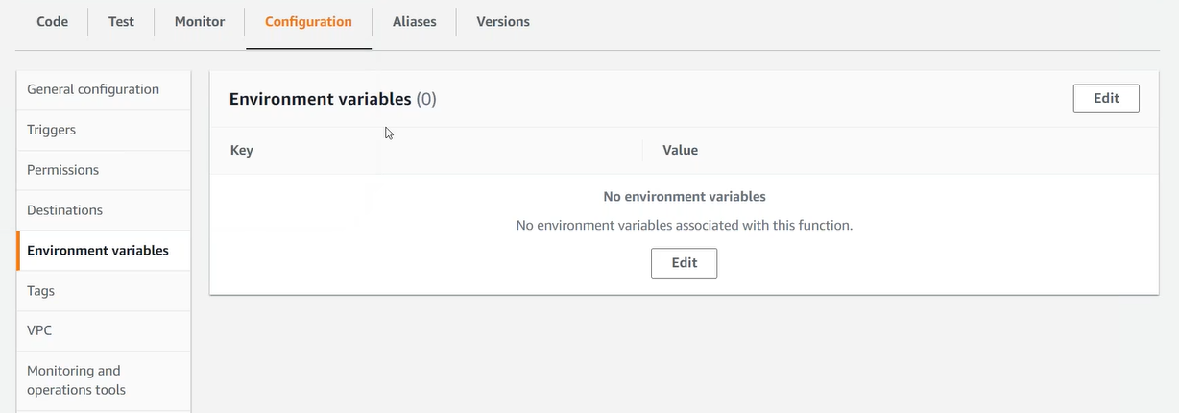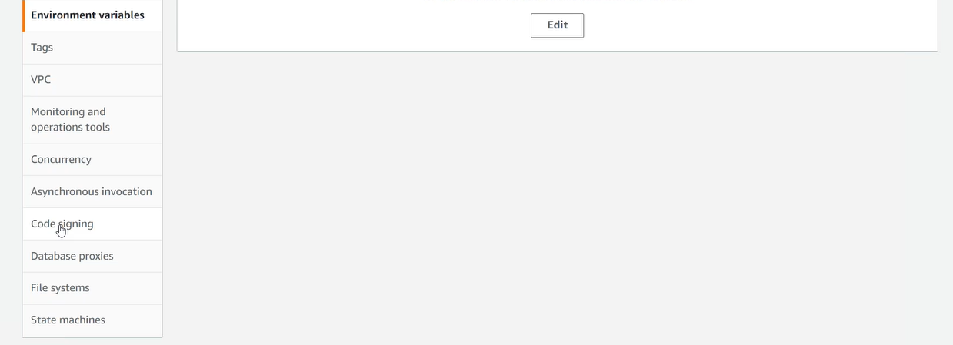
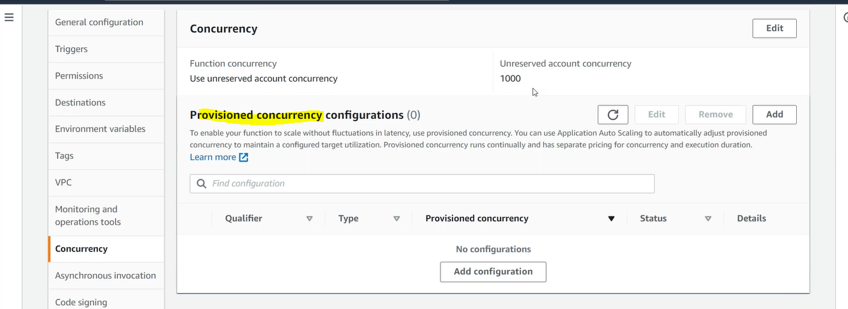

Day7
Serverless Solution in AWS (SAM CLI)
API Gateway->Lambda->DynamoDB/S3
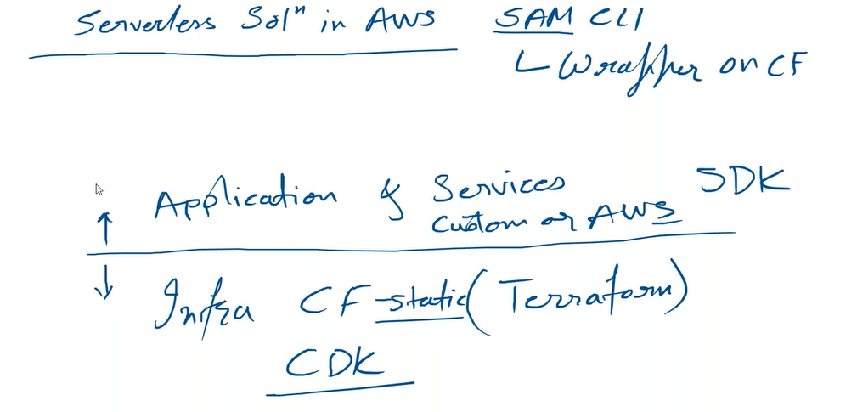

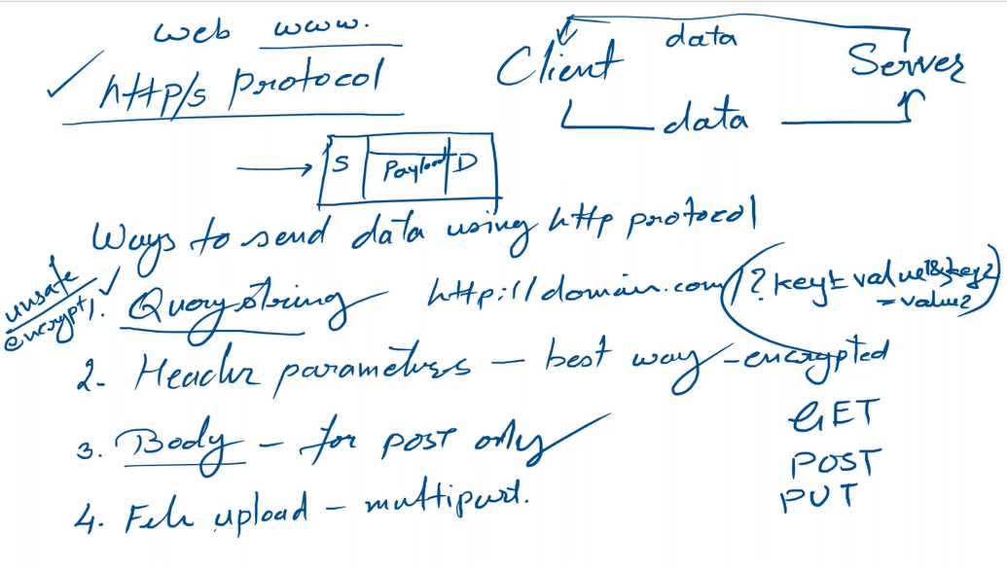
API Gateway
REST API
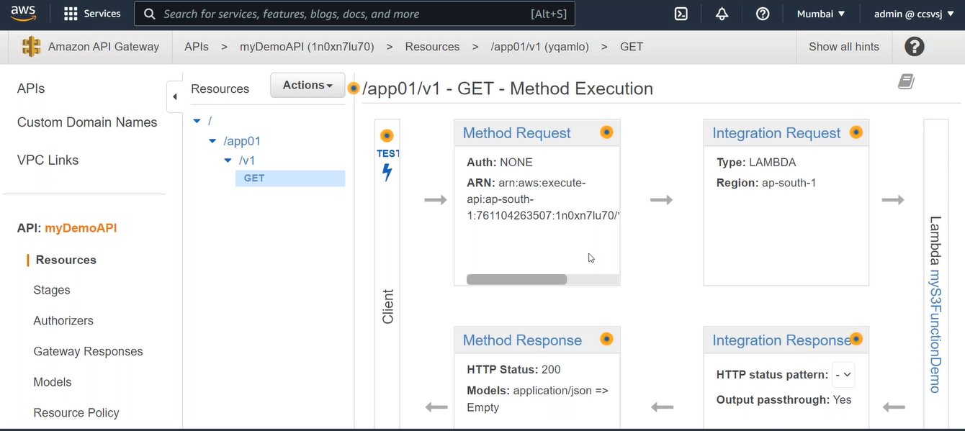
Models:
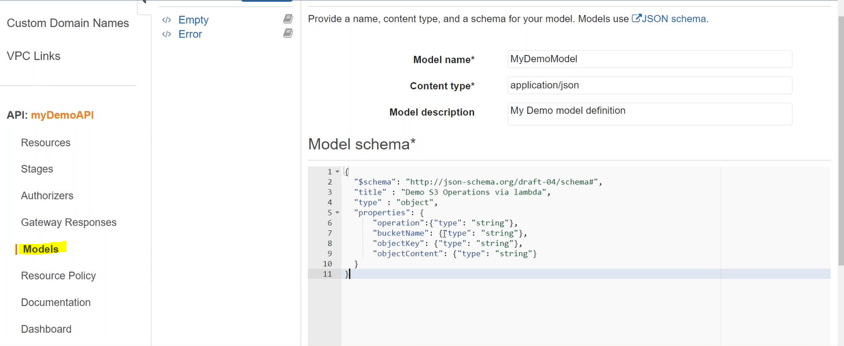
GET-> Method Request
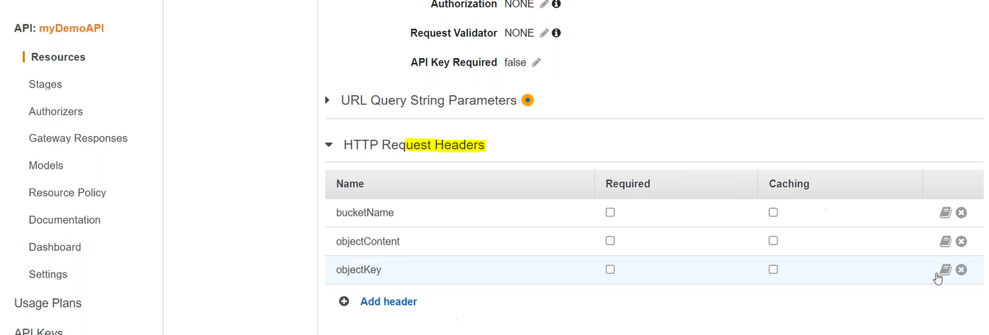

GET->Integration Request
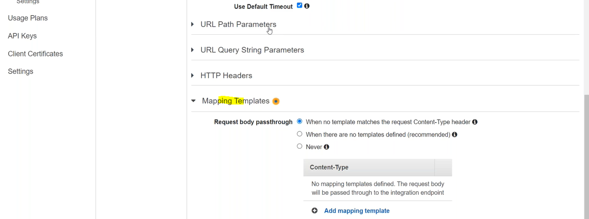

Test
CORS
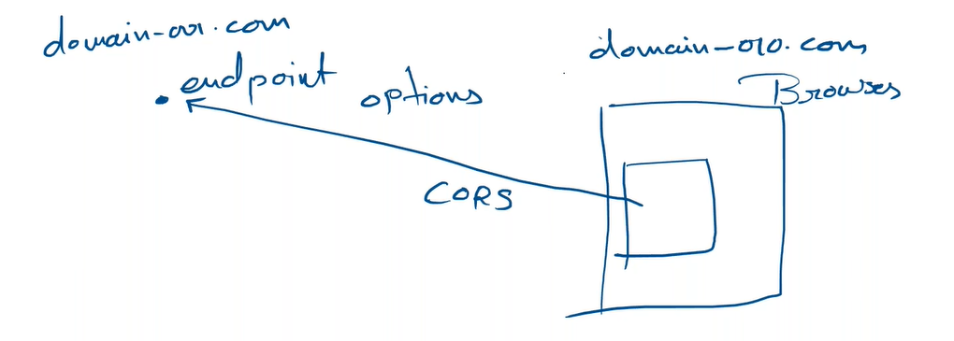
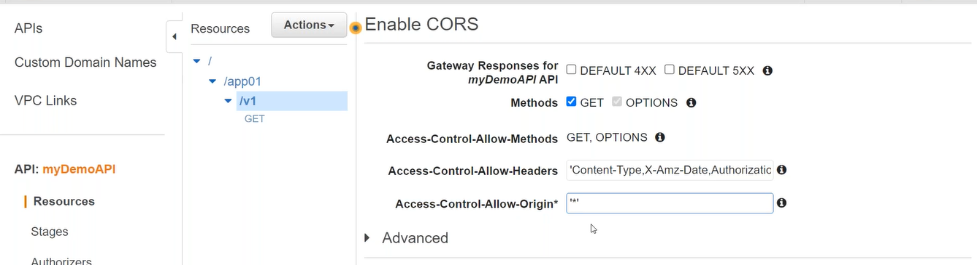

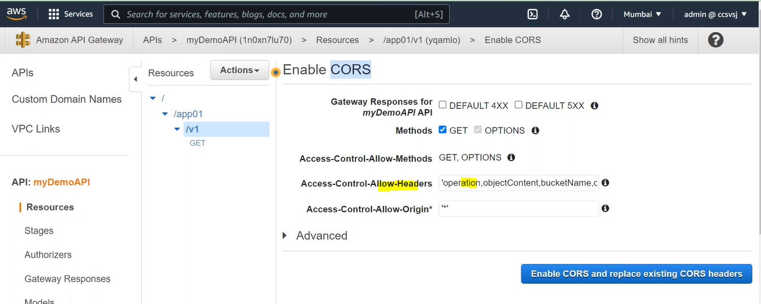

GET-Response Method
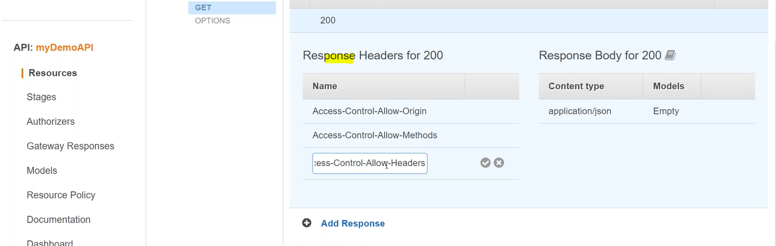
Deploy
Allow only from specific domain using CORS
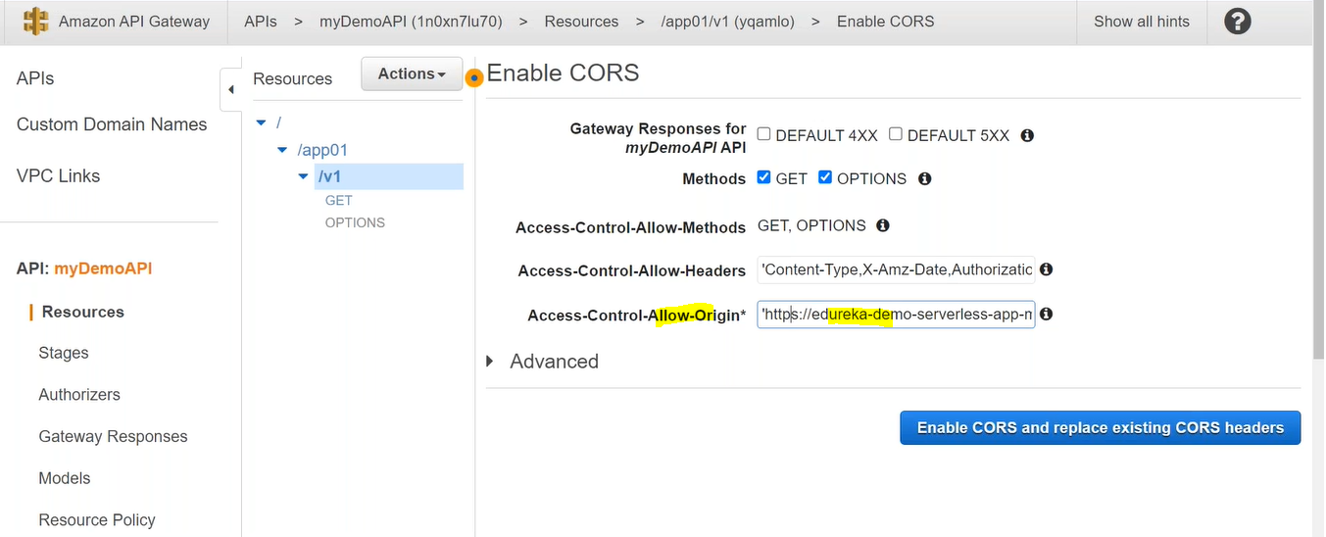

Deploy

Day8
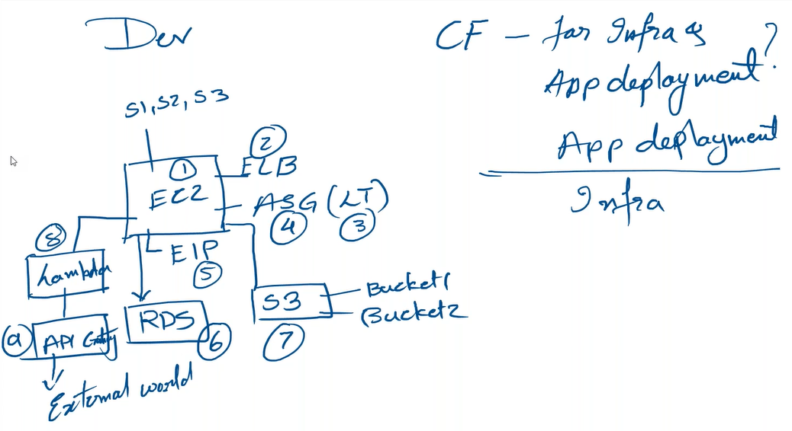
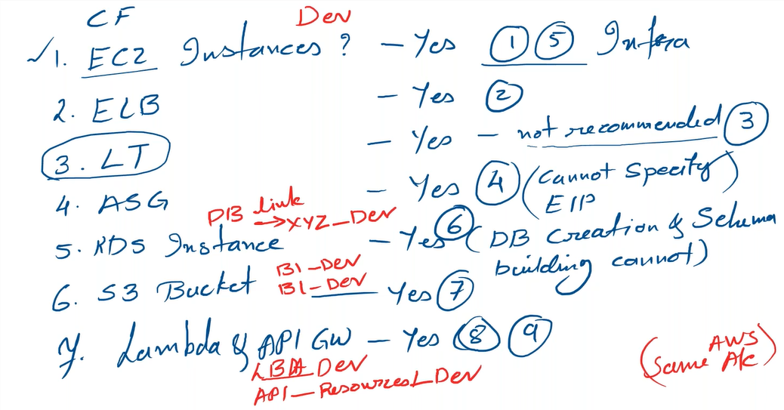

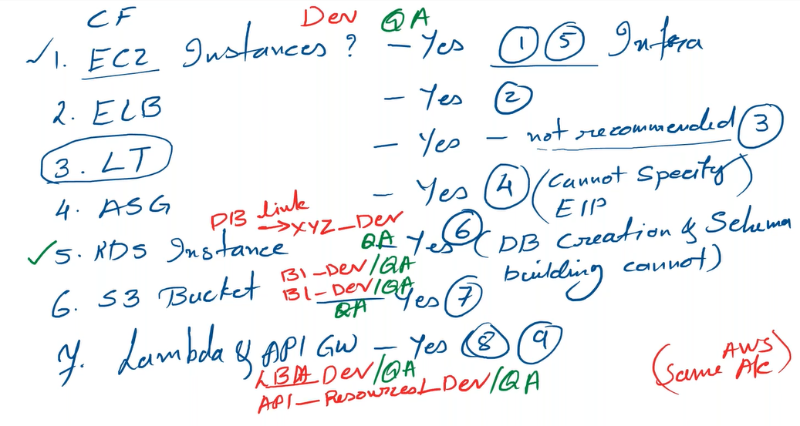

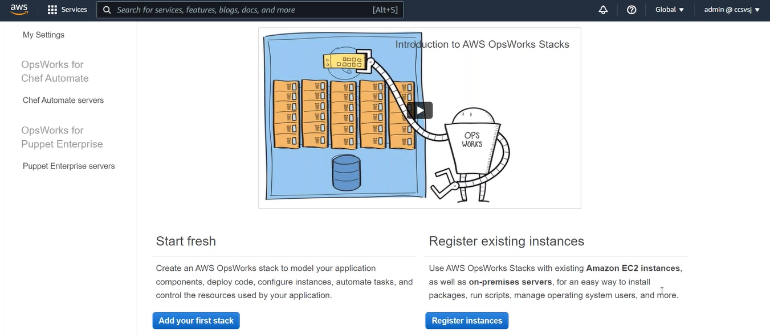

Secret Manager (System manager->Parameter Store)
