What is Cloud Computing? Definition(s)
“A standardized IT capability (services, software, or infrastructure) delivered via internet technologies in a pay-per-use, self-service way.”
“Cloud computing is a model for enabling ubiquitous, convenient, on-demand access to a shared pool of configurable computing resources (e.g., networks, servers, storage, applications and services) that can be rapidly provisioned and released with minimal management effort or service provider interaction.”
Ubiquitous: able to access cloud environment from anywhere.
Business Drivers (Why use Cloud computing?)
- Capacity Planning: determine and fulfil future demands of an organization’s IT resources.
  - Computing Resources
    - CPU
    - Memory
    - Storage
    - Network
  - Over-provisioning
  - Under-provisioning
- Cost Reduction
- BCP/DR
  - RTO (Recovery Time Objective)
  - RPO (Recovery Point Objective)
- Organization Agility
  - Responsiveness to change
Basic concepts and Terminologies
- Cloud
  - Distinct Distributed IT environment that is designed for the purpose of remotely provisioning scalable and measurable IT resources.
- IT Resource
- On Premise
- Cloud Provider: (AWS, GCP, Azure…...)
- Cloud Consumer
- Scaling (towards service)
  - Horizontal: (Scaling out/ Scaling In)
  - Vertical: Requires downtime (Scaling Up/ Scaling down)

Cloud Characteristics
- On-demand usage
- Ubiquitous usage
  - Accessible from any where
  - Accessible from any device
- Multitenancy
  - Pools: Physical servers, virtual server, storage, network, memory etc.
- Elasticity (IT resources)
  - Ability to transparently scale IT resources as required in response to runtime conditions pre-defined by cloud consumer.
- Measured usage
- Resiliency – Address reliability and availability of applications
  - Fault tolerance
  - Failover technique readily available

- BCP/DR inbuilt in the cloud platform.
Cloud Delivery Models
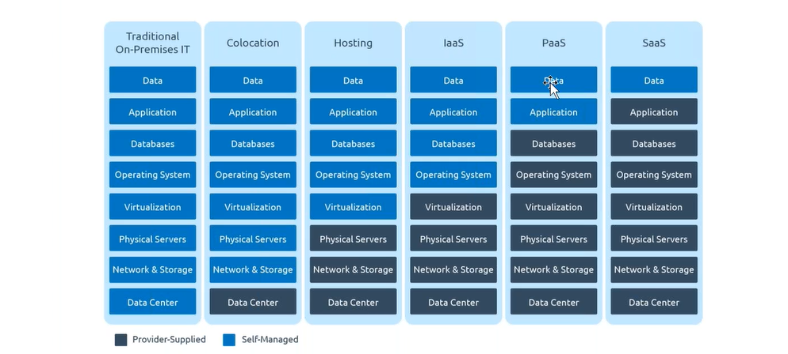
- IaaS
- PaaS
- SaaS
- Storage as a Service
- Database as a Service
- Security as a Service
- Communication as a Service
- Integration as a Service
- Process as a Service
- Function as a Service
Cloud Deployment Models
- Public Cloud
- Community Cloud
- Private
- Hybrid Cloud

Migration from on-premise to AWS cloud
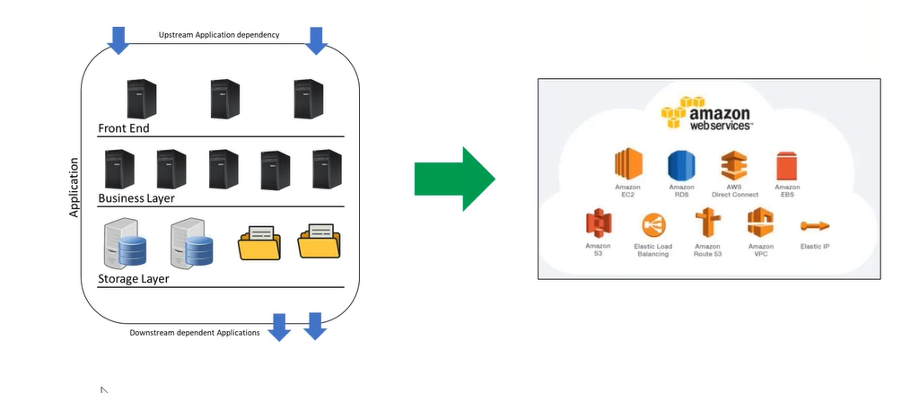
H/W never migrated to the cloud, S/W ( O/S, app) installed on top of that migrated to the cloud, and accessed over the internet.
Upstream Application Dependency- Input to application
Downstream Application Dependency- output of application
Migration Phases
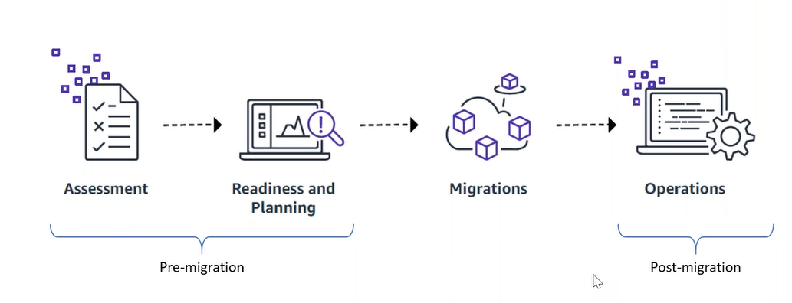
- Pre-Migration (70%)
  - Assessment
  - Readiness and Planning
- Migration (20%)
- Post-Migration (10%)
  - Operations
Assessment: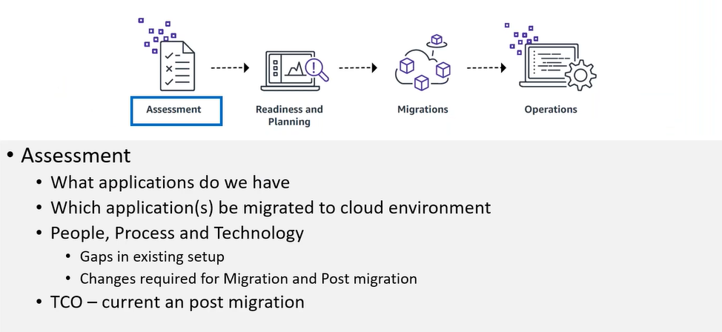
TCO: total cost of ownership.
Storage, Networking, Computing
Typical Application Artifacts
- Application (focus of migration)
  - Front End Components
    - Server(s) – Optimized for specific application
    - Third party component(s)- optional
  - Business Layer Components
    - Application specific logic.
    - Hosting H/W specific
    - Third party component(s)- optional
  - Storage Layer Components
    - File Storage: NFS, SMB
    - Data Storage: logs, temp etc.
    - Database: media(s)
  - Integration Components
    - One or more dependencies.
    - via API-online
    - Batch mode- offline
  - Network Components
    - Typically, not migrate.
- Process Assessment
  - End to End application process to identify challenges
    - Run through all use cases e.g. from where input comes from? What to do with those inputs? What is the end result of those inputs?
  - Batch process
    - Sources data (What type of the data coming from)
    - ETL
    - Frequency
  - Third party process and their support during migration
  - Reporting requirements (who is the consumer of those reports)
    - Manual processes involved if any
    - Communication modes
  - New Release roll-out
- Technology Assessment
  - Operating System
    - Constraints
    - Special Requirements
  - Patch Management
  - New Release roll-outs
  - Back-ups/Restore
  - BCP/DR

Readiness and Planning
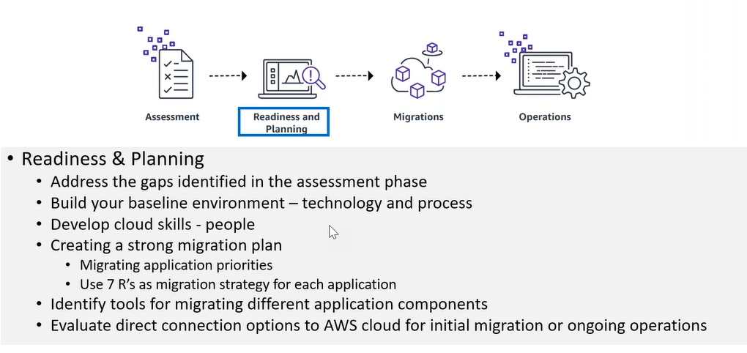
Common Application Migration Strategy (7’R)
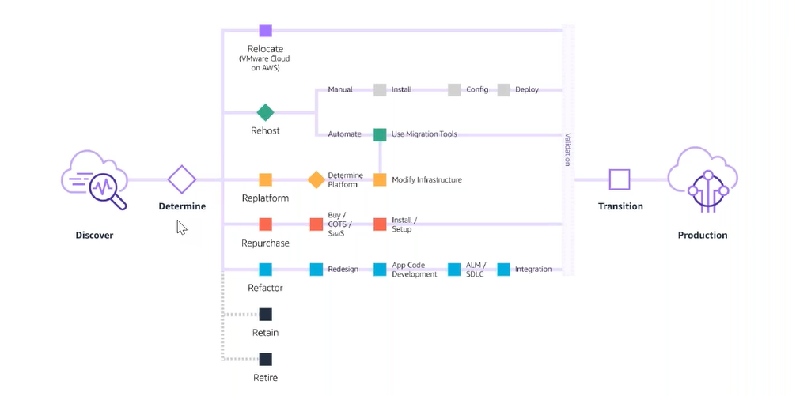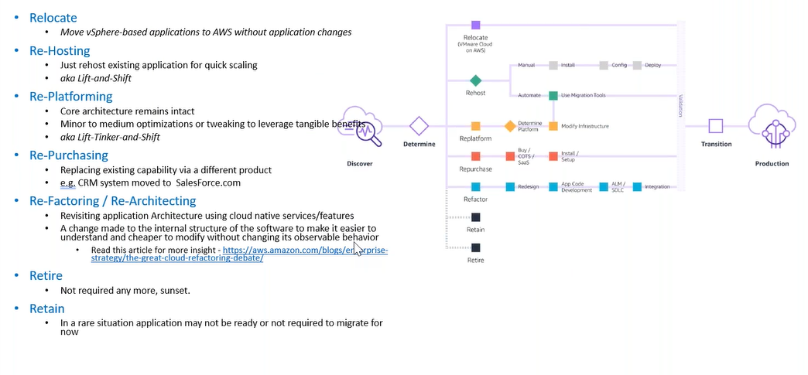
Re-Host: Windows<> Windows
Re-Platform: Windows<>Linux (Underneath platform change)
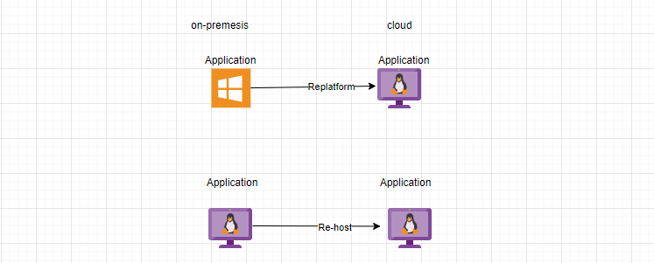

Interpreter, well know your on-prem (one language) as well as Cloud (other language), there is always exam of language not the interpreter.
Migration Phase:
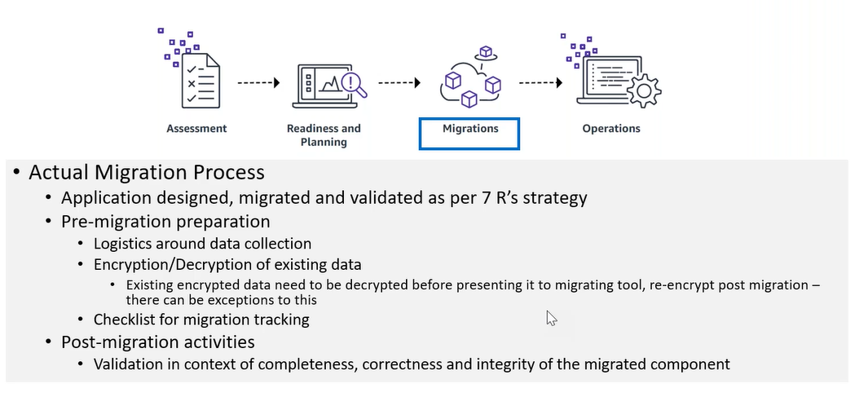

Operations:
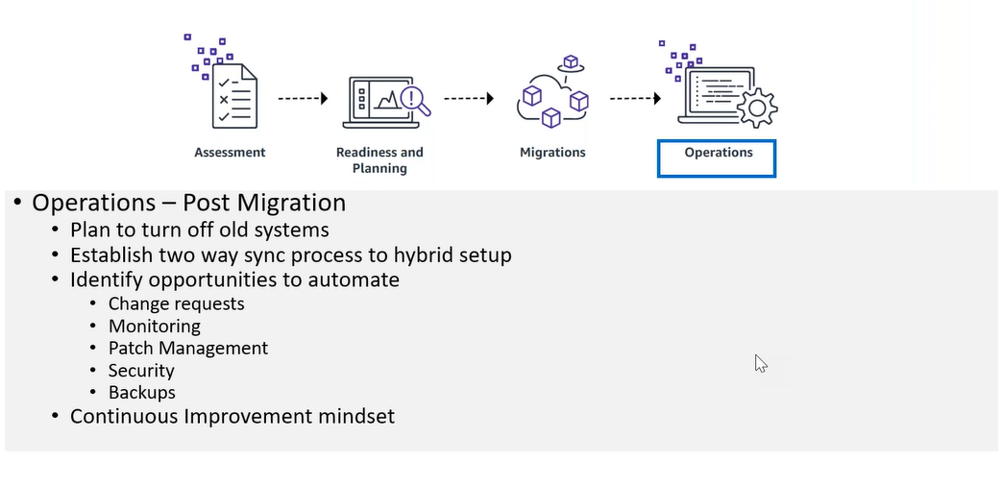
Shared Responsibility Model
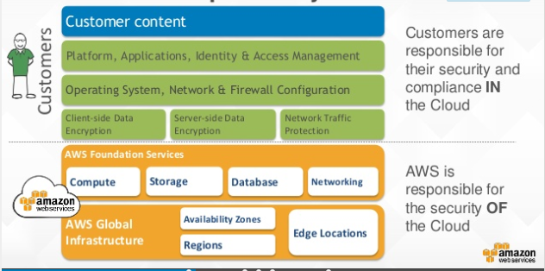
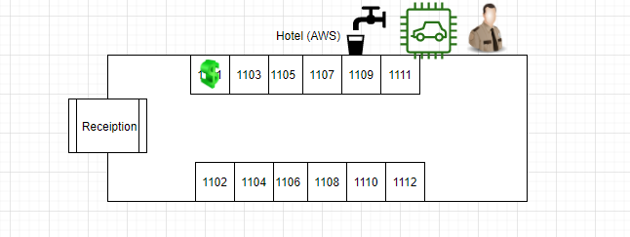
Internet provisioning is AWS responsibility, securing the same is our responsibility.
How O/S responsibility lies on Customer?
AWS just provide the O/S you are responsible for apply patches.
Region Failure?
It’s our responsibility to design as per disaster recovery Using Route53

https://infrastructure.aws/
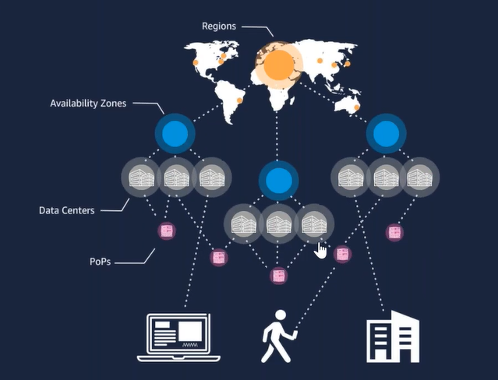
- Gov Cloud: Not accessible from public
- Beijing: China Government
- Generally Available
Partition (Different Networks):
- aws
- aws-us-gov
- aws-cn
- Regions: Geographical Location (Logical term)
- Availability Zone: (Logical term)
  - Data Centers (Physical presence)
- Local Zone: Reduce the latency (full fleshed data center)
- Points of Presence: (minimum 10GB lines connected with data centers) also called Edge Location. Just for caching purpose. (Wave Length).
status.aws.com (AWS service status)
- personal health dashboard (Is AWS down service impact in my account?)
  - Event Log
arn (amazon resource name): partition:service::region:accountid:resource-id
- cloudharmony.com
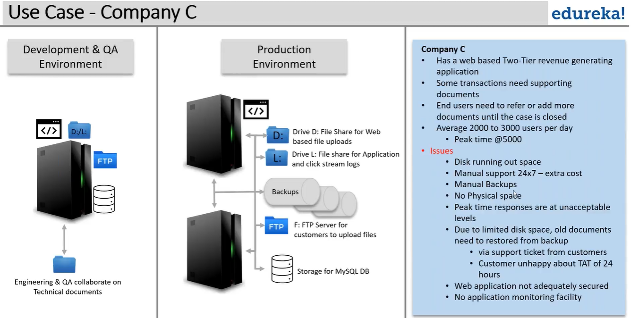

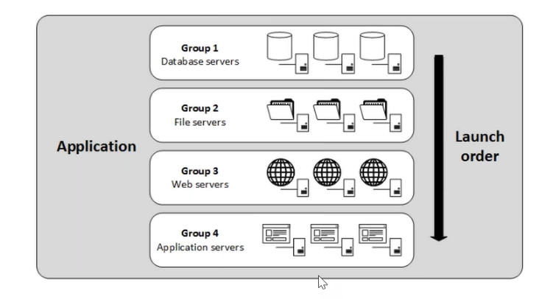
Total Cost Projection:
Always we have to provide the range not the actual estimation.

