Day2:
AWS Key Services for Storage Migration
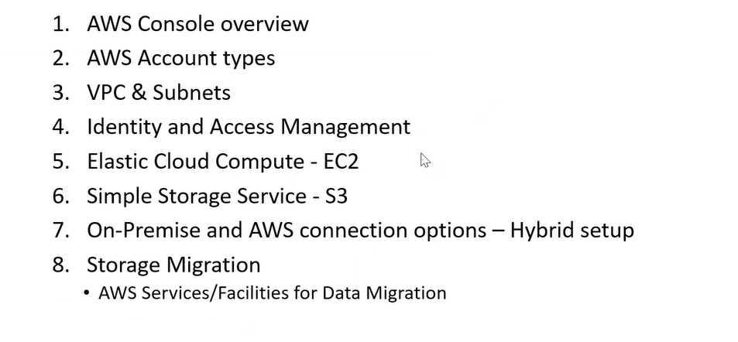
How to Access AWS?
- Create an Individual account with AWS.
- Organization Account
Organization Account:
- AWS Organization-> Services
- AWS Organization-> Policies
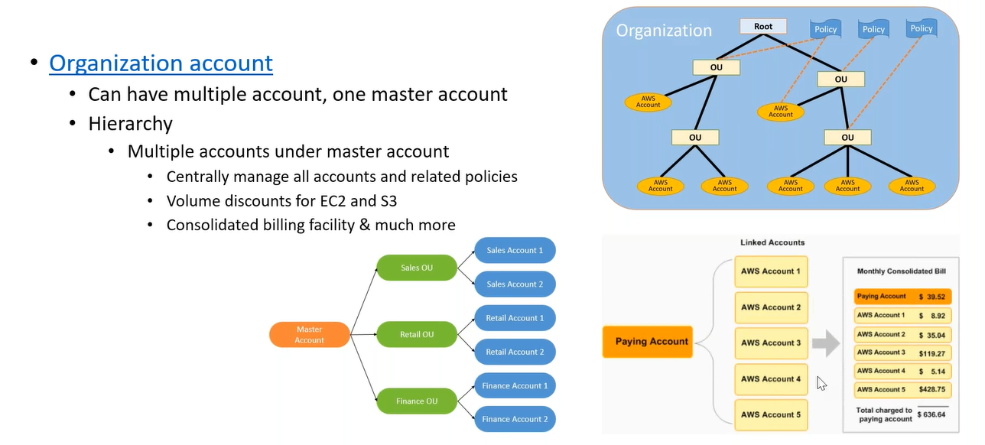
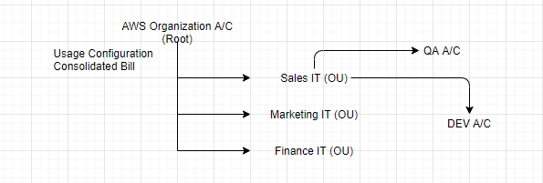
Architecture Diagram Icons:
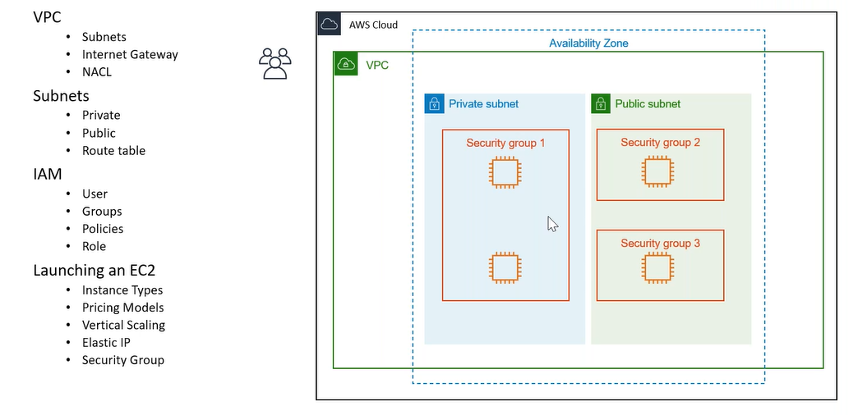
AWS Calculator:
Simple monthly calculator

Setup:
How I Isolate my resources from other’s resources?
VPC:
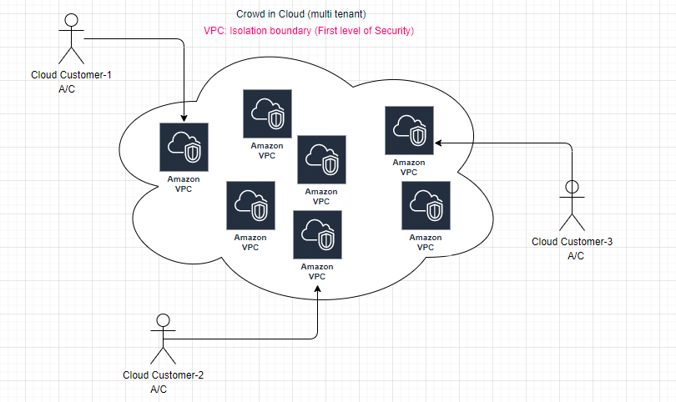
VPC- one default VPC per region
Subnet- subnet corresponding to each AZ.
public subnet: associated with IGW (entry of igw in associated route table), auto assign public ip
private subnet: not associated with IGW (NAT Gateway)
main objective of VPC is to isolate our resources , never use the pre-configured VPC (spans over all AZ with in the region).
IP address range:
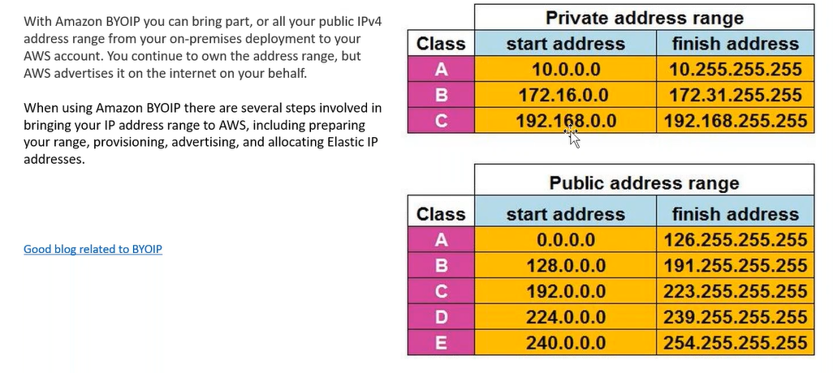
private address don’t move between different networks, can assign custom private network during creation time, can’t update private network after creation.
step1: create your own VPC ( LAN-default 5 vpc per account): private IP range
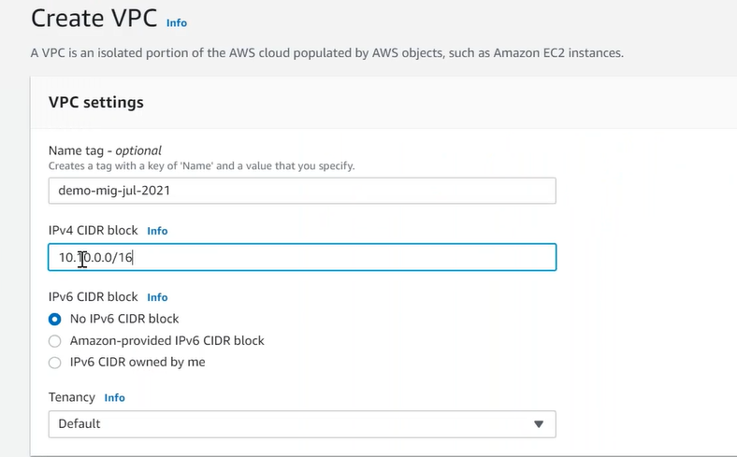
step2: By default one subnet per AZ is available, in customized vpc create own two subnets in AZ1 and AZ2, and create EC2 instances with in the subnets.
step3: As of now EC2 is not accessable to the Internet.
step4: Create your own IGW (attach with VPC).
step5: Create route table associated with subnet.
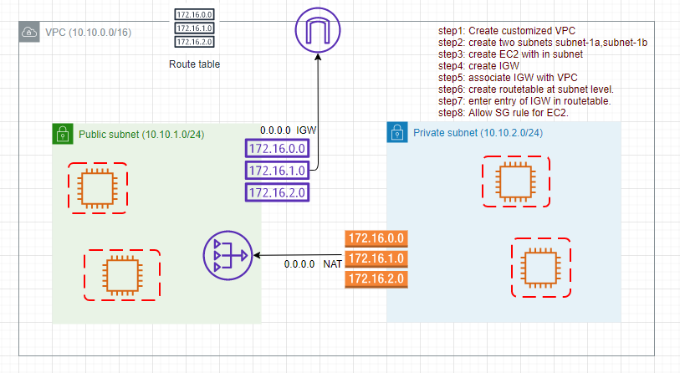
NAT Gateway: EC2 instance inside private subnet access internet through the NAT.
DHCP issues private IP for EC2 .
SG (EC2 level): Deny all traffic by default (Statefull).


NACL (subnet level): Allows all traffic by default (Sateless). Rule are evaluated sequentially.
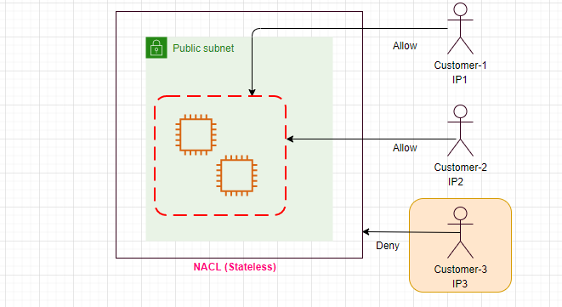
ports?
entry point, without port can’t run more than one application on the same server.
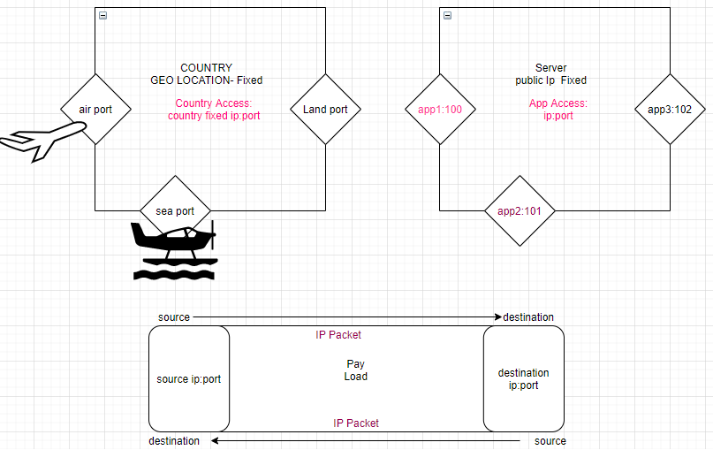
BYOIP: Bring your own IP,all public IP are paid, by default AWS assigns public ip address from its owned pool of public ip addrsses.
Elastic IP: static IP address (associate/release)
status check:
public subnet: - EC2 instances have public as well as private IP addresses.
private subnet: - EC2 instances have only private IP addresses.
CIDR- Classless Inter domain routing

Why tag?
Resource Groups-> Saved Groups
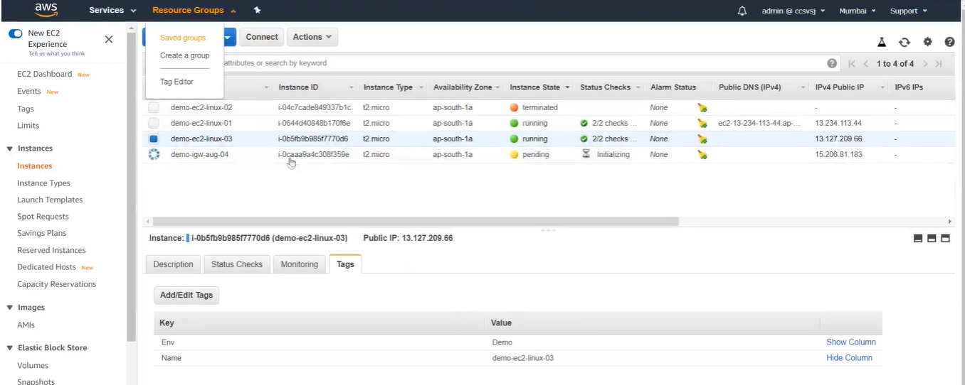

IAM: (who has access to the resources)
IAM (Authorization, Authentication, Users, Groups,Roles,Policy)
ABAC (Attribute based access control): Using tags
Context: With in the Account
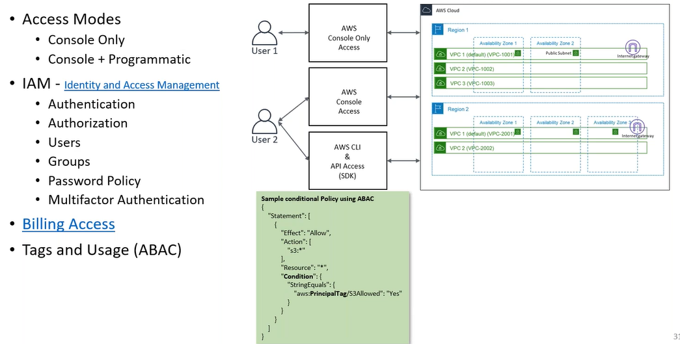

step1: IAM-> create a user
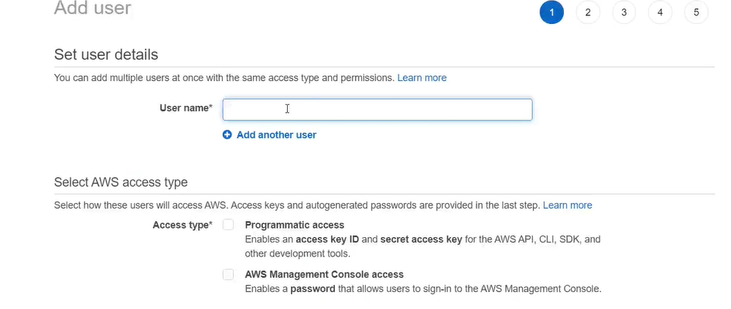

Access Modes:
- Programmatic(SDK,CLI): access key id, secret access key
- AWS Console: password
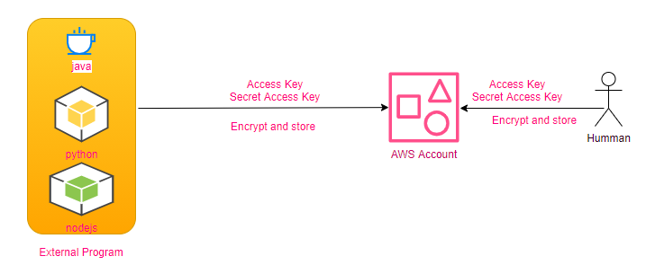
User Group: One than more Users
Policy: access permissions
“Statements”: { “Effect”: “Allow”,
“Action”: [“s3-outposts:Get*”,” s3-outposts:List*”],
“Resource”: “*”,
“condition”: {tag condition}
},
] //statements
Roles: ( Initiater of the Role)
Two services (AWS resources) with in AWS must be communicate to each other through the Role.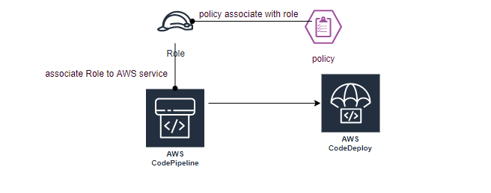
When human trying to access AWS resources using: console / Access and Secret Key, when AWS resource trying to access another AWS resource using: role
Policies can be assigned to user/user group or to Role.
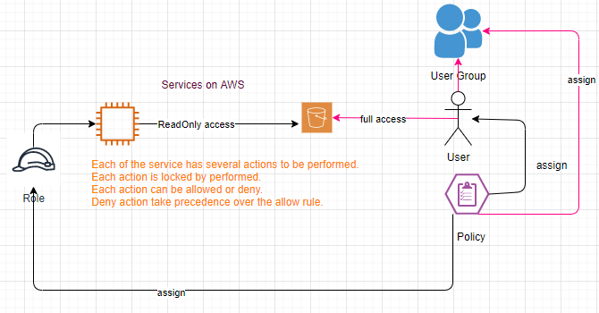
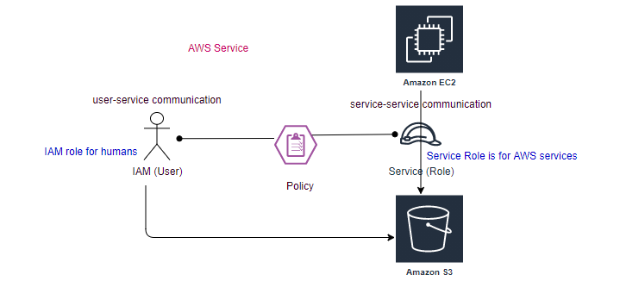
access key and secret key stored in .aws\credentials its only for CLI and SDK access. Its not for console access, its for external access.
Policies are written in JSON (Java Script Object Notation).
Each service can provide different actions using policies can allow or deny specific action.

Billing Access
Tags and Usage -ABAC (Attribute Based Access Controls)
Federated?
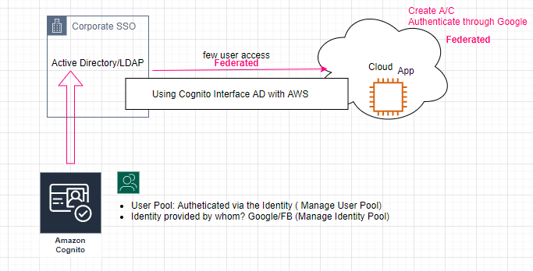
Cognito-> Manage Identity Pool-> Create Identity Pool
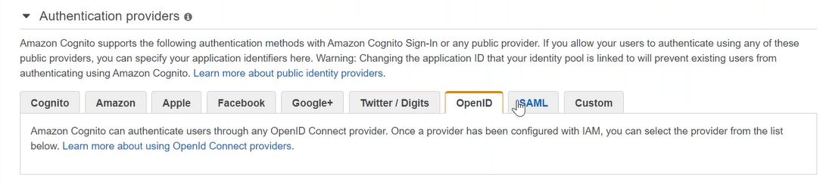
SAML for AD configuration.

EC2: (AMI): Amazon Machine Image
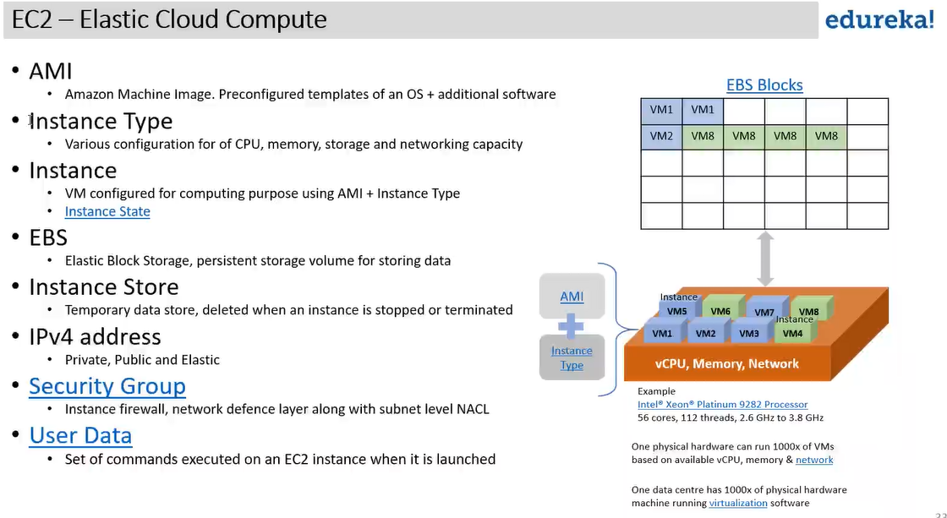
AMI: O/S + additional s/w
- Root Device Type (boot drive): ebs (persistent)/ instance store(temprary)
- Virtulization Type: hvm/paravirtual
- ENA enabled: Yes/No
Instance Type: Various configuration for CPU,memory,storage and network capacity.
Instance Store: Temprary (transitory work load)
EBS: (Elastic Block Storage): Can Only Increase the Storage, but can’t reduce, have boot drive.
Logical Unit Number (LUN)
Difference between EBS enabled (storage) Instance Store enabled devices
O/S has to load from some where, It is a temprary drive as soon as we stop the device instance type drive is revoked.

Storage Type:
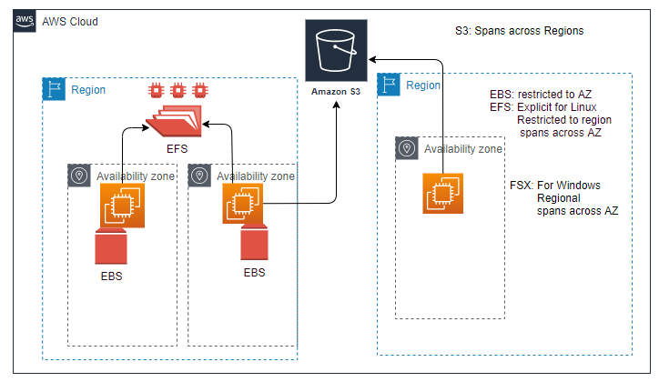
Status Checks
System Check: This check verifies that your instance is reachable. We test that we are able to get network packets to your instance. If this check fails , there may be issue with the infrastructure hosting your instance (such as AWS power, networking or software system). You may need to restart or replace the instance, wait for our system to resolve the issue, or seek technical support.This check does not validate that your operating system and applications are accepting traffic.( Underneeth configuration is available and not corrupted)
Instance Status Check: Once System check is passed, this check verifies that your instance’s O/S is accepting traffic.If this check fails you may need to reboot your instance or make modification to your operating system configuration.( Is reachable from outside the world)

Scalling:
Vertical Saling: Stop ( update from t2.micro->t2.small) , and then restart.
Can’t vertical scale instance type at run time, first stop the instance then vertical scale the type.
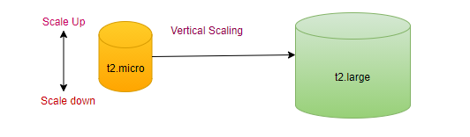
Horizontal Saling: automate with zero downtime, Increase the number of resources of same capacity.
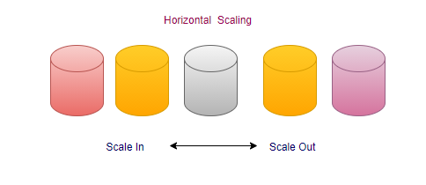
User Data:
Set of commands executed on the EC2 instance when it is launched (boot starp).
step1: choose the EC2 instance.
step1.1: right click-> Monitor and troubleshoot-> Get System log
All communication with in subnet through private IP.
HA through multi-AZ.

