Migrating application to cloud
- Data
- Application
- Database
AWS Services: As interpreter from A to B, knowledge of AWS service is must to migrate.
Use Case:
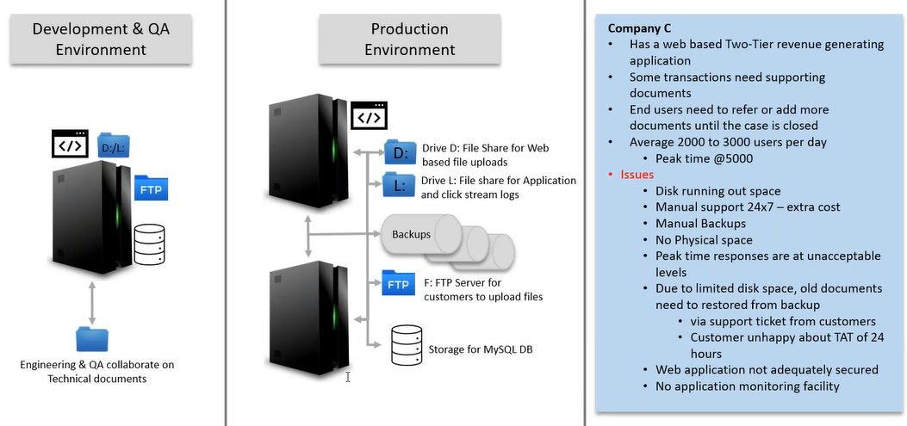
AWS Data Migration Services:
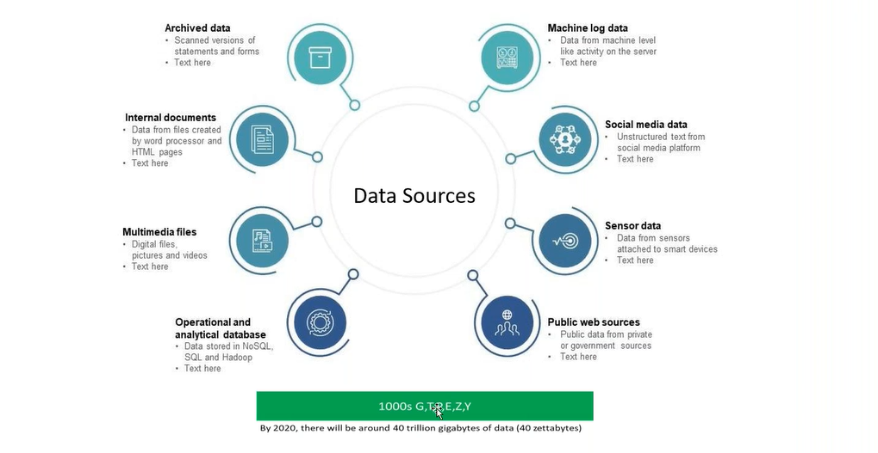
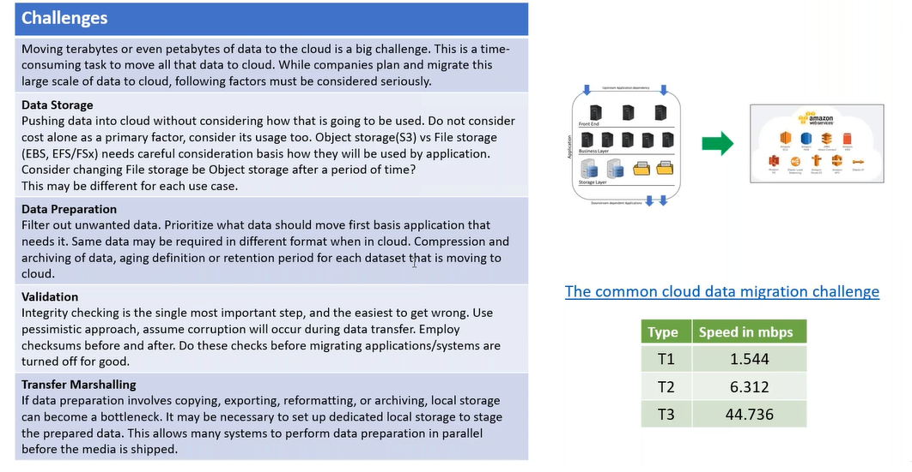
Data Storage:
File Storage:
- Update
- Append
- Collaborate with other team members
Object Storage: can’t do anything, its key value database when we update it overwrite, file name is key and its contents is value.
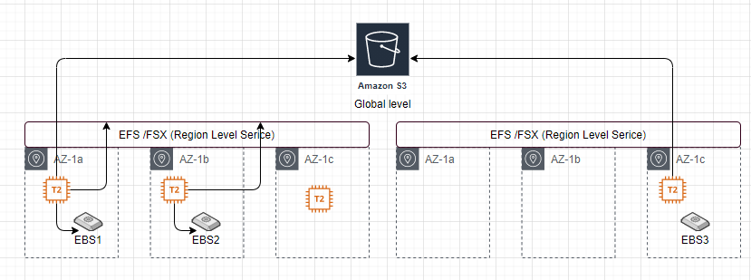

Data Preparation:
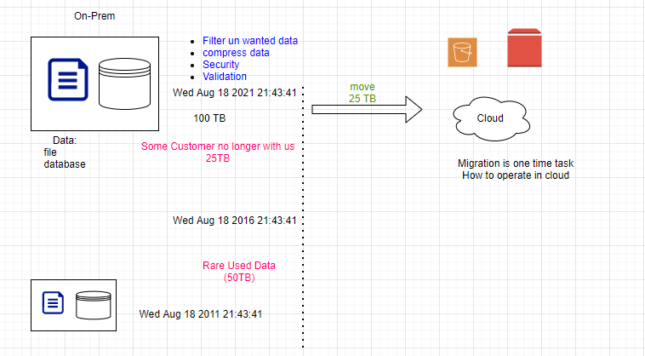
Estimate time to migrate, in range (30-40) not estimate (35).
How to ensure the connectivity between the on-prem and cloud?
What is Gateway: Enable you to connect two different environments.
- Direct Connect
- Virtual private gateway
- Transit gateway
Direct Connect:Gate
AWS Direct Connect makes it easy to establish a dedicated network connection from your premises to AWS. Using AWS Direct Connect you can establish private network connectivity between AWS and your datacentre, office or colocation environment.

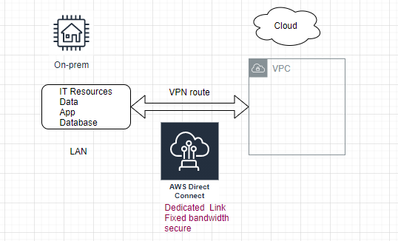
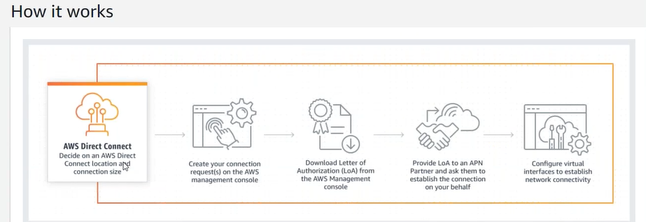
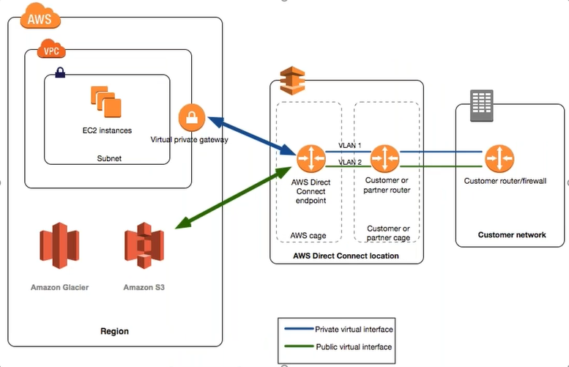
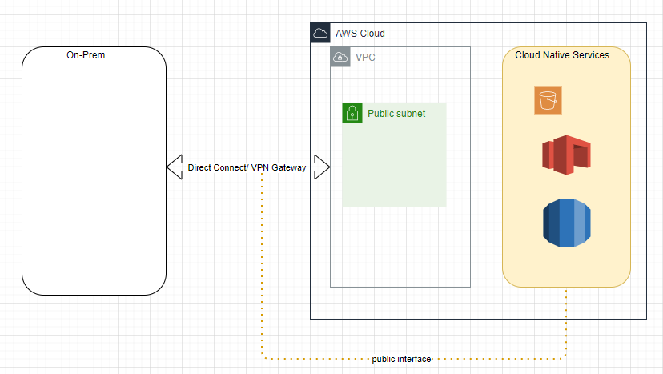
Direct connect can access VPC as well as Cloud Native Services.
Site-to-Site VPN Connectivity: If you want temporary connectivity and data is less than 500 GB, then go with VPN. If want to operate on Hybrid mode for too long then go for Direct Connect.
Virtual Private Gateway (Direct Connect): connects your VPC to the on-premises. Is secure but not encrypted.
Virtual Private Gateway is only to access your VPC level services, not to access cloud native services.
Enable VPN on top of Direct Connect. Direct Connect data flow through the third-party connectivity.
UC:
Once Connection establishes, either use machine on-prem or use machine on vpc both are same, they are part of same network.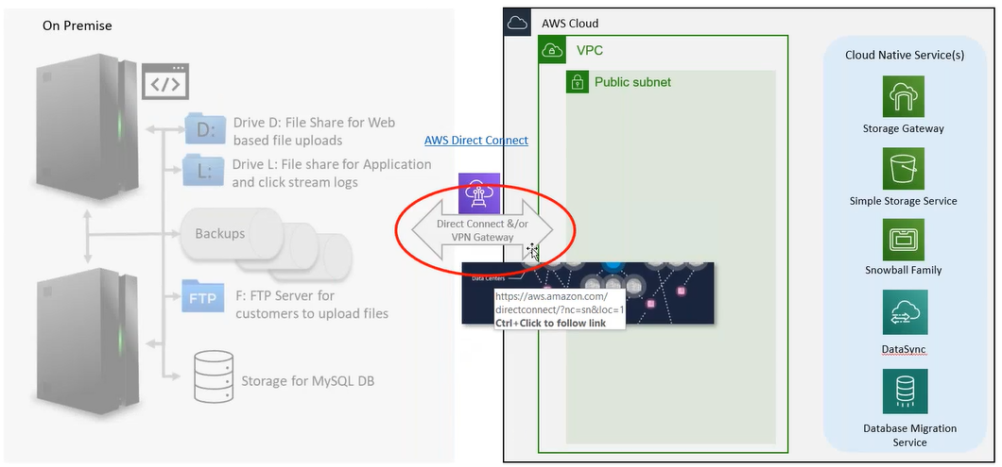
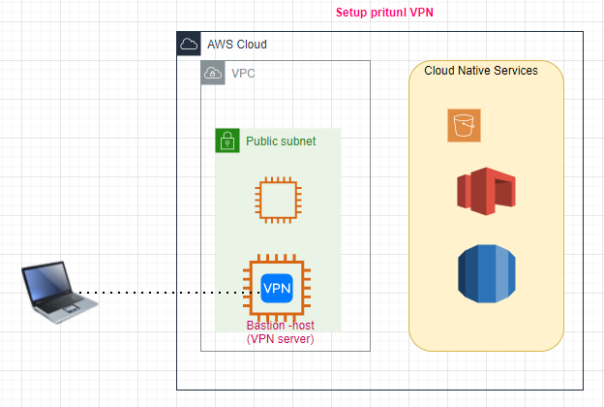
step1: Launch an EC2 instance (bastion host) # 1:30
step2: Install pritunl s/w on EC2
Storage Gateway:
Cloud Coming to your on-prime, connect to the drives (D:/, E:/) in backend it stores in S3, translating of file-storage to object storage done through the s/w appliance.
step1: Create a Storage Gateway (Gateway type: Amazon S3 File Gateway).
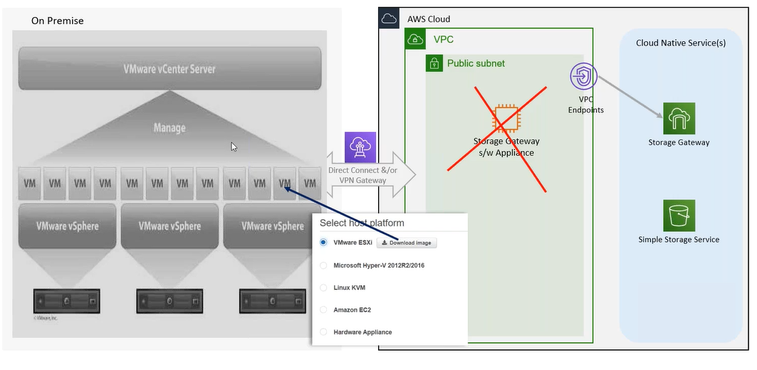
step2: Platform options (EC2 m4. large + 50 GB).
step3: SG for storage gateway appliance.
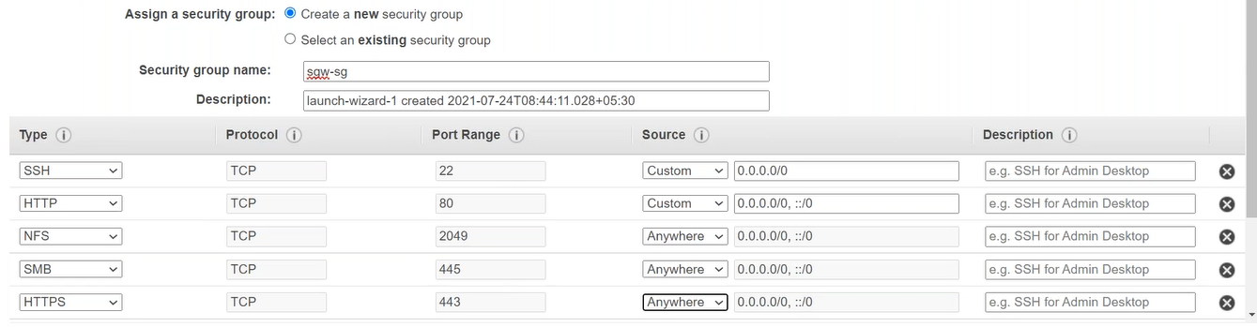
step4: select service endpoint (VPC).
step4.1: create a vpc end point. (First enable DNS resolution/hostname for VPC).
This appliance will help us to convert the file storage to object storage.
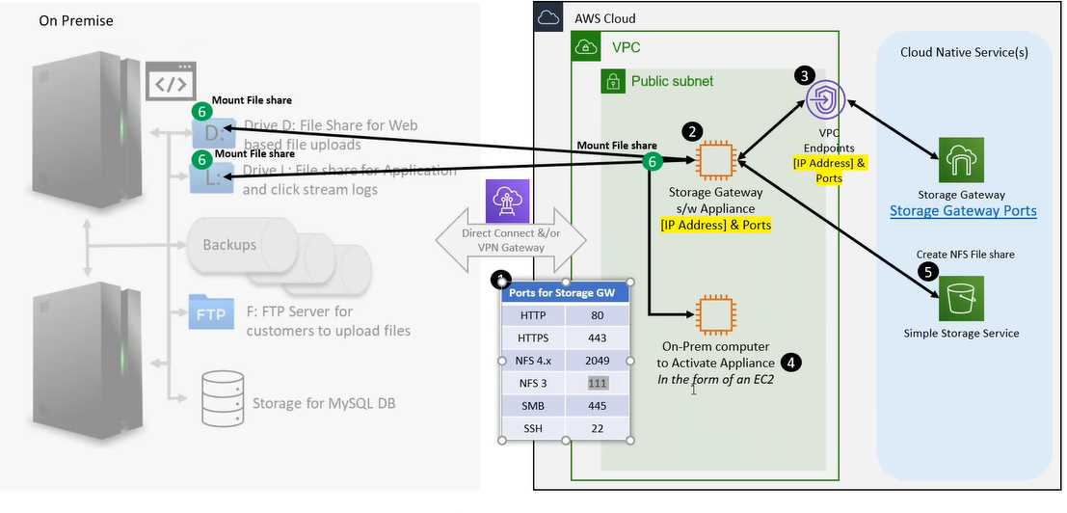
Note: To connect the storage gateway appliance (VPC)<-> storage gateway (Cloud native) service, either connect through public network (option not secure), since VPC and Storage-Gateway service both are provided by AWS can be connected through VPC end point (private network, secure and fast).
step5: connect to gateway
ip of end point, ip of s/w appliance (private ip).
step6: Activate Gateway (Also add default sg)
step7: configure local disks (cache memory on S/W appliance).
step8: logging
step9: Storage Gateway is ready; Storage Gateway is an appliance on top of that we create a file share.
step1: Create file share (S3)
step2: S3 file share available
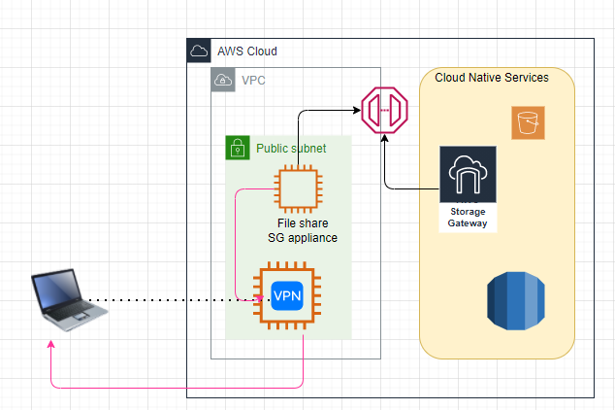
step1: login to bastion-host (add sg default)
step2: mount on window/linux as D: and L:
step2.1: 7.9EB space available on windows
step3: copy data in D: will move to S3 bucket.
step4: copy file in S3 available in D:
Storge Gateway supports Volume Gateway (c:), Tape Gateway.
Tapes are for archive/backup purpose.

What is benefit of Volume Gateway?
C drive backed with volume share, can convert your server to EC2 image.
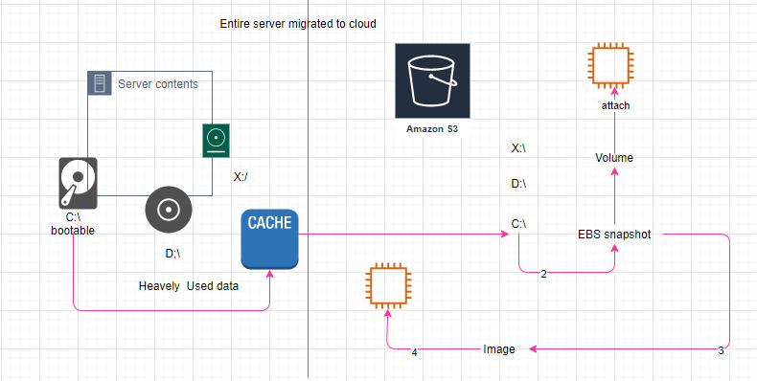
Data Sync:
S3 Transfer acceleration (access through the Edge location)
Beneficial if and only if your bucket is far away from your current location
As we enable the S3 Transfer Acceleration enabled, all the DC and POP must update their DNS entry.

