Object Storage- Client (S3 browser)
Encrypt the data, transfer the data through public internet.
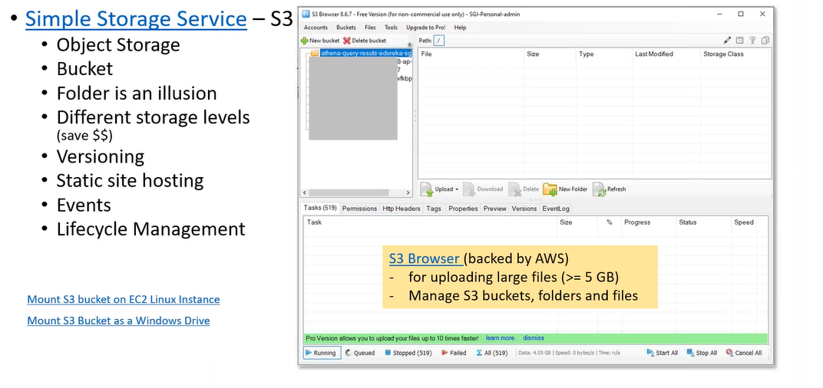
mount S3 bucket on EC2 instance (TNT Drive).
Object Storage- Client (WinSCP)
Using the script, automate the data transfer.
Snow Family
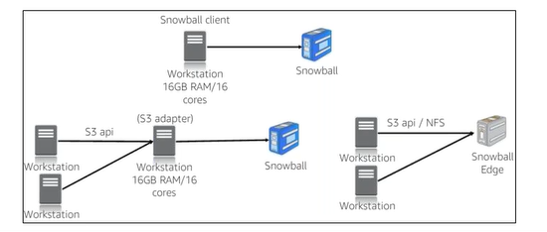
Helps eliminate challenges that can be encountered with large-scale data transfers including high network costs, long transfer time and security concerns.
Use for import data to cloud or export data from cloud at computing locations.
- Snowcone
- Snowball Edge
- Snow Mobile
AWS Transfer Family (SFTP,FTPS,FTP)
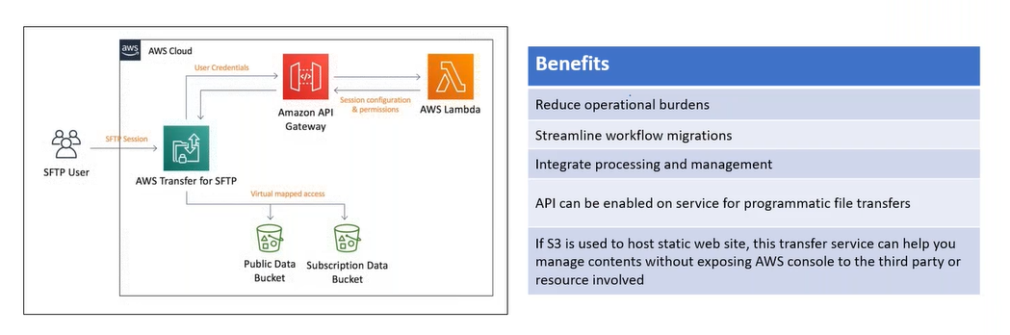
- SFTP, FTPS, FTP (exchange data on cloud)
- SFTP: SSL (end point ssl)
- FTPS: TLS
- FTP: non secure
step1: create a server.
step2: select the protocol (SFTP).
step3: Choose an Identity provider (service managed).
step4: Choose an end point
step5: Choose a domain
step6: Configure additional details
How app securely communicate?
Concept: Encrypt Data using the public key can be only decrypted using corresponding private key.
step7: Connect SFTP server through WinSCP
We have to create a user and every user carry a certificate, certificate is a public/private key generated through the putty key generator
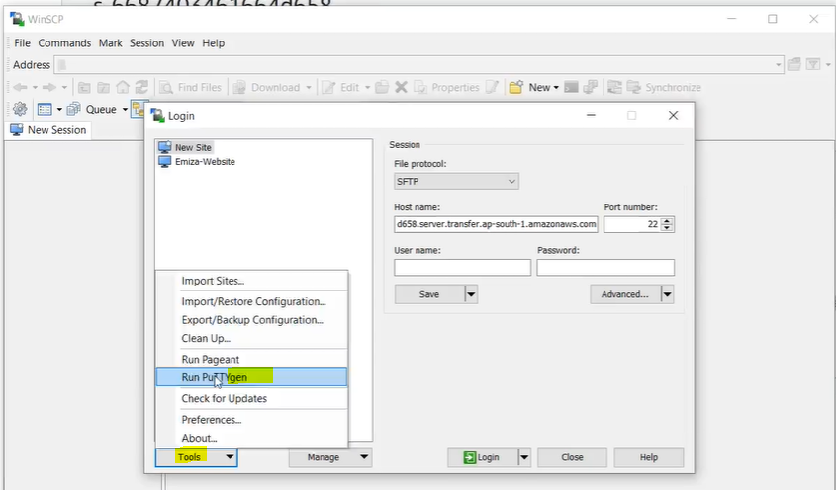
- click on generate button (move key randomly to generate key)
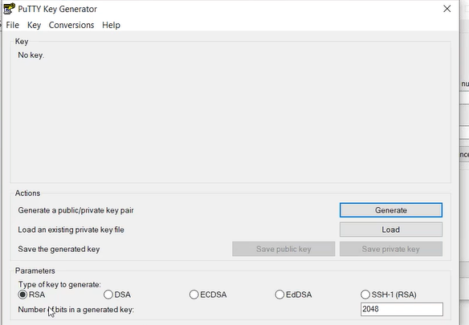
- save public key ( RSA 2048)
- save private key ( RSA 2048)

step8: click on SFTP server
- Add User
  - step8.1: create a role for Transfer (S3Full Access)
  - User Name
  - IAM role – sftp role
  - Home Directory ? S3 bucket (dump the data)
  - SSH public key- copy the public key
  - Click on Add button
WinSCP:
connect to the SFTP server.
- host: SFTP end point
- user name:
- password: (Advanced)
- password-> authenticate-> private key
- click on login
copy the files, available is S3 bucket.
How to retain timestamp?
Tools-> preferences->transfer-> default-> edit (uncheck set permissin,preserve time stamp)
Diff between DataSync and S3 Tranfer Acceleration?
- DataSync provides two way communication, can switch the endpoints
- DatSync also provides validation feature.
- S3 Transfer Acceleration also don’t ensure about data inegrity.

UC:
- Direct Connect is so costly $.
- Not sure if we can operate in cloud.
  - Need to explore
- Not comfortable transferring data on the public internet.
- What would be the net benefit post migration?
Outposts:
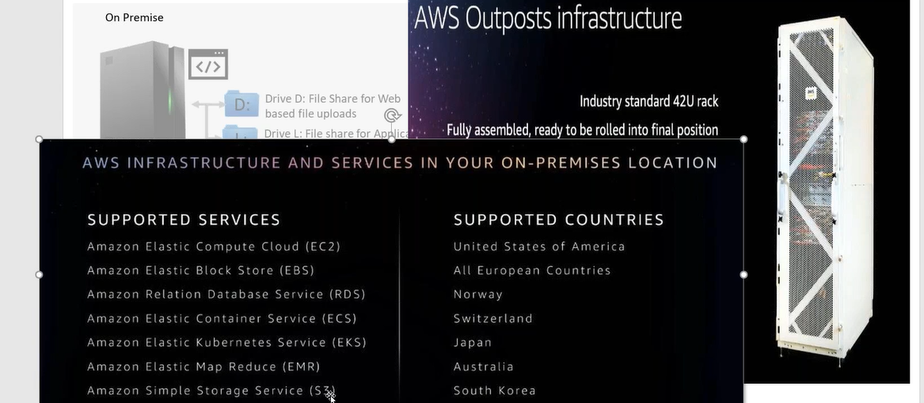
AWS remote work and learning:
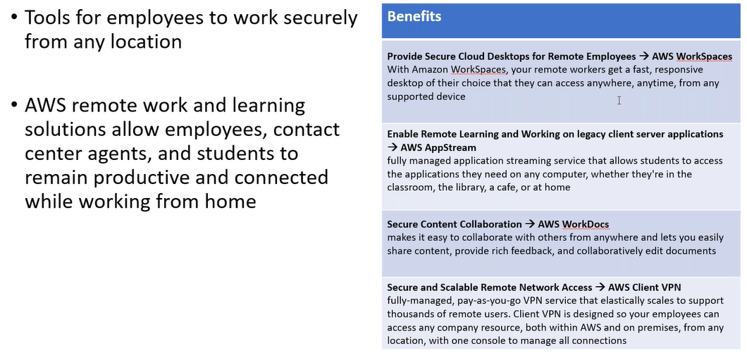

Application Migration:
What is application migration?
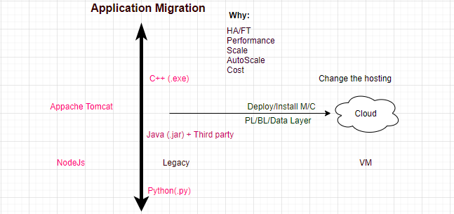
ELB (Elastic Load Balancing): NLB uses burst algo to balance the traffic.
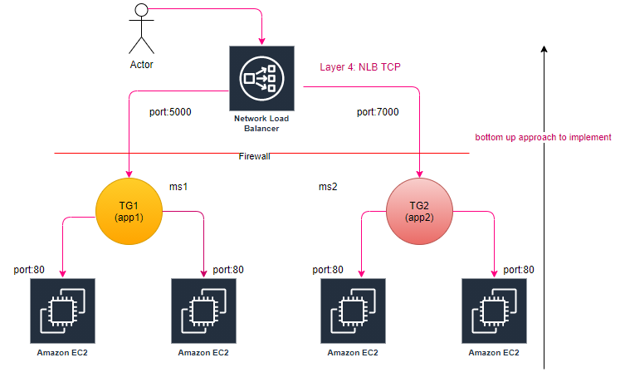
step1: Launch 2-2 instances per AZ
step2: Create TG for NLB (TCP), actual load balancing happens at TG level, health check always be HTTP
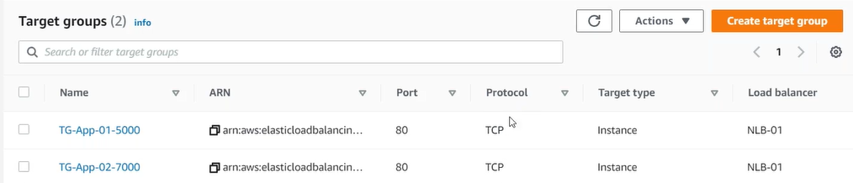
step3: Register the Instaces (targets) with TG.
step4: Configure Routing Configure Target Group
Mapping-> corresponding to each subnet(routing) a seprate NIC is created.
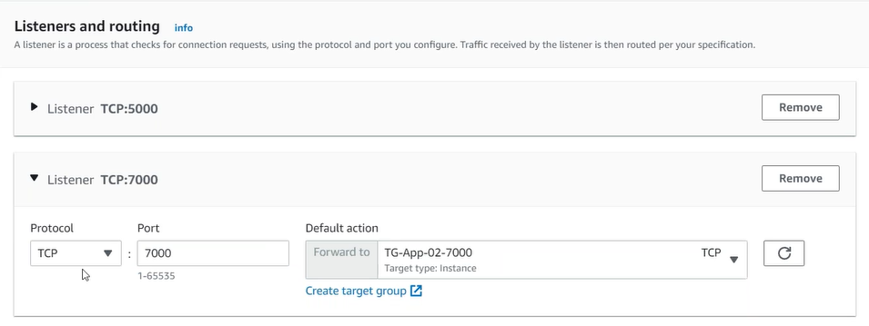
These ports are immediately dropped as traffic routed
Validate:
- Is NLB end point is active.
- Is target group’s targets are healthy
- This is also called reverse proxy?
You can host multiple applications behind single end point and redirect the traffic based on the port number.
Tab: Integrated Services
- VPC Endpoint Service (AWSPrivateLink) Layer4
  - You can create your NLB as a service, for others to consume as a VPC Endpoint Service.
- Traffic Mirroring (Layer4)
- Global Configuration (pop)
- Config (record each activity in the account)
Endpoint: From consumer point of view
Endpoint Service-> publisher/provider
As a vpc end point can access within the VPC, while using endpoint service other can access.
All applications worked at region labels.
ELB (Elastic Load Balancing): ALB, uses round robin algo to balance the traffic.
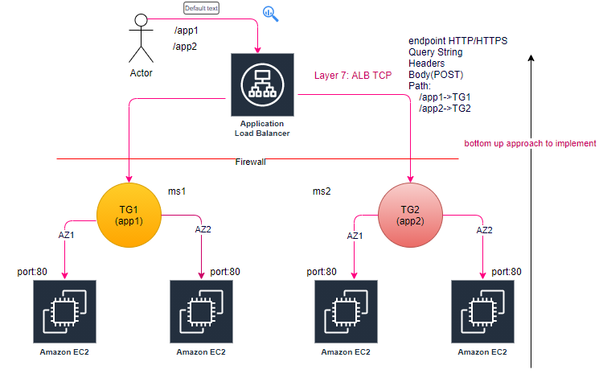
step1: Launch 2-2 instances per AZ
step2: Create TG for NLB (TCP), actual load balancing happens at TG level, health check always be HTTP
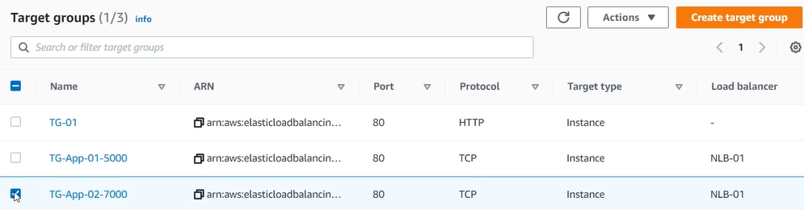
step3: Register the targets with TG.
step4: Configure Routing Configure Target Group
Mapping-> corresponding to each subnet(routing) a seprate NIC is created.
Validate:
- Is ALB end point is active.
- Is target group’s targets are healthy
- This is also called reverse proxy?
You can host multiple applications behind single end point and redirect the traffic based on the http/https, host-based routing (IP), path-based routing, http header-based, http-method based, Query String parameter-based, Source IP address CIDR based.
Tab: Integrated Services
- AWS WAF (Layer7)
- Global Configuration (pop)
- Config (record each activity in the account)

How to set Query based load balancing?
Tab: Listener
step1: Click on view/edit rule
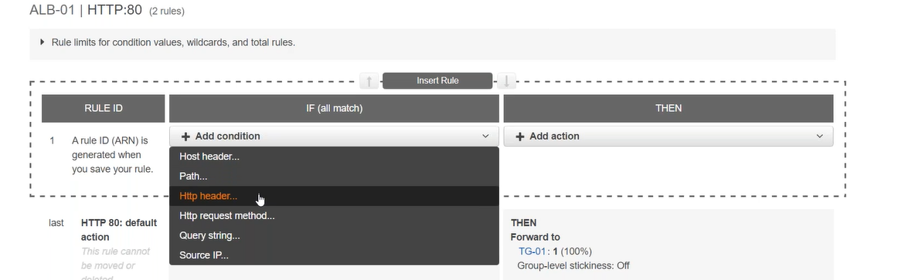
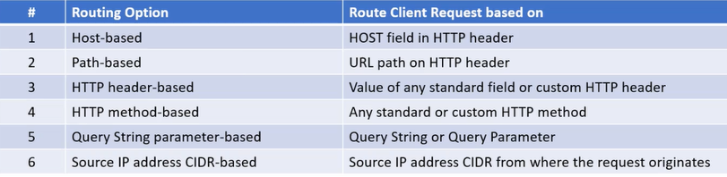
All applications worked at region labels.
Autoscaling (HPA):
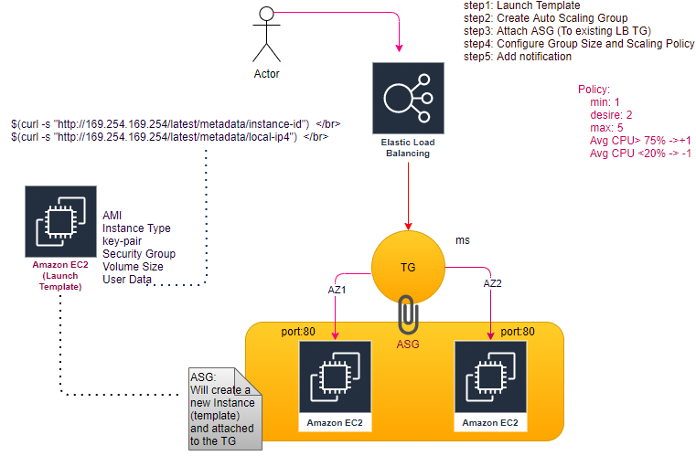
step: Just map Auto Scaling group with the target group, along with policy, will automatically creates EC2 instance as per policy.
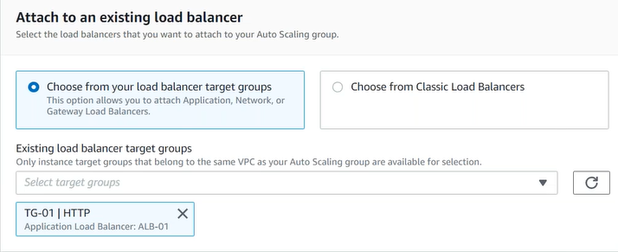
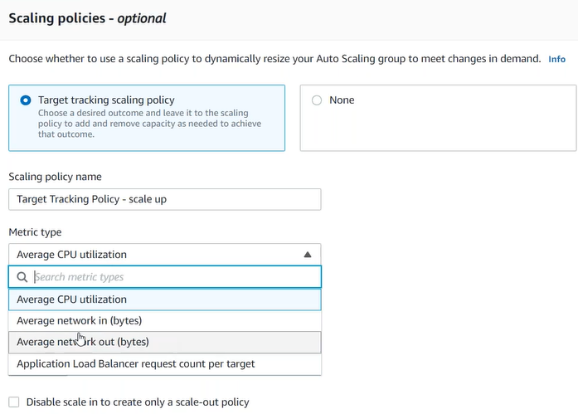
AWS Beanstalk (PaaS): Just handover your application to it (CloudFormation script executed internally).
- Auto Scaling
- Load Balancing
- Monitoring
- Logging
- Tracking
- Deployment Options
- Application Platforms
- Customization
- Web, Batch, Containers
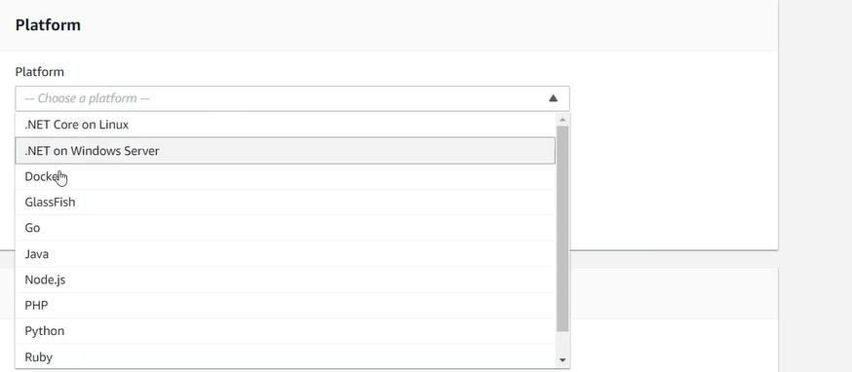
Using Beanstalk we can migrate our application, using the environments
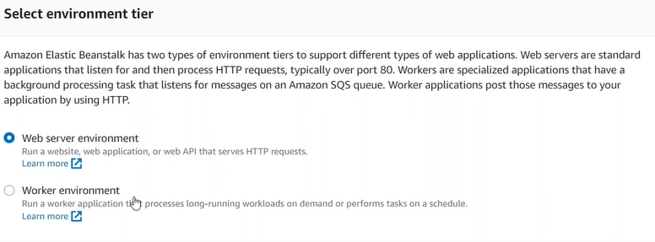
It has its own limitation.
CloudFormation (IaaS): Stack to create AWS resources, Beanstalk creates a default (readymade) stack for given application, while using CloudFormation we can create customized (as per our requirement) stack.

