AWS CloudFront:
CDN: Content Delivery Network (Extend ELB endpoint to CloudFront for boosting Performance).
Amazon CloudFront is a fast content delivery network (CDN) service that securely delivers data, videos and API to customers globally with low latency and high transfer speed.
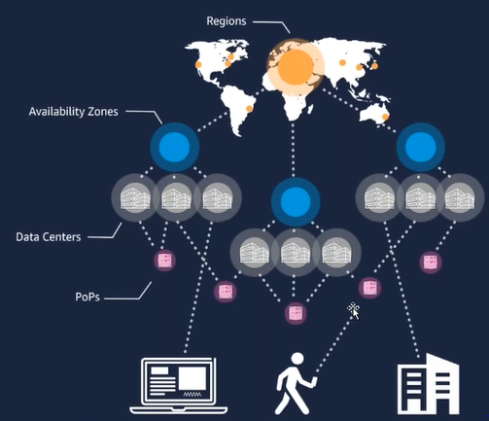
step1: Create a CloudFront distribution.
step1.1: Select the Origin
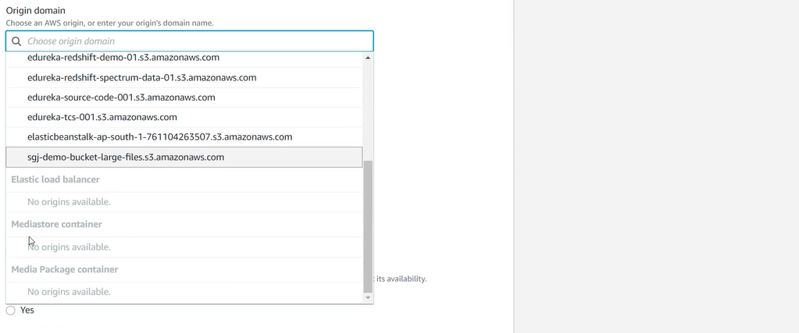
step1.2: setting
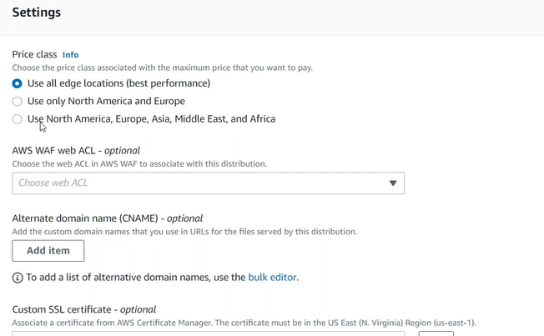
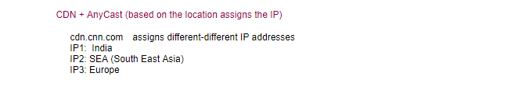

EC2 pricing
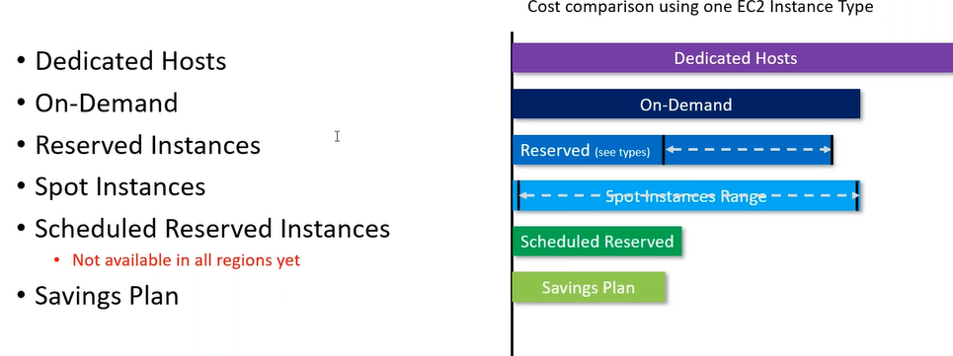
EC2 cost calculation:
calculator.s3.amazon.com (Simple Monthly Calculator): Always be a range.

Database Migration Service:
step1: create a RDS MySQL Database or (restore from snapshot).
OLAP- Redshift (Dataware house)
Homogeneous Database Migration:
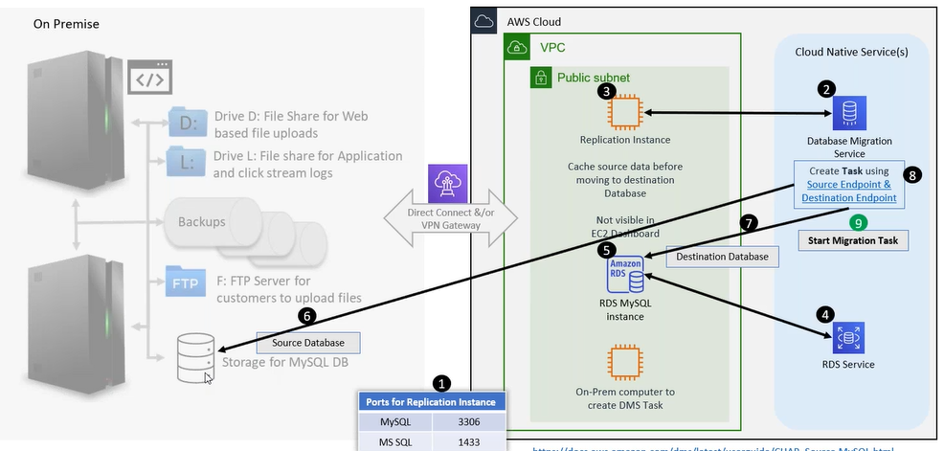

DMS (Database Migration Service) 3.4.4
step1: Go to DMS, now we have source DB (running on EC2 instance), target DB (RDS Instance), and DMS.
step2: Create replication Instance
step2.1: create source endpoint and test connection.
step2.2: create target endpoint and test connection.
step3: Create Database Migration tasks
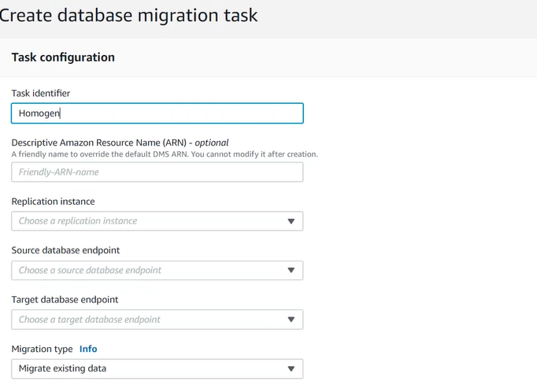
CDC (Change Data Capture)
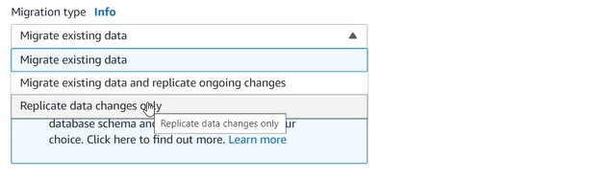
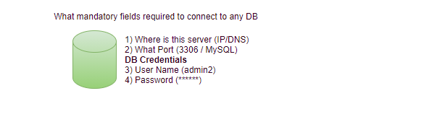
Heterogeneous Database Migration: (MSSQL->MySQL)
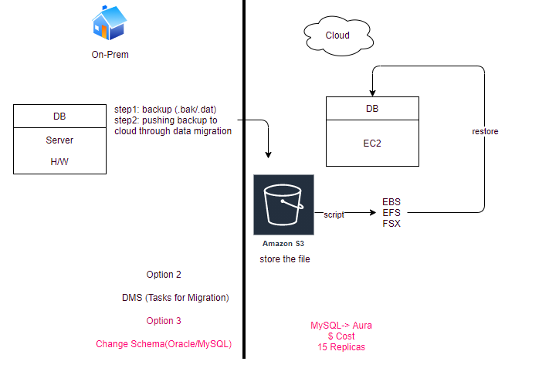
step1: on-prem MSSQL DB on EC2(Windows).
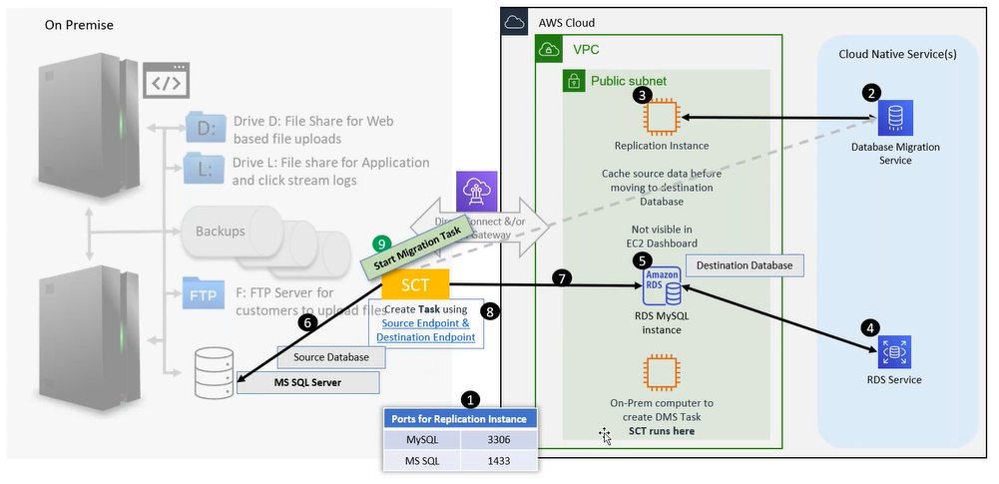
step2: download aws SCT.

step2.1: settings->global setting->AWS Service profile
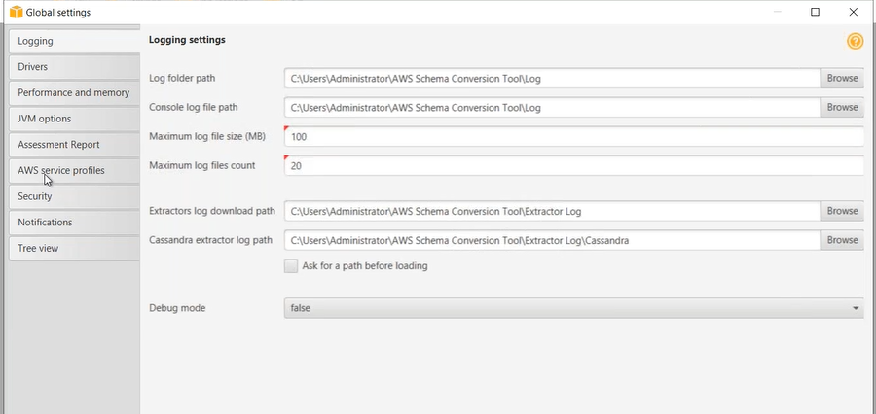
Test Connection
step2.2: Drivers
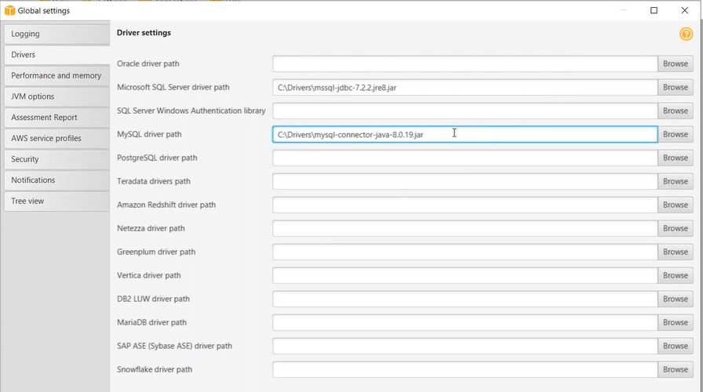
step3: file->new project
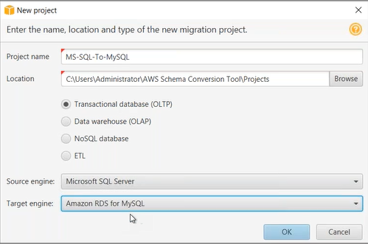
step3.1: connect to source db
step3.2: connect to target db
step4.1: uncheck everything from target db
step4.2: select the schema from source db.
step4.3: right click create report
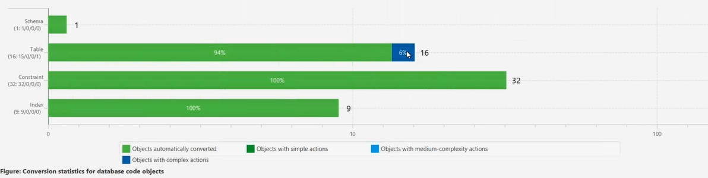
step4.4: click on action item tab
step5: select the schema from source db.
Step5.1: convert schema
step6: select the schema from source db (remove the procedures).
step6.1: create DMS task
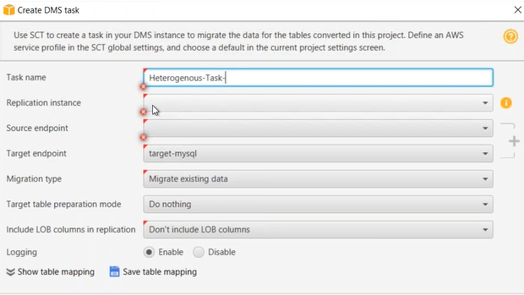
Local/Local and DMS Task: When you have huge amount of database to be migrated.
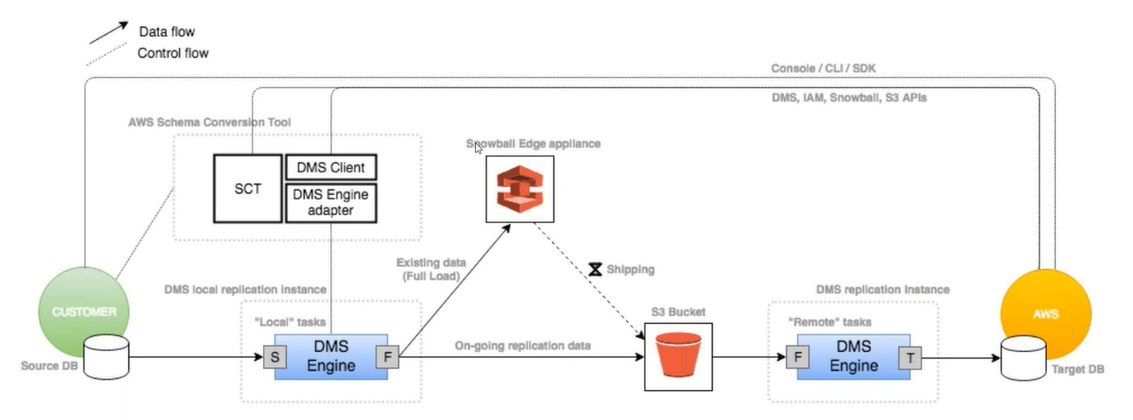

S3-RDS Migration
UC: backup files stores in S3.
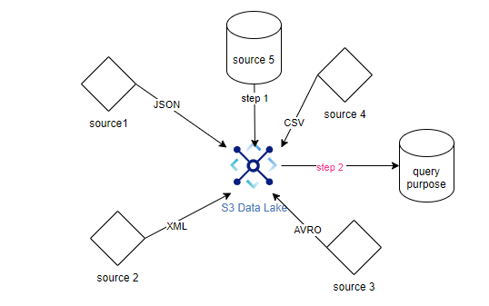
step1: create IAM role (DMS read data from S3).
step2: create a new source end point (s3)
step2.1: table structure (.json)
step3: create a DMS migration task.
