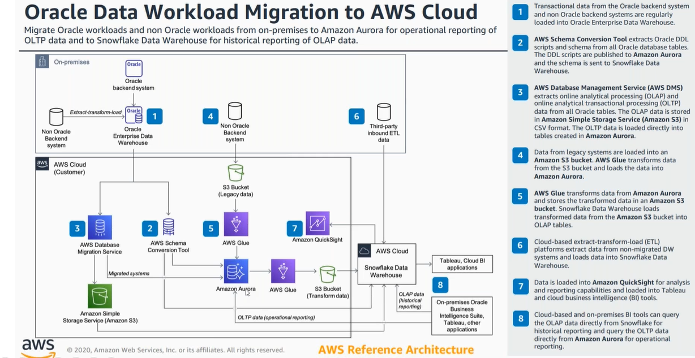
Application Migration Process and Tools:
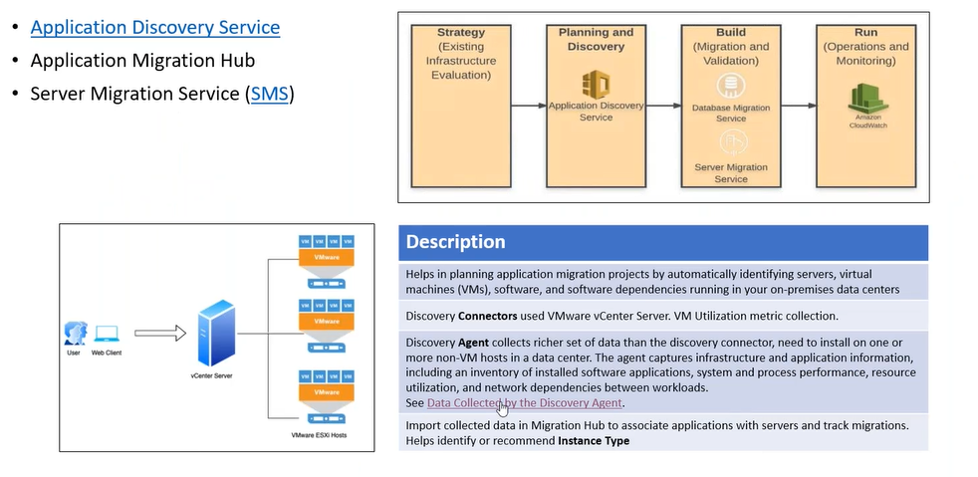
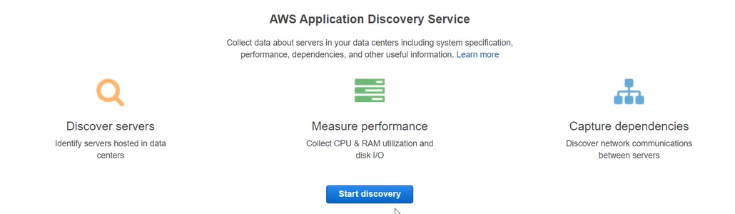

Server Migration Service:
SMS is only for virtualized environment
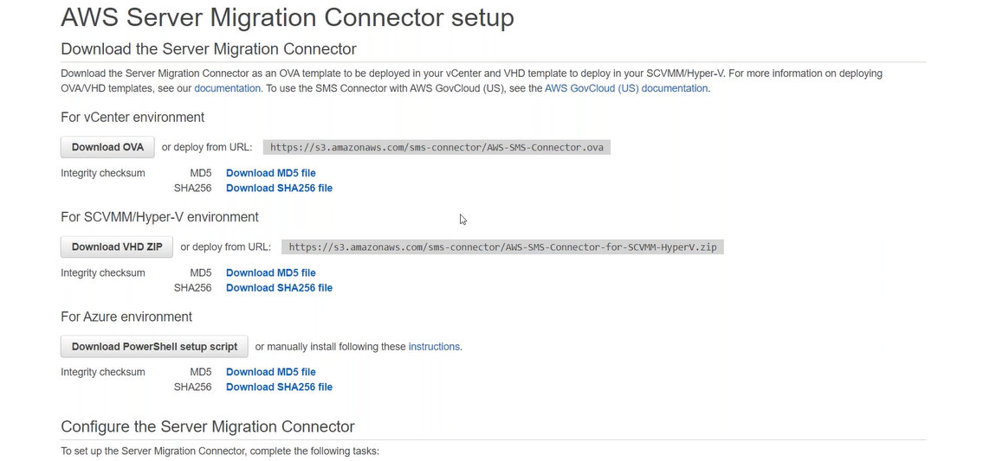

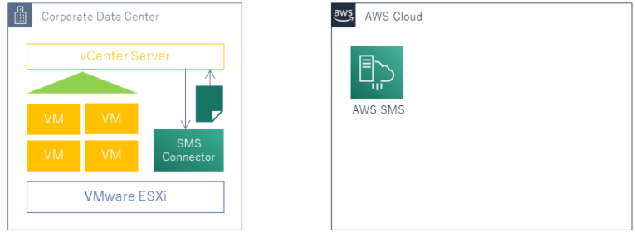

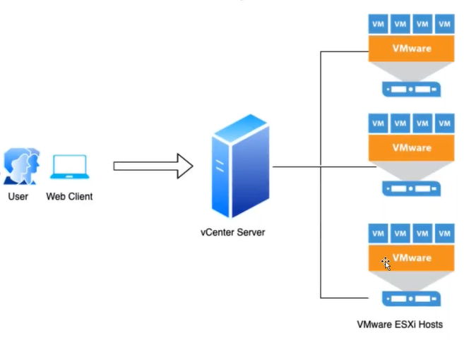
What if on-prem is not virtualized?
Storage Gateway is also providing server migration service through the volume gateways.
Storage Gateway’s performance is not good.
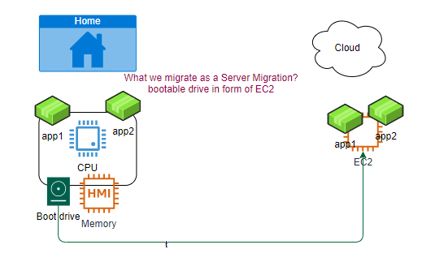
What we do for Window to VM migration?
CloudEndure service
step1: create account on CloudEndure.
step2: Install agents on H/W machines.
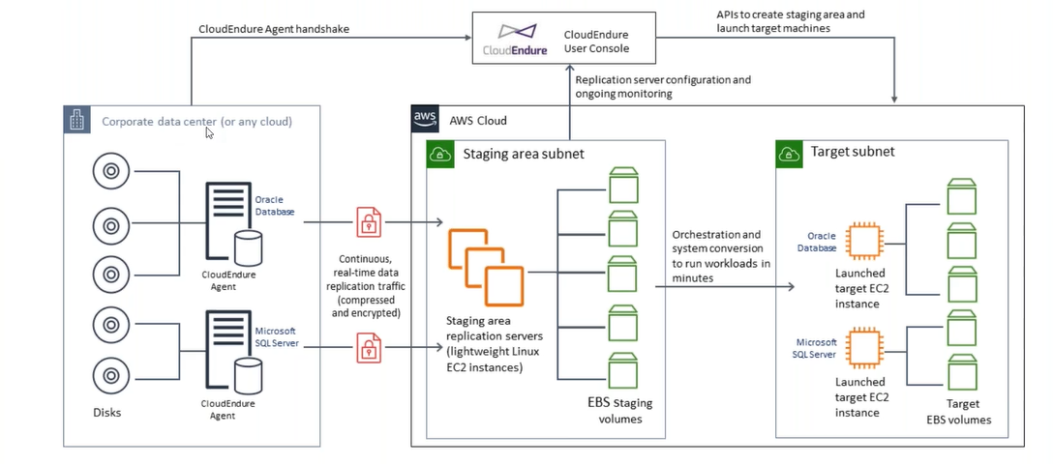

Migration to Cloud
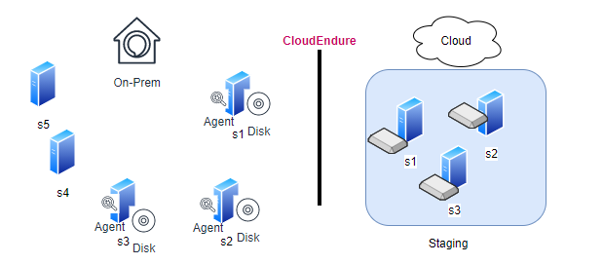

Migrating the whole application:
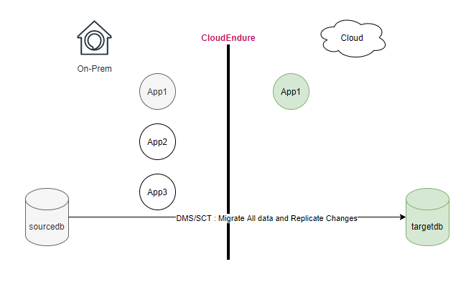
Migrating the part of the application (Hybrid):
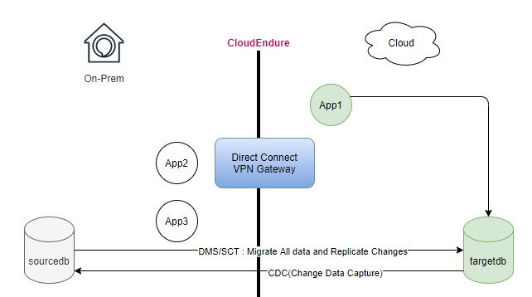
Our objective is to move your disk storage to S3

Representative Architecture
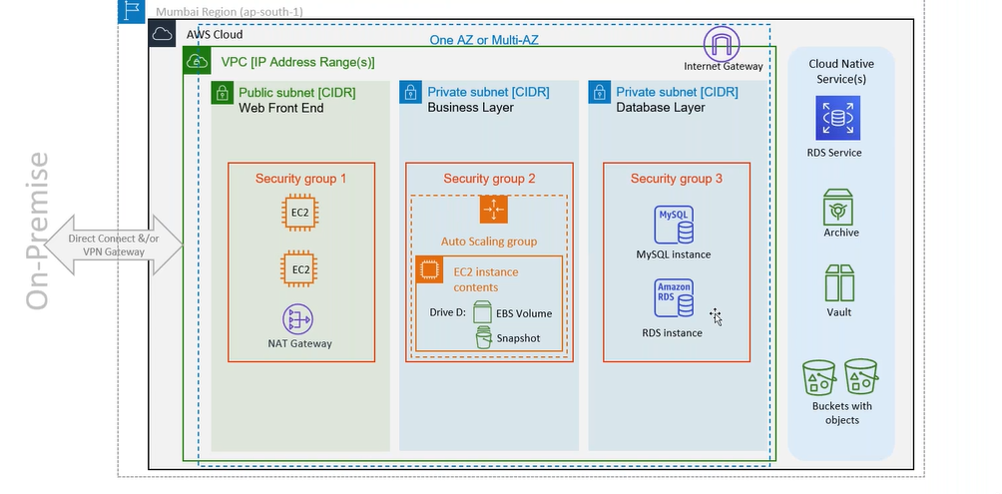

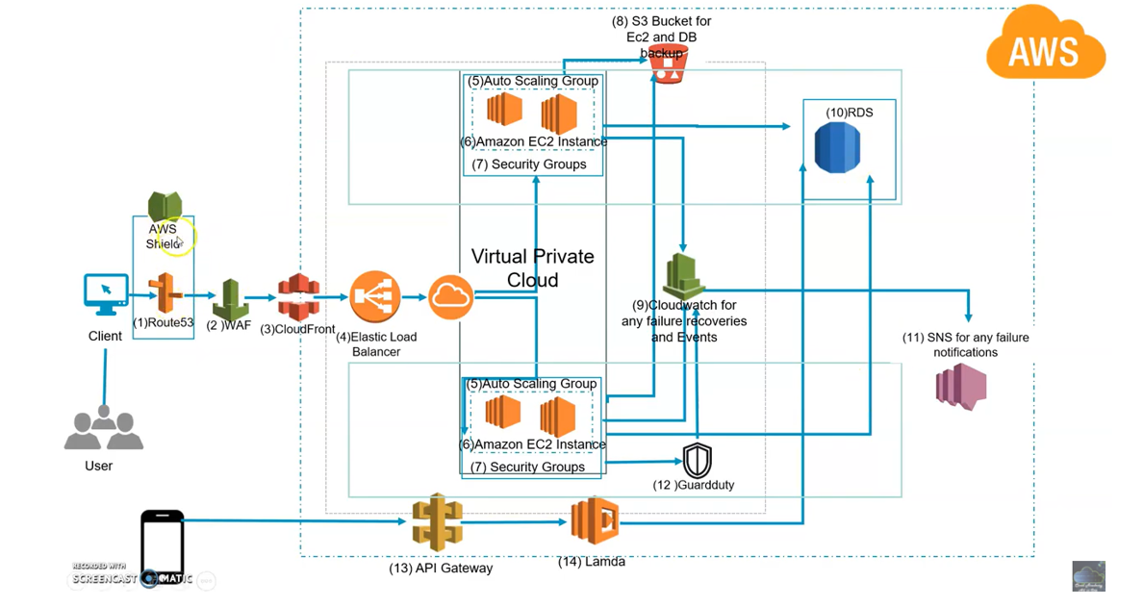

Operations (post migration activities)
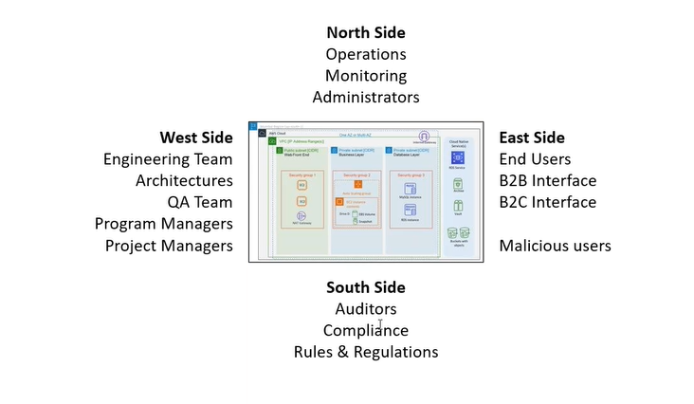
East Side: Exposed to end user
AWS WAF (SQL Injection, Cross-Site Scripting (XSS), Sensitive data exposure) common attacks defined by OWASP (Open Web Application Security Project)
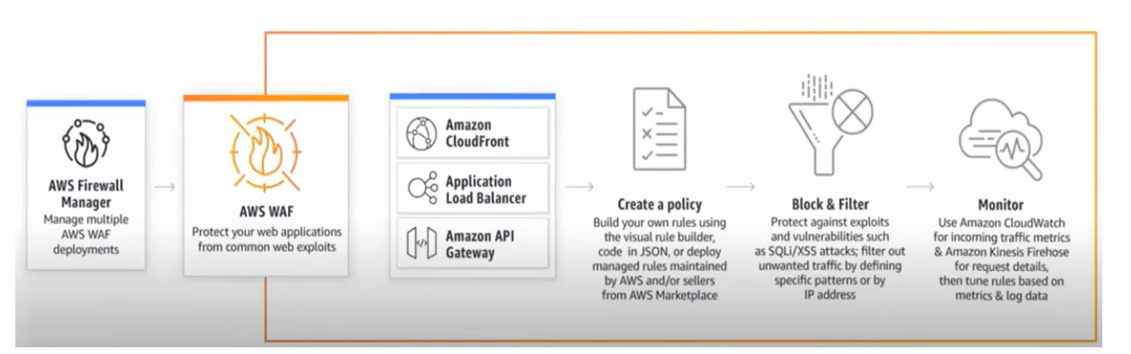

AWS Shield (DDoS): threatmap.checkpoint.com
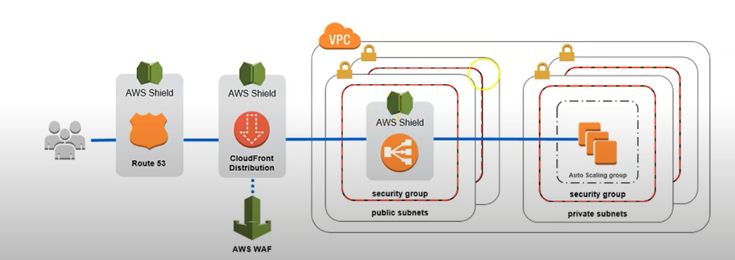
Guard Duty (Threat Detection Service that continuous monitors for malicious activity and unauthorized behaviour to protect your AWS account and workloads): 0-day attack
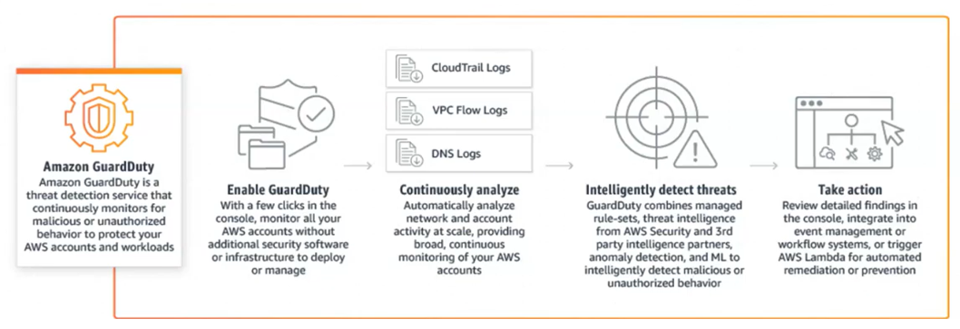
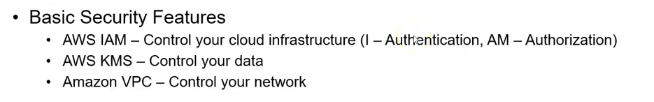
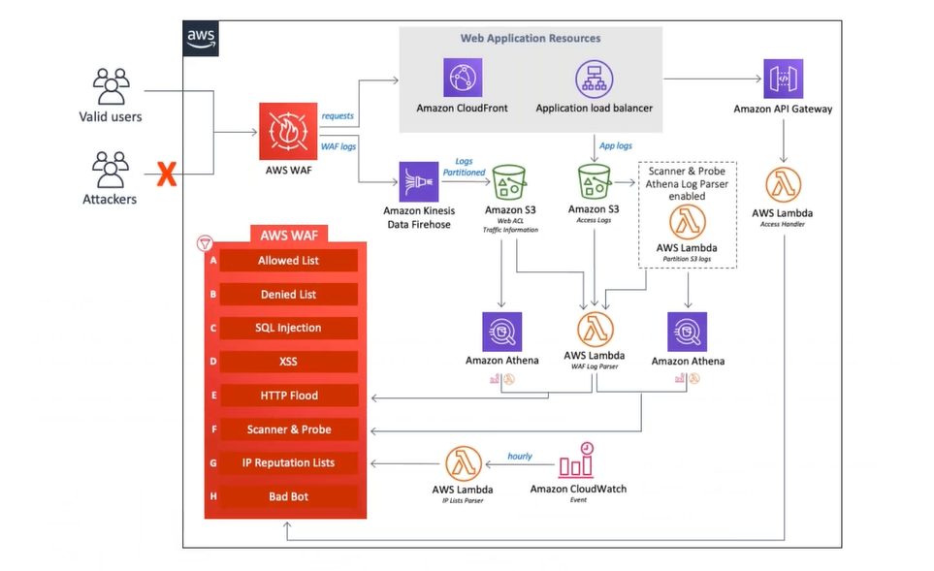
South Side: (Auditor purpose)
Config Service: Track resource inventory and changes over period of time.
At any given time, what are the resources provisioned in your account and what was their configuration.
AWS Managed Rules: send the notification
- What: Which resource configured
- When: When resource configured
Cloud Trail: Enabled by default
Track user activities and API usage, and retain it for 90 days for free.
- What:
- When:
- Who: from where?
- Mode: console, SDK, CLI
VPC Flow Logs: Activities of each ENI (ALB,EC2), with in this VPC.
Subnet Flow Logs: Activities of each ENI (ALB, EC2), with in this Subnet.
EC2 Flow Logs: Activities of each ENI, with in this EC2.
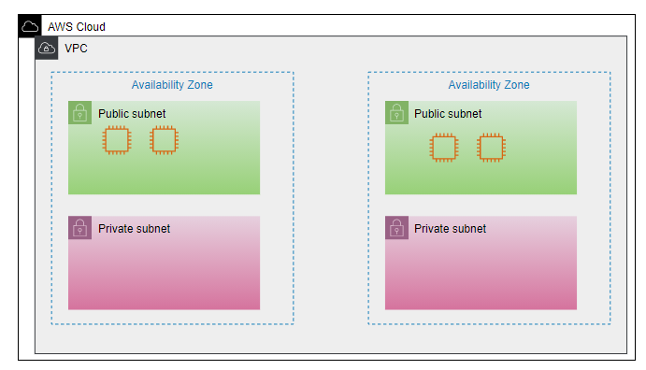
Using these logs, used in NACL
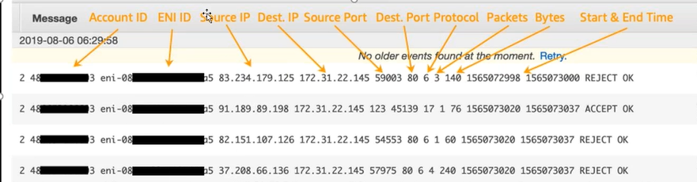
West Side: (Engineering team)
CloudFormation: Create scripts for Solution
Beanstalk:
North Side: (Monitoring)
CloudFormation: Create scripts for Solution
CloudWatch:
System Management:
ParameterStore: To store secrets

Backup:
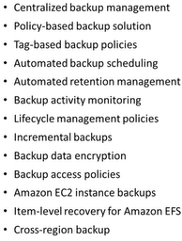
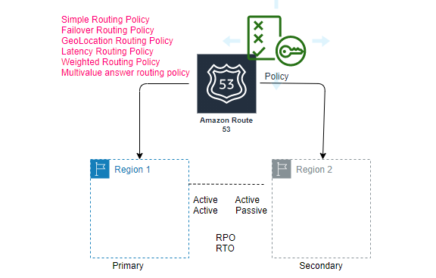
RDS: takes snapshot
EC2: AMI

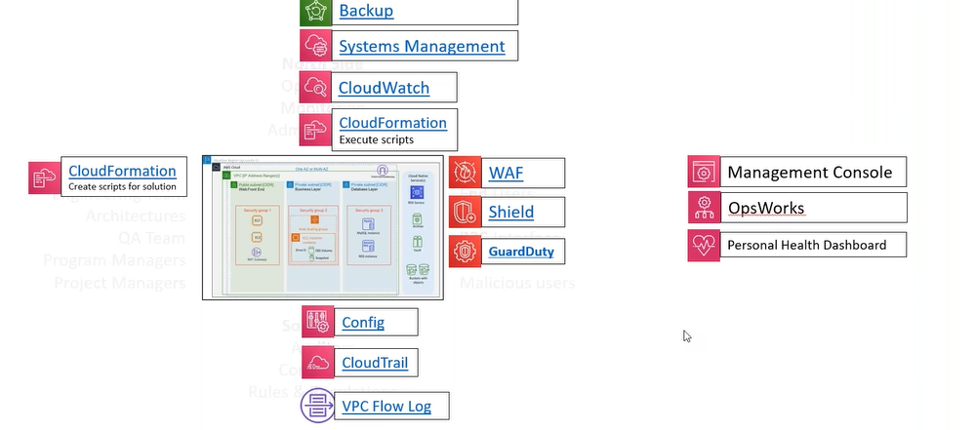

Container Technology:

Monolithic: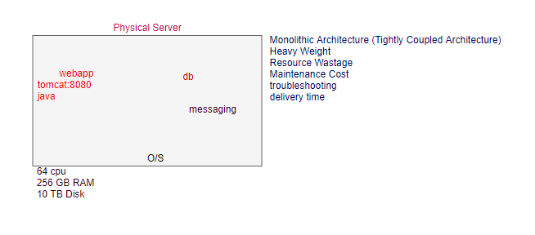

VM:
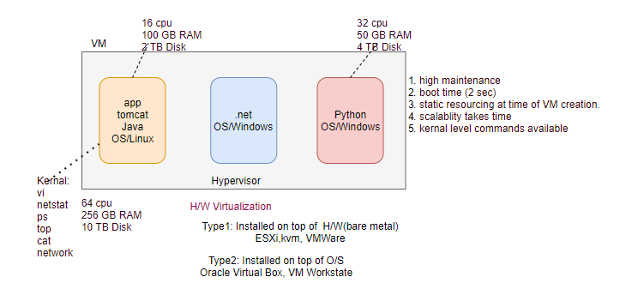

Container:
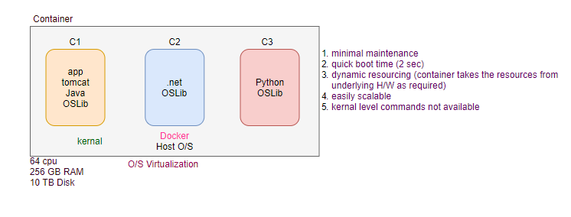
ECR: Elastic Container Registry
ECS: Elastic Container Service
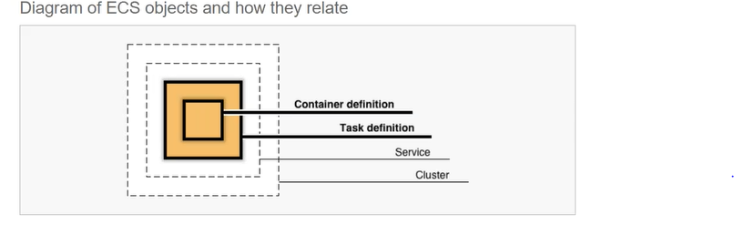
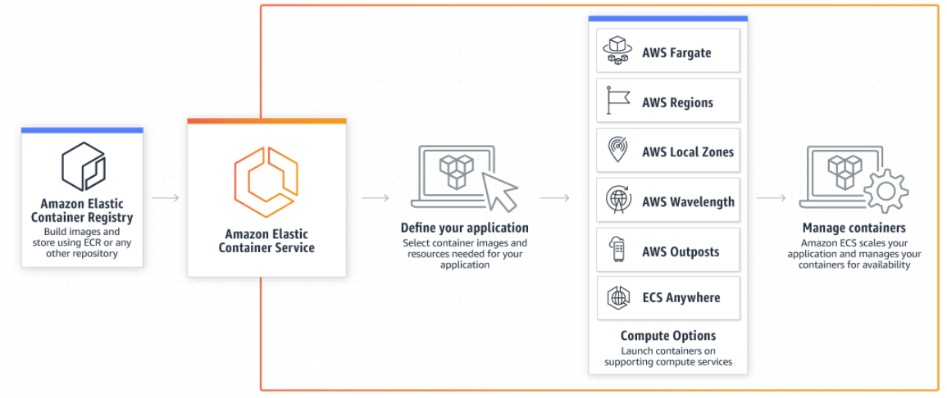
Task: Pod
Deployment and Service: Service
Task Definition:
- A task definition is required to run Docker containers in Amazon ECS. The following are some of the parameters you can specify in a task definition:
- The Docker image to use with each container in your task
- How much CPU and memory to use with each task or each container within a task
- The launch type to use, which determines the infrastructure on which your tasks are hosted
- The Docker networking mode to use for the containers in your task
- The logging configuration to use for your tasks
- Whether the task should continue to run if the container finishes or fails

- The command the container should run when it is started
- Any data volumes that should be used with the containers in the task
- The IAM role that your tasks should use
You can define multiple containers in a task definition. The parameters that you use depend on the launch type you choose for the task.
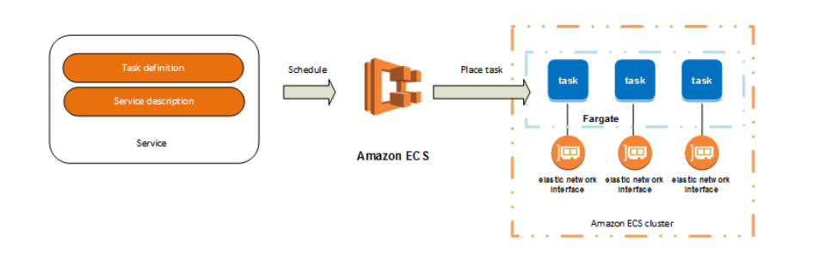
Clusters:
An Amazon ECS cluster is a logical grouping of tasks or services. Your tasks and services are run on infrastructure that is registered to a cluster. The infrastructure capacity can be provided by AWS Fargate, which is serverless infrastructure that AWS manages, Amazon EC2 instances that you manage, or an on-premise server or virtual machine (VM) that you manage remotely. In most cases, Amazon ECS capacity providers can be used to manage the infrastructure the tasks in your clusters use.
Container Agent:
The Amazon ECS container agent allows container instances to connect to your cluster. The Amazon ECS container agent is included in the Amazon ECS-optimized AMIs, but you can also install it on any Amazon EC2 instance that supports the Amazon ECS specification. The Amazon ECS container agent is only supported on Amazon EC2 instances.
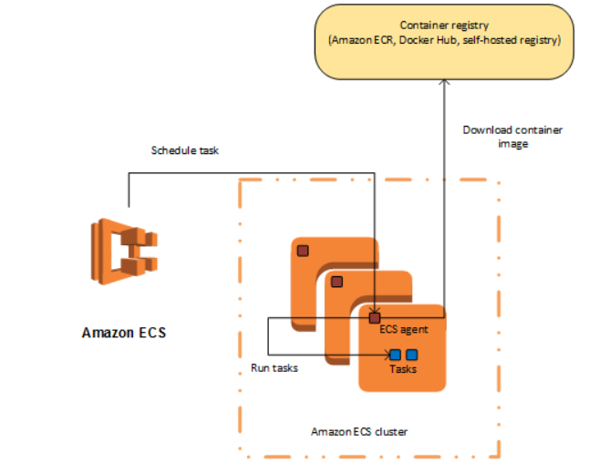

Cloud Adoption Framework:
AWS Well-Architected Tool:
Lambda:
API Gateway
OpsWorks

