How to connect to Linux Machine remotely?
To connect to a remote Linux machine, we must have a tool on your laptop/desktop called -SSH Client
Windows users:
- gitbash
- putty
- mobaXterm
- Window PowerShell

What we need to connect to the remote server?
- IP address
- Create a key-pair (user name password)
- Allow Security Group Access
ssh -i key.pem ubuntu@<public ip>

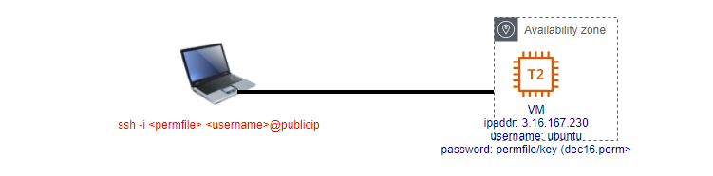
What is a Server?
Where you host an application, you send a request and get the response. Computer which allows to run our application.
Use to run software/application – request and response

What is an Application/S/W?
Piece of code serves some business requirements

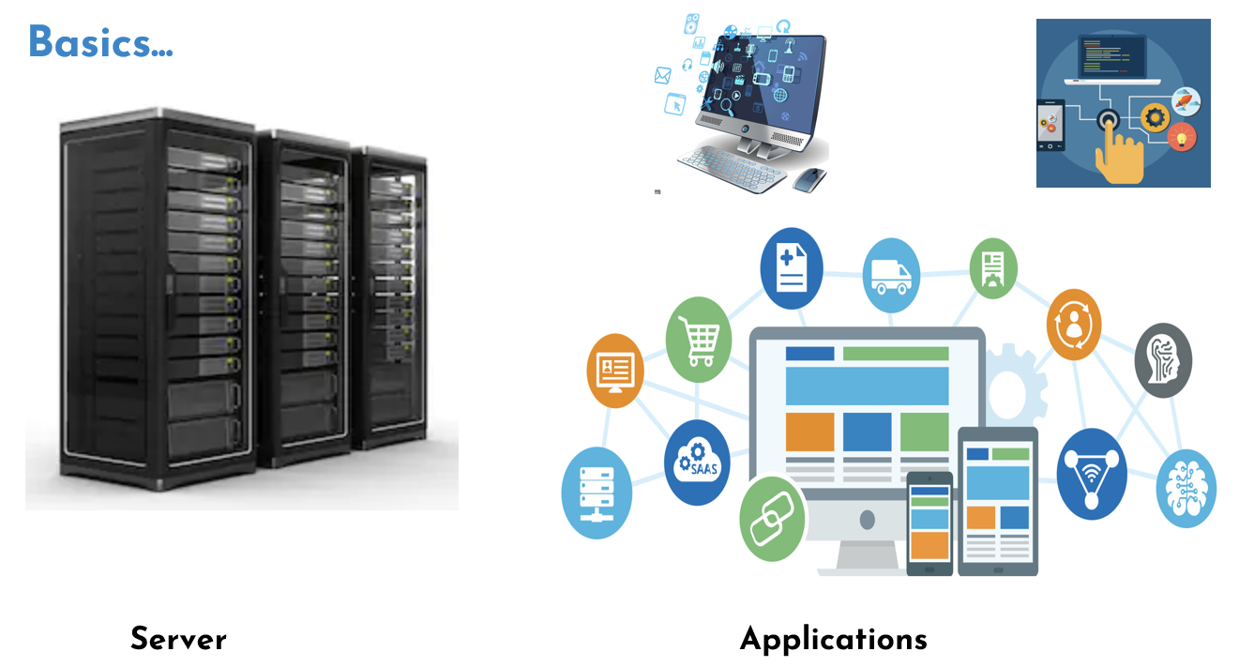

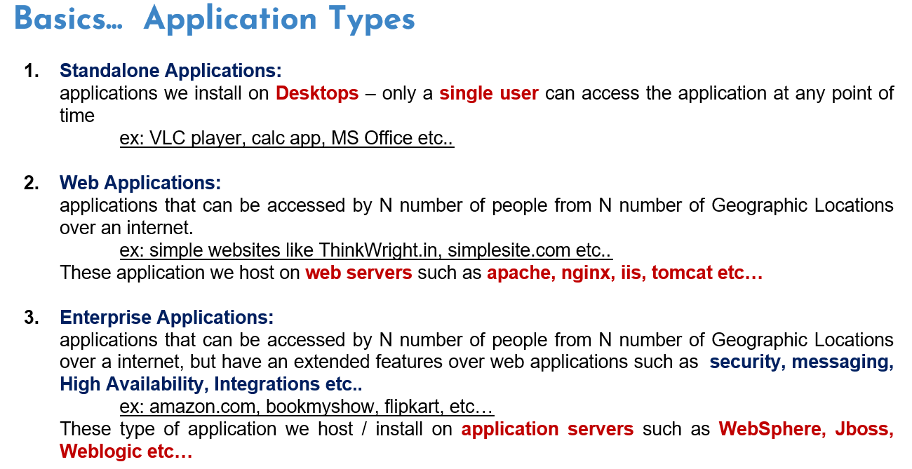
Type of Applications:
Stand-alone applications:
ex: paint/ ms office / calc / vlc player
Web application: Any application that can be opened in a browser
ex: amazon.in /facebook.com
web server needs a runtime to run them
web servers: tomcat /Apache/ IIS/ nginx
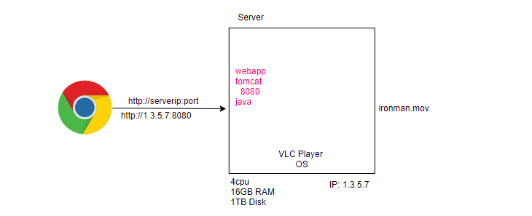

What is the difference between webserver and app server?
App server can also provide the business logic, messaging, security features, an extension of Web Server.

Software Engineering?
Our main goal is developing an S/W, deliver the S/W to the customer and maintain the S/W, ensure that must be used by end users.
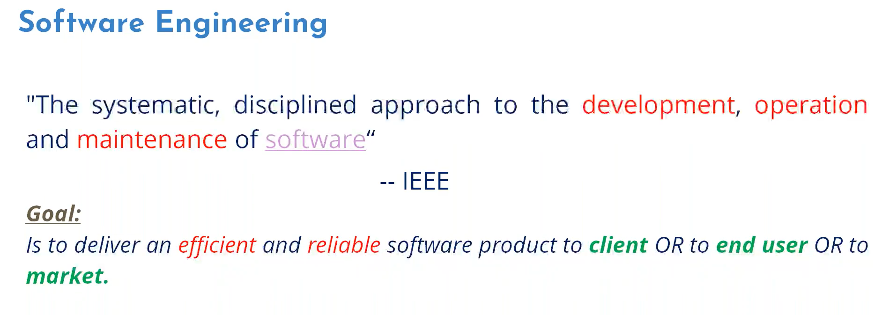

To deliver the same, we are following some processes called SDLC models.
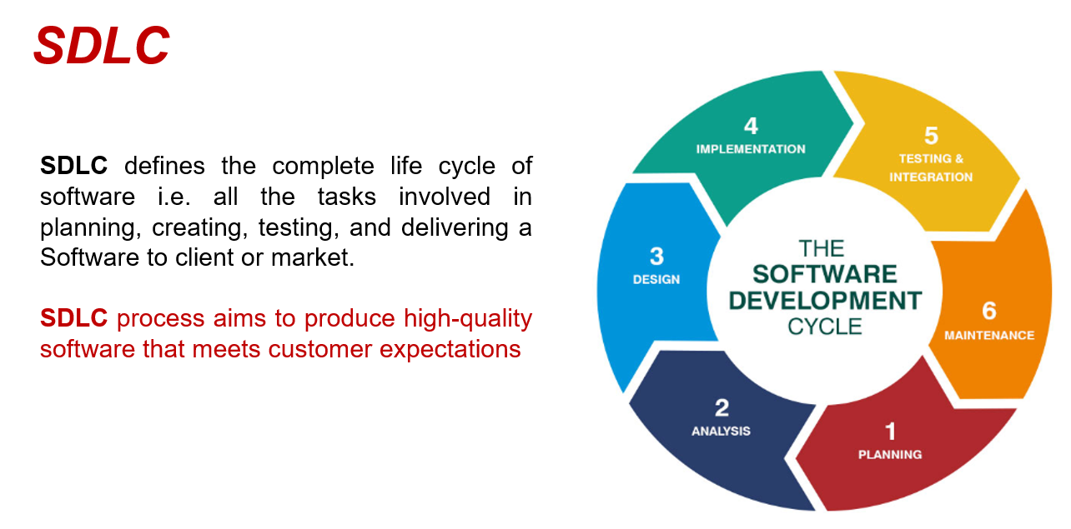
We have different SDLC models… Various SDLC models in IT

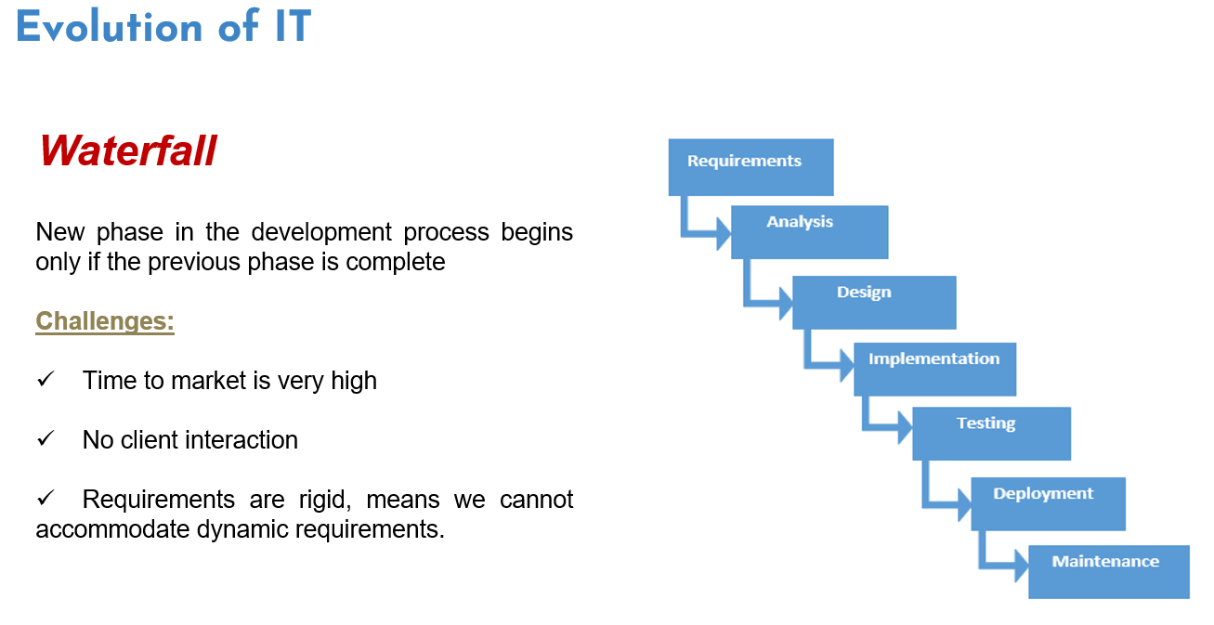
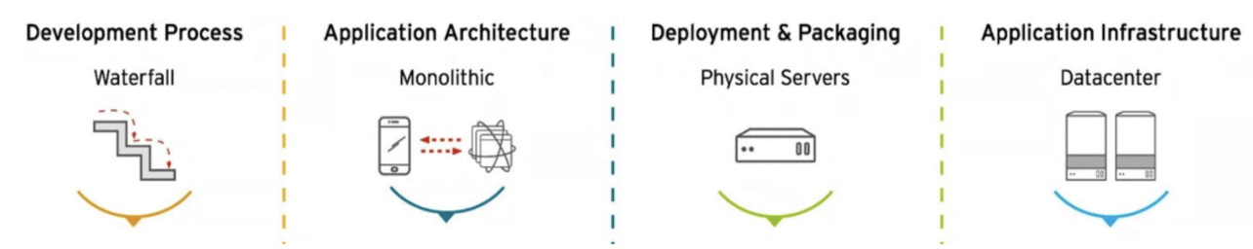

Monolithic Architecture (Tightly Coupled Architecture)
Many components bundled and deployed together (single artifact).
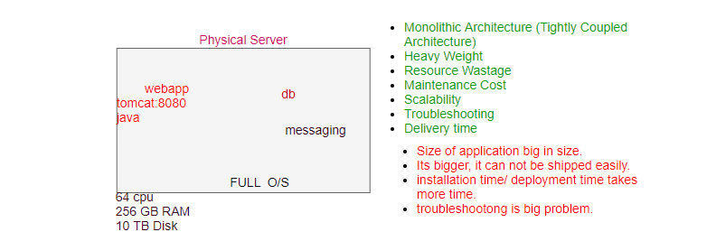
All the dependent components tightly coupled and bundled together, since they are bundled together, they are heavy, it is heavy weight it takes longer time to install, difficult to deploy together must be executed together to run the application smoothly.

Data Centers:
Organization’s building where they kept their all H/W servers, like a home kitchen/self-home.

Current Market demand is speed...
Agile :( Iterative and Incremental)

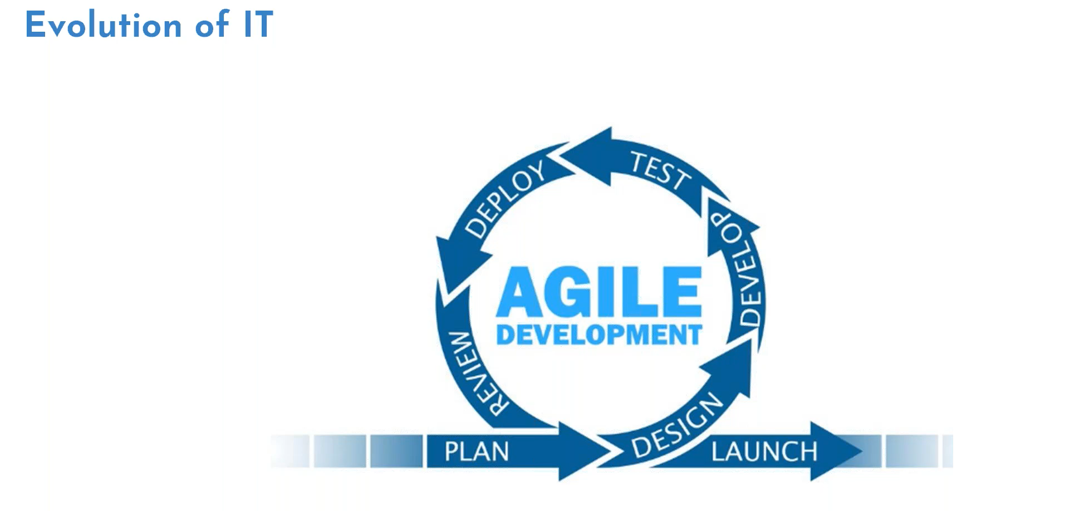
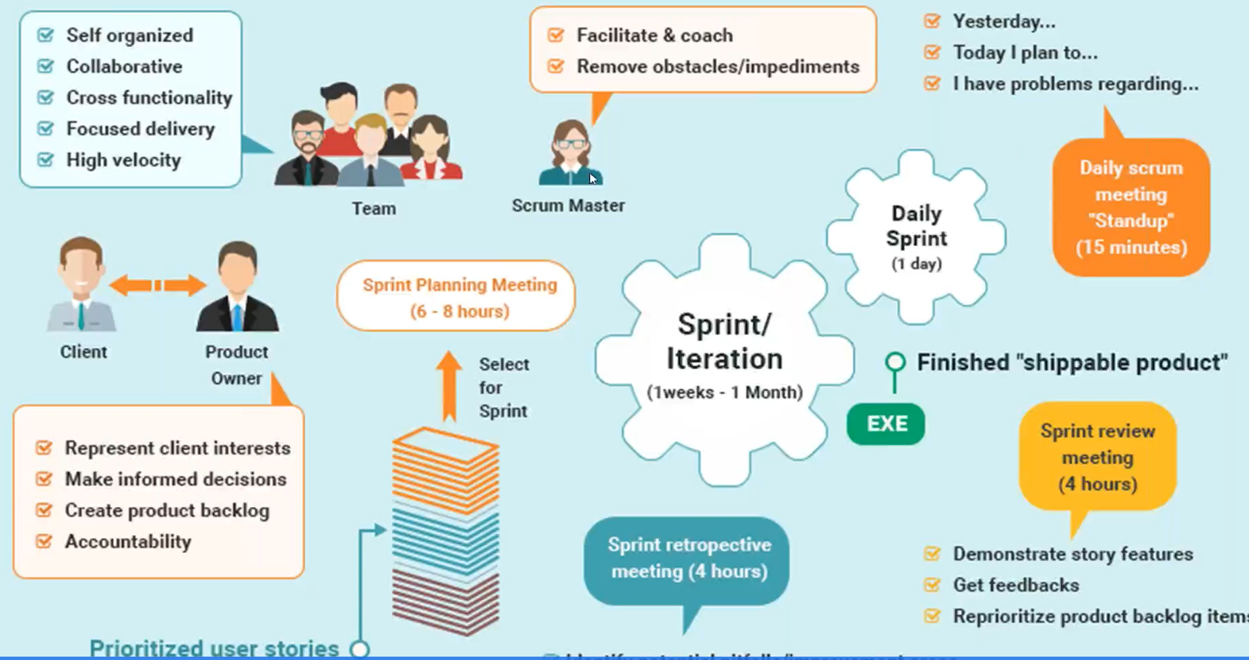
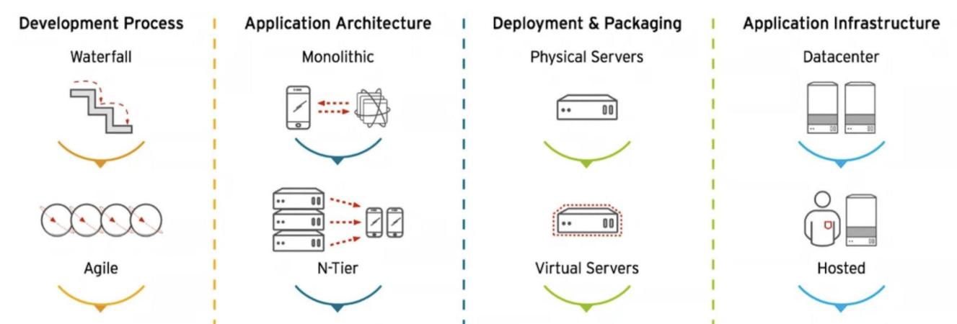

Virtual Servers:
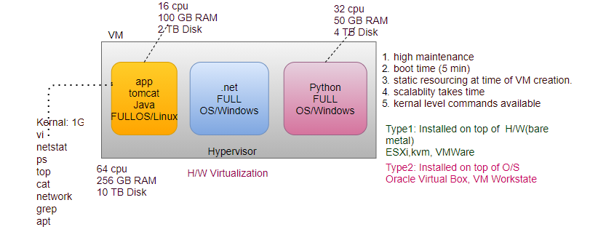
Virtual Server: Hypervisor, Convert Big Fat server into multiple small virtual servers, each virtual machine has their own O/S, same time we have a resource shared among these virtual machines.
Type1: install hypervisor on top of bare metal. During creation of virtual machine asks for allocated resources, e.g... ESXi, VMware, kvm

Type2: Hypervisor installed on the top of O/S (para virtualization), e.g., Oracle Virtual Box

N-Tier Application Architecture:
MVC (decoupled architecture): presentation layer in different server, business layer in different server, backend layer in different server, e.g., Oracle
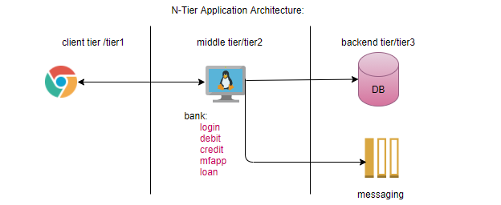
Hosted:
Third party data centers. Like a rented house /hotel either eat or not have to pay.

Benefits:
- Development speed increased.
- Utilization of resources more effectively.
- Light weight components easy to deploy and manage.

Challenges at Operation side…
Infrastructure Readiness:
Infrastructure is not ready compare to the development, e.g., we deploy higher version features on lower version of server.

Scalability:
Big Friday Salary (10-100 servers) how quickly can scale my environment. Lots of effort required. Process takes longer time to create VM.

Quality of the Product:
Due to tight delivery schedule, compromise with quality, e.g. sprint is ending tomorrow and development is completed today.

Limited Release Window- Release may slip/fail:
Client don’t allow to deploy during peak business hours, only sat-sun allowed. How to deliver without any downtime.

What is the Need?
- Shorter Deployment Cycles, Faster Innovation.
- Reduced Deployment Failures, Rollbacks, and Time to Recover
- Improved Communication and Collaboration
- Increased Efficiency.
Approach?
- Infrastructure readiness
- Scalability
- Quality of the product (Automation)
- Limited Release Windows
  - We don’t want downtime (CICD)

Problem Statement
Application is running fine in development environment but not working in QA environment.
Reason:
- Different versions
- Dependencies

There is pre-requisite of environment must be ready (O/S, Java, tomcat) on all the environments.
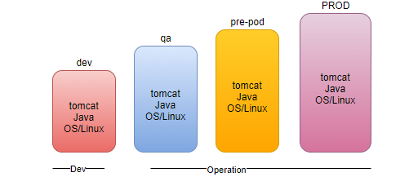
We are delivering only artifacts (.war) but not the dependencies. It may be possible that in different environment different version of java running, causes application is running in one environment but not in other environment.

Challenges:
- Infrastructure Readiness
- Scalability
- Quality of product
  - Automation
- Limited Release windows
  - Release may slip/fail
- We want no downtime deployment
  - CICD
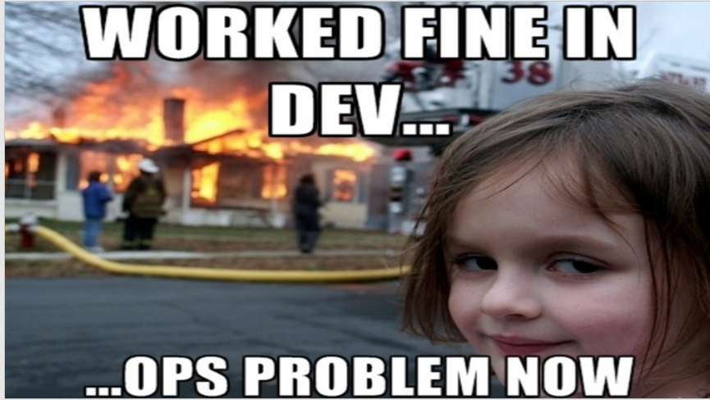

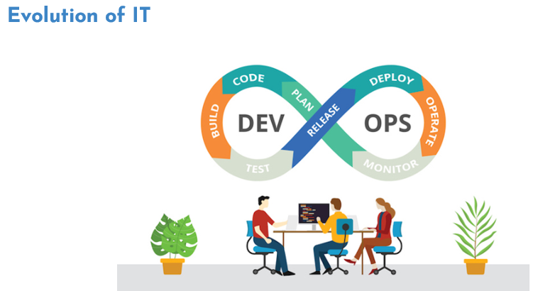
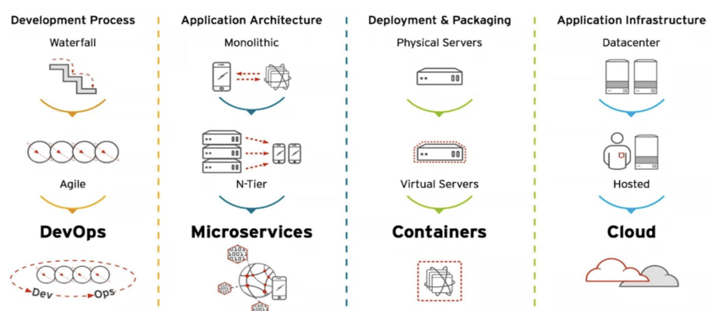

DevOps:
DevOps is a re-org, not a new team to hire.
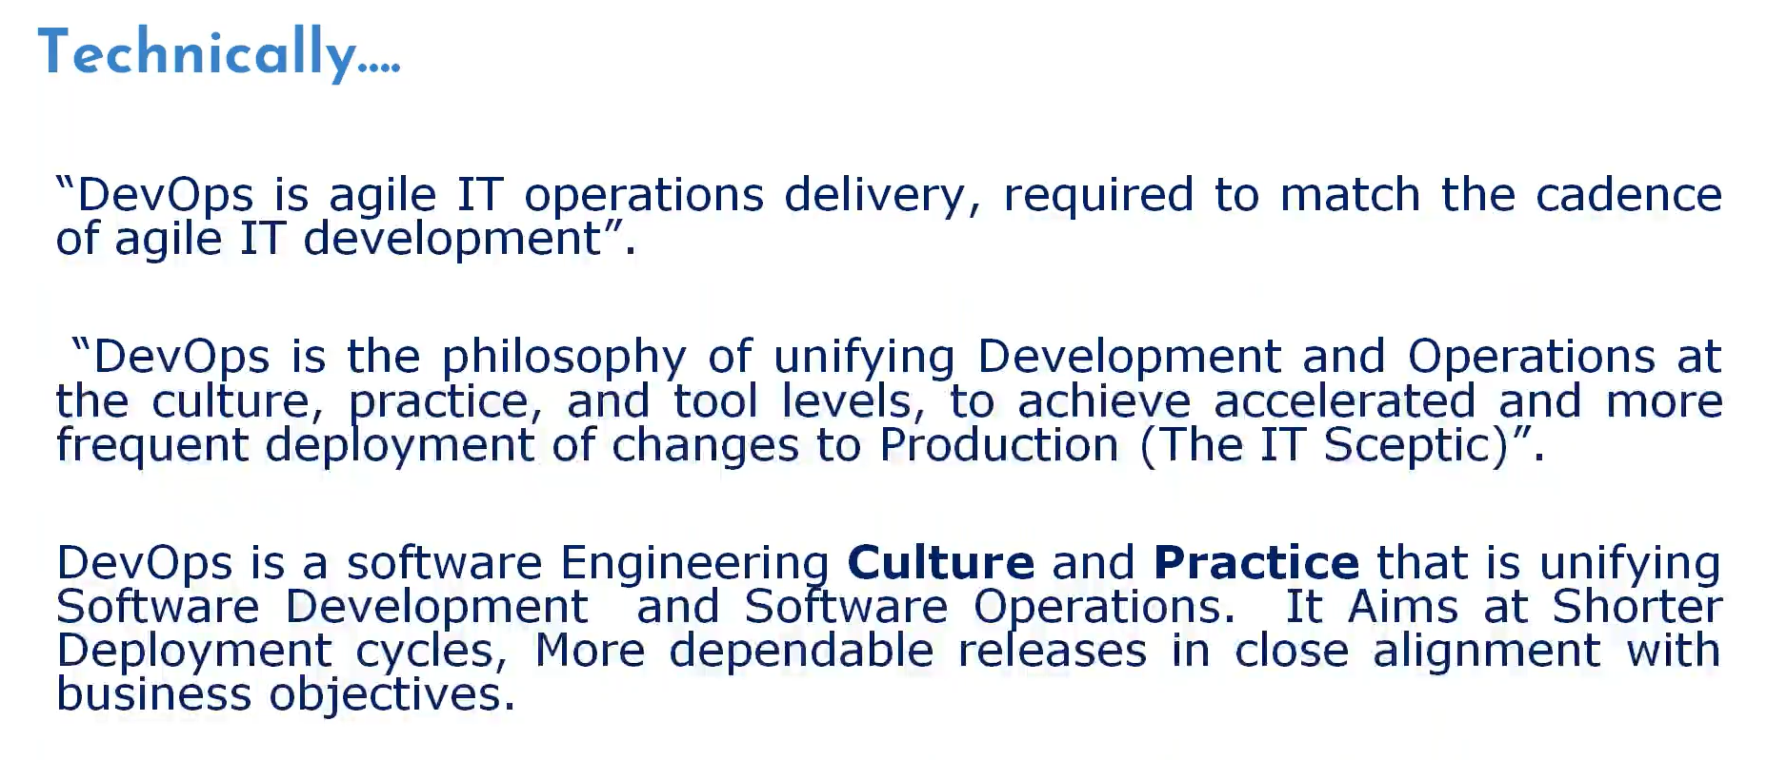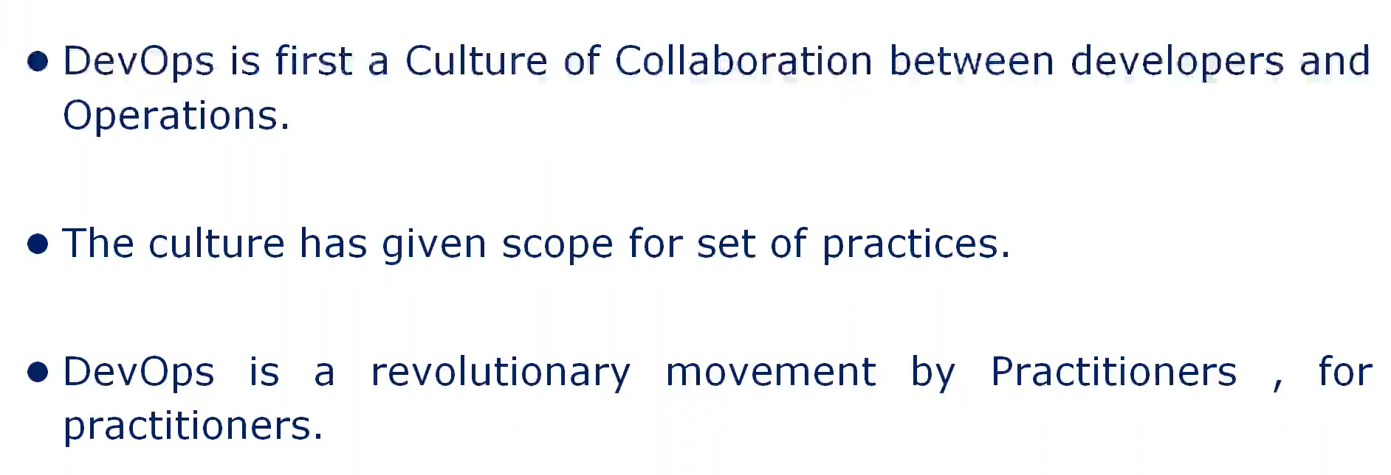

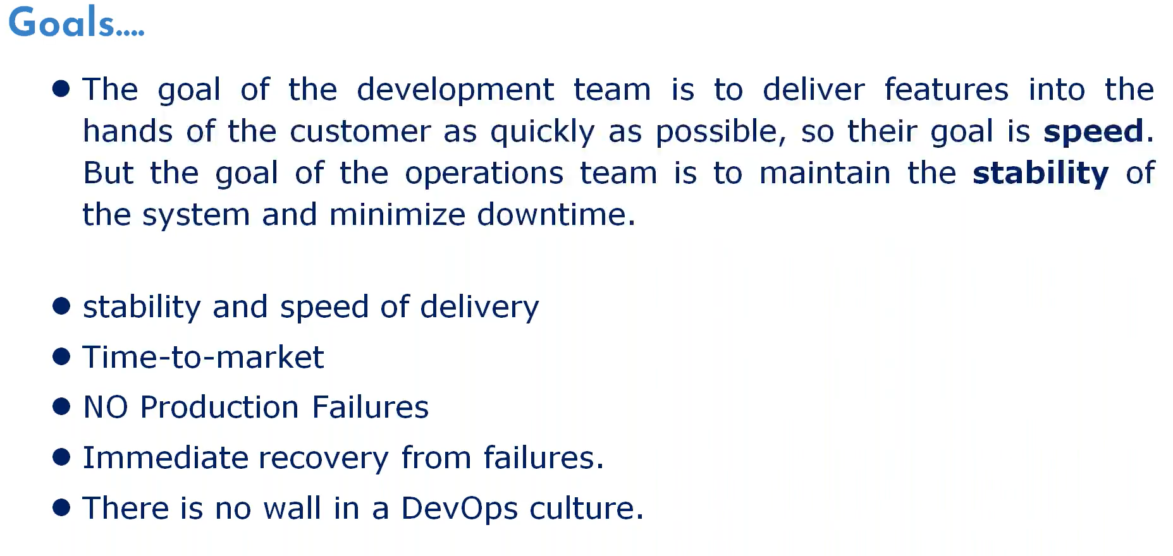
Container:
Before Container: Pre- configuring our application environment and then deploying our code.
Problem: Application is running on one environment but not running on another environment.
Why? We are just moving artifacts (.war) from one environment to another environment what about dependencies? E.g., OS version, Java version and tomcat version, servers may have inconsistent configuration due to which application is running in one environment but no other environment.
Solution? Container

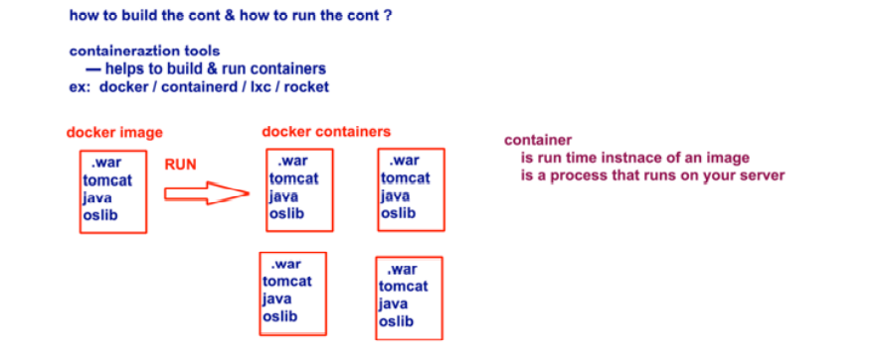
Instead of delivering old style, we containerized (bundle the code with all its dependencies into single package and deliver the complete package). This complete package technically called the image.
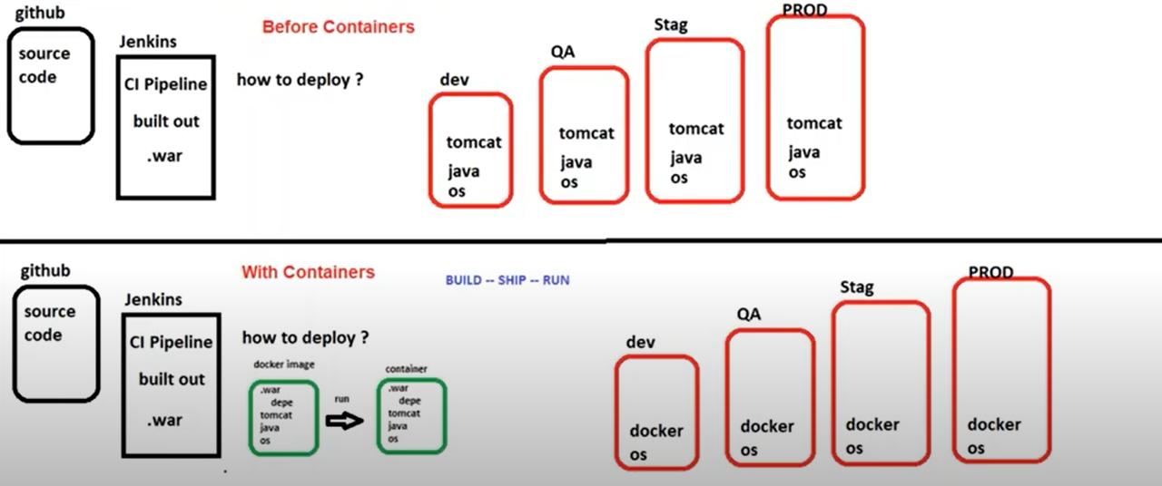
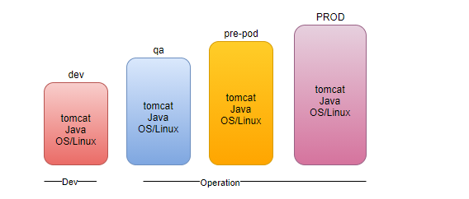
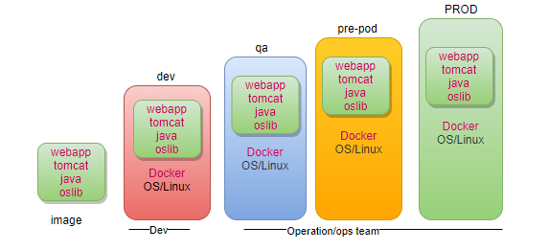

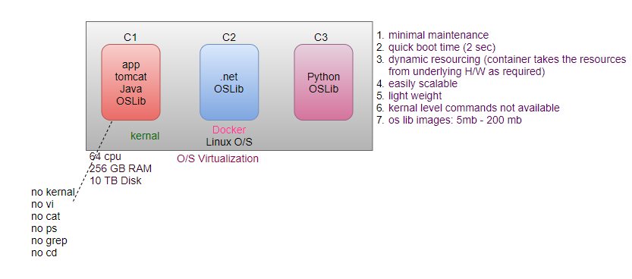
Microservices: (decouple the modules as a separate application)
In our banking application 90% users use debit card and 10% users use credit card, suddenly everything is working fine expect the credit card, there is issue in credit card, whole application will be down which will impact the debit card users also be impacted.

Solution: deploy the modules as a separate application and each application deployed separately on different servers, light weight application can transfer and deploy smoothly, debit card users will not be impacted.
- Technology agnostic.
- Light weight application easy to deliver.
- Easily deployable.
- Debugging is very easy.
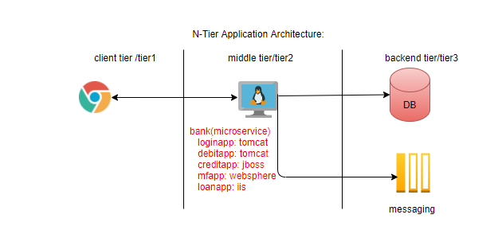
Cloud:
Online delivery, pay as you go. It completely service model. It’s like an online food delivery everything available at your home.

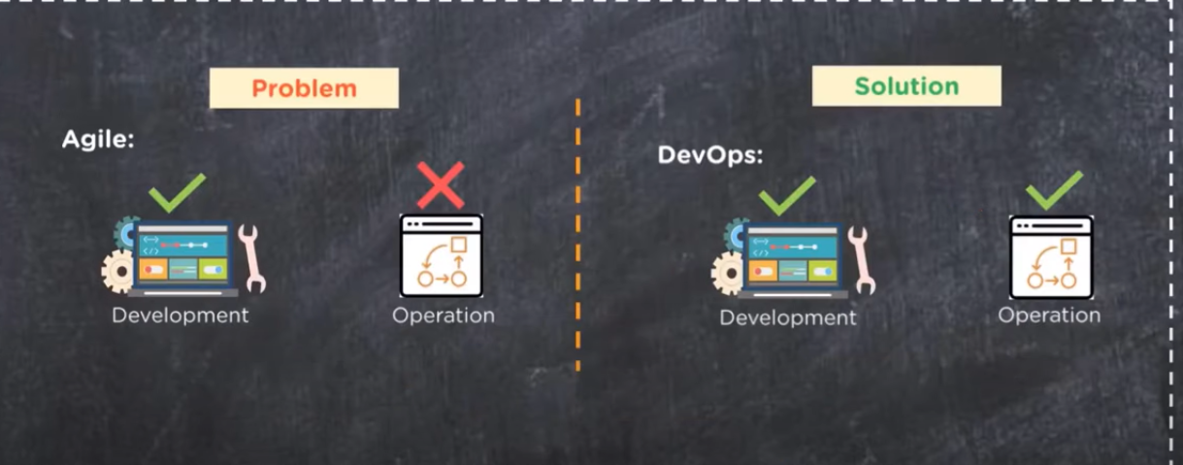
Problem Statement: We already have development team, operation team but are not communication properly.
Solution: grouped them together as a single team.
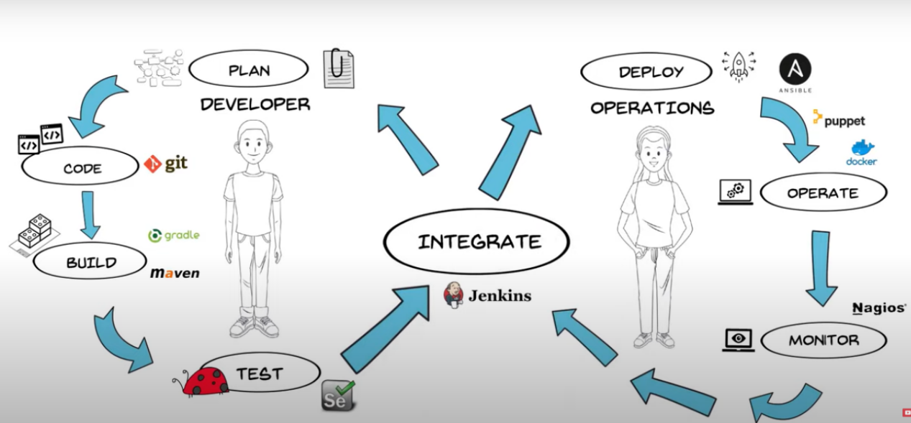

DevOps Stages and Tools
Stage1-1 Plan | JIRA, Rally
Stage-2 Version Control (SCM/VCS) | Git/GitHub, SVN, CVS
Stage-3 Build Code | Maven
Stage-3 Continuous Integration | Jenkins, Travis, TeamCity
Stage-4 Continuous Testing | Jenkins, Selenium, TestNG, Junit
Stage-5 Containerization | Docker
Stage-6 Container Orchestrator | Docker Swarm/ Kubernetes
Stage-7Configuration Management | Ansible/puppet/Chef
Stage-8 Continuous Monitoring | Splunk, EFK Stack, Nagios
CI/CD achieved through combination of all the tools.
Environment and Tools
Dev
Source Code Management | Git/GitHub/ CodeCommit
Operations
Build process | Maven (java)/CodeBuild
Build automation | Jenkins/ Codepipeline
Config Management | Ansible/Config
Infra management tool | Terraform/CloudFormation
Containers | Docker
Container Orchestration | Docker Swarm/Kubernetes
Maintenance
Monitoring | Nagios, Prometheus/Grafana, CloudWatch
Logging | EFK/CloudWatch

What is Lean?
DevOps Engineer role is a mindset, you should nor restrict yourself in a single area, always flexible to shift your area here and there.
Open to learn always, open mind to shift left or right.
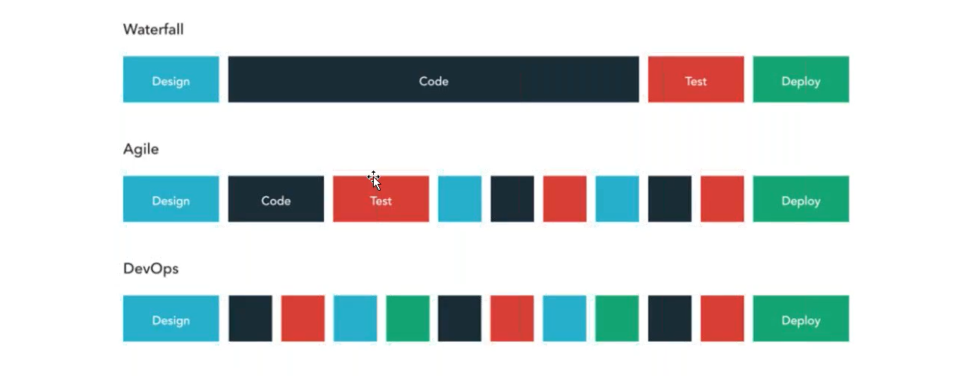

Primary Goal of the DevOps is to create a culture of work together to achieve the speed and stability.

