Why Continuous Delivery?
Getting value to the business fast
What is continuous Delivery

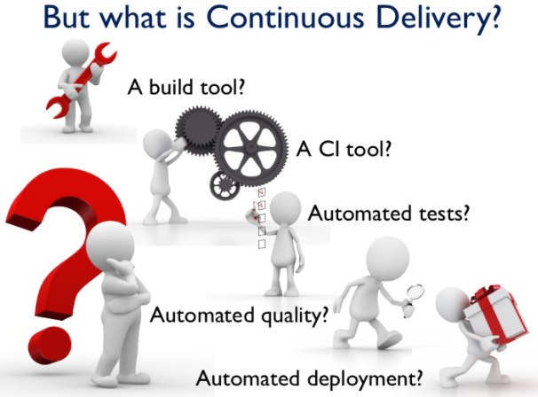
principle1:
Every build is a potential release
principle2:
Eliminate manual bottlenecks.
principle3:
Automate wherever is possible

principle4:
Have automated tests you can trust.
Build Pipelines
The conveyer belts of Continuous Delivery.

