JenkinsFiles? It is a text file that contains the definition of a Jenkins pipeline, and it is checked into the source control repository (SCR). Pipeline as a code.
How to Integrate the Jobs?
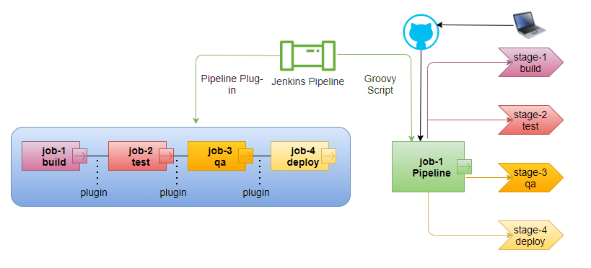
Pipeline as a code
Limitations of Pipeline Using Plugins
- Using Jenkins UI Interface
- All jobs are executed sequentially, can’t skip any Job from the middle.
- If job4 fails, means our tasks are not completed, our tasks will be completed only once complete pipeline will be executed, then we have to correct the job4 and execute the pipeline again, second time pipeline will be executed from the starting (Time consuming).
- No concept of looping/conditions.
- All jobs are executed only in master till master is live.
Benefits of Pipeline Using Groovy Scripts
- Using Jenkins UI Interface, as well as using Jenkins files (pipeline as a code).
- We can skip Job3 from the middle while Job 3 is still there (condition).
- In case of Job4 failure, second time we can only restart Stage4.
- Groovy Scripts have In-build suite of plugins.
- We can apply conditions and looping in Groovy Scripts.
- We can distribute the load with agents.

Types of Pipelines Using Groovy Scripts?
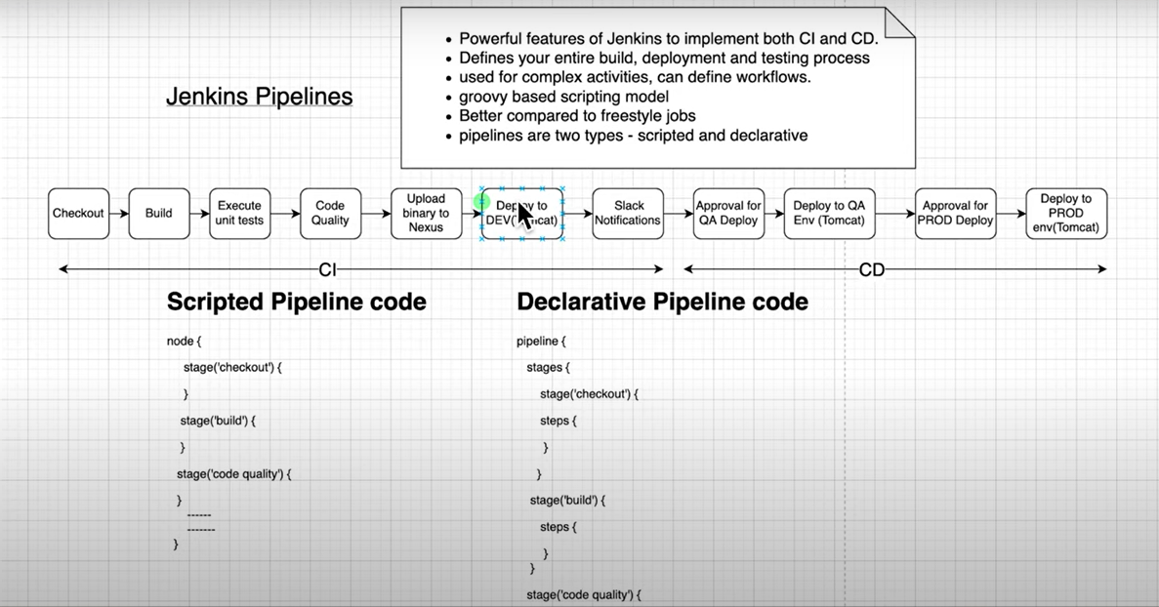
- Whereas the scripted pipeline is a traditional way of writing the code. In this pipeline the Jenkinsfile is written on the Jenkins UI Instance.
- In Declarative Pipeline Code Validation happens at startup.
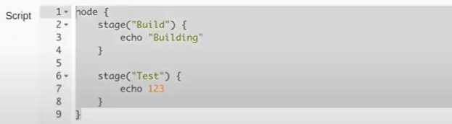
In Case of scripted pipeline Build Stage will executed successfully, will throw an exception at the time of Test stage execution, will in the case of Declarative pipeline script will throw exception at startup before execution of the Build stage.
- In Declarative pipeline we can restart the specific stage in case of failure.
- In Declarative Pipeline have option of skip the stage using the conditions.
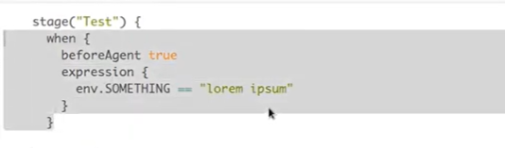
- Declarative Pipeline Options?

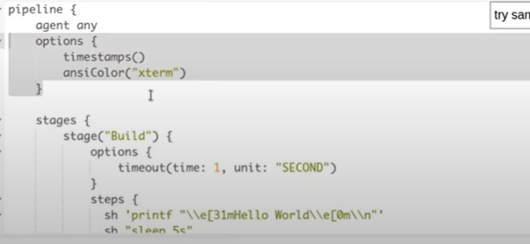
Global options at pipeline level means it can be applied at any stages.
Declarative Pipeline?
Syntax:
Required fields of Jenkinsfile
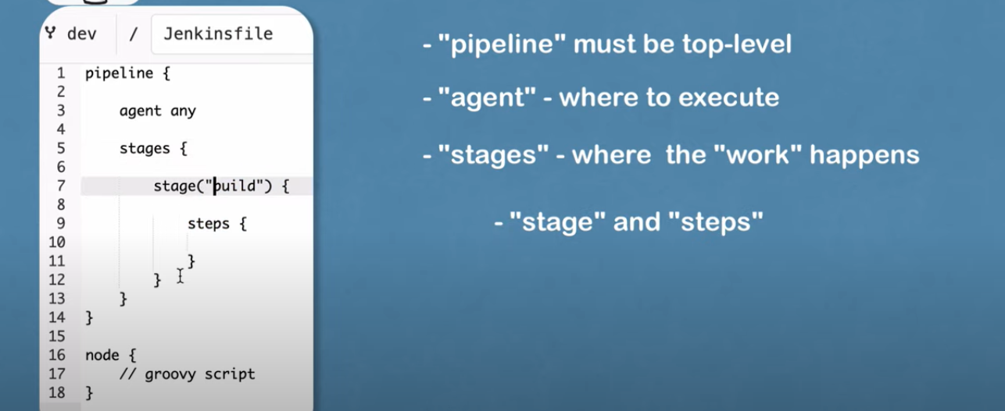

Benefits of Pipeline (Declarative) Using Groovy Scripts
- Using Jenkins UI Interface, as well as using Jenkins files (pipeline as a code).
- We can skip Job3 from the middle while Job 3 is still there (condition).
- In case of Job4 failure, second time we can only restart Stage4.
- Groovy Scripts have In-build suite of plugins.
- We can apply conditions and looping in Groovy Scripts.
- We can distribute the different stage with different agents.
- Validation happens at startup.
- Options
Post Attribute in Jenkins
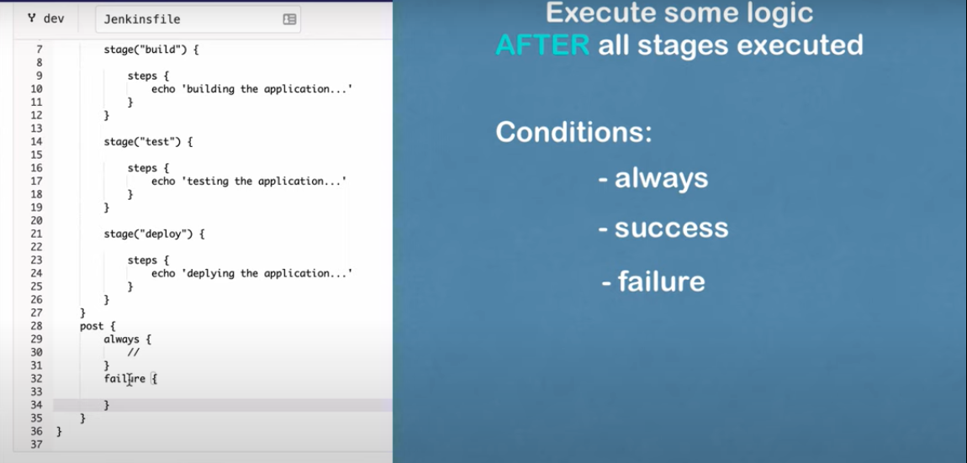
Define Conditionals for each stage, using the expression within when block
UC: execute the “test” stage only on dev branch
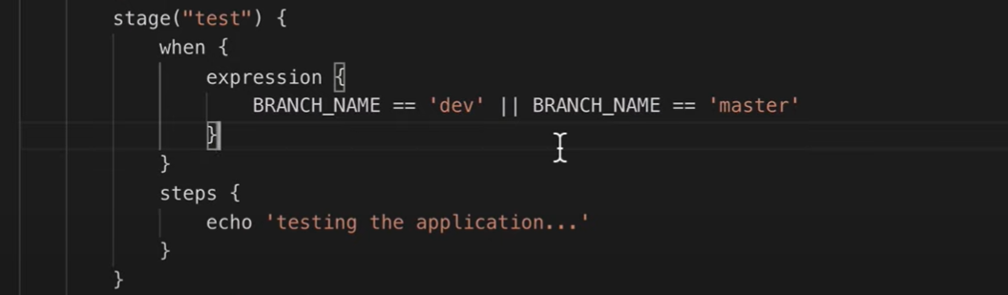
How get the branch name?
Environmental Variable provided by Jenkins
What variables are available from Jenkins? #localhost:8080/env-vars.html

//CODE_CHANGES = getGitChanges()
def gv
pipeline {
agent any

tools{ // build tool
maven 'mymaven'
}// tool

environment { //available to all stage
NEW_VERSION='1.3.0'
SERVER_CREDENTIALS = credentials('1426dee9-d21f-4e79-bce2-50f2905927f6')
}// environment

parameters { // parameters pass suitable candidates for expressions

// string(name, defultValue, description)
//choice(name,choices,description)
//booleanParam(name, defaultvalue,description)
string(name: 'SELECT_VERSION', defaultValue: '1.1.0', description: 'string version parameter to be deployed')
choice(name: 'CHOICE_VERSION',choices: ['1.1.0','1.3.0','1.5.0'],description: 'choice parameter')
booleanParam(name:'executeTests',defaultValue: 'true',description: 'boolean parameter')

}// parameters

stages {
stage('init'){
steps{
script{
gv=load "script.groovy"
}
}
}// init-stage
stage('1-build') {
steps {
echo 'Hello Build'
echo "custome variable double ${NEW_VERSION}"
echo "server credentials ${SERVER_CREDENTIALS}"
}
}//1-build

stage('2-test') {

when{
expression { // inbuild environment
env.BRANCH_NAME == 'master' || env.BRANCH_NAME == 'main'
}//expression
}// when

steps {
echo 'Hello Test'
}
}//2-test

stage('3-deploy') {
when{
expression {
params.executeTests

}//expression

}//when
steps {
echo 'Hello Deploy'
echo "deploying with choice version ${params.CHOICE_VERSION}"
echo "deploying with string version ${params.SELECT_VERSION}"
}
}//3-deploy

stage('5-execute groovyscript'){
steps{
script {
// to execute groovy script define globally def gv
// gv.execute()
}
// echo 'execute groovy scripts'
}
}//5- execute groovy

}//stages

post{ // build status or status changes

always{
echo ' send email always'
} //always

success{
echo ' send email on success'
} //always

}//post-stages after all stages are done
}//Pipeline

Using external Groovy Script
Clean the jenkinsfile and move the logic in external groovy script files, add the functionality using the script tag.
step1: write a groovy script (script.groovy)
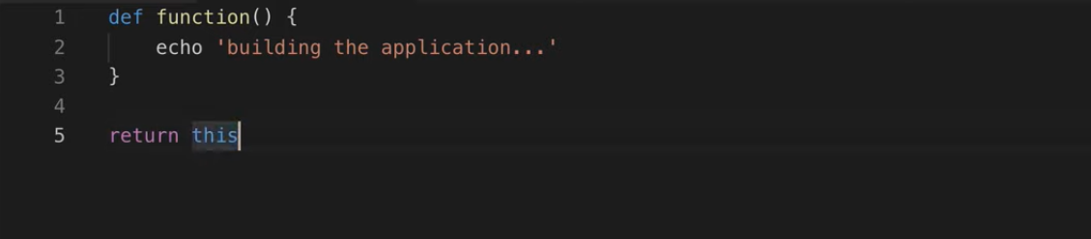
step2: Define the global variable to hold the groovy script
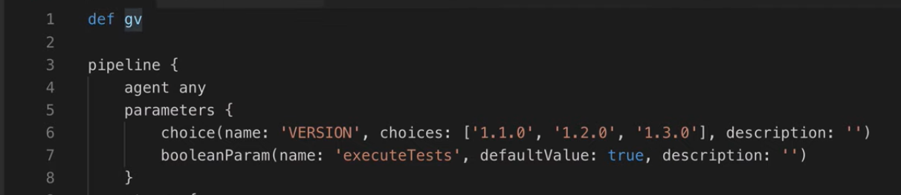
step3: In init stage load the groovy script
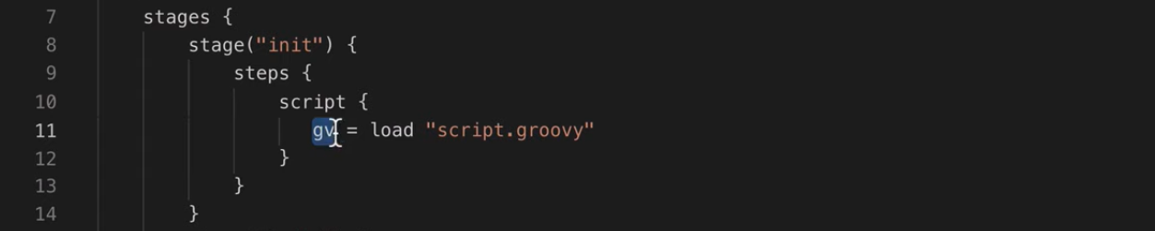
step4: use function written in groovy script in jenkinsfile
step4.1: Update the groovy script
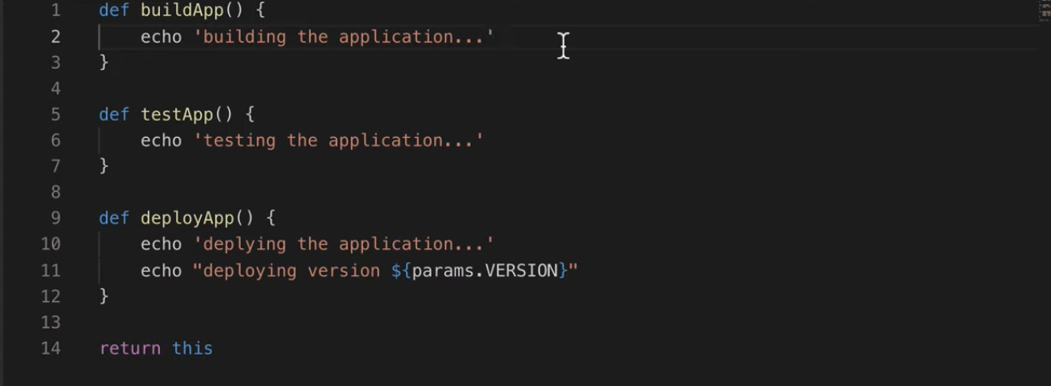

step4.2: Use functions of groovy script in jenkinsfile
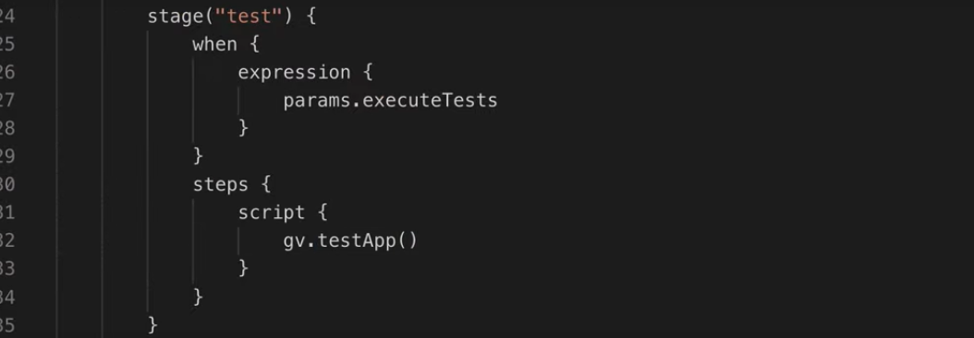
All the environmental variables In Jenkinsfile are available in groovy script.

Delegate the job in specific agent:
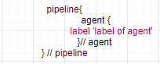
Execute the job in parallel:
A parallel keyword encounters Jenkins ensure that stage inside parallel must be executed parallel.

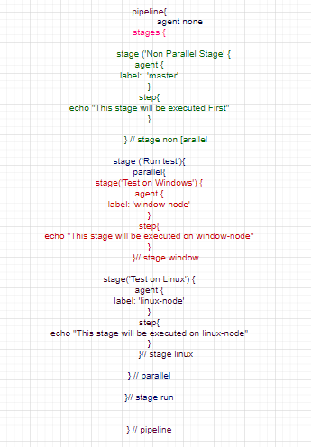

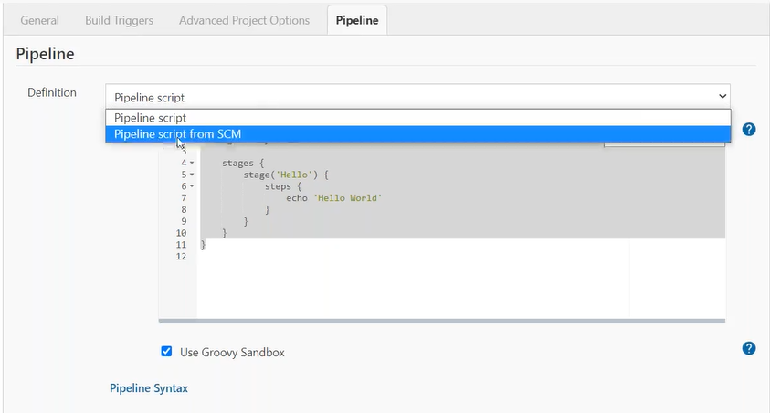
multibranch pipeline:
solve the issue to build for each branch
plugin- Pipeline: Multibranch
project type: Multibranch Pipeline
automatically find the available branches in the repository, start build pipeline against each pipeline

multiconfiguration pipeline:
suitable for projects that needs a large number of different configurations, such as testing on multiple environments, platform-specific tasks etc.
plugin- Pipeline: Multiconfiguration
project type: Multiconfiguration Pipeline

