Integrate SonarQube with Jenkins
Pre-requisite:
- Sonar Server is running
- Jenkins’s server is running
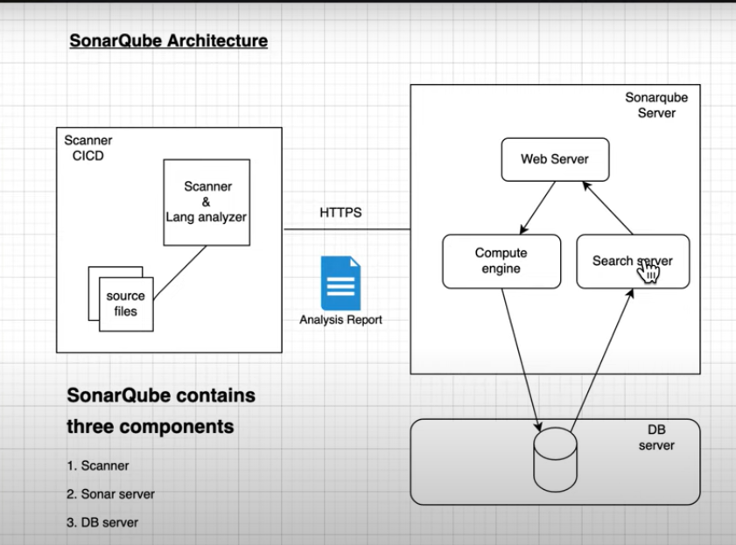
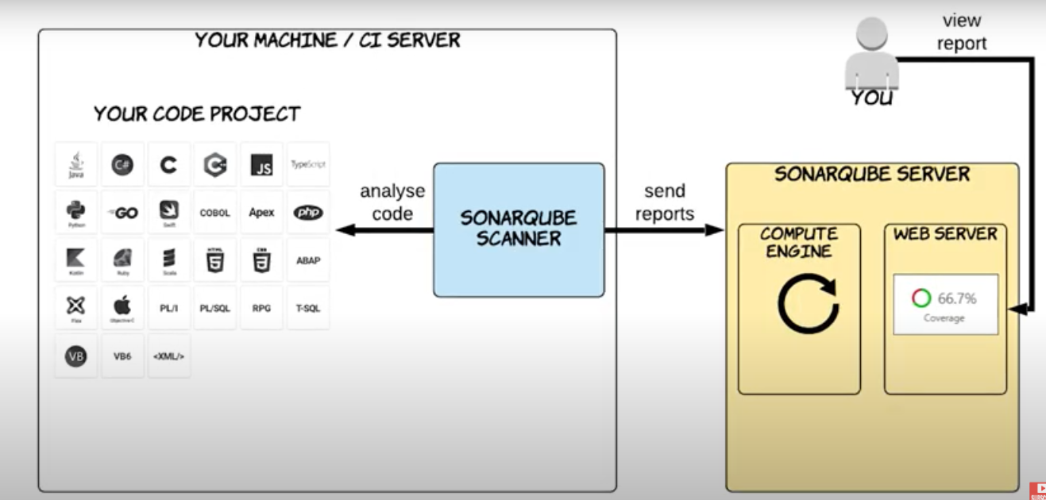
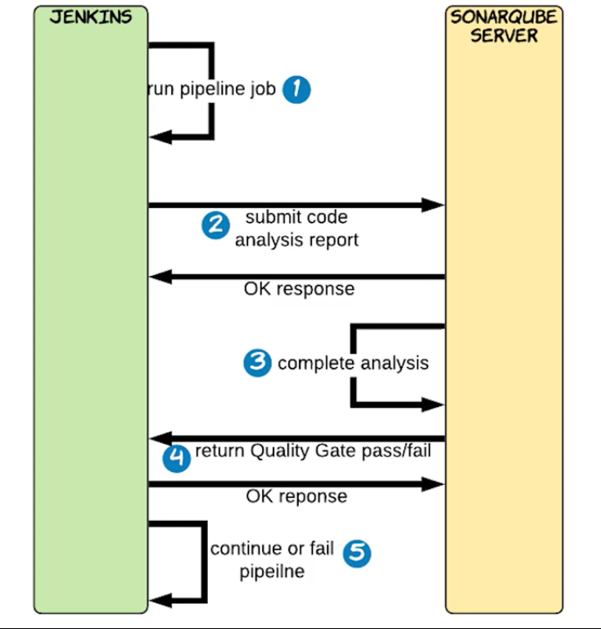
Step1: Sonar Plugins
Mange Jenkins-> Manage Plugins (SonarQube Scanner)
Step2: Go to SonarQube and create a token
Step3: Register SonarQube with Jenkins
Manage Jenkins-> Configure Systems
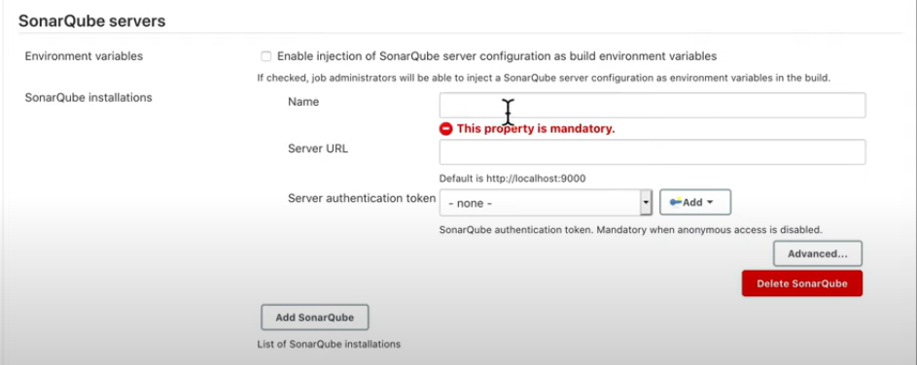
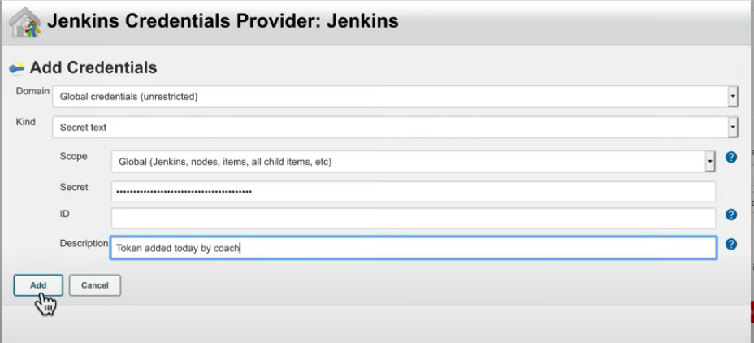
Step4: Create a new Job in Jenkins
Type: freestyle
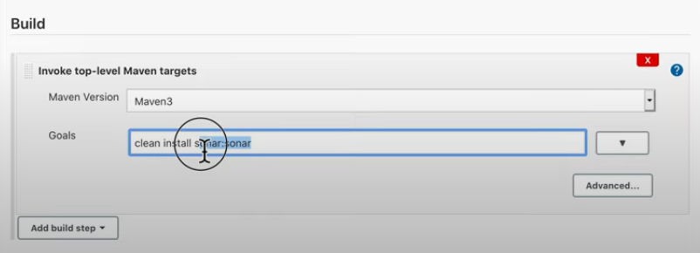
Click on the Advance (Give Path of the. pom)
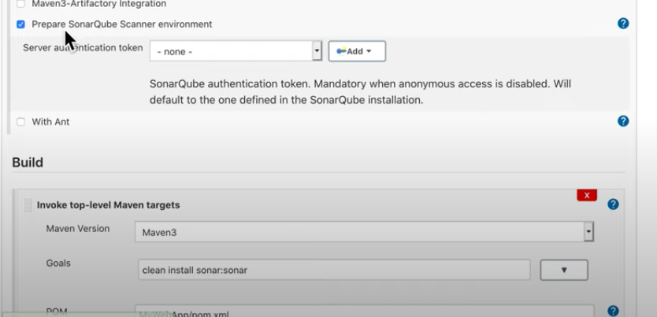
How to apply sonar scan in pipeline?
Create a new Job
Type: Pipeline
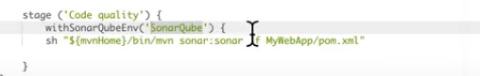

Variable Name?
