Ansible (Master-Slave agentless Push Model)?
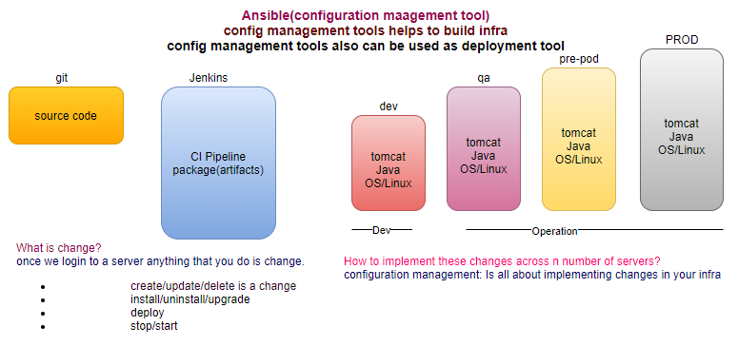
Ansible is a configuration management tool which traditionally uses push approach to achieve its objectives, by managing all the servers through one single machine running the Ansible Configuration Management tool.
UC: There are 100 of servers are running in the production environment, your manager comes to you ask to please shutdown all the server/update the path.
You don’t do the immediately, first ask for CR, then what will be the impact on the production. When you perform any change in server is called configuration change.
  - Why?
  - When?
  - How? What are the instructions to these changes?
  - Who? Will implement
  - How? to rollback
CAB (Change Advisory Board): Track all the changes, any change is also called configuration change.
Final goal is to deploy artifacts on the production environment, from where it can be accessed from end users.

Why we need configuration management tool?
UC: we need to install tomcat and java on 1 server? Manually OK
UC: we need to install tomcat and java on 100 servers? Automation/ Orchestration
Configuration management tool login into the all-slave servers and perform the action on behalf of you.
Login into one system and implement the changes across your infrastructure.
When you join an organization, get Laptop. If any update released in future is DLA comes in your seat or do the updation from their location.
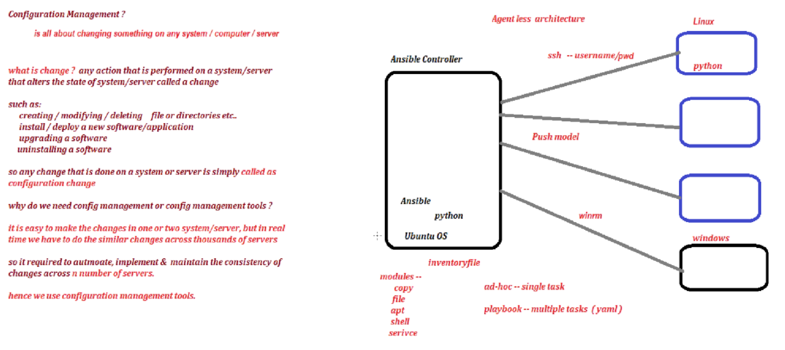
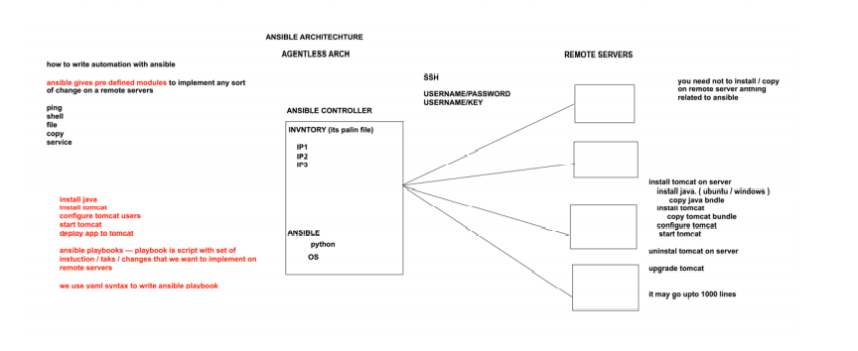
step1: Install ansible
ansible –version
/etc/ansible/hosts # inventory
hosts file is inventory file where we define the ip addresses of the target servers.
/etc/ansible/ansible.cfg #configuration
# configuration (inventory, sudo-user, host_key_checking=false)
/etc/ansible/roles # roles directory

step2: setup communication with target servers (SSH connection)
/*
How to login into Linux machine using username and password?
by-default, ec2 ubuntu instance have only ubuntu user, your instance doesn’t have username and password.
step1: Install ssh client (putty, MobaXterm-portable edition)
*/
step1: create user(devops), in all three instances
adduser devops
step2: set password for this user, in all three instances
passwd devops
step3: switch as devops user
su – devops
step4:
touch file1 # successfully created
apt install httpd -y # denied you need to be root to perform this command
sudo apt install httpd -y
# request for password, after enter password, says ansible user is not in sudoers file
step5: This ansible user doesn’t have sudo privilege as of now, is you want to give sudo privilege to devops user, switch to root user (only root user can provide).
su -
visudo
root ALL=(ALL) ALL
devops ALL=(ALL) NOPASSWD: ALL
:wq!
step6:
apt install httpd -y # you need to be root to perform this command
sudo apt install httpd -y
#request for password, after enter password, install the httpd
step7: Now establish connection between master and worker
su - devops
ssh <IP> # permission denied (public key)
step8:
exit # as a root user
sudo su -
vi /etc/ssh/sshd_config
permitRootLogin Yes # uncomment
PasswordAuthentication Yes # uncomment
PasswordAuthentication No # comment
service sshd restart

step9:
su - devops
ssh <IP> # Will ask for password every time
step10: Establish Trust relationship Go to ansible server and generate keys.
Trust relationship established at same level (root-> root, ansible>ansible)
su - devops
ssh-keygen
ls -a # o/p .ssh (hidden file)
cd .ssh
ls -l # o/p id-rsa, id-rsa-pub
step11: copy the public key of server to the worker nodes
cd .ssh
ls -l # o/p id-rsa, id-rsa-pub
ssh-copy-id <username>@<IP>
step12: from the controller node ssh worker node
su - ansible
ssh <username>@<IP> # only first time ask for key
cat /etc/ansible/hosts
hostname -i // private ip
hostname -f // dns name
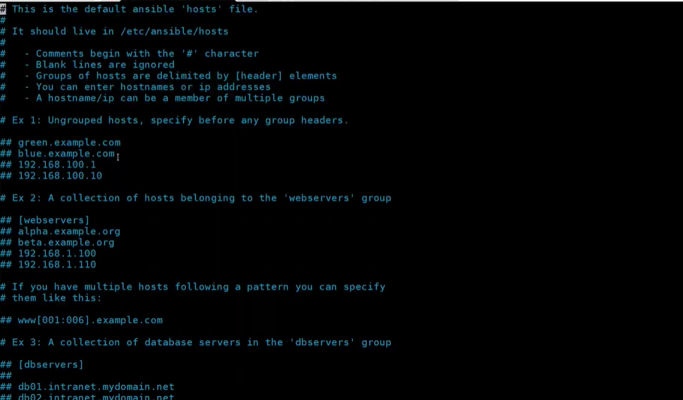
nano hosts
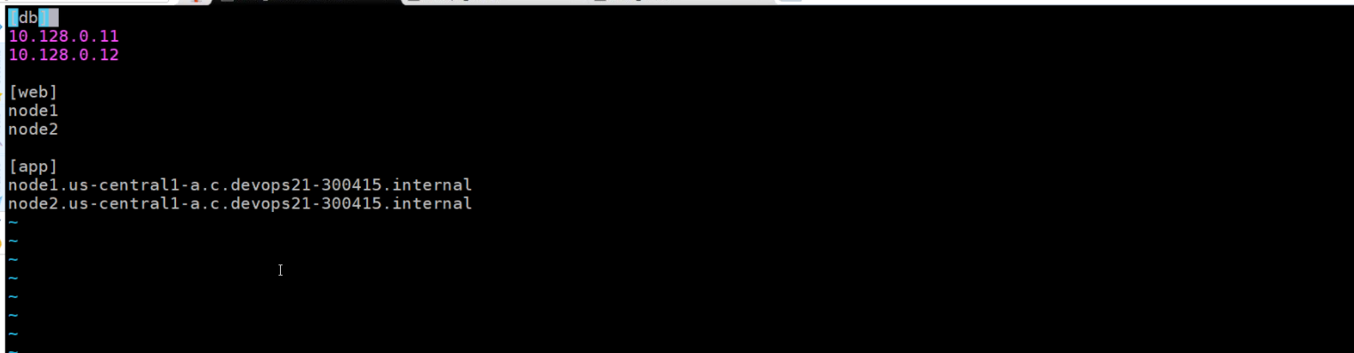
Host pattern
“all” pattern refers to all the machines in an inventory
ansible all --list-hosts
ansible <groupname> --list-hosts
ansible <groupname> [0] --list-hosts
<groupname> [0]: picks the first machine of group
<groupname> [-1]: picks the last machine of group
<groupname> [0:1]: picks the first two machines of group
<groupname> [2:5]: picks the 3,4,5,6 machines of group
group separated by a colon can be used to use hosts from multiple groups
groupname1: groupname2
How controller instruct to the target servers?
- Adhoc commands
- Playbook
What is Module?
Ansible modules are reusable, standalone scripts that can be executed by the Ansible API, or by the ansible or by the ansible-playbook programs.
Modules: everything in Ansible is module
Adhoc commands
How to prepare inventory?
You can modify default inventory file /etc/ansible/hosts
ansible-doc -l
ansible-doc shell
ansible all -m ping -u devops -k (--ask-pass) # Failed Host key checking is enabled
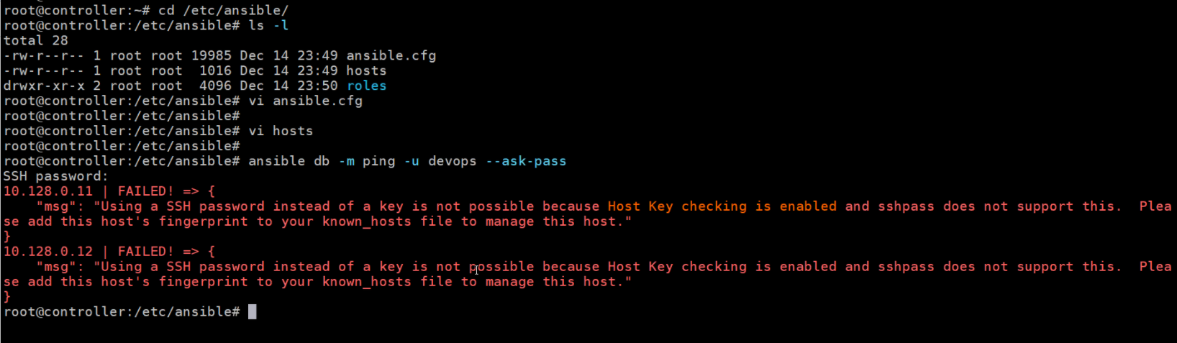
It just like ssh devops@<IP> and say No

How to solve?
nano ansible.cfg
disable the attribute host_key_checking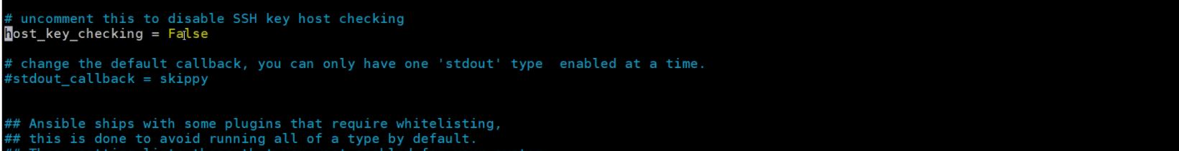
How to create your customize inventory file?
we may have different inventory files for different environments
touch myinv
nano myinv
ansible all -i /home/ansible/myinv -m ping # i (inventory file path)
Adhoc commands with arguments?
#copy module
/*copy module copy from controller to target, source must be on controller machine, and file must be existing on the controller machine else it will not be executed”. */
ansible all -i /home/ansible/myinv -m copy -a “src=/tmp/neeraj.txt dest=/tmp”
ansible all -m copy -a “src=/tmp/devops.txt dest=/tmp backup=yes” -u devops -k
# file module helps you to create file or directory
ansible all -i /home/ansible/myinv -m file -a “path=/tmp/devops state=directory/touch”
#shell module (which command want to execute on target server)
ansible all -i /home/ansible/myinv -m shell -a “ls -a /tmp” -u devops -k
ansible all -m shell -a “df -h” -u devops -k --limit node1,node2
ansible all -i /home/ansible/myinv -m shell -a “df -h /” -u devops -k // disk utilization
ansible all -i /home/ansible/myinv -m shell -a “free -m” -u devops -k // memory utilization
ansible all -i /home/ansible/myinv -m shell -a “service cron status” -u devops -k
# setup module
just displays the Gather facts (ansible collects information about worker nodes before executing any command)
ansible all –i <path of inventory file> -b -m setup
#src must be on server and must be available (Idempotence no change)
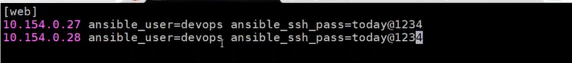
ansible web -i prodenv -m ping # i-> inventory
How to limit your execution?
ansible dev -i /home/ansible/myinv -m shell -a “df -h” --limit=< IP>
How to execute commands as a root user? (run as an ansible user)
ansible all -i /home/ansible/myinv -m file -a “path=/opt/devops state=directory”
permission denied
by default, Ansible perform any action as an ansible user
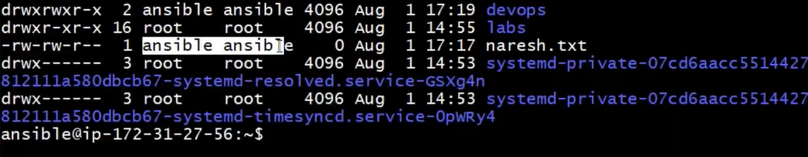
ansible all -i /home/ansible/myinv -b -m file -a “path=/opt/devops state=directory”
UC: You have a fleet of 100 servers and you want to run a command apt-get update in all 100 servers
# command module
ansible -m command -a “apt-get update” webserver
How to add user manually?
adduser <username>
cat /etc/passwd // user will be created
su <username>
How to create user using ansible?
ansible -m user -a “name= neeraj password=password generate_ssh_key=yes” webserver
Check in target
cat /etc/passwd
su neeraj
cd /.ssh
ls
id_rsa id_rsa.pub
Yaml
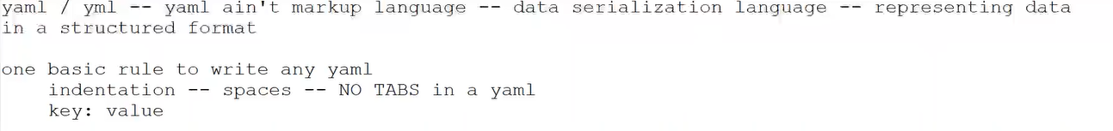
scalars: key: value
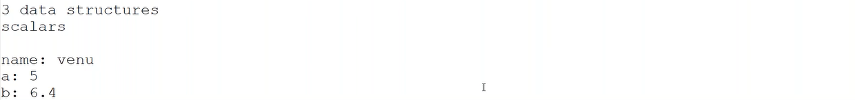
dictionary/map: holds multiple properties of an object
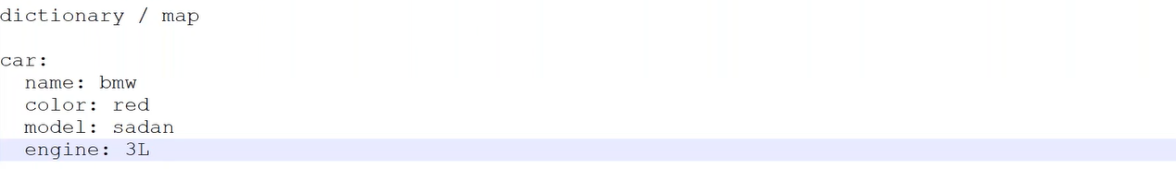
Array/list: collection of multiple objects
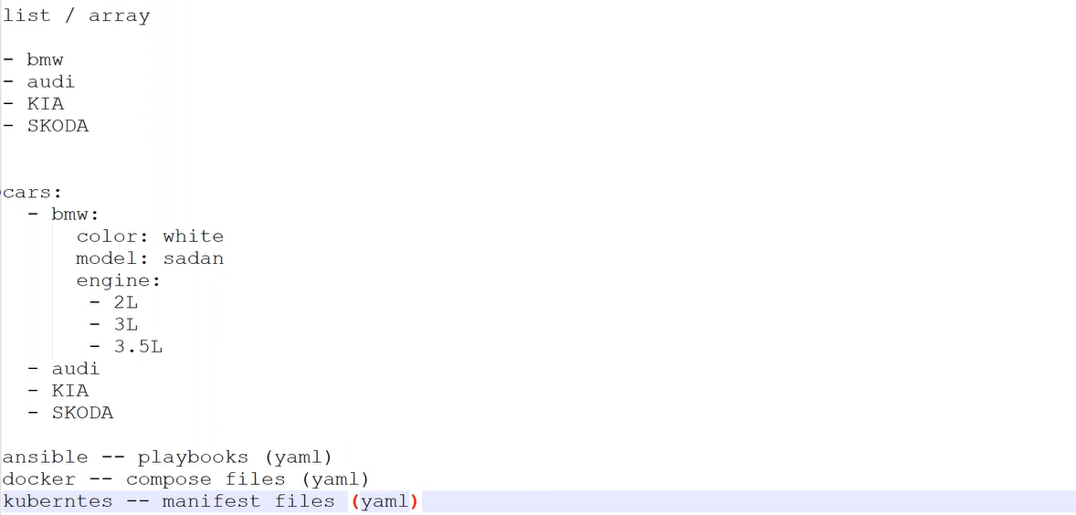

Playbook
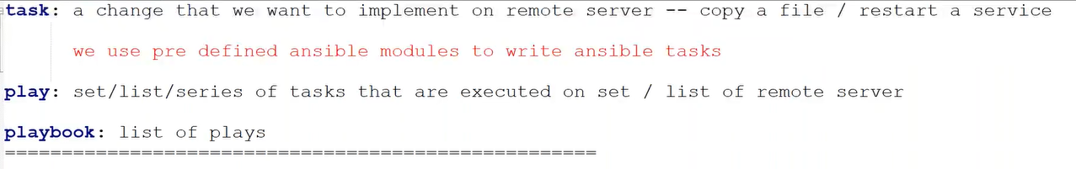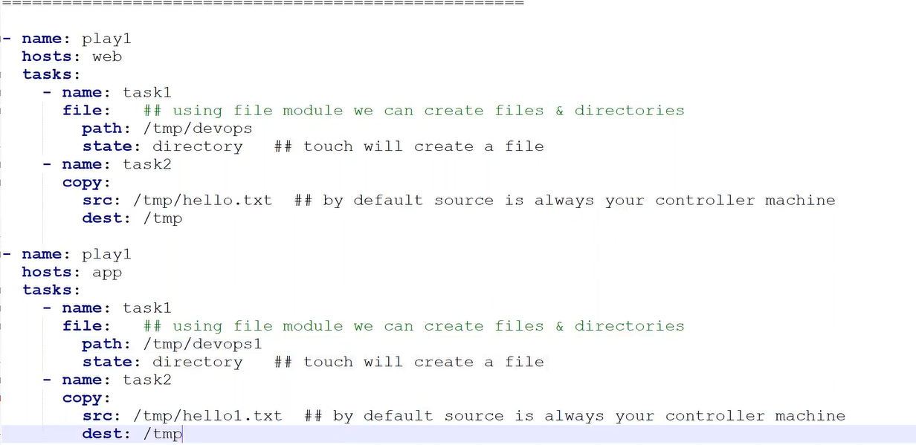 How to run playbook
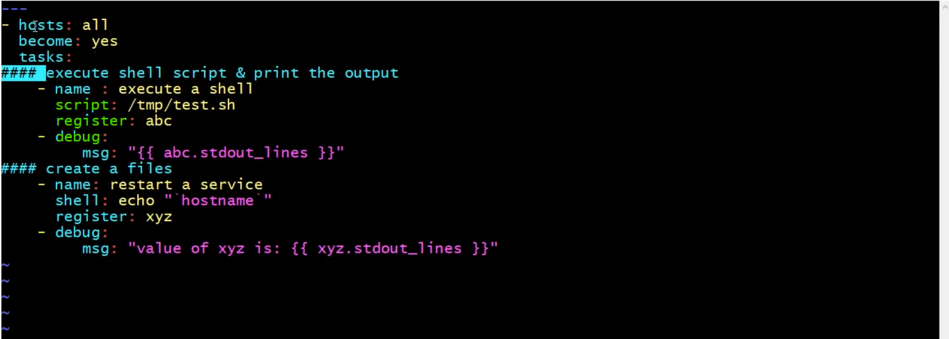
script module execute script

step1: nano /tmp/test.sh

chmod 755 /tmp/test.sh
register module -> stores the output of the previous script module
debug: display the contents of the variable “The value of variable: {{}}”
ansible-playbook <name of playbook. yaml> -i < inventory path>
It is serial execution, if one task fails it not starts another task
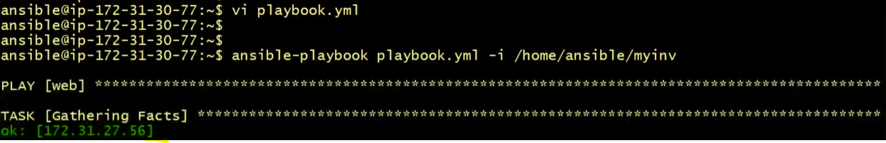
What are Facts?
Cached all the information about the target hosts, before performing any task on the target host ansible first tries to gather all the information about the target host (performance impact). During the execution keeps in cached memory once execution completes, it frees the cached memory.
Whenever ansible try to implement any change on the remote server, it will try to gather some information about the target server, that is called the Facts.
Conditions?
when: (ansible_distribution get from the gather facts)
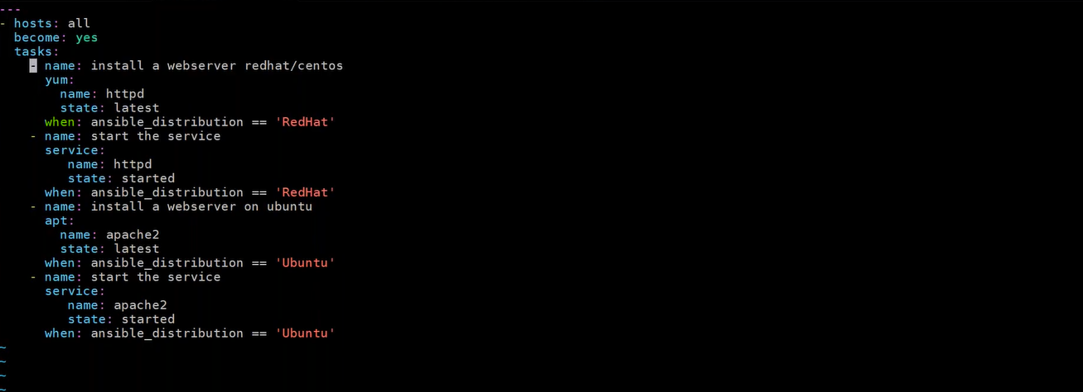
UC: we want to switch to ubuntu user not to the root user?
become_user: ubuntu
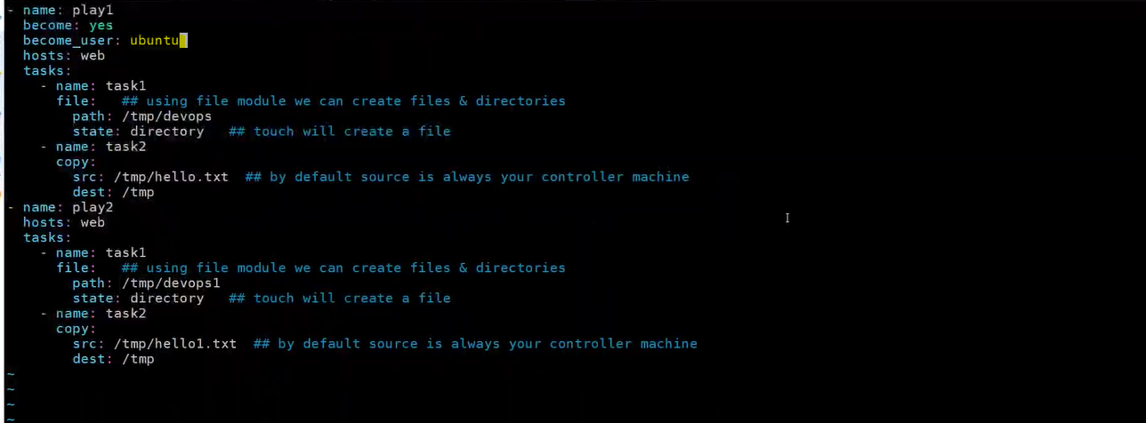

How to define variables?
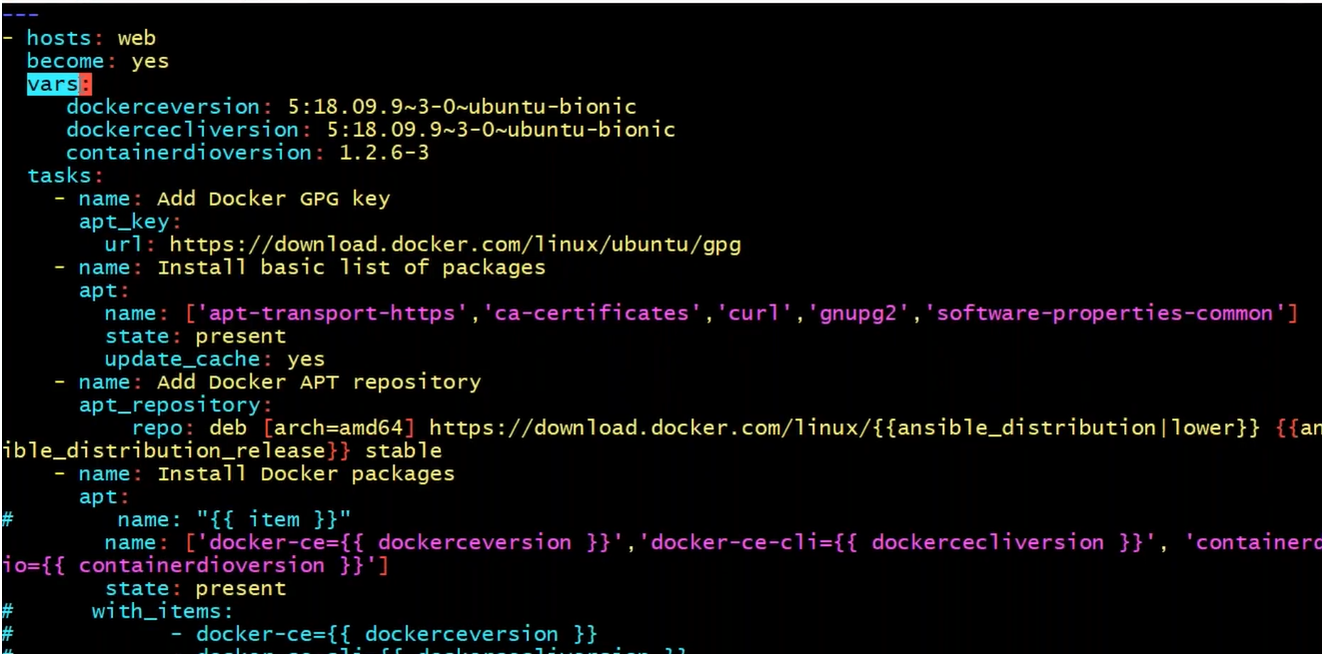
Looping?
[‘apt-transport-https’,’ca-certificate’,’curl’,’gnupg2’]
ignore_errors //module
Ansible Roles: split the bigger playbook in to smaller one
UC: reusability, breaking a playbook into multiple files. This simplifies writing complex playbooks, and it makes them easier to reuse.
Roles provide a framework for fully independent or interdependent collections of variables, tasks, files, templates and modules.
Roles are defined using the YAML files with a predefined directory structure.
Why Ansible Roles?
In ansible, the role is the primary mechanism for breaking a playbook into multiple files. This simplifies writing complex playbooks and it makes them easier to reuse.
Roles provide a framework for fully independent, or interdependent collections of variables, tasks, files, template and modules.
Roles are defined using yaml files with a predefined directory structure.
A role directory structure contains directories: defaults, vars, tasks, files, templates, meta, handler. Each directory must contain a main.yaml which contains relevant contents.
defaults: contains default variables for the role, variables in the default have the lowest priority, so they are easy to override.
vars: contains variables for the role, variables in vars have higher priority than variables in default directory
tasks: contains the main list of steps to be executed by the role
files: contains files which we want to be copied to the remote hosts. We don’t need to specify a path of the resources stored in this directory.
templates: contains file template which supports modifications from the role. We use the Jinja2 templating language for creating templates
meta: contains metadata of role like an author, support, platforms, dependencies.
handlers: contains handlers which can be invoked by ‘notify’ directives and are associated with the service.
task is the mandatory folder
step1: create a top-level directory
mkdir roles
cd roles
step2: create an automation for role(tomcat)
mkdir tomcat
cd tomcat
step3: create a pre-defined folder structure
mkdir tasks // mandatory folder
cd tasks

step4: mandatory yaml (main.yaml)
touch main.yaml
Instead, or writing multiple tasks in main. yaml, write multiple .yaml files within the tasks folder, and call that file from the main.yaml (tasks folder).
touch install.yaml
touch uninstall.yaml
step5: how to execute this automation, as a single playbook? To call the entire automation called tomcat, we need to write a top-level file
step5.1: write a top-level file, resides one level above the roles
vi tomcat-role.yaml

Instead of tasks, we need to call the role
step6: how to call remaining configuration (.yaml files)?
top level <tomcat-playbook.yaml> will only executes the main.yaml of the task folder then how to call other .yaml files?

Using the include_tasks, here we face same problems all the tasks will be executed in sequence, means still we have a large playbook.
step7: condition
Solution: Using the conditional execution using the environment variable(action)

Without passing the action variable?
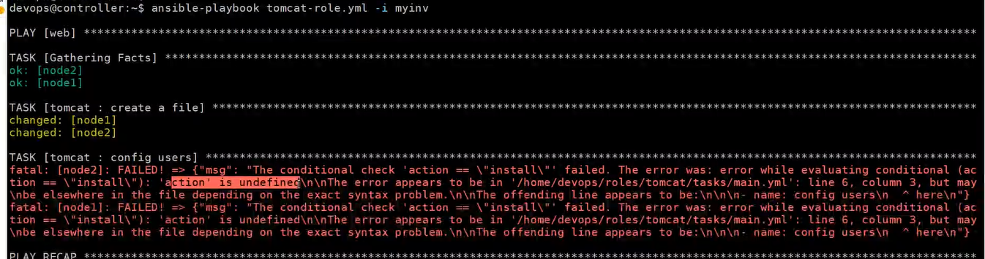
step7.1: How to pass the action (condition check action)
How to pass the action (name can be any either action or trigger) variable? Action variable pass from the command line
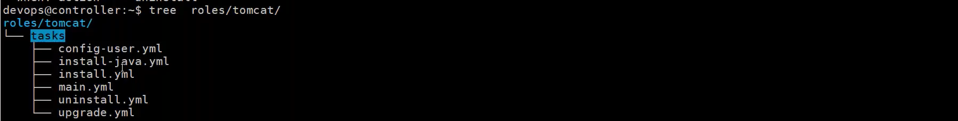
step8: default and vars
nano defaults/main.yaml // define your variables
nano vars/main.yaml // define your variables
vars have higher precedence over the default
step8.1: How to call these variable? (Within any .yaml e.g., main.yaml)
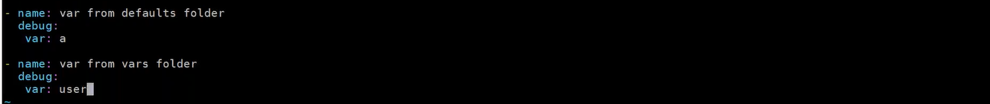
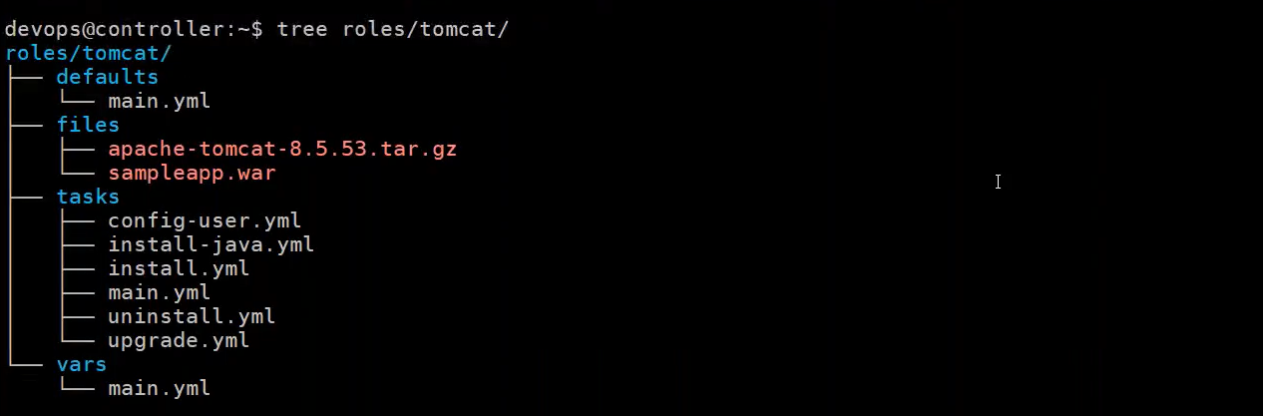
command line will take highest precedence.
step8: files
files: copy the files which you want to copy in target server
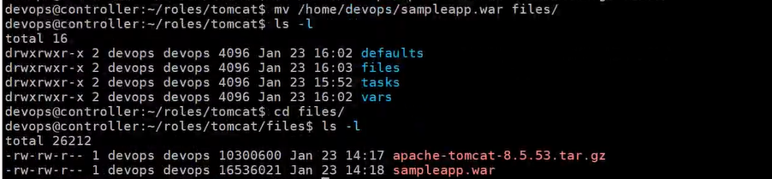
structure: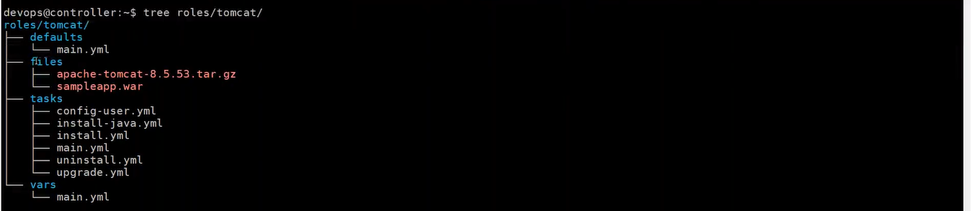
step9: templates (blue print)- host specific data (Jinjer templating)
cd templates
vi app.props
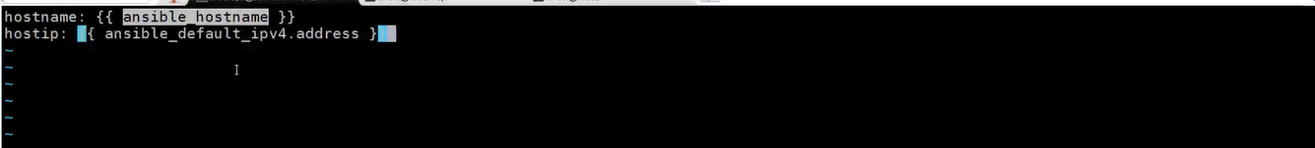
step9.1: How to call these templates? (Within any. yaml e.g., main. yaml)
From where we will get the variables?
/* before executing a command on the host first ansible gather the facts */
How to execute on the host
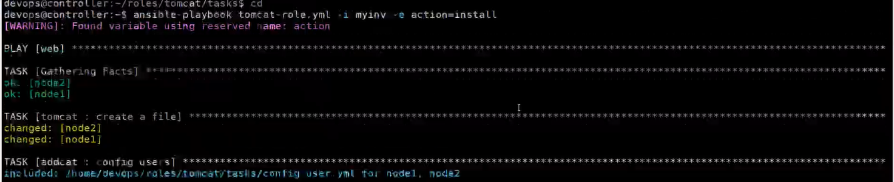
Validate
In node1
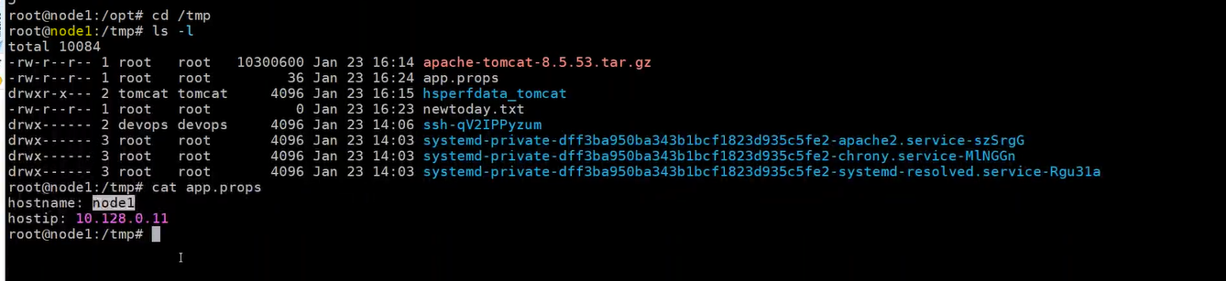

In node2
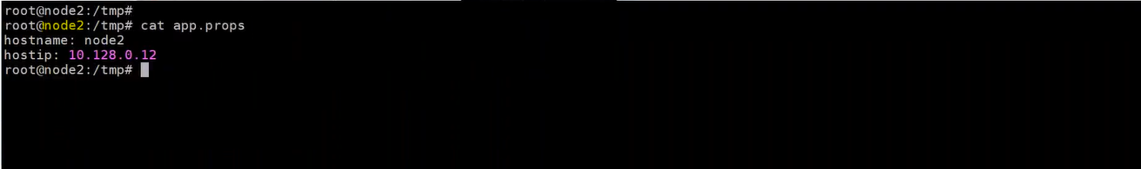
step10: handler (special tasks) which called through the notify
notify
purpose: repetitive/dependent tasks
nano /handler/main.yaml
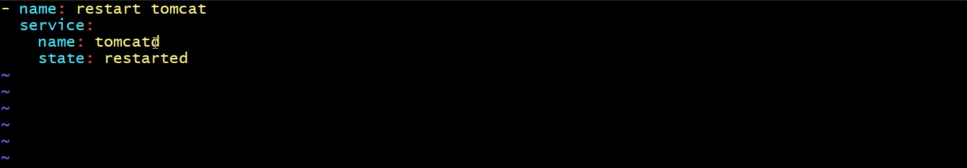
step10.1: How to call
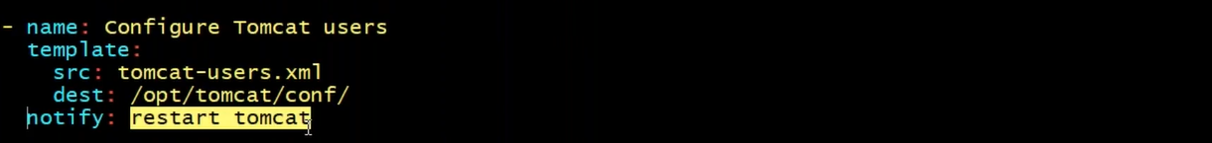
notify: name of the handler task
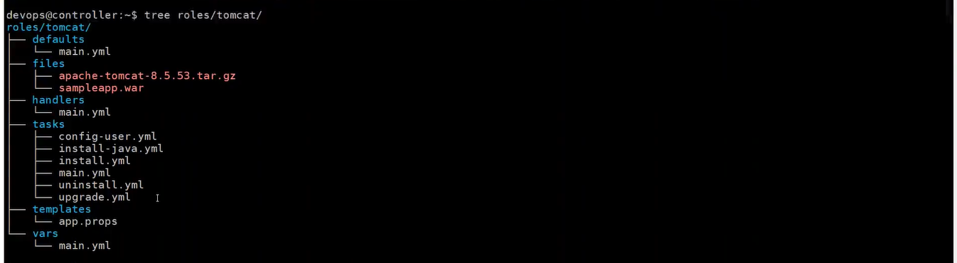

How to generate role structure automatically
ansible galaxy
cd /roles
ansible-galaxy init <automation name/docker>
ansible-galaxy init docker
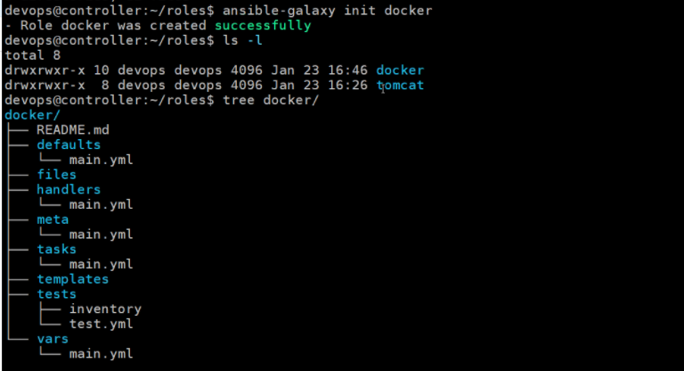
ansible-galaxy has a repository, (galaxy.ansible.com), can share our automation
ansible-galaxy install <role directory>
galaxy.ansible.com # just like docker hub

What is Ansible Vault?
Encrypt the ansible playbook (AES250)
Ansible allows keeping sensitive data such as password or keys in encrypted files, rather than in plaintext in your playbook.

UC1: Encrypt the playbook at time of creation.
step1: create a new encrypted playbook
ansible-vault create <vault>.yaml # as we enter ask for password
step2: edit the encrypted playbook
ansible-encrypted edit <vault>. yaml
step3: change the password
ansible-vault rekey <vault>. yaml
UC2: Encrypt the existing playbook.
step1: Encrypt the existing playbook
ansible-vault encrypt <target>.yaml
step2: decrypt the encrypted playbook
ansible-vault decrypt <target>. yaml

