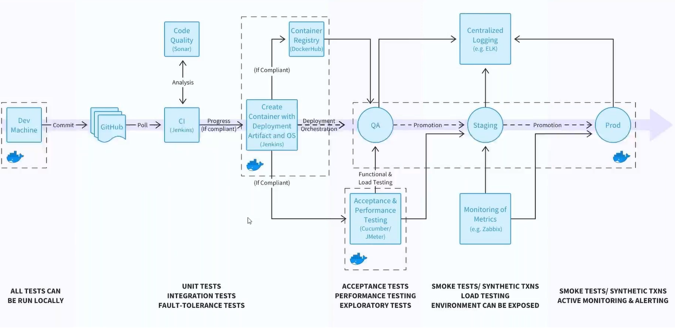
The output of CI => artifact (.war).
How to create docker image with the .war, and how to push it to the dockerhub
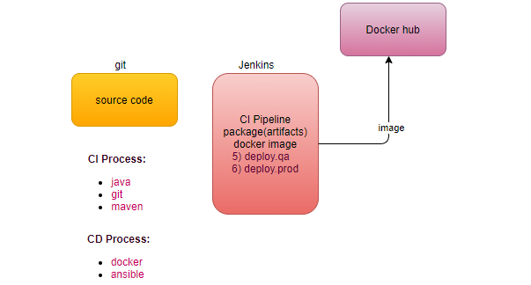
Continuous Delivery Process
Integrate with docker -> create image
Integrate with ansible-> deploy in different environments (Environment is a group of servers).
pre-requisite-> Before deployment our environment must be ready.
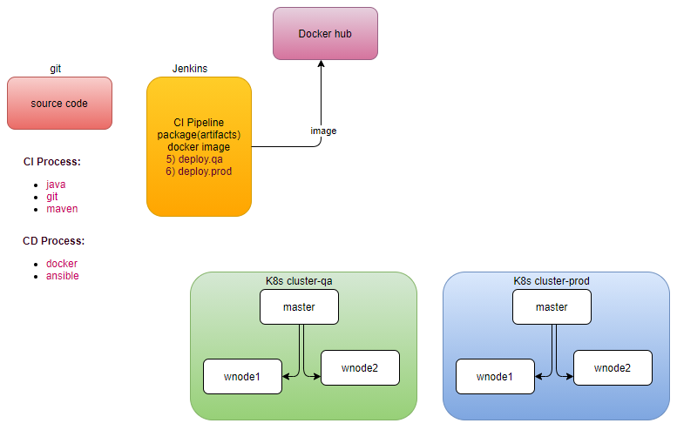
Note: Jentink’s its self doesn’t login just trigger ansible to login into k8s master.
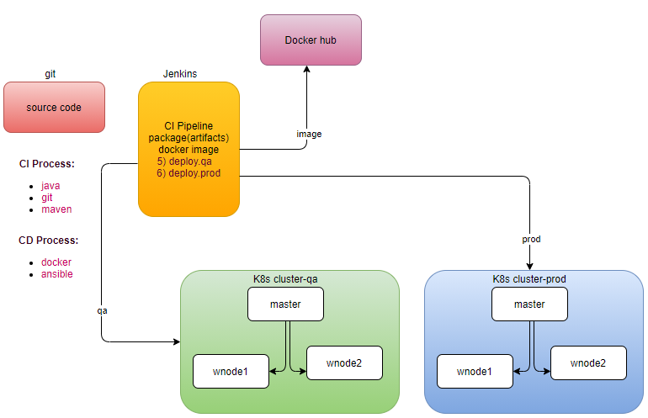
build docker image
step1: integrate docker with jenkins
step1.1: Install docker on the jenkins machine, just like we installed maven.
step1.2: Can jenkins run docker commands? Permission denied
step1.3: by default, jenkins runs the job as a jenkins user, whereas docker run as user root (access O/S kernel), means jenkins user doesn’t have root privileges
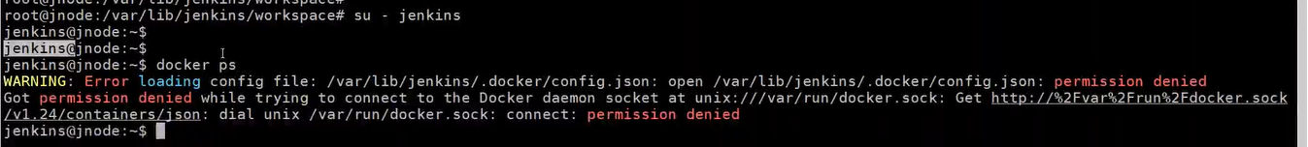
step1.4: su - jenkins
docker ps # permission denied
sudo docker ps # no sudoers
sudo docker ps # ask for password
step1.5: Give a Jenkins user sudoers privilege, or add jenkins user in the docker group.
/etc/sudoers
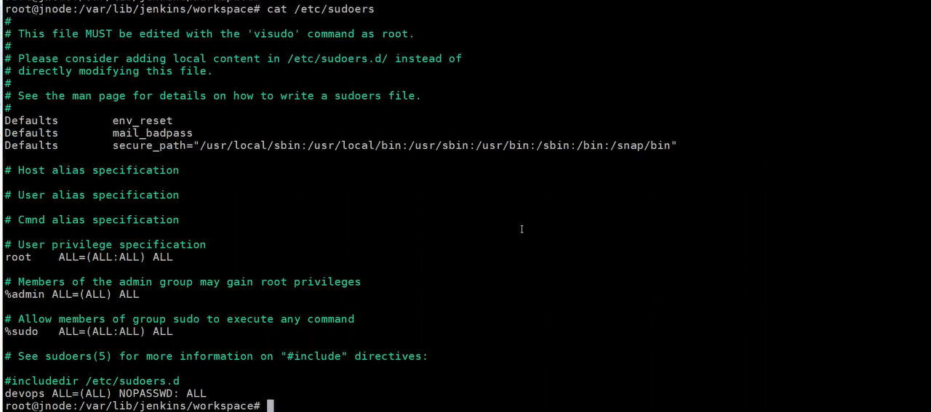
visudoers
service jenkins restart # service command always execute as a root user
now jenkins user can execute docker command as sudo
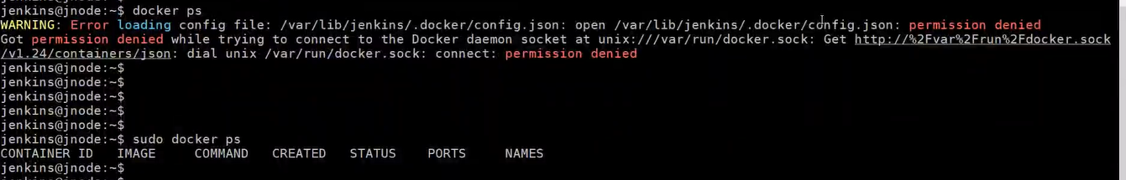
Validate:
re-login in to jenkins console
How to run docker commands from Jenkins’s console?
(shell script)
In the package job
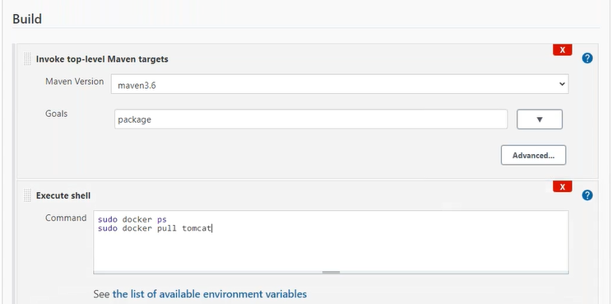
How to build an automated process?
Dockerfile
Where docker clones the repository, under the workspace
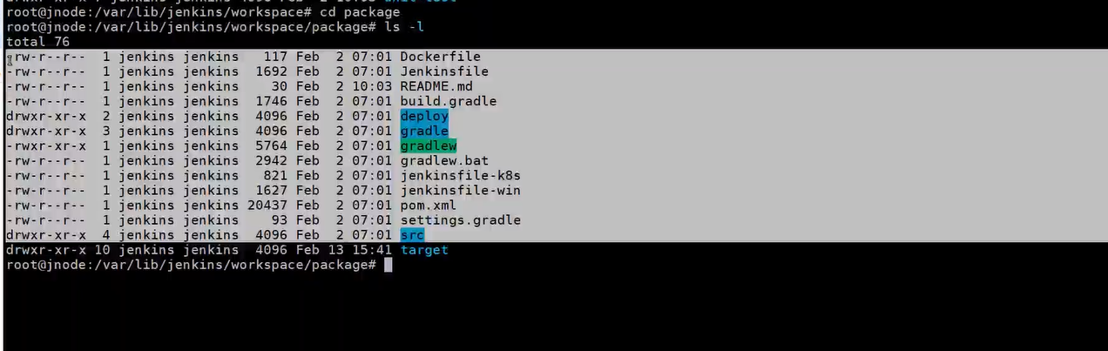
step1: In the package job
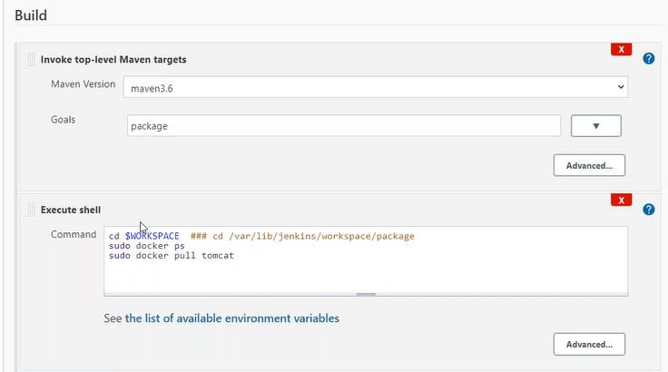
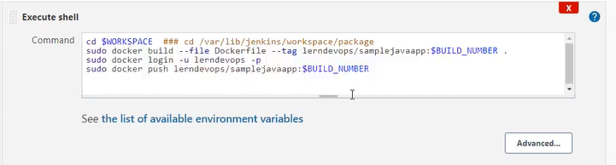
/*
#!/bin/sh
WORKSPACE=/var/lib/jenkins/workspace/package
cd "$WORKSPACE"
$WORKSPACE ##cd /var/lib/jenkins/workspace/package
sudo docker build --file Dockerfile --tag neerajvohra/samplejavaapp:$BUILD_NUMBER .
sudo docker login -u neerajvohra -p $Docker_Hub_Pass
sudo docker push neerajvohra/samplejavaapp:$BUILD_NUMBER */
step1.1: How to encrypt password?
Manage Jenkins-> Manage Credentials # plugin Credentials
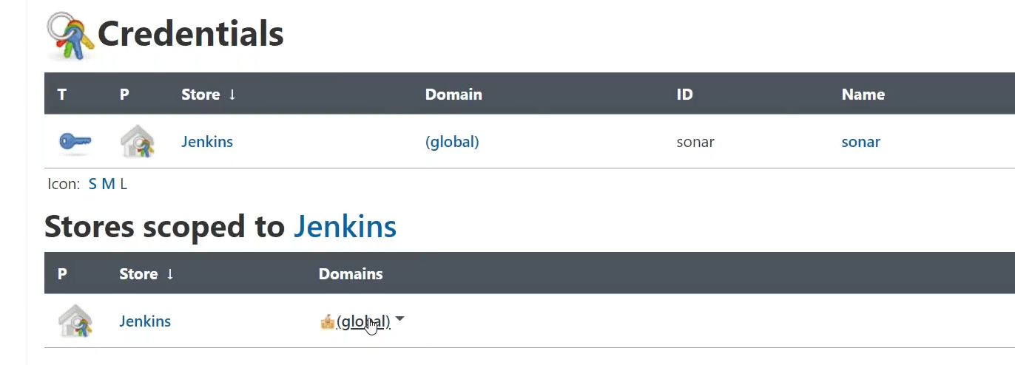
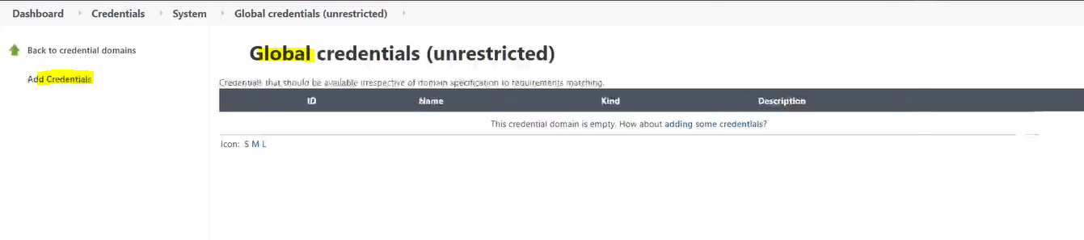
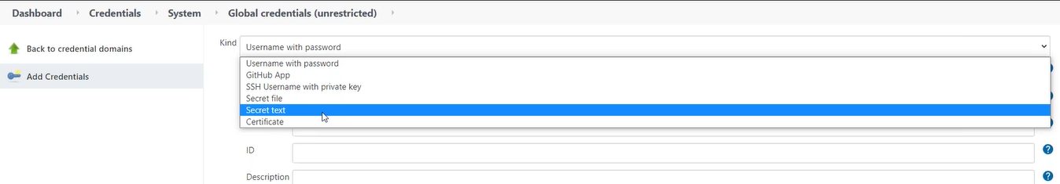
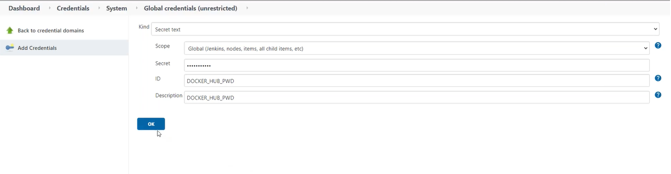
step1.2: How to get my credentials in my Job
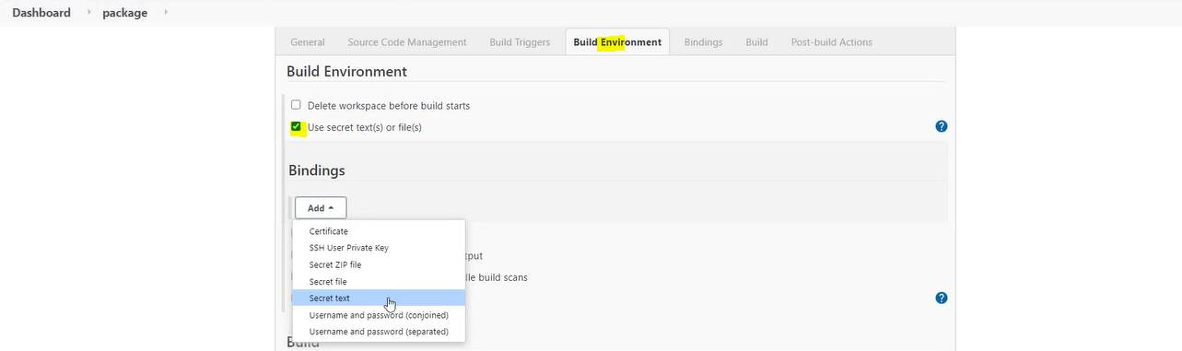
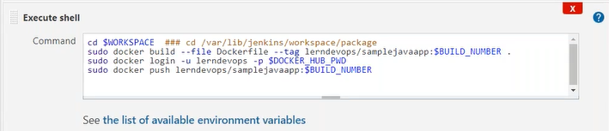

How Integrate Ansible with Jenkins?
step1: setup the environment (k8s cluster)
step2: Jenkin can’t log into master servers, will use ansible as a configuration tool to invoke the k8s client, we have to integrate ansible with jenkins
step2.1: If jenkins invoke ansible playbook or modules, install ansible on the same machine in which jenkins server is running.
step2.2: now we can call this machine is as an ansible controller, how controller identify the target servers (k8s master)? Inventory
step2.3:
su – devops # switch to devops user
vi myinv
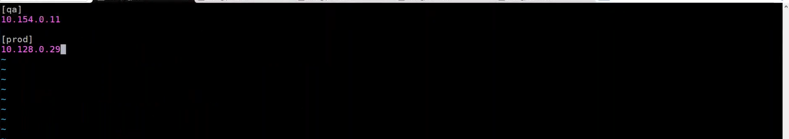
step2.4: Now we need connection also, with username and password or username and sshkey. If we go with username and password then we have to again go with jenkins console.
step2.5: configure ssh keys
step2.5.1: generate ssh for ansible controller
ssh-keygen
ssh-copy-id devops@<ip of target masterqa>
ssh-copy-id devops@<ip of target masterprod>
step2.5.2: validate
ssh devops@<ip of target masterqa>
ssh devops@<ip of target masterprod>
ansible all -i myinv -m ping
step3: create a new job -> freestyle deploy-qa
step3.1: where is my playbook?
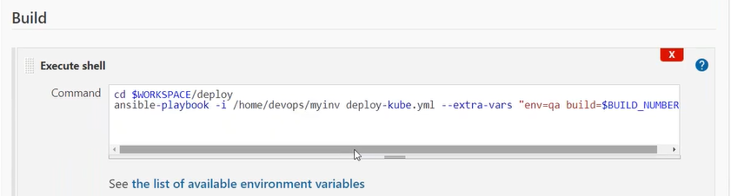
$BUILD_NUMBER: must be from previous section.
How to pass environment to next job? We have to add plugin build with parameter #CREDENTIAL_BINDING
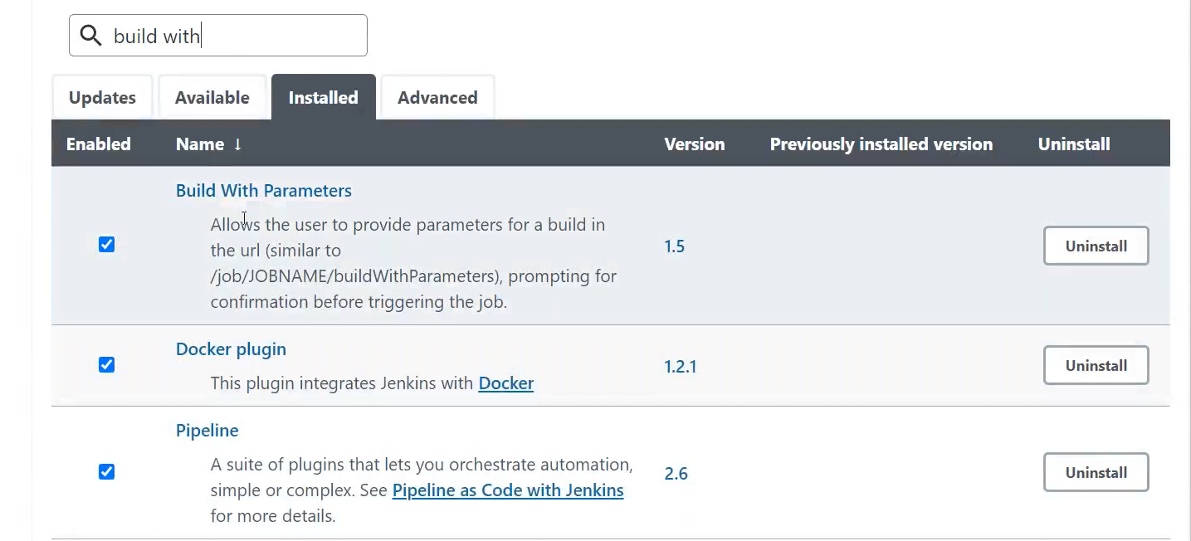
Step4: Go to the source job (package)
Add post-build-action-> Trigger parameterized build on other projects.

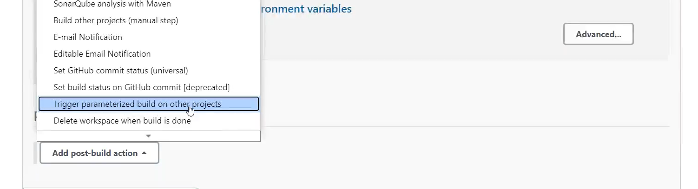
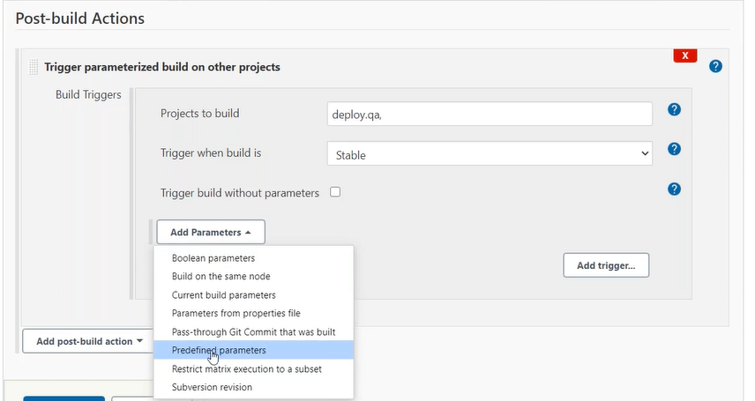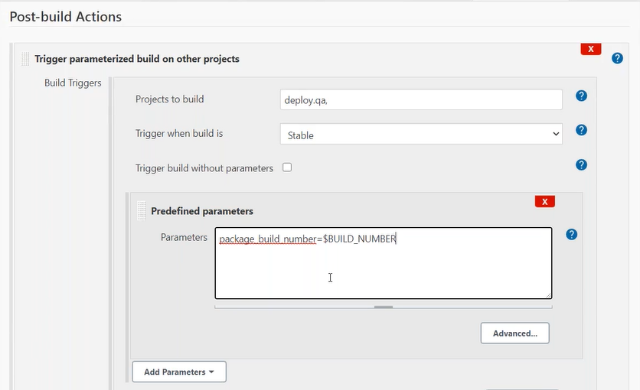
Step5: Go to the target job (deploy-qa)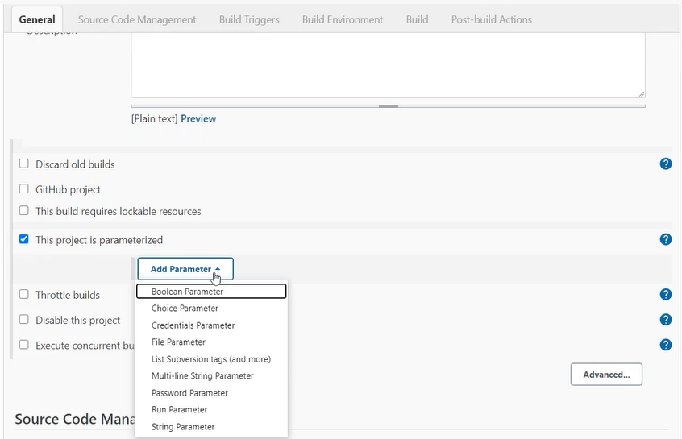 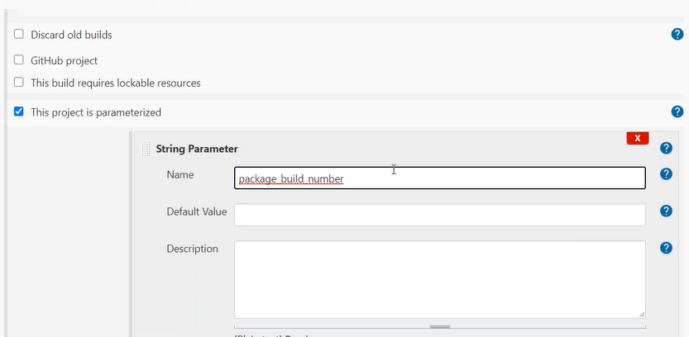 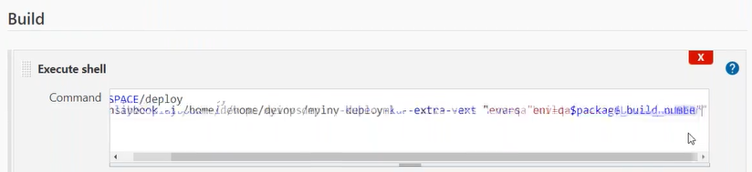
/*#!/bin/sh
WORKSPACE=/var/lib/jenkins/workspace/ApplicationDeploy/deploy
cd "$WORKSPACE"
sudo su devops -c "ansible-playbook -i /home/devops/myinv deploy-kube.yml --extra-vars='env=qa build=$package_build_number'" */
permission denied, ansible command is running as a jenkins user.
We have shared the ssh key for devops user but not for ansible user.
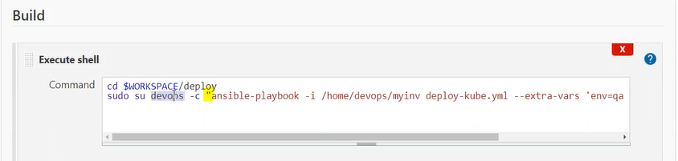
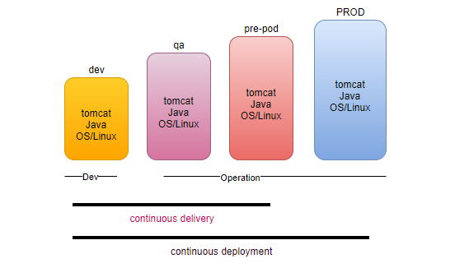
Continuous delivery is automated, with a single click our application available for QA.
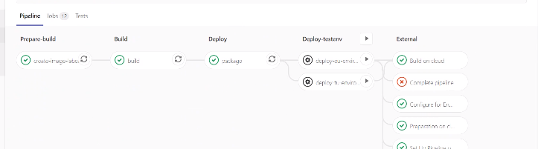
How to create job deploy-prod, pass the variable from deploy-qa
Cloud provided devops tools.
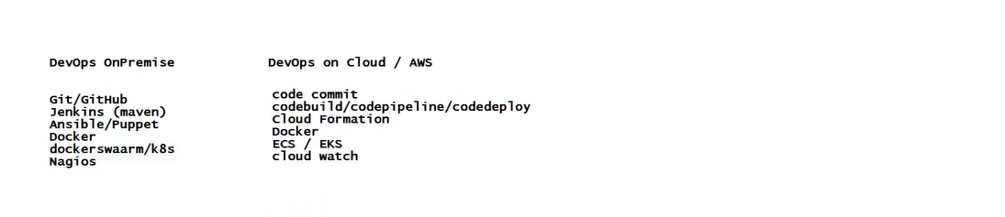
- DevOps is a mindset, adapt the changes quickly and work on that.
- It’s a collaboration with various team. The way you implement, using various tools.
- Deliver your application in the market quicker ASAP.
- Adapting the new tools and technologies.
