Before Container: Pre- configuring our application environment and then deploying our code.
Problem Statement: Application is running fine in development environment but not working in QA environment.
Reason:
- Different versions
- Dependencies
.
How to ship application in to different environment,
Environments (o/s, java, and tomcat) must be ready before deploying the artifacts (.war), we just move artifacts from one environment to another environments.

We are just moving artifacts (.war) from one environment to another environment what about dependencies? E.g., OS version, Java version and tomcat version, servers may have inconsistent configuration due to which application is running in one environment but no other environment.
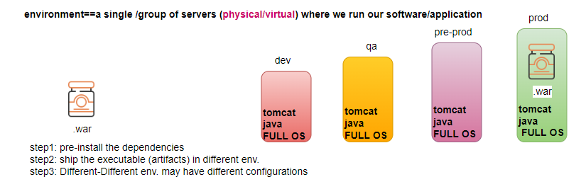

Solution? Container
Container: Is a package that consist of an app/software + all of its dependencies bundled together and deliver this package different environments
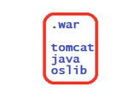
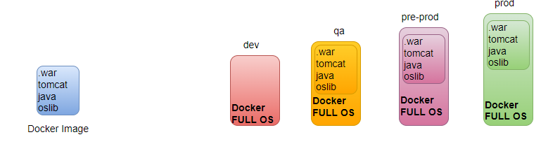

How to build and run the container?
What is the tool used to build .war (MAVEN), we convert the source code into a single executable file, similarly we need a tool to create a package (bundle artifacts and its dependencies in a single package) i.e., a containerization tool/container run time
- helps to build container package (Image)
- helps to run/deploy the containers
ex: docker/containerd/lxc/rocket/crio/podman
Docker is a tool help us BUILD the container->SHIP the container in different environments-> also RUN the package as a container.
Technically package is called the docker image, run time instance of the image is container. We can create multiple instances from a single image.

Docker Image:
- Is a software package sitting on your disk using the disk space
- We copy the image/ install on server
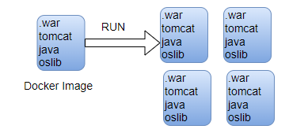
Docker Container:
- Container is runtime instance of an image.
- Container is just a process that run inside your computer/ server (physical/ vm) and consumes the resources (cpu/ram).
- From a single image we can run n number of containers

Docker-Architecture
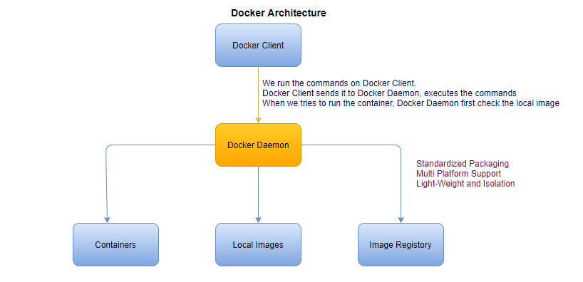

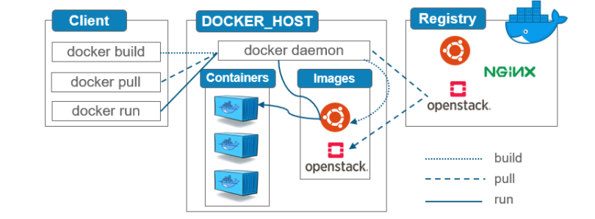
The docker client and daemon run in separate environments

How docker really works behind the scenes?
- Namespace is responsible for isolation b/w the containers. Type of namespaces are PID, n/w, User, filesystem and so on (processId)
- Cgroup is responsible for resource management or resource limitation in each container CPU, mem, Network and I/O.

Difference between Physical, VM and Container
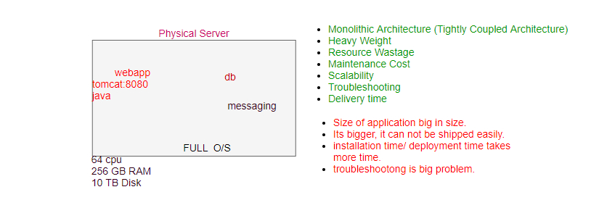

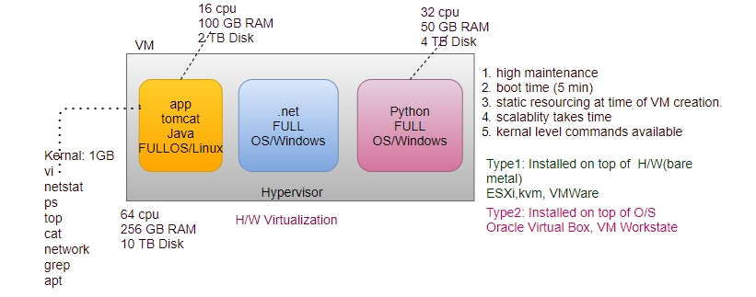

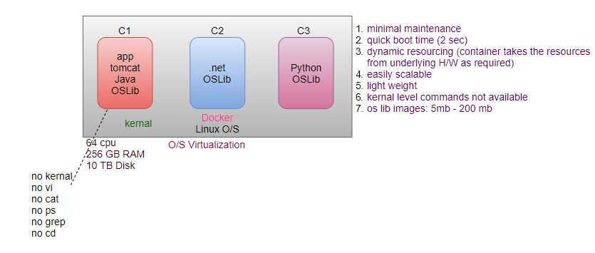

In VM, we split the H/W resources in smaller pieces, Every VM provided a set of dedicated H/W resources. (H/W Virtualization, O/S level Isolation)
Every VM have full O/S.
Every VM have own IP address.
To run a container we need a machine, with a Full O/S either a physical machine or a VM, on top of that install Docker.
Every container has own IP address.
O/S Virtualization, App level Isolation
Difference between Full O/S and O/S lib (don’t have dedicated kernel)?
- Minimum O/S (O/S lib) never requires license, they are open source and free.
- When we create a container, we don’t allocate any resource to the container, because container is just a process running on your system, and process can take any resources from underline H/W as required. It’s a docker which provides necessary resources to the container dynamically. Docker talks to the O/S kernal feature to provide the necessary resources to the container, then kernal talks to the H/W.

Installation
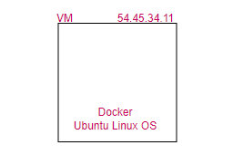
docker -v
/var/lib/docker
service docker status

To run a container what we need?
docker image: We will use some publicly available images from official docker image repository and run container from it.

Where we get the Images?
dockerhub to get the public images. Dockerhub has default account library.
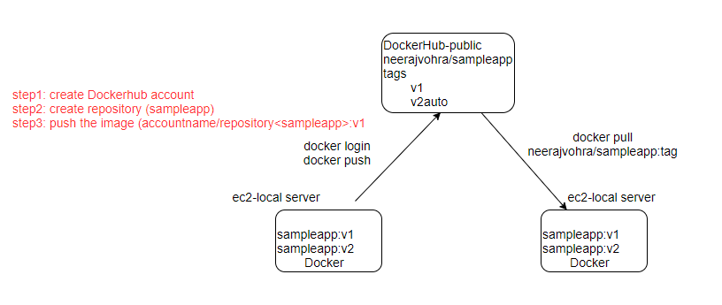
What is Docker Image?
- A docker image is a read-only template that contains source code, libraries, dependencies and set of instructions for start a container.
- docker image is immutable
What is Docker Container?
- container is running instance of the image.
- Every time you start a new container, an extra writable layer is created for it, where it stores the container specific changes.
- Changes are done on container, not on image (immutable)

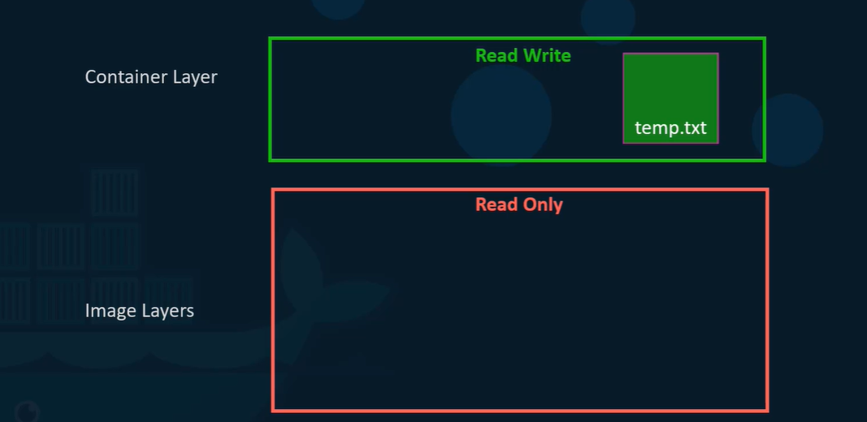
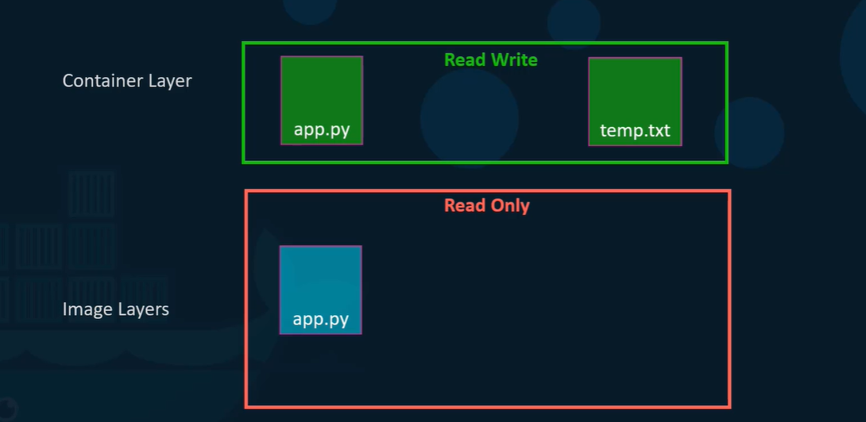
docker image ls # to see if there is any image in system
docker pull tomcat
docker pull nginx
docker image ls
/var/lib/docker
ls -l
docker image rm <ID>

How to run container from a given image?
To create/run a container from a given image we always use docker run command
Interactive mode (-it)/ foreground # default dev env
Whenever you want to interact with container O/S to validate what is inside? Or to make changes inside the container (dev use case)
docker run <image: tag>

detached mode(-d) / background
To run a container in background mode (production use case)
docker run -d <tomcat: latest>
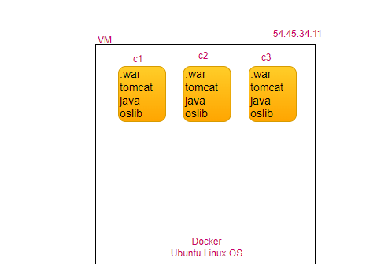
How to know status of the container?
docker container ls # docker ps all running container
docker container ls -a # all containers running and dead

docker run -it <image> bash
docker run -it tomcat:latest bash

How to get details of the container?
docker container inspect <container-id>

Container Lifecycle
- created
- running
- stop
- restart
- kill
- remove
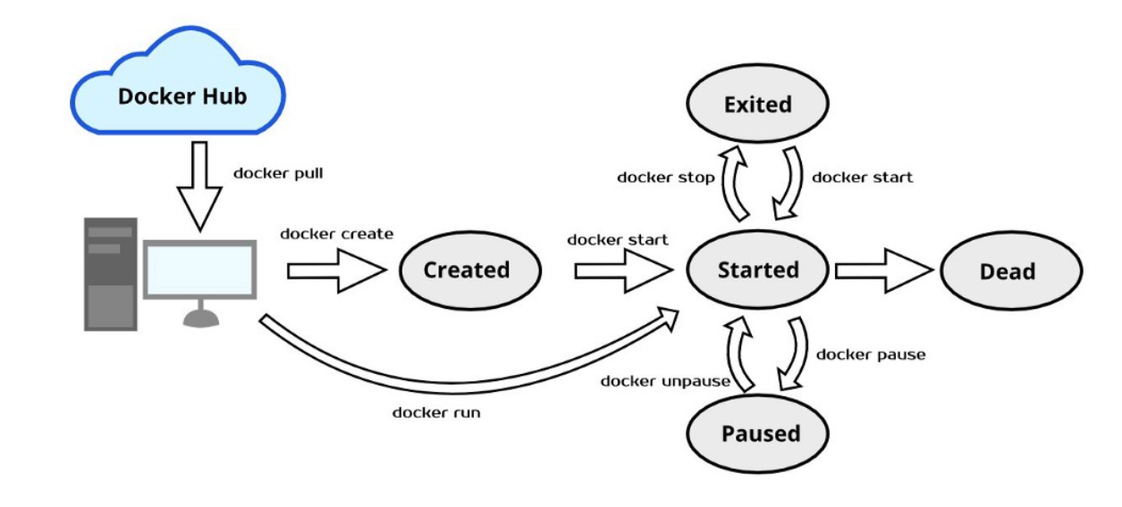

First create an Image, create a container from Image, container may be in running state or in exited state. If in running state can be stopped, restarted, kill can be removed.
docker run nginx # foreground
docker run -d nginx # background
docker ps # shows all running containers on your server
docker stop <CONTAINERID>
docker ps -a # shows all running/stopped containers on your server
docker restart <CONTAINERID>
docker kill <CONTAINERID>
docker rm -f <CONTAINERID>
docker stat # CPU/Memory Utilization
docker logs -f <CONTAINERID> # follow live logs
docker inspect <CONTAINERID> # detailed information of container bridge network, dynamic IP
/var/lib/docker/container
curl <IP> # command line browser
free
free -m

How to get inside the running container?
We can login to a container only if it is up, docker exec helps to login to a running container.
docker exec -it <containerId> bash

How to execute command inside the running container without getting inside?
docker exec <containerId> ls-l
docker exec <containerId> cat /etc/os-release
docker exec <containerid> java -version
docker exec <containerId> netstat
# Will fail (O/S lib, default features of O/S not available)

Why you want to go inside the container?
Want to customized, want to know version of java running inside tomcat container etc.
How to access the application running inside the container from the outside?
Port Publish
How to publish the port?
docker run -d -P <image> # P dynamically allocate the port
docker run -d -p 9090:8080 <image> #p <host>:<cont>allocate port statically

browser: vmip(ec2ip):port
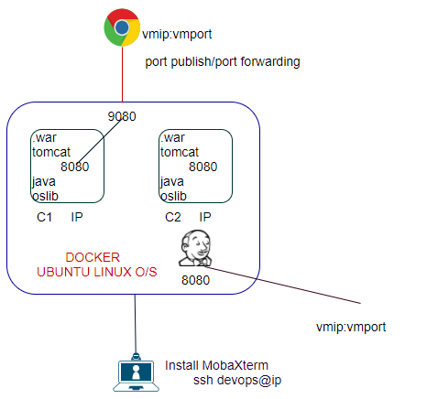

How to build own docker image?
- manual process
- automated process

Automated Process

- We write a script called Dockerfile
- Dockerfile is a plain text file without any extension.
- We will use some pre-defined dockerfile Instructions given by Docker e.g., FROM, RUN, COPY, ADD... etc.
- dockerfile Instruction is a single word and must be written in CAPITAL letter.
- Every line in dockerfile must start with dockerfile Instruction only

FROM: start a new build stage and sets the base image, usually, must be the first directive in the Dockerfile.
RUN: creates a new layer on top of the previous layer by running a command inside that new layer and committing the changes.
give instructions to the docker, docker runs these instructions within the container while preparing an image.
COPY: copy files from the local machine to the image.
ADD: same as COPY, additionally It can also copy files and directory from remote URL and also can copy the .tar file inside the container untar it in one shot.
CMD: default instruction Will be executed when container start from the given image, if someone wants to overwrite, the CMD instruction defined in the docker file, can be done at run time by passing another CMD.
FROM tomcat:8.5.40 # <accountid>/repository/tag
COPY target/sampleapp.war /usr/local/tomcat/webapps
EXPOSE 8080
CMD /usr/local/tomcat/bin/catalina.sh run
RUN touch /tmp/neeraj.txt
docker build -f Dockerfile --tag myImage:tag context (path)

nano Dockerfile
FROM tomcat:8.5.46 # pull the image, run as container, login into the container
RUN apt-get update
RUN apt-get install -y vim
RUN wget https://github.com/lerndevops/code/raw/main/sampleapp.war -P /usr/local/tomcat/webapps
docker build -f Dockerfile --tag sampleapp:v2 /root # in which directory Dockerfile available (context)
docker image ls
docker run -d -P sampleapp:v2

UC2:
step1: download tomcat, jdk, myapp.war in root directory
step2: nano myapp
FROM ubuntu:18.04 # pull the image, run as container, login into the container
# ADD instruction extracts/unzips the tar/zip files and copies the extracted contents to container
ADD jdk-8u331-linux-x64.tar.gz /tmp
RUN mv /tmp/jdk1.8.0_331 /opt/java
ADD apache-tomcat-9.0.63.tar.tz /tmp
RUN mv /tmp/apache-tomcat-9.0.63 /opt/tomcat
ENV JAVA_HOME /opt/java
ENV TOMCAT_HOME /opt/tomcat
ENV JAVA_VERSION 1.8
ENV TOMCAT_VERSION 9.0.63
COPY myapp.war /opt/tomcat/webapps/
# ADD Instruction can also be used to download the file from given URL
# RUN wget https://github.com/lerndevops/code/raw/main/sampleapp.war -P #/usr/local/tomcat/webapps
ADD https://github.com/lerndevops/code/raw/main/sampleapp.war /opt/tomcat/webapps
# docker image inspect tomcat:9.0.63, sets the default port for the container that it helps docker to #publish the ports when you use -P
EXPOSE 8080
# The purpose of whole image creation is to start tomcat process when someone run the image
#helps to set default command for a image to execute when someone run image as container
CMD [“/opt/tomcat/bin/catalina.sh”,”run”]
docker build -f myapp --tag myapp:v1 /root
docker image ls
docker run -d -P myapp:v1

/*
https://mirrors.estointernet.in/apache/tomcat/tomcat-9/v9.0.40/bin/apache-tomcat-9.0.40.tar.gz
FROM ubuntu
RUN apt-get -y update
RUN apt-get -y install openjdk-11-jdk wget
RUN mkdir /opt/tomcat
ADD apache-tomcat-9.0.40.tar.gz /tmp
RUN mv /tmp/apache-tomcat-9.0.40/* /opt/tomcat/
COPY myapp.war /opt/tomcat/webapps
EXPOSE 8080
ENTRYPOINT ["/opt/tomcat/bin/catalina.sh", "run"]
*/

