Monolith: all components/modules in one single main component
Monolith application (eCommerce Application)
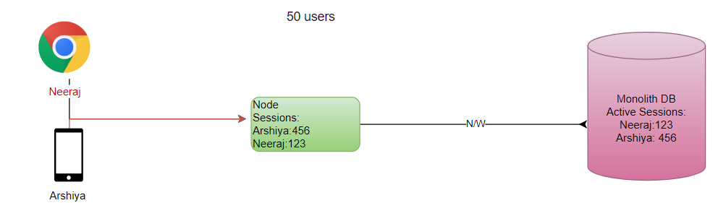

UC: Work load Increasing?
Adding more nodes: Horizontal Scaling
Adding more capacity (H/W): Vertical Scaling (SPF)

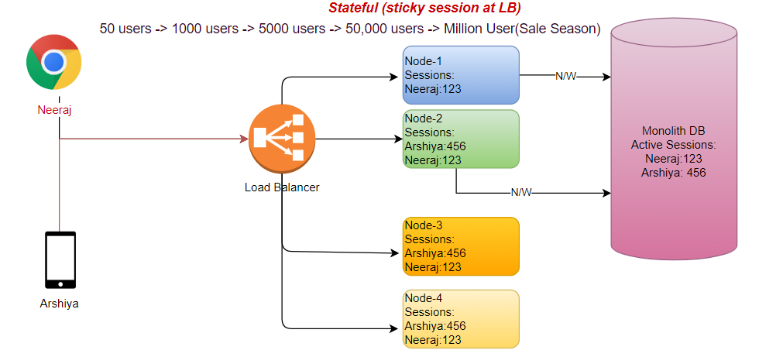
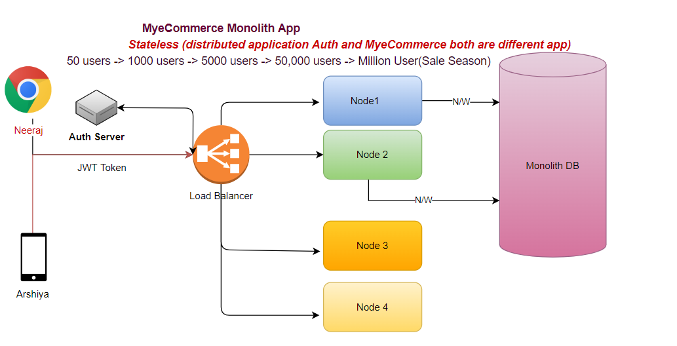
- No session management (using tokens user authenticate/authorization)
- Every request has enough info to process the request.

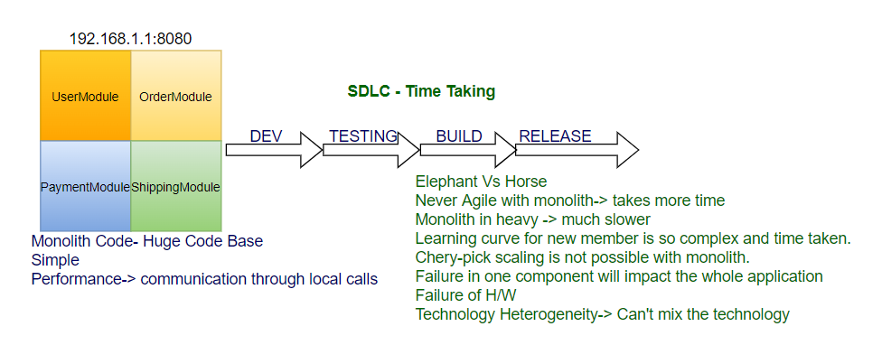
SOA: Service Oriented Architecture
service: task that achieves a functionality
ESB: Enterprise Service Bus (SPF)
- Routing
- Security
- Transformation
- Orchestrating

Microservices: Also known as the microservice architecture- is an architectural style that structures an application as a collection of services that are
Difference between Architecture of Monolith/ Microservice.
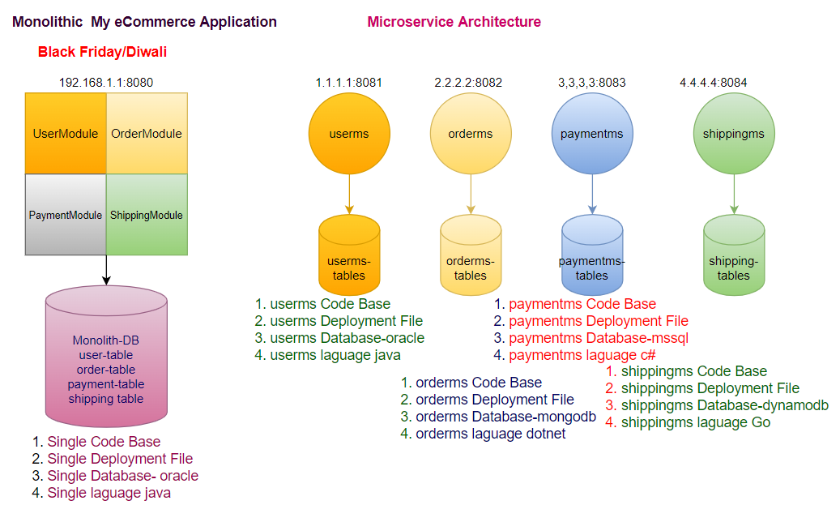

Pros of Microservice:
- Scaling + Cherry pick
- Agility-1 Development fast
- Agility-2 Build fast
- Agility-3 Testing faster
- Agility-4 CI/CD
- Agility-5 Release Faster
- Resiliency
- Distributed Nature (Service Load Distribute)
- Distributed Database Load
- Technology Heterogeneity
- Database Heterogeneity
- Security through Segregation-reduce surface area of attack

Cons of Microservice:
- Latency between ms
- Distributed Data Access (Aggregation/TX Management)
- Complexity in Managing Nodes (servers +DB)
- Cost (Infra+ Developers/DBA)
- Monitoring
- Tracing
- Testing
Building Blocks of Microservices:
- Single Responsibility Principles (High Cohesion)
- Domain Driven Design- Bounded Context
- Communication Synchronous/Asynchronous

Design and Implementation of Microservices?
- The design of microservices basically follows 12 factor principles:
- The implementation of microservice will be developed using spring boot framework:
Microservices 12 factor principles:
- Single Code base per microservices for all environments (dev, test, prod)-Git
- All application should bundle their dependencies along with application bundle - Maven
- Externalize configuration using Configuration Server - Springboot (GitHub)
- All backing services should be accessible through an addressable URL
- Strong Isolation between build, release and run ,e.g. DevOps, CI/CD
- The application should be stateless for high fault tolerance (JWT-session data at client side)
- A service able to tolerate fault (Replication)
- Expose service using port bindings
- Services should be scale out with concurrency
- Building applications with minimal startup and shutdown times
- Keeping all environment Identical as Identical as possible.
- Centralized logging for the microservices (Splunk, ELK, EFK (Fluent Bit))
  - Logstash- parser, agent
  - Elasticsearch- Storage
  - Kibana- Visualization

Spring Boot:
- microservices is not technology specific
- microservice in java can be easily implemented using spring boot
Spring Framework:
Inversion of control:
Factory Design Pattern: take care responsibility of object creation
Application don't take responsibility of object creation; container creates object at run time and give to application.
Objects are created by container with configuration define and give to the application
dependency injection:
Dependent Objects Injected automatically
Spring Core (IOC/DI)- Business Logic
What is springboot:
UC: Develop a webservice/webapp/microservices using spring mvc/spring Rest and JPA.
- Decide which versions of spring mvc, jpa, hibernate to use.
- Which version of jms(activemq)/amqp (RabbitMQ), if application uses messaging systems
- Spring security compatible versions.
- We need to define the configurations (beans/objects) to be created, define the wiring (dependency injection), application context (spring container creates objects-ioc)
- setup hibernate in data layer, creates beans/objects to create hibernate session factory (like connection factory which gives the database connection objects
- setup logging frame work
- setup caching
- setup monitoring and health check-up
- decide the application server to deploy the application/webservice/microservice
- BUSINESS LOGIC to accomplish all the business requirements.
If you go with spring boot framework efforts reduced by 25%:
Springboot is built on spring only, and spring is built on java.
Springboot is not alternative to spring mvc/spring rest/spring security/spring data
Springboot uses underneath spring modules and make developers tasks easier and faster in setting up framework.
In a summary, spring boot makes easy to create stand alone, production grade spring-based applications that we can just run
@Configuration
@ComponentScan
We are telling to spring container in the @Configuration class to create the objects of the classes that are annotated with @Componenet with the help of @ComponentScan
@Autowired - for dependency Injection where application contexts contain spring beans through ioc
REST->: Architecture Style of web service which follow http methods
Restful Webservice:
restful api:
api: piece of code that is exposed where the other piece of code can connect
REST-it works on the top of HTTP protocol
- Mainly client-server-based communication
- Client calls the REST API that hosted on the server and server sends the response back
- Key concepts:
  - Resources and url's
    - Resource: The Object or the entity
    - URL: path location of the resource
HTTP Methods:
- GET: http method where client reads data from rest api
- POST: http method where client inserts/creates/sends data to rest api
- PUT: http method where client updates data to rest api
- DELETE: http method where client deletes data through rest api
@Controller- endpoint
@Service- business logic
@Repository - DAO
Springboot:
- With Springboot we can eliminate the dispatcher servlet registrations, @EnableMvc.
- We don't need separate tomcat server, spring boot comes internally with embedded tomcat server
- start.spring.io
- spring initializer creates project template (2.7)
- Spring Web - dependency pom.xml generated by Initializer
- spring boot comes with starter
- @SpringBootApplication=@Configuration+@ComponenetScan+@EnableAutoConfiguration
Springboot main features:
- Auto Configuration
- Starter Packs with version management
- tomcat server (embedded)
- provides quicker development, comes with more than 40 different starter modules, these starter modules provide integration libraries to many frameworks such as a database connection, webservices, logging, testing libraries (Mockito,), Logging, Template rendering. e.g., for web and mvc related pack is spring-boot-starter-web, for data and jpa, the starter related pack is spring-boot-starter-data.
- When you build a project, when we need to build a spring boot with mvc, security, jdbc then we just add
  - spring boot parent module-2.7.0
  - spring-boot-starter-web
  - spring-boot-starter-jdbc
  - spring-boot-starter-security
@EnableAutoConfiguration:
- Will create the bean automatically if it sees the libraries in the class path, for example if we include spring-boot-starter-web in the pom.xml, automatically
- servlet dispatcher, handler mapping, default view resolver is automatically created.
- Will looks for libraries in the class path and creates beans automatically
- This will auto configure the required components if their dependencies are on the class path, example: if we have spring-boot-starter-web as a dependency in pom.xml (that means it is in classpath) then web mvc is automatically configured (dispatcher servlet registration, handler mappings, default view resolver, json to java and java to json conversions are automatically configured.
Microservices:
- Spring boot is the library or framework where we can implement microservices easily
- Speed in development
- Easily integrated with devops and agile model
- Containerized model- each microservice runs in its own server
- Springboot with help of autoconfiguration makes the config setup quickly
- Spring boot comes with tomcat server and it can be easily containerized.
The thumb rule:
- If we need to develop 3 microservices, that means practically we need to develop 3 spring boot projects
- Each springboot project:
  - controller (defining the rest api end points)
  - service (business logic)
  - repositories or DAO layer (data access operations)

Flow:
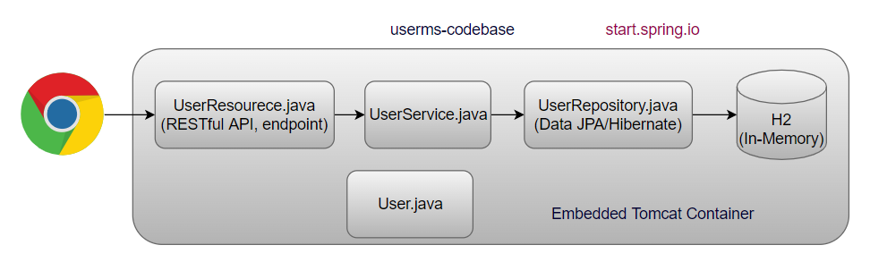
Concepts:
- Service Registry and Discovery- Netflix Eureka
- Client-Side Load Balancing- Netflix Ribbon/Spring Cloud LoadBalancer
- Resiliency Implementation Using Circuit Breaker- Hystrix/Resilence4j
- Monitoring Using Actuator and Micrometre - Prometheus/Grafana
- API tracing using spring cloud sleuth and Zipkin
- Centralized Config Using Spring Cloud Config
- Centralized logging using ELK
- Security Using OAuth and JWT
- API Gateway- Zuul/Spring Cloud Gateway
Env:
- eclipse latest
- java 17
- mysql
- maven 3
- arc- advance rest client
- tomcat 10
- Git Client
- activemq
- kafka
- aws cli
- WinSCP

UC: userms wants to call orderms, but ip address of ms is not static its dynamic in nature, how to find the ip address of orderms?
Solution: Service Discovery/Service Registry, just like telephone directory, it keeps track of each ms.
- Register each ms in eureka registry, each instance of ms sends their heart beat to the eureka server.
- server doesn’t look for, instance itself sends the heartbeat to the eureka registry
- if instance down, stops to send the heartbeat, eureka registry remove that instance details from the registry.
- It is not for load balancing, just only for discovering services dynamically.

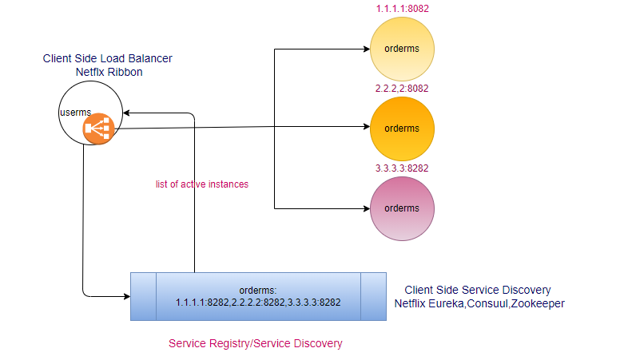
- If there are more than one instance of orderms available then which instance will be called?

Client-Side Load Balancer: Inside the source ms (Ribbon)
- First time ribbon takes values from the registry after that it keeps in cache (TTL) provided by eureka and calls the orderms, getting reference from cache directly.

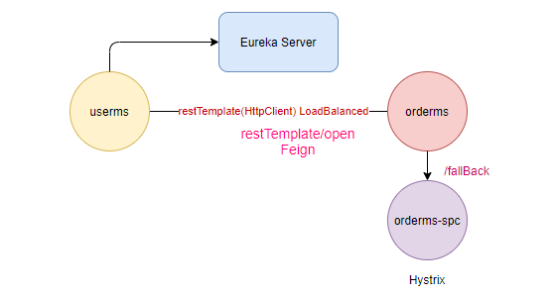

@SpringBootApplication
- @EnableAutoConfiguration- scan all classpath .jar on your behalf
- @ComponentScan

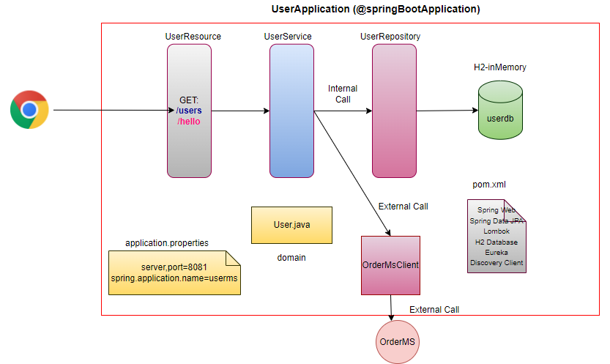
.jar Vs .war
Make .jar Not .war # making .jar is cloud native approach for building microservices, .war requires external container. .jar are self-contained

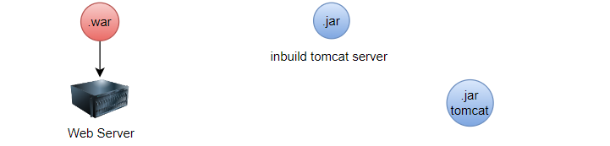
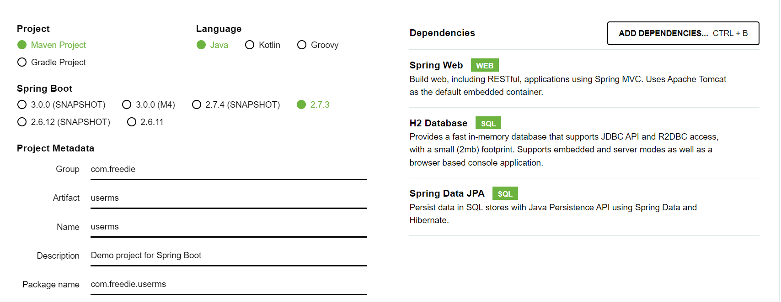
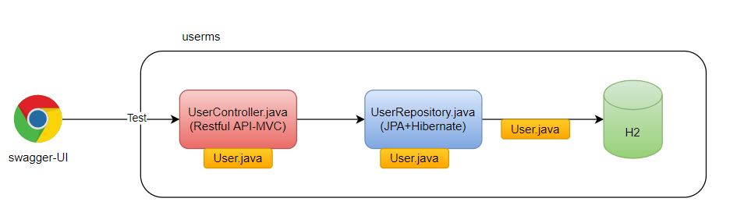
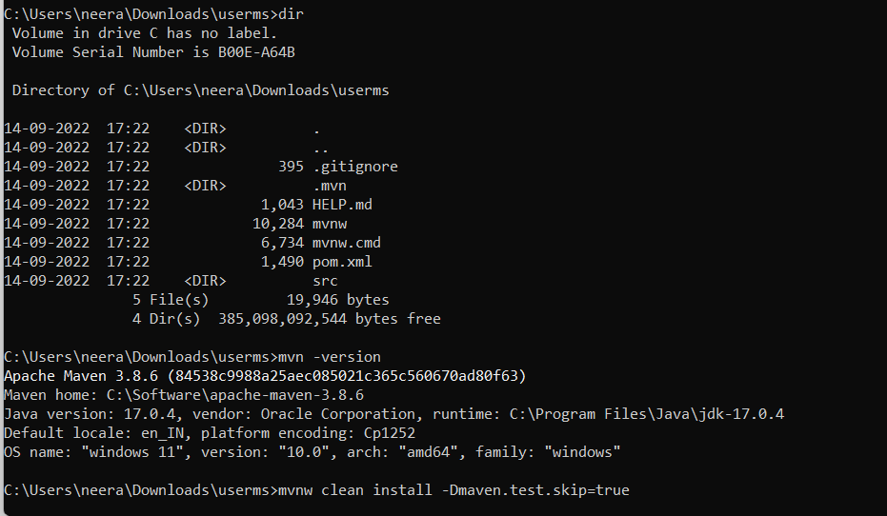
mvnw clean package -Dmaven.test.skip=true
Import maven project in Eclipse
@SpringBootConfiguration
@EnableAutoConfiguration
@ComponentScan
In Spring framework
@ComponentScan (“com. freedie. myus”), Initialize bean on our behalf
- @Component
- @Service
- @Controller
- @RestController
- @Entity
- @Configuration
- @Repository # Is optional from spring 5 onwards

@Bean # Method level
public MyJavaClass initializeMyJavaClass(){
MyJavaClass myJavaClass=new MyJavaClass();
myJavaClass.setMyProperty(“abc”);
retu/rn myJavaClass;
}
@EnableAutoConfiguration
Will scan the lib directory , automatically establish default configuration if not available in properties file.
localhost:port/h2-console
localhost:port/swagger-ui/

