UC: Voltage Increase from 110V->220V, due to which LED may be crashed.
USB will break the circuit, will save LED from crash.

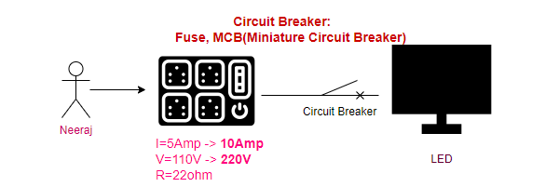

Circuit Breaker (applies where there is a network call) for Resiliency:
userms getting 300 req/sec (100req/sec->orderms, 100req/sec->paymentms, 100req/sec->db), orderms is crashed, userms retries and after 5 minutes it retries 3000 req/sec. most of the resources busy on retries, will impact the performance of whole application.
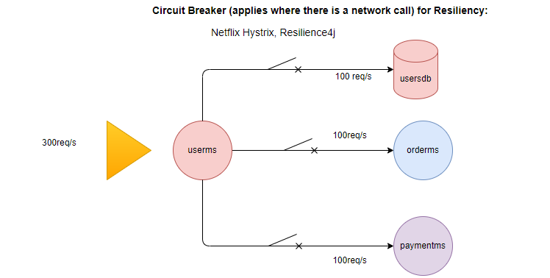
Solution: open the circuit of down service (orderms) after 3 consecutive tries, now userms will not retries.
In background continue checks the heart beating once get again (after 3 consecutive calls) close the circuit again.

Resiliency:
Failure in one component can affect to other components and after sometime intern fail the whole application. Failure don’t cascade into other parts of application. This is not a resilience application.

Solution: Circuit Breaker (Hystrix)
Fallback is a method where defines the behavior of failure.

Once circuit restores, fallback method will not be called. Hystrix provides the Resiliency for our application not the HA. Hystrix works with Ribbon and Eureka.
Ribbon is .jar, used by caller ms, wrap your network calls over the Hystrix. It acts a Fault Tolerant, wherever you are calling other ms wrap over there

Hystrix: Works on network failure, for other failure you have to do Exception Handling
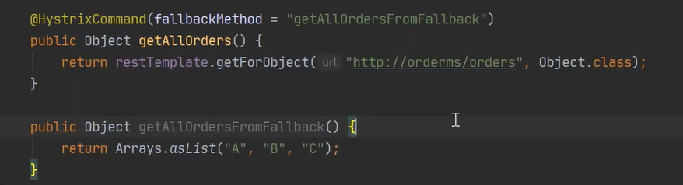

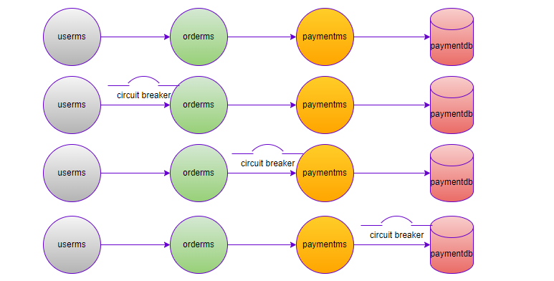

Bulkhead design pattern: due to issue in one part will not impact the whole application (Resilience design pattern)
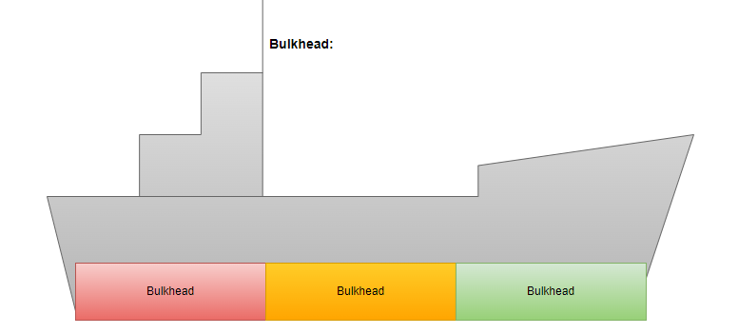
How Implement?
Reactive manifesto: End-to-End
WebClient is reactive version of Http Client, Number of threads are very less, and threads are not blocked (Asynchronous), there is no message broker.

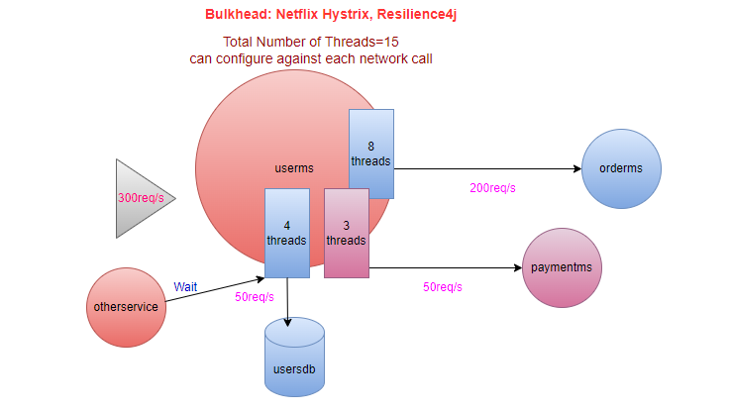
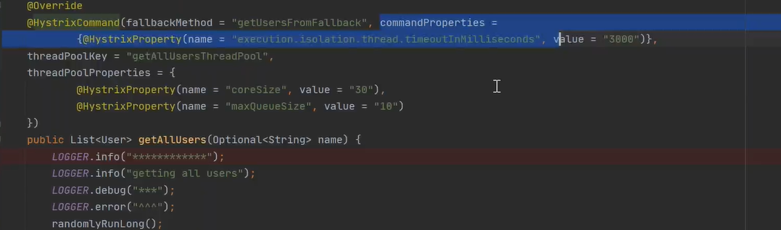
UC:

API Gateway
- NFR (Security/Authentication/Caching/URL-hiding.)
- Every cross-cutting concern moves to API Gateway
- API Gateway is for external user, Eureka is for internal components
- Single point of entry in your application
- Must be stateless
- No business logic
- API can have a logic of token validation
- If token is Invalid ApiGateway rejects the request, will not forward it to Eureka/other microservice.
- URL hiding
- Rate Limit (Throttling)
- Denial of Service (Dos)



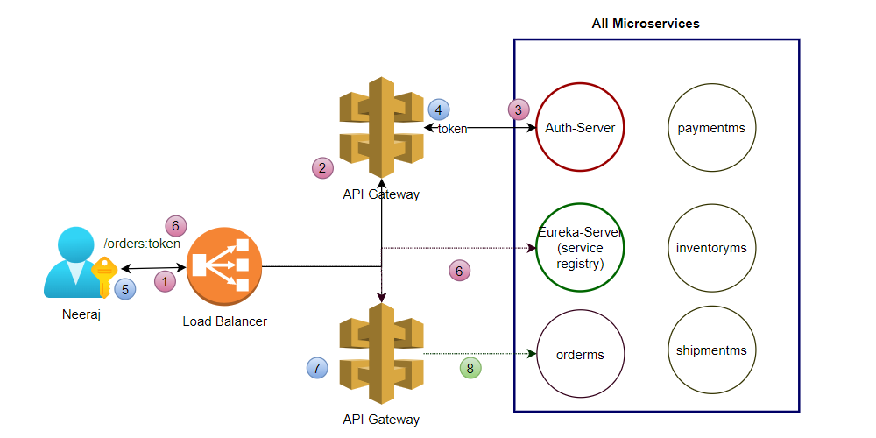
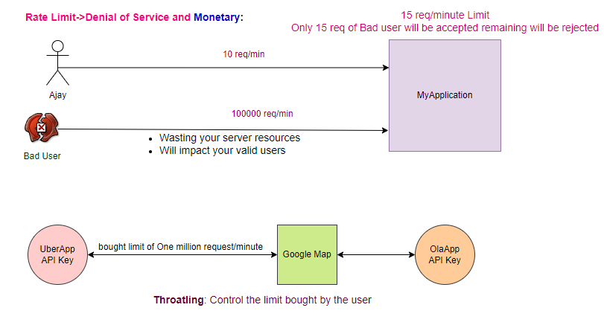

RateLimit at ApiGateway level.
Solution: Zuul-Netflix (run on port 8080)
Zuul API comes with the route’s URL by default.
localhost:8080//actuator/routes
Whatever eureka sees, ApiGateway can also see same (userms and orderms).
Access userms and orderms through ApiGateway
localhost:8080/<name in eureka userms>/users
localhost:8080/<name in eureka orderms>/orders

UC: We don’t want that apigateway access all the routes?
We have to change the default behavior of apigateway
zuul.ignored-services=orderms
zuul.ignored-services=userms

UC: How we do the URL-Hiding?
Url-hiding (orderms by default will not be exposed, exposed using url-hiding)
zuul.ignored-services=orderms
zuul.routes.<ordermsid>.serviceId=orderms #third part ordermsid is configurable
zuul.routes.ordermsid.path=/dummy-orderms/**
#http://localhost:8080/dummy-orderms/orders
Url-hiding (userms by default will not be exposed, exposed using url-hiding)
zuul.ignored-services=userms
zuul.routes.<usermsid>.serviceId=userms
zuul. routes. <usermsid>. path=/dummy-userms/**
#http://localhost:8080/dumy-userms/users

UC: How Zuul do the Load Balancing
Internally apiGateway (Zuul) uses ribbon as a client-side load balancing.
Cross Cutting Concern- Service Mesh (common across most of the services at common place).
ApiGateway is only for external calls.
server.servlet.context-path=myuserms # appended in the path

UC: How to manage certificates?
We have to provide some TLS setting at apigateway (Zuul).

UC: Filters Using Zuul?
Filter: If you want to add some additional information (uses as a proxy to the ms).
request -> LB-> API Gateway (multiple for HA)
step1: ApiGateway first checks request is for dummy-userms, is there any entry of dummy-userms
step2: ApiGateway internally uses the Ribbon for client-side load balancing.
step3: Internally uses the Circuit breaker to maintain the resilience.

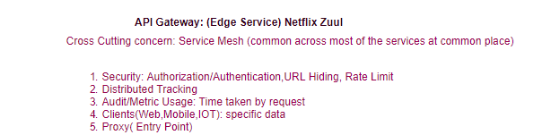

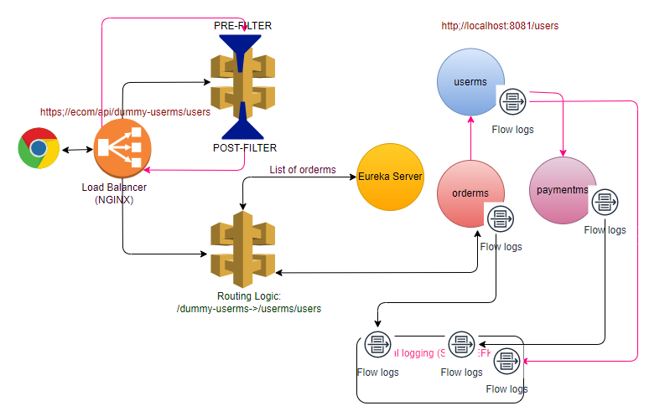
Note: Load Balancer (NGINX) is only for external services, Ribbon Load Balancer is not for external service, just for internal client-side load balancing.
step1: create a pre filter class within the filter package which implements the ZuulFilter
- filterType: before or after (pre or post)
- filterOrder: If there are more than one filter of same type then in which order it will be executed.
- shouldFilter: At which condition filter will be executed.
- run: What filter will do (actual logic)
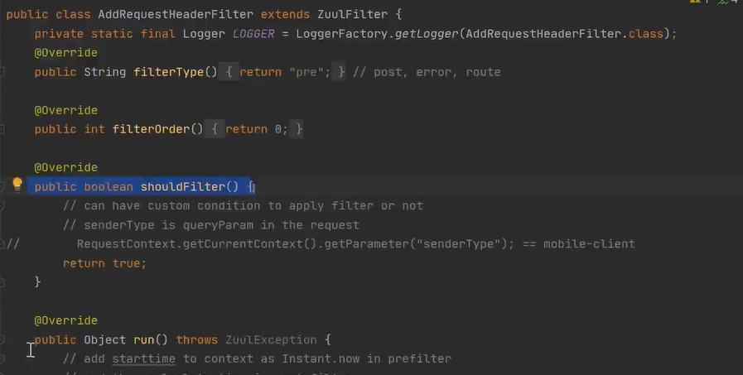
step2: create a post filter class within the filter package which implements the ZuulFilter
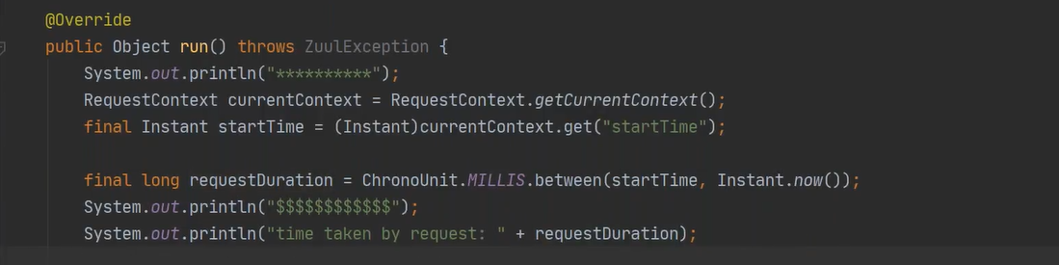
step3: add the @Bean of both the filters in apiGatewayApplication

Types of Filters:
pre
post
error

@Bean: Is the way of initializing your java class, we delegate this work to spring framework.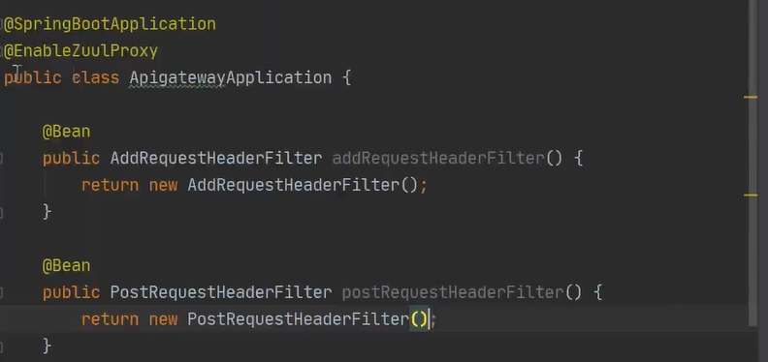
Note: First request takes more time why?
First time apigateway (Zuul) reads from eureka after that it cache the details of Eureka, and subsequently directly calls the service (caching).

Distributed Tracking: Sleuth
UC: money is deducted from the account, but order still showing in pending state.
There is a mesh of microservices, for each request we want to know where request gone (complete request flow).
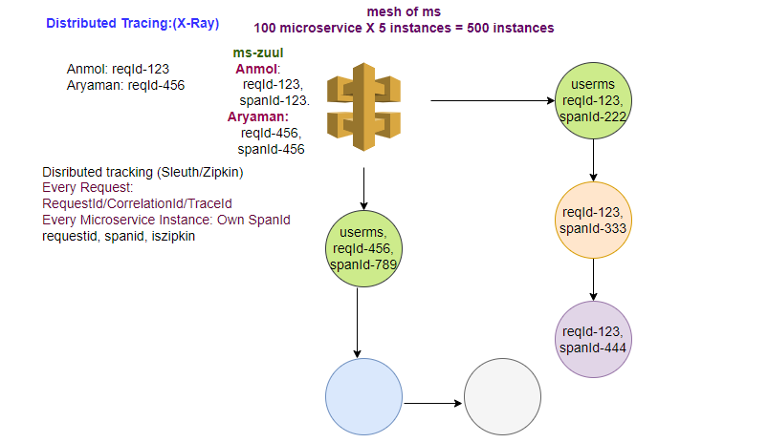
Sleuth Logs of tracing the request?
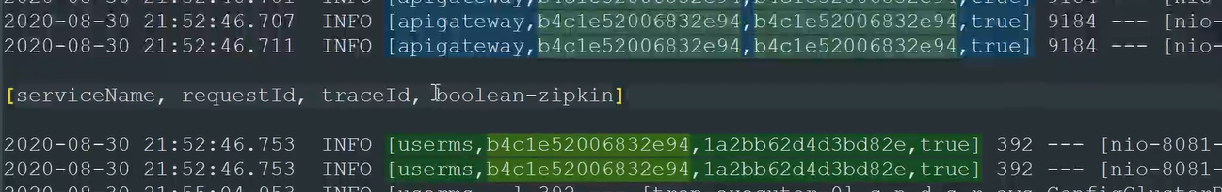
Arrays:
First element: name of the ms
Second element: request Id (same for the request): generated by apigateway
Third element: trace Id (specific to the ms instance in same request)
Fourth element: Whether we export these logs to Zipkin or not?
appending to the log. In real time check the traffic. Troubleshooting the issue.
logs are distributed at ms locations, can be moved to central location.

Spring Data Rest (HATEOS)
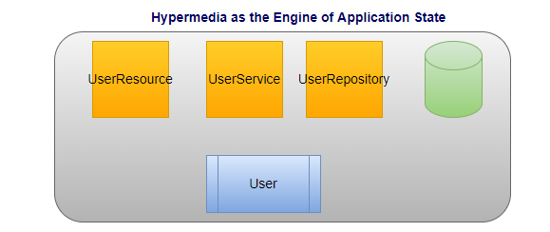
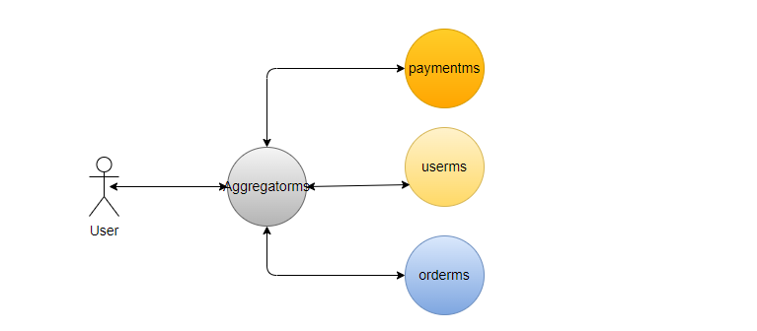
Centralized logging (EFK, Splunk)

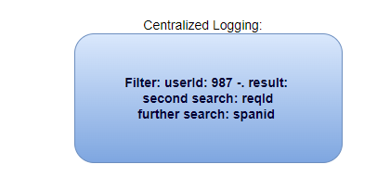

catalogms
mvn clean install -DskipTests
localhost:8080
localhost:8080/catalogues
localhost:8080/catalogues?size=1
localhost:8080/catalogues?page=1&size=1
Based on the repository it automatically creates all the CRUD operations.
Its consumer driven API, consumer just use reference URL to navigate.
Limitation: It takes fully control; we can’t write service logic.
IDEMPOTENT

Swagger:
