Untangling the ball of Mud (Migrating from Monolith)
BigBang Approach
Migrate complete monolith in First Day of Release, is not recommended

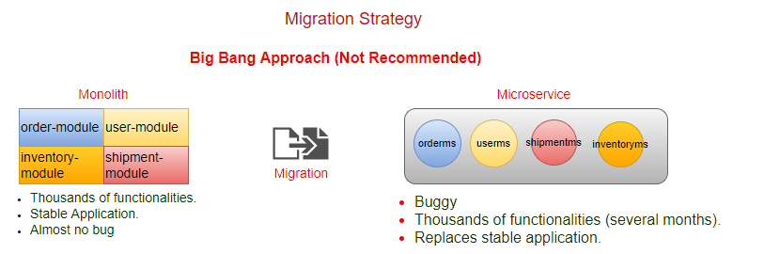

DDD way to decompose Big Mud Ball
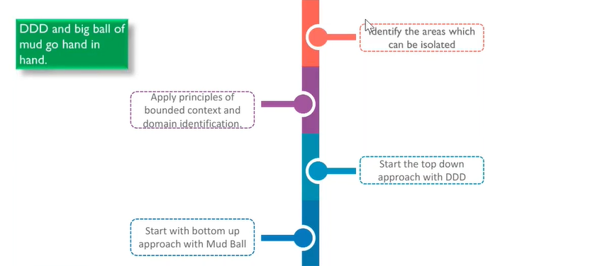
Strangler Vine Approach (Hybrid): Says start from a one simple module, and convert it into ms after DDD (do the refactoring at monolith side before the migration).
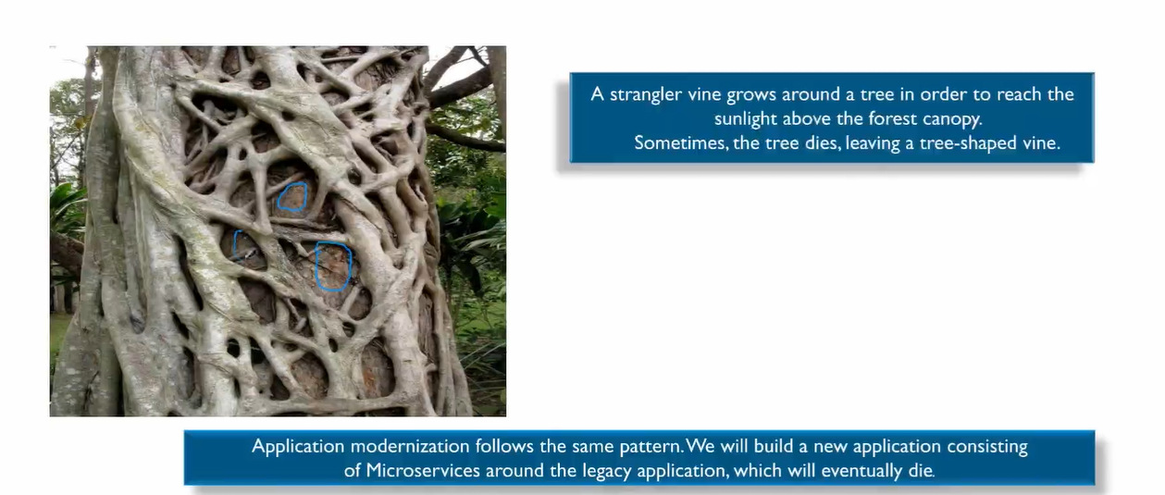

Hybrid Architecture (Strangler Vine):
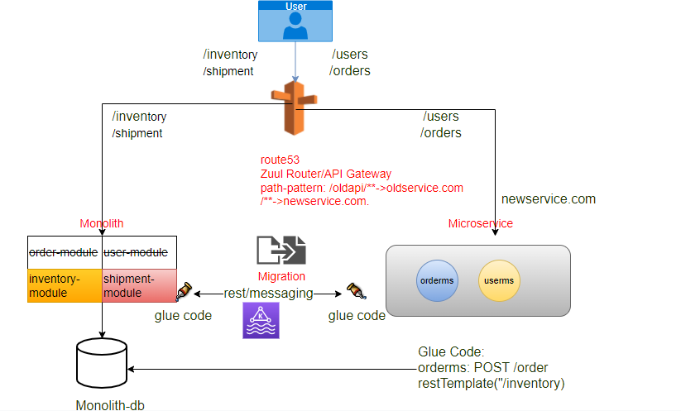

Is hybrid architecture
Once we move userms from monolith to ms, remove the code of user ms from monolith side (size of monolith code reduces).
UC: Whether we hit to monolith or to ms?
Through API Gateway (URL hiding)
Note: migrate small-small modules(functionality) step-by-step (Iterative Incremental). Our aim to reduce the size of monolith, if any major change or new enhancement come will be done at microservice side.

UC: How ms access the database?
Glue Code (External Library): It may be Restful logic or through Messaging
Refactoring at monolithic side (convert method calls to remote call).
How Glue Code looks like?
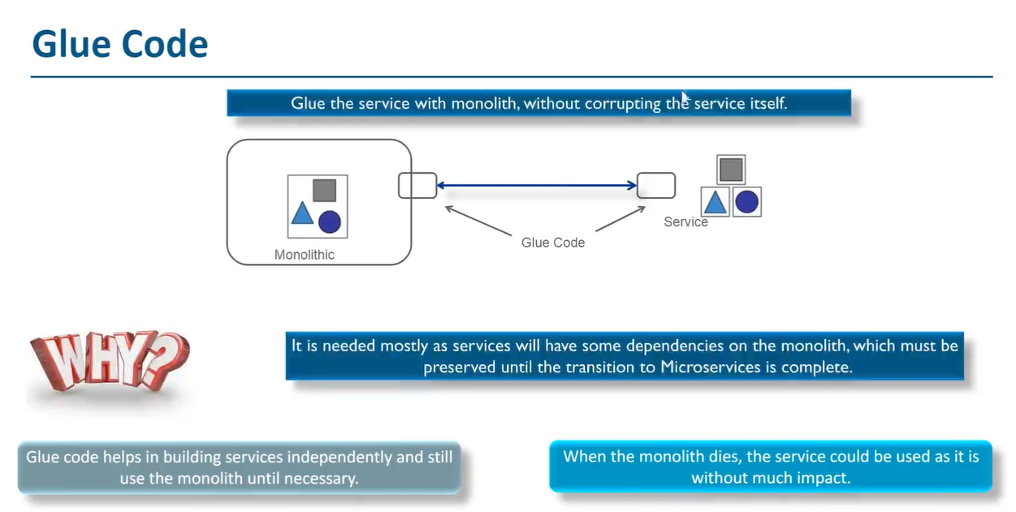
Untangle Monolith-Strategies
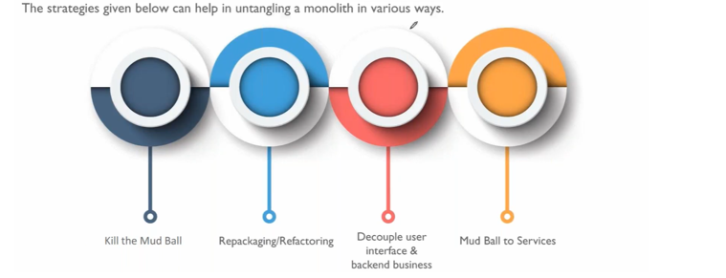

How to stop the Monolith from Growing
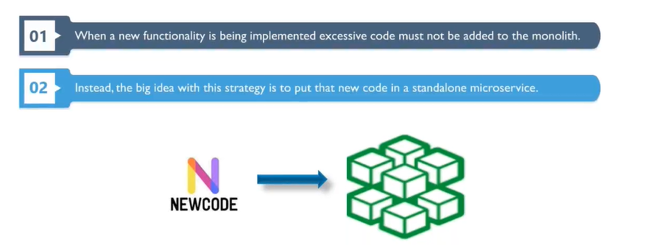
Adding a Microservice to mud ball
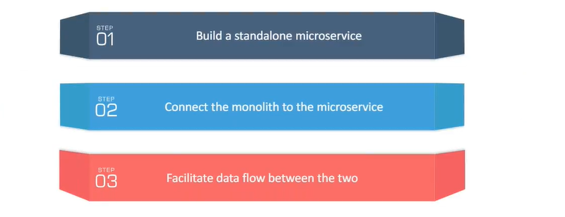
New System Architecture
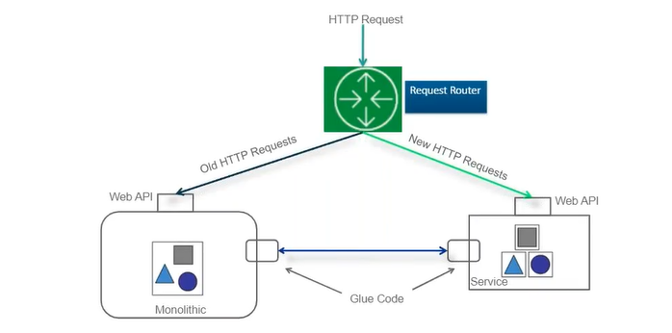
Data Access
Hybrid DB Architecture (Who is owner of DB): Only owner has access of write operations
- Access the monolith’s database directly.
- Monolith provides a function to access data remotely.
- Replicate and synchronize a local copy of data.

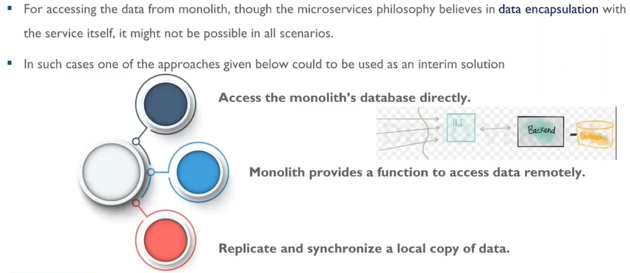

UC1: Access the monolith’s database directly.
Using DBWrapperms, single point of access from ms side.

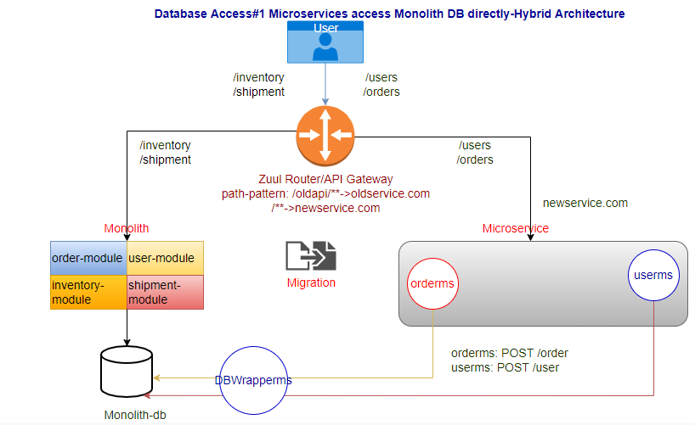
Limitation: Data Modeling, if there are data coupling between order and user db.

UC2: Access the monolith’s database through monolith.
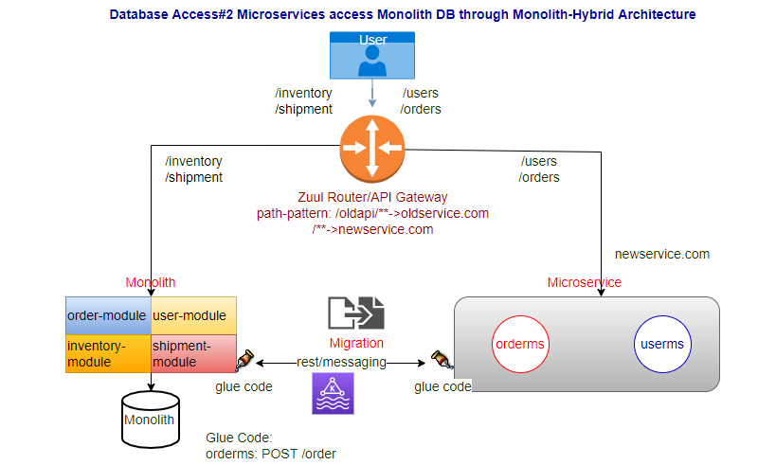
Limitation: ms calls REST API of monolith (changes in monolith side), later on once app will be migrated fully require changes in ms side (remove the call).
Note: In both above case there is a single source of truth (monolith).

UC: user-module needs all order-modules details
In monolith
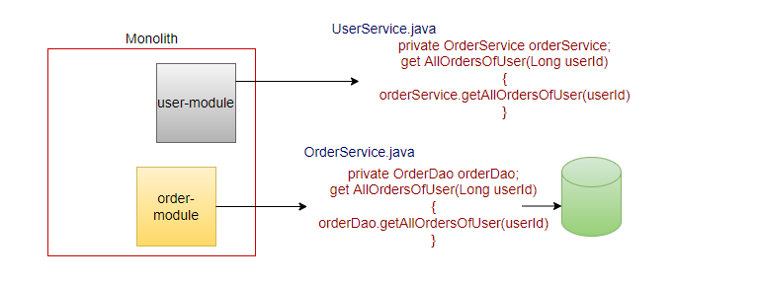

UC: we have taken user service module taken out and moved to userms
First, we have to refactor the code (userservice.java) in monolith will not exist.
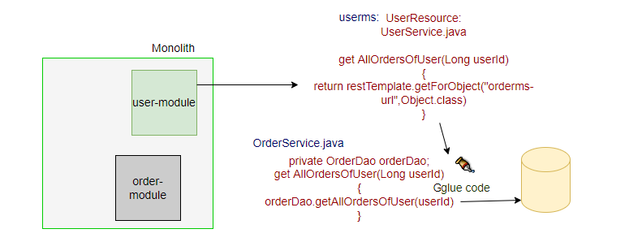

UC3: Replicate and Synchronize.
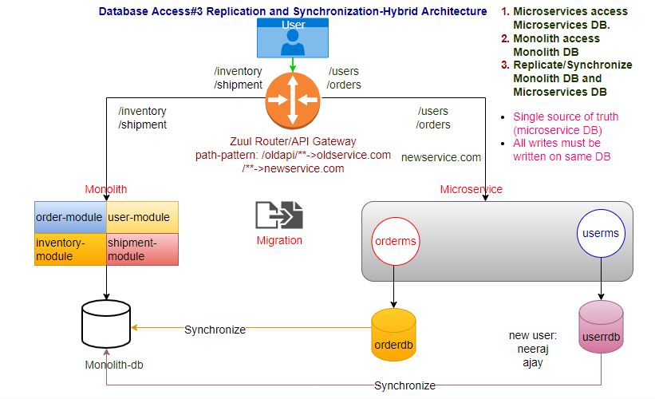
step1: New user Ajay comes and registered himself in userms-db.
step2: Ajay wants to place order in monolith application, but user was created in userms-db not in monolith db.

How to ensure data must be in sync?
Monolith and ms must be replicate and synchronized.
Always there will be single source of truth, you must be synchronized either from userms-db to monolith db, or synchronize from monolith db to userms-db but never from both sides. Never two-way synchronization (RACE condition).
We must have to keep orderms-db as a single source of truth for orderms
We have to replicate the orderms-db to order db of monolith.

CDC (Change Data Capture): Eventual Consistency
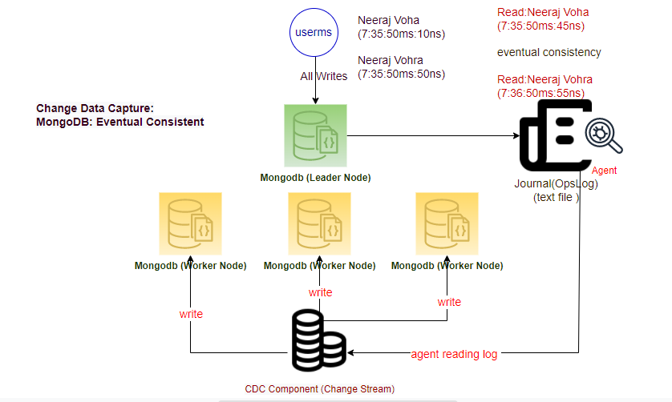
CAP Theorem:
- Consistency
- Availability
- Partition Tolerance

Distributed Database MongoDB:
- Distribute DB maintain a Journal In mongo db it’s called OpsLog
- Whenever leader node receives any write operation (write/update/delete) it writes the same into Journal (OpsLog).
- Using this Journal all updates are recorder line-by-line, every update must be added here.
- These updates must be traveled to worker nodes, in case of distributed mongodb.
- There is another component CDC component (agents running on CDC component reading the log).
- Whatever it changes receives from OpsLog writes to the worker nodes.
- Mongo db not supports consistency property of CAP Theorem, It Eventually consistent.
- In case of RDBMS provides the Immediate Consistency, while it’s not supporting Partition Tolerance. RDBMS not supports CDC because they don't support distributed db architecture.
- Read Only through the worker-node.
- Data resides in cluster of nodes.
- Data writes on single leader node.

How to replicate?
UC1: Call service to replicate
step1: update the db
step2: call service to replicate other DB
step3: commit the change
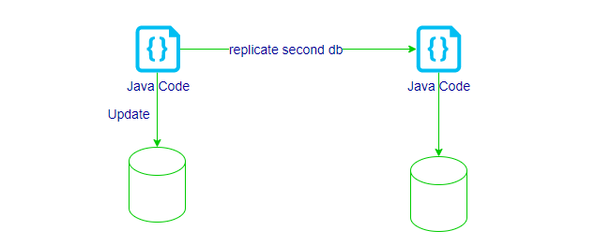
UC2: Write your client (listen to the CDC components), convert schema and write to other DB.
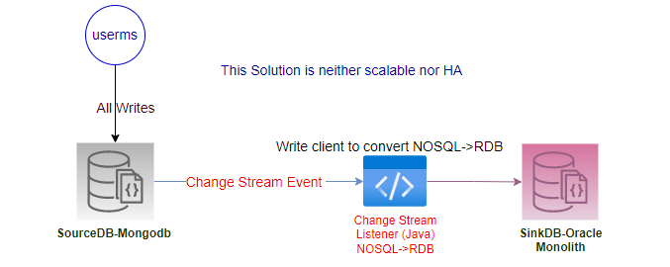
UC3: Using DB provided CDC feature
We plug-in our component with-in CDC component, and through that component we replicate our database.
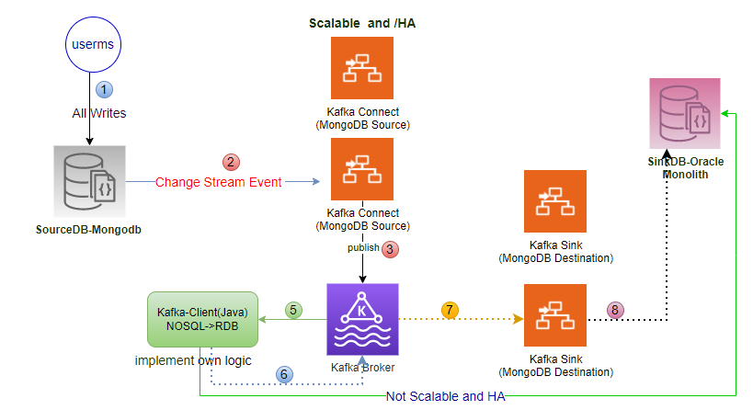
Kafka Connect is out of box solution, provided by Kafka, Kafka Connect Job is consuming the messages from Change Stream Event and publish to Kafka, don’t need to write them just configure the same.
In case of Oracle, use another Out of Box Solution -Debezium Connector for Oracle DB, Use Debezium Connect for Oracle.
kafka is meant for low-latency tool: Gives 7 days persistent by default

Event Sourcing and CQRS
UC: Extremely high writes
Event sourcing, we track every event the journey of your data.

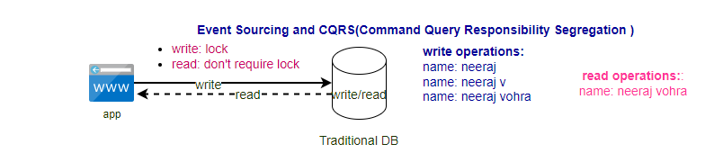

CQRS: Command Query Responsibility Segregation
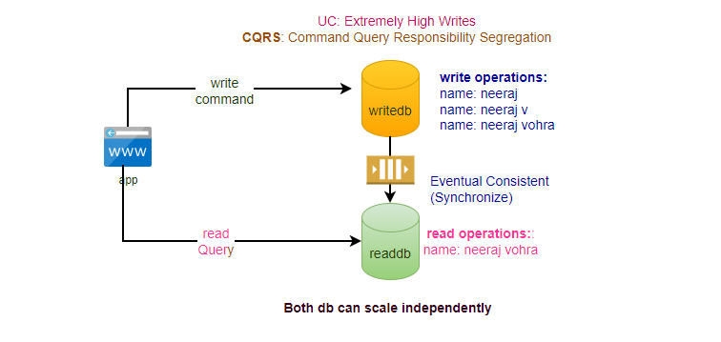
Event Sourcing:
- In tradition database approach destination was more important than journey.
- In Event Sourcing Journey is more important than destination.
- It is very important for auditing purpose.
- It takes any update as an event.
- Event sourcing is also possible in Oracle DB.
- limitation is that can't query the data.
- Data is Eventual consistent.

Limitation of event table can’t query the data used with CQRS.
Event Sourcing + CQRS:
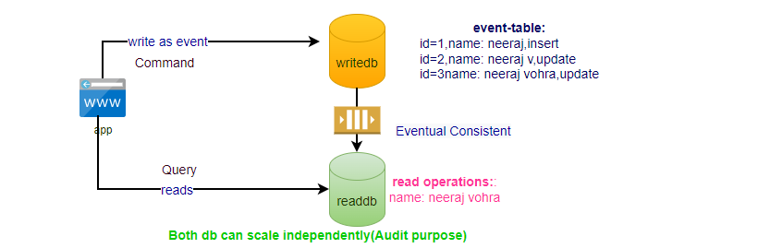

Repackaging (specific for enterprise applications)
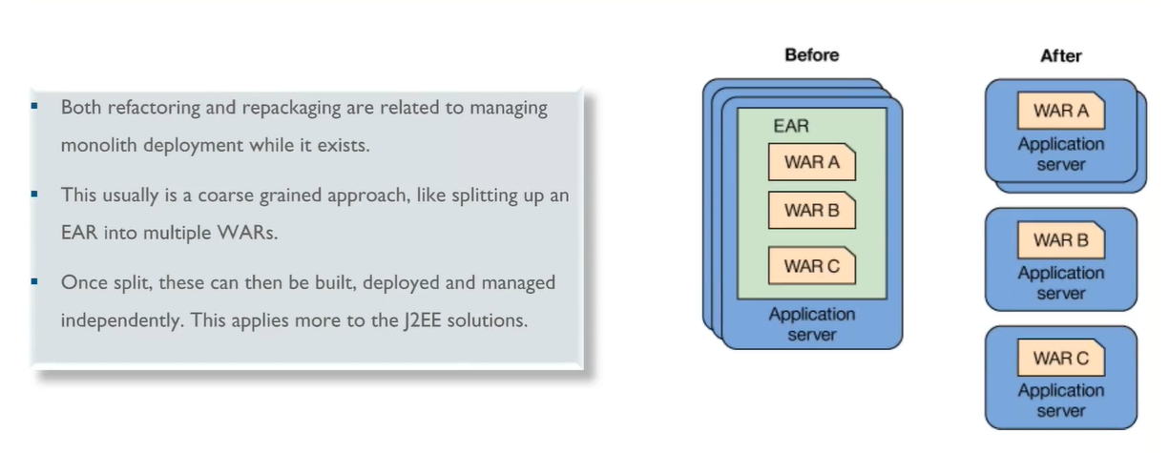

Refactoring Gradually
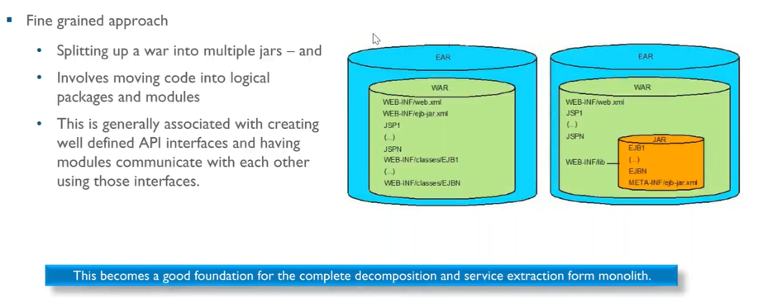

Decouple the UI and the Backend Business Logic
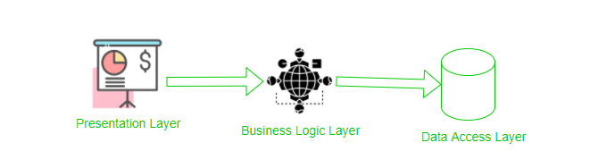
In old style when user clicks from one page to another there was a server call

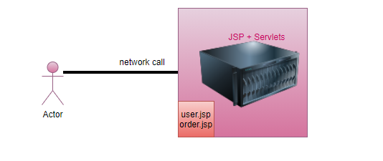
Single Page Application-> Angular, React, ViewJS
When user clicks from one page to another page, don’t need of server call, pages are already available at client side, they need server call only for data.
e.g., present as ms
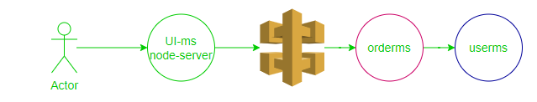

Business logic and Presentation

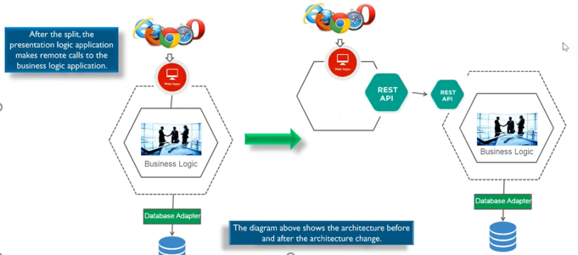
Mud ball to Services
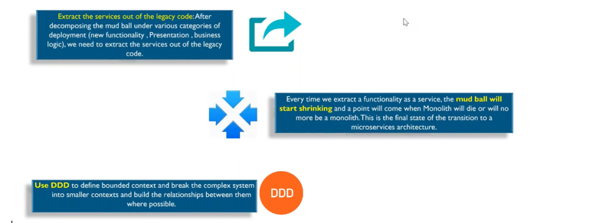

steps:
Identify candidates
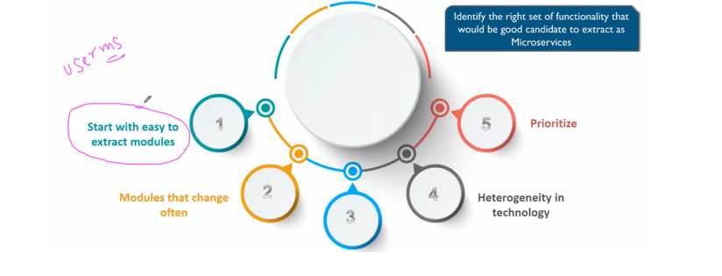
Service Extraction
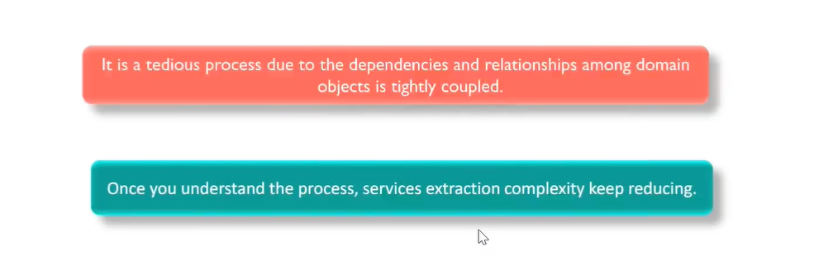

Service Extraction- step1
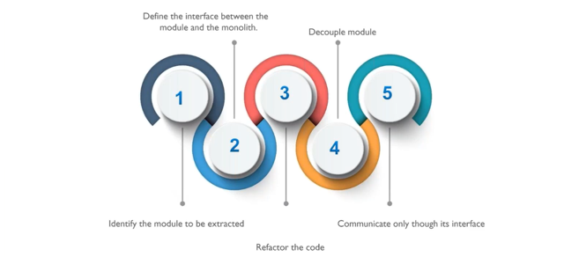

Service Extraction- step2
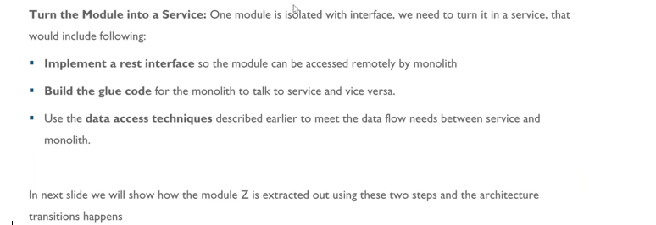
Popping small balls from big mud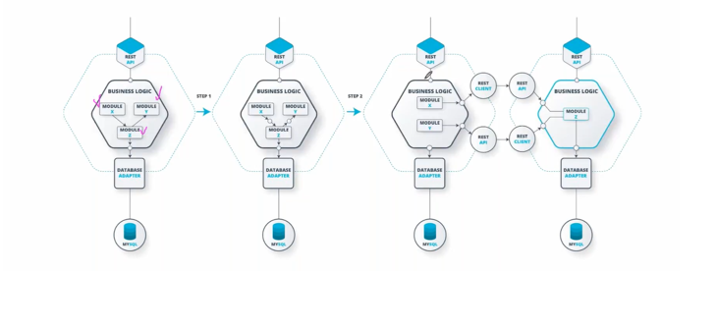
Monolith Code
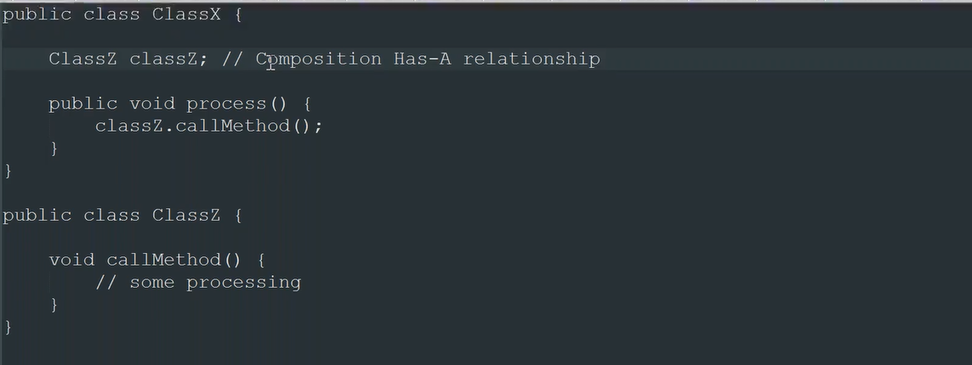
Refactoring
Step1: first convert HAS-A relationship in to interface (IS-A)
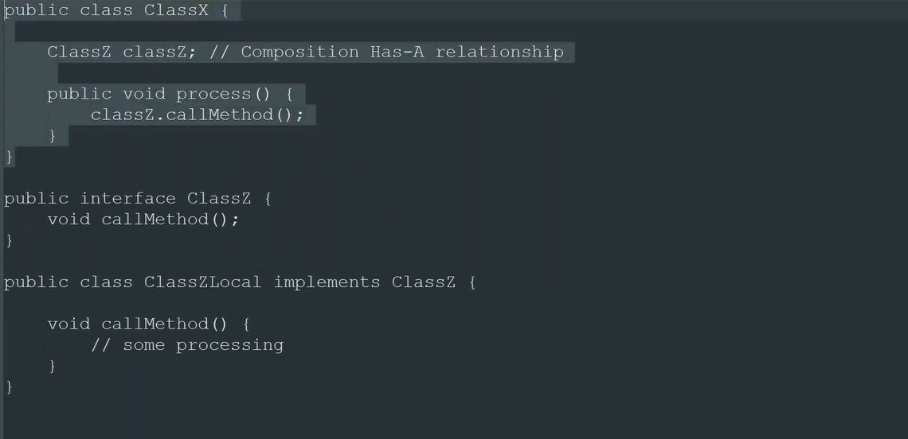
Step2: For refactor create one more class ClassZRemote
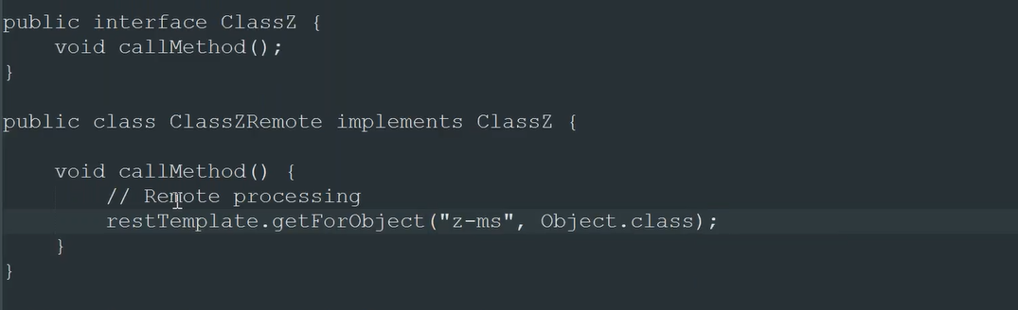
Step3: By default, ClassZLocal defined as a @Primary
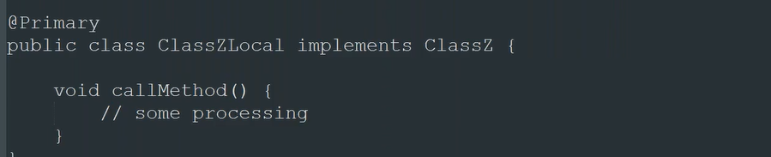
Step4: Once ms is created, update the annotation @Primary to ClassZRemote.
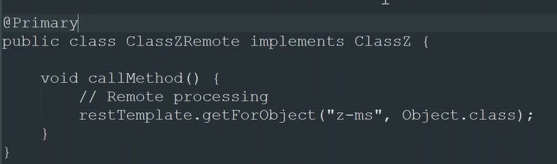

Key Architecture Decisions
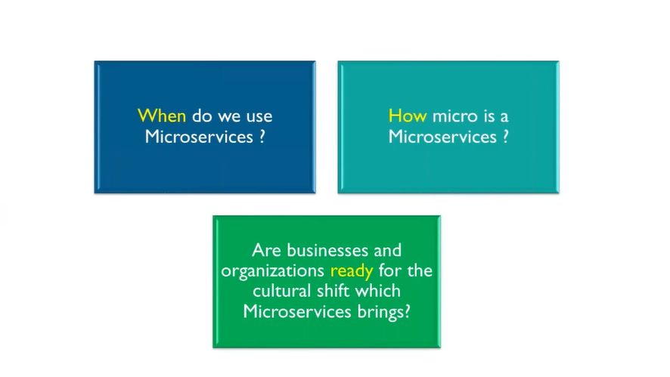
When: Benefits we get from ms
Agility
Light Weight
HA
Heterogeneity
Chery-Pick Scalability
Maintenance
Highly Scalable
How:
DDD to Identify the Bounded Context
<3-5 ms calls
Benchmarking
Ready:
ADAPT
Cost (High)-> License + Developer
Many teams (2 Pizza team)
DevOps Culture

