Security:
Securing Microservices: Our data is our responsibility
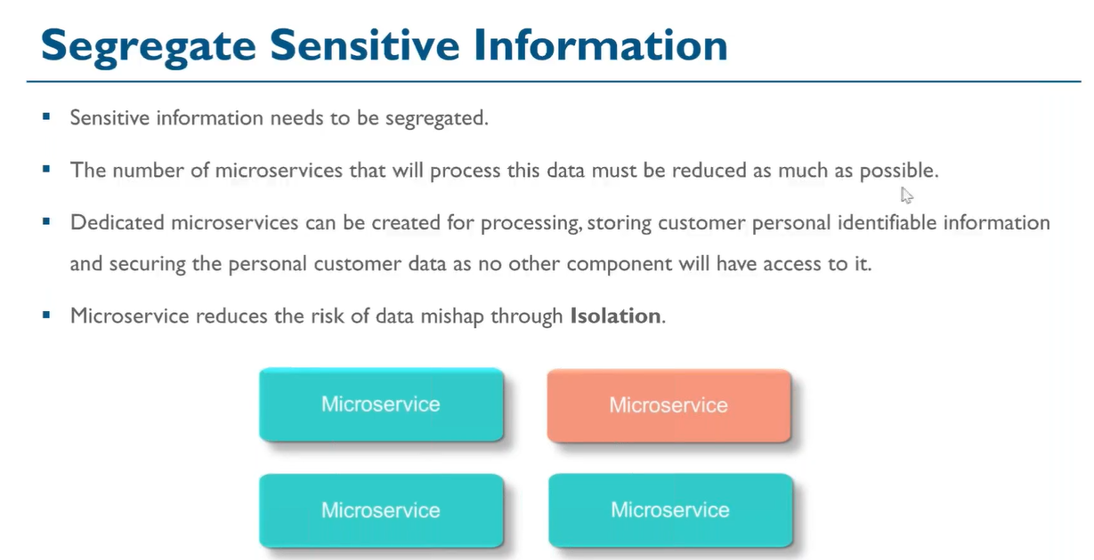
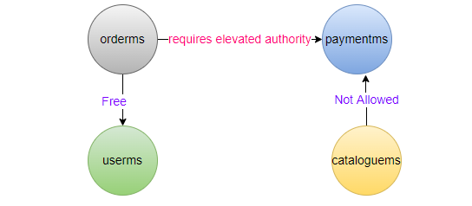
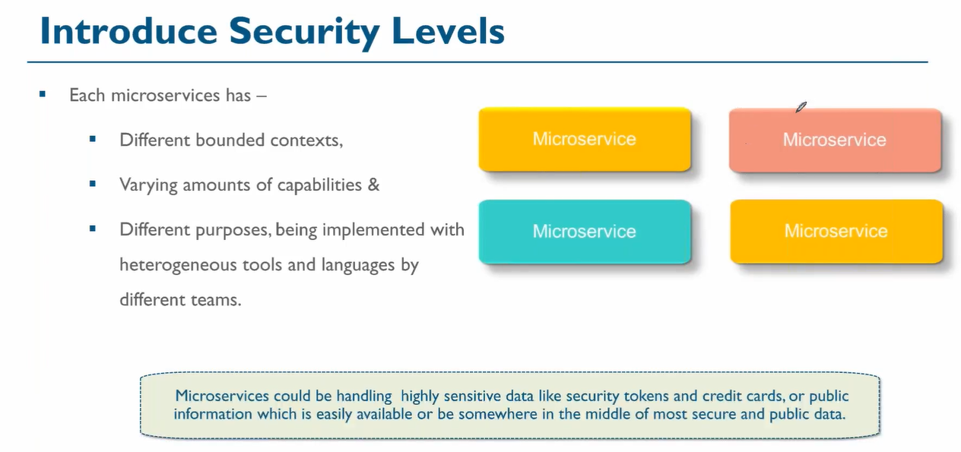
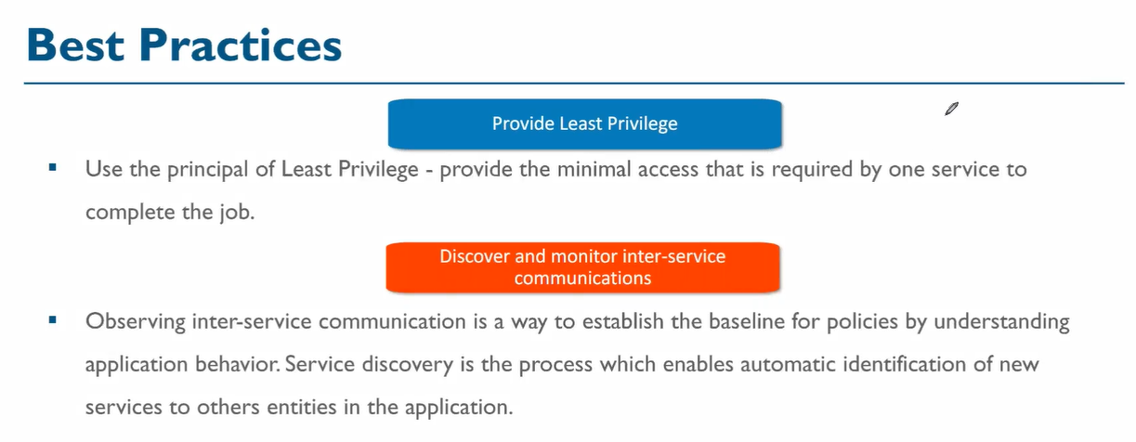

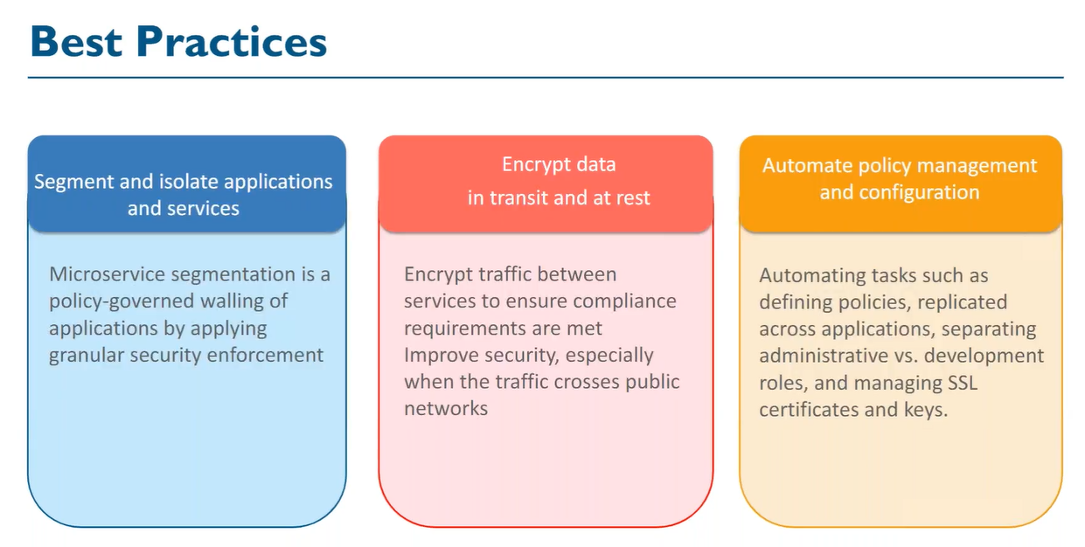
UC: security of data
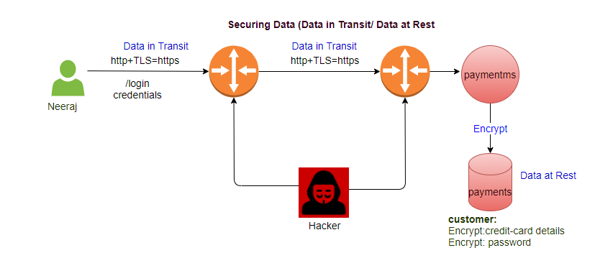

Microservices Big Picture:
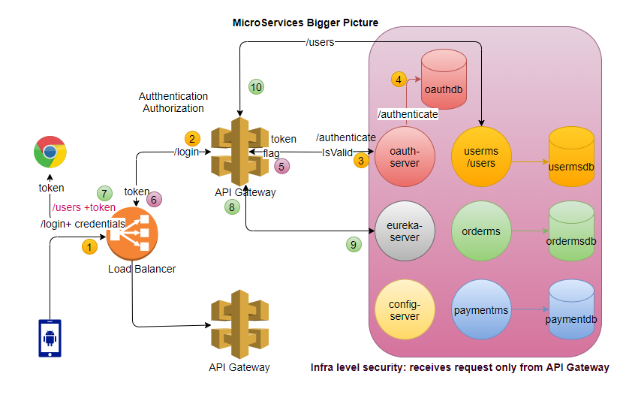
step1: API Gateway receives request /login, forward the request to the oauth-server, oauth-server returns the token.
step2: User sends the request (/users) to access one of the service, API Gateway receives the request and find this request is for accessing one of the services under its control.

step3:
UC: Opaque token (Bearer):
API Gateway forward the request to oauth-server to validate the token. Oauth-server have internally
method to validate the token, if token is valid, it returns the true flag to API Gateway.
step4: If API Gateway positive response from oauth-server, it consults eureka-server about requested service (/users).
step5: eureka-server returns the url of the /userms.
step6: API Gateway calls the /userms

UC: JWT token (Bearer):
step3:
API Gateway, stores the key required for validation, validate the request itself (Improve the performance).
step4: If API Gateway positively validate the token, it consults eureka-server about requested service (/users).
step5: eureka-server returns the url of the /userms.
step6: API Gateway calls the /userms

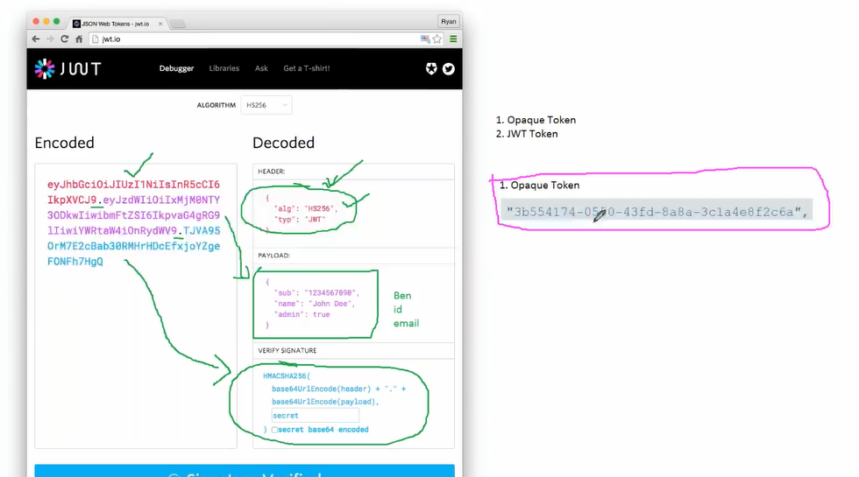

External Load Balancer
- Apache HTTP server
- NGINX
- F5
- HA Proxy
Oauth-server implementation?
- single-signoff
- create your own oauth-server
- out of box solution to implement the security:
  - Okta
  - KeyClock

Difference between Opaque and JWT token?
Opaque Token is dump token, just a random string does not contain any inherent value.
JWT is smart token, it contains the inherent information (HEADER, PAYLOAD and VERIFY SIGNATURE).
Oauth2 (Application-level Security: Third party login):
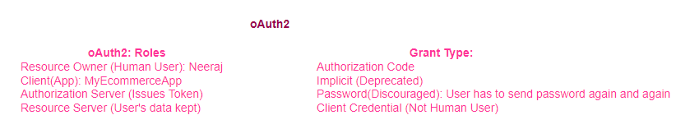
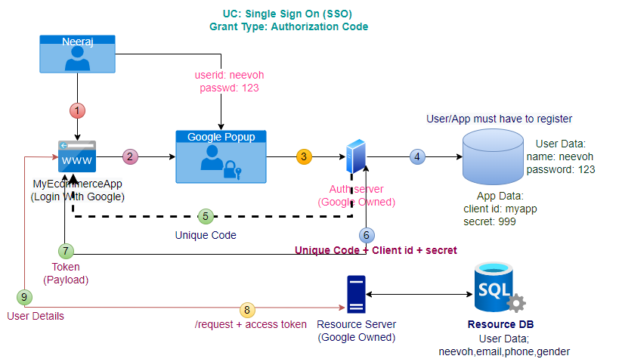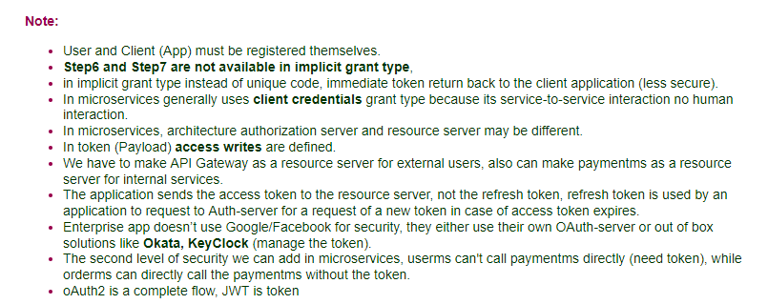

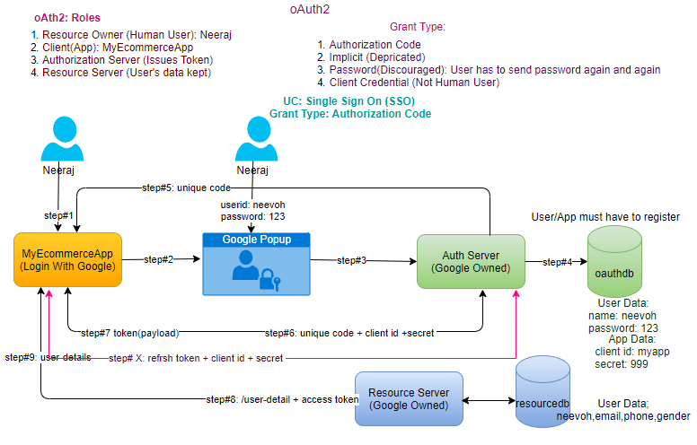
step1: User access the client application (MyEcommerceApp), have option of Login with third party (Google, GitHub, Facebook etc,)

step2: User clicks on Login with Google, Google provided Popup open.

step3: User enters Google Credentials, request goes to Auth server (Owned by Google).

step4: Authorization Server validate the credentials.

step5: Authorization Server returns the unique code back to the client application. (After this user interaction is done).

step6: Client application sends a request to Authorization Server with the request parameters (unique id + client id +secret).

step7: Authorization Server returns the token (payload) back to client application.

step8: client application sends request with token to resource server to get the user details.

step9: Resource server validate the token and after validation sends the requested details back to client application.

How Payload looks return by Auth-server?
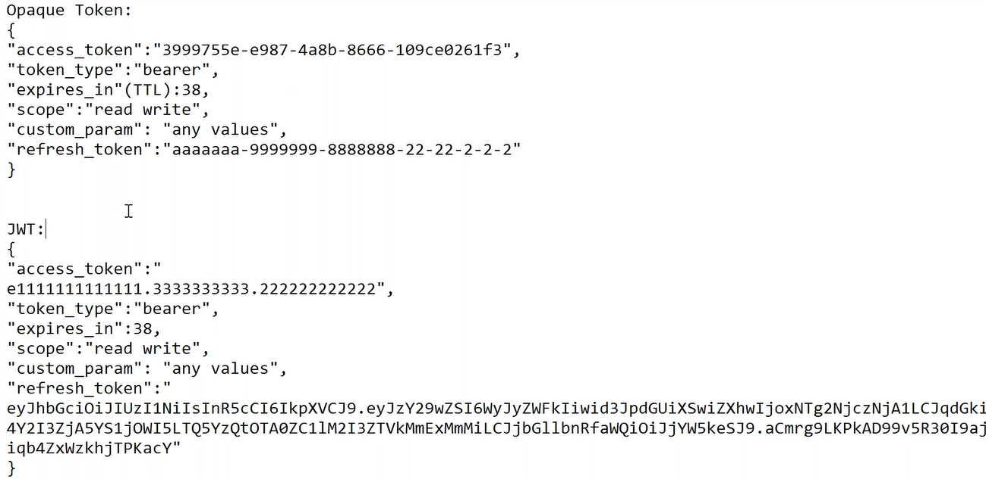

It’s end-user specific not the ms specific.
Note:
- User and Client (App) must be register themself.
- step6 and step7 are not available in implicit grant type, in implicit grant type instead of unique code, immediate token return back to the client application (less secure).
- In microservices generally uses client credentials grant type because its service-to-service interaction no human interaction.
- In microservices architecture authorization server and resource server may be different.
- In token (Payload) access writes are define.
- We have to make API Gateway as a resource server for external users, also can make paymentms as a resource server for internal services.
- application sends the access token to the resource server, not the refresh token, refresh token is used by application to request to auth-server for request of new token in case of access token expires.
- Enterprise app doesn’t use google/Facebook for security, they either use their own oauth-server or out of box solutions like Okata, KeyClock (manage the token).
- Second level of security we can add in microservices, userms can't call paymentms directly (need token), while orderms can directly call the paymentms without the token.
- oAuth2 is a complete flow, JWT is token.
UC: security between the microservices (make some services doubly secure)

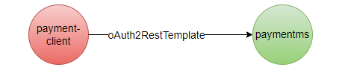

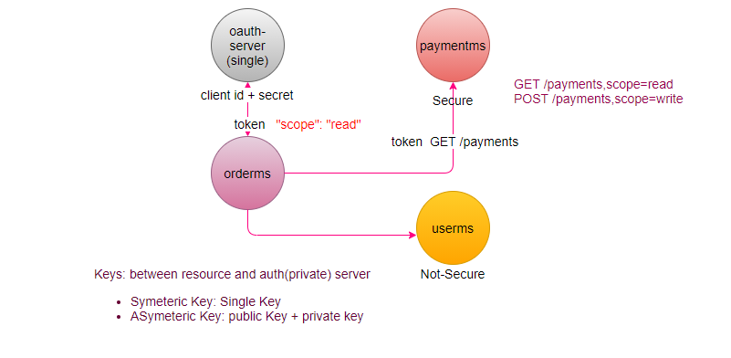
There is always two-calls (one to get the token, second to get the resource)

Trust boundaries
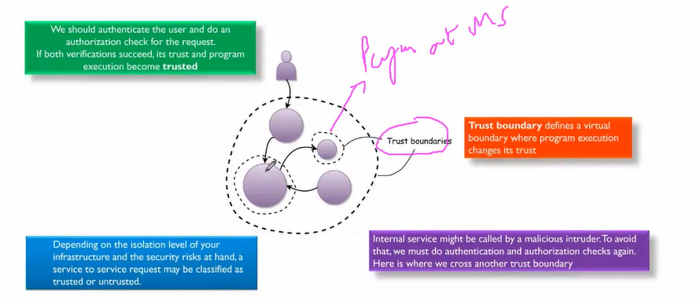
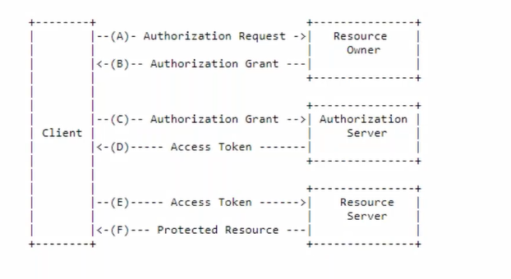
How to register client application with auth server?
GitHub-> Setting
Commercial Auth Servers:
- Okta
- KeyClock

Infra Security
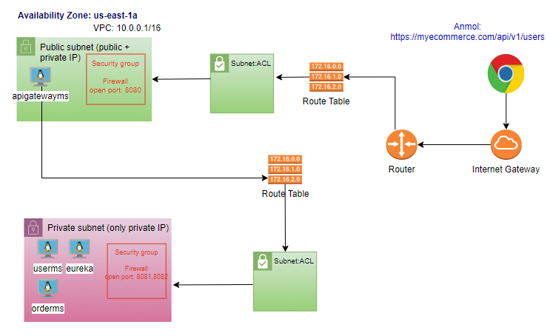

Denial of Service Attack
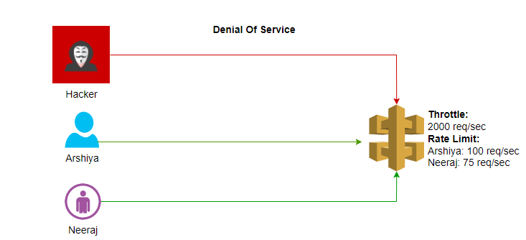

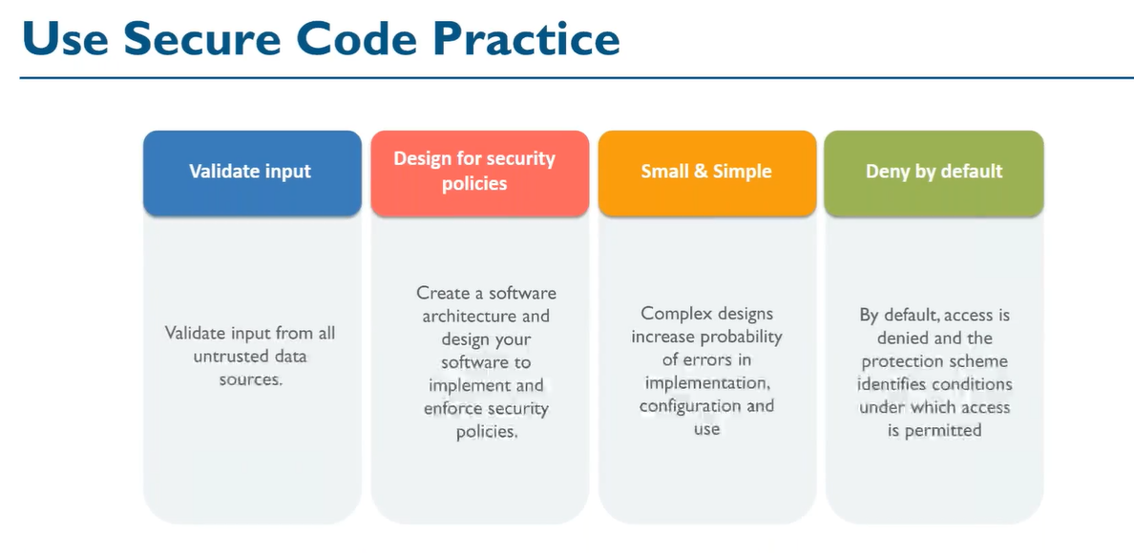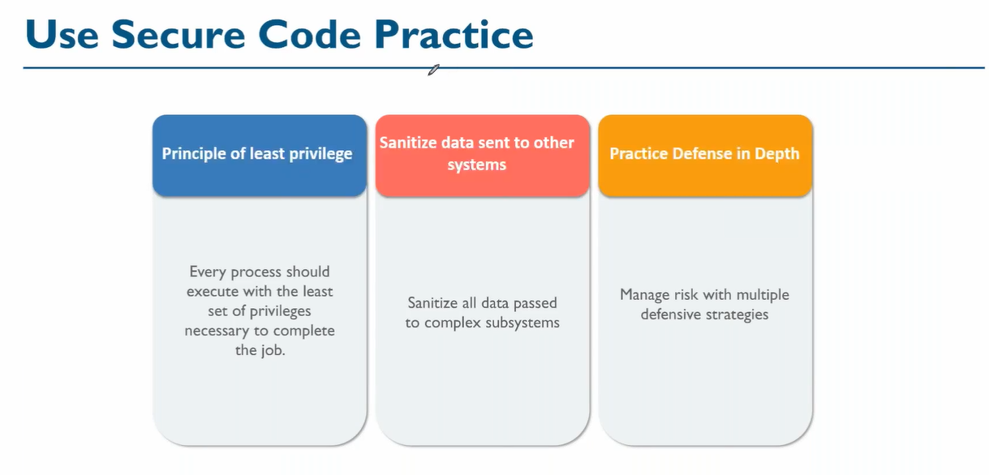
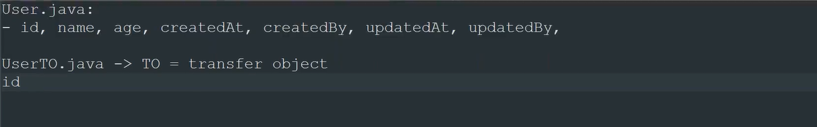
Paymentms needs only Id
Orderms need Id and name

Cloud Intro (VPC)

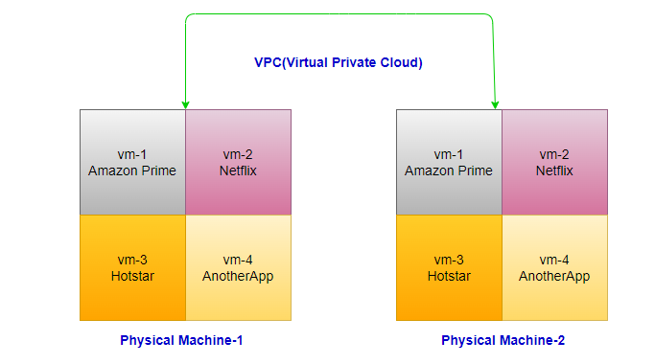
Region and Availability Zone
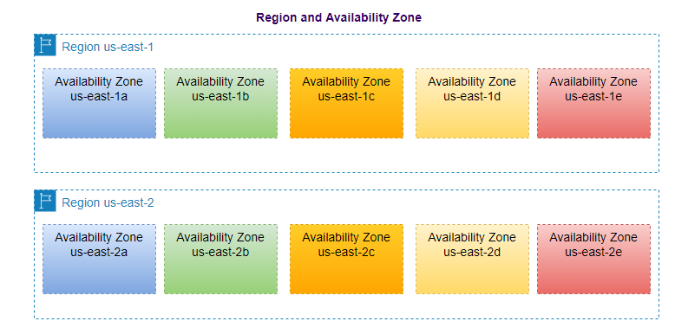
oAuth2 can be used for SSO, JWT can be used with or without oAuth2.
Cloud provides federation for authentication/authorization.

