Monolith: all components/modules in one single main component
Monolith application (eCommerce Application)
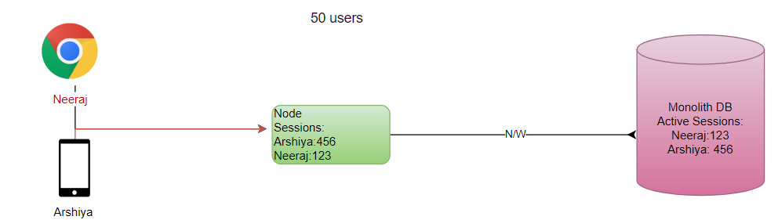

UC: Work load Increasing?
Adding more nodes: Horizontal Scaling
Adding more capacity (H/W): Vertical Scaling (SPF)

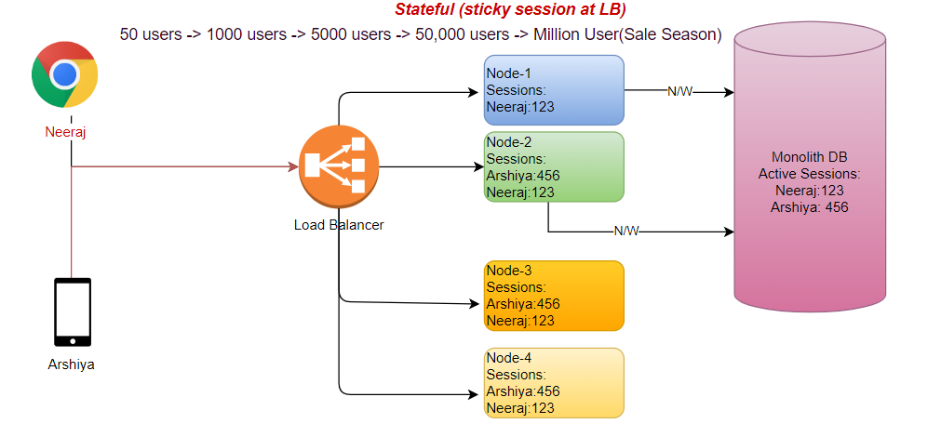
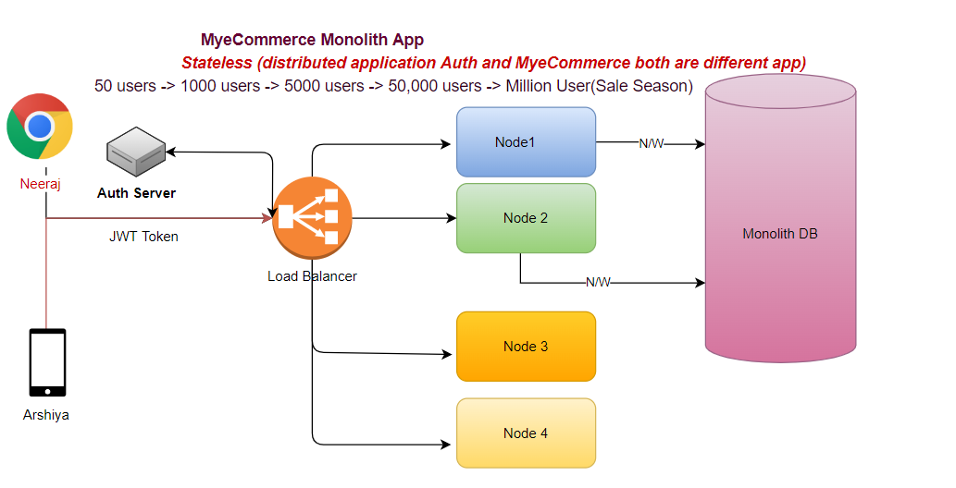
- No session management (using tokens user authenticate/authorization)
- Every request has enough info to process the request.

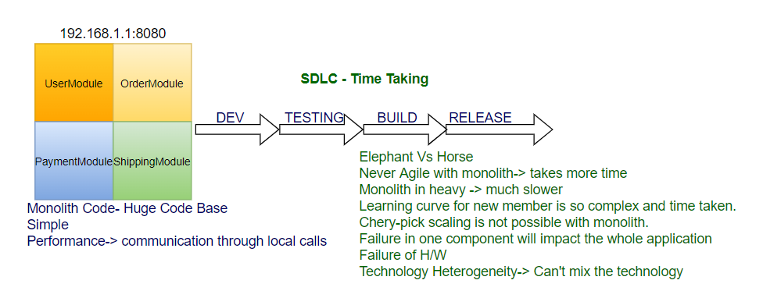
SOA: Service Oriented Architecture
service: task that achieves a functionality
ESB: Enterprise Service Bus (SPF)
- Routing
- Security
- Transformation
- Orchestrating

Microservices: Also known as the microservice architecture- is an architectural style that structures an application as a collection of services that are
Difference between Architecture of Monolith/ Microservice.
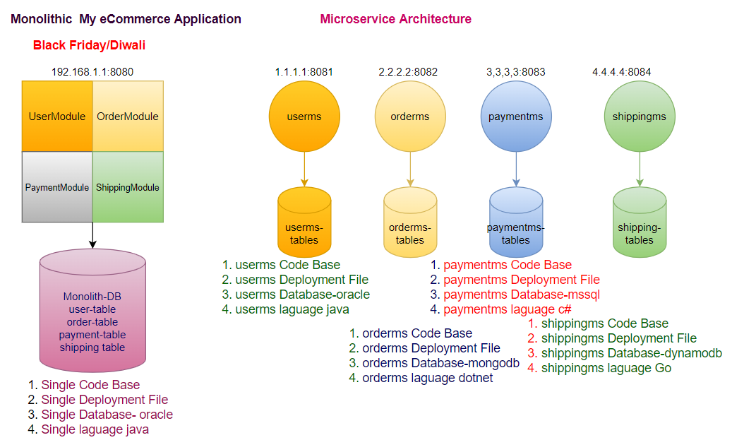

Pros of Microservice:
- Scaling + Cherry pick
- Agility-1 Development fast
- Agility-2 Build fast
- Agility-3 Testing faster
- Agility-4 CI/CD
- Agility-5 Release Faster
- Resiliency
- Distributed Nature (Service Load Distribute)
- Distributed Database Load
- Technology Heterogeneity
- Database Heterogeneity
- Security through Segregation-reduce surface area of attack

Cons of Microservice:
- Latency between ms
- Distributed Data Access (Aggregation/TX Management)
- Complexity in Managing Nodes (servers +DB)
- Cost (Infra+ Developers/DBA)
- Monitoring
- Tracing
- Testing
Building Blocks of Microservices:
- Single Responsibility Principles (High Cohesion)
- Domain Driven Design- Bounded Context
- Communication Synchronous/Asynchronous

Design and Implementation of Microservices?
- The design of microservices basically follows 12 factor principles:
- The implementation of microservice will be developed using spring boot framework:
Microservices 12 factor principles:
- Single Code base per microservices for all environments (dev, test, prod)-Git
- All application should bundle their dependencies along with application bundle - Maven
- Externalize configuration using Configuration Server - Springboot (GitHub)
- All backing services should be accessible through an addressable URL
- Strong Isolation between build, release and run ,e.g. DevOps, CI/CD
- The application should be stateless for high fault tolerance (JWT-session data at client side)
- A service able to tolerate fault (Replication)
- Expose service using port bindings
- Services should be scale out with concurrency
- Building applications with minimal startup and shutdown times
- Keeping all environment Identical as Identical as possible.
- Centralized logging for the microservices (Splunk, ELK, EFK (Fluent Bit))
  - Logstash- parser, agent
  - Elasticsearch- Storage
  - Kibana- Visualization

Spring Boot:
- microservices is not technology specific
- microservice in java can be easily implemented using spring boot
Spring Framework:
Inversion of control:
Factory Design Pattern: take care responsibility of object creation
Application don't take responsibility of object creation; container creates object at run time and give to application.
Objects are created by container with configuration define and give to the application
dependency injection:
Dependent Objects Injected automatically
Spring Core (IOC/DI)- Business Logic
What is springboot:
UC: Develop a webservice/webapp/microservices using spring mvc/spring Rest and JPA.
- Decide which versions of spring mvc, jpa, hibernate to use.
- Which version of jms(activemq)/amqp (RabbitMQ), if application uses messaging systems
- Spring security compatible versions.
- We need to define the configurations (beans/objects) to be created, define the wiring (dependency injection), application context (spring container creates objects-ioc)
- setup hibernate in data layer, creates beans/objects to create hibernate session factory (like connection factory which gives the database connection objects
- setup logging frame work
- setup caching
- setup monitoring and health check-up
- decide the application server to deploy the application/webservice/microservice
- BUSINESS LOGIC to accomplish all the business requirements.
If you go with spring boot framework efforts reduced by 25%:
Springboot is built on spring only, and spring is built on java.
Springboot is not alternative to spring mvc/spring rest/spring security/spring data
Springboot uses underneath spring modules and make developers tasks easier and faster in setting up framework.
In a summary, spring boot makes easy to create stand alone, production grade spring-based applications that we can just run
@Configuration
@ComponentScan
We are telling to spring container in the @Configuration class to create the objects of the classes that are annotated with @Componenet with the help of @ComponentScan
@Autowired - for dependency Injection where application contexts contain spring beans through ioc
REST->: Architecture Style of web service which follow http methods
Restful Webservice:
restful api:
api: piece of code that is exposed where the other piece of code can connect
REST-it works on the top of HTTP protocol
- Mainly client-server-based communication
- Client calls the REST API that hosted on the server and server sends the response back
- Key concepts:
  - Resources and url's
    - Resource: The Object or the entity
    - URL: path location of the resource
HTTP Methods:
- GET: http method where client reads data from rest api
- POST: http method where client inserts/creates/sends data to rest api
- PUT: http method where client updates data to rest api
- DELETE: http method where client deletes data through rest api
@Controller- endpoint
@Service- business logic
@Repository - DAO
Springboot:
- With Springboot we can eliminate the dispatcher servlet registrations, @EnableMvc.
- We don't need separate tomcat server, spring boot comes internally with embedded tomcat server
- start.spring.io
- spring initializer creates project template (2.7)
- Spring Web - dependency pom.xml generated by Initializer
- spring boot comes with starter
- @SpringBootApplication=@Configuration+@ComponenetScan+@EnableAutoConfiguration
Springboot main features:
- Auto Configuration
- Starter Packs with version management
- tomcat server (embedded)
- provides quicker development, comes with more than 40 different starter modules, these starter modules provide integration libraries to many frameworks such as a database connection, webservices, logging, testing libraries (Mockito,), Logging, Template rendering. e.g., for web and mvc related pack is spring-boot-starter-web, for data and jpa, the starter related pack is spring-boot-starter-data.
- When you build a project, when we need to build a spring boot with mvc, security, jdbc then we just add
  - spring boot parent module-2.7.0
  - spring-boot-starter-web
  - spring-boot-starter-jdbc
  - spring-boot-starter-security
@EnableAutoConfiguration:
- Will create the bean automatically if it sees the libraries in the class path, for example if we include spring-boot-starter-web in the pom.xml, automatically
- servlet dispatcher, handler mapping, default view resolver is automatically created.
- Will looks for libraries in the class path and creates beans automatically
- This will auto configure the required components if their dependencies are on the class path, example: if we have spring-boot-starter-web as a dependency in pom.xml (that means it is in classpath) then web mvc is automatically configured (dispatcher servlet registration, handler mappings, default view resolver, json to java and java to json conversions are automatically configured.
Microservices:
- Spring boot is the library or framework where we can implement microservices easily
- Speed in development
- Easily integrated with devops and agile model
- Containerized model- each microservice runs in its own server
- Springboot with help of autoconfiguration makes the config setup quickly
- Spring boot comes with tomcat server and it can be easily containerized.
The thumb rule:
- If we need to develop 3 microservices, that means practically we need to develop 3 spring boot projects
- Each springboot project:
  - controller (defining the rest api end points)
  - service (business logic)
  - repositories or DAO layer (data access operations)

Flow:
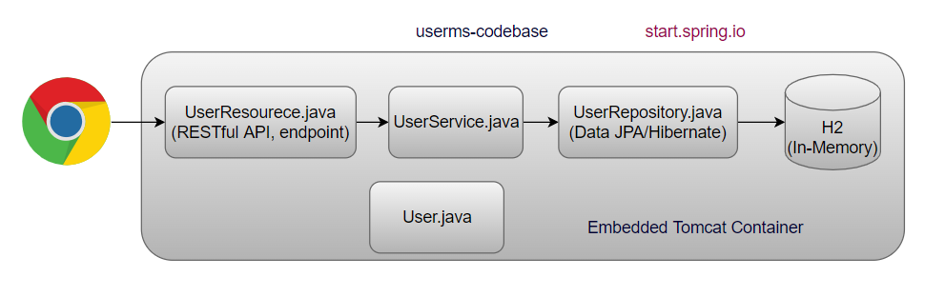
Concepts:
spring cloud (build on top of spring boot), spring cloud has its own libraries, and it has tie up with Netflix libraries to achieve functionalities like service discovery, client-side load balancing, circuit breaker. Earlier spring cloud completely dependent on Netflix lib, since Netflix suport is withdrawn, spring cloud developed its own libraries
- Service Registry and Discovery- Netflix Eureka
- Client-Side Load Balancing- Netflix Ribbon/Spring Cloud LoadBalancer
- Resiliency Implementation Using Circuit Breaker- Hystrix/Resilence4j
- Monitoring Using Actuator and Micrometre - Prometheus/Grafana
- API tracing using spring cloud sleuth and Zipkin
- Centralized Config Using Spring Cloud Config
- Centralized logging using ELK
- Security Using OAuth and JWT
- API Gateway- Zuul/Spring Cloud Gateway
Env:
- eclipse latest
- java 17
- mysql
- maven 3
- arc- advance rest client
- tomcat 10
- Git Client
- activemq
- kafka
- aws cli
- WinSCP

UC: userms wants to call orderms, but ip address of ms is not static its dynamic in nature, how to find the ip address of orderms?
Solution: Service Discovery/Service Registry, just like telephone directory, it keeps track of each ms.
- Register each ms in eureka registry, each instance of ms sends their heart beat to the eureka server.
- server doesn’t look for, instance itself sends the heartbeat to the eureka registry
- if instance down, stops to send the heartbeat, eureka registry remove that instance details from the registry.
- It is not for load balancing, just only for discovering services dynamically.

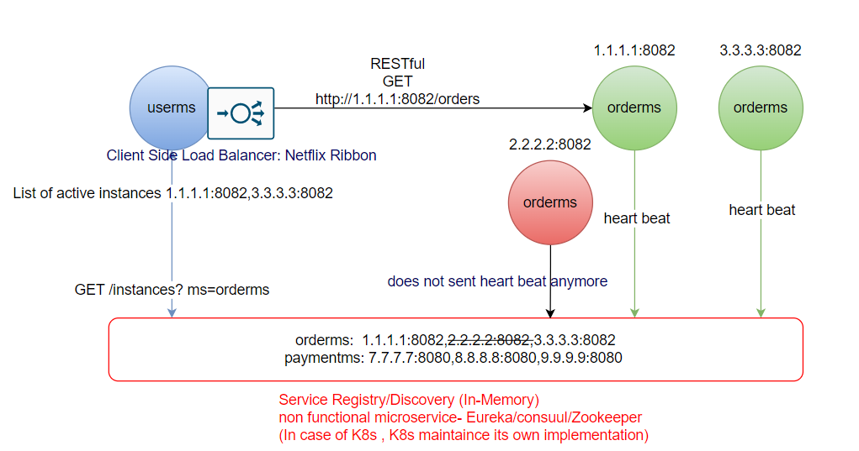
- If there are more than one instance of orderms available then which instance will be called?

Client-Side Load Balancer: Inside the source ms (Ribbon)
- First time ribbon takes values from the registry after that it keeps in cache (TTL) provided by eureka and calls the orderms, getting reference from cache directly.

- After registry in eureka
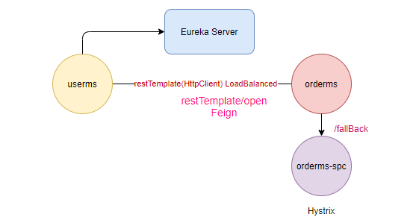

@SpringBootApplication
@EnableAutoConfiguration- scan all classpath .jar on your behalf
@ComponentScan

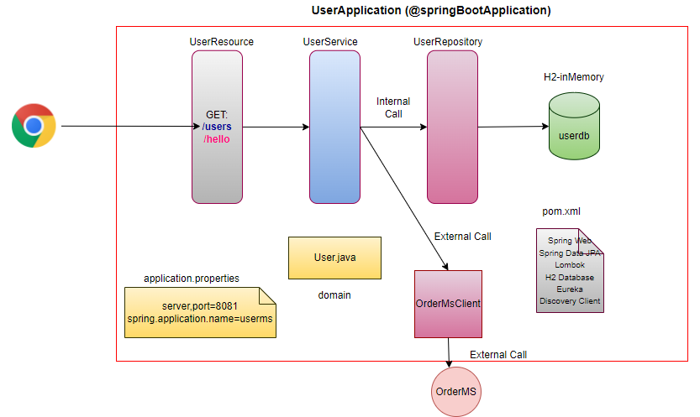

API Gateway
- NFR (Security/Authentication/Caching/URL-hiding.)
- Every cross-cutting concern moves to API Gateway
- API Gateway is for external user, Eureka is for internal components
- Single point of entry in your application
- Must be stateless
- No business logic
- API can have a logic of token validation
- If token is Invalid ApiGateway rejects the request, will not forward it to Eureka/other microservice.
- URL hiding
- Rate Limit (Throttling)
- Denial of Service (Dos)

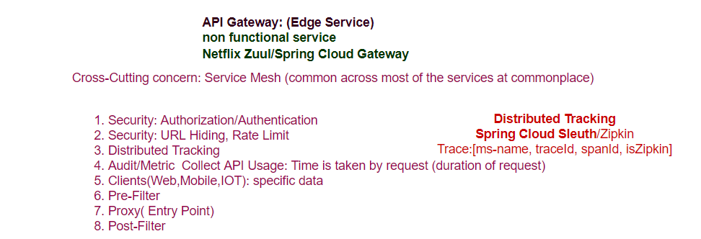
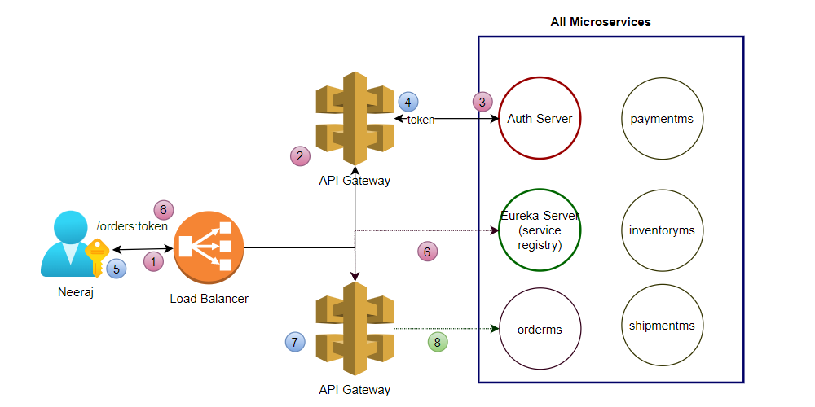

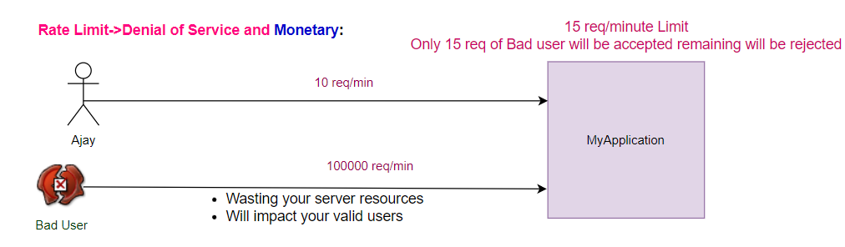

Microservice Design Patterns
- Apigateway - Zuul/Spring Cloud Gateway/ApiGee, AWS-Apigateway, Nginx
- Proxy - Zuul, Nginx
- Service Discovery/Registry - Eureka/etc/Zookeeper/Consuul
- Circuit Breaker - Hystrix, Resilience4j
- Client-side load balancing - Ribbon, SpringCloudLoadBalancer
- Distributed Tracing – Sleuth/Zipkin (UI Visualization)
- Saga - StateMachine (Orchestrator/Choreography)
- Metrics Collection (Actuator Prometheus/Datadog)
- Strangler Vine - Migration from Monolith to MSA
- Shared Data pattern - Migration from Monolith to MSA
- Database per service - MSA
Functional Pattern:
- Aggregator
- Chained
- Branch Pattern
- Event Sourcing
- CQRS
- Log Aggregation (Centralized Logging)
- External Configuration
Deployment Design Pattern
- Service per Machine
- Service per Container
- Sidecar
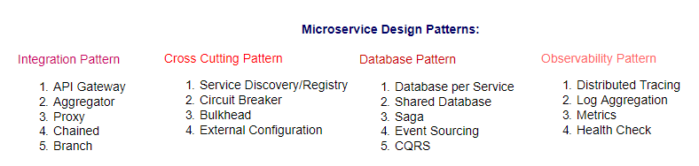
Aggregator Service
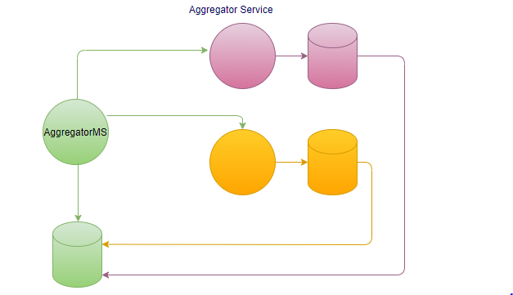
Chain Pattern
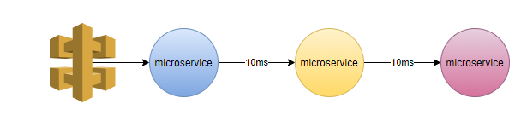
When go for microservices?
When you want to modular / distributed applications.
Not suitable for low latency applications (go for low level language).
Event Sourcing and CQRS
UC: Extremely high writes
Event sourcing, we track every event the journey of your data.

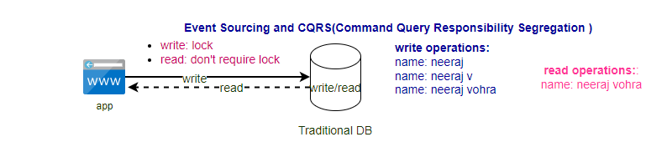
CQRS: Command Query Responsibility Segregation
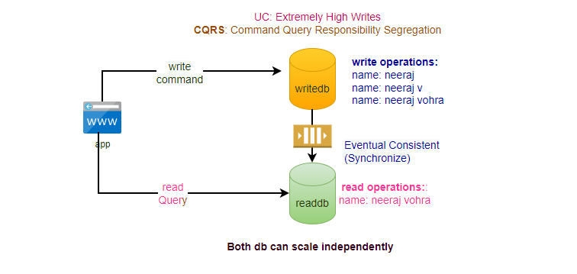
Event Sourcing:
- In tradition database approach destination was more important than journey.
- In Event Sourcing Journey is more important than destination.
- It is very important for auditing purpose.
- It takes any update as an event.
- Event sourcing is also possible in Oracle DB.
- limitation is that can't query the data.
- Data is Eventual consistent.

Limitation of event table can’t query the data used with CQRS.
Event Sourcing + CQRS:
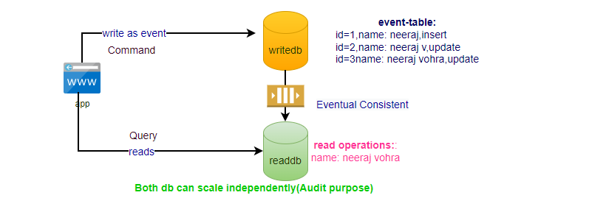

Decentralization at DB level:
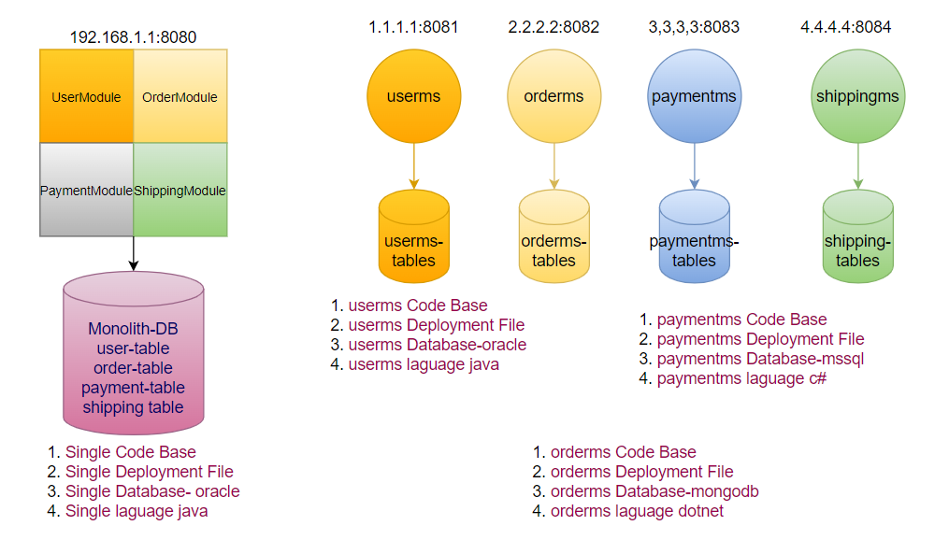
UC: something happens with userdb, failure of one DB will not impact the other flows.
Every MS allows to call only its own DB, suppose if userms wants to know about the orders then userms call Rest Service of orderms to get the order details, can’t call order db directly. Every MS is owner of its own DB.
Advantage
- Scalable
- Higher Throughput
- Resilient
- DB Heterogeneity
Disadvantage
- Cost: Increase
- Maintenance: Increase
- Constraints: No Relationship between DB

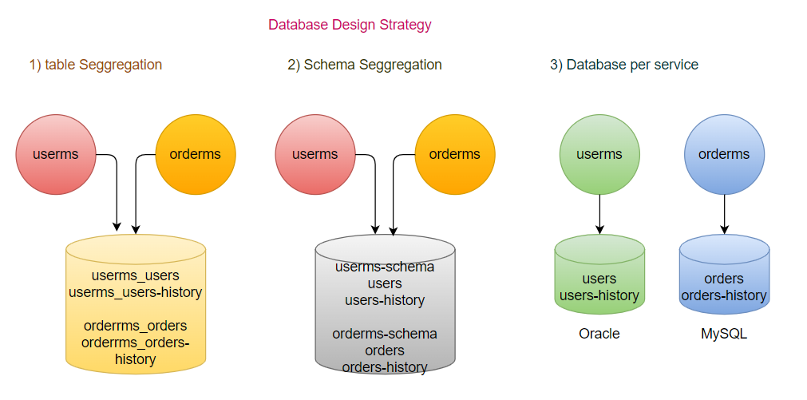
How to relate data (correlation maintain) between two different db?
Identifier may be present in other DB.
DRY: Don’t repeat yourself
WET: Write Everything twice
step1: user registered in the system (userid will be generated)
step2: registered user calls the orderms, will sends all details with the request in header (will send the userid).
step3: registered user calls the payments for his order, sends all details with the request in header (will send the userid, orderid).
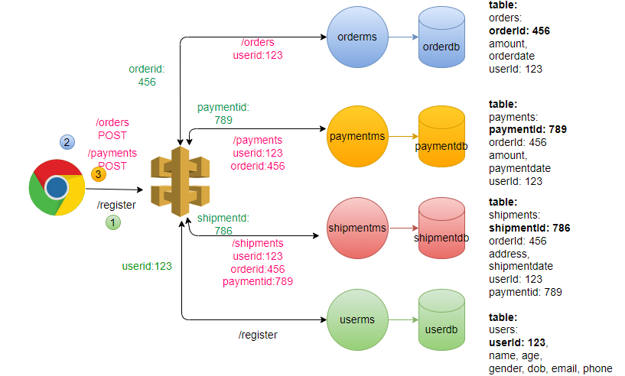
Rule:
- paymentms can’t be called unless order is created.
- orderms can’t be called unless user is onboarded
- Identifier taken care by ms itself.
How to Aggregation of Data happen?
Aggregation done at MS level not at DB, Aggregator as a separate service.

Transaction Management:
Local Transaction:
In Single DB (Atomicity-either all or none)- Transaction (executing group of Database operations as a one single logical operation) ACID
Distributed Transaction:
2-phase commit
- Prepare Phase: Transaction mgr will ask the participant nodes whether they are ready to commit their individual local transactions
- Commit Phase: If all the participating nodes reply positively then transaction manager will tell the nodes that commit your transactions
Limitation: SPF (Transaction Manager)
Transaction Coordinator has to wait for confirmation from all the nodes
SAGA: Distributed transaction for microservices using different DB
- Choreography
- Orchestrator
Choreography:
- Every service participates in its own local transaction. If any service transaction fails, responses back to service received the event, so that those services will generate a compensatory transaction that roll back
Orchestrator:
- There will be an orchestrator that manages entire transaction among the services.
- Orchestrator call services sequentially, if it receives success response from service, it calls another service. If one of the services fail then orchestrator will rollback all previous service transactions.
- Camunda/Apache Camel (mini ESB)

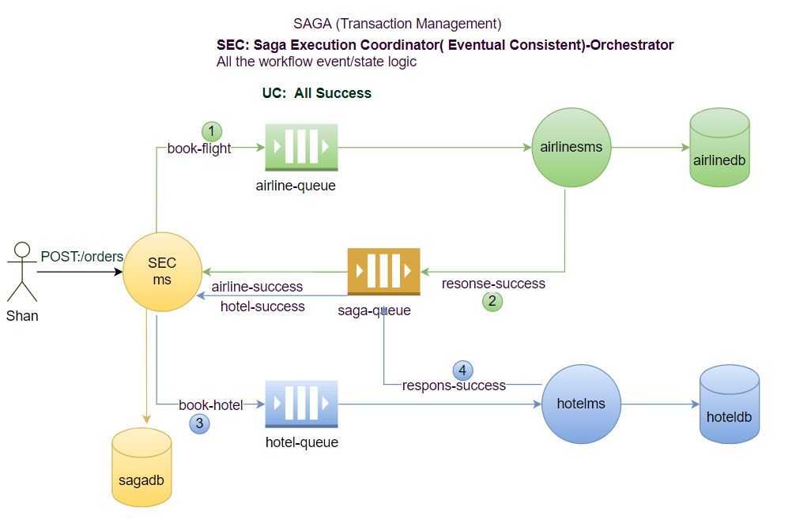

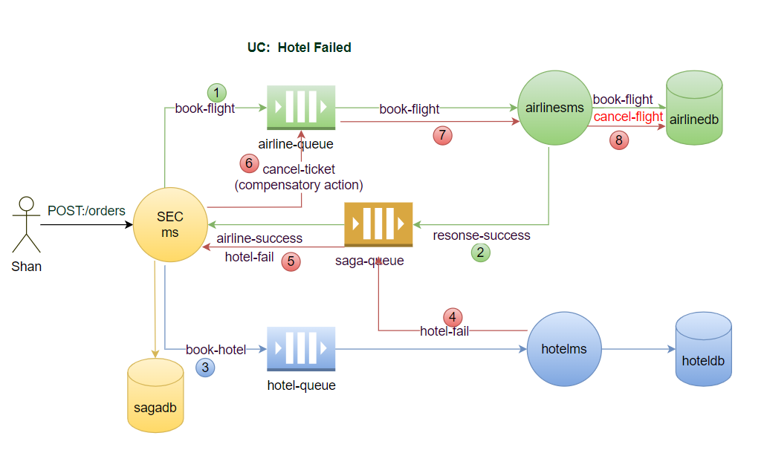

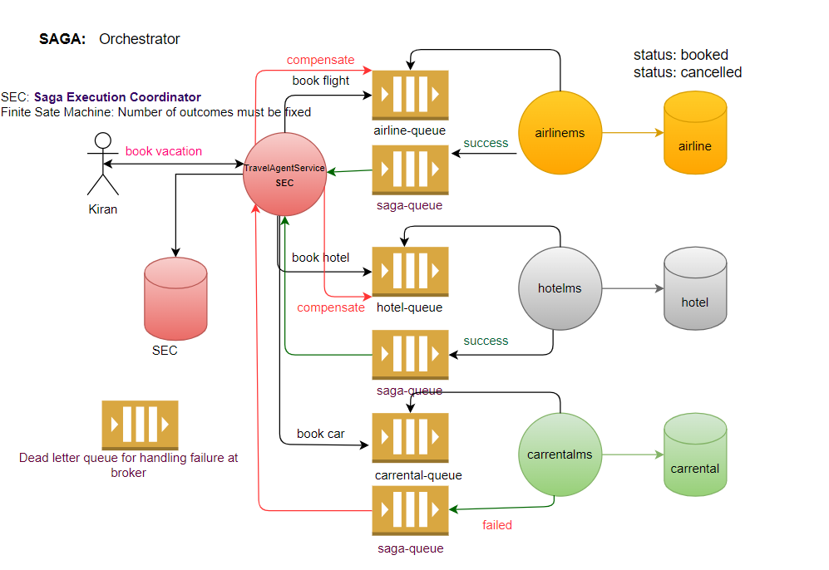
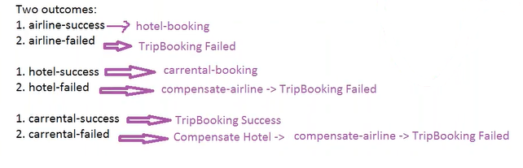
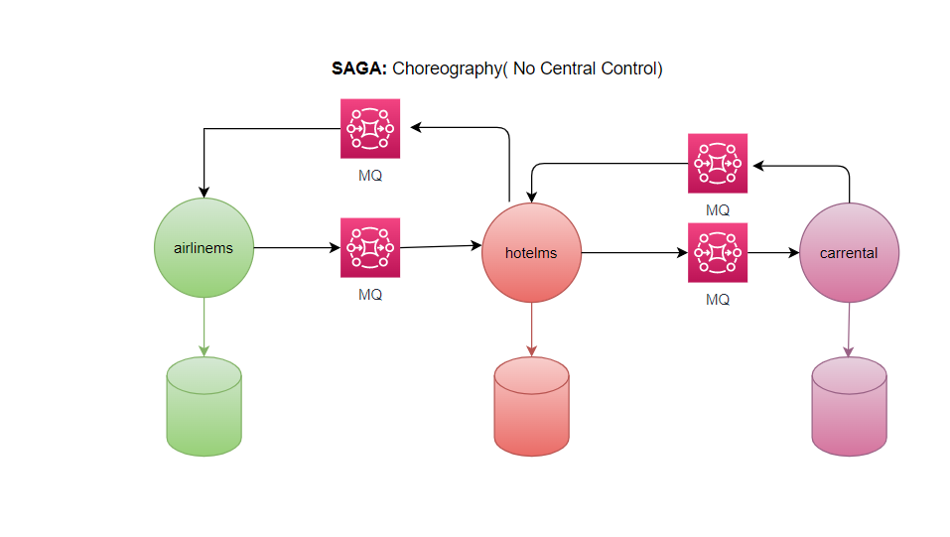
It’s an Event driven pattern, not an Event sourcing. Event sourcing comes with CQRS.
It’s all about handling the transaction, not from customer point of view when customer cancel the ticket, in that case charges are deducted will be another svc.

Inter-process communication Ways of communications?
Synchronous (RESTful)
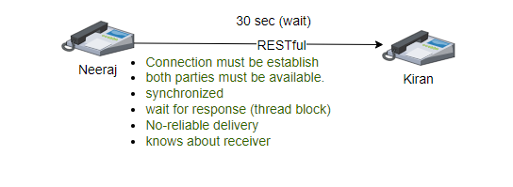
Asynchronous (Messaging- guaranteed to be delivered)
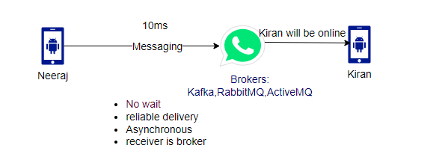
Messaging Solution
ActiveMQ- Push based (Broker has to do push the message): AMQP
RabbitMQ – Push based, good for medium traffic: AMQP
Apache/Confluent Kafka- Pull based (consumer pulls the message), good for heavy traffic, high scalable, high throughput and low latency: Kafka
AWS SQS- Push based
AWS SNA- Pull based
AMQP: Advanced Messaging Queue Protocol (ActiveMQ, RabbitMQ)- PUSH
Kafka: Own protocol (Kafka Protocol)- PULL
JMS
Messaging Types:
Point-to-Point(one-to-one) Queue: Only one receiver (push based)- SQS
UC: orderms published the message for paymentms, if there are multiple instances of paymentms, we want only should be received by only 1 instance, don’t want duplicate processing.
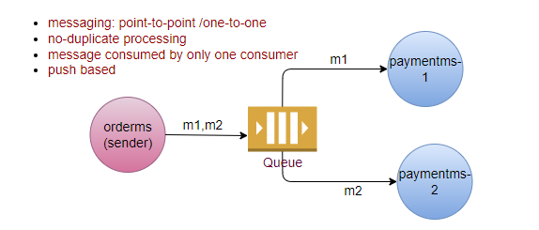
Pub-Sub (one-to-many) Topic (deliver only if consumer available): Multiple receiver (pull based consumer poll the message)- SNS
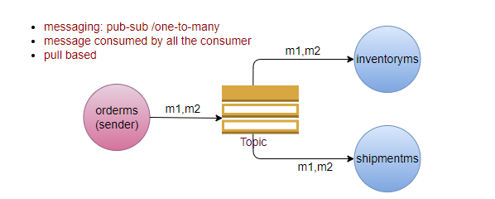
Pub-Sub Kafka:
- Poll message
- High throughput
- Low Latency
- High Scalability
- Keeps message for 7 days (reliable)
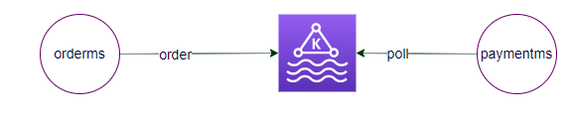
When go for RESTFul and when go for Messaging?
It depends upon the use case to use case
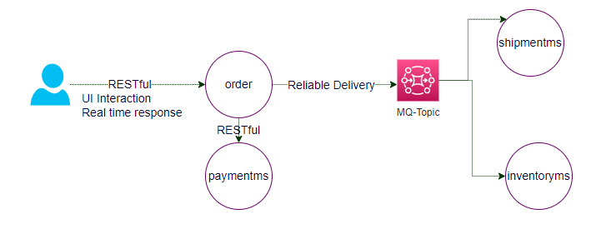
Domain Driven Design
The main objective of DDD is divide and conquer (technical + business experts)
How the organization trends to design their application in the way similar to the work.
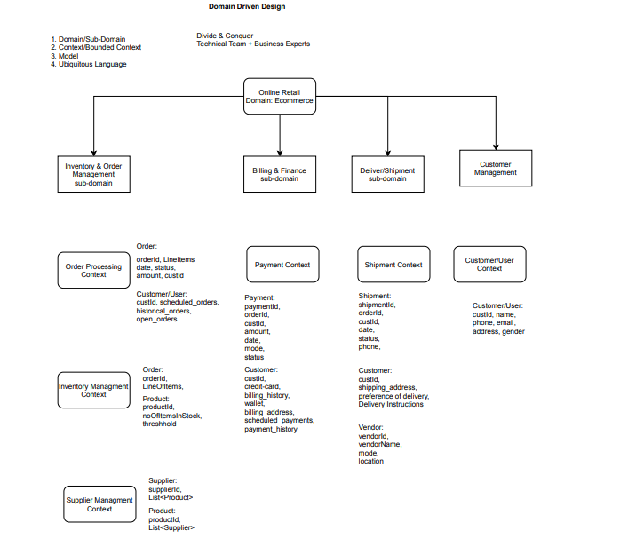

There are four aspects of DDD
- Domain/Subdomain
- Bounded Context/Context
- Model (w.r.t context)
- Ubiquitous Language (applied on the model)
Approach: Divide and Conquer between Technical and Business experts
Bounded Context (logical boundary) specific to the business context, each bounded context maps to the individual ms, this helps us to Identify what ms needs. Logical boundary across the certain functionality of the business.
Each context has their own model, same model (customer)may reside in different contexts, each context has different meaning of the model.
customer in customers context as well as customer in payment context, and customer in order processing context, every context has different meaning of the customer.
In above example Ubiquitous language (same thing but different meaning in different context)
UC: Telecom Organization: Telephone
Departments:
- Customer Context: Phone calls
- Operation Context: A device installed at customer premise.
- Finance: Bills
- Telematics: A number with an area code
It’s a DDD not a database design, DDD is all about the business not about the technology, model may be implemented as database table.
Source of truth: customer Id
Granularity of MS
- DDD
- Every request <3-5 ms
- Benchmarking (recording the performance of application) is always done after code written.
Securing Microservices: Our data is our responsibility
UC: security of data
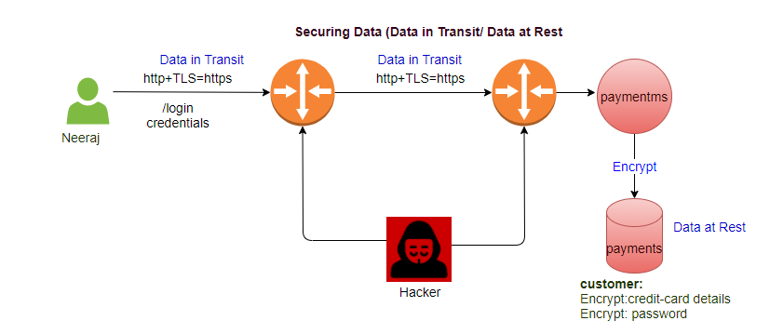
Microservices Big Picture:
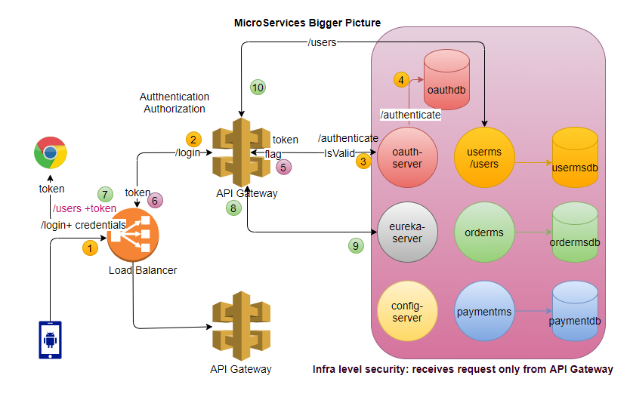
Oauth-server implementation?
- single-signoff
- create your own oauth-server
- out of box solution to implement the security:
  - Okta
  - KeyClock
Oauth2 (Application-level Security: Third party login):
