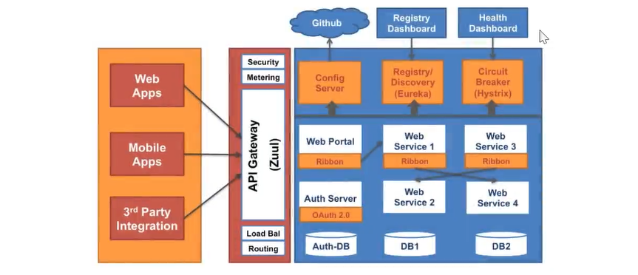
Microservices: Also known as the microservice architecture- is an architectural style that structures an application as a collection of services that are
- Highly maintainable and testable
- Loosely coupled
- Independently deployable
- Organized around business capability
- Owned by small team
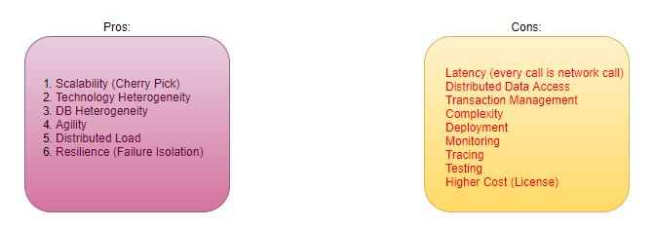
@SpringBootApplication
@SpringBootConfiguration
@EnableAutoConfiguration- scan all classpath .jar on your behalf
@ComponentScan
Service Registry and Discovery- Eureka
Ribbon- Client-Side Load Balancing
Hystrix (Resilience)- Fail Over
OpenFeign and RestTemplate: ms communication
API Gateway- Zuul Proxy
Distributed Tracking: Sleuth/Zipkin [service name, requestid, trackid, zipkin-flag-
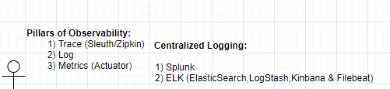

API Gateway
- NFR (Security/Authentication/Caching/URL-hiding.)
- Every cross-cutting concern moves to API Gateway
- API Gateway is for external user, Eureka is for internal components
- Single point of entry in your application
- Must be stateless
- No business logic
- API can have a logic of token validation
- If token is Invalid ApiGateway rejects the request, will not forward it to Eureka/other microservice.
- URL hiding

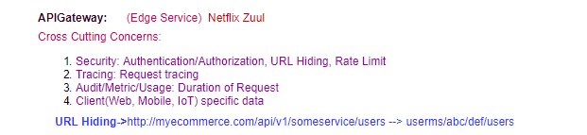

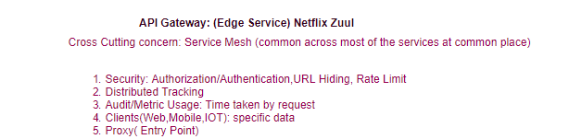

Swagger/Docket
DRY: Don’t repeat yourself
WET: Write Everything twice
SAGA: Orchestrator
SAGA: Choreograph
SAGA: (using messaging): Finite State Machine
It’s an Event driven pattern, not an Event sourcing. Event sourcing comes with CQRS.
Inter-process communication Ways of communications?
Synchronous (RESTful)
Asynchronous (Messaging- guaranteed to be delivered)
Messaging Solution
ActiveMQ- Push based (Broker has to do push the message)
RabbitMQ/Erlang – Push based, good for medium traffic
Apache/Confluent Kafka- Pull based (consumer pulls the message), good for heavy traffic, high scalable, high throughput and low latency
AWS SQS- Push based
AWS SNA- Pull based
AMQP: Advanced Messaging Queue Protocol (ActiveMQ, RabbitMQ)-push
Kafka: Own protocol (Kafka Protocol)
- Poll message
- High throughput
- Low Latency
- High Scalability
- Keeps message for 7 days (reliable)
Microservice Design Patterns
- Apigateway - Zuul/Spring Cloud Gateway/ApiGee, AWS-Apigateway, Nginx
- Proxy - Zuul, Nginx
- Service Discovery/Registry - Eureka/etc/Zookeeper/Consuul
- Circuit Breaker - Hystrix, Resilience4j
- Client-side load balancing - Ribbon, SpringCloudLoadBalancer
- Distributed Tracing – Sleuth/Zipkin (UI Visualization)
- Saga - StateMachine (Orchestrator/Choreography)
- Metrics Collection (Actuator Prometheus/Datadog)
- Strangler Vine - Migration from Monolith to MSA
- Shared Data pattern - Migration from Monolith to MSA
- Database per service - MSA
Functional Pattern:
- Aggregator
- Chained
- Branch Pattern
- Event Sourcing
- CQRS
- Log Aggregation (Centralized Logging)
- External Configuration
Deployment Design Pattern
- Service per Machine
- Service per Container
- Sidecar
When go for microservices?
- When you want to modular / distributed applications.
- Not suitable for low latency applications (go for low level language).

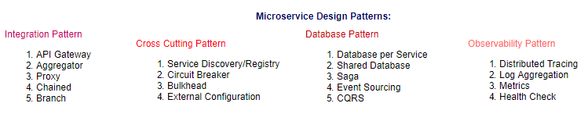
GitHub/ ConfigServer/ Spring Cloud Bus (Rabbit MQ /Kafka)
- Broker
- Topic
- Record (Message)
- Producer
- Consumer
- Consumer Group
- Partition (Scalable)
- Replication Factor (Highly Available)
- Offset
- Zookeeper
To maintain the uniqueness of processing, we have to implement the consumer group (Idempotent)
ActiveMQ and RabbitMQ follow the AMQ (Advanced Messaging Queue) protocol (Push based), Kafka has its own protocol. (Poll based).
Untangling the ball of Mud (Migrating from Monolith)
BigBang Approach
Migrate complete monolith in First Day of Release, is not recommended
Strangler Vine Approach (Hybrid): Says start from a one simple module, and convert it into ms after DDD (do the refactoring at monolith side before the migration).
Immediate consistency-Synchronously
Eventual Consistency- Asynchronously
How to improve the performance? Eventual consistency-Asynchronous
DDD
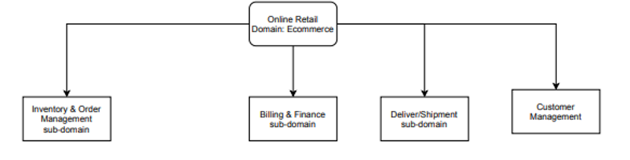

There are four aspects of DDD
- Domain/Subdomain
- Bounded Context/Context
- Model (w.r.t context)
- Ubiquitous Language (applied on the model)
- Bounded Context (logical boundary) specific to the business context, each bounded context maps to the individual ms, this helps us to Identify what ms needs. Logical boundary across the certain functionality of the business.
Each context has their own model, same model (customer)may reside in different contexts, each context has different meaning of the model.
In above example Ubiquitous language (same thing but different meaning in different context).
Refactoring at monolithic side (convert method calls to remote call).
How to stop the Monolith from Growing
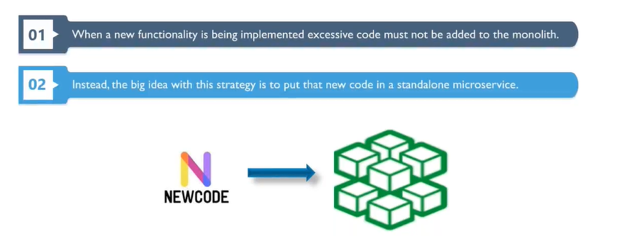
Data Access
Hybrid DB Architecture (Who is owner of DB): Only owner has access of write operations
- Access the monolith’s database directly.
- Monolith provides a function to access data remotely.
- Replicate and synchronize a local copy of data.

CDC (Change Data Capture):
CAP Theorem:
- Consistency
- Availability
- Partition Tolerance
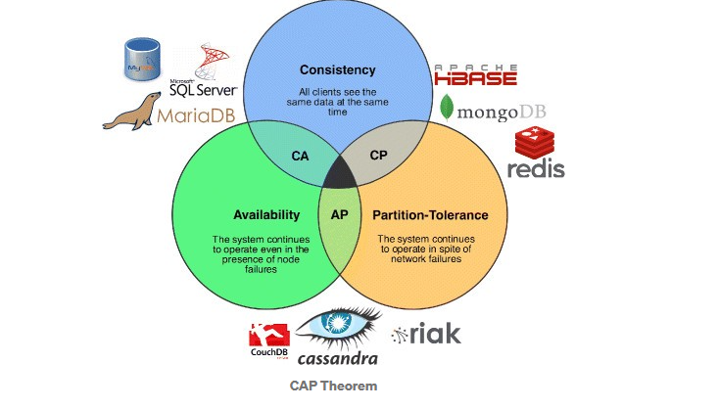
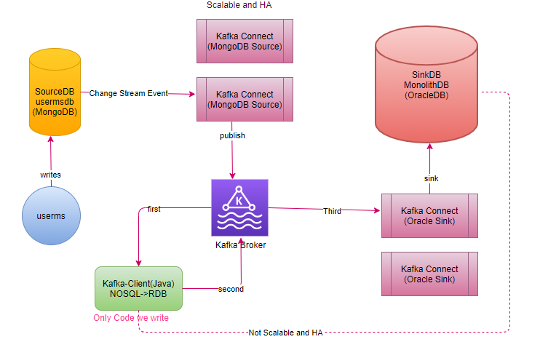
Kafka Connect is out of box solution, provided by Kafka, Kafka Connect Job is consuming the messages from Change Stream Event and publish to Kafka, don’t need to write them just configure the same.
In case of Oracle, use another Out of Box Solution -Debezium Connector for Oracle DB, Use Debezium Connect for Oracle.
kafka is meant for low-latency tool: Gives 7 days persistent by default
Event sourcing, we track every event the journey of your data.
Event Sourcing and CQRS
UC: Extremely high writes: auditing purpose
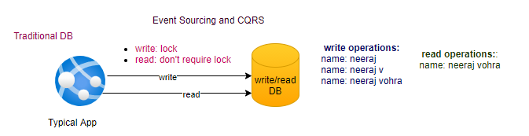
CQRS: Command Query Responsibility Segregation
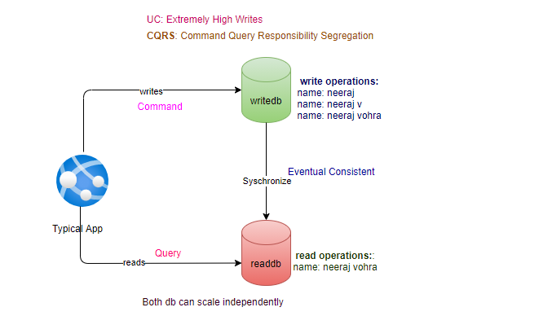
- Data is Eventual consistent.
- It is very important for auditing purpose.
- It takes any update as an event.

Refactoring
Step1: first convert HAS-A relationship in to interface (IS-A)
Step2: For refactor create one more class ClassZRemote
Step3: By default, ClassZLocal defined as a @Primary
Step4: Once ms is created, update the annotation @Primary to ClassZRemote.
@Primary indicates that a particular bean should be given preference when multiple beans are candidates to be autowired to a single-valued dependency. If exactly one 'primary' bean exists among the candidates, it will be the autowired value.
Use namespaces to divide the cluster .
separate resource quota and access for each namespace.
Use network policy to control pod traffic.
control traffic by IP, label, or namespace.
Implement RBAC (Role Based Access Control)
specify separate roles for separate groups (admin , developer, tester etc.)
Do not allow privileged escalation.
Prepare for privileged Vs root
Use OPA(open policy agent) to enforce restrictions.
Images from approved repo, namespace with labels with point of contact etc.

Biggest challenge faced on cloud
There is so many services, it's hard to determine when to use for what.
The scaling example we went through
Its challenging to cost optimize the application (Give an example)



HA: Active passive
DR- read replicas (Region Specific)

Immediate consistency-Synchronously
Eventual Consistency- Asynchronously
DAX: Amazon DynamoDB Accelerator (DAX) is a fully managed, highly available, in-memory cache for Amazon DynamoDB that delivers up to a 10 times performance improvement—
Elasticache:
Memcached: In Memory
Redis: Persistent
What is cloud computing?
Cloud Computing is on-demand delivery of IT resources over the Internet with pay-as-you-go pricing. Instead of buying, owning, and maintaining physical data centers and servers you can access services, such as computing power, storage and databases, on as-needed basis from cloud provider.

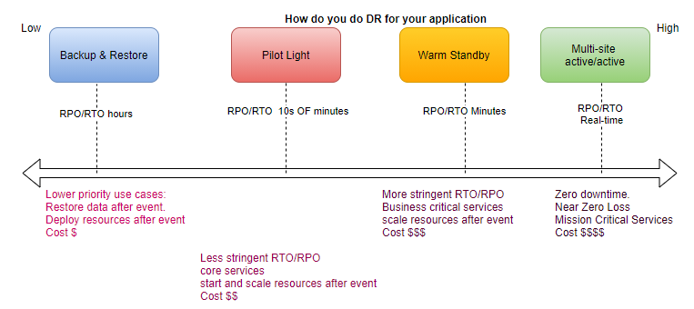
actuator /CDC change data capture
immediate vs eventual consistency
HA: Active passive
DR- read replicas (Region Specific)

Immediate consistency-Synchronously
Eventual Consistency- Asynchronously

Kafka Connect is out of box solution, provided by Kafka, Kafka Connect Job is consuming the messages from Change Stream Event and publish to Kafka, don’t need to write them just configure the same.
In case of Oracle, use another Out of Box Solution -Debezium Connector for Oracle DB, Use Debezium Connect for Oracle.
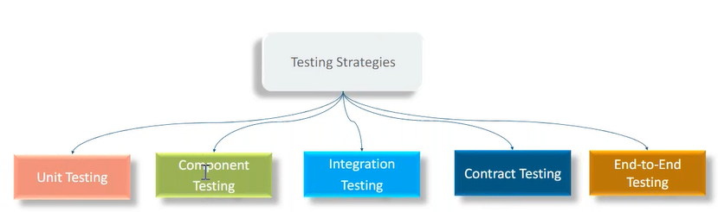
microservice either interact with another microservice or interact with database.
Integration Testing (w.r.t single ms)
Focus on to test the Integration boundaries rather than to test the business logic, business logic intensively tested on unit test
Contract-Testing: (Extension of Integration Testing)
Testing Tools (part of Pipeline):
- Fortify (Security Vulnerability in your code)
- Black Duck (Security Vulnerability in third party code)
- IDE Plugin (Eclipse: EclEmma, Maven: Jacoco, SonarLint)- Line Coverage
- SonarQube (Line Coverage + Conditional Coverage + Code Smells)
- Mutation Test (Testing of Tests)-PIT (pitest.org)
- Chaos Engineering
DevOps Tools:
- Code Version: Git
- Configuration Management: Chef, Puppet, Ansible
- Containerization: Docker
- Container Orchestration: Kubernetes
- CI/CD Pipeline: Jenkins

Securing Microservices: Our data is our responsibility
Sensitive Information needs to be segregated.

security of data
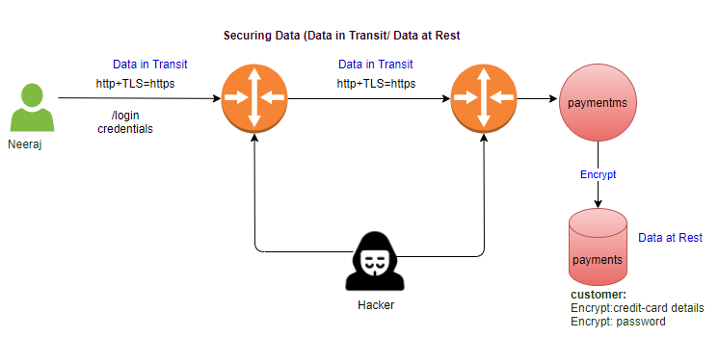
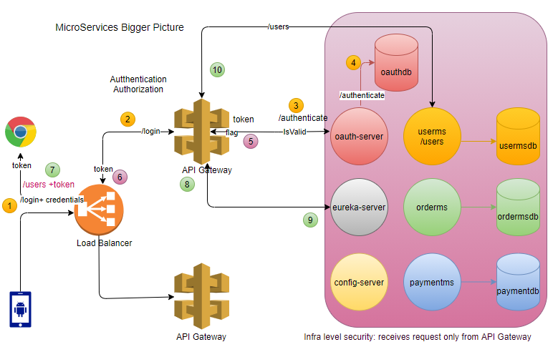
UC: Opaque token (Bearer):
UC: JWT token (Bearer):
External Load Balancer
- Apache HTTP server
- NGINX
- F5
- HA Proxy

Oauth-server implementation?
- single-signoff
- create your own oauth-server
- out of box solution to implement the security:
  - Okta
  - KeyClock

Difference between Opaque and JWT token?
Opaque Token is dump token, just a random string does not contain any inherent value.
JWT is smart token, it contains the inherent information (HEADER, PAYLOAD and VERIFY SIGNATURE).
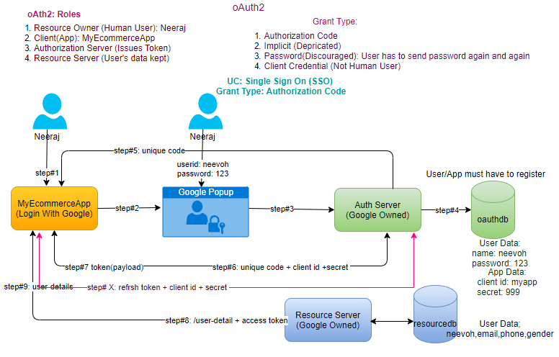
Commercial Auth Servers:
- Okta
- KeyClock

DB:
DR- Read Replica-Asynchronization
HA- Synchronized
How to make your application scalable.
Auto Scale
LB
pre-warm LB:
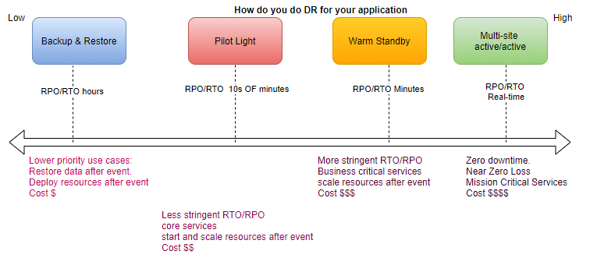
Security:
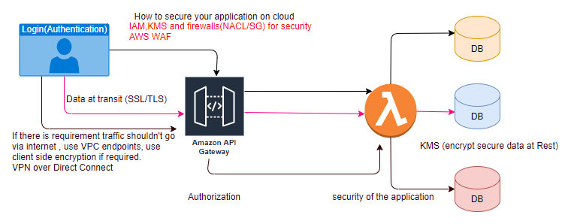
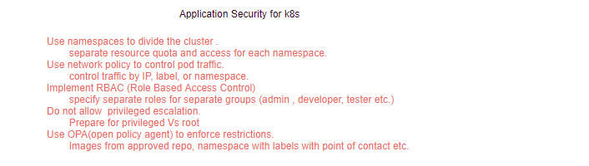
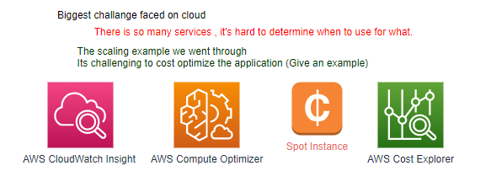
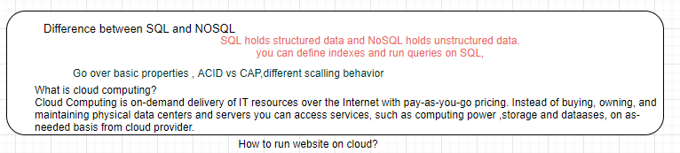
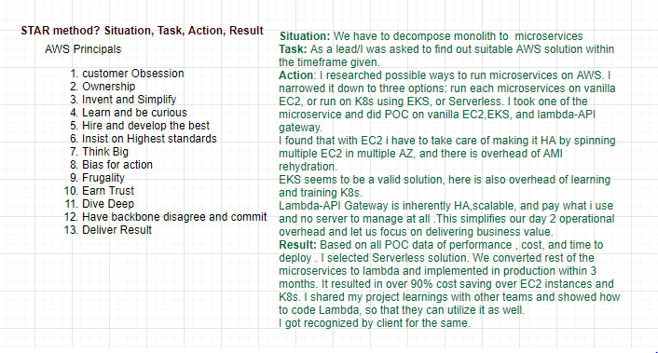
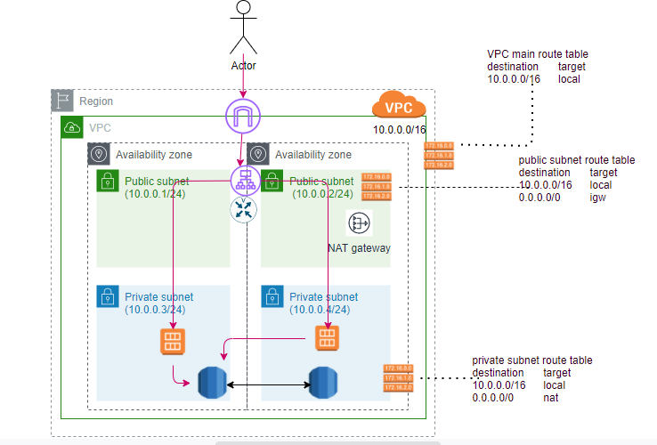
DevOps
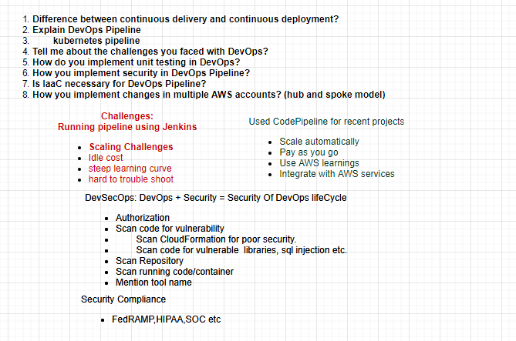
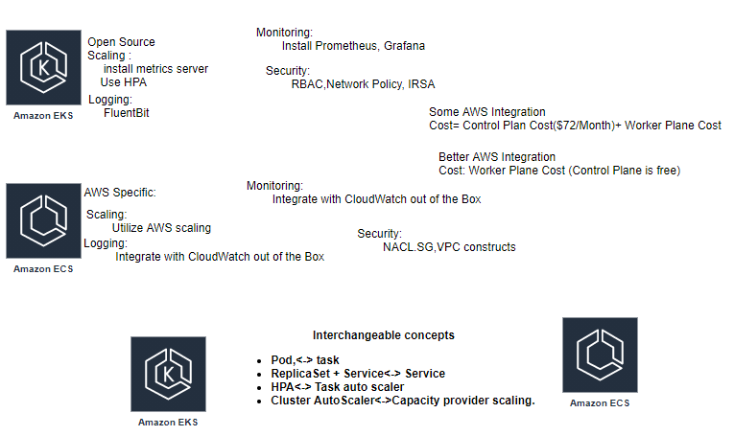
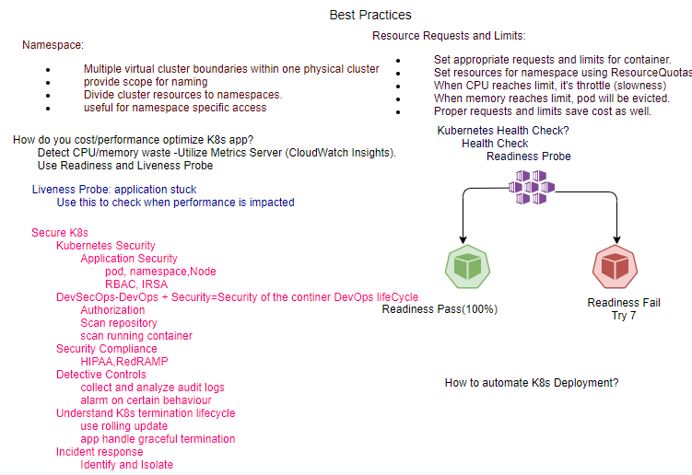
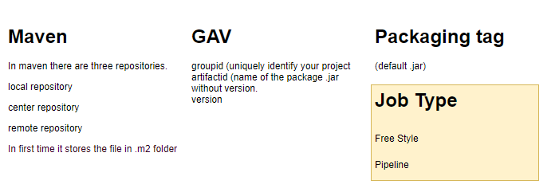
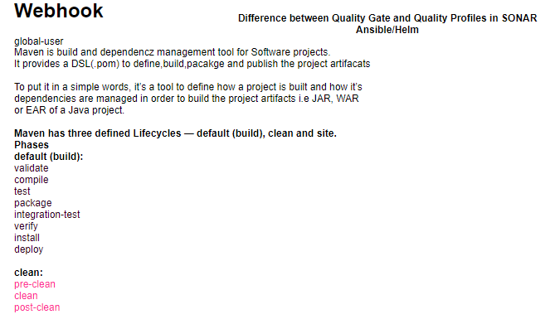
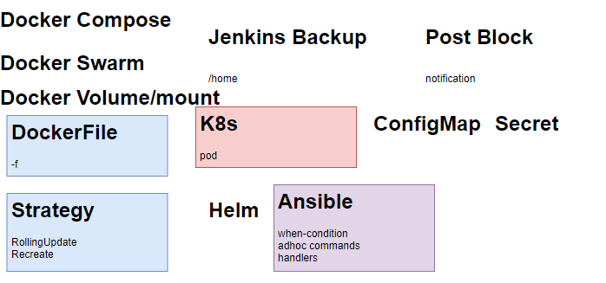

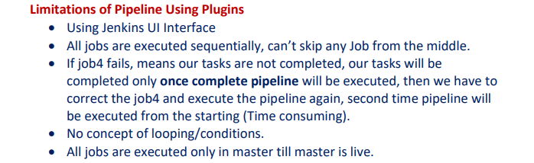
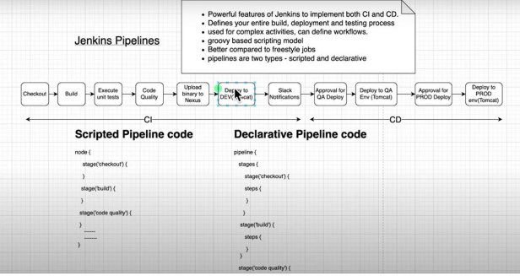
TCO
AWS Trusted Advisor
calculator.aws

Pillars of Observability
- Trace-fluent Bit
- Log
- Metrics
Penetration Testing:
Exception Handling?
Learning is continuous journey not the destination.

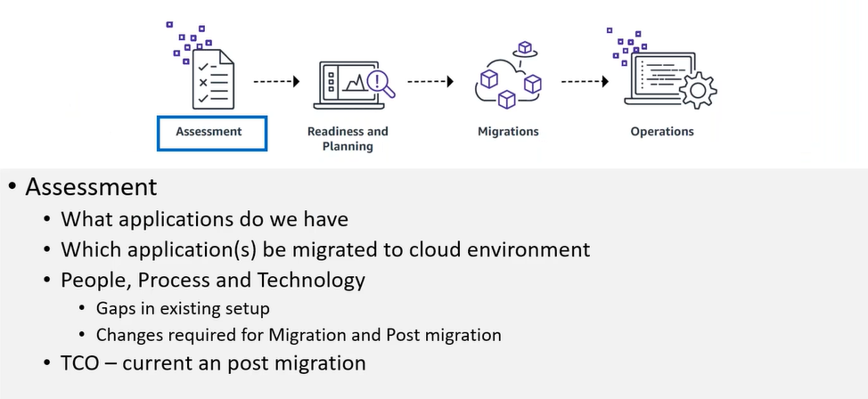
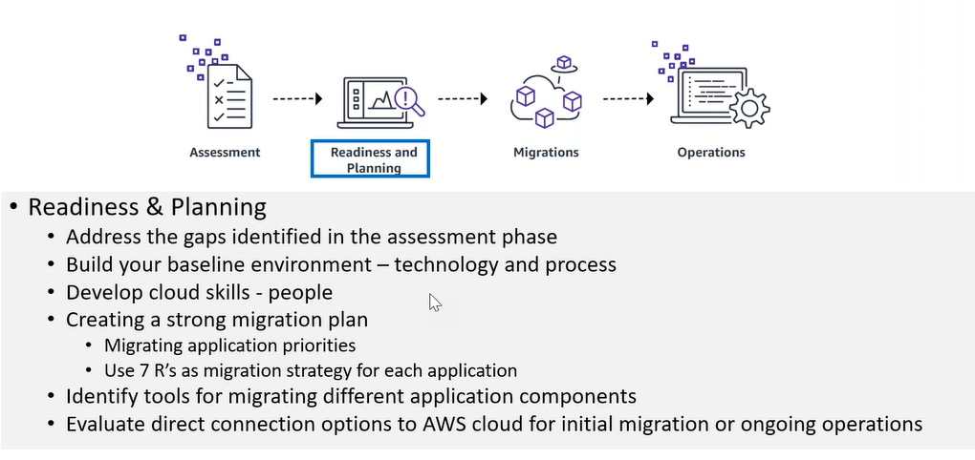
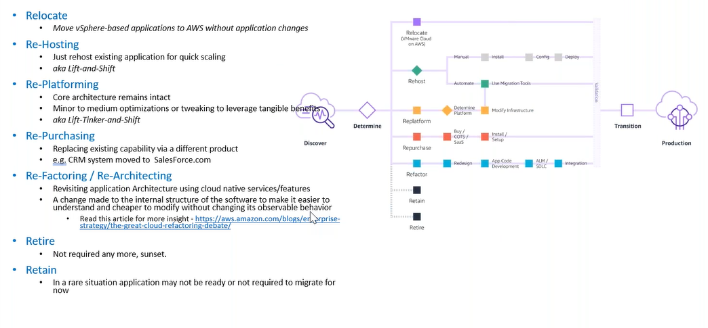
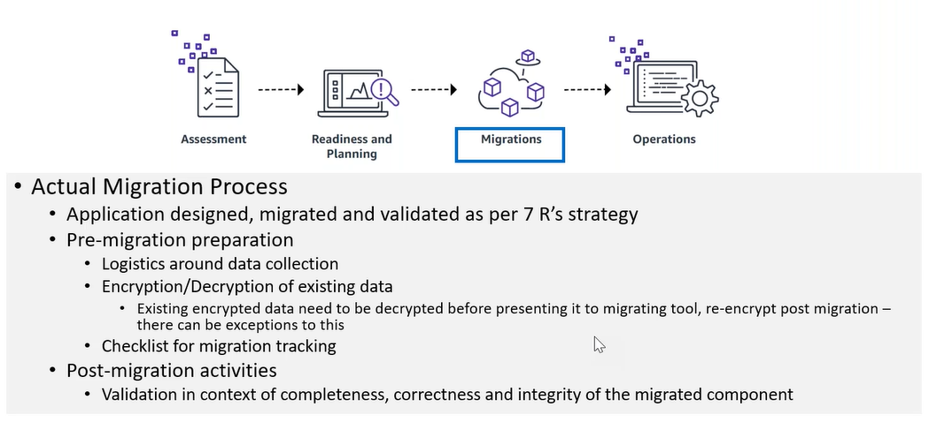
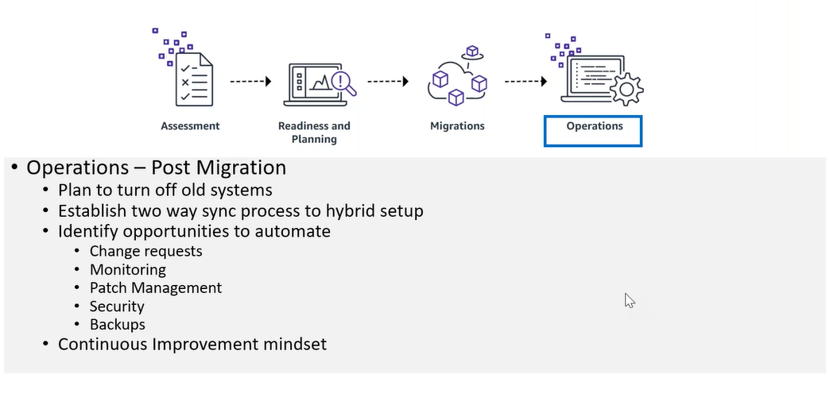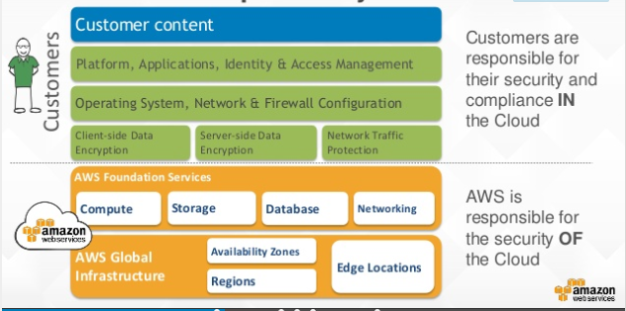
cloudharmony.com
AWS Calculator:
Simple monthly calculator
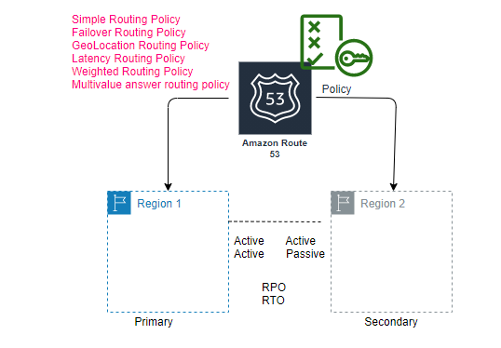

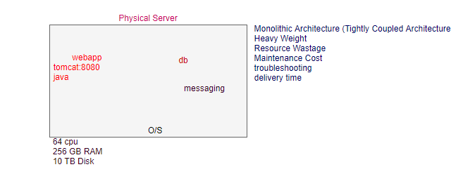
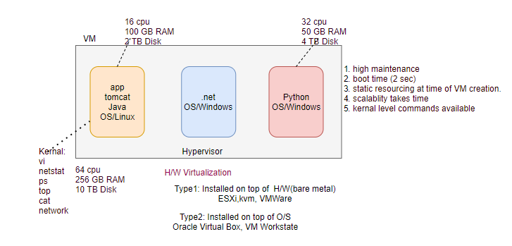
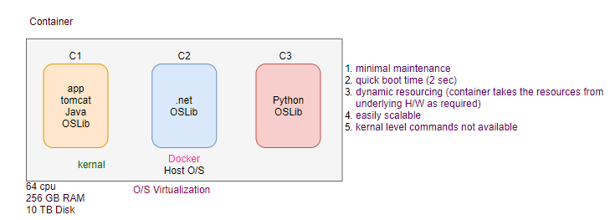
Data Preparation:
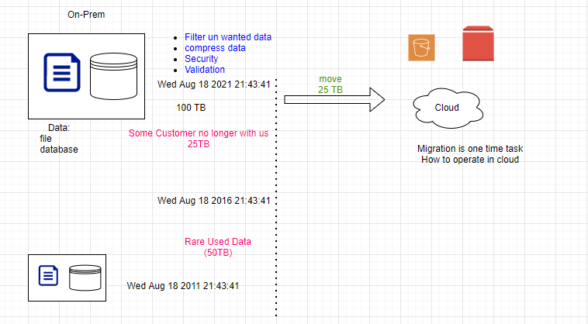
What is application migration?
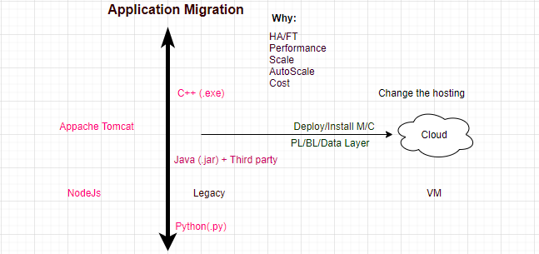
AWS Beanstalk (PaaS): Just handover your application to it (CloudFormation script executed internally).
- Auto Scaling
- Load Balancing
- Monitoring
- Logging
- Tracking
- Deployment Options
- Application Platforms
- Customization
- Web, Batch, Containers
CloudFormation (IaaS): Stack to create AWS resources, Beanstalk creates a default (readymade) stack for given application, while using CloudFormation we can create customized (as per our requirement) stack.
AWS CloudFront:
CDN: Content Delivery Network (Extend ELB endpoint to CloudFront for boosting Performance). Edge Locations
EC2 cost calculation:
calculator.s3.amazon.com (Simple Monthly Calculator): Always be a range.
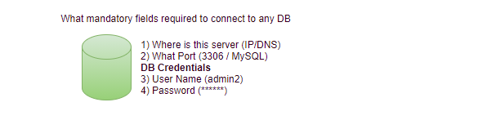
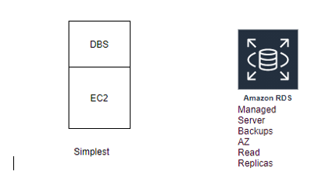
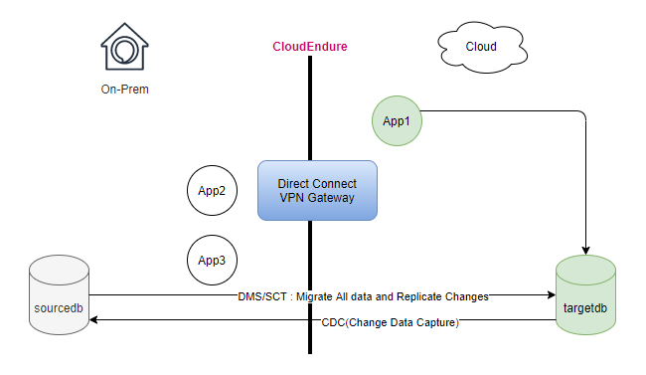
Application Migration Process and Tools:
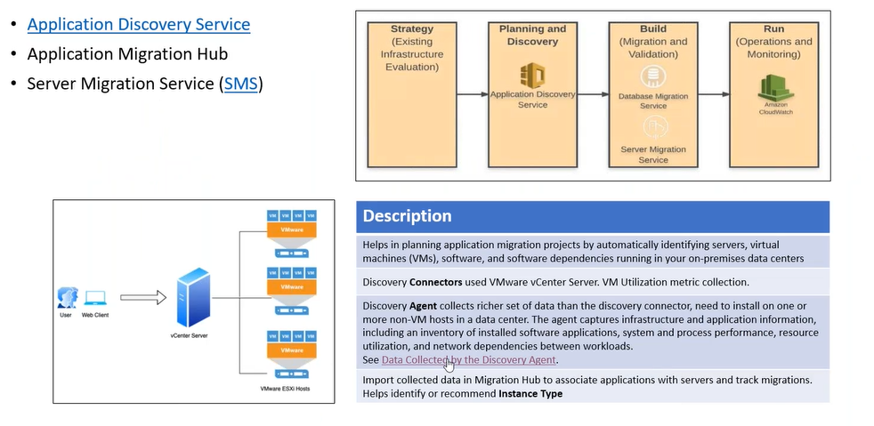
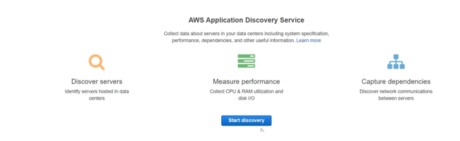

Server Migration Service:
SMS is only for virtualized environment
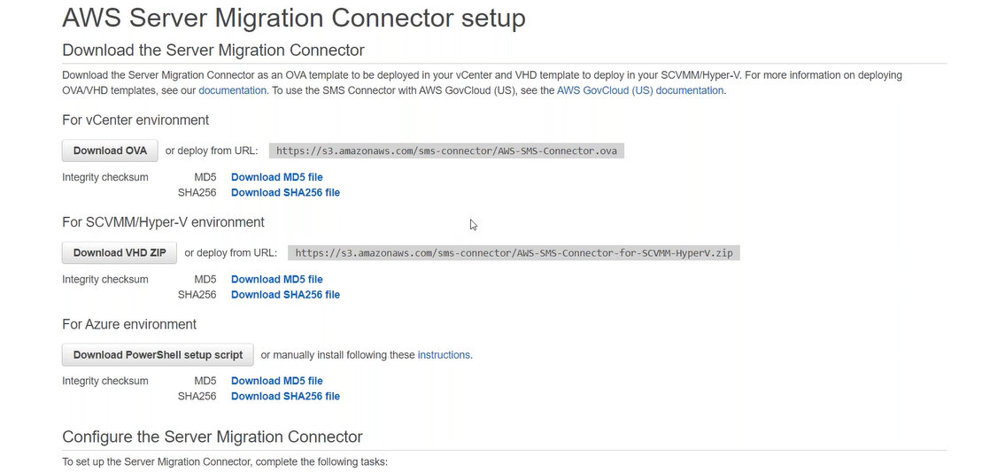

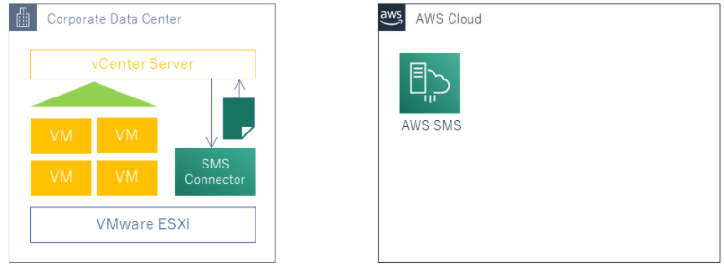

What if on-prem is not virtualized?
Storage Gateway is also providing server migration service through the volume gateways.
Storage Gateway’s performance is not good.
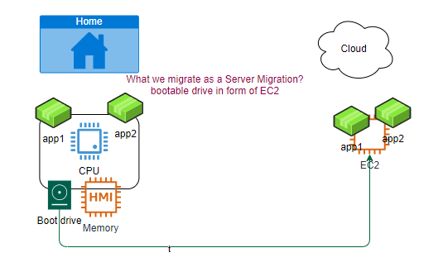
What we do for H/W to VM migration?
CloudEndure service
step1: create account on CloudEndure.
step2: Install agents on H/W machines.
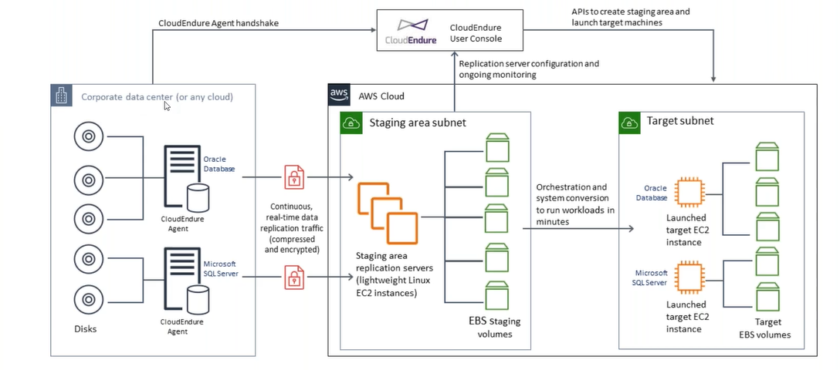

Migration to Cloud
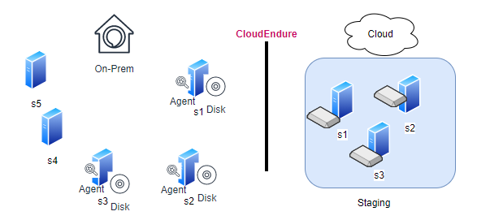

Migrating the whole application:
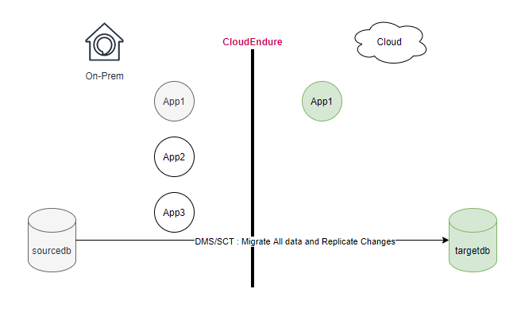
Migrating the part of the application (Hybrid):
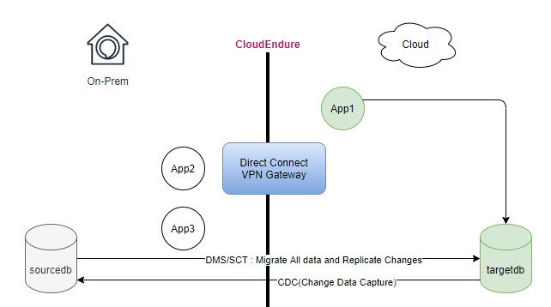
Our objective is to move your disk storage to S3

Representative Architecture
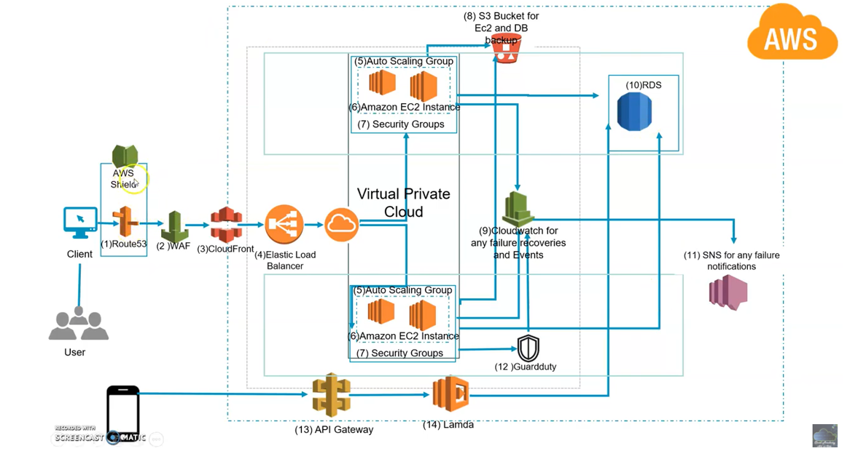
AWS Shield (DDoS): threatmap.checkpoint.com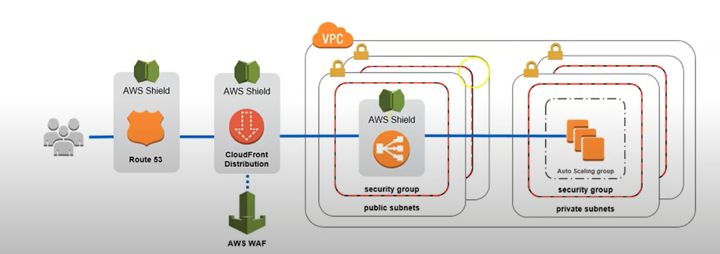
Guard Duty (Threat Detection Service that continuous monitors for malicious activity and unauthorized behaviour to protect your AWS account and workloads): 0-day attack
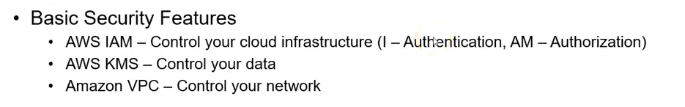
Config Service: Track resource inventory and changes over period of time.
At any given time, what are the resources provisioned in your account and what was their configuration.
AWS Managed Rules: send the notification
- What: Which resource configured
- When: When resource configured
Cloud Trail: Enabled by default
Track user activities and API usage, and retain it for 90 days for free.
- What:
- When:
- Who: from where?
- Mode: console, SDK, CLI
VPC Flow Logs: Activities of each ENI (ALB,EC2), with in this VPC.
Subnet Flow Logs: Activities of each ENI (ALB, EC2), with in this Subnet.
EC2 Flow Logs: Activities of each ENI, with in this EC2.
CloudFormation: Create scripts for Solution
CloudWatch:
System Management:
ParameterStore: To store secrets
Backup:
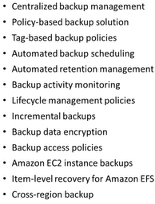
RDS: takes snapshot
EC2: AMI

DevOps
git fork
rolling back (before moving to the remote area):
git reset --hard (deletes the commit id and deletes the changes)
git reset --soft (deletes the commit id but not deletes the changes, just moved it to the staging area)

git restore --staged <file name>:
rm abc.txt (remove from working area)
git stash
git stash list
git stash apply <>

git checkout master # switch the branch
Rebase:( ensure the clean history)
On 1st Oct
master: m1 m2 d1 d2
feature: m1 m2 f1 f2
git checkout feature # switch to feature branch
git log --oneline
m1 m2 f1 f2
git rebase master # you have cleaner history local->local in feature branch
git log --oneline
m1 m2 d1 d2 f1 f2
git checkout master # switch to master branch
git merge feature
git log --oneline
m1 m2 d1 d2 f1 f2
How to delete the branch
git checkout master
git branch
git branch -D feature
Git workflow
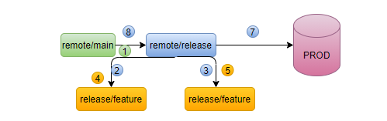

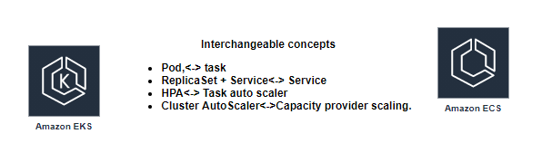
Jenkins
Jenkins is a tool integrate all tools together
Home->Manage Jenkins-> Global tool configuration
- Java_Home: /usr/lib/jvm/java-8-openjdk-amd64
- Git: which git
- Maven_Home: /opt/apache-maven-3.6.3
Jenkins is just a dummy tool; you must instruct to jenkins what to do.
How?
- create a job (Item).
Without Jenkins, All the code is in our local, and we have to do the following steps manually.
- Compile
- Code Review
- Unit Testing
- Code Coverage
- Package
What is plugin?
- Enhance the functionality of basic S/w.
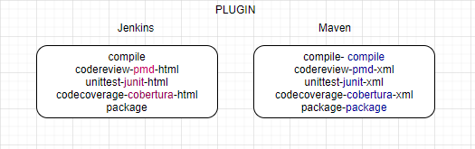
Use Case: Understand how manually application working?
Compile->Test->Review->Package->Deploy
Jenkins’s security configuration?
Home-> manage Jenkins-> configure Global Security.
- Matrix-based access
- Project-based matrix authorization strategy
Master Slave Architecture? Why we need? (Parallel running jobs)
principle1:
Every build is a potential release
principle2:
Eliminate manual bottlenecks.
principle3:
Automate wherever is possible

principle4:
Have automated tests you can trust.
Build Pipelines
The conveyer belts of Continuous Delivery
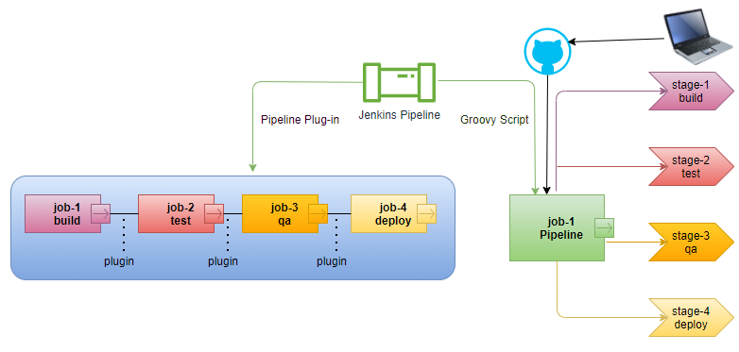
Limitations of Pipeline Using Plugins
- Using Jenkins UI Interface
- All jobs are executed sequentially, can’t skip any Job from the middle.
- If job4 fails, means our tasks are not completed, our tasks will be completed only once complete pipeline will be executed, then we have to correct the job4 and execute the pipeline again, second time pipeline will be executed from the starting (Time consuming).
- No concept of looping/conditions.
- All jobs are executed only in master till master is live.

Types of Pipelines using Groovy Script
- Scripted Pipeline
- Declarative Pipeline

Declarative Pipeline?
Syntax:
Required fields of Jenkinsfile
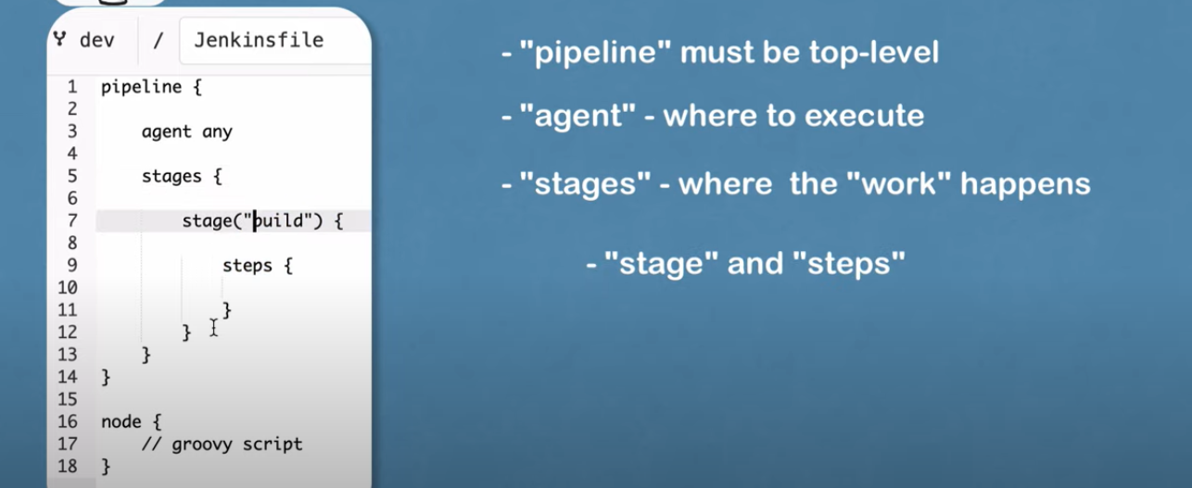
Home-> Manage Jenkins-> Manage Credentials (secrets)
Parameters in Jenkinsfile (external configuration to provide to your build)
Types of Parameters
UC: want to deploy in staging, would like to specify the version at run time.
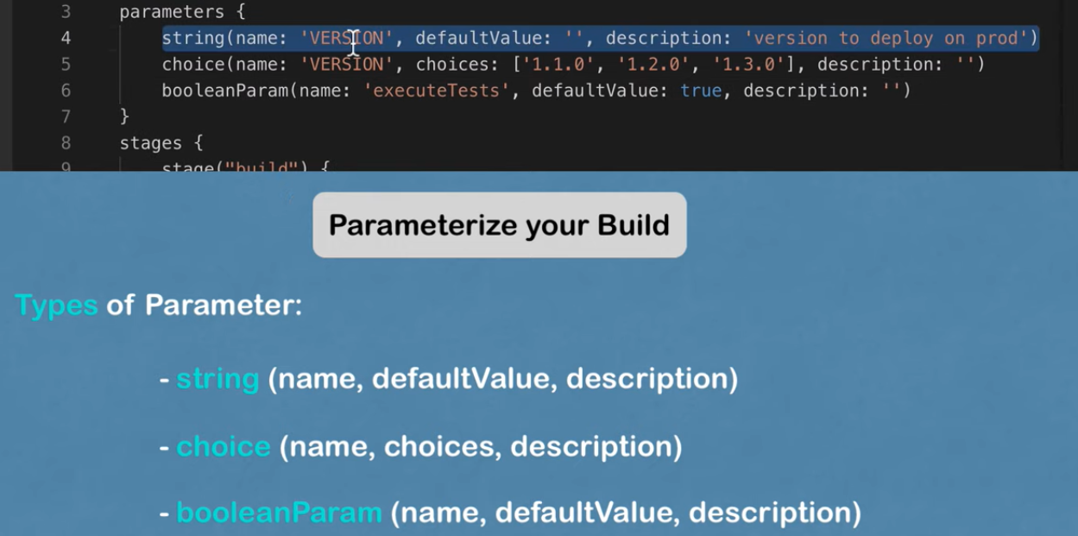
Using external Groovy Script
Clean the jenkinsfile and move the logic in external groovy script files, add the functionality using the script tag.

Delegate the job in specific agent:
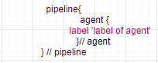

Execute the job in parallel:
Multibranch Pipeline:
solve the issue to build for each branch
plugin- Pipeline: Multibranch
multiconfiguration pipeline:
suitable for projects that needs a large number of different configurations, such as testing on multiple environments, platform-specific tasks etc.
plugin- Pipeline: Multiconfiguration
project type: Multiconfiguration Pipeline

Integrate SonarQube with Jenkins
Pre-requisite:
Sonar Server is running
Jenkins’s server is running
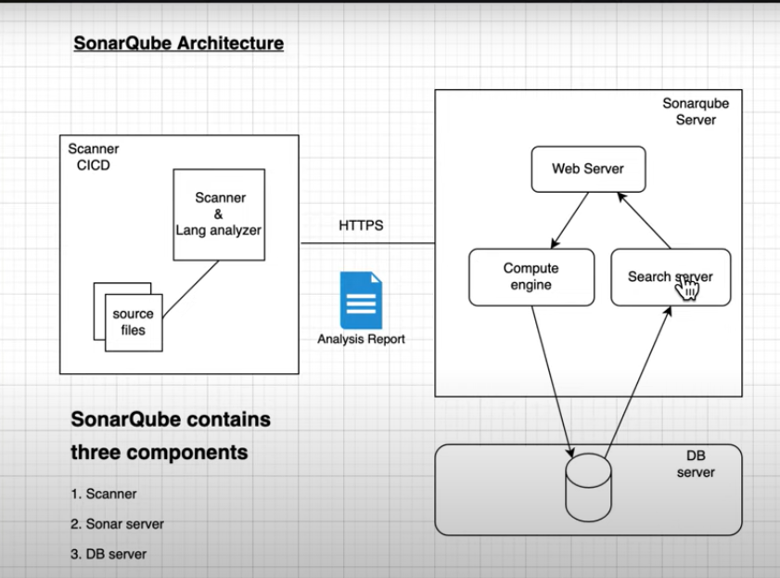
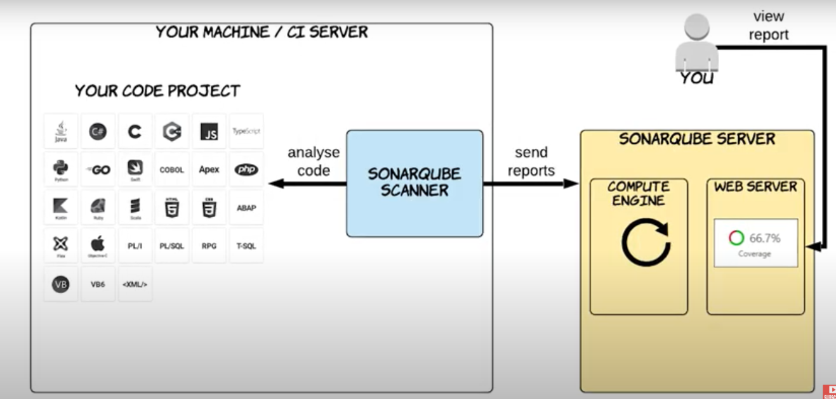
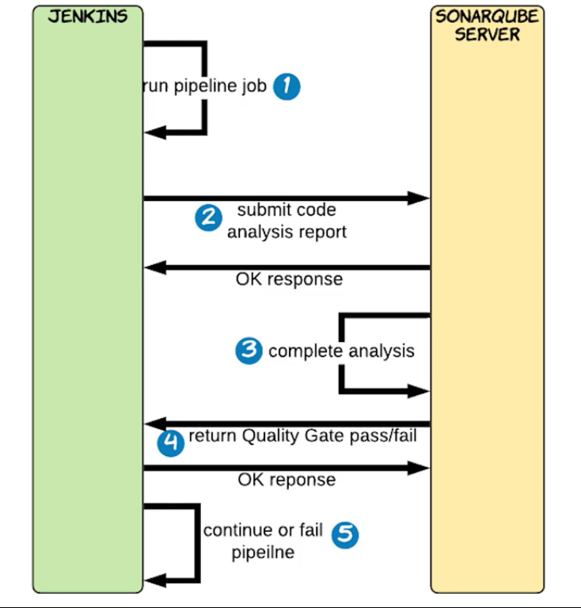

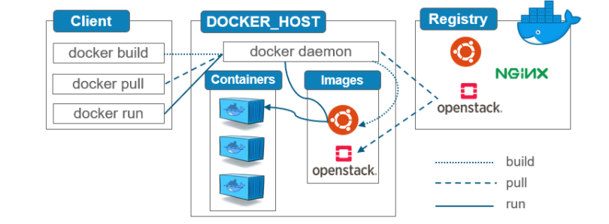
Docker is a tool help us BUILD the container->SHIP the container in different environments-> also RUN the package as a container.
Image requirement is just a storage to store the File System just like car parking to store it filesystem, while container requirement is CPU and RAM. Don’t need to allocate any resources to the image, docker take care at run time Dynamic allocation of the resources.
How docker really works behind the scenes?
Where namespace, group and UnionFS is used in docker?
Namespace is responsible for isolation b/w the containers. Type of namespaces are PID, n/w, User, filesystem and so on (processId)
Cgroup is responsible for resource management or resource limitation in each container CPU, mem, Network and I/O.
UnionFS is a filesystem service which is used for creating docker image layer.
If your application is heavy then go with VM.
How to create a Containers from given image?
Interactive mode: If wants to customize the image
docker run -it tomcat:latest bash
Detached mode: ready to use image
docker run -d tomcat:latest

How to get inside the running container?
docker exec -it <containerId> bash
How to execute command inside the running container without getting inside?
docker exec <containerId> ls-l
docker exec <containerId> cat /etc/os-release
docker exec <containerId> netstat
# Will fail (O/S lib, default features of O/S not available)
What is Docker Image?
- A docker image is a read-only template that contains source code, libraries, dependencies and set of instructions for start a container.
- docker image is immutable
What is Docker Container?
- container is running instance of the image.
- Every time you start a new container, an extra writable layer is created for it, where it stores the container specific changes.
- Changes are done on container, not on image (immutable)

How to access the application running inside the container from the outside?
- Port Publish
docker run -d -P --memory 500M --memory-reservation 256M nginx
How to build own docker image?
- manual process
  - docker commit -m “custom changes” <contId> newimgname:tag
- automated process
  - docker build -f Dockerfile --tag newimgname:tag

Dockerfile directive:
COPY: copy files from the local machine to the image.
ADD: same as COPY, additionally It can also copy files and directory from remote URL and also can copy the .tar file inside the container untar it in one shot.
CMD: default instruction Will be executed when container start from the given image, if someone wants to overwrite, the CMD instruction defined in the docker file, can be done at run time by passing another CMD.
We can pass it as an argument to the ENTRYPOINTS, CMD Instruction is a default argument to the ENTRYPOINT Instruction.
If there are more than 1 CMD then last will override previously CMD.
docker run <ubuntu> [command]
docker run ubuntu sleep 5 # default bash (process listen to terminal)
CMD [“sleep”,”5”] # first parameter must be executable
ENTRYPOINT: Is also run time instruction just like CMD instruction, we cannot overwrite the ENTRYPOINT instruction, if we trying at run time then newly command will be appended with the EntryPoint.
The ENTRYPOINT specifies a command that will always be executed when the container starts. The CMD specifies arguments that will be fed to the ENTRYPOINT.
Both CMD and ENTRYPOINT instructions define what command gets executed when running a container. There are few rules that describe their co-operation.
Dockerfile should specify at least one of CMD or ENTRYPOINT commands.
FROM Ubuntu
ENTRYPOINT [“sleep”]
In case of CMD instruction the command line parameter passed will gets replaced entirely, while in case of ENTRYPOINT command line parameters gets appended.
FROM Ubuntu
ENTRYPOINT [“sleep”]
CMD [“5”]
Docker Multistage Builds (Smaller Docker Image)
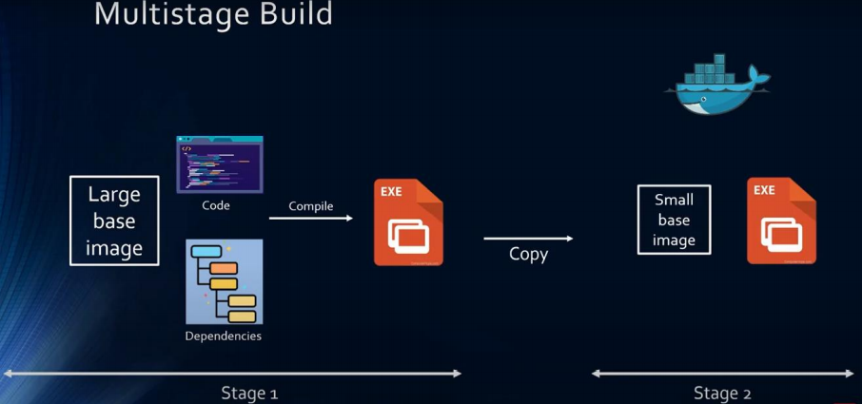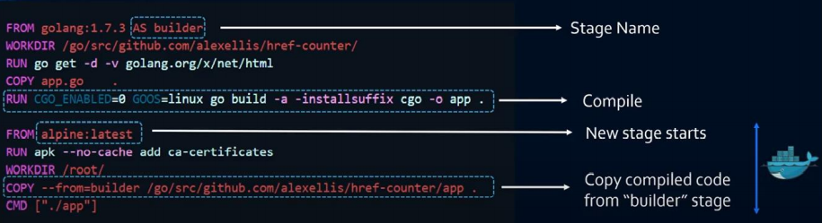
Who is responsible to maintain the layered architecture?
UnionFS is a filesystem service which is used for creating docker image layer.
Unlike a VM containers are not meant to host an O/S, containers are meant to host specific task or process, such as to host an Instance of the webserver, an instance of an application server or db server instance or to carry out some computation.
Once the task is over container exits. Container lives only till process inside it alive, if the webservice inside the container stops or crashes the container exits.
UC: How to overwrite the ENTRYPOINT instruction?
docker run –entrypoint sleep2.0 ubuntu-sleep
How to transfer images to another machine?
- Dockerhub -> push your image to remotely publicly accessible repository
- ECR -> Elastics container Registry
- Offline

How to publish docker image to dockerhub?
docker login
# docker login jfrog.com/useraccount/repository
docker push sampleapp: v3 # denied
# [docker.io/library (default docker account)/sampleapp]
docker tag sampleapp:v3 <accountname>/<repository>: <image>
How to push image in private repository?
- Default remote is dockerhub (URL of JFrog)
- Default account is docker (Your Account)
- Default repository (Your Repository: Image)
docker tag <image name> <jFrog Id>/<account name>/<repository name>: tag
UC: How UC: transfer the image from one environment to another environment without remote repository.
docker save -o myimages.tgz sampleapp: v3 sampleapp: v2 sampleapp: v2
scp myimages.tgz devops@10.128.0.18:/tmp
cd /tmp
docker load < myimages.tgz
Docker Volume
docker rm -f ‘docker ps -qa’ # remove all containers
docker volume create myvol # local volume
docker volume ls
docker volume inspect myvol # /var/lib/docker/volumes/myvol/_data
docker run -d -P --volume myvol:/opt/tomcat/logs sampleapp: v3
cd /var/lib/docker/volumes/myvol/_data
ls -l
For existing container, we can’t attach a volume, volume can be attached during container creation time.
UC3: custom location (bind mount)
mkdir /logs
mkdir /config
docker run -d -P --volume /logs:/var/nginx --volume /config:/usr/share/nginx/html nginx

docker run -d -P --mount type=bind, source=/config, dst=/usr/share/nginx/html --mount type=bind, source=/logs, dst=/var/nginx nginx: latest

docker run -d -P --mount type=volume, source=myvol, dst=/opt/tomcat/logs sampleapp: v3
What if data is in different server?
We have to keep data is central location like S3.
Docker Network:
When your computer is not connected to any network by default it contains a loopback IP address (127.0.0.1)
eth0: Interface at vm (IP address allocated by switch)
ens4: vm joins external network (GC).
docker network ls
- bridge
- host
- none
docker0 (CNM): container network model
docker inspect <network id>
docker container run –d --name=cont1 lerndevops/alpine:sleep
docker container run –d --name=cont2 lerndevops/alpine:sleep

How to create your own customized bridge?
docker network create --help
docker network create --driver bridge mybridge1
How to create container in customized network?
docker run -d –name=cont3 lerndevops/alpine:sleep # join default bridge
docker run -d –name=cont3 --network mybridge lerndevops/alpine:sleep
docker run -d –name=cont4 --network mybridge lerndevops/alpine:sleep
UC: How can cont1 can communicate with cont4?
Solution: join the container in other network also, container can join different networks at same time.
docker network connect cont1 mybridge
docker network disconnect cont1 mybridge
How to create our own subnet ?
docker network create --help
docker network create --driver bridge mybridge1 --subnet=192.168.0.0/16
create a container in mybridge1 network
docker run -d --name=cont5 --network mybridge1 lerndevops/alpine:sleep
docker run -d --name=cont6 --network mybridge1 lerndevops/alpine:sleep
What is none network?
What happen if we switch off our wifi? None network
create a container in none network
docker run -d --name=cont7 --network none lerndevops/alpine:sleep
Cont7 is not a part of any network. No eth0 interface, not reachable to outside the world.
It’s a independent process, apart from the default docker networking can use any network provider (CNI), not bounded with docker default (CNM).
What is host network?
create a container in host network
docker run -d --name=cont8 --network host lerndevops/alpine:sleep
don’t need to publish the port
Limitation: As of now we have discussed the networking within the same host, which is not a realistic scenario.
How containers communicate across different node?
By default, nodes are able to communicate to each other through the underlay network (AWS, GCP)
Docker swarm:
- Container orchestration tool
- Container management tool
How to activate the swarm?
docker swarm init
# As we initialize a docker swarm, docker creates a new extra network which span across the cluster, when you join the multiple docker hosts on the single cluster, docker joins the multiple docker host in single virtual network again as an overlay network. creates overlay ingress network
docker swarm join –token <>
docker node ls
UC: how to regenerate the token?
docker swarm join-token worker
single vm (container), cluster (service- group of containers)
docker service create --name myapp --replicas 7 -p 9000:3000 lerndevops/samplepyapp:v2 # group of containers called service
docker swarm service provides horizontal scaling, self-healing and load balancing.
How to create your custom overlay network?
docker network create myoverlay --driver overlay
How to create a service on custom overlay network?
docker service create --name mysvc --network myoverlay --replicas=5 lerndevops/alpine:sleep
docker service ls
docker service ps <name of the svc> # detailed info of service
docker exec <container id> hostname –i
All containers are created under the same subenet, so they can ping to each other by default.
docker network create –help
Docker Compose (Single Node)
How to run multiple containers from a single image, with a single command?
How to run multiple containers from a multiple image, with a single command?
solution: docker compose
docker compose file: is a script which helps to run multiple container
docker-compose -v
service: group of containers from a single image.
docker-compose up -d # up bring up the containers
docker-compose up --scale web=4 --scale app=6 -d
docker container ls # docker ps
It’s a vertical scaling happening on the single VM.
docker-compose down
docker-compose up --file mycompose. yaml --scale web=2 --scale app=3 -d
docker-compose up --file mycompose. yaml down
difference between Dockerfile and docker-compose?
dockerfile creates images.
docker-compose file creates containers from a given image.
Challenges with docker-compose: SPF (Not suitable for production environment) - Failover*
It just provides feature of replicas and scaling up and scaling down.
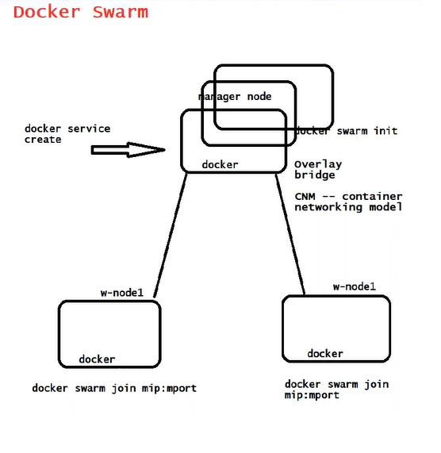
group of VMs-> cluster
group of containers-> service
How to deploy multiple containers (service)?
docker service create --name myapp –replicas=7 -p 9000:3000 lerndevops/samplepyapp:v1
docker service ls
docker service ps myapp # details cluster level command
docker ps # local command
docker service scale myapp=15
docker service scale myapp=2
docker stack deploy -c mycompose. yaml <name of stack>
docker stack deploy -c mycompose.yaml myappstack
docker node update --label-add role=app node01
docker node update --label-add role=db node02
docker node inspect node01
docker node inspect node02
Limitation:
- don’t provide autoscale.
- support only docker
- Container Network Model
- don’t support Helm
- RBAC (in-built security)
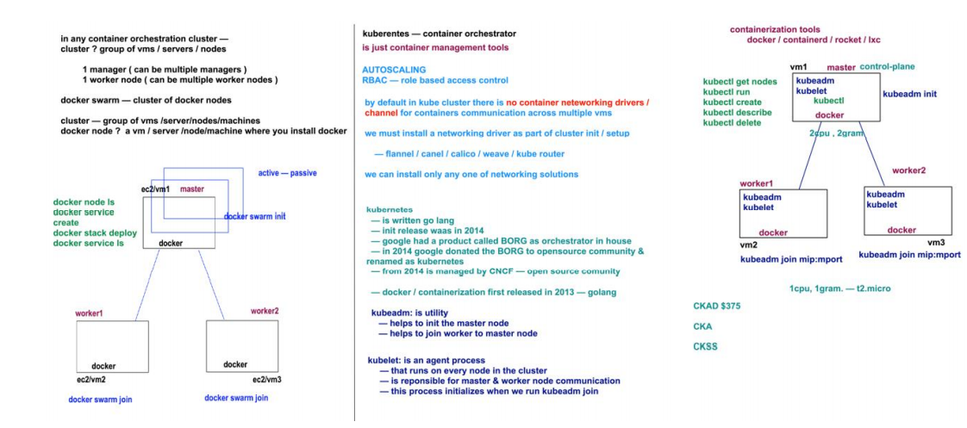

Ansible:
CAB (Change Advisory Board): Track all the changes, any change is also called configuration change.
Final goal is to deploy artifacts on the production environment, from where it can be accessed from end users.
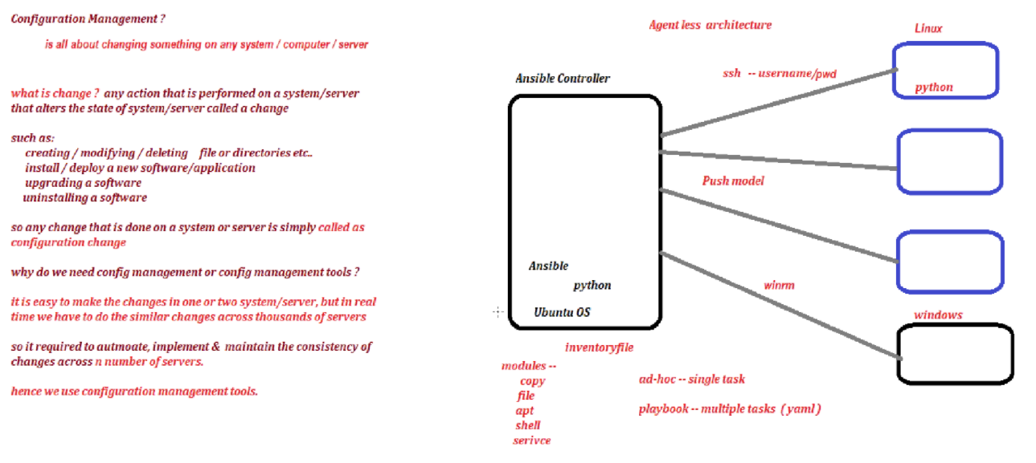
ansible –version
/etc/ansible/hosts # inventory
/etc/ansible/ansible.cfg #configuration
# configuration (inventory, sudo-user, host_key_checking=false)
/etc/ansible/roles # roles directory

su -
visudo
root ALL=(ALL) ALL
devops ALL=(ALL) NOPASSWD: ALL
:wq!
Establish Trust relationship
ansible all --list-hosts
ansible <groupname> --list-hosts
How controller instruct to the target servers?
- Adhoc commands
- Playbook

What is Module?
Ansible modules are reusable, standalone scripts that can be executed by the Ansible API, or by the ansible or by the ansible-playbook programs.
Adhoc commands
How to prepare inventory?
You can modify default inventory file /etc/ansible/hosts
ansible-doc -l
ansible-doc shell
ansible all -m ping -u devops -k (--ask-pass) # Failed Host key checking is enabled
ansible all -i /home/ansible/myinv -m ping # i (inventory file path)
#copy module
ansible all -i /home/ansible/myinv -m copy -a “src=/tmp/neeraj.txt dest=/tmp”
ansible all -m copy -a “src=/tmp/devops.txt dest=/tmp backup=yes” -u devops -k
ansible all -i /home/ansible/myinv -m file -a “path=/tmp/devops state=directory/touch”
#shell module (which command want to execute on target server)
# setup module
# script module execute script
just displays the Gather facts (ansible collects information about worker nodes before executing any command)
ansible all –i <path of inventory file> -b -m setup
permission denied
by default, Ansible perform any action as an ansible user
ansible all -i /home/ansible/myinv -b -m file -a “path=/opt/devops state=directory”
Playbook
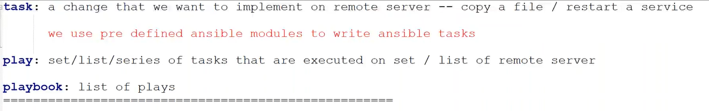
register module -> stores the output of the previous script module
debug: display the contents of the variable “The value of variable: {{}}”
ansible-playbook <name of playbook. yaml> -i < inventory path>
What are Facts?
Cached all the information about the target hosts, before performing any task on the target host ansible first tries to gather all the information about the target host (performance impact). During the execution keeps in cached memory once execution completes, it frees the cached memory.
Whenever ansible try to implement any change on the remote server, it will try to gather some information about the target server, that is called the Facts.
Conditions?
when: (ansible_distribution get from the gather facts)
Ansible Roles: split the bigger playbook in to smaller one
Roles provide a framework for fully independent or interdependent collections of variables, tasks, files, templates and modules.
files: copy the files which you want to copy in target server
templates (blue print)- host specific data (Jinjer templating)
handler (special tasks) which called through the notify
notify
purpose: repetitive/dependent tasks
nano /handler/main.yaml

How to generate role structure automatically
ansible-galaxy init <automation name/docker>
ansible-galaxy init docker
What is Ansible Vault?
Encrypt the ansible playbook (AES250)
UC1: Encrypt the playbook at time of creation.
step1: create a new encrypted playbook
ansible-vault create <vault>.yaml # as we enter ask for password
step2: edit the encrypted playbook
ansible-encrypted edit <vault>. yaml
step3: change the password
ansible-vault rekey <vault>. yaml
UC2: Encrypt the existing playbook.
step1: Encrypt the existing playbook
ansible-vault encrypt <target>.yaml
step2: decrypt the encrypted playbook
ansible-vault decrypt <target>. yaml
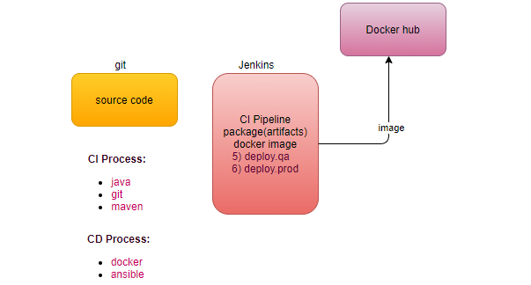
Continuous Delivery Process
Integrate with docker -> create image
Integrate with ansible-> deploy in different environments (Environment is a group of servers).
pre-requisite-> Before deployment our environment must be ready.
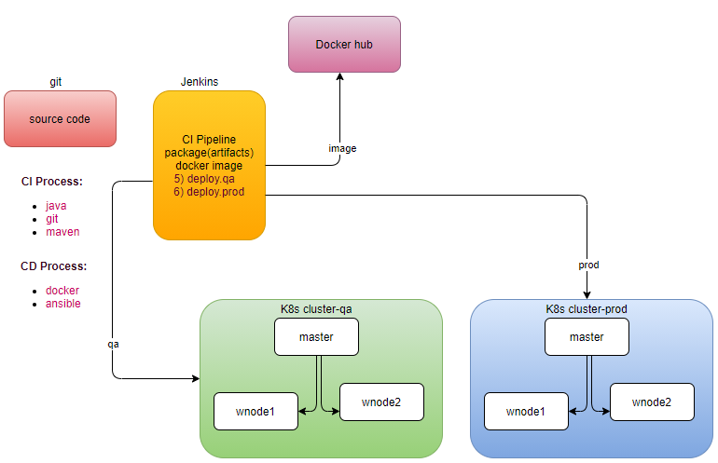
build docker image
step1: integrate docker with jenkins
step1.1: Install docker on the jenkins machine, just like we installed maven.
step1.2: Can jenkins run docker commands? Permission denied
step1.3: by default, jenkins runs the job as a jenkins user, whereas docker run as user root (access O/S kernel), means jenkins user doesn’t have root privileges
step1.4: su - jenkins
docker ps # permission denied
sudo docker ps # no sudoers
sudo docker ps # ask for password
step1.5: Give a Jenkins user sudoers privilege, or add jenkins user in the docker group.
/etc/sudoers
visudoers
service jenkins restart # service command always execute as a root user
How to build an automated process?
Dockerfile
Where docker clones the repository, under the workspace
step1.1: How to encrypt password?
Manage Jenkins-> Manage Credentials # plugin Credentials
How Integrate Ansible with Jenkins?
step1: setup the environment (k8s cluster)
step2: Jenkin can’t log into master servers, will use ansible as a configuration tool to invoke the k8s client, we have to integrate ansible with jenkins
step2.1: If jenkins invoke ansible playbook or modules, install ansible on the same machine in which jenkins server is running.
step2.2: now we can call this machine is as an ansible controller, how controller identify the target servers (k8s master)? Inventory
step2.3:
How to pass environment to next job? We have to add plugin build with parameter #CREDENTIAL_BINDING

penetration test
A penetration test, also known as a pen test, is a simulated cyber attack against your computer system to check for exploitable vulnerabilities. In the context of web application security, penetration testing is commonly used to augment a web application firewall (WAF).

What Is a Memory Leak?
A Memory Leak is a situation when there are objects present in the heap that are no longer used, but the garbage collector is unable to remove them from memory and, thus they are unnecessarily maintained.
A memory leak is bad because it blocks memory resources and degrades system performance over time. And if not dealt with, the application will eventually exhaust its resources, finally terminating with a fatal java.lang.OutOfMemoryError.
There are two different types of objects that reside in Heap memory — referenced and unreferenced. Referenced objects are those who have still active references within the application whereas unreferenced objects don't have any active references.
The garbage collector removes unreferenced objects periodically, but it never collects the objects that are still being referenced. This is where memory leaks can occur:

Symptoms of a Memory Leak
- Severe performance degradation when the application is continuously running for a long time.
- OutOfMemoryError heap error in the application
- Spontaneous and strange application crashes
- The application is occasionally running out of connection objects.

Types of Memory Leaks in Java?
Memory Leak Through static Fields:
The first scenario that can cause a potential memory leak is heavy use of static variables.
In Java, static fields have a life that usually matches the entire lifetime of the running application (unless ClassLoader becomes eligible for garbage collection).
How to Prevent It?
Minimize the use of static variables
When using singletons, rely upon an implementation that lazily loads the object instead of eagerly loading.
Through Unclosed Resources:
Whenever we make a new connection or open a stream, the JVM allocates memory for these resources. A few examples include database connections, input streams, and session objects.
Forgetting to close these resources can block the memory, thus keeping them out of the reach of GC. This can even happen in case of an exception that prevents the program execution from reaching the statement that's handling the code to close these resources.
In either case, the open connection left from resources consumes memory, and if we don't deal with them, they can deteriorate performance and may even result in OutOfMemoryError.
How to Prevent It?
Always use finally block to close resources
The code (even in the finally block) that closes the resources should not itself have any exceptions
When using Java 7+, we can make use of try-with-resources block.

Improper equals() and hashCode() Implementations
When defining new classes, a very common oversight is not writing proper overridden methods for equals() and hashCode() methods.
HashSet and HashMap use these methods in many operations, and if they're not overridden correctly, then they can become a source for potential memory leak problems.
But since we haven't defined proper equals() method, the duplicate objects pile up and increase the memory, that's why we see more than one object in the memory. The Heap Memory in VisualVM for this looks like:
How to Prevent It?
As a rule of thumb, when defining new entities, always override equals() and hashCode() methods
It's not just enough to override, but these methods must be overridden in an optimal way as well.
Through finalize () Methods:
Use of finalizers is yet another source of potential memory leak issues. Whenever a class' finalize() method is overridden, then objects of that class aren't instantly garbage collected. Instead, the GC queues them for finalization, which occurs at a later point in time.
Additionally, if the code written in finalize() method is not optimal and if the finalizer queue cannot keep up with the Java garbage collector, then sooner or later, our application is destined to meet an OutOfMemoryError.
How to Prevent It?
We should always avoid finalizers

Ways to monitor memory leakage:
Enable Profiling:
Java profilers are tools that monitor and diagnose the memory leaks through the application. They analyze what's going on internally in our application — for example, how memory is allocated.
Using profilers, we can compare different approaches and find areas where we can optimally use our resources.
Java Profilers to learn about different types of profilers, like Mission Control, JProfiler, YourKit, Java VisualVM, and the Netbeans profilers.
Verbose Garbage Collection:
By enabling verbose garbage collection, we're tracking detailed trace of the GC. To enable this, we need to add the following to our JVM configuration:
-verbose:gc
By adding this parameter, we can see the details of what's happening inside GC:
Eclipse Memory Leak Warnings:
Benchmarking:
Code Reviews:
Conclusion:
In layman's terms, we can think of memory leak as a disease that degrades our application's performance by blocking vital memory resources. And like all other diseases, if not cured, it can result in fatal application crashes over time.

Memory leaks are tricky to solve and finding them requires intricate mastery and command over the Java language. While dealing with memory leaks, there is no one-size-fits-all solution, as leaks can occur through a wide range of diverse events.

However, if we resort to best practices and regularly perform rigorous code walk-throughs and profiling, then we can minimize the risk of memory leaks in our application.
Java Profiler:
Overview:
Sometimes writing code that just runs is not enough. We might want to know what goes on internally such as how memory is allocated, consequences of using one coding approach over another, implications of concurrent executions, areas to improve performance, etc. We can use profilers for this.
A Java Profiler is a tool that monitors Java bytecode constructs and operations at the JVM level. These code constructs and operations include object creation, iterative executions (including recursive calls), method executions, thread executions, and garbage collections.
A Java Profiler is a tool that monitors Java bytecode constructs and operations at the JVM level. These code constructs and operations include object creation, iterative executions (including recursive calls), method executions, thread executions, and garbage collections.
JProfiler:
JProfiler is a top choice for many developers. With an intuitive UI, JProfiler provides interfaces for viewing system performance, memory usage, potential memory leaks, and thread profiling.

With this information, we can easily know what we need to optimize, eliminate, or change – in the underlying system.
Like most profilers, we can use this tool for both local and remote applications. This means that it's possible to profile Java applications running on remote machines without having to install anything on them.
JProfiler also provides advanced profiling for both SQL and NoSQL databases. It provides specific support for profiling JDBC, JPA/Hibernate, MongoDB, Casandra, and HBase databases.

Java VisualVM:
Java VisualVM is a simplified yet robust profiling tool for Java applications. By default, this tool is bundled with the Java Development Kit (JDK). Its operation relies on other standalone tools provided in the JDK, such as JConsole, jstat, jstack, jinfo, and jmap.
One interesting advantage of Java VisualVM is that we can extend it to develop new functionalities as plugins. We can then add these plugins to Java VisualVM's built-in update center.
Java VisualVM supports local and remote profiling, as well as memory and CPU profiling. Connecting to remote applications requires providing credentials (hostname/IP and password as necessary) but does not provide support for ssh tunneling. We can also choose to either enable real-time profiling with instant updates (typically every 2 seconds).
