CLI:
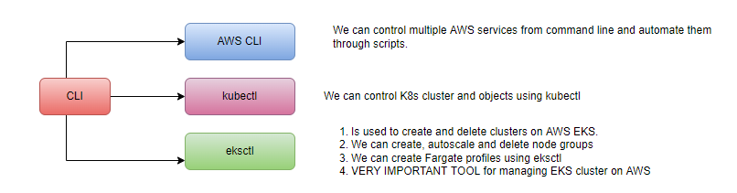
Install aws CLI
aws –version
Use only IAM user to generate Security Credentials.
ec2 describe-vpcs
Install kubectl
curl -o kubectl.exe https://s3.us-west-2.amazonaws.com/amazon-eks/1.23.7/2022-06-29/bin/windows/amd64/kubectl.exe
kubectl version
Install eksctl
eksctl version
EKS -Core Objects
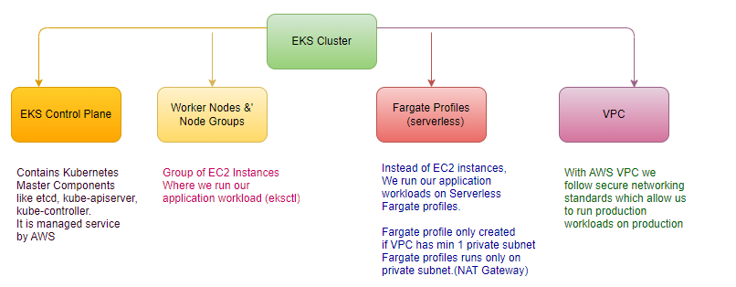
Fargate profiles runs only on private subnet.
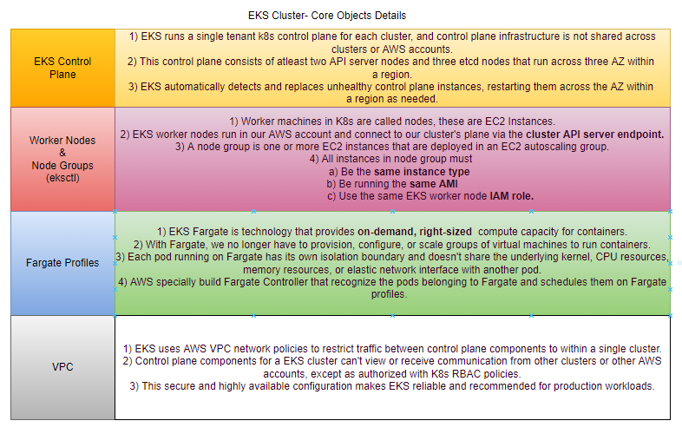
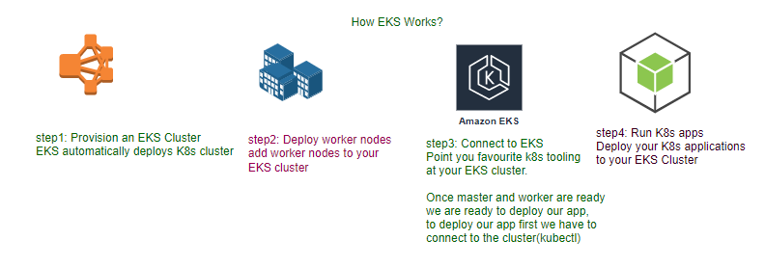
step1: Create EKS Cluster using eksctl.
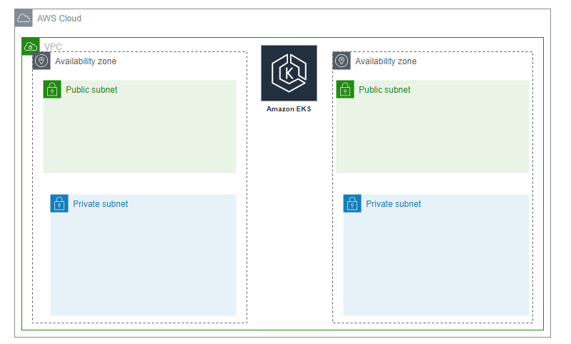
It will take 15 to 20 minutes to create the Cluster Control Plane
# Create Cluster # default public access
eksctl create cluster --name=eksdemo1 --region=us-east-1 --zones=us-east-1a,us-east-1b --without-nodegroup # default 2 node of m4.large

kubectl get nodes # no nodes

# Get List of clusters
eksctl get cluster

step2: Create and associate IAM OIDC provider for EKS Cluster.
To enable and use AWS IAM roles for Kubernetes service accounts on our EKS cluster, we must create & associate OIDC identity provider.
- To do so using eksctl we can use the below command.
- Use latest eksctl version (as on today the latest version is 0.21.0)
# Template
eksctl utils associate-iam-oidc-provider \
--region region-code \
--cluster <cluster-name> \
--appr

# Replace with region & cluster name
eksctl utils associate-iam-oidc-provider --region us-east-1 --cluster eksdemo1 --approve

step3: Create EC2 key-pair
Create a new EC2 Keypair with name as kube-demo # .ppk
- This keypair we will use it when creating the EKS NodeGroup.
- This will help us to login to the EKS Worker Nodes using Terminal.
step4: Create a NodeGroup with additional (Add Ons)
eksctl create –help
- These add-ons will create the respective IAM policies for us automatically within our Node Group role.
# Create Public Node Group
eksctl create nodegroup --cluster=eksdemo1 --region=us-east-1 --name=eksdemo1-ng-public1 --node-type=t3.medium --nodes=2 --nodes-min=2 --nodes-max=4 --node-volume-size=20 --ssh-access --ssh-public-key=kube-demo --managed --asg-access --external-dns-access --full-ecr-access --appmesh-access --alb-ingress-access
kubectl get nodes -o wide
step5: Verify Cluster and Node
# List EKS clusters
eksctl get cluster

# List NodeGroups in a cluster
eksctl get nodegroup --cluster=<clusterName>

# List Nodes in current kubernetes cluster
kubectl get nodes -o wide

# Our kubectl context should be automatically changed to new cluster
kubectl config view –minify

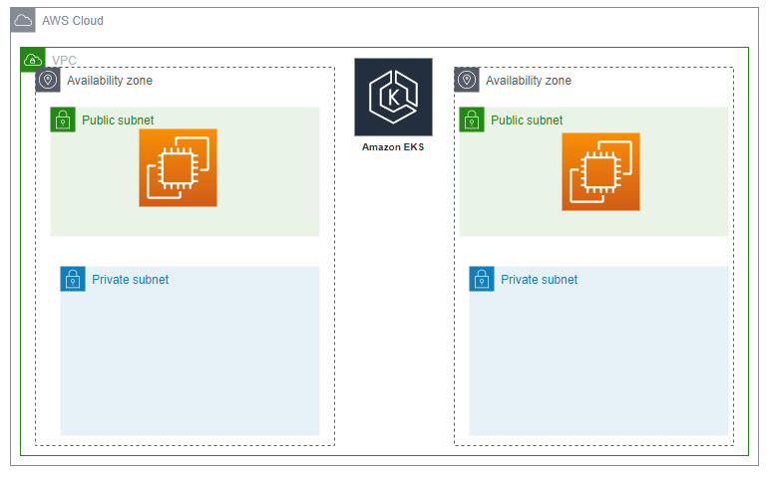

Login to Worker Node using Keypair kube-demo
- Login to worker node
step6: Update Security Group to allow all traffic.
step7: delete the cluster
EKS Storage:
Advantage of RDS Database:
- High Availability
- Backup and Recovery
- Read Replicas
- Metrics and monitoring available out of the box
- Automatic Upgrades
- Multi-AZ Support
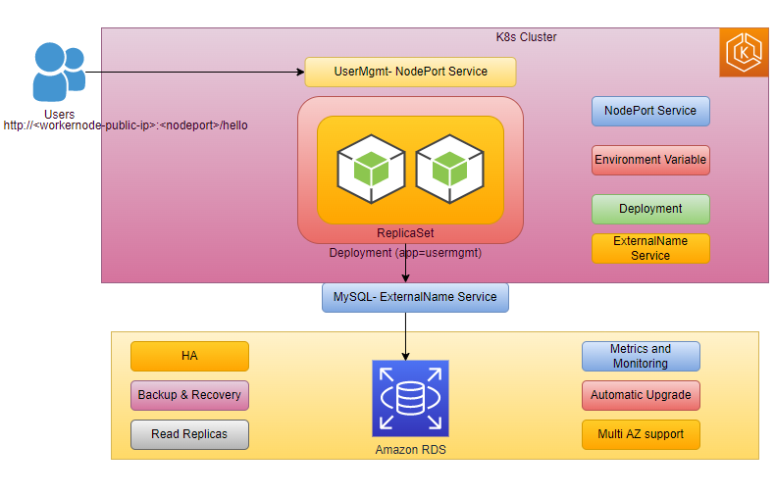

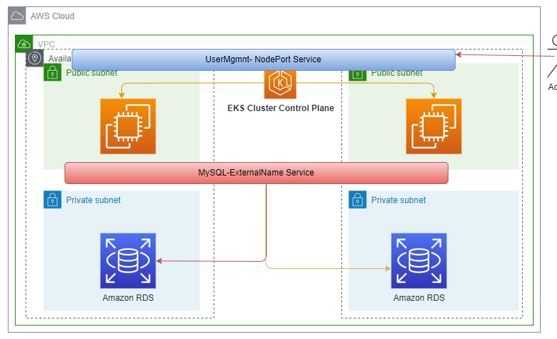
step1: Create RDS DB in private subnet. (VPC of EKS Cluster)
As a part of EKS cluster creation, create 2 private subnets, our ec2 instances are running in public subnet

Review VPC of our EKS Cluster
Go to Services -> VPC
VPC Name: eksctl-eksdemo1-cluster/VPC
Pre-requisite-1: Create DB Security Group
Create security group to allow access for RDS Database on port 3306
Security group name: eks_rds_db_sg
Description: Allow access for RDS Database on Port 3306
VPC: eksctl-eksdemo1-cluster/VPC
Inbound Rules
Type: MySQL/Aurora
Protocol: TPC
Port: 3306
Source: Anywhere (0.0.0.0/0)
Description: Allow access for RDS Database on Port 3306
Outbound Rules
Leave to defaults
Pre-requisite-2: Create DB Subnet Group in RDS
Go to RDS -> Subnet Groups
Click on Create DB Subnet Group
Name: eks-rds-db-subnetgroup
Description: EKS RDS DB Subnet Group
VPC: eksctl-eksdemo1-cluster/VPC
Availability Zones: us-east-1a, us-east-1b
Subnets: 2 subnets in 2 AZs # private subnet
Click on Create
Create RDS Database
Go to Services -> RDS
Click on Create Database
Choose a Database Creation Method: Standard Create
Engine Options: MySQL
Edition: MySQL Community
Version: 5.7.22 (default populated)
Template Size: Free Tier
DB instance identifier: usermgmtdb
Master Username: dbadmin
Master Password: dbpassword11
Confirm Password: dbpassword11
DB Instance Size: leave to defaults
Storage: leave to defaults
Connectivity
VPC: eksctl-eksdemo1-cluster/VPC
Additional Connectivity Configuration
Subnet Group: eks-rds-db-subnetgroup
Publicly accessible: YES (for our learning and troubleshooting - if required)
VPC Security Group: Create New
Name: eks-rds-db-securitygroup
Availability Zone: No Preference
Database Port: 3306
Rest all leave to defaults
Click on Create Database
Edit Database Security to Allow Access from 0.0.0.0/0
Go to EC2 -> Security Groups -> eks-rds-db-securitygroup
Edit Inbound Rules
Source: Anywhere (0.0.0.0/0) (Allow access from everywhere for now)
Step-03: Create Kubernetes externalName service Manifest and Deploy
Create mysql externalName Service
01-MySQL-externalName-Service.yml
apiVersion: v1
kind: Service
metadata:
name: mysql
spec:
type: ExternalName
externalName: usermgmtdb.c7hldelt9xfp.us-east-1.rds.amazonaws.com
Deploy Manifest
kubectl apply -f kube-manifests/01-MySQL-externalName-Service.yml

Step-04: Connect to RDS Database using kubectl and create usermgmt schema/db
kubectl run -it --rm --image=mysql:5.7.22 --restart=Never mysql-client -- mysql -h usermgmtdb.c7hldelt9xfp.us-east-1.rds.amazonaws.com -u dbadmin -pdbpassword11

mysql> show schemas;
mysql> create database usermgmt;
mysql> show schemas;
mysql> exit

Step-05: In User Management Microservice deployment file change username from root to dbadmin
# Change From
- name: DB_USERNAME
value: "root"

# Change To
- name: DB_USERNAME
value: "dbadmin"

Step-06: Deploy User Management Microservice and Test
# Deploy all Manifests
kubectl apply -f kube-manifests/

# List Pods
kubectl get pods

# Stream pod logs to verify DB Connection is successful from SpringBoot Application
kubectl logs -f <pod-name>

Step-07: Access Application
# Capture Worker Node External IP or Public IP
kubectl get nodes -o wide

# Access Application
http://<Worker-Node-Public-Ip>:31231/usermgmt/health-status

Step-08: Clean Up
# Delete all Objects created
kubectl delete -f kube-manifests/

# Verify current Kubernetes Objects
kubectl get all

