When a service is creating a DNS, entry is added automatically
DNS (name resolution) in K8s cluster
UC: We have a 3 node k8s cluster with some pods, services deployed on them, each node has a node name and ip address assign to it, the node name and ip addresses of the nodes are registered in DNS server.
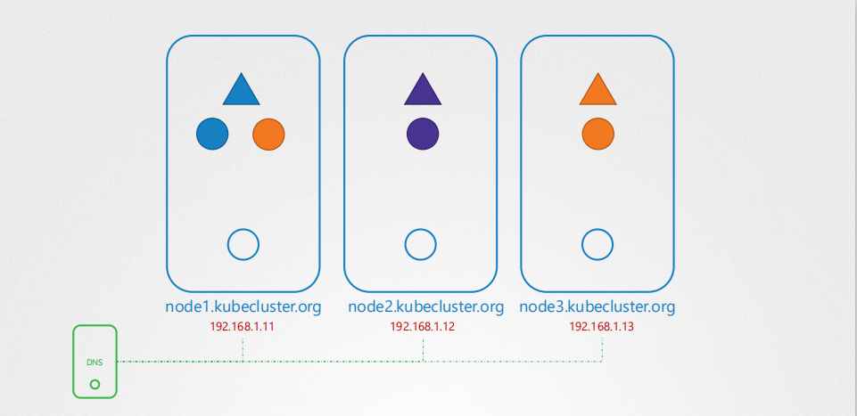
K8s deploys a build in DNS server by default when you setup a cluster.
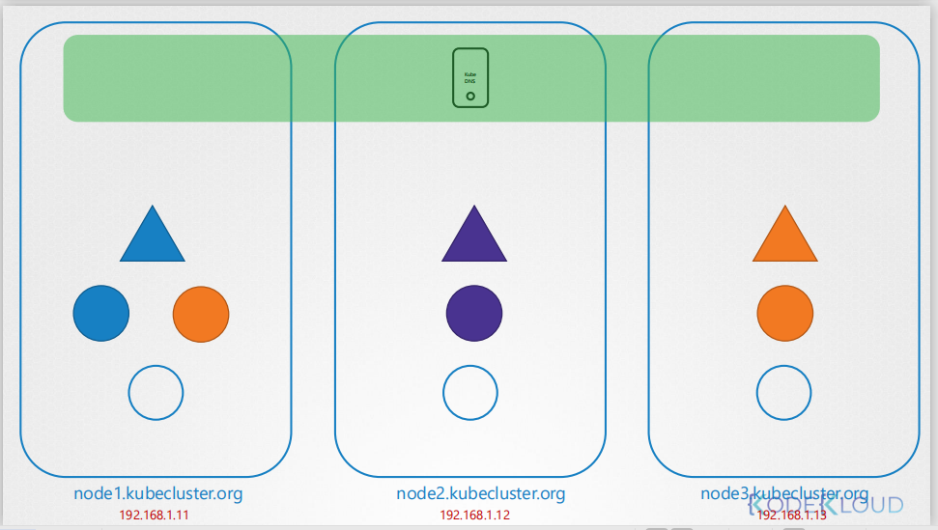

How kubernetes implements the DNS.
coredns server is deployed as a pod in kube-system namespace
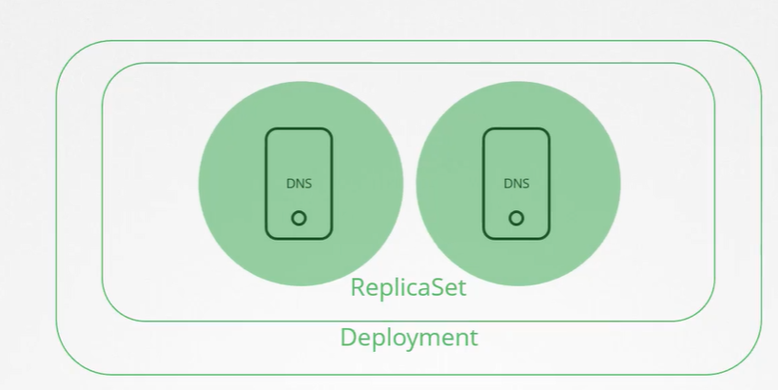
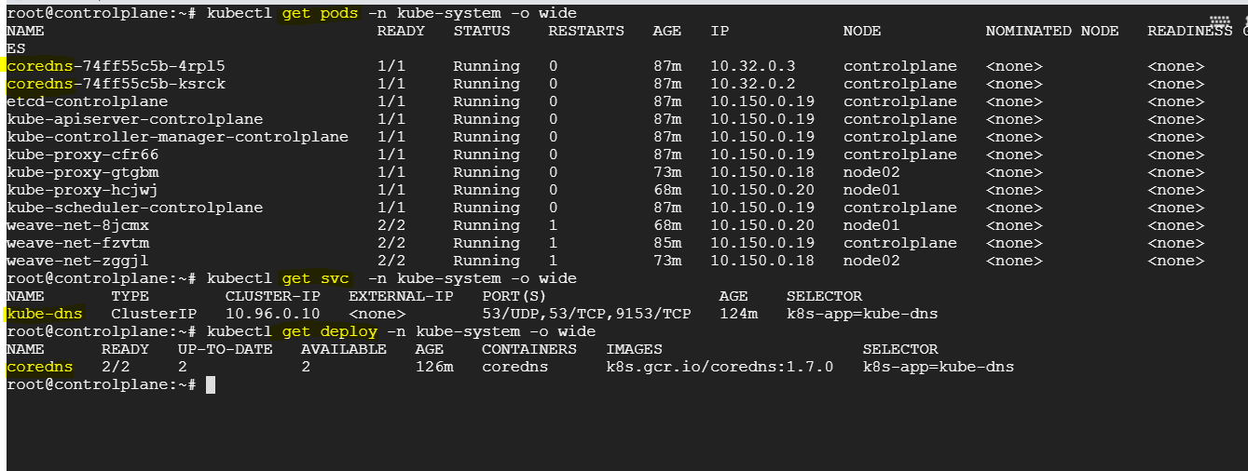
/etc/host
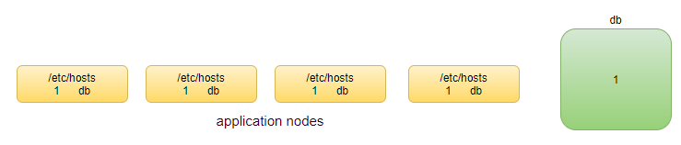

UC: If IP of dbserver changes?
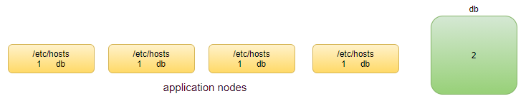
updating the /etc/host file is very time-consuming.
We create a DNS server
/etc/resolv.conf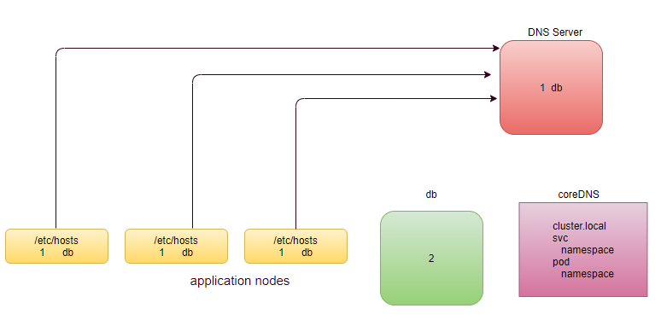
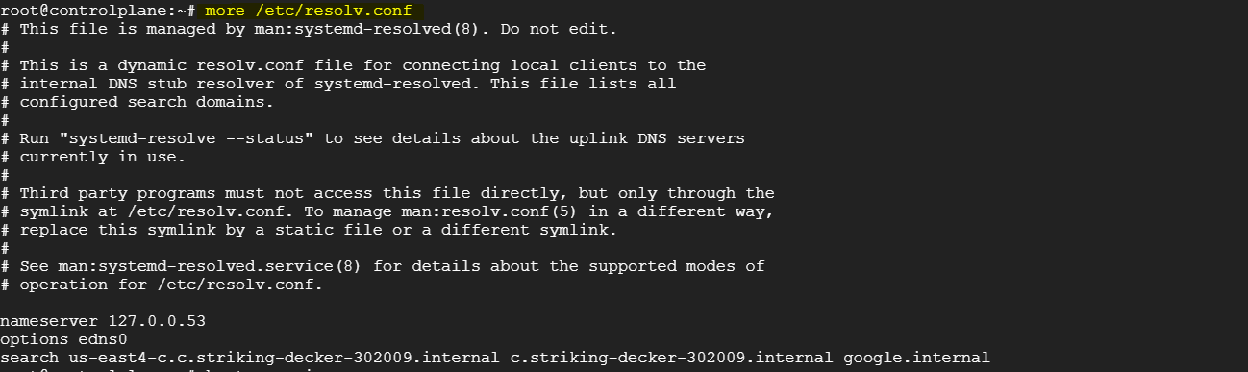
When pod is created, same time an ip address generated by weave network assigned to the pod and at same time api-server is going to update etcd db, going to register with default core dns server. Pod can be reached out using its ip address or its dns name.
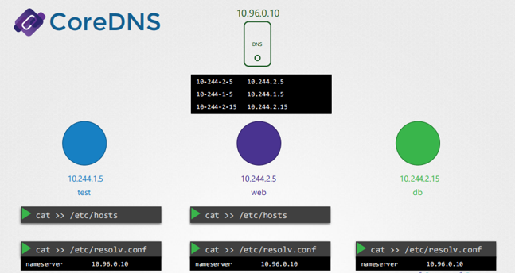
Within every pod there is a DNS server entry
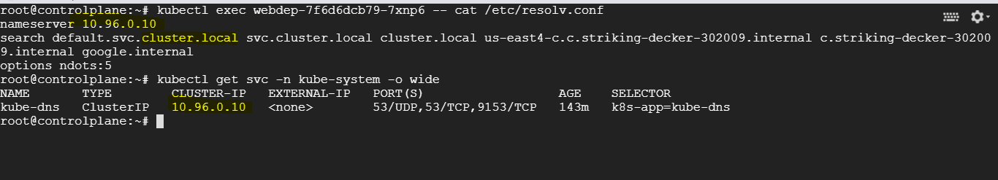
UC: We have two pods, test and web pod to access web pod we create a service. Whenever service is created k8s DNS service creates a record for the service, it maps the service name to the ip address.
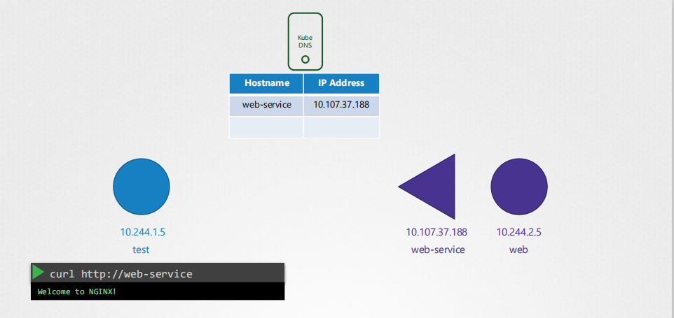
In this case pods and services are all in the same namespaces, you are able to reach webservice simply by its name.
Just similar to family members can reach to one-another by their name, resources in one namespace can reach to one-another by their name, e.g., if web application in default namespace wants to access db-service in default namespace can be accessed through their service name directly.
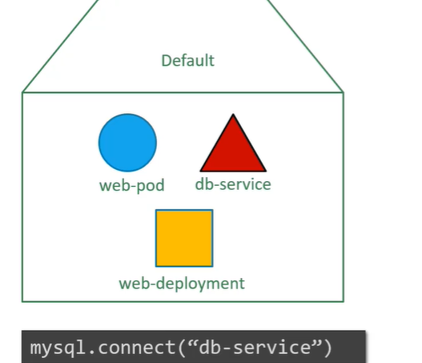
UC: web pod and service are in different namespace? The last name of the service will be its namespace.

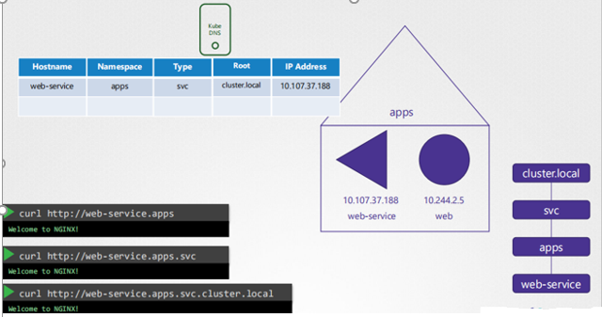
For pods
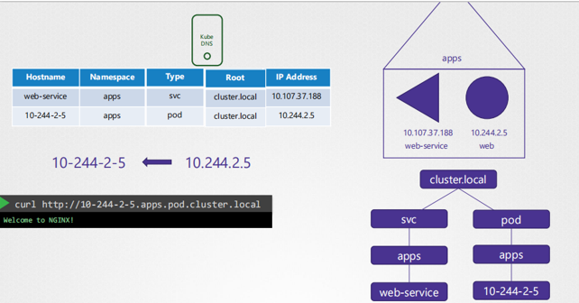
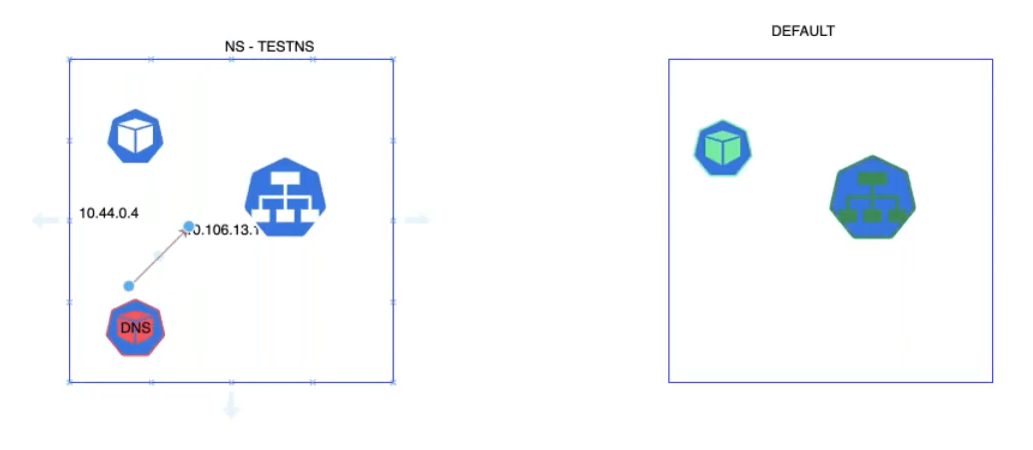
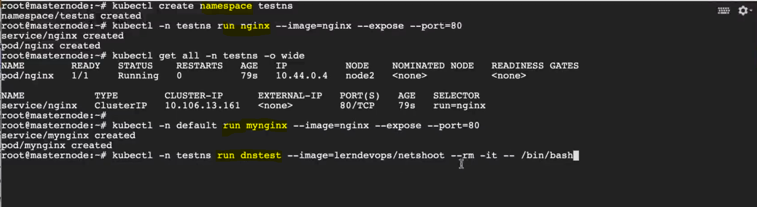
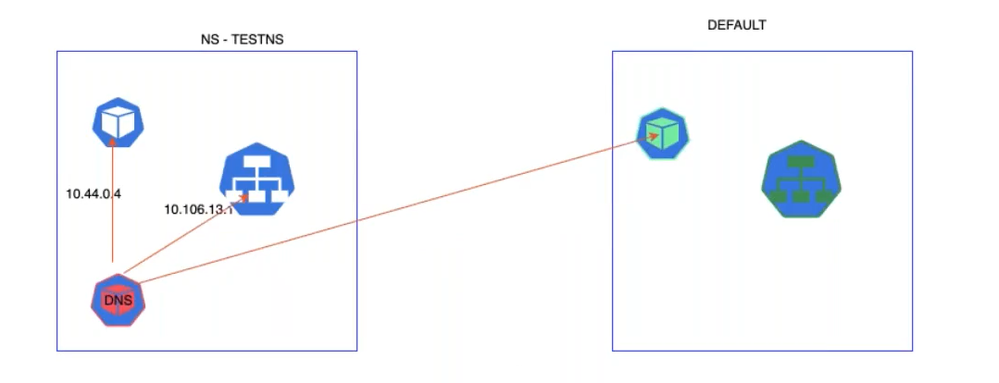
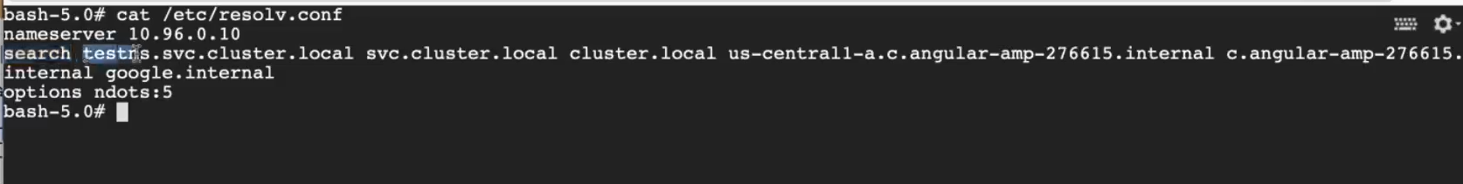



kubectl get ep kube-dns -n kube-system
kubectl exec <pod name> -- nslookup <service-name>.default.svc.cluster.local
core dns just register the Pod or service, not the node.

