Backup and Restore:
Backup Candidates
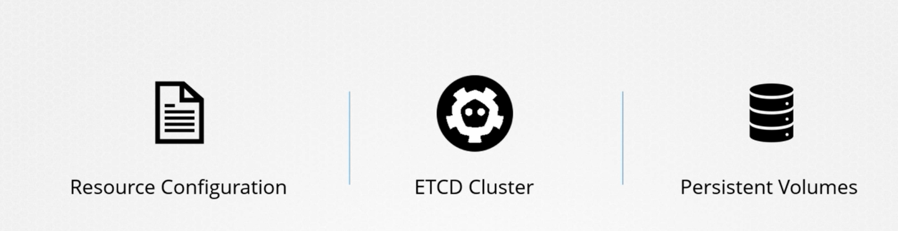
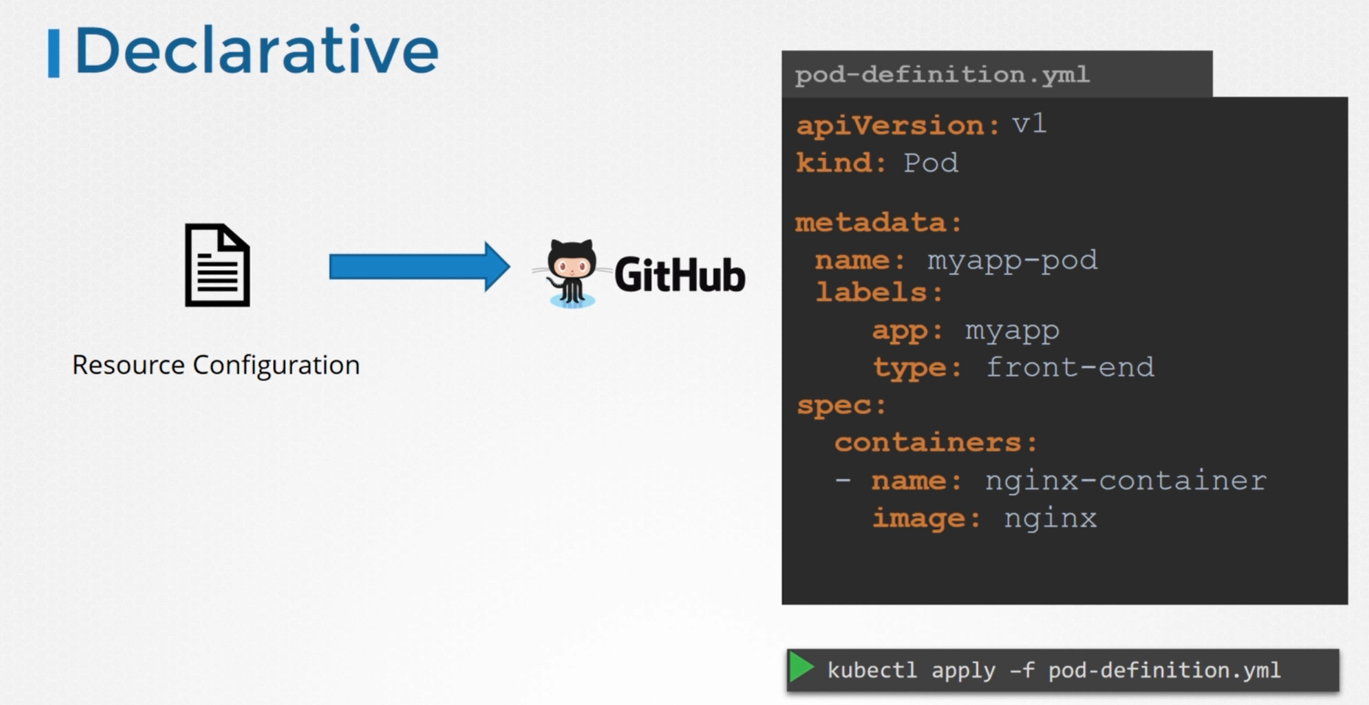
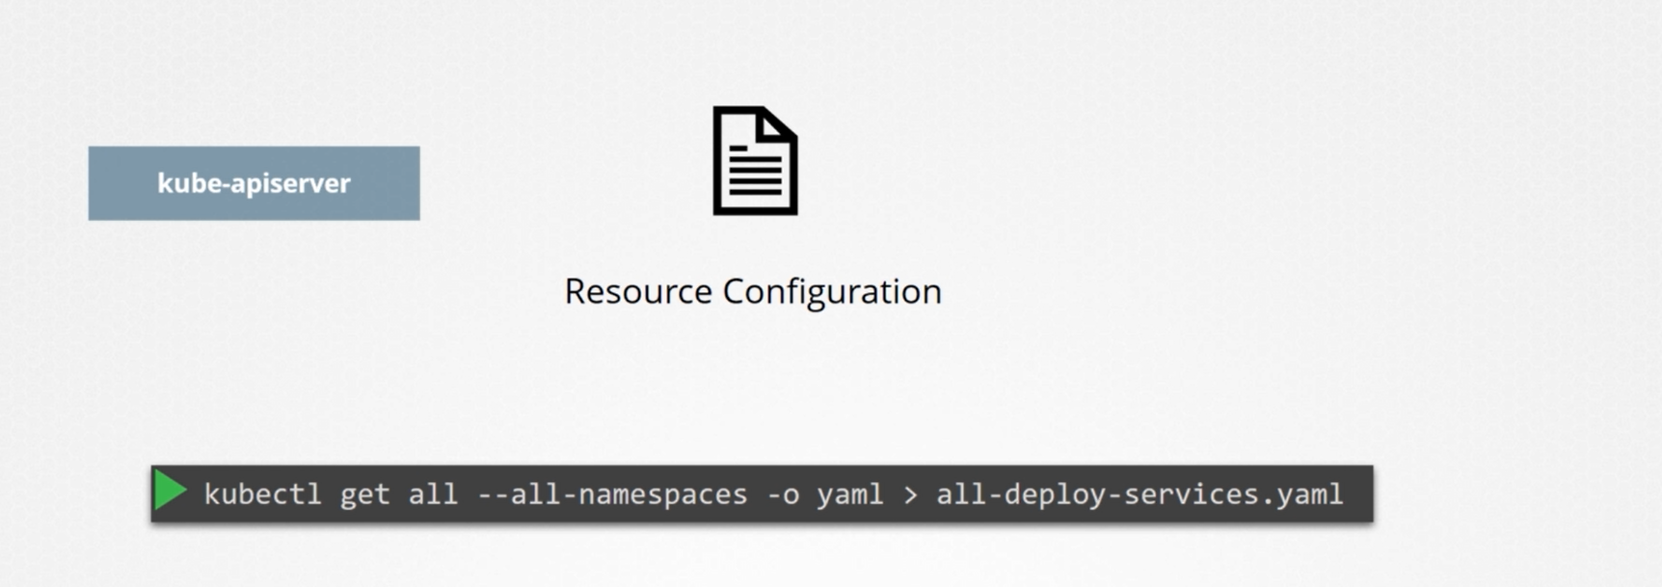

ETCD cluster
ETCD store information about state of the cluster, cluster info stored in etcd
etcd- entire cluster state (metadata) available in etcd database

ETCD cluster is hosted on master node, while configuring etcd specify the location where all the data will be stored.
ETCD also comes with built in snapshot solution. You can take snapshot of etcd database.
To restore the cluster from this backup on later time, first stop the kube-apiserver service.
ETCD is deployed as static pod in K8s cluster in kube-system ns.
Who communicate with etcd database?
api-server, how to communicates with etcd database directly with the help of client utility etcdctl.
Only api server, can access etcd component by default, if we have to access separately then you have to install separate utility client on your box is called etcdctl. etcdctl is a client to access etcd server.
step1: Install etcdctl
export RELEASE="3.3.13"
wget https://github.com/etcd-io/etcd/releases/download/v$ {RELEASE}/etcd-v${RELEASE}-linux-amd64.tar.gz
tar xvf etcd-v${RELEASE}-linux-amd64.tar.gz
cd etcd-v${RELEASE}-linux-amd64
sudo mv etcdctl /usr/local/bin
etcdctl --version
To communicate with etcd, client must know where etcd db is, must know the ip and port of etcd db.
kubectl describe pod etcd-master -n kube-system
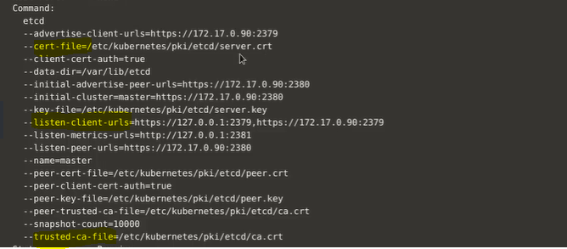
Since etcd is secure server, it does not allow any http communication must go through the https, it has its own certificates
/etc/kubernetes/pki/etcd
ca.crt, server.crt, server.key
end point is server ip address
ETCDCTL_API=3 etcdctl snapshot save -h
ETCDCTL_API=3 etcdctl --endpoints="" --cacert="" --cert="" --key="" snapshot save /tmp/etcd-backup.db
ETCDCTL_API=3 etcdctl --endpoints="" --cacert="" --cert="" --key="" -w=table snapshot status /tmp/etcd-backup.db

Validate:
ETCDCTL_API=3 etcdctl snapshot member list --cacert=/etc/kubernetes/pki/etcd/ca.cert --cert=/etc/kubernetes/pki/etcd/server.crt --key=/etc/kubernetes/pki/etcd/server.key --endpoints=127.0.0.1:2379

How to restore your backup?
Steps of restore of ETCD db?
ETCDCTL_API=3 etcdctl snapshot restore -h
ETCDCTL_API=3 etcdctl --data-dir= /var/lib/etcd-from-backup snapshot restore /tmp/etcd-backup.db
cat /etc/kubernetes/manifests/etcd.yaml # update the hostPath /var/lib/etcd->/var/lib/etcd-from-backup

