Monitor
How do you monitor resource consumption on Kubernetes? Or more importantly what would you like to monitor? I’d like to know Node level metrics such as the number of nodes in the cluster, how many of them are healthy as well as performance metrics such as CPU, memory, and network and disk utilization.
As well as POD level metrics such as the number of PODs, and performance metrics of each POD such the CPU and Memory consumption.
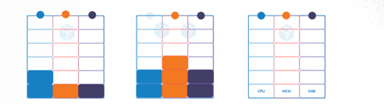
So, we need a solution that will monitor these metrics, store them and provide analytics around this data.
As of now k8s does not comes with such type of solution, while there are lots of third party, open-source solutions are available today, such as the Metrics-Server, Prometheus, the Elastic Stack, and proprietary solutions like Datadog and Dynatrace. You have one metrics server per K8s cluster.

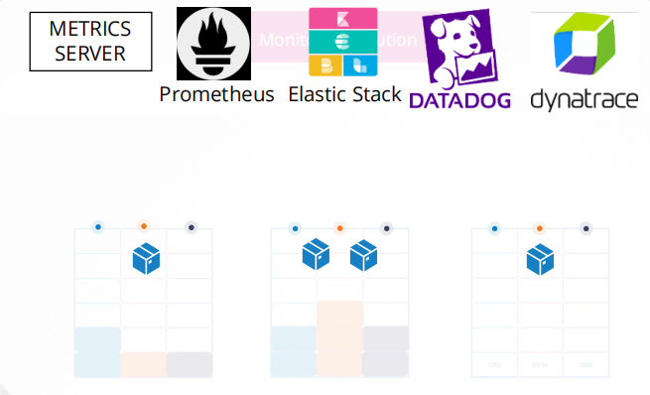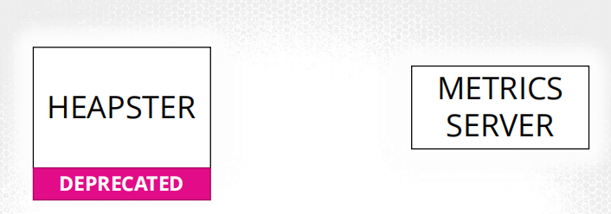

The metrics server retrieves metrics from each of the kubernetes nodes and pods, aggregates them and stores them in memory. Note that the metrics server is only an in-memory monitoring solution and does not store the metrics on the disk, and as a result you cannot see historical performance data.
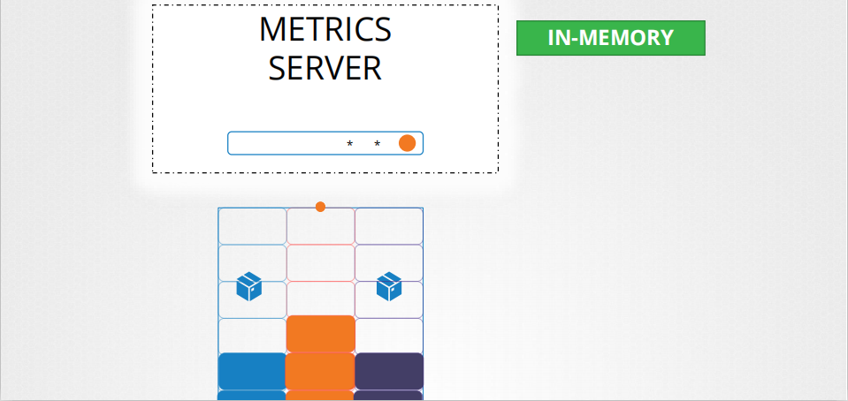
Solution: you have to rely on one of the advance monitoring solutions.

How are the metrics generated for the PODs on these nodes?
Kubernetes runs an agent on each node known as the kubelet, which is responsible for receiving instructions from the kubernetes API master server and running PODs on the nodes. The kubelet also contains a subcomponent known as cAdvisor or Container Advisor, cAdvisor is responsible for retrieving performance metrics from pods, and exposing them through the kubelet API to make the metrics available for the Metrics Server.
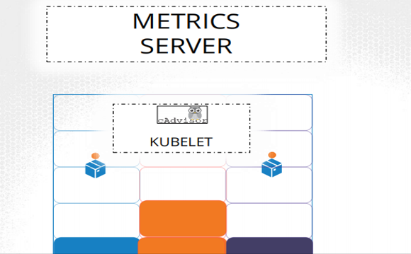

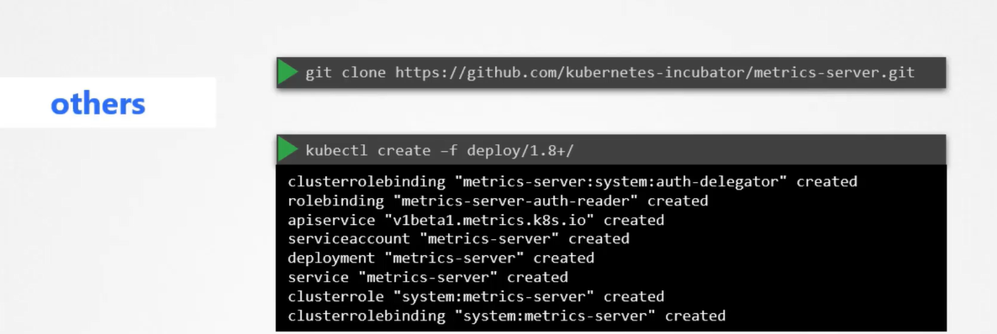
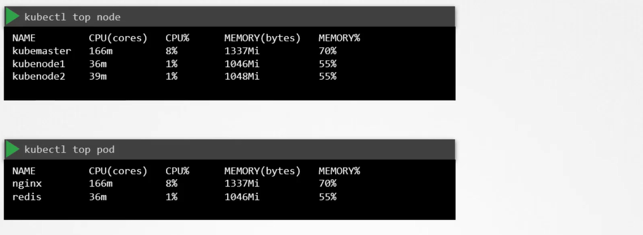
General monitoring concepts: I would like to monitor my production infrastructure; we have to monitor different components separately so that we can identify the root cause of the issue.
- System level monitoring
  - cpu/ram/disk/ping/router/network io
- Process level monitoring
  - docker/tomcat/kubelet/cron/db/ldap/email/dns/kafka/
  - cpu/ram/pods
- Application-level monitoring
  - availability/ response time/ transaction time of application

Prometheus help us in System level and Process level monitoring.

Prometheus: monitoring tool (system and process level), with Prometheus, helps us at k8s cluster level whether my pods are available or not, how much CPU taken by my pods.
Prometheus is a monitoring tool it has to install somewhere, it will collects metrics of the current status of pods running in your k8s cluster using it, it has to some input, it has to go somewhere to fetch the information, by default api server has all information available but by default api server don’t have capability to provide the metrics , api server have already lots of other things to do, so prometheus has not to go to api server now instead of that we have to install another component purely collects the metrics from api server , which talks to api server and continuous collects the all metrics, that is called kube-state-metrics (add on)which is given by k8s again ,which collects the metrics from api server is some interval.

Once we deploy only then it’s going to collect all the metrics from the cluster. But this don’t have db to store the metrics which it is collecting.

Now Prometheus comes in picture, Prometheus talk with kube-state metrics and keeps on collecting, it works on pull model, it pulls the metrics from kube-state-metrics and store the metrics in its in-build default database influxDB. Everything is stored in its db influxDB continuously, it stores all the metrics now it has history of metrics.
Prometheus can’t directly collect the metrics, k8s created a metrics server kube-state metrics
Main Components: Prometheus Server
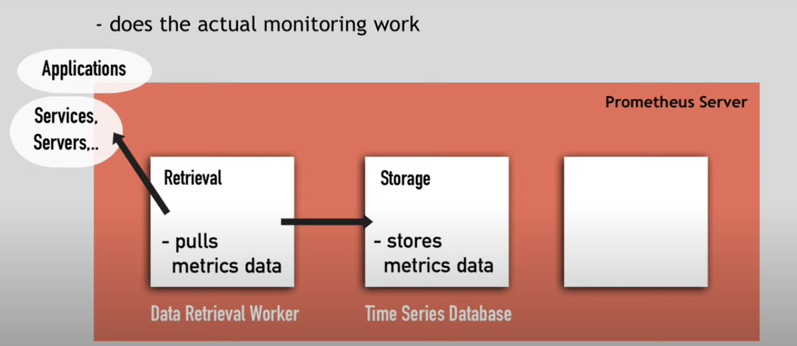
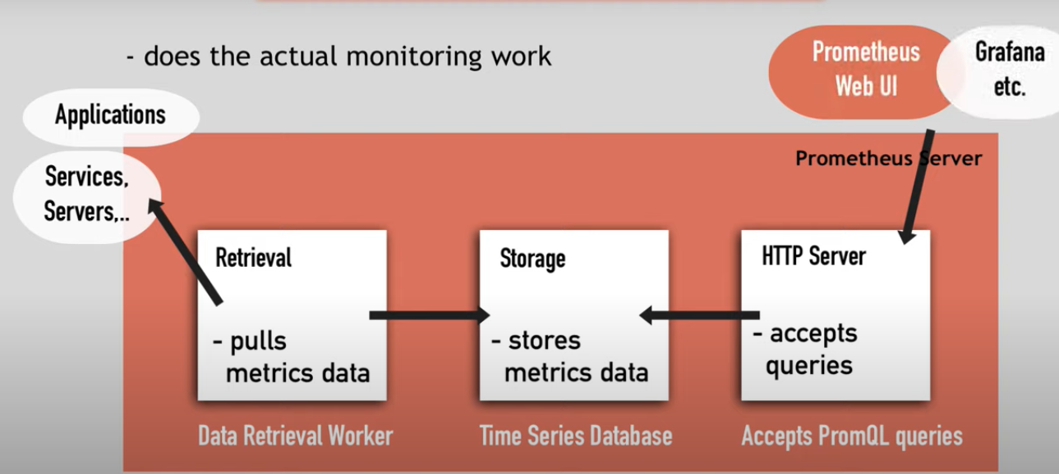

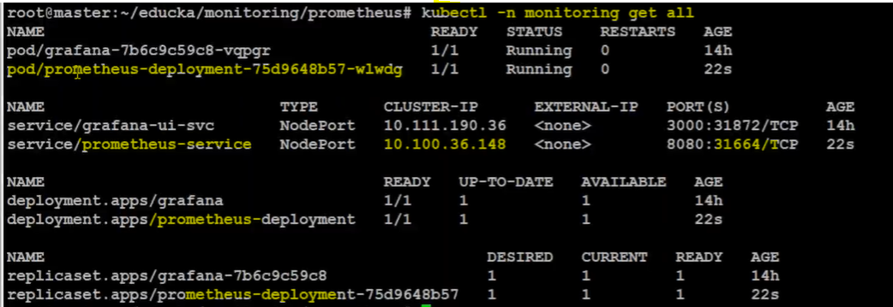
prometheus – is best monitoring tool, good collector but don’t have rich UI

grafana- have rich UI // k8s dashboard for grafana 6417 /11141 (for pod)
<nodeip: NodePort> // prometheus default graph dashboard
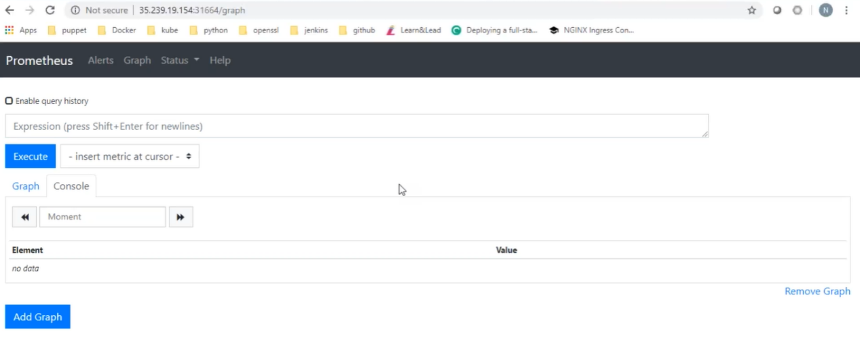
status->target // target from it collects the metrics
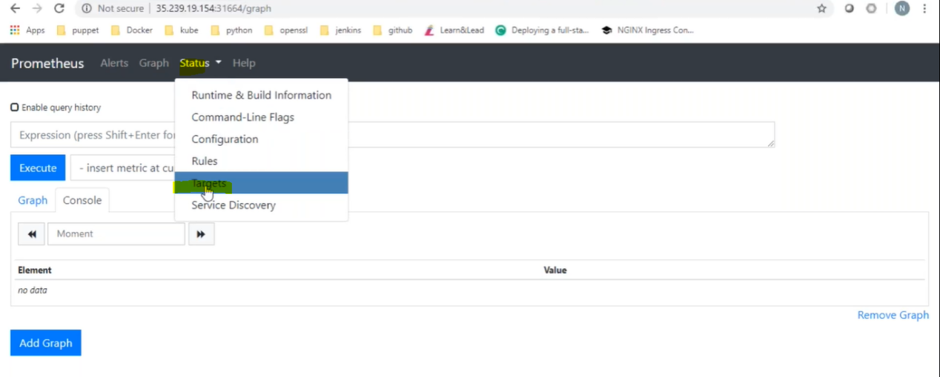
Prometheus doesn’t have rich dashboard, it shows only default metrics, it has all the data but don’t have rich dashboard.
How to show rich dashboard?
Grafana Is all about how to visualize the data better, it collects the data from Prometheus db, need to connect with the Prometheus (as a data source), it will pull the data from Prometheus db.
login: admin/admin, add data source: new dashboard:
How to configure Grafana dash board?
Create-> new dash board
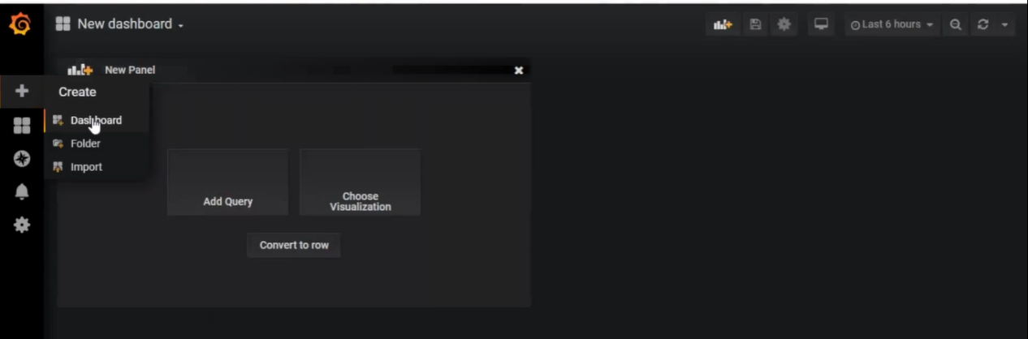
create-> import // existing dash boards
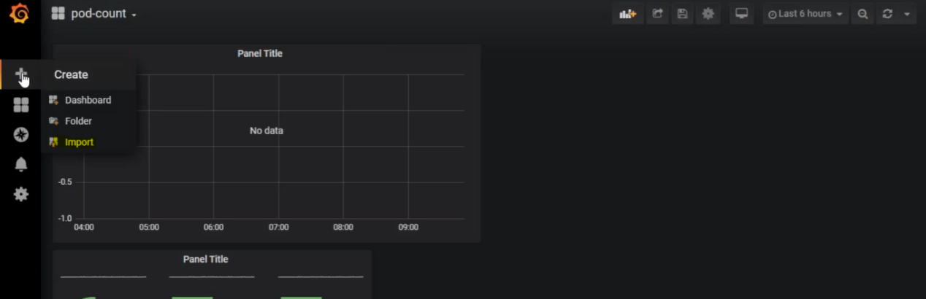
6417, 11141
How can we configure mail server?
Inside your grafana pod, first grafana mailing service to be enable.
Alerting, Notification channels
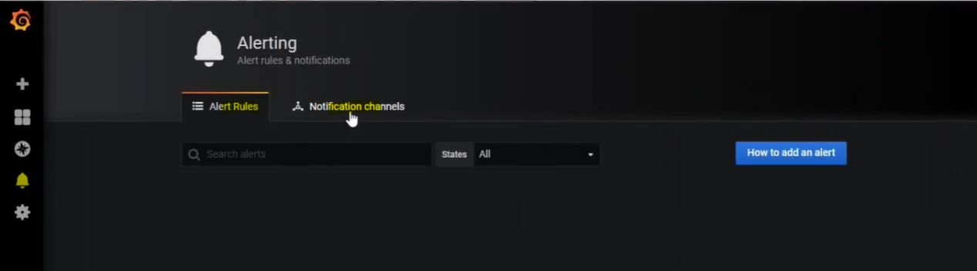

Managing Applications Logs?
Logs-Docker
docker run <image>
UC: If we run the container in detached mode, we can’t view the log.
docker run -d <image> // kodekloud/event-simulator
docker logs <container id>
docker logs -f <container id> // to see the live logs

Logs-K8s
Kubectl logs -f < name of the pod> -c <name of the container>
kubectl logs etcd-master -n kube-system
If pod is not available go one step behind
