Troubleshoot:
Identify the problems is the first step in troubleshooting an application in the cluster. Problems can be identified by
- Debugging Pods
- Debugging Services
- Debugging Deployment
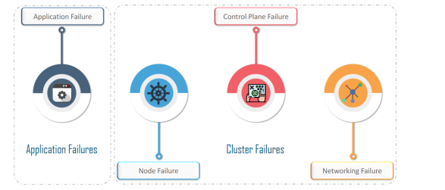
UC: We have 2-tier application Web and DB servers, DB server hosts on the DB pod and serves the web server through the DB-service, Web server is hosted on web pod and serves the user through web-service.
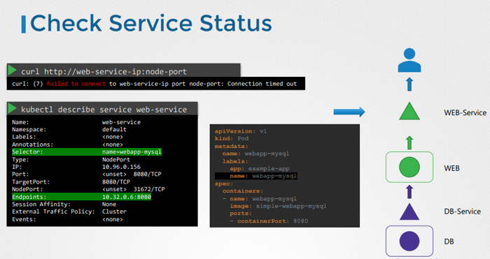

Application Failure
User reports the issue to accessing the application.
Check each and every point of this map until find the issue. In this case we start with application front end.
- Check the resources names
- Check the target-ports
- Check the endpoints
- Check the environment variables
- Check the NodePort
step1: Check the application is accessible on the IP of the NodePort?
curl http://web-sevice-ip:node-port
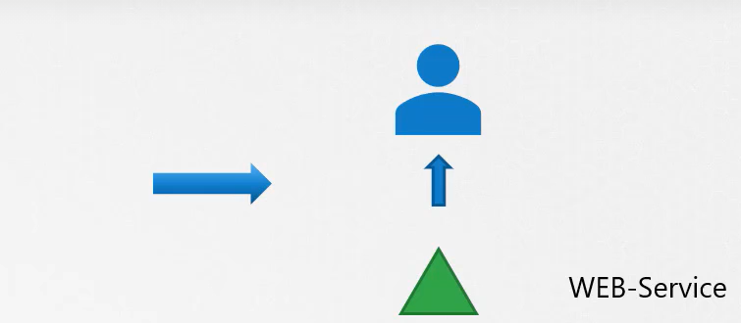
step1.1: Check the web-service
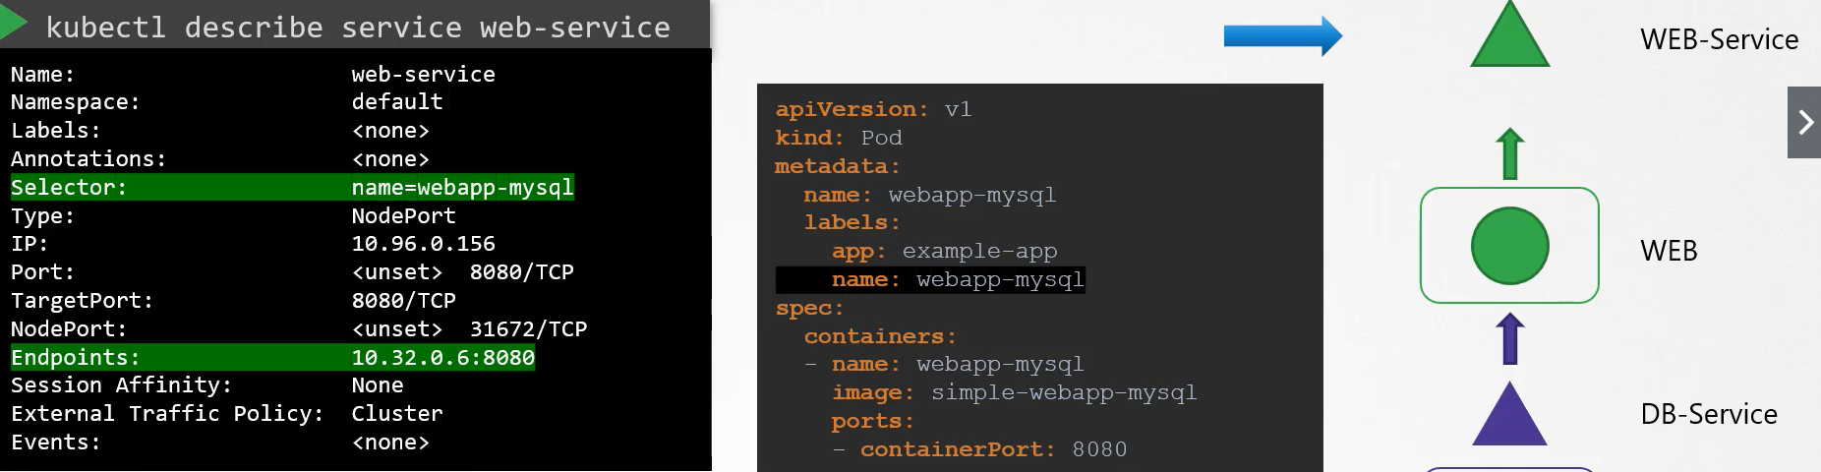
kubectl describe svc web-service

Services: Missing Endpoints
Service might not load balance the traffic when the endpoints are not attached
Check if the endpoints are attached using the get endpoints command
Services: Labels not matched
Check the selector matches with the Pod’s label.
Services: exposed Ports
If the pods listed are the expected set of Pods, there could be problem with exposed ports
Match the service’s target port and the pods container port.
step1.3: Check the web Pod itself.
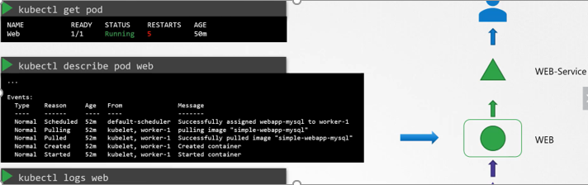
make sure it is in running state, check the status as well as the number of restarts.
kubectl get pods.
check the events of the pod using describe command
kubectl describe pod <web>
check the logs of the application using logs command.
kubectl logs –f web // --follow active flow
kubectl logs –f web –p // check the previous logs in case of restart
step1.4: check the dependent service (db-service) and Pod (db-pod).

Control Plane Failure:
On the master node, the control plane may fail because of an issue in:
- Scheduler
- API Server
- Control Manager
- describe the component
- check the log of the component
- check the yaml of the component
- one-layer deeper docker ps
- docker logs <containerId>
step1. check the status of Control plan Pods
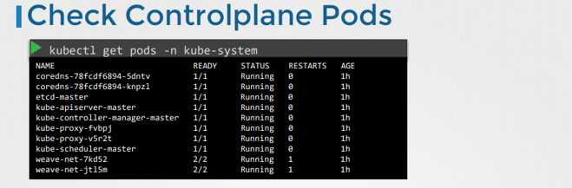
step1.1 describe the status of Control plan Pods
step1.2 check the logs of Control plan Pods
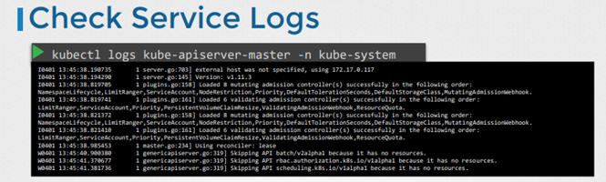
UC: api-server is not running? – StaticPod
step1. check the status of api-server pod
step1.1 describe the status of api-server pod
step1.2 check the logs of api-server pod

UC: replicas scaling is not working?
step1. check the status of controller pod (responsible for scaling)
step1.1 describe the status of controller pod
step1.2 check the logs of controller pod

UC: Pod is in Pending state?
step1. check the status of scheduler pod (responsible for scheduling)
step1.1 describe the status of scheduler pod
step1.2 check the logs of scheduler pod

Worker node Failure:
UC: wnode is in NotReadyState?
kubectl get nodes
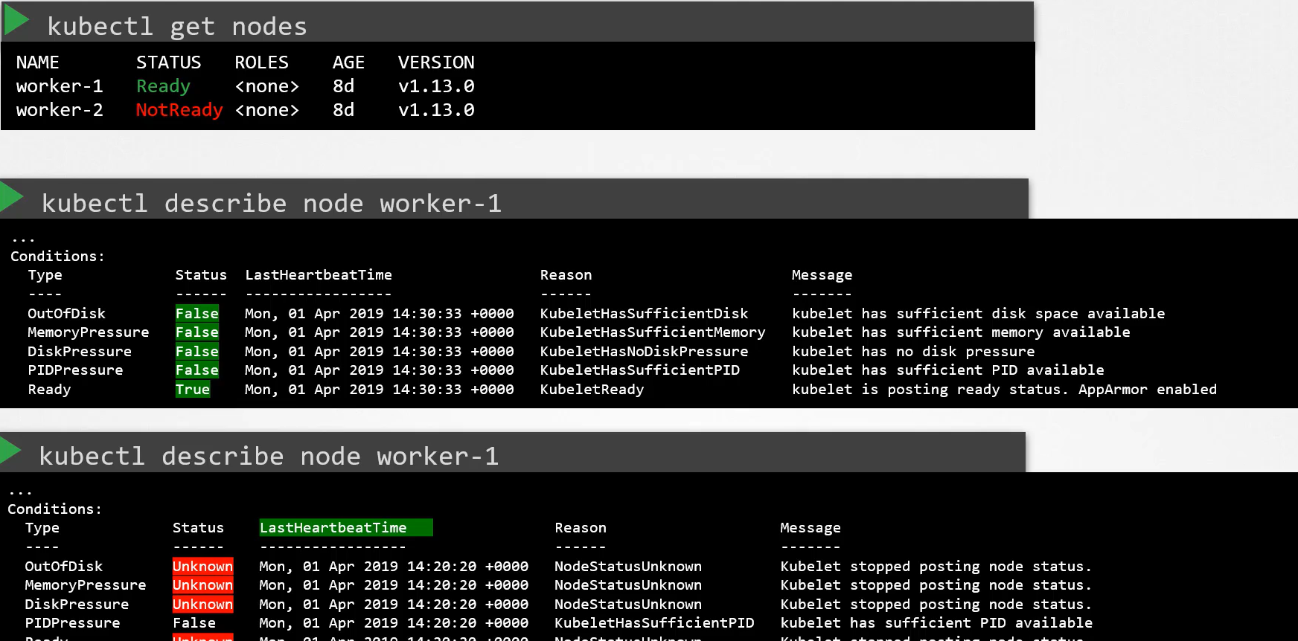
- ssh wnode01
- service docker status
- service kubelet status
- journalctl -u kubelet
- service kubelet restart
- one-layer deeper docker ps
- docker logs <containerId>

step: check the kubelet certificate, ensure they are not expired
openssl x509 –in /var/lib/kubelet/worker-1.crt -text
