Helm
What is helm?
UC: We have a 100 Micro Services, each of them has config file, service. yaml how we manage as a single unit.
Helm is K8s package manager.
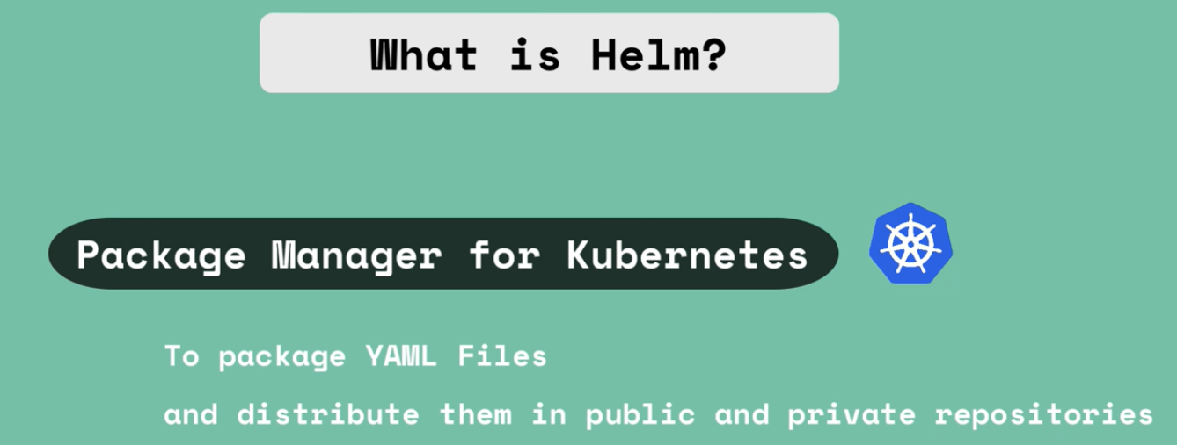
To package YAML files and distribute them in public and private repositories
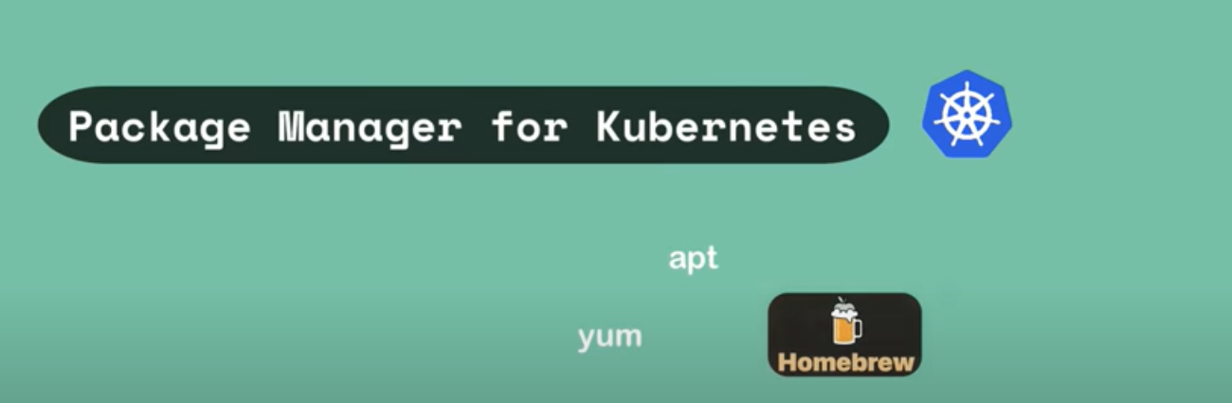
UC: We have already deployed our application in K8s cluster, you want to deploy additionally, Elastic Search in your cluster to collect logs of your application, in order to deploy Elastic stack in your cluster you need additional resources e.g., StatefulSet (for stateful app), ConfigMap (for external configuration), secret (for secret data), K8s User with permissions and couple of services, manually it will take lots of time, if someone collects all these yaml file and package them and made them available somewhere by pushing in Helm Repo, that bundle of yaml files are called Helm Chart.
Helm Chart:
- Bundle the yaml files
- Create your Own Helm Charts with helm
- Push them to Helm Repository
- Downloaded and use existing ones
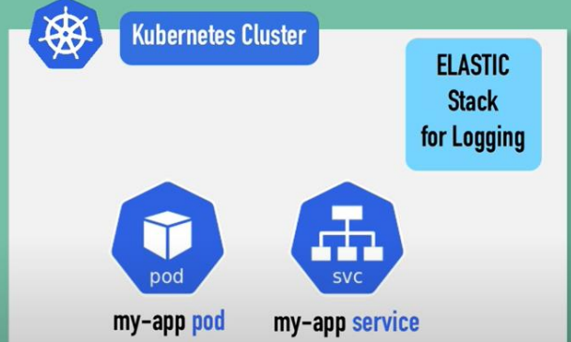
Commonly Used Deployments: (Those Charts already available)
- Database applications
- Elastic Search
- MongoDB
- MySQL
- Monitoring App (Prometheus)
You can reuse the existing charts using the helm install <chart name> without additional efforts.
helm search <keyword> # search in helm hub

What we can do with helm chart?
- helm install <chart Name>
- helm upgrade <chart Name>
- helm delete <chart Name>
How to Install Helm?
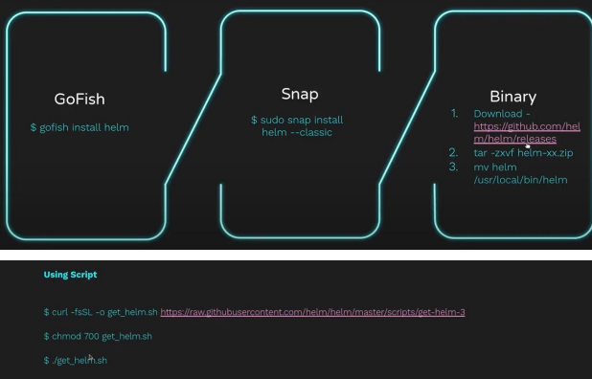
Chart: A Chart is a Helm package. It contains all of the resource definitions necessary to run an application, tool, or service inside of a Kubernetes cluster. Think of it like the Kubernetes equivalent of a Homebrew formula, an apt dpkg, or a Yum RPM
file.
- Bundle of YAML files
- Create your own Helm Charts with Helm.
- Push them to Helm Repository
- Download and use existing ones
- Public Registries
- Private Registries
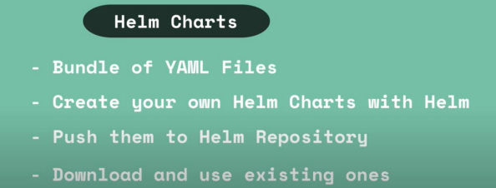
Another feature: Templating Engine
UC: You have an application made up of multiple Micro Services, we have to deploy in K8s cluster, all of them have deployment and service configuration almost the same, with only difference is application name and the version.
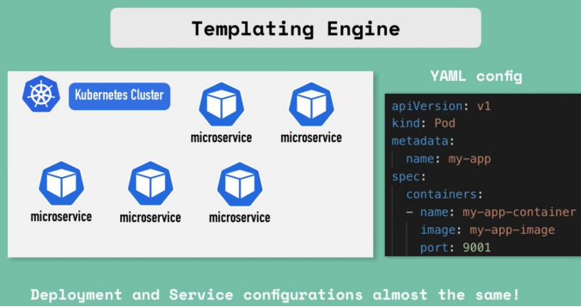
Without the helm, you have to write different yaml files for each of the deployment.
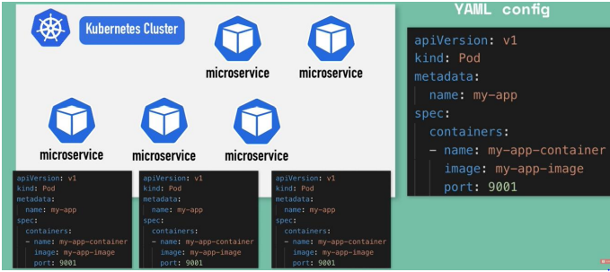
Since most of the values are same.
With the help of helm
1) Define a common blue print (That would be a template file)
2) Dynamic Values are replaced by placeholder
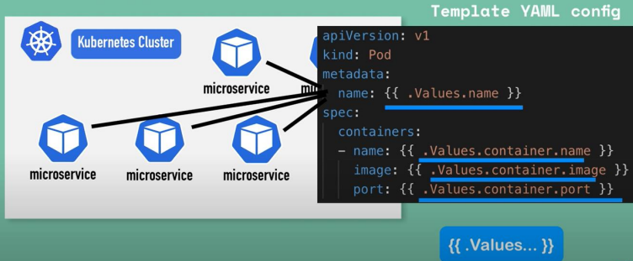
{{. Values}} means you are taking values from external configuration (value. yaml), .Value is an object , which is created based on the values defined.
Values defined either via yaml file or with –set flag
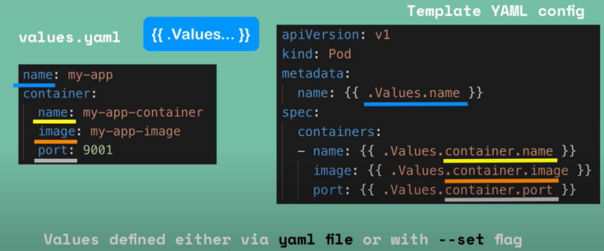
Now instead of many yaml files, you have one values are change dynamically.
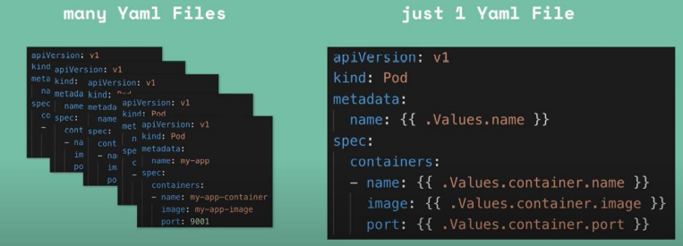
Use in CI/CD pipeline:
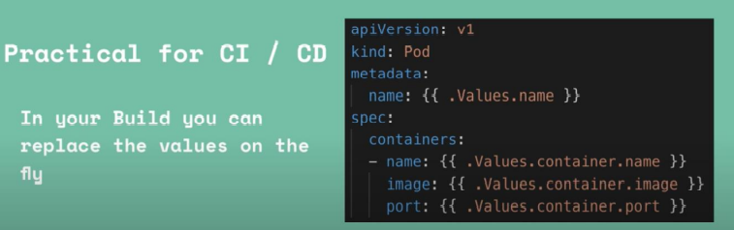

UC#3 Same application across different environments, across K8s Cluster, you have to deploy your microservice in different-different environments.
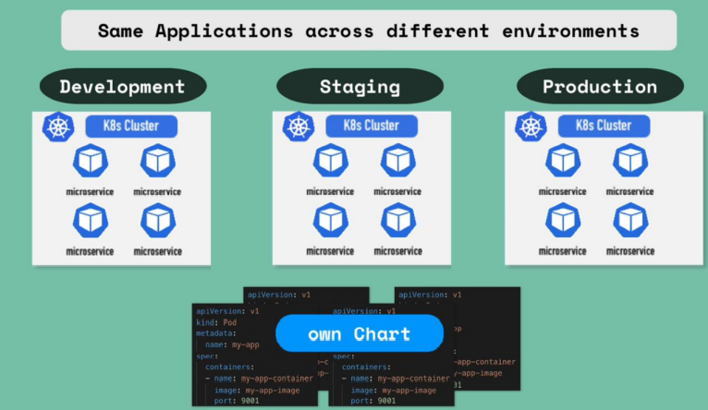
Instead of deploy separate files in each cluster, you package them to create your own helm chart, use the same to deploy in different environment.
Helm Chart Structure:
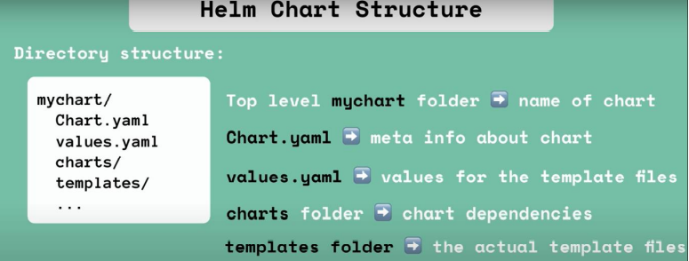
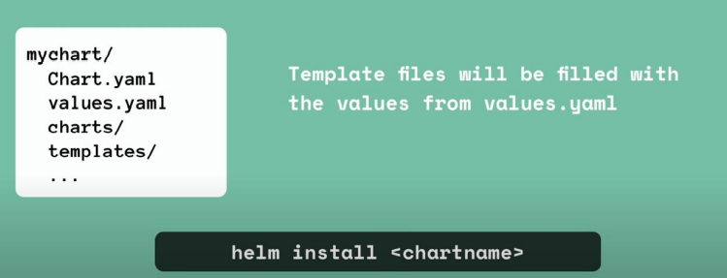
values injected into the template file.
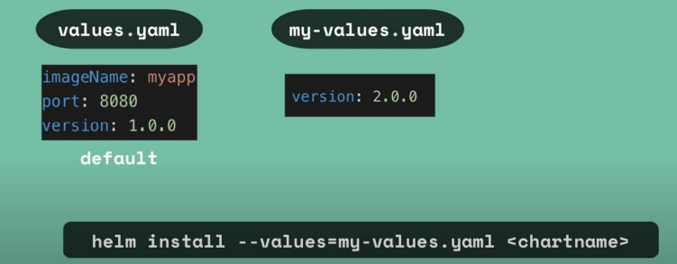
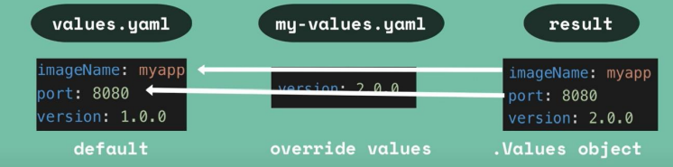

UC3# Release Management (Difference between v2 Vs. v3)
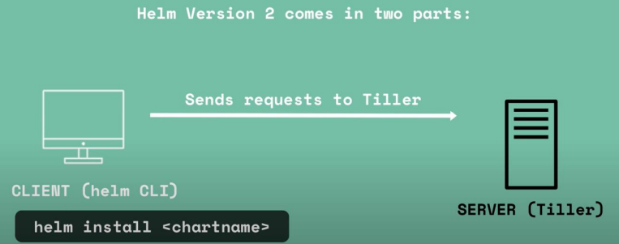
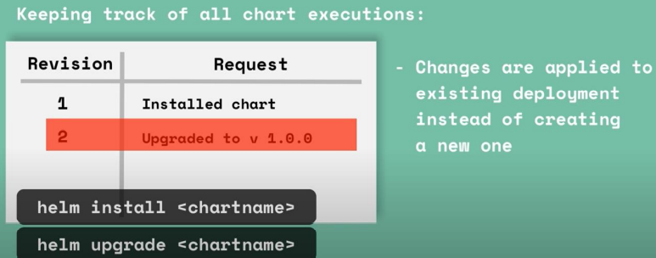
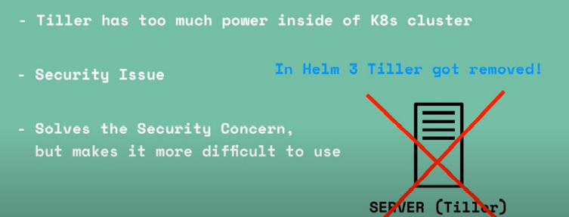

helm create demochart
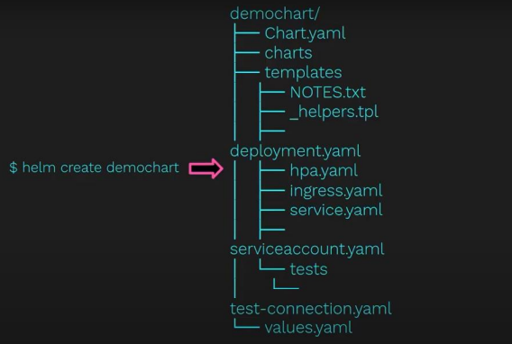
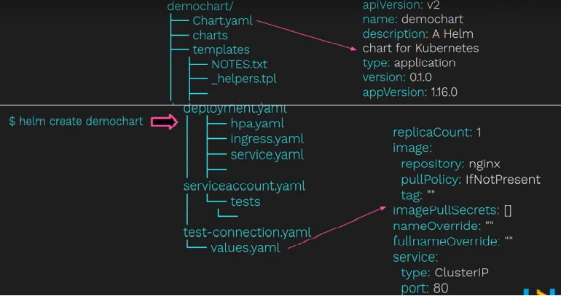

Difference between normal deployment and Helm deployment?
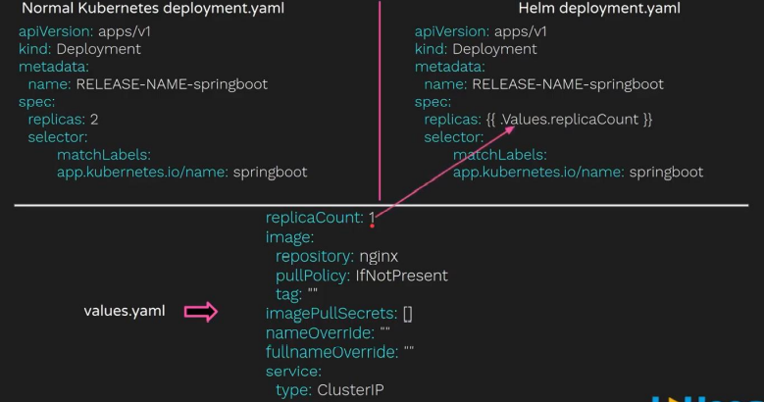
Day to Day Operations?
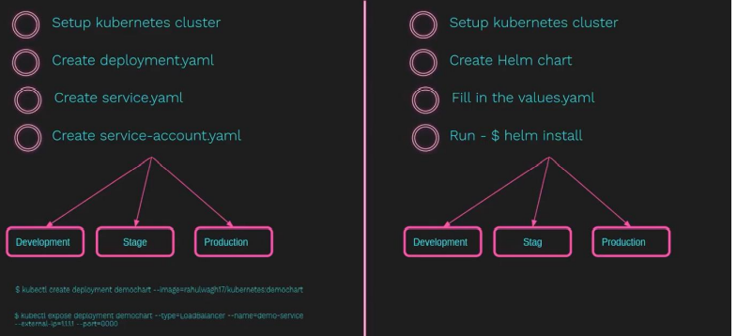

Demo How to create Helm Chart?
step1: install helm
step2: kubectl get all
step3: helm create springboot
step4: tree springboot
step5: view actual yaml
cd ..
helm template springboot
step6: Identify possible issue
helm lint springboot # just like compilation
step7: dry-run
helm install <release name> --debug --dry-run <chartname>
step7 : helm install
helm install <release name> <chartname>
step8 : verify helm install
helm list -a
kubectl get all
How to upgrade helm release?
upgrade helm <release name> <chartname>
How to rollback helm release?
helm list -a
helm rollback <release name> < revision number>

Client Only Architecture
Helm 3 has a client-only architecture with the client still called helm. As seen in the following diagram, it operates similar to the Helm 2 client, but the client interacts directly with the Kubernetes API server. The in-cluster server Tiller is now removed.
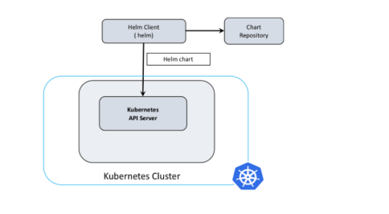
It’s not related to K8s, it’s Add on top of k8s. Helm is package manager for your K8s, you have to install helm as separate package just like kubectl.

convert kubernetes.yaml to Helm chart yaml
