UC: In your organization there are multiple cluster
Jump Box/Bastion host
What required in Jump Box?
kubectl +. kubeconfig
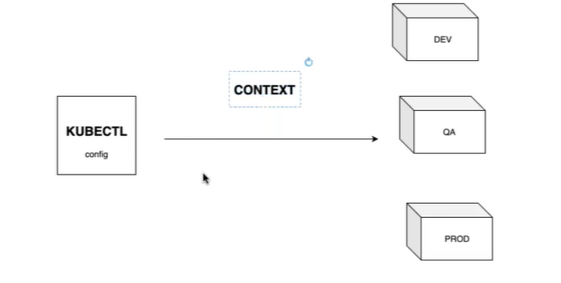
step1: create a new instance jumpbox.
step2: Install kubectl
sudo apt-get install -y kubectl (only kubectl client utility)
step3: create devops user (password today@1234)
step4: create devops user (password today@1234) in master
step5: cp .kube/config /tmp; chmod 755 /tmp/config
step6: scp of .config from existing master
scp devops@<master> :/tmp/config .
step7: mkdir .kube
step8: mv config .kube/
step9: kubectl get nodes
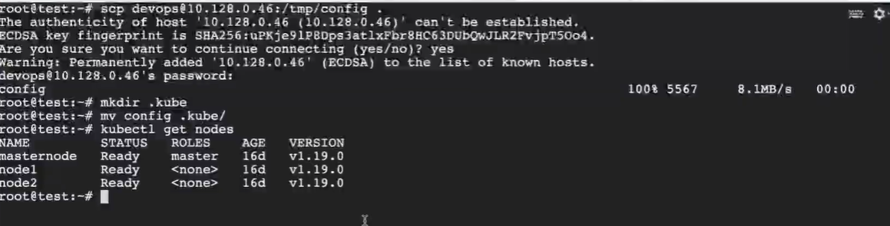

how to create a user
mkdir -p /home/prod-user/certs
cd /home/prod-user/certs

generate private key
openssl genrsa -out prod-user.key 2048

create certificate signing request (csr) file
openssl req -new -key prod-user.key -out prod-user.csr # common name, organization name

request is the base64 encoded value of the CSR file content. You can get the content using this command:
cat prod-user.csr | base64 | tr -d "\n"

create csr manifests
nano prod-user.yaml

apiVersion: certificates.k8s.io/v1
kind: CertificateSigningRequest
metadata:
name: prod-user
spec:
groups:
- system:authenticated
request: cat prod-user.csr | base64 | tr -d "\n"
signerName: kubernetes.io/kube-apiserver-client
usages:
- client auth

kubectl create -f prod-user.yaml
kubectl get csr # pending approval
kubectl certificate approve prod-user # csr approved

how user use this certificate
sudo cp /etc/kubernetes/admin.conf .
mv admin.conf prod-user.conf
Update the prod-user.conf
.kubeconfig Kubeconfig file is in specific format, config file has three sections Cluster, User and Context

kind: Config
apiVersion: v1
preference: {} # current-context
clusters:
users:
contexts:

kind: Config
apiVersion: v1
clusters:
- name:
cluster:
users:
- name:
user:
contexts:
- name:
context:

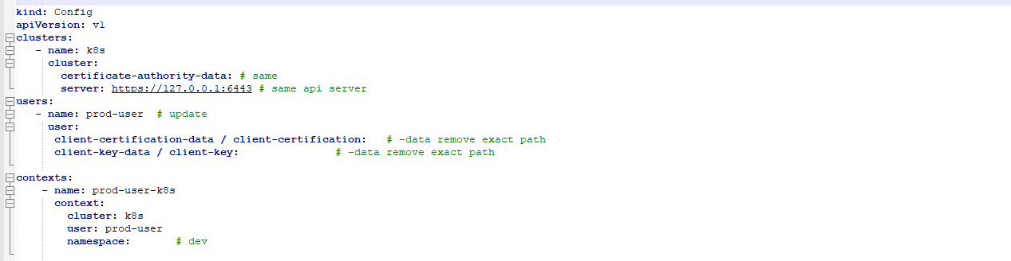

commands
k config -h
k config view # default config from /.kube
k config --kubeconfig=/my-custome-config view # custom config
k config get-contexts # displays list of the context
k config current-context # display the current-context
k config set-context --current --namespace=dev #permanently save the namespace for all subsequent kubectl commands in that context.
k config unset users.foo # delete user foo
k config use-context prod-k8s-playground@prod-k8s-admin
k config use-context prod-k8s-playground@prod-k8s-admin --kubeconfig=/my-custom-config

Once we move our custom-config in to .kube/ folder then it becomes our default config

validate
kubectl --kubeconfig=prod-user.conf version –short
kubectl --kubeconfig=prod-user.conf get nodes # As of now authenticated not authorized

UC: we have multiple clusters, how to connect to the Dev?
Using Context
kubectl config get-contexts
kubectl config use-context <name>
Context binds your kubectl with your cluster
Context tells you which user is connected to which cluster

