JSON Path in K8s
Why JSON Path?
UC: Large data sets
- 100’s of nodes
- 1000’s of Pods, Deployments, ReplicaSet
What is Kubectl?
Is a K8s CLI Utility, used to read and write K8s objects? Every time you run a kubectl command it interacts with kube-apiserver. Kube-apiserver knows the json language so it returns the requested information in json format. kubectl receives the json response and convert it in the human readable format and prints in the screen, during that process lots of the json information is hidden in order to make them human readable.
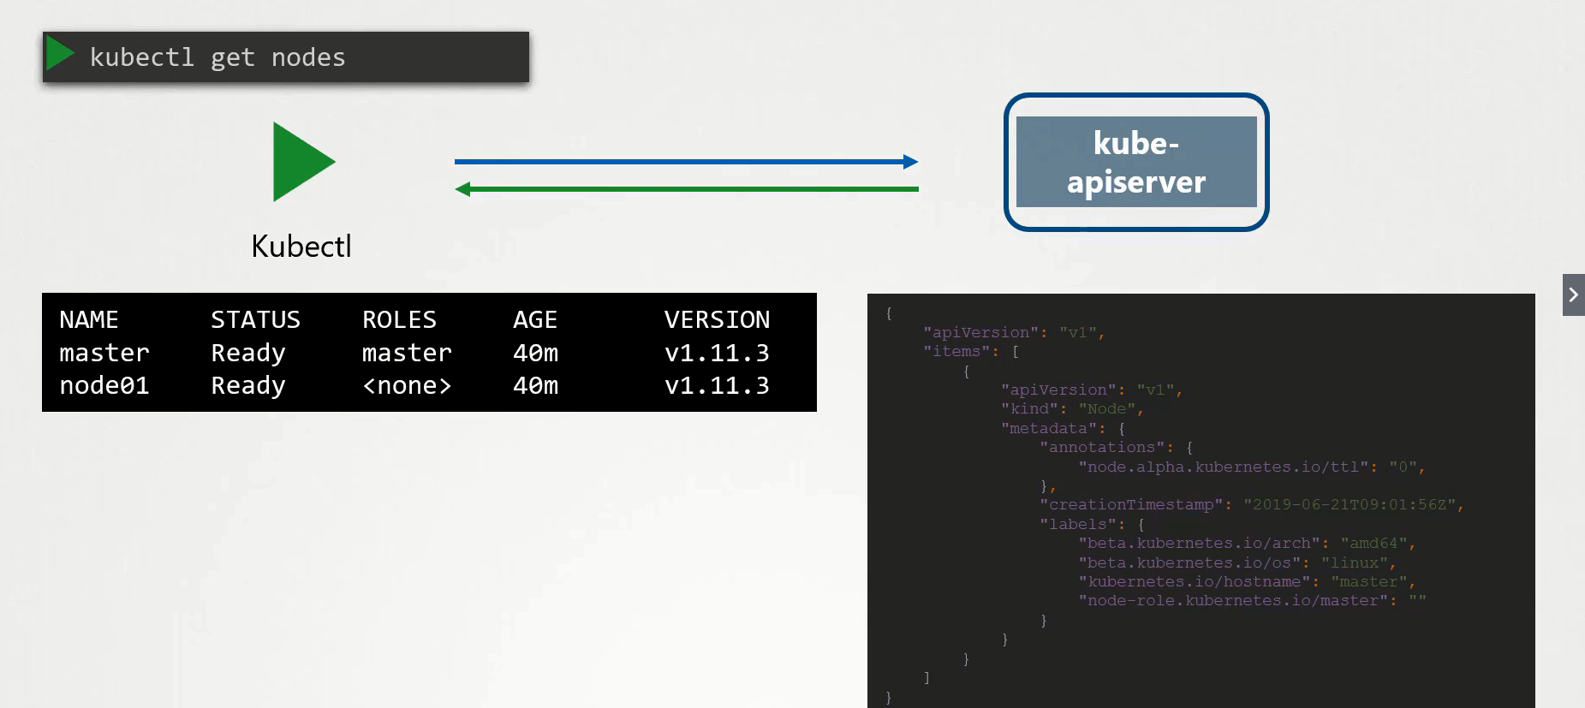
If you want to see the additional information, use the –o wide option.
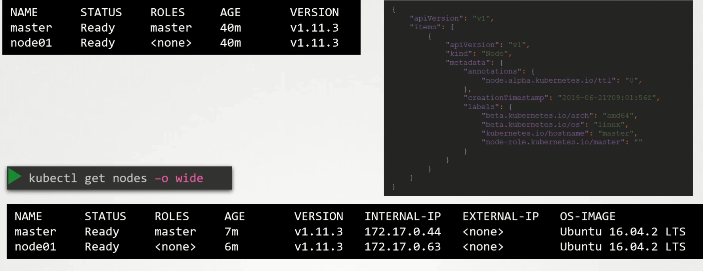
But still this is not complete there is lots of information is still hidden and not shown in the output e.g., resource capacity available on this node, taints sets on the node etc.
How to JSON Path in kubectl?
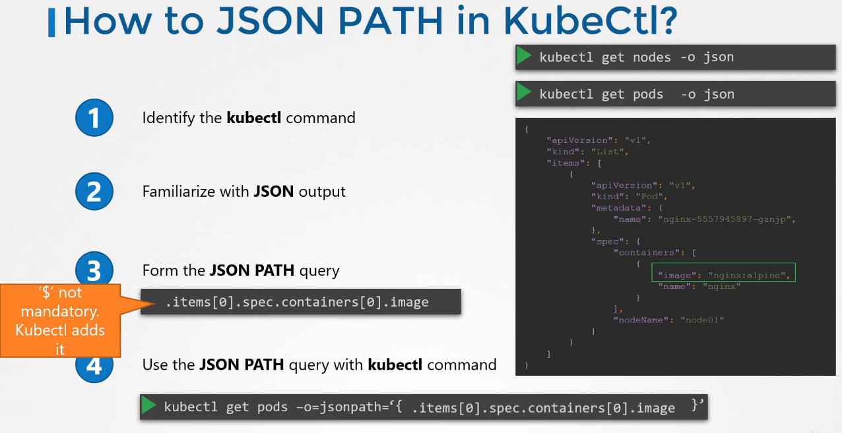
How to JSON PATH in kubectl?
Identify the kubectl command? kubectl get nodes
Familiarize with JSON output (-o json) kubectl get nodes -o json

Form the JSON PATH Query
JSON PATH Query: With the help of json path query you can filter, and format the output of the command as you like.
.items[*].status
Use the JSON PATH Query with kubectl command
Note: encapsulate the jsonpath query with ‘{}’
kg nodes -o jsonpath='{.items[*]}'
kg node -o jsonpath='{.items[*].status.addresses[].address}'
JSON PATH – Wildcard
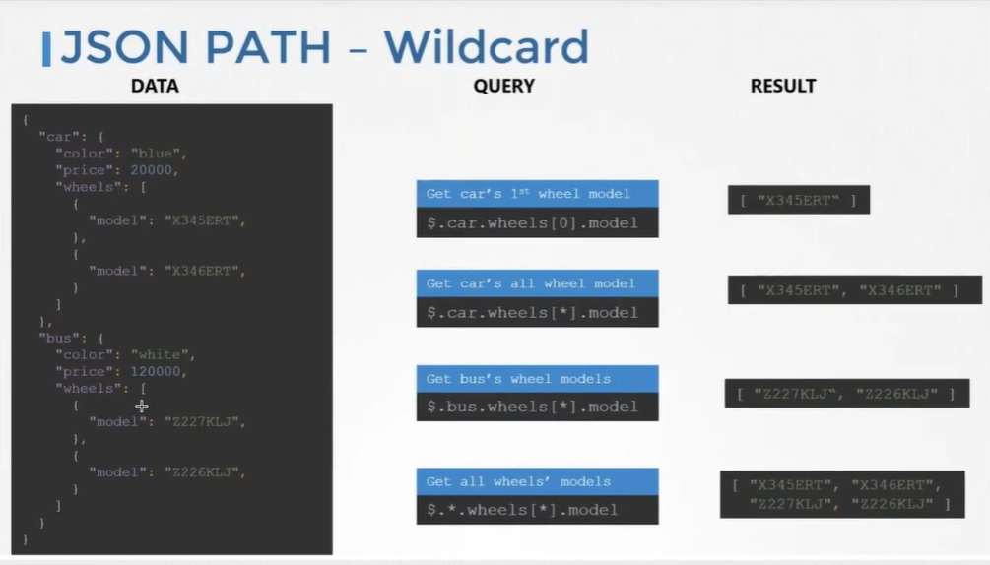
JSON PATH – Example
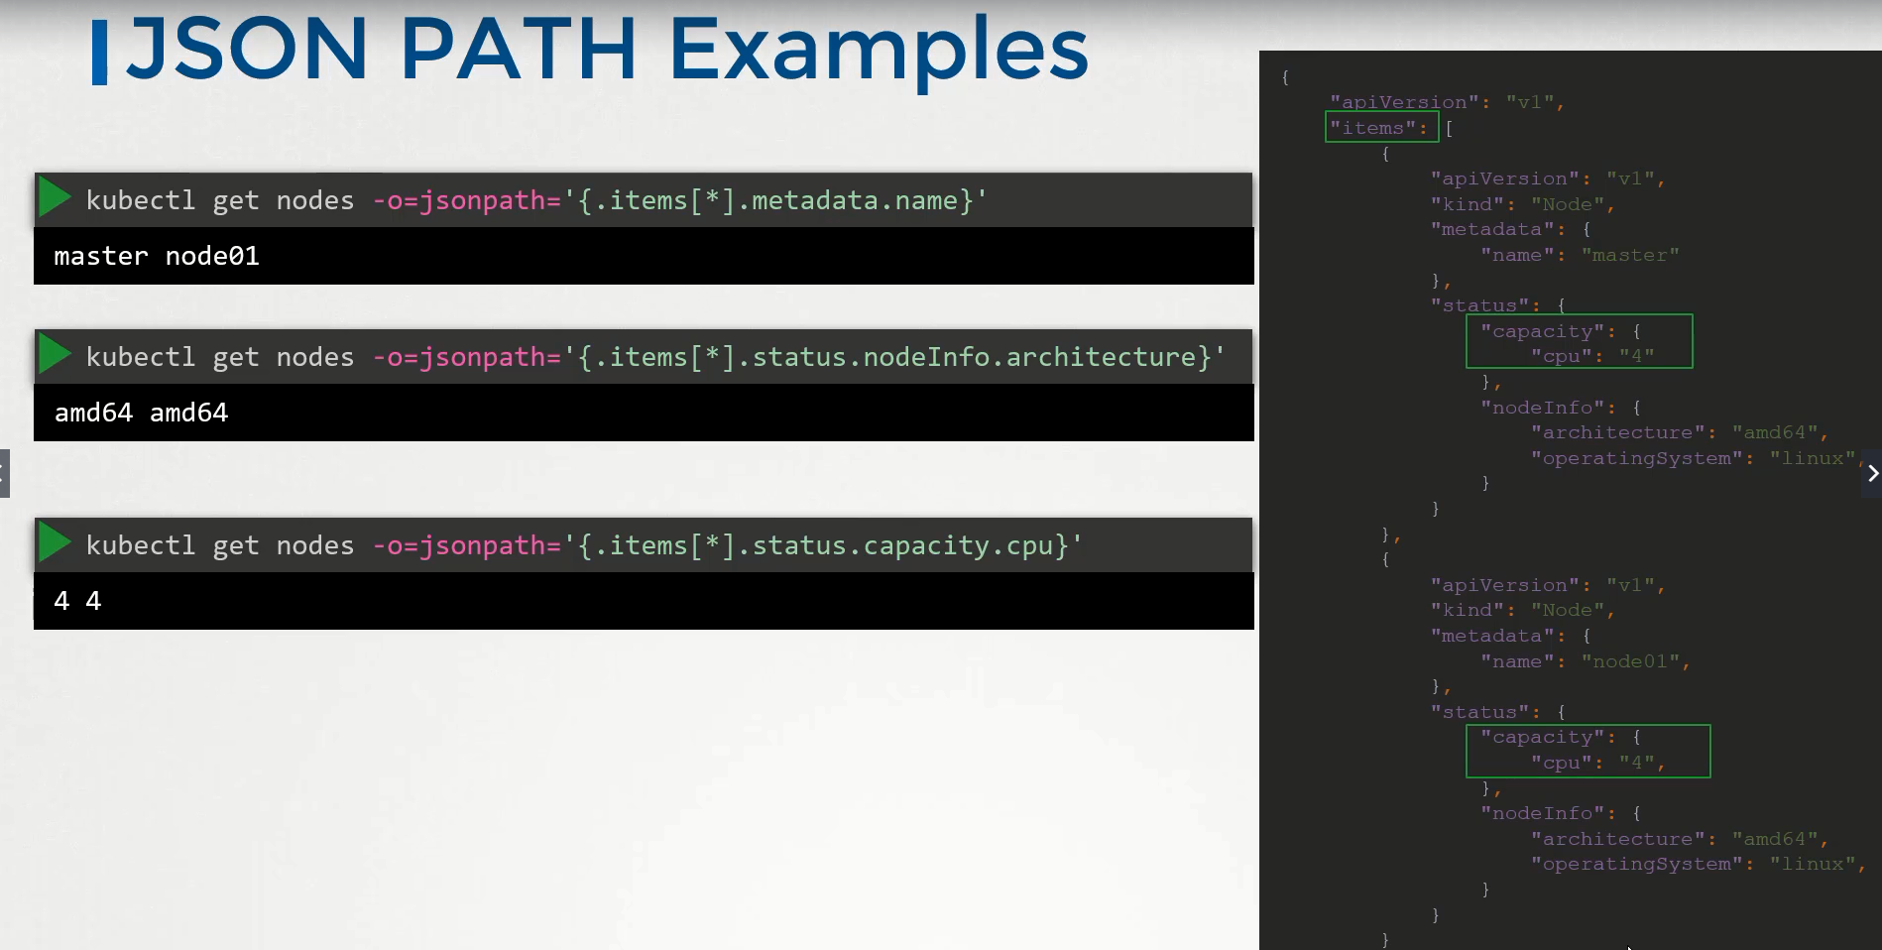
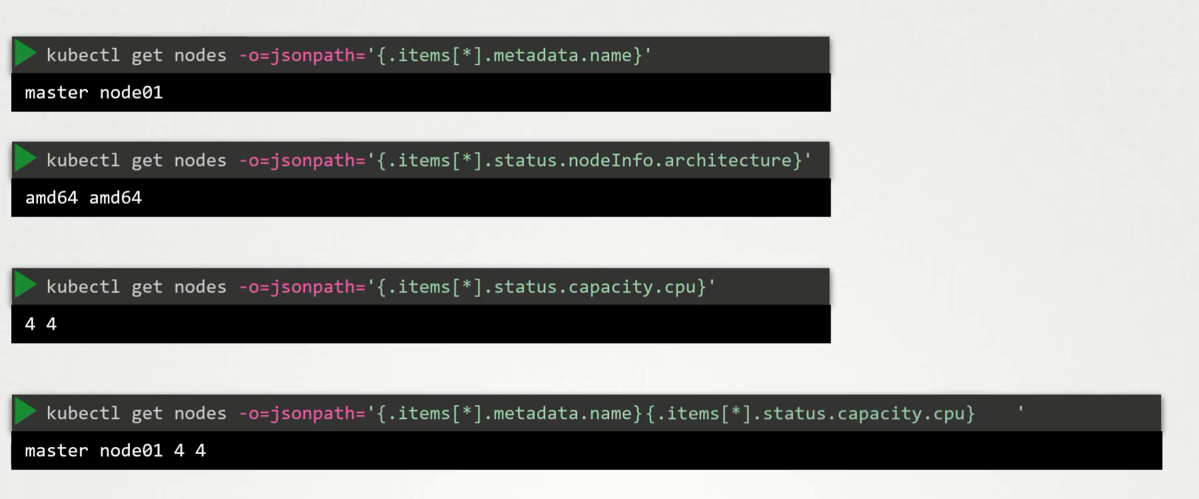
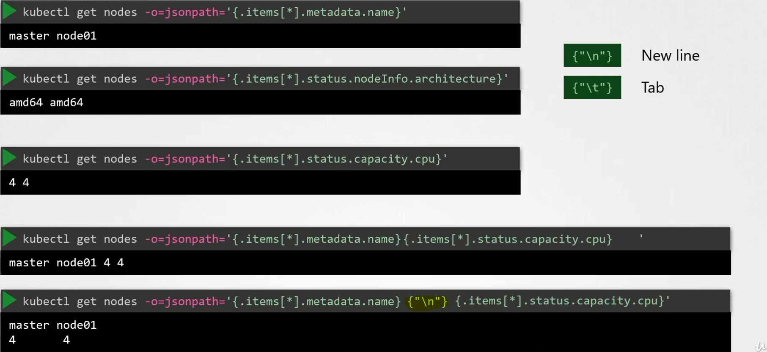
Custom-Columns
kg nodes -o custom-columns=<COLUMN_NAME>:<JSONPATH> # not a querypath
kg nodes -o custom-columns=NODE:.metadata.name,CPU:.status.capacity.cpu
kg pod -A -o=custom-columns=NAME:.metadata.name,CPU:.status.capacity.cpu --sort-by=.status.capacity.cpu
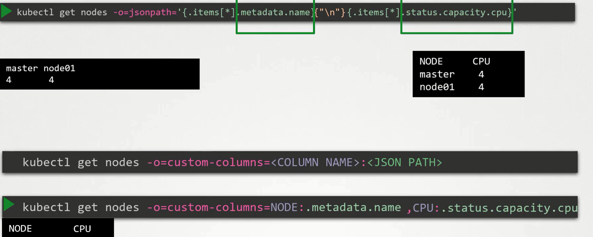
SORT-BY
kg nodes --sort-by=.metadata.name # not a querypath
kg nodes --sort-by=.status.capacity.cpu
