Static Pods
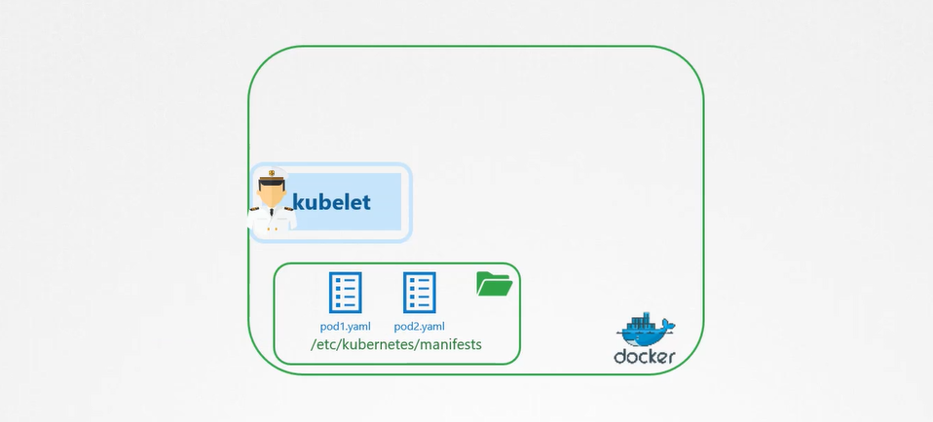
kubelet work at pod level,
How to pass the location? staticPodPath: /etc/kubernetes/manifests
docker ps
kubectl get pod
When kubelet creates a static pod, and it also a part of k8s cluster then it’s also creates a mirror object for api-server.
Difference between Static Pod and DaemonSets
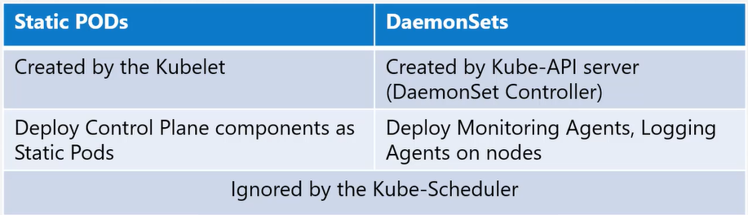

Multi Scheduler
kubectl get pods -o yaml -n kube-system // kube-scheduler-master
By default K8s have their own scheduler (kube-scheduler-master), taking decision in which node, pod should be run.
Why we need another scheduler?
You have a specific application that requires it components deployed on nodes after performing some additional checks. K8s is highly extensible you can write your own k8s scheduler, package it and deploy it as a default scheduler or as an additional scheduler in K8s cluster, all the application can use default scheduler and your specific application can use customized scheduler, can have a multiple scheduler at same time. When creating a Pod can define to which scheduler within spec attribute,e.g. If you want on scheduler your own customization, I want to set my priority e.g. if pod fail default scheduler takes 10 min to reschedule the pod in another node, I want it takes 5 min to schedule.
Deploy additional Scheduler-Kubeadm
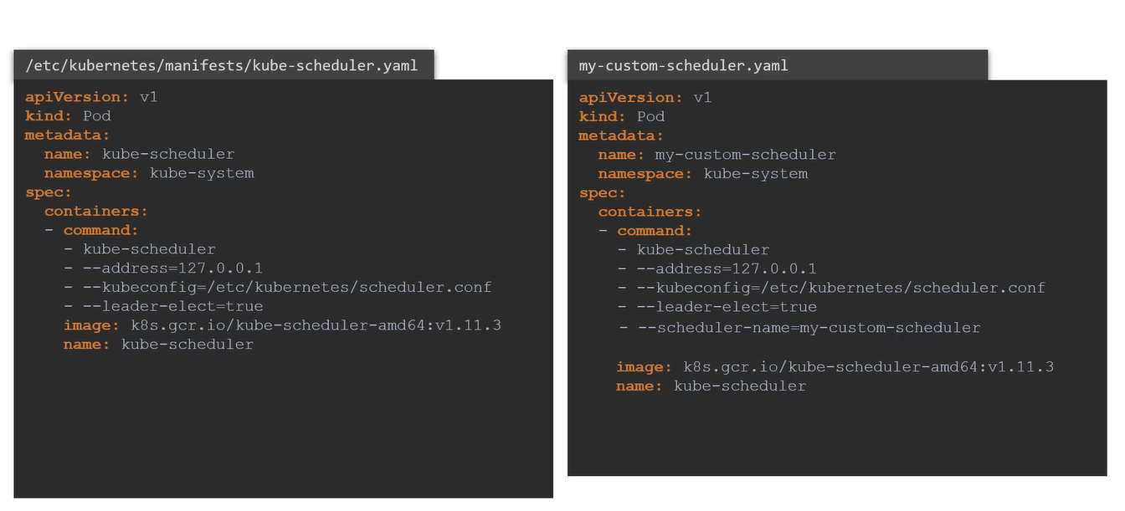
step1: copy the kube-scheduler.yaml
step2: change the name of my-custom scheduler

kubectl apply -f <my-scheduler.yaml>
kubectl -n kube-system get pods # check myschedular is running
UC: If multiple schedulers are running on cluster then at a time only one can be active.
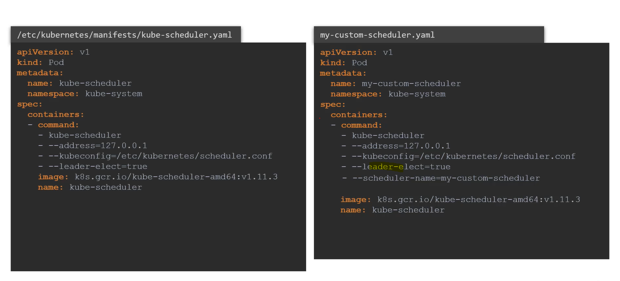
How to tell our Pod to use our scheduler else it will use default scheduler?
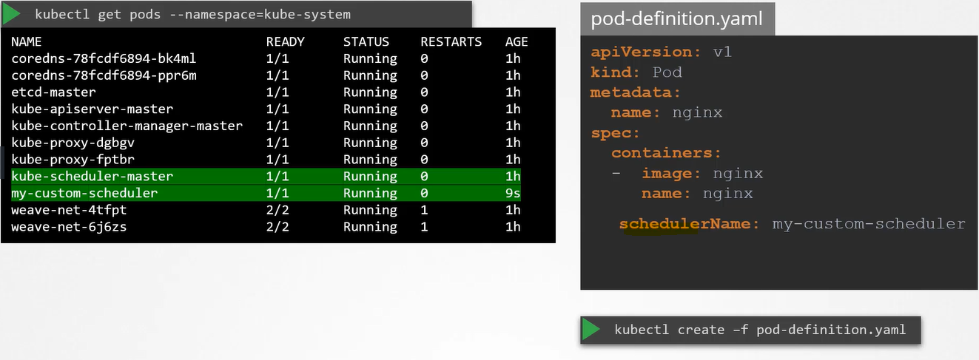
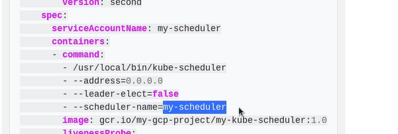
Configuring K8s Scheduler
