Service in K8s (Load Balancer, Service Discovery):
In Docker Compose Service is to create multiple containers from a single image.
Why Service?
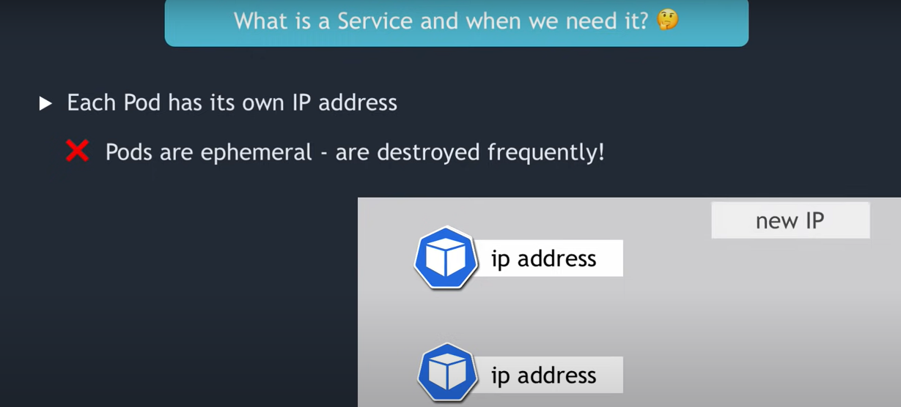
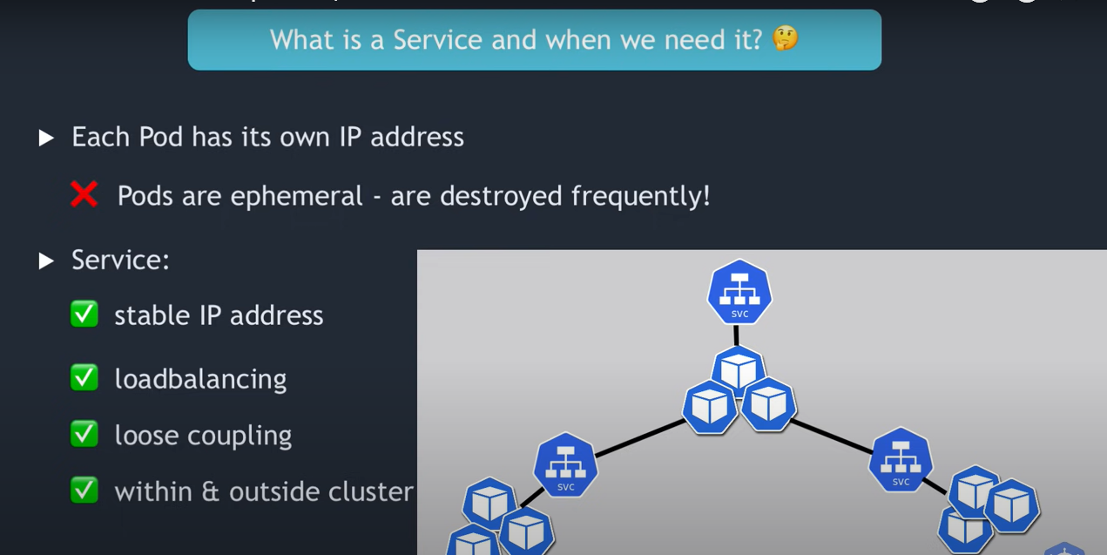
- In K8s service enable the communication between the Pods and also going to acts as a Load Balancer.
- Service is responsible for routing the request behind the containers.
- Services acts as an Internal LoadBalancer as well as forwarding the request into all backend pods.
Services: (Virtual entity not a physical SVC IP is virtual IP, API server assigns service a Virtual IP).

Types of Services:

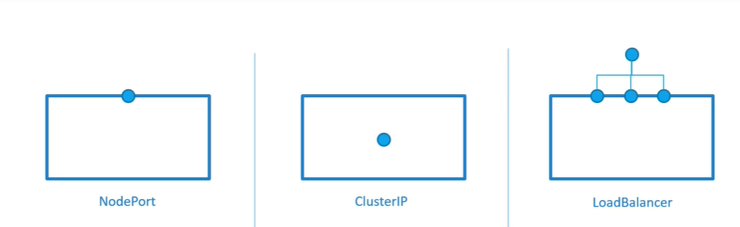
ClusterIP: (Internal Service)
NodePort: Access from outside the cluster
LoadBalancer: Cloud Vendor Specific
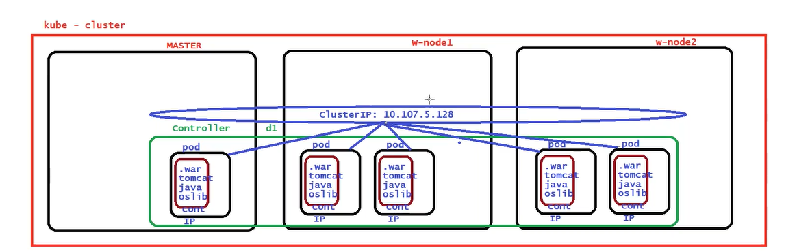

How to access Pod from outside the cluster (browser)?
When we create a Pod, K8s assigns IP address to the Pod, Pod IP address not accessible from outside the world, because this IP address from the weave network, weave network we installed within the K8s that is only for K8s communication, internal communication of the K8s.We can’t use it from outside the world.

Within Docker we use –p or –P to publish the port number, nodeport(serviceport) is always created in case of docker swarm.
We need to create a service, service is like a proxy to your pod, sender of request to your pod. Service will have its own IP address, then by using IP of the service can access the Pod.

What is the backend of this service?
In k8s when we create a Service Object, internally it also creates endpoint object
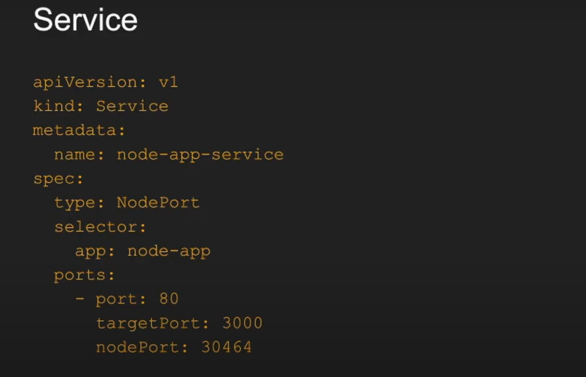
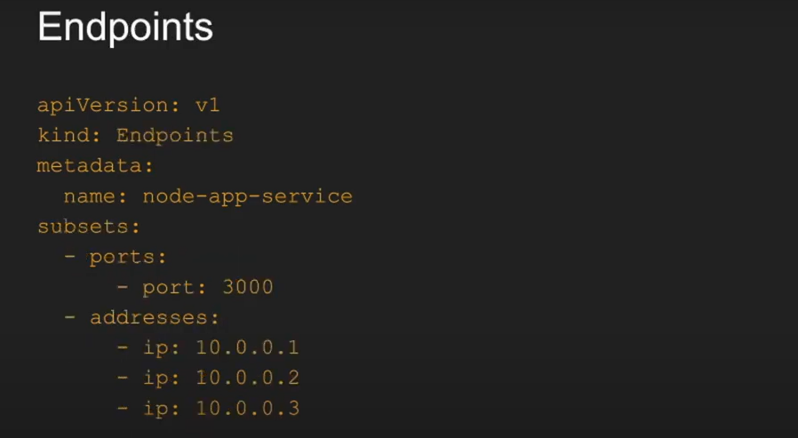
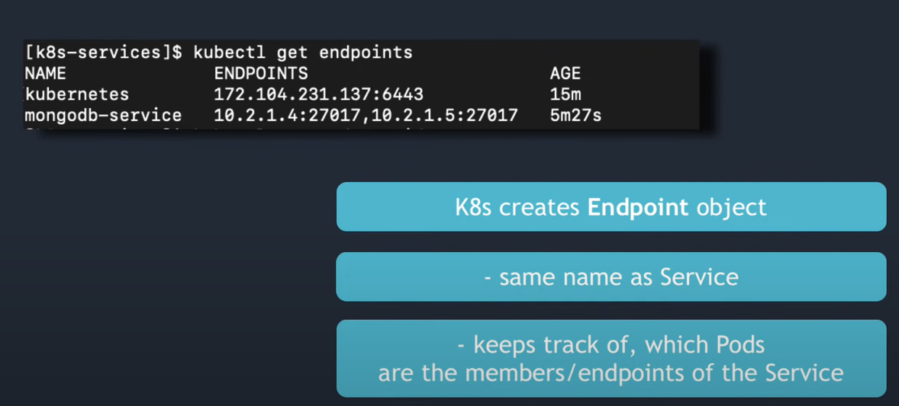
Kubectl describe service <name of service>
kubectl get ep <name of service> // endpoints
kubectl get pods -o wide

NodePort
Use Case: You have deployed your web app on to Kubernetes cluster, now you need to expose it outside world on the internet.
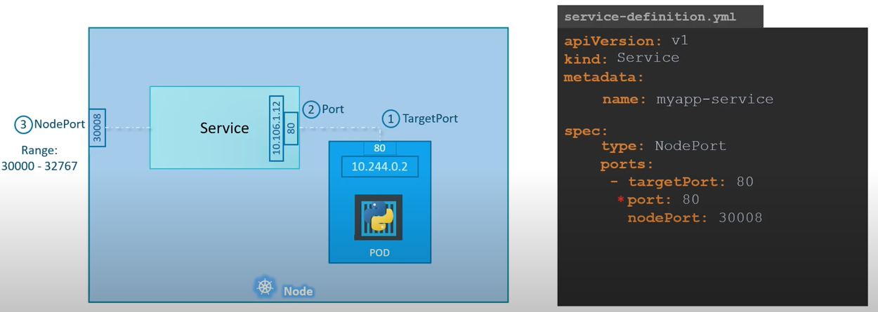
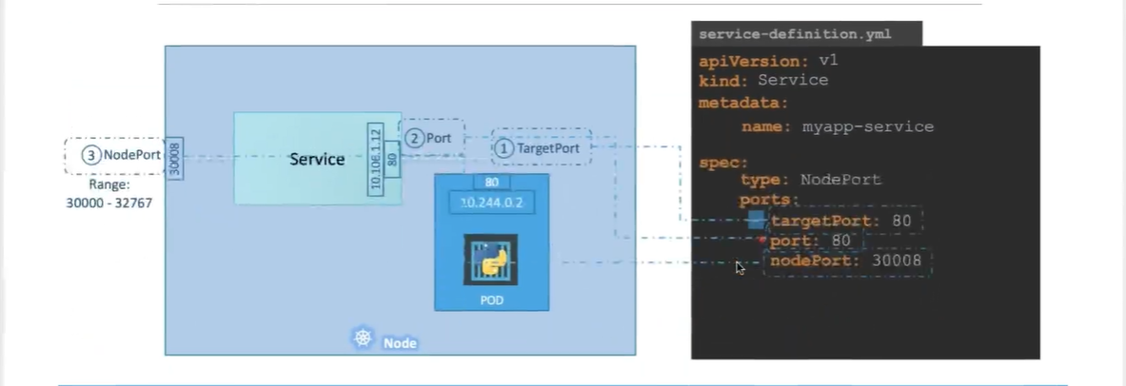

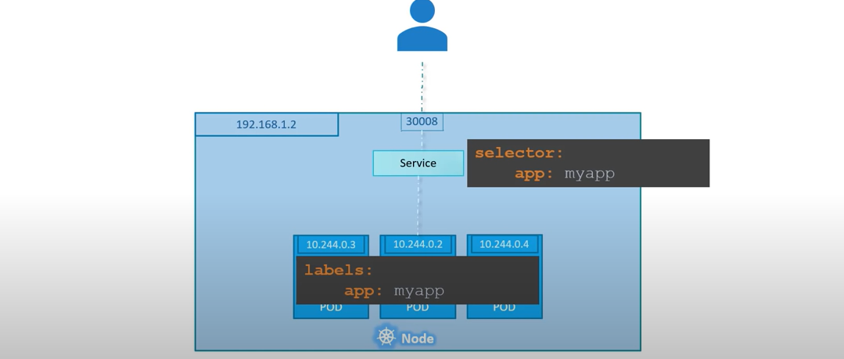
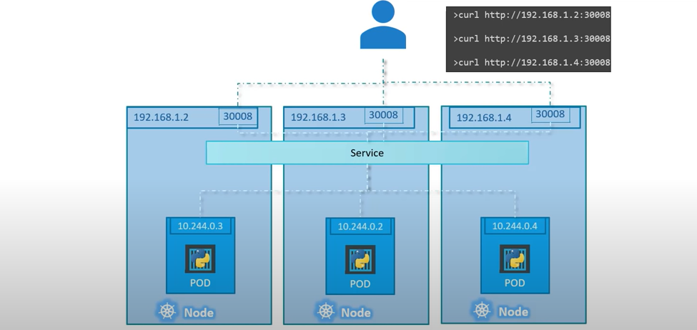

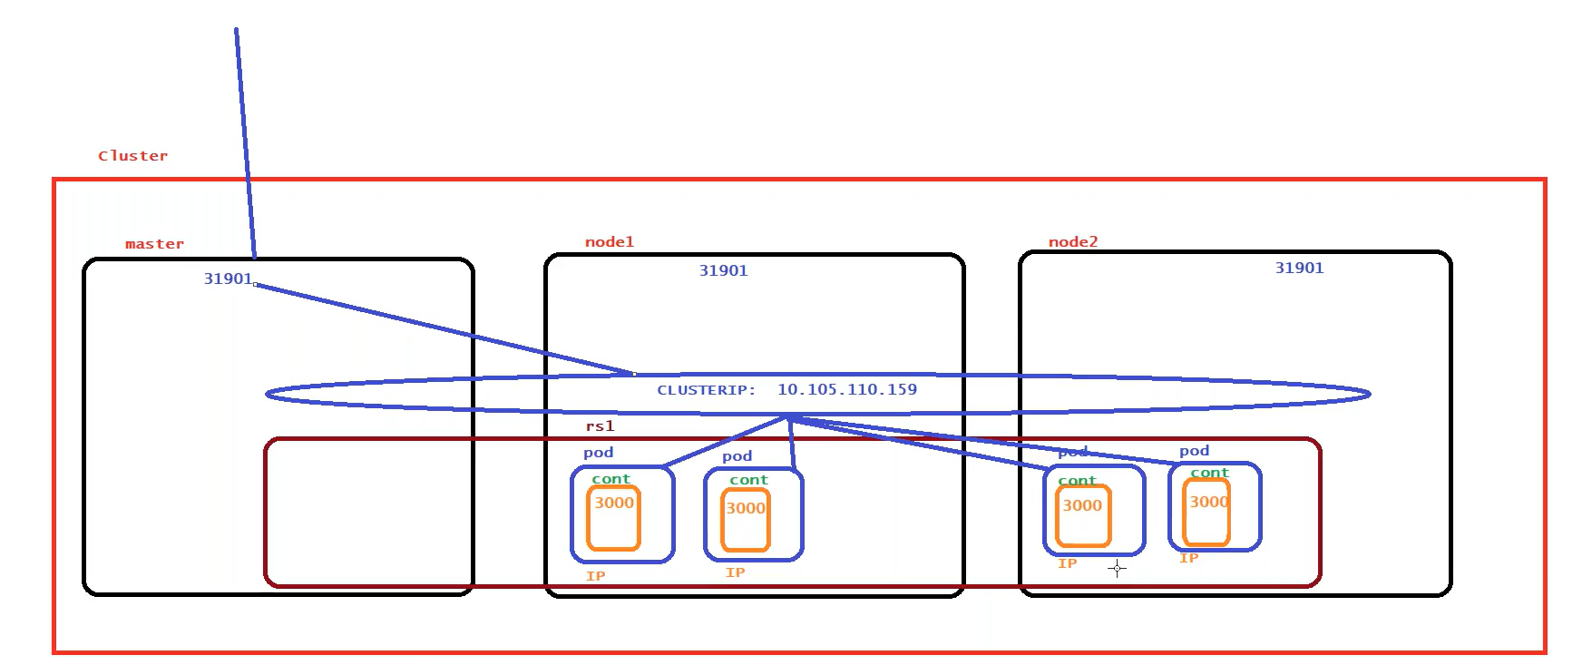
k expose deploy <deployment name> --name=<service name> --port=<service port> --target-port=<container port> --type=NodePort
k expose deploy foo --name=foo --port=6262 --target-port=8080

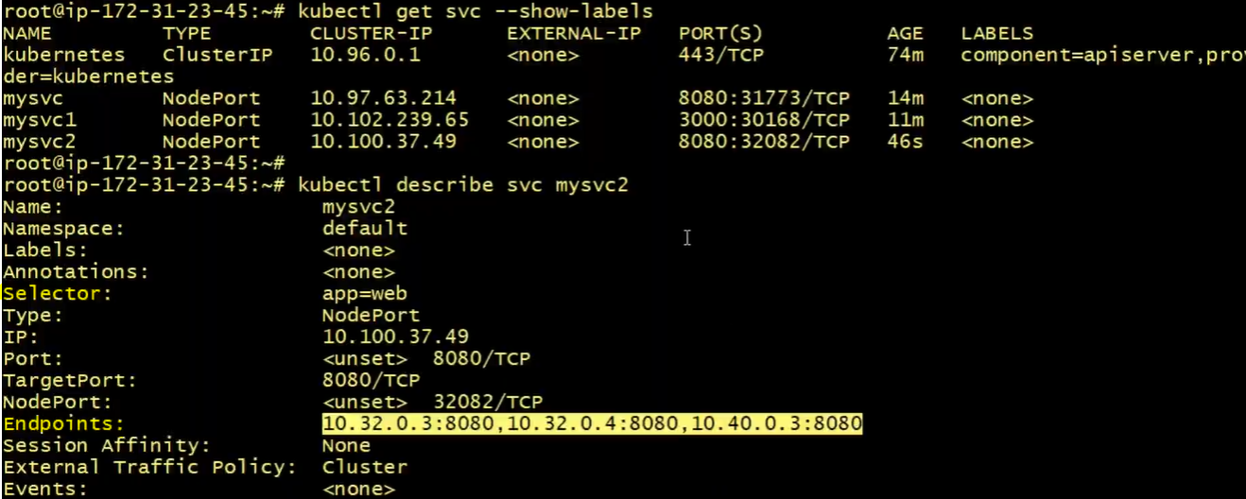

Limitation:
In real scenario we will never share our node ip to end user, is good for development but not for production.
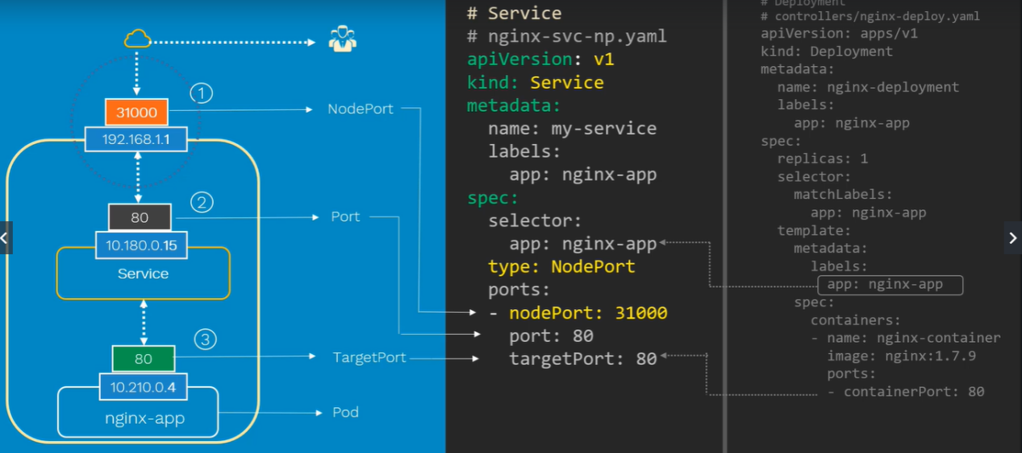

Port Types:
nodePort: port on the node, where pod is running (30000-32767)
port: on Service: This is the port on the service itself.
targetPort: This is the port on the actual pod where web application is actually running.
To access from browser first we need to first access node then from node to access cluster and then from cluster to Pod.

Service publish the nodePort, using the nodePort can access Pod from outside the world. Service forwards the request to the Pod.

LoadBalancer:
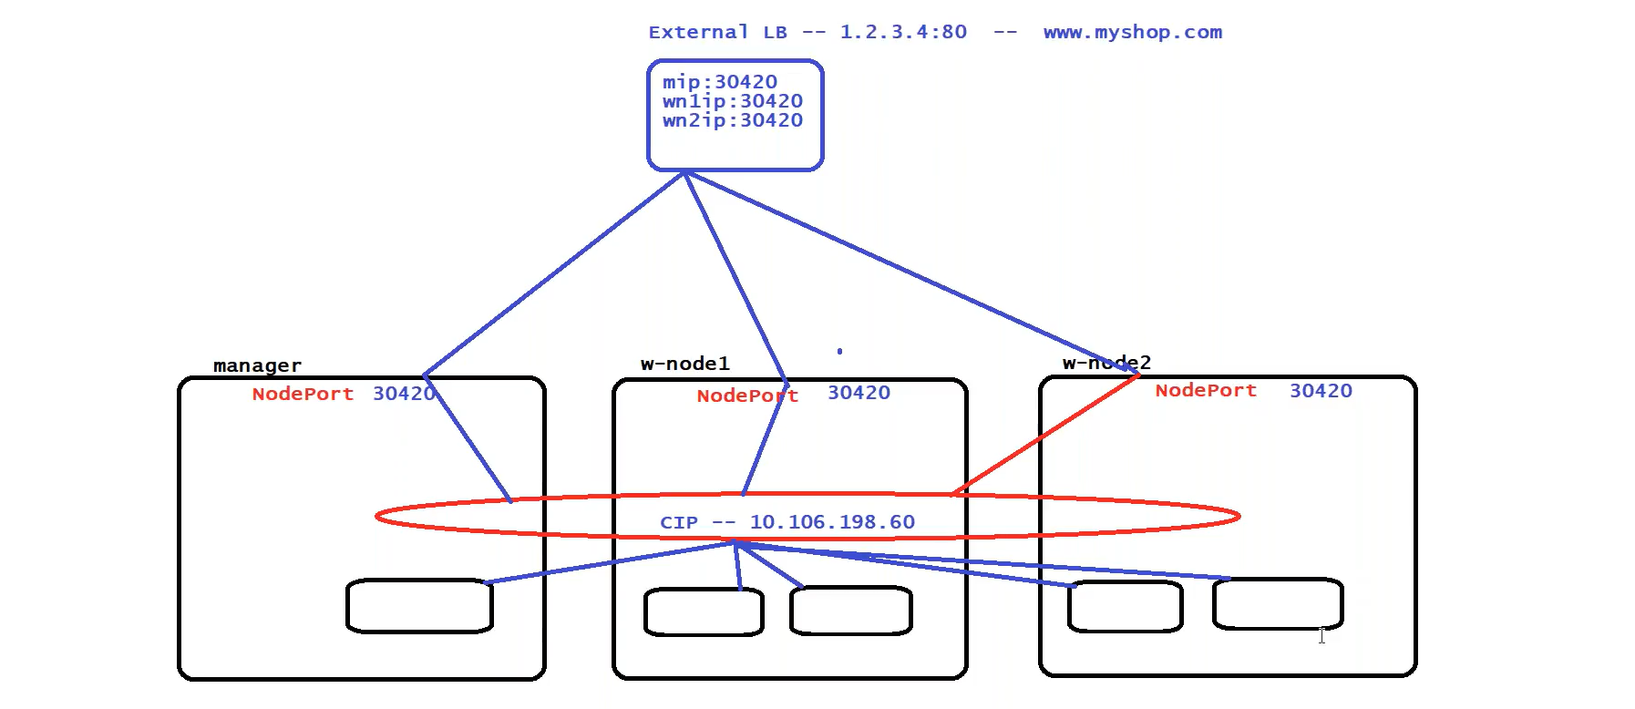
Kubernetes does not provide external LoadBalancer, type: LoadBalancer will work only in case of External LoadBalancer (If we create a LB service in our local environment without configuring external LB, service will not work), we can take advantage of cloud providers (GCP, AWS) e.g.
GCP->Kubernetes Engine->Clusters-> create cluster
External LoadBalancer: By default, provided by all cloud provider at time of cluster creation e.g., GKS, EKS, PKS (Cluster provided by vmWare) at time of Object creation. LoadBalancer registered with available nodes in the cluster. This LB have single IP or DNS name.
Cloud Vendor automatically creates LoadBalancer on the backend when we create a service of type LoadBalancer
LoadBalancer is not a cheap it’s very costly, think before creating LoadBalancer.
When we have a cluster in cloud which provides default external LoadBalancer, and when we create an object of type LoadBalancer, cloud provider automatically will associate external load balancer with all the nodes of the cluster.

UC:
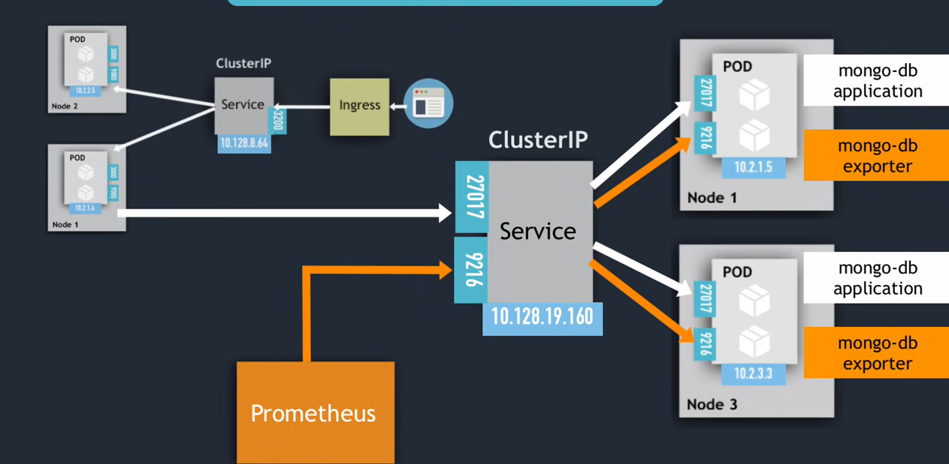

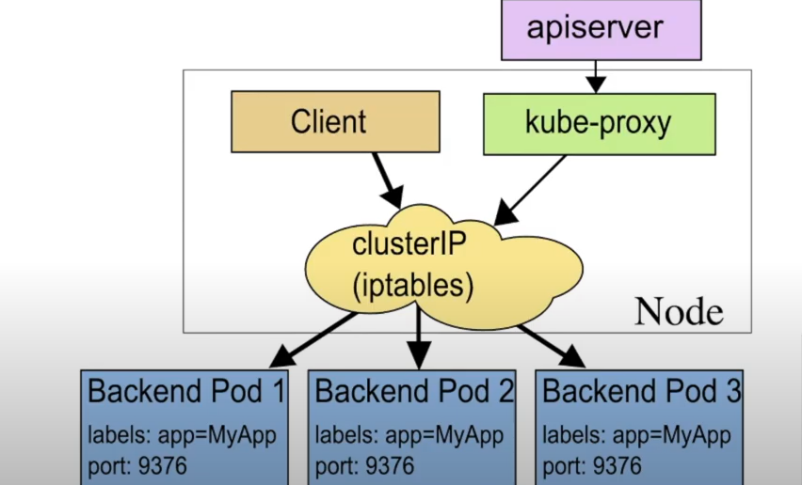

How to create GKS cluster?
Home->Kubernetes Engine->Clusters-> create cluster + add Nodes
Home->Network Services-> Load Balancing // No LoadBalancer exist
kubectl apply -f <loadbalancer. yaml> // Internally creates ClusterIP, NodePort and External IP and LB

kubectl get svc
External LoadBalancer automatically created and map with the NodePort.
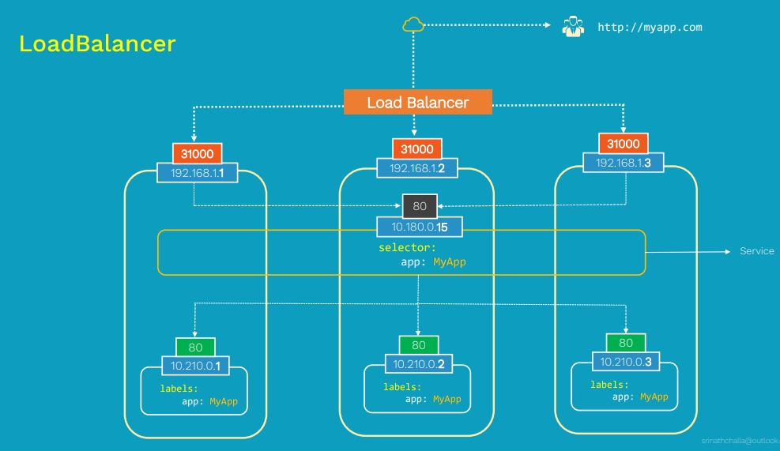
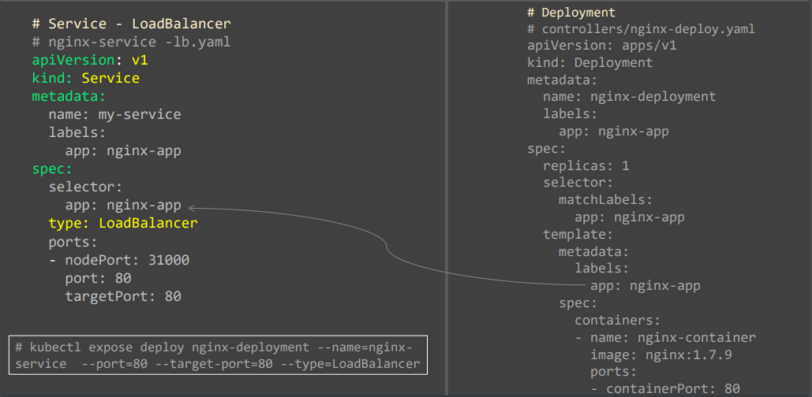
Step1: When you access the application from external world request access through any node of the cluster.
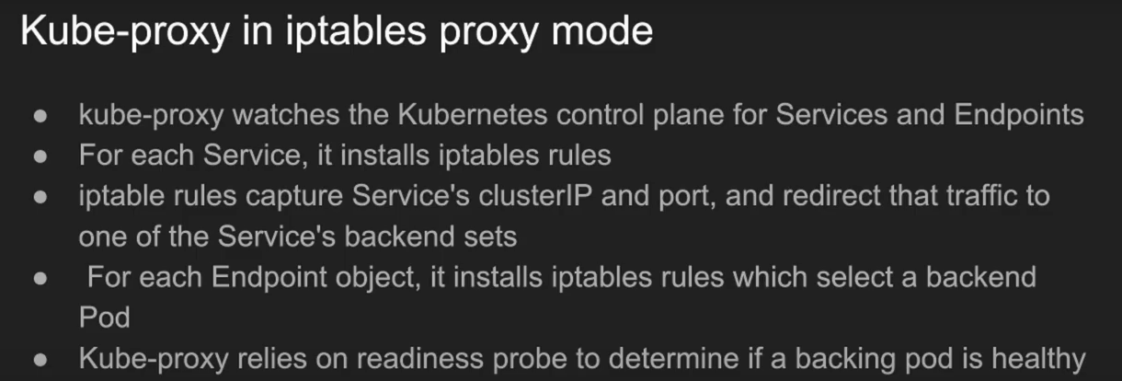
while true; do curl <ip: port>; sleep 2; echo “”; done

In k8s the only resource, which physical run on a virtual machine is are Pods, apart from that any other resource in k8s are just configuration they are not running executable.
Service is a cluster level resource, it’s just a configuration, and it’s always point to the pods on the top of which service is created. Service does the following two things when it’s created. It registers themselves inside CoreDNS Pod. (Virtual IP assigned to service), Service is just only the configurations it can never be crashed, it is just a combination of firewall rules and the IP tables.
Service is a configuration in IP tables.
A service is a grouping of pods that are running on the cluster.

kind: Service # k api-resources
apiVersion: v1 # k explain < resource>
metadata:
spec:
type:
ports:
- port: # service port
targetPort: # container port
nodePort: # nodePort
selector:
app: front-end

UC1:
- You want to have an external database cluster in production, but in your test environment you use your own databases.
- You want to point your Service to a Service in a different Namespace or on another cluster
- You are migrating a workload to Kubernetes. While evaluating the approach, you run only a portion of your backends in Kubernetes.
In any of these scenarios you can define a Service without a Pod selector. For example:
apiVersion: v1
kind: Service
metadata:
name: my-service
spec:
ports:
- protocol: TCP
port: 80
targetPort: 9376

Because this Service has no selector, the corresponding Endpoints object is not created automatically. You can manually map the Service to the
network address and port where it's running, by adding an Endpoints object manually:

apiVersion: v1
kind: Endpoints
metadata:
name: my-service
subsets:
- addresses:
- ip: 192.0.2.42
ports:
- port: 9376

Accessing a Service without a selector works the same as if it had a selector. In the example above, traffic is routed to the single endpoint
defined in the YAML: 192.0.2.42:9376 (TCP).
UC1.1: External Service (DB outside the K8s Cluster)
We may have different Instances for different environments
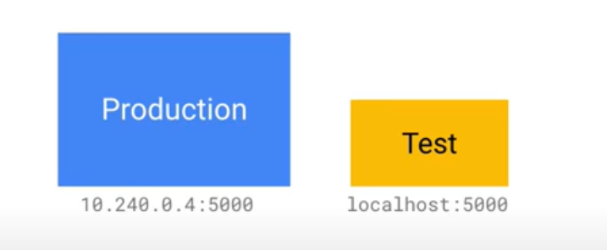
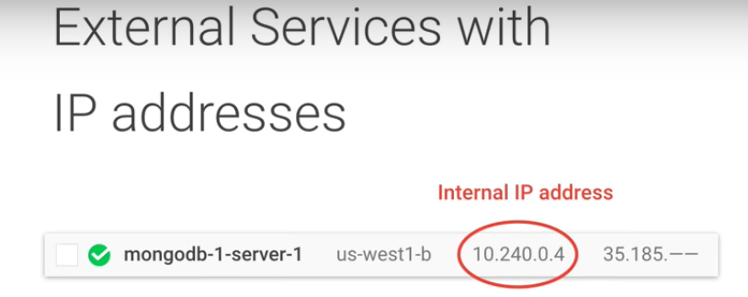
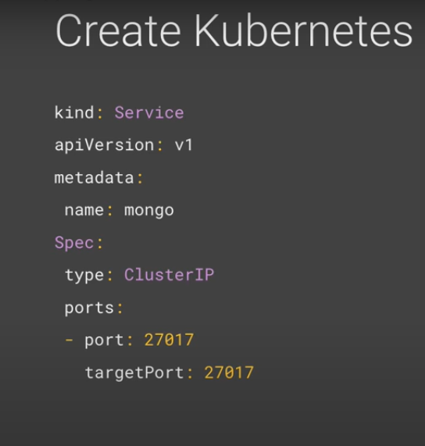
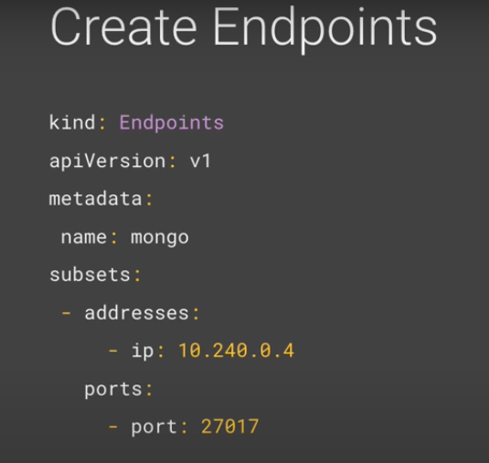

UC3:
An ExternalName Service is a special case of Service that does not have selectors and uses DNS names instead Services of type ExternalName map a Service to a DNS name, not to a typical selector such as my-service or cassandra. You specify these Services
with the spec.externalName parameter.This Service definition, for example, maps the my-service Service in the prod namespace to my.database.example.com:
apiVersion: v1
kind: Service
metadata:
name: my-service
namespace: prod
spec:
type: ExternalName
externalName: my.database.example.com

UC4:
If there are external IPs that route to one or more cluster nodes, Kubernetes Services can be exposed on those externalIPs. Traffic that ingresses
into the cluster with the external IP (as destination IP), on the Service port, will be routed to one of the Service endpoints.
externalIPs are not managed by Kubernetes and are the responsibility of the cluster administrator.
apiVersion: v1
kind: Service
metadata:
name: my-service
spec:
selector:
app: MyApp
ports:
- name: http
protocol: TCP
port: 80
targetPort: 9376
externalIPs:
- 80.11.12.10

