How networking Implements?
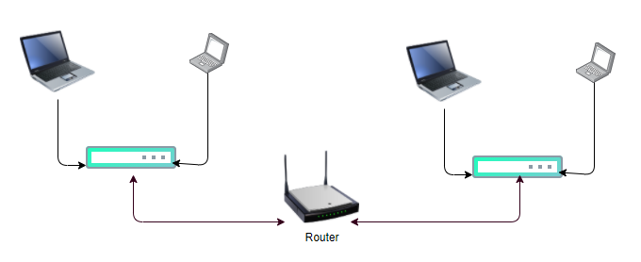
How networking Implements in K8s?
UC: suppose we have two nodes with in the same network, then both nodes can communicate with each-other using underlay network
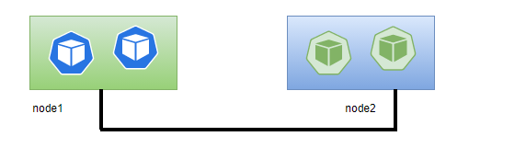

UC1: If not connected to any network
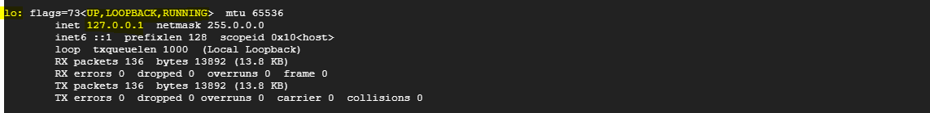
Io: LOOPBACK: 127.0.0.1

UC2: If connected to any network (GCP)
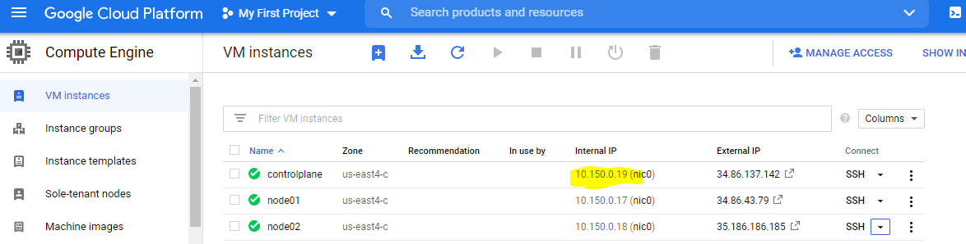
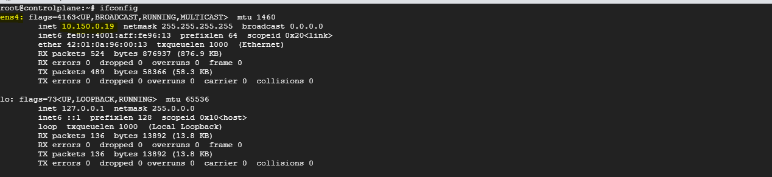
ens4: 10.150.0.19
UC3: After Installation of docker (pre-requisite for k8s)-docker0 created by docker
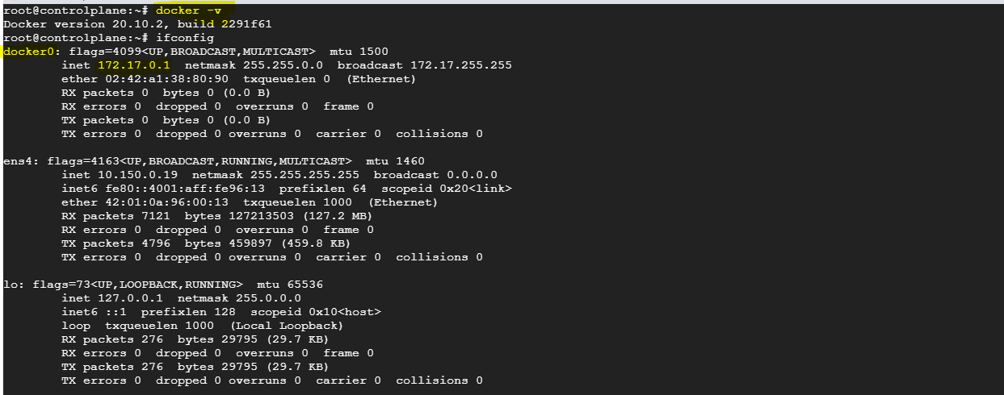
docker0: 172.17.0.1

UC4: After Installation of CNI (Weave)
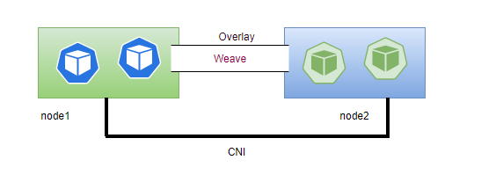
CNI runs agents on each machine, are responsible for assigning IP to Pod and Pod-Pod communication.
In Master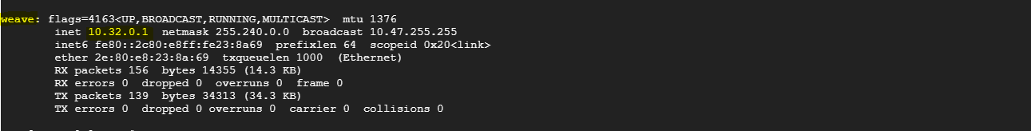
weave: (subnet: 10.32.0.1)
In wnode01
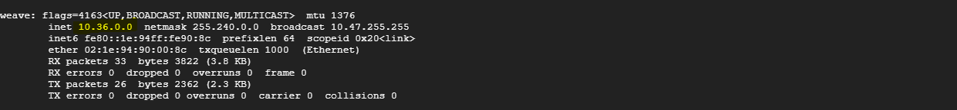
weave: (subnet: 10.36.0.0)
In wnode02
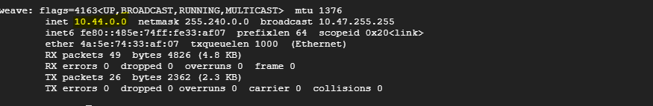
weave: (subnet: 10.44.0.0)
Network solution (Weave) is responsible for creating a virtual switch (bridge network) on each node.
In case of Docker, docker0 take care of container-container communication but in case of K8s, underlying CNI (weave) is responsible for pod-pod communication.
If we see the same in wnode01 node it is in different subnet...
If we see the same in wnode02 node it is in different subnet...
Pod in wnode01 will get IP from subnet 10.36.0.0, Pod in wnode02 will get IP from 10.44.0.0
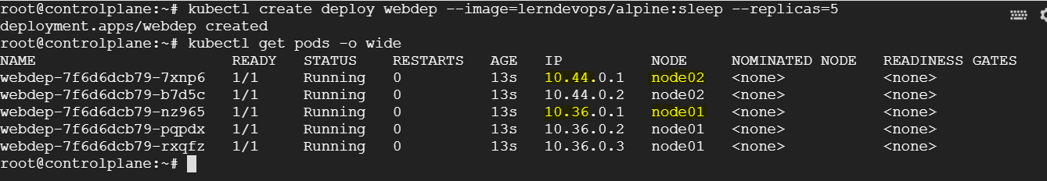
In this way K8s ensures that if we create a Pod, assigned the IP based on the weave subnet deployed on the node.
Can we assign our own IP addresses to the Pod?
Yes, while defining the CNI can assign own subnet range, each node has its own virtual switch.
UC: Pods with in same nodes are able to communicate to each other (within same subnet).
apt-get install iputils-ping
kubectl exec <pod> --ping <IP>
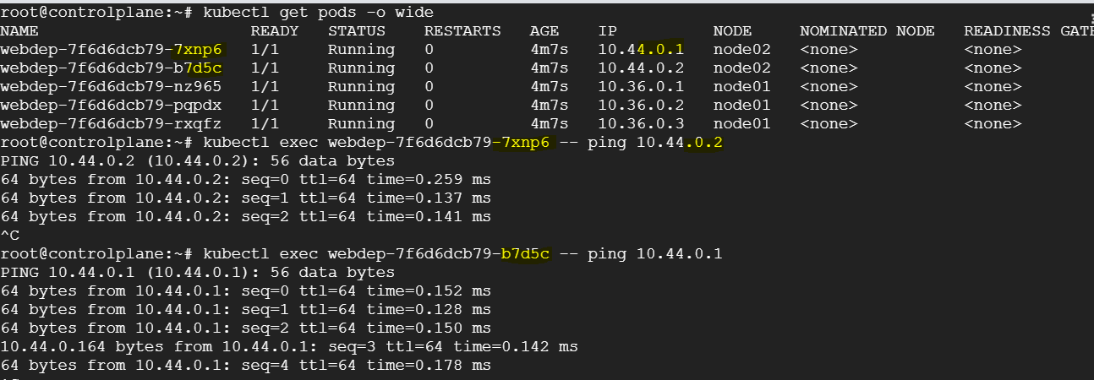
kubectl exec <pod> --traceroute <IP>
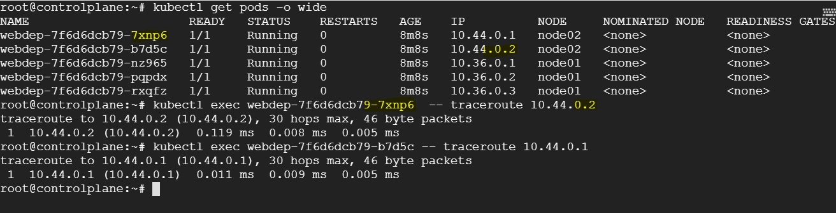
UC: Pods in wnode1 are trying to access the Pod in wnode2, able to access through the underlay network.
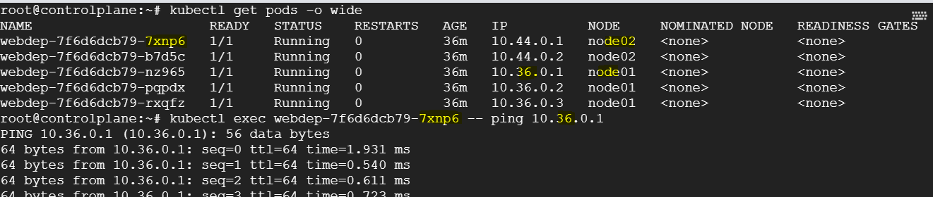
How communication between pods in different nodes using underlay network happen?
It’s the weave network responsibility to route the response to Pod on other node this is going to use your underlay node network
On every node there is an iptable which allows to communicate among various nodes in the underlay network.
There is a route table created on every node, when you run the command route
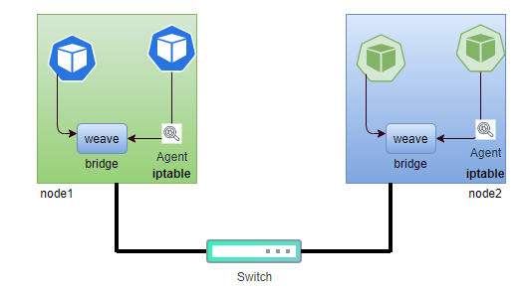
There is a route table in each node.
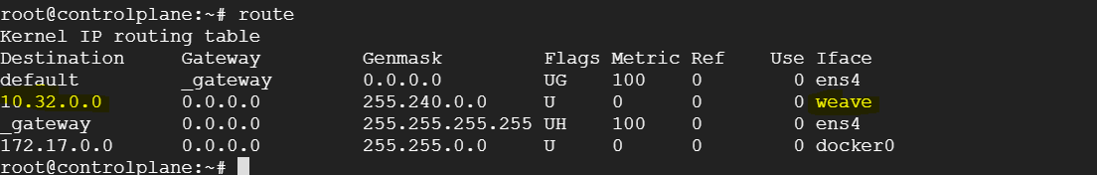
There is a virtual network created by weave, there is a weave network agent running on each node as a pod, which is maintain all information of the Pod running on specific node.
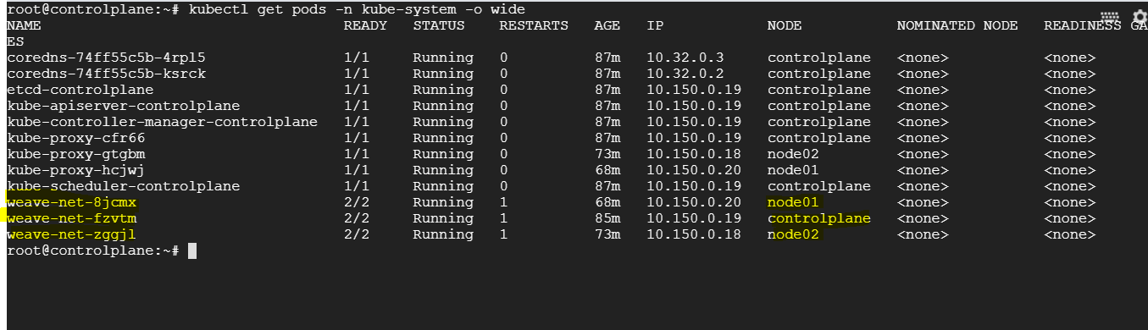
Weave is overlay network establish at cluster level, when we install the weave network, it’s a DaemonSet

IP of master components
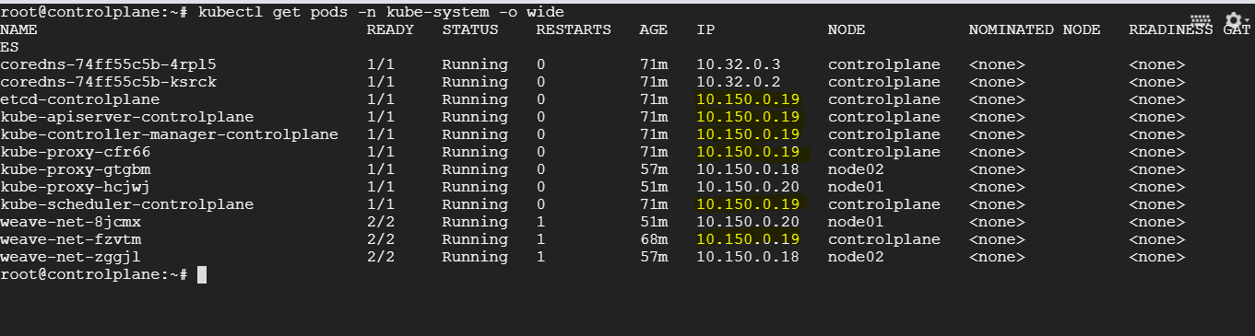
Master components joins host network
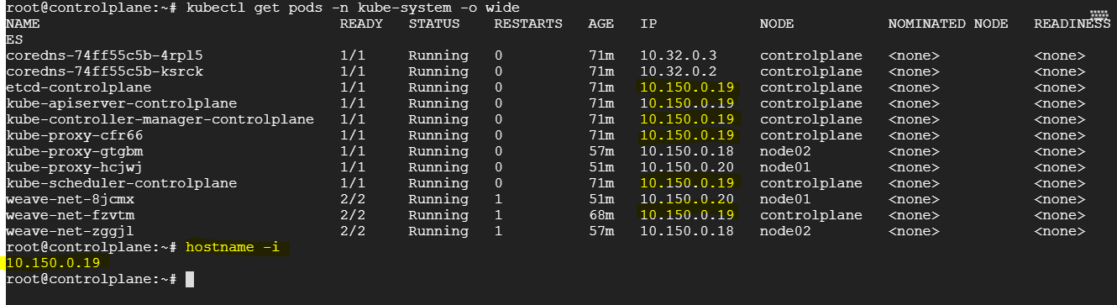
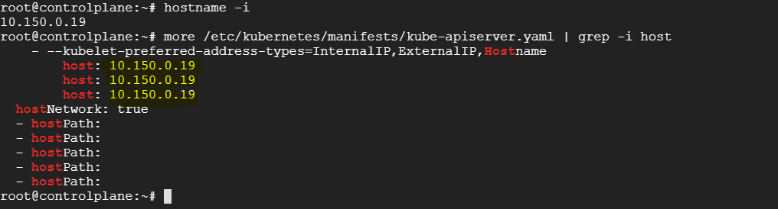
IP for nodes comes from cloud provider, not from weave.

Service Networking
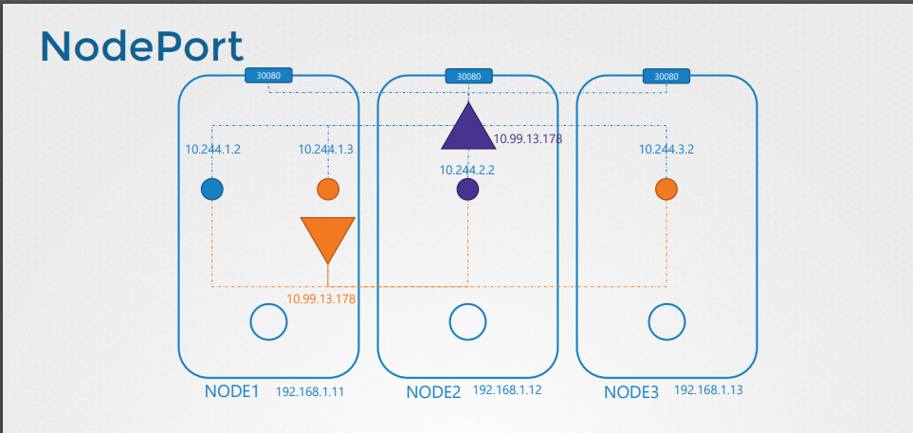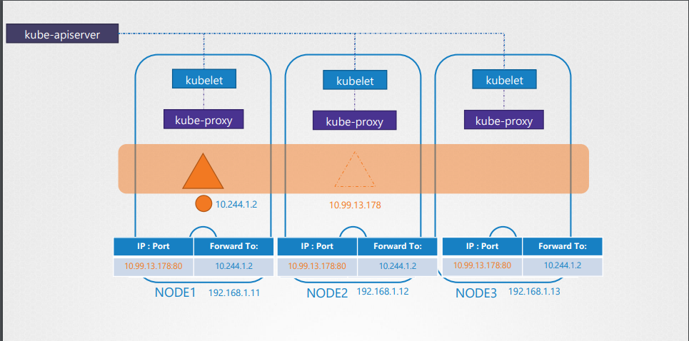
You rarely configure pod to communicate directly with each other, pod communicate to each other through the service. Services are not bounded to specific node services, are always specific to cluster level .
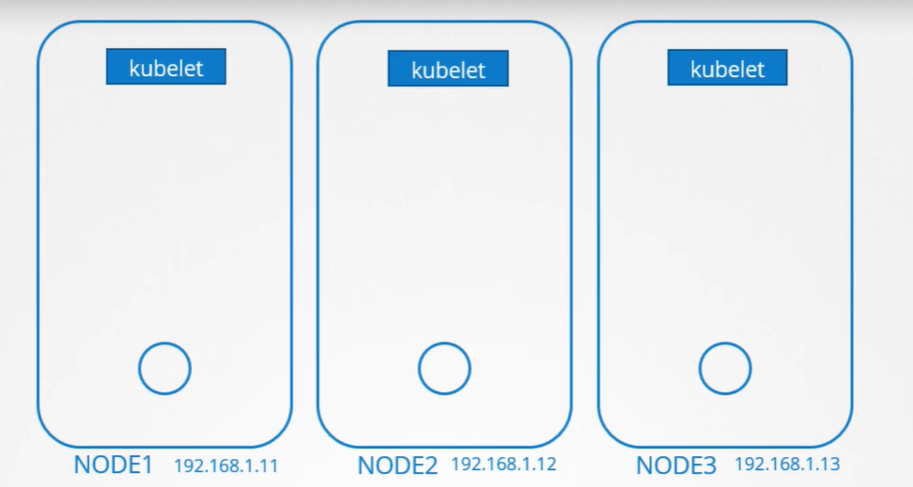
kubelet
kubelet is an agent run on each node of the cluster, its job is to look for new pod creation request from api-server, forward the request to runtime engine. When pod is created, it works with CNI network and to generate the ip, ip address generated by weave network assigned to the pod and at same time, update to apiserver and api-server is going to update etcd db, going to register with default core dns server. Pod can be reached out using its ip address or its dns name.
kube-proxy
- kube-proxy is an agent run on each node of the cluster, its job is to watches the kubernetes control plane for services and endpoints, for each service it installs iptable rules in each node of the cluster.
- Iptable rules capture service’s ClusterIP and port, and redirect that traffic to one of the service’s backend sets.
- For each endpoint object, it installs iptable rules which select a backend pod.
- kube-proxy relies on readiness probe to determine if a backing pod is healthy.
- When a service is created a DNS entry automatically created in DNS server.
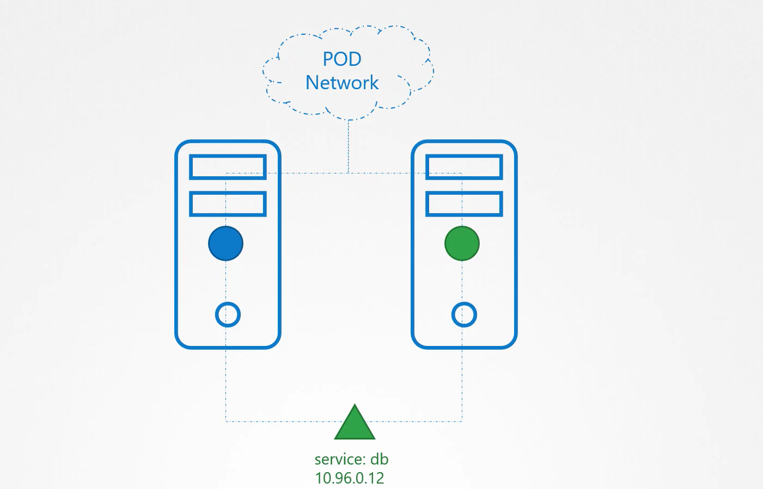
In above case web pod can access the db-service using the db-service name, service also get an IP address assigned to it, whenever web pod tries to reach the service using its IP or name, it forward the traffic to backend Pod, in this case the database.
UC: What is the service and how it gets an IP address?
Does the service join the same Pod network? The service can’t join the Pod network, because the service is not an actual thing it is not a container like Pods, so it does not have an interface or an actively listening process it is a virtual component that only lives in K8s memory, service is also accessible from any node of the cluster, so how it is achieved?
Here kube-proxy comes in
kube-proxy is a process run on each node of the cluster, its job is to look for new services and every time a new service is created, it creates an appropriate rule on each node, to forward the traffic to those services to the backend pods, one way of do this using IP table rules.

