UC: In Docker we have run multiple containers, within the same host. When we need HA, we need more machines to host containers.
Problem Statement:


How to Organize??

Why Manager??
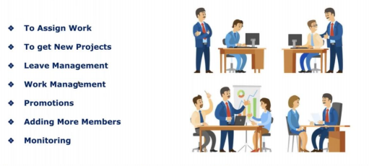

How to Manage More Containers???
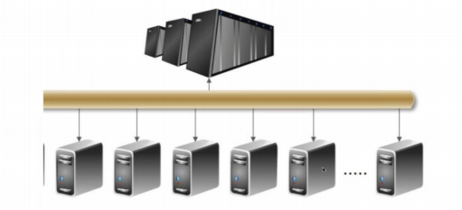

Cluster: Group of servers
If you deploy your application across 100 of servers in cluster then how you manage your applications?
Problem Statement:

- How containers communicate to each other?
- How container communicate to each other across multiple nodes?
- How implement Autoscaling?
- How to manage/monitor cluster (group of servers)?
- High Availability?
- Security?

Container-based application brings many challenges to IT & DevOps teams
- Managing the underlying infrastructure on which these apps are running.
- Managing the actual applications, which is especially challenging in upstream environments like PROD.
Once application is deployed, there are several requirements for managing them
- High Availability- distributed hosts/regions
- Backups
- Monitoring & Alerts
- Auto-Scaling
- Continuous Delivery for Enterprise Apps
- Service Discovery
- Logging
- Integration with Existing Services
- Auditing
Solution: Container Orchestration tools (docker swarm, K8s)
We need container orchestration, so that our containers are highly available

Why Container Orchestration?
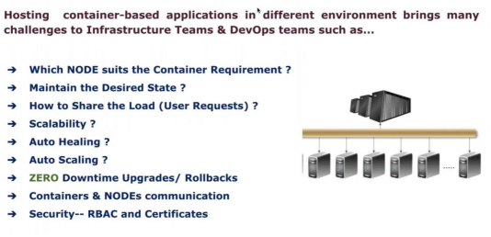

What is the difference between Docker Swarm and K8s?
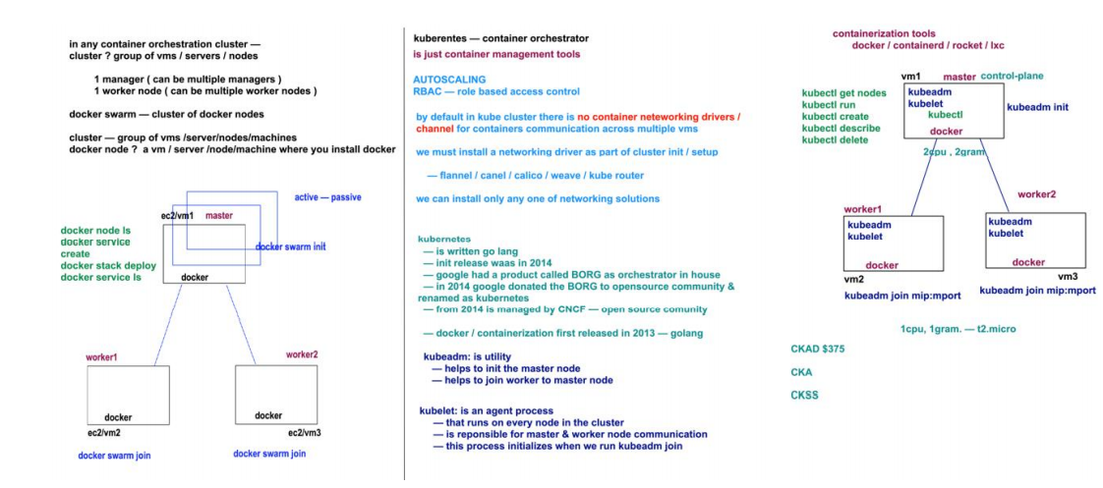

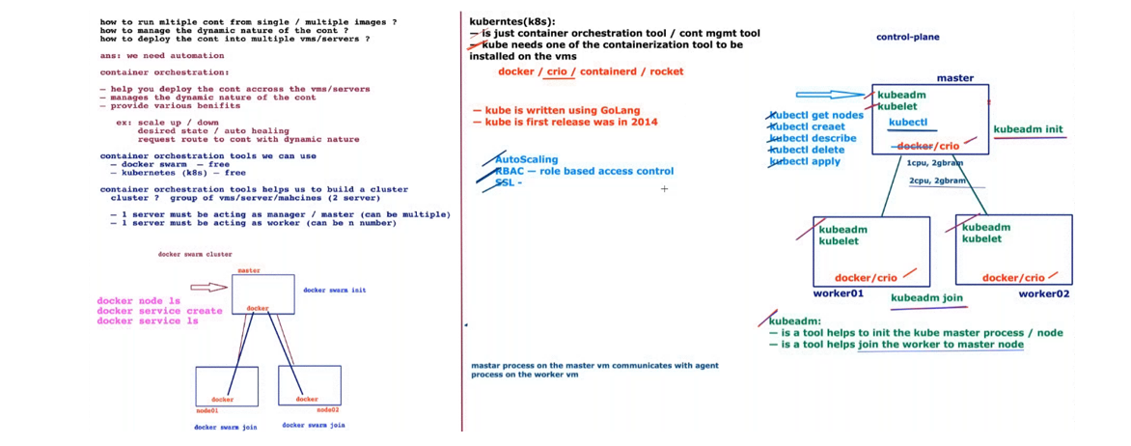
both are the container orchestrator, group of hosts to create a cluster.
K8s support different containerization techniques
- docker
- rocket
- lxc
- containerd
Flexible in containerization techniques
Flexible in networking solution (Weave, Calico, Flannel)
heavier than docker swarm (2CPU,4GB)
- autoscaling
- scheduling
- ingress (Network Load Balancing)
- package manager (helm)
- network policy
- RBAC
free -m
K8s sits on top of docker to manage the containers, while Docker provides run time environment to run the containers.K8S is container management tool.
How do we setup K8s Cluster?
There are two ways to work with k8s?
K8s as a service (KAS) - Cluster is created by cloud vendor and handover to you.
All cloud provider provides k8s as a service. All responsibilities of the utilities handled by cloud provider. As a user we have to demand only for number of servers in cluster. Charged only for servers in cluster not for service.
EKS provided by Amazon, Google Kubernetes Engine by Google cloud.
Kubernetes managed by cloud provider.
EKS? Cluster is created by AWS and handover to you.

Self-hosted
self-created cluster using kubeadm utility as a pod.
Components:
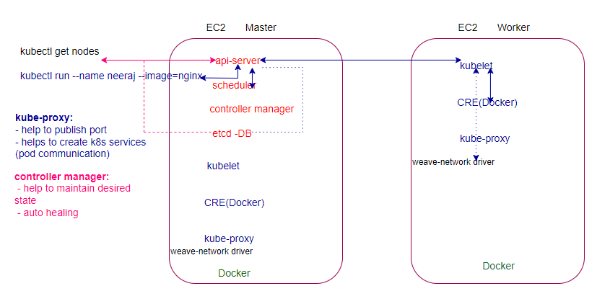
api-server: Single point of contact
scheduler- assign node
controller manager- desired state, self- healing
etcd-metadata (key-value database store cluster information)
kubectl get nodes
request->api-server->etcd
kubectl run --name Neeraj --image=nginx
request->api-server->scheduler->api-server->kubelet->Docker& kube-proxy->kubelet->api-server->etcd

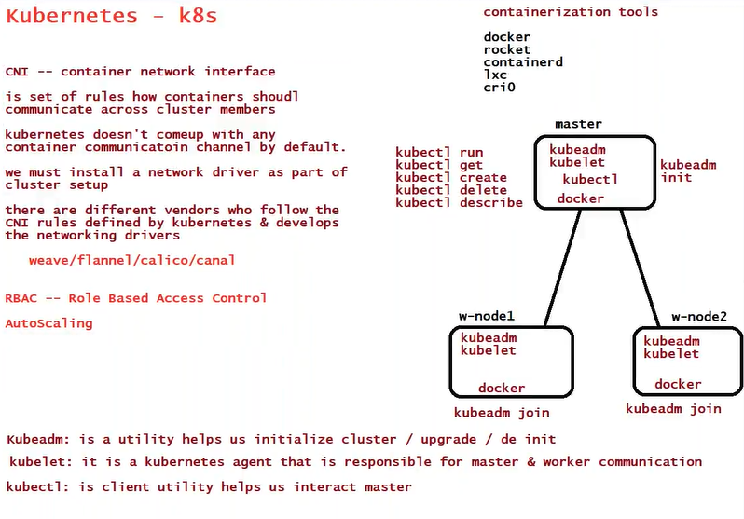

Kubernetes Pods:
- Is an abstract layer that can create and manage a single/group of containers.
- Container runs inside the pod always
- Single pod==single Instance of an app
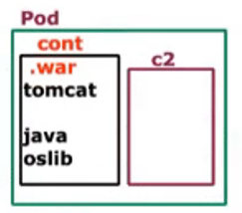

To achieve HA, must have multiple pods, not the multiple containers.
# kubectl run webapp –image=gcr.io/google-container/nginx: latest
If node fail, will K8s take care?
No, Its Infrastructure related Issue, K8s take care only the containers.

kubelet: Is a command line utility (agent) sits on every node and responsible to report the status of the nodes, pods to master (cAdvisor -> Metrics Server). Initiate the health check.

How Nodes Knows Manager is down?
It’s not responsibility of node to know about master, will continue with present workload, but no new deployment will be allowed, and feature provided by master will not be available.

How to interact with K8s master?

kubectl: Is a command line utility installed only on master to communicate with nodes, client to interact with cluster to create, delete, edit the resources within the cluster.

How to Install K8s?
HARDWAY
Kubeadm way?
Kubeadm is a utility takes responsibility to install all the components and establish a communication between the components.
kubeadm will not install or manage kubelet or kubectl for you, so you will need to ensure they match the version of the Kubernetes control plane you want kubeadm to install for you.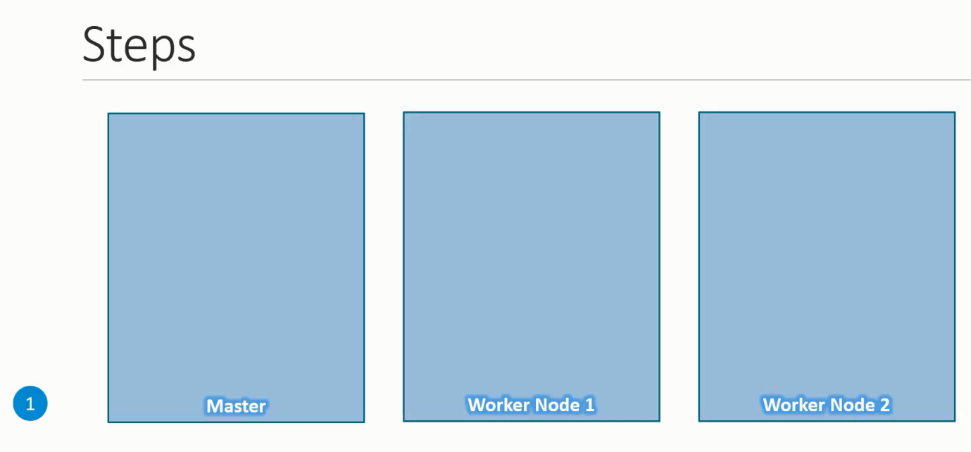
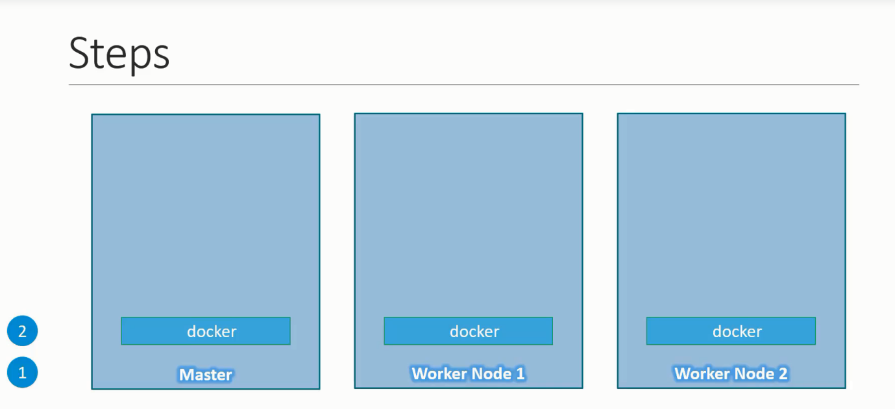

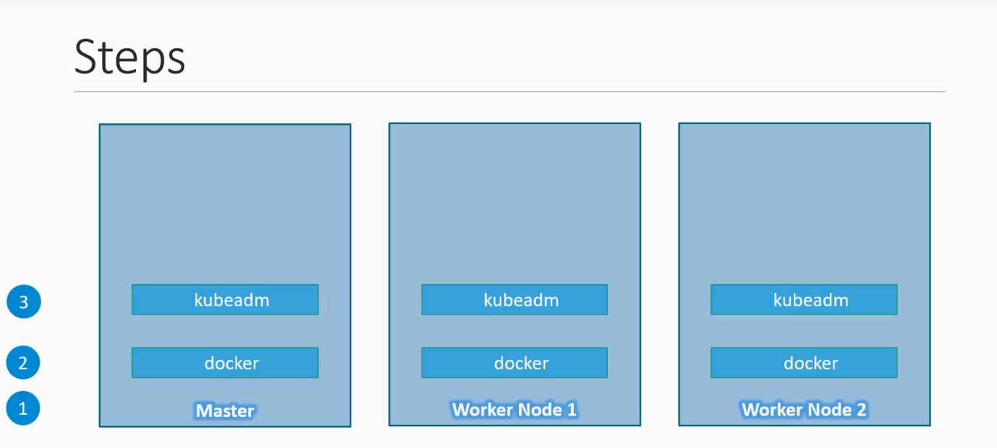
kubeadm help us bootstrapping the k8s cluster.
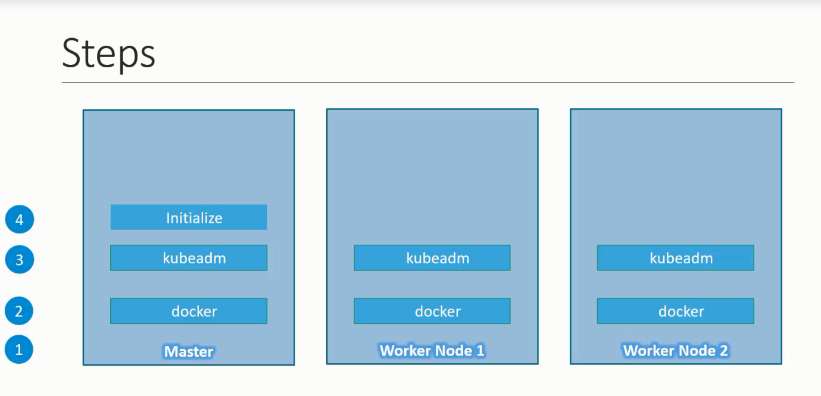
Initializing the master, during this process all required components are installed and configured on the master node.
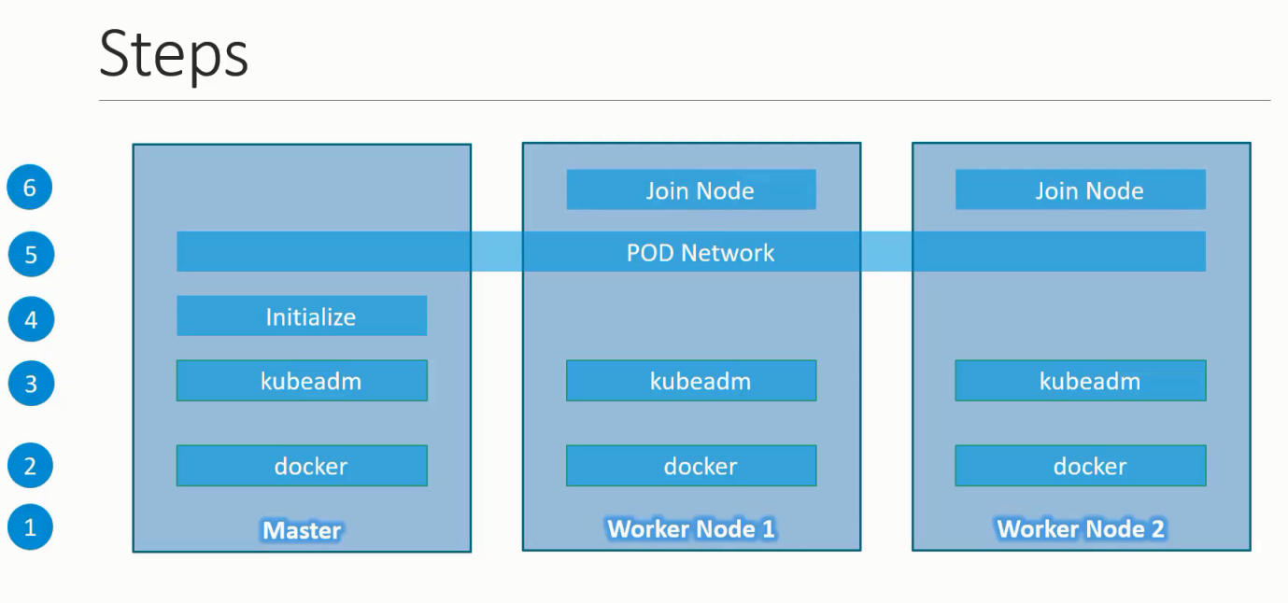
Installation Steps
step1: In each node Install pre-requisite
docker
service docker status
service docker start
service docker stop
service docker restart

step2: In each node Install mandatory components
kubeadm: the command to bootstrap the cluster.
kubelet: the component that runs on all of the machines in your cluster and does things like starting pods and containers.

step2.1: In master node only
kubectl: the command line util to talk to your cluster.

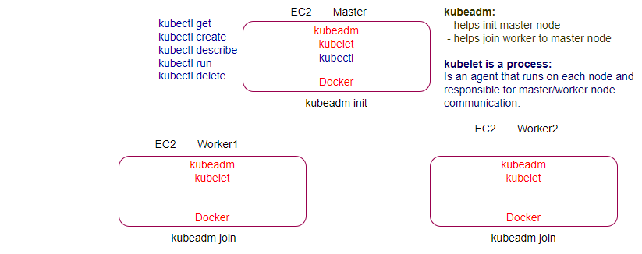
step3: Elect the Master
In Master
kubeadm init
/*
/etc/kubernetes/kubelet.conf" to point to a rotatable kubelet client certificate and key
[addons] Applied essential addon: CoreDNS
[addons] Applied essential addon: kube-proxy

Your Kubernetes control-plane has initialized successfully!
To start using your cluster, you need to run the following as a regular user:
mkdir -p $HOME/. kube
sudo cp -i /etc/kubernetes/admin.conf $HOME/. kube/config
sudo chown $(id -u): $(id -g) $HOME/. kube/config

*/
Now we have elected the master,
kubectl get nodes
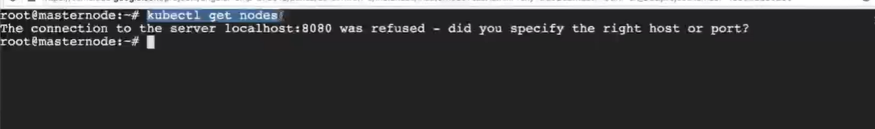
It means kubectl is unable to find the path of the api-Server, so not able to connect with api-server.
How to make it communicate to the api-server?
Note: config path? /etc/kubernetes/admin.conf
In order to work with kubectl you need to give the api-server address to the kubectl, hey! kubectl use the configuration which is available here
kubectl get nodes --kubeconfig=/etc/kubernetes/admin.conf

It’s not a best practice that we have to provide the configuration path to kubectl.
What is the best practice?
In java if we set the environment variable in classpath we can run the java program from anywhere
/*
To start using your cluster, you need to run the following as a regular user:
mkdir -p $HOME/.kube // create a .kube folder in home directory
sudo cp -i /etc/kubernetes/admin.conf $HOME/.kube/config
sudo chown $(id -u):$(id -g) $HOME/.kube/config
*/
kubectl get nodes
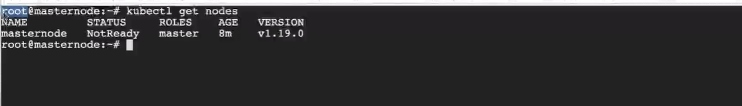
Still NotReady Status

step4: Add networking solution (CNI) weave
Why we need to add Networking Solution?
When we run docker container, we don’t need any extra network solution, you don’t need to provide IP addresses to container because docker follows the CNM (Container Network Modal), Network features are in-build with docker.
In K8s does not give Networking by default, you have to install your own Networking solution K8s follows CNI (Container Network Interface).

Why K8s don’t provide Networking Solution?
There is no standard container runtime you used in K8s, can use docker, rocket, and may not be compatible with all container run time.
Networks are just to provide Ip address to the pod and provide communication between the pods inside the cluster. Networking solution is for Pod IP, not for node IP.

Networking Solution CNI plugin: Weave (to establish a communication between different containers in cluster)
/*
kubectl apply -f "https://cloud.weave.works/k8s/net?k8s-version=$(kubectl version | base64 | tr -d '\n')"
*/
kubectl get nodes
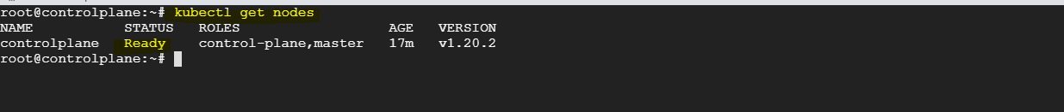

step4.1: create token
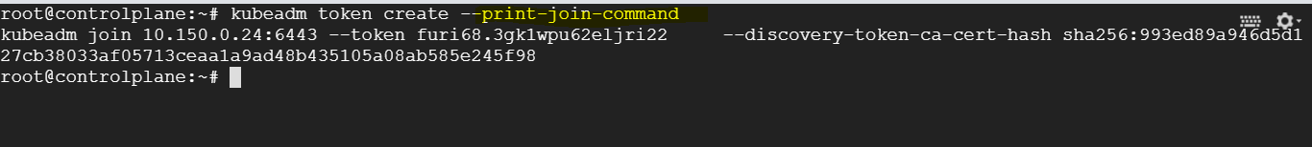
step5: Add the worker to the cluster
kubeadm join….
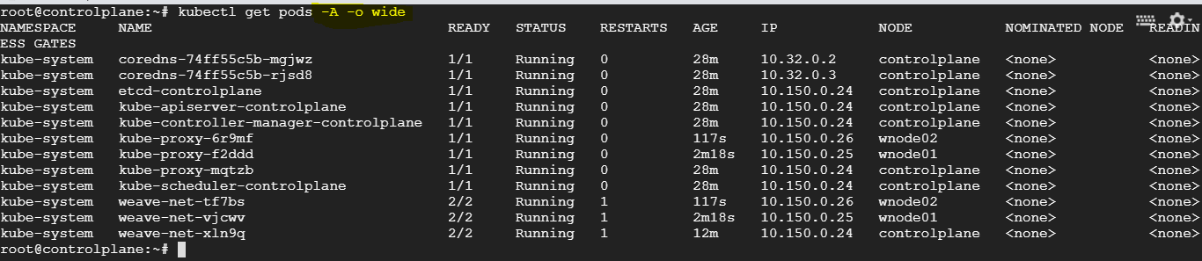
kubelet is missing?
kubelet does not run as a container it run as a service.
service kubelet status
service kubelet start
service kubelet stop
service kubelet restart
/*
master components -> static pod managed by kubelet
kube-proxy & weave components available on all nodes -> DaemonSet
coredns (provides DNS service)-> HA access through the svc
*/
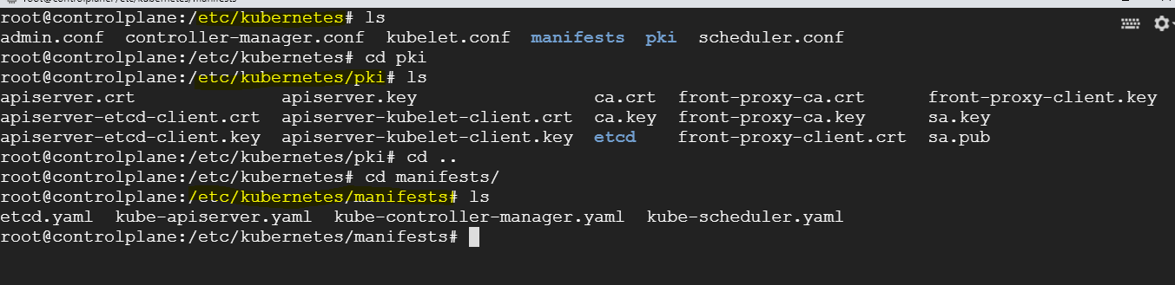
kubelet. yaml and certificates are missing?
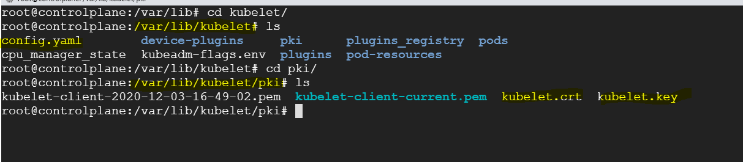
/var/lib/kubelet // config. yaml
/var/lib/kubelet/pki // certificates
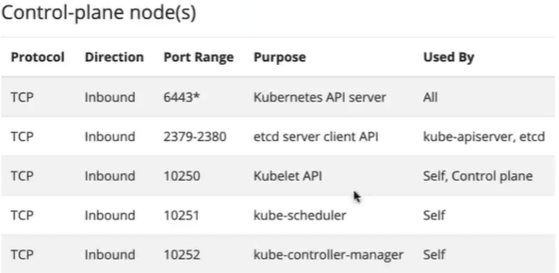

K8s Architecture
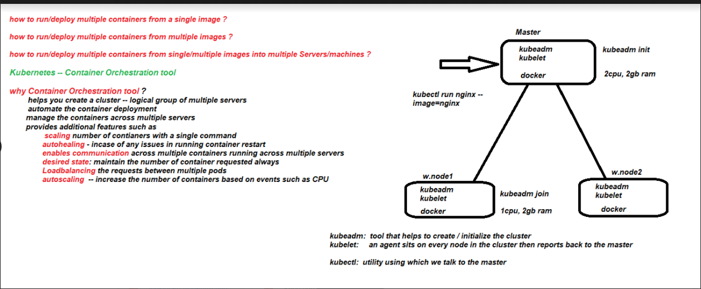
The purpose of K8s is to host your application in form of containers in an automated fashion so that you can easily deploy as many instances of your application as many they required and easily enable a communication between different services within your application.

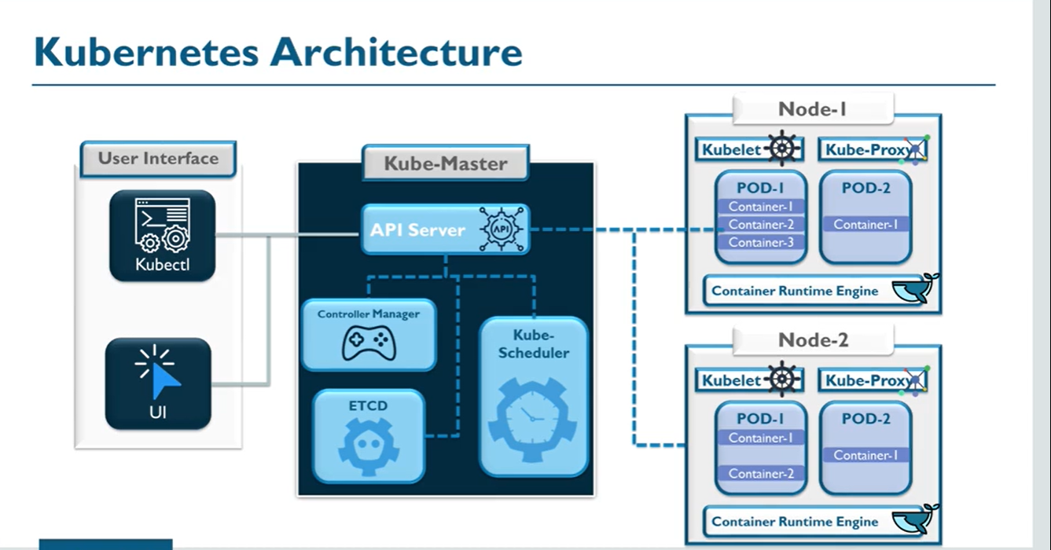
Utility and Components
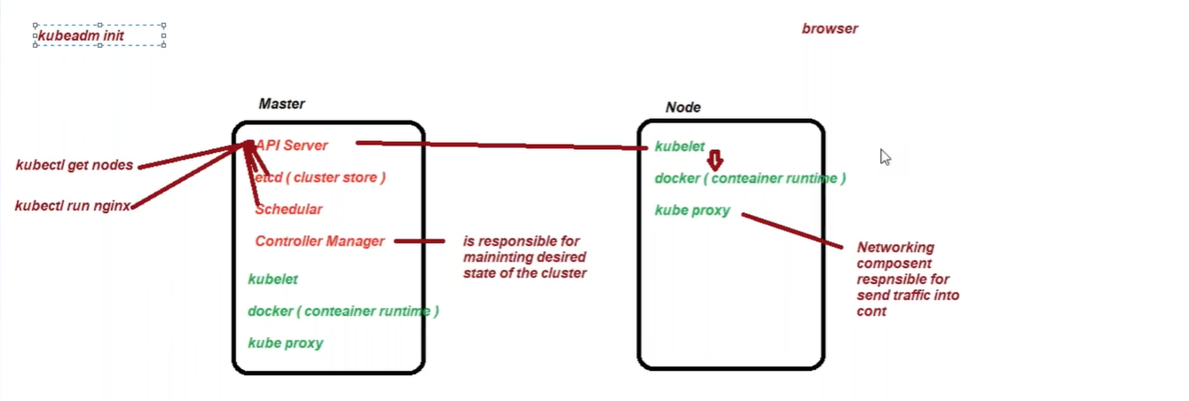
K8s is a container management tool not a containerization tool (docker)
Utilities:
kubectl: Is a command line utility for running commands against kubernetes cluster interact with K8s master(api-Server) for creating/ updating/ deleting/ describe the resources in the cluster.
kubectl syntax: kubectl [command] [type] [name] [flags]
kubectl is the client utility run on only the master
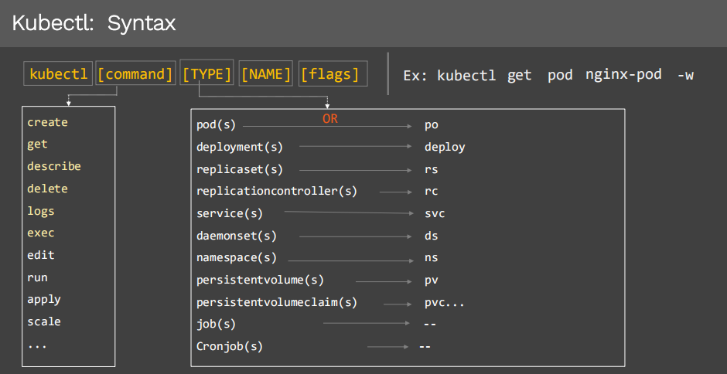

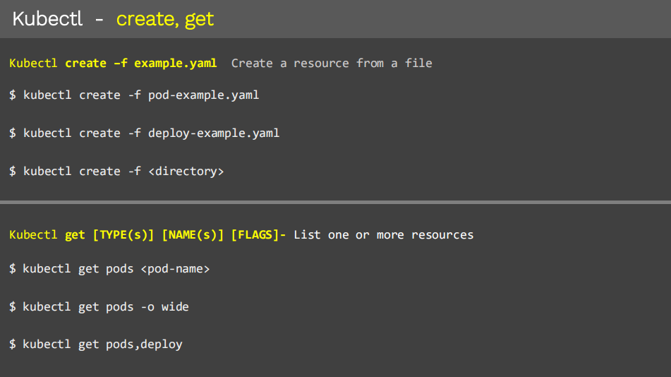
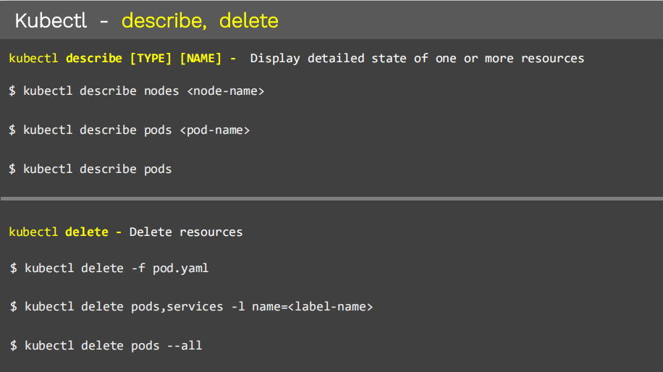

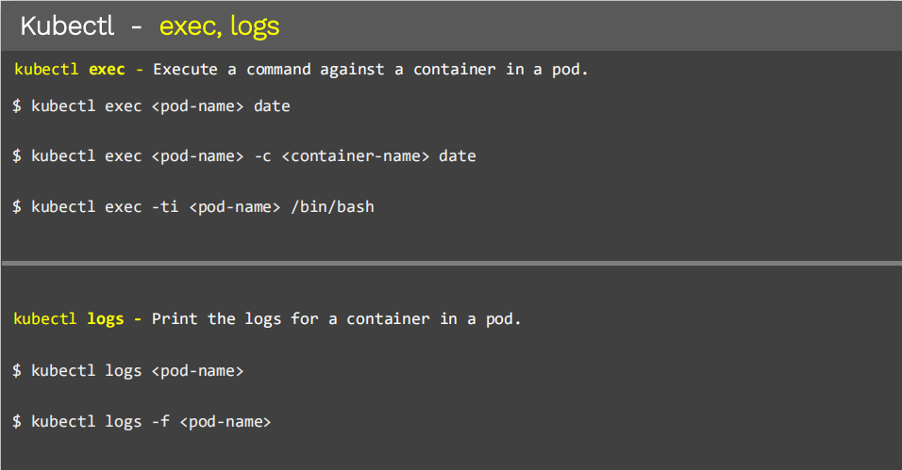

kubeadm: (bootstrap)
Using kubeadm utility, which helps us to initialize the cluster, everything deployed as a Pod

Command | Description
kubeadm init | to bootstrap a Kubernetes control-plane node  K8S master also called control-plane
kubeadm join | to bootstrap a Kubernetes worker node and join it to the cluster
kubeadm upgrade | to upgrade a Kubernetes cluster to a newer version
kubeadm token | to manage tokens for kubeadm join
kubeadm reset | to revert any changes made to this host by kubeadm init or kubeadm join
kubeadm version | to print the kubeadm version

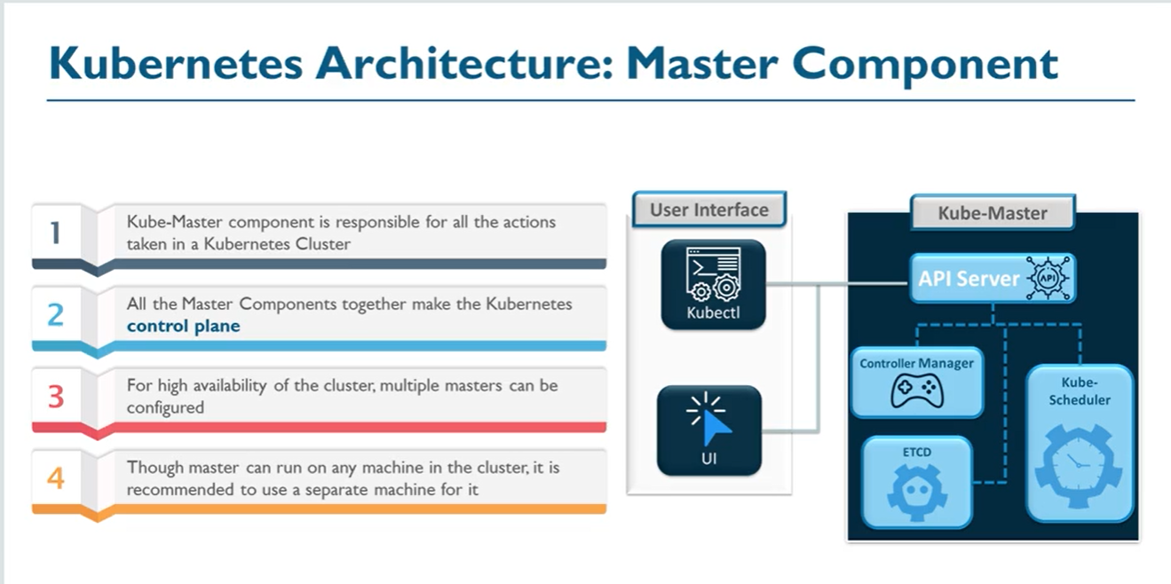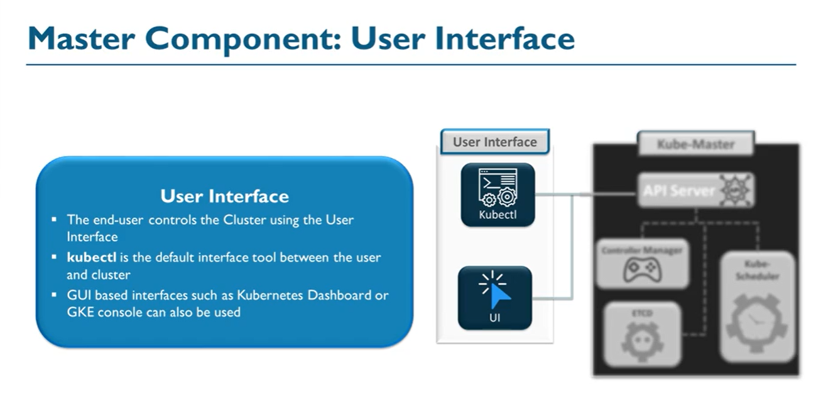

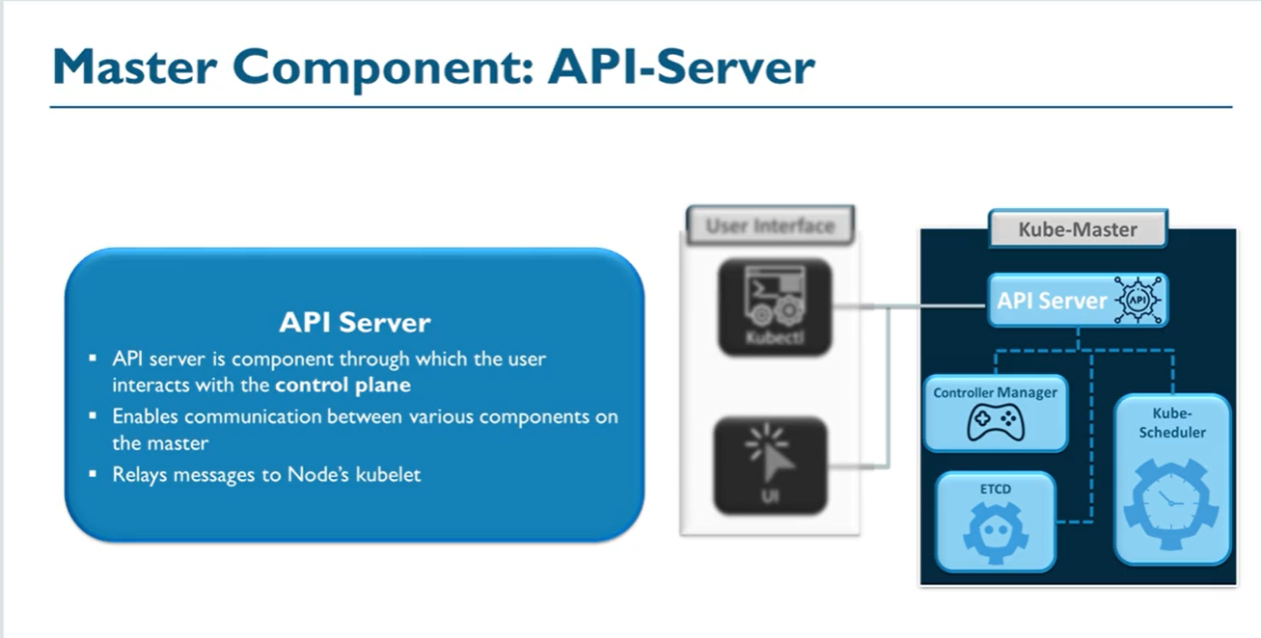
kube-apiserver is primary management component in k8s, when you run kubectl command, the kubectl utility in fact reaches to the kube-apiserver, kube-apiserver first authenticate the request and validates it and then retrieve the data from etcd cluster and response back with the requested information.
cat /etc/kubernetes/manifests/kube-apiserver.yaml
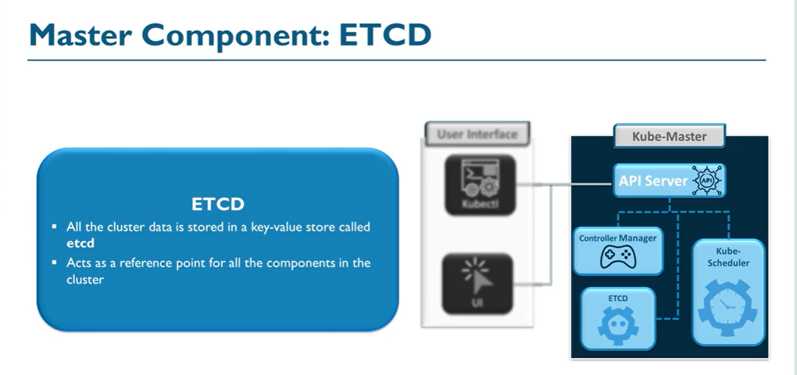

Entire cluster meta-data managed by etcd, store entire information about your cluster such as information about the following.
- Nodes
- Pods
- Config
- Secrets
- Accounts
- Roles
- Bindings
- Which CNI is used?
When api-server receives a request for get Object, it checks with etcd to send response back.
Once receives the Pod creation confirmation from kubelet, first stores the information in etcd and then sends response back.
ETCDCTL is the CLI tool used to interact with ETCD.
cat /etc/kubernetes/manifests/etcd.yaml

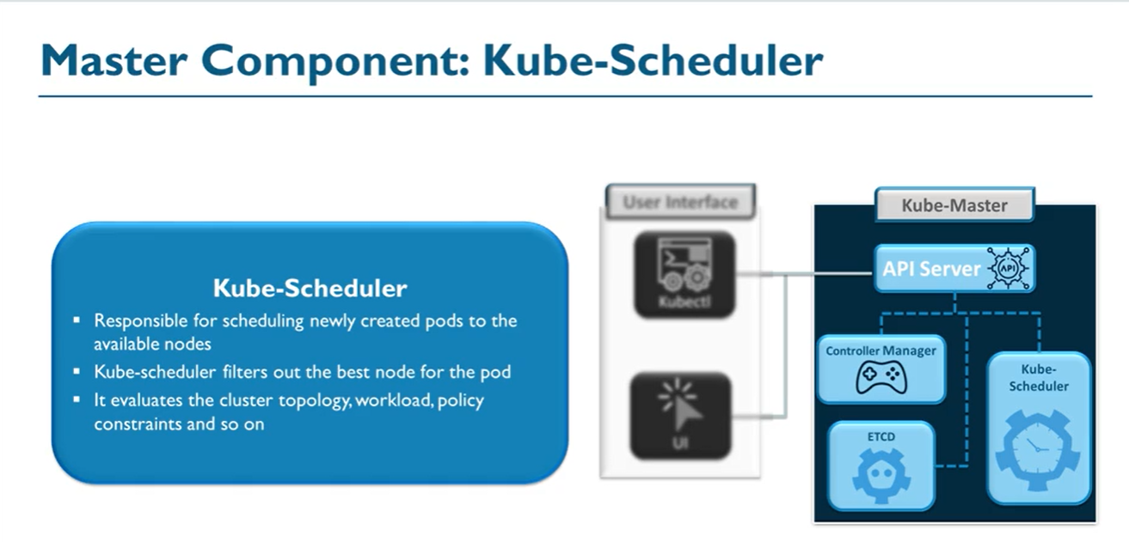
Is responsible for scheduling pods on the nodes.it is responsible only for deciding which pod goes on which node it doesn’t actually place the Pod on the nodes that’s the Job of the kubelet, to ensure right container(pod) on the right ship(node). node must have sufficient capacity to accommodate those containers.
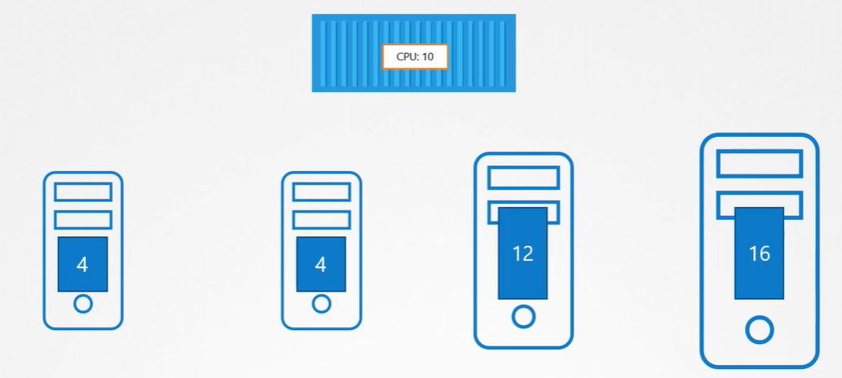
When api-server receives a request for Object creation, it sends the request to scheduler, asks to scheduler hey! Scheduler can you please find a node where I can create a container/object.
Scheduler duty is to find appropriate node for deploy the container, and sends the response back to api-server, hey! Api-server please deploy the container at node1.It assign appropriate node for a pod based on the resource requirement of Pod and available resources in Node. It keeps track of resource utilization and makes sure that workload is not scheduled on nodes which are already full. If there are no suitable nodes, the pods are put in a pending state until such a node appears.
cat /etc/kubernetes/manifests/kube-scheduler.yaml

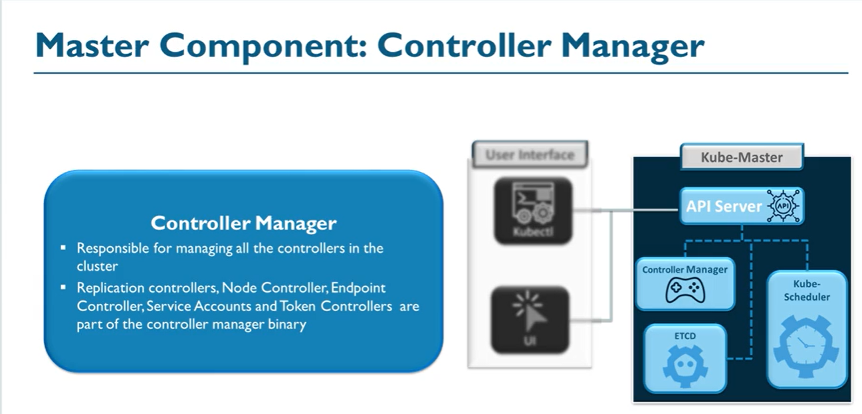
Node Controller: Is responsible for on-boarding new nodes on the cluster handle situation where node is unavailable or get destroyed.
Is responsible for monitoring the status of the nodes and takes necessary actions to keeps the application running. It does through the kube-apiserver, Node controller checks the status of nodes in every 5 sec, It checks the heartbeats of the node, if it stops receiving the heartbeat from the node then the node is mark as UNREACHABLE but it waits for 40 sec before marking it UNREACHABLE after the node mark as UNREACHABLE it gives 5 min to come back up if it doesn’t, it remove the Pod assigned to this node and provision them in healthy one if the Pod is a part of rs.
- Watch status
- Remediate Situation
- Node Monitor Period =5s
- Node Monitor Grace Period=40s
- POD Eviction Timeout = 5m
Replication Controller: Ensures that desired number of containers running all time.
- Auto healing
Cloud-controller-manager Specific to Cloud.
They all grouped together in kube-controller manager package.

Monitoring and maintain the state of the cluster, current vs. desired state.
if you are running 3 replica then its k8s responsibility that if any replica down then kubelet starts reporting to api-server , saying one of the container is down can you please check it, api-server requesting to controller-manager go and validate and then it compares with current and desired state current state is 2 and desired state is 3,then it convey to api-server, controller-manager continue looking in to current and desired state in cluster, every 5 sec, continues checking the resources state in cluster.

cat /etc/kubernetes/manifests/kube-controller-manager.yaml
ps -aux | grep kube-controller-manager

Worker Components (Actual runs the Pods)
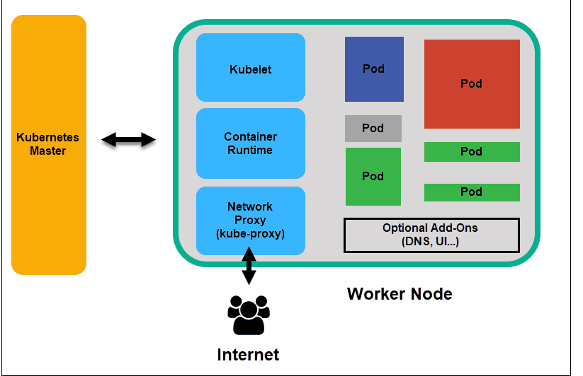
Worker nodes listen to the API Server for new work assignments; they execute the work assignments and then report the results back to the API Server in Master node.
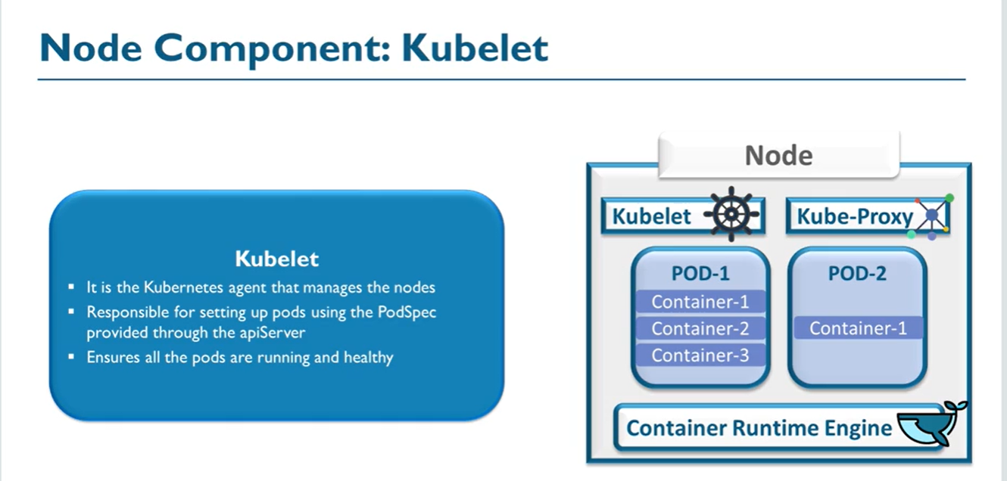
kubelet run as a service on all nodes
service kubelet status // on all nodes
- Agent service running on each worker node.
- Is the only component interacting with the apiserver?
- After getting information from scheduler to deploy pod on node1, api-server interacts with kubelet of node1 and convey to him please create a Pod, now its responsibility of kubelet to create a Pod in that specific node. Kubelet Interact with underlying container run time engine (docker) to create and manage pods, get specification of pod from apiServer. Then docker creates a Pod internally (Interact with docker registry to download image) and inform to kubelet, kubelet pass the information back to api-server.
- Once Pod is created interacts with underline CNI to assign IP to the Pod.
- Making ensure that container is running.
- provide metrics and health check information (after 5 sec) to apiserver (cAdvisor), which api-stores in etcd
- Provide heart beats to apiserver, acts as an agent on worker nodes, which api-server stores in etcd.
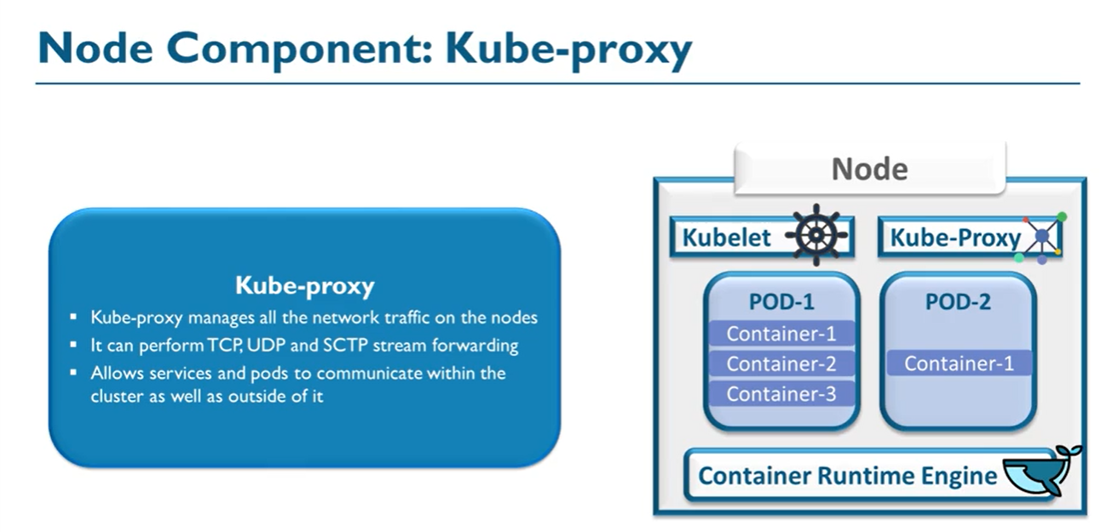
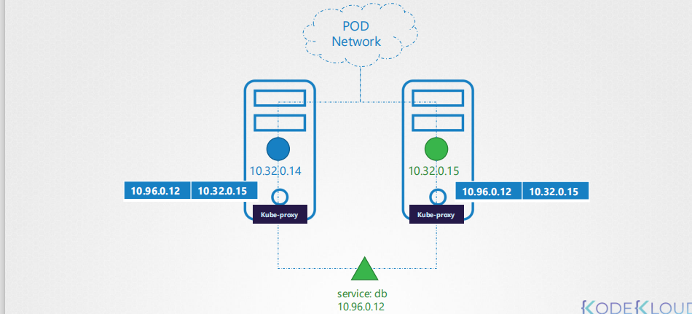
kube-proxy is a process that runs on each node in the k8s cluster, its job is to look for new services and every time a new service is created it creates the appropriate rules (DNS) on each node to forward request to those services to the backend application. kubeadm define it as a daemonset controller.
- Its works at service management layer.
- Service is a layer of abstraction between pod and requester
- It’s a packet forwarding component between service and pod.
It’s a kubelet inform node status to api-server, sometimes it may happen that kubelet is down, in that case node’s status is shown as NotReady.
- service kubelet status
- service docker status
kubectl describe node worker1
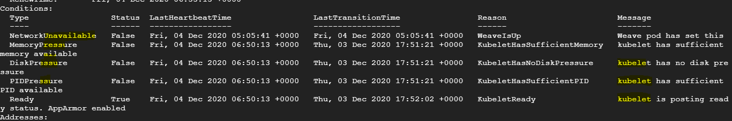

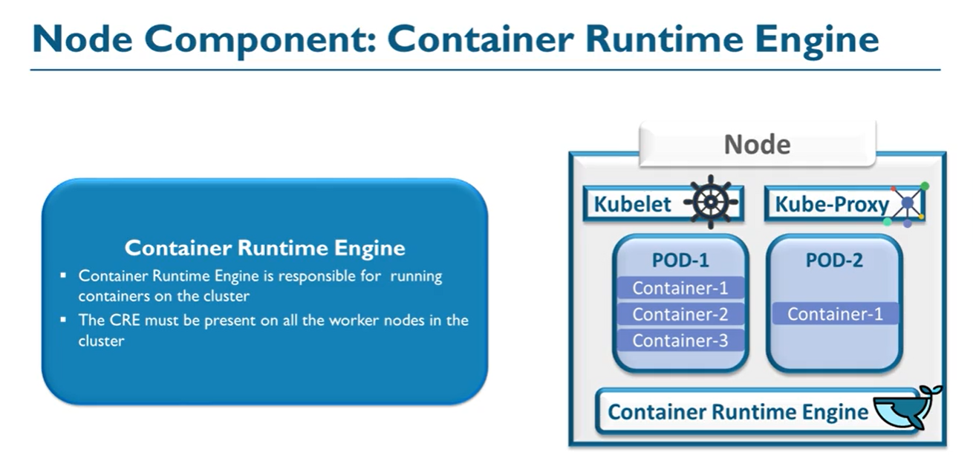
The container runtime pulls images from a container image registry and starts and stops containers. A 3rd party software or plugin, such as Docker, usually performs this function.

