External Configuration (config-server)
container package (Image): Is package that contains everything need to run a application/software.
Environment specific config data can’t be packaged in container image.
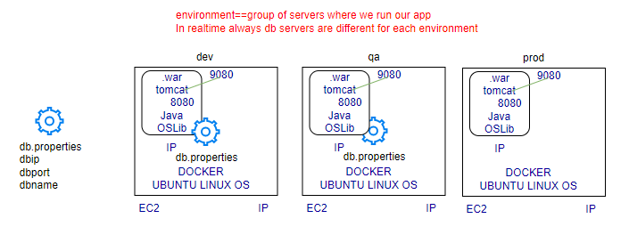
Environment specific configuration data needs to injected into container when we run the container from image at respective environment.
How to inject the config data into cont at runtime?
- configmap- plain config data
- secret: sensitive data
UC: My application requirement is to connect to database, will connect to database through connection URL, can we keep database URL inside image?
No: Image is prepared during development and contains connection string of dev database, can’t be build image with dev database URL, if we ship the same image in production will not work, we cannot put database details inside image which requires environment level configuration not the application level, our requirement is to deploy application in different environment.
In this case there is still something which is specific to the environment, means environment level configuration can’t be put inside image, so that we need some configuration at environment level which can’t be keep inside image.

Why Configuring Containerized Applications?
- Container images are built to be “portable”.
- Decouple the configuration from pods and components.
- Store configuration data as key-value pairs

Env Variable in Kubernetes

Containers expect configuration from
- Configuration Files: (configMap and Secrets)
- Command Line Arguments
- Environment Variables: (plain key-value pair)

UC: There are multiple environments in my organization, how can we pass URL dynamically. We Can provide data dynamically to container through Volumes or through the env variable, If we want to send some data through the files then go for volumes, if we want to send some data as environment variable then we use ENV.

ConfigMap
- Is a way of storing some plain configuration data in the kube cluster itself.
- Once the data is stored in the cluster, we can inject the data into container at run time.
  - As volume data
If we have one or two env variables, we can define in Pod definition file, if you have lots of Pod definition files it will become difficult to manage the env data to store in this definition files we have to take this information out of the Pod definition and manage centrally using configmap.
A ConfigMap is an API object used to store non-confidential data in key-value pairs. Pods can consume ConfigMap as environment variables, command-line arguments, or as configuration files in a volume.

A ConfigMap allows you to decouple environment-specific configuration from your container images, so that your applications are easily portable.

Is kind of Storage, when you create a ConfigMap it creates a data and that data stored in the clustered database (etcd) database, and managed by apiServer. Small information
Sharing Information among multiple Pods (cluster level)
Read Only

Limitation: ConfigMap does not provide secrecy or encryption.
If the data you want to store are confidential, use a Secret rather than a ConfigMap, or use additional (third party) tools to keep your data private.

There are two steps in configMap
- Create ConfigMap
- Inject into Pod
Creating ConfigMap
Imperative approach
kubectl create configmap <map-name> data-source, data-source can be
- Directories
- Files
- Literal Values
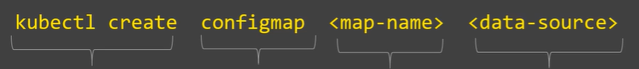
Declarative approach
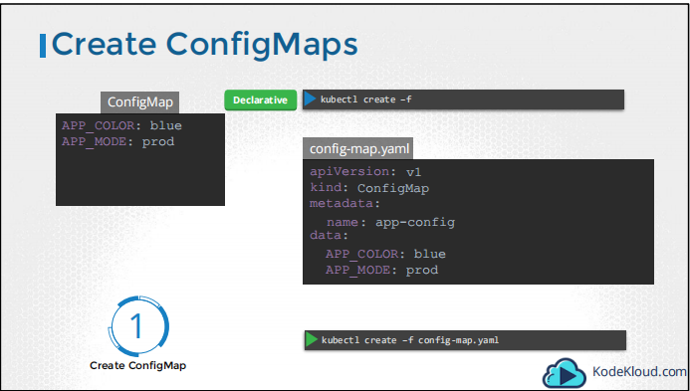
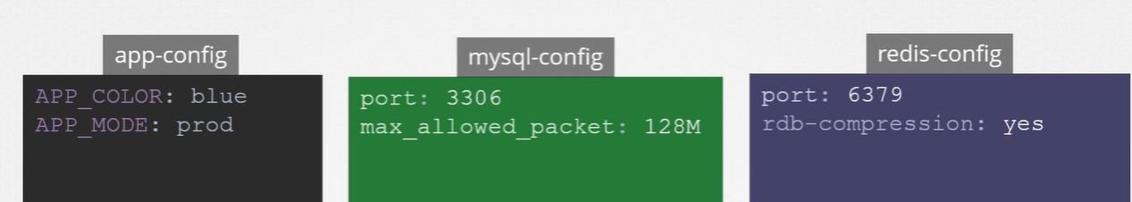
kubectl get configmaps
kubectl describe configmaps

How to access ConfigMap Inside the Pod?
There are two ways
- Volume - files
- envVariables - variable

ConfigMap allow you to decouple configuration artifacts from image, content to keep containerized application portable.
Portable image: same image can be run on any environment
UC: create a db. property, in order to provide. properties values through volumes
Whenever we create a configMap save data in etcd database.
kubectl create cm <dbconfigmap> --from-file=’db. properties’
values retrieved from etcd database available to the pod either using volumes or using env variable.
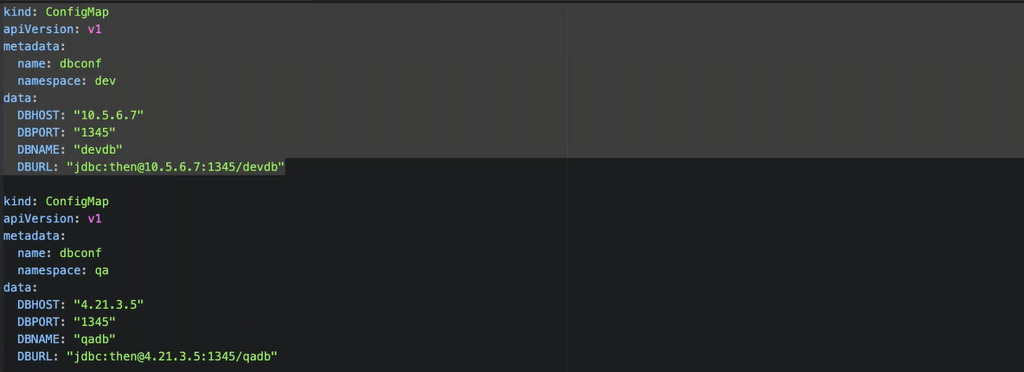
Secrets:
- Is a way of storing some sensitive configuration data in the kube cluster itself.
- Once the data is stored in the cluster, we can inject the data into container at run time.
  - As volume data
Kubernetes Object to handle small amount of sensitive data. (password, tokens or keys).
The main purpose of secrets is to reduce the risk of the accidental exposing of sensitive data.

- Created outside Of Pods.
- Stored inside ETCD database on Kubernetes Master
- Not more than 1 MB
- Used in two ways -Volumes or Env Variables
Sent only to the target node, not broadcast to all the nodes.
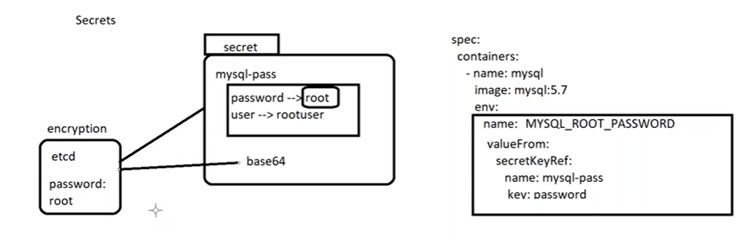

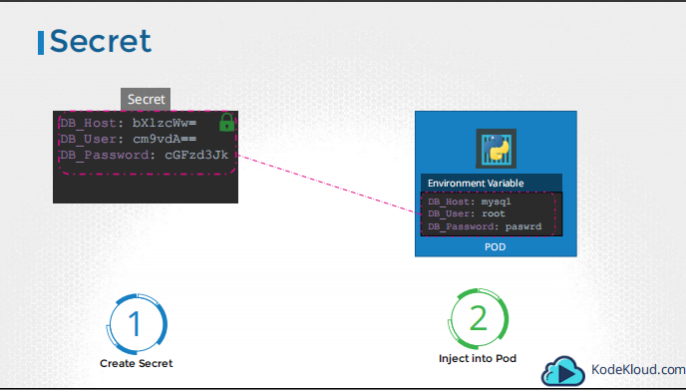

There are two steps in Secrets
- Create Secret
- Inject into Pod

Creating Secrets
Imperative approach
Don’t create a config file to create a secret object, instead we are going to run imperative command
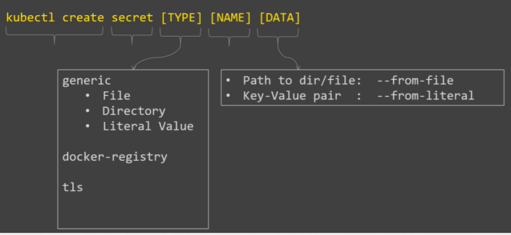

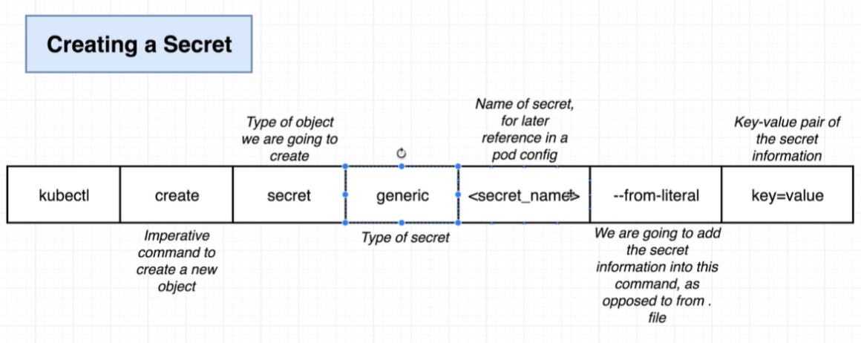
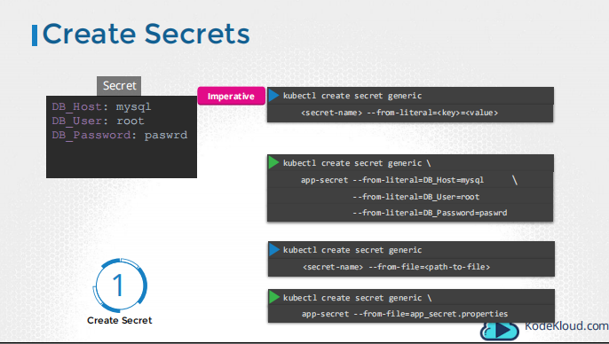

Using Declarative approach
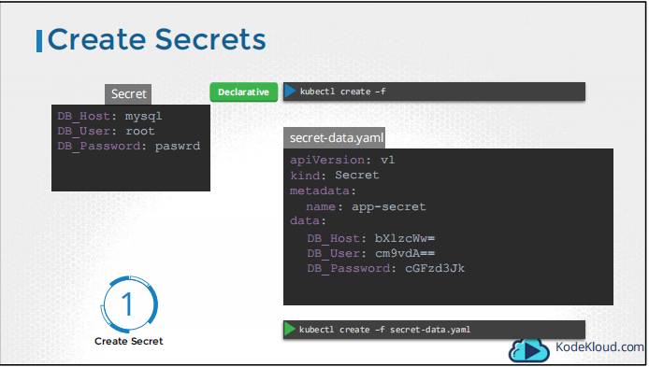

Secrets: Stores sensitive information, first encrypt the data using base 64 or other cryptography
echo admin | base 64
kubectl create secret generic <db secret> --from-file=’db. properties’

How to decode?
echo ec9vda== | base64 –d

How to validate the environment variables inside the Pod?
