UC: In Docker we have run multiple containers, within the same host. When we need HA, we need more machines to host containers.
Problem Statement:


How to Organize??

Why Manager??
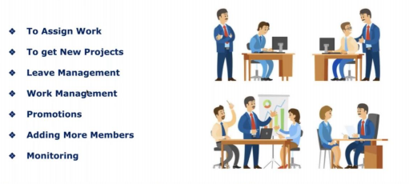

How to Manage More Containers???
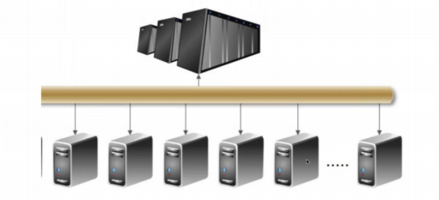

Cluster: Group of servers
If you deploy your application across 100 of servers in cluster then how you manage your applications?
Problem Statement:

- How containers communicate to each other?
- How container communicate to each other across multiple nodes?
- How implement Autoscaling?
- How to manage/monitor cluster (group of servers)?
- High Availability?
- Security?

Container-based application brings many challenges to IT & DevOps teams
- Managing the underlying infrastructure on which these apps are running.
- Managing the actual applications, which is especially challenging in upstream environments like PROD.
Once application is deployed, there are several requirements for managing them
- High Availability- distributed hosts/regions
- Backups
- Monitoring & Alerts
- Auto-Scaling
- Continuous Delivery for Enterprise Apps
- Service Discovery
- Logging
- Integration with Existing Services
- Auditing
Solution: Container Orchestration tools (docker swarm, K8s)
We need container orchestration, so that our containers are highly available

Why Container Orchestration?
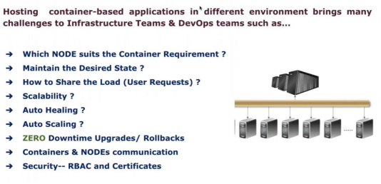
How do we setup K8s Cluster?
There are two ways to work with k8s?
K8s as a service (KAS) - Cluster is created by cloud vendor and handover to you.
All cloud provider provides k8s as a service. All responsibilities of the utilities handled by cloud provider. As a user we have to demand only for number of servers in cluster. Charged only for servers in cluster not for service.
EKS provided by Amazon, Google Kubernetes Engine by Google cloud.
Kubernetes managed by cloud provider.
EKS? Cluster is created by AWS and handover to you.
Self-hosted
self-created cluster using kubeadm utility as a pod.
Components:
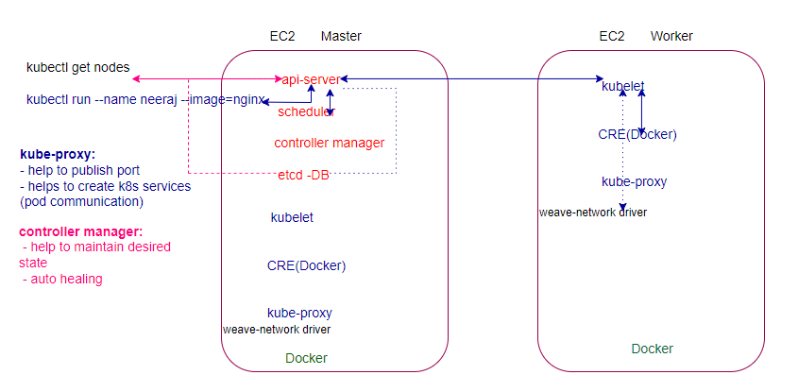
Kubernetes Pods:
- Is an abstract layer that can create and manage a single/group of containers.
- Container runs inside the pod always
- Single pod==single Instance of an app
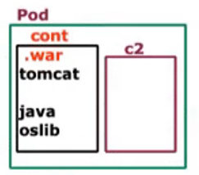

To achieve HA, must have multiple pods, not the multiple containers.
# kubectl run webapp –image=gcr.io/google-container/nginx: latest

If node fail, will K8s take care?
No, Its Infrastructure related Issue, K8s take care only the containers.

How Nodes Knows Manager is down?
It’s not responsibility of node to know about master, will continue with present workload, but no new deployment will be allowed, and feature provided by master will not be available.

How to interact with K8s master?

kubectl: Is a command line utility installed only on master to communicate with nodes, client to interact with cluster to create, delete, edit the resources within the cluster.

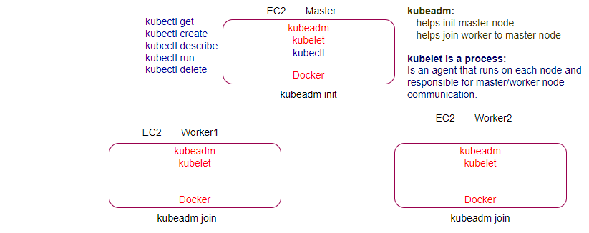
Utilities:
kubectl: Is a command line utility for running commands against kubernetes cluster interact with K8s master(api-Server) for creating/ updating/ deleting/ describe the resources in the cluster.
kubectl syntax: kubectl [command] [type] [name] [flags]
kubectl is the client utility run on only the master
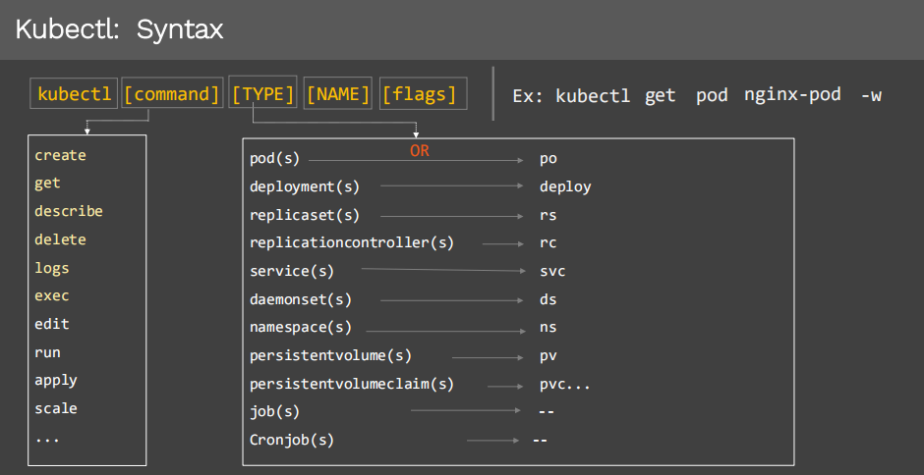

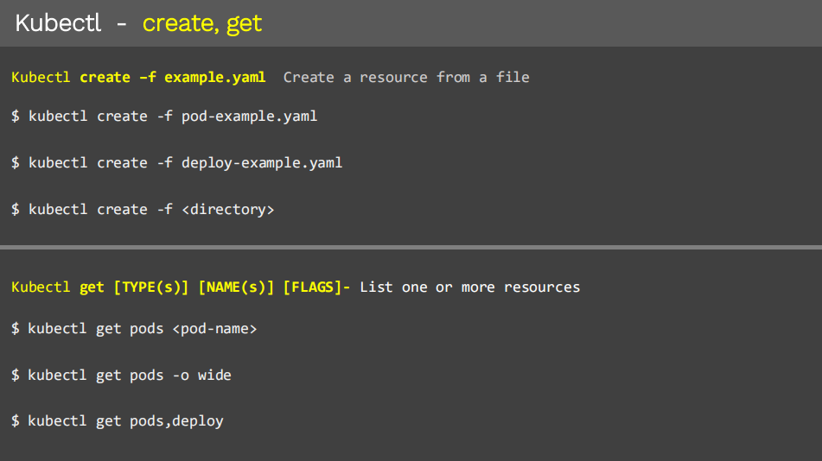
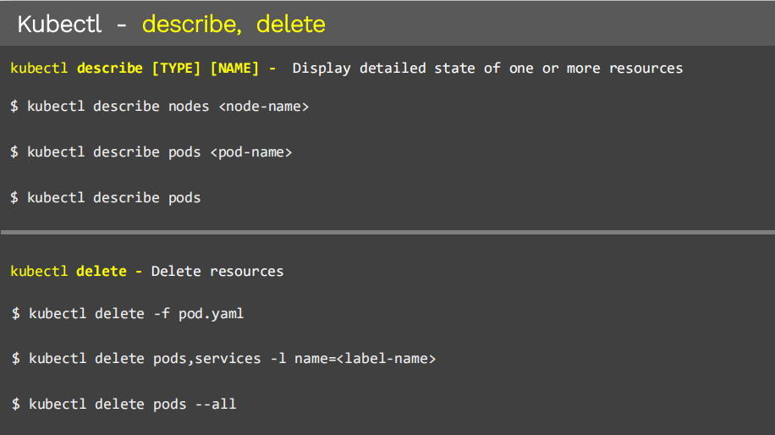

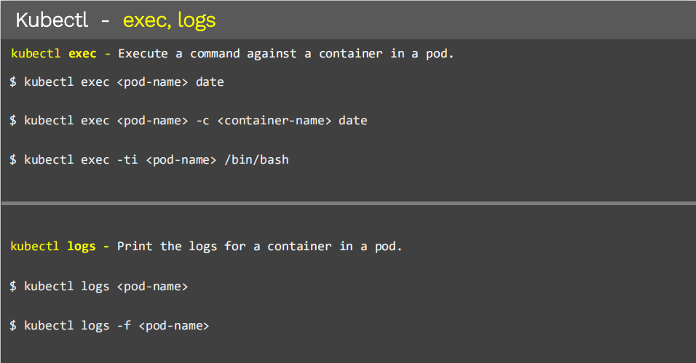

kubeadm: (bootstrap)
Using kubeadm utility, which helps us to initialize the cluster, everything deployed as a Pod

Kubernetes Objects/Resources
Anything we create in kubernetes is called as Object ex: Pod, Replicaset, Deployment, Service etc…
The main objective of K8s is to deploy our application in the form of containers into set of machines that are configured as a worker node in the cluster however k8s doesn’t directly deploy the containers on the worker node, containers are encapsulated into k8s object called Pod. If you need to scale your app, you can only do so by adding or removing pods. The pod serves as a ‘wrapper’ for a single/multiple containers with the application code.
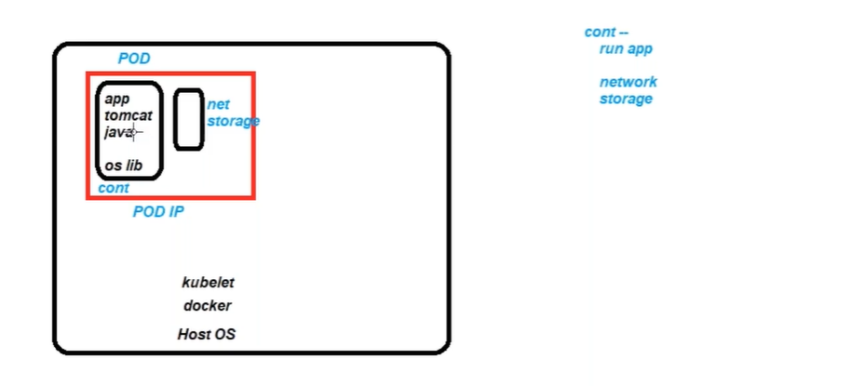

Pod (Abstraction Over Container):
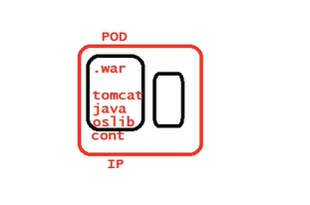
In K8s pod is the actual real thing, everything else revolve around, pod is smallest unit we created, pod is running instance of your application.
In k8s the only resource which physical run on a virtual machine are Pods, apart from that any other resource in k8s are just configuration they are not running executable.
Pod has ability to restart the container. In docker run time unit is container, In K8s run time unit is Pod. Pod is the smallest object in K8s.
How to deploy Pods?
Imperative approach: use the command line
kubectl run <name> --image=<name>
Declarative Approach?
#Declarative (kams)
kind: # kubectl api-resource
apiVersion: # kubectl explain <pod>
metadata:
name:
namespace: dev
spec:
kubectl create -f <manifest>.yaml
#@create shortcuts
alias k='kubectl'
alias kg='kubectl get'
alias kr='kubectl run'
kr nginx --image=nginx --dry-run=client -o yaml
kr nginx --image=nginx --port=80 --dry-run=client -o yaml #port
kr nginx --image=nginx -l='env=dev,app=frontend' --dry-run=client -o yaml #labels
kind: Pod #k api-resources
apiVersion: v1 #k explain <Pod>
metadata:
name: nginx
labels:
env: dev
app: frontend
namespace: dev
spec:
serviceAccountName: admin
automountServiceAccountToken: false
containers:
- name: nginx-containerd
image: nginx

ports:
- name: webport
containerPort: 80
command: ["/bin/sh","-c","date;sleep 3600"]
env:
- name: uname
value: user
- name: pin
value: password
resources:
requests:
memory: 128Mi
cpu: "1"
limits:
memory: 256Mi
cpu: "2"

In case of docker if container is stopped and restarted everything is changes e.g., it’s IP, networking, in Case of Pod (Abstraction layer over container just like tempered glass over the mobile), IP assigned to Pod not to the container. In case of Pod if container restart inside the Pod it doesn’t change the IP of Pod. Pod manage the container means containers are controlled by Pod, Pod as ability to restart the container in case container stopped. Only Pod and Node have IP addresses Container don’t have.
In docker run time unit is container, while in K8s run time unit is Pod.
Multi-Container Pod (Each container must have different image)
How to access a specific container within the pod in case of multi container?
kubectl exec -it <pod name> -c <container name> -- /bin/bash
kubectl exec multi-cont-pod -c cont3 -- ls -l
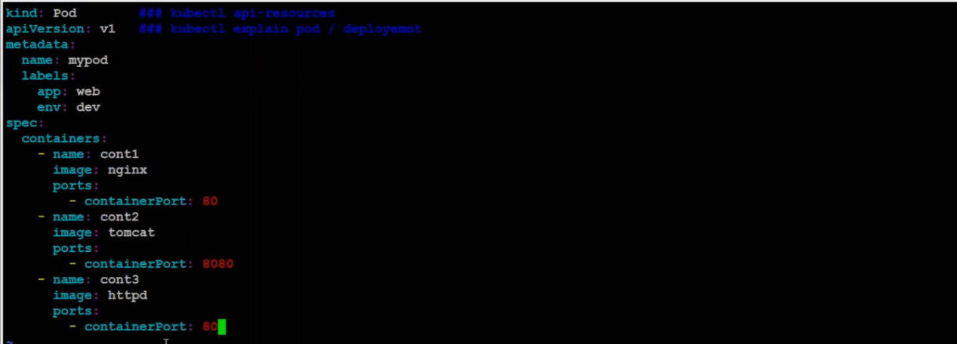
We can’t run more than one container in same port within pod.
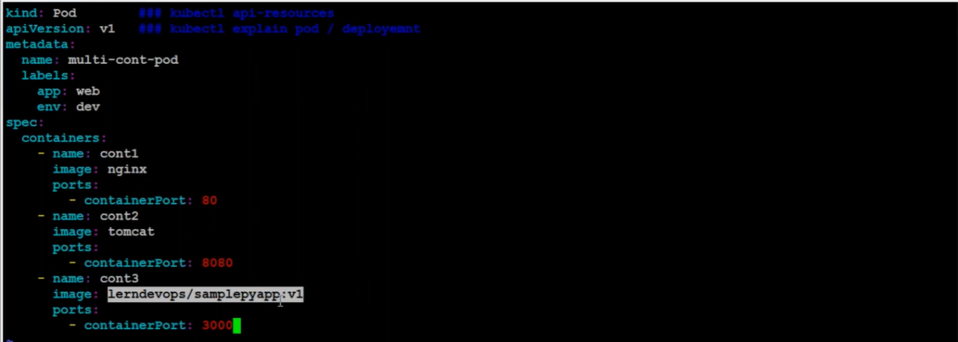

InitContainer
InitContainer provides input to the main container, just like constructor parameter. In multi container pod second container running forever, while in init container which runs for completion, if init container successfully completed only then actual container will be start.
Static Pods (Can’t be scaled) *- Managed by kubelet

