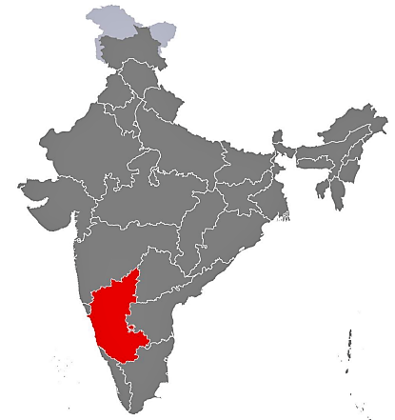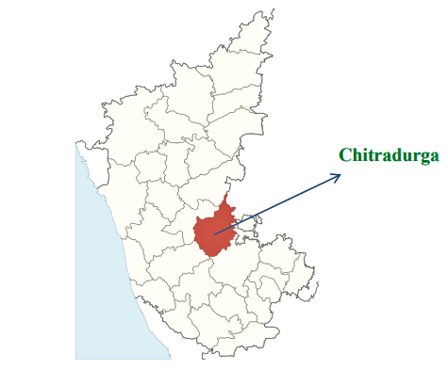
India Karnataka state

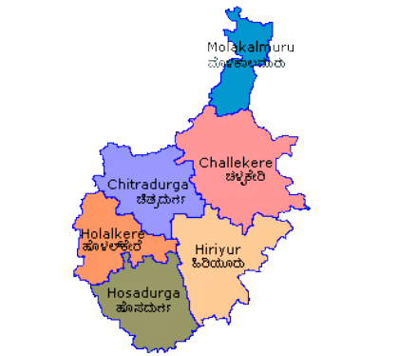
Chitradurga district

Fig 3.1 Map depicting all taluks in Chitradurga district
KARNATAKA
State
District

CHITRADURGA
Hiriyur
Challakere
Sondekere

Dodderi

Nanniwala

Taluks
Veeradi-mmanahalli

Challakere

Mallappanahalli

Ramjogihalli

Maddanakunte

F=10
F=10
F=10
F=10
F=10
F=10
F=10
F=10
Market intermediaries = 15
Market intermediaries = 15

Fig. 3.2 Sampling procedure

