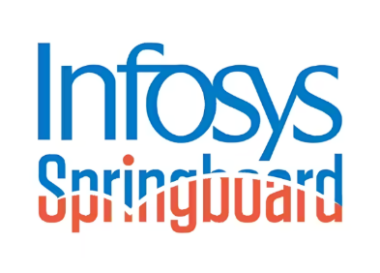
INFOSYS SPRINGBOARD – VIRTUAL INTERNSHIP PROGRAM 6.0

PROJECT REPORT
SkillGapAI – Analyzing Resume and Job Post for Skill Gap

Submitted by:
TALASU NEERAJA
talasuneeraja2003@gmail.com

Under the guidance:
Mr. ELDHOSE MATHEW
Springboardmentor005@gmail.com

ACKNOWLEDGEMENT

I would like to express my sincere gratitude to Infosys Springboard for providing me the opportunity to participate in the Virtual Internship Program 6.0 under the Python Technology domain. This internship has enabled me to gain practical exposure and enhance my technical understanding through real-time project development.

I extend my heartfelt thanks to my mentor, Mr. Eldhose Mathew sir, for his continuous guidance, encouragement, and valuable feedback throughout the project. His support has played a crucial role in building and refining this work.

I am also thankful to my family and friends for their constant support, motivation, and belief in my capabilities during the project development journey.

Submitted by:
Talasu Neeraja

ABSTRACT

In today’s competitive job environment, candidates must align their skills effectively with job requirements to improve hiring chances. Recruiters also face challenges in evaluating skill relevance across numerous resumes. This project, SkillGapAI, aims to automate the process of comparing a candidate’s resume with a job description and identify gaps between the expected and possessed skills using Natural Language Processing (NLP) techniques.
The system extracts skills from both documents using NLP processing and Sentence-BERT embeddings to compute similarity between related skills. It identifies exact, partial, and missing skills and generates a visual dashboard to represent skill strengths and areas for improvement. The solution helps candidates understand their readiness for a role and suggests skill enhancement recommendations. The model is implemented using Python, Flask, PDF parsing tools, and visualization libraries.

PROBLEM STATEMENT

Many job seekers struggle to identify how well their skills match the job roles they apply for. Manually comparing job descriptions and resumes is time-consuming and often inaccurate. There is no easy automated tool that analyzes resumes against job requirements and clearly highlights skill gaps. This project addresses this challenge by designing a system that compares both documents and identifies exact, partial, and missing skills using NLP and semantic similarity.

OBJECTIVES

- To extract professional skills from candidate resumes and job descriptions.
- To identify matching, partially matching, and missing skills by semantic comparison.
- To calculate a skill match score representing candidate job readiness.
- To visualize results through interactive charts and dashboards.
- To provide skill improvement recommendations based on missing and partially matched skills.

SCOPE OF THE PROJECT

The proposed system SkillGapAI is designed for job seekers, students, professionals, and recruiters who want to understand how suitable a candidate is for a particular job role. The scope of the project includes extracting skills automatically from resumes and job descriptions, identifying missing or partially matched skills, and presenting insights through an interactive dashboard. The system supports real-time evaluation and can help users enhance their employability by understanding what additional skills they need to learn. Recruiters can also use this system to quickly shortlist candidates whose skills align with job expectations.

EXISTING SYSTEM VS PROPOSED SYSTEM

Existing System:
Feature | Status
Manual resume screening | Time-consuming & inconsistent
Hard to understand exact skill match | Requires experience
No automated comparison with JD | Not available
No visualization of candidate’s readiness | Lacks clarity
Limited suggestions for upskilling | Not provided

Proposed System:
Feature | Status
Automated skill extraction using NLP | Fast & accurate
Semantic similarity skill matching via BERT | Finds related skills as well
Highlights matched, partial, and missing skills | Clear comparison
Interactive visual dashboard | Improved readability
Personalized recommendations | Guides candidates for improvement
Match score calculation | Helps in evaluating job readiness

The proposed system reduces manual effort, speeds up selection, and gives job applicants a clear understanding of their strengths and areas for improvement.

METHODOLOGY / WORKFLOW

The methodology of the project follows a structured process:
Step-1: Upload Resume & Job Description
User uploads both documents (PDF format) through a web interface.
Step-2: Text Extraction
The system extracts text from both files using PDF parsing tools.
Step-3: Skill Extraction using NLP
The extracted text is cleaned, tokenized, and processed to identify skills from a predefined knowledge base.
Step-4: Semantic Comparison using BERT
Sentence-BERT embeddings compute similarity between resume skills and job skills to identify exact and partial matches.
Step-5: Skill Gap Identification
The system identifies:
- Skills already present in resume
- Partially matched skills
- Missing skills from JD
Step-6: Visualization
Charts and dashboard display the results with Donut, Gauge, and Bar graphs.
Step-7: Recommendations
The system suggests skills that the candidate needs to improve to qualify for the role.

SYSTEM ARCHITECTURE

Architecture Flow:

User Uploads Resume & JD
↓
Text Extraction
↓
NLP Skill Extraction
↓
Sentence-BERT Similarity Model
↓
Skill Comparison Engine
↓
Visualization & Dashboard Output
↓
Recommendations

Explanation:
The text extracted from the PDF files is processed using NLP to detect skills. These skills are then compared using semantic similarity calculation powered by Sentence-BERT. The results are analyzed to determine matched, partial, and missing skills. Finally, the dashboard visualizes the results and displays recommendations along with a downloadable report.

TECHNOLOGIES USED

Software & Tools:
Technology | Purpose
Python | Core programming language used for backend logic
Flask Framework | Web application framework to connect UI and processing
Natural Language Processing (NLP) | Skill extraction and text processing
Sentence-BERT Embeddings | Semantic similarity to detect partial matches
pdfplumber | To extract text from PDF files
Plotly | For creating interactive graphs and visual dashboards
HTML, CSS | Front-end interface and styling
Pandas | Data manipulation and table formatting
NumPy | Numerical computation support

MODULES DESCRIPTION

1. File Upload Module
Allows the user to upload Resume and Job Description PDFs through the web interface.
2. PDF Parsing Module
Extracts raw text from the uploaded PDF files using pdfplumber.
3. NLP Skill Extraction Module
Processes the extracted text, performs tokenization, stopword removal, and identifies skills based on a predefined knowledge-based list.
4. Semantic Similarity Module
Uses Sentence-BERT to compute similarity between resume skills and job description skills to identify:
- Matched Skills
- Partially Matched Skills
- Missing Skills
5. Skill Comparison Module
Calculates skill match score and determines missing & partial matches based on similarity score threshold.
6. Visualization Module
Displays:
- Donut chart (skill distribution)
- Gauge chart (match score)
- Bar chart (similarity levels)
- Skill table and recommendations
7. Recommendation Module
Suggests the most important missing or partially matched skills to improve job readiness.
8. Report Generation Module
Generates downloadable CSV report summarizing skill results.

ALGORITHMS USED

1. NLP-Based Skill Extraction Algorithm
Input: Resume text, Job Description text
Process:
- Tokenize text
- Normalize & clean text
- Identify words matching skills in knowledge base
Output: Extracted skills list
2. BERT Semantic Similarity Algorithm
For each JD skill:
Compute BERT embeddings for JD skill & Resume skill
Calculate cosine similarity for matching pairs
If similarity ≥ threshold:
Mark as partial match
3. Skill Match Score Formula
Skill Score = (Exact Matches + 0.5 × Partial Matches) / Total JD Skills × 100

RESULT/ OUTPUT

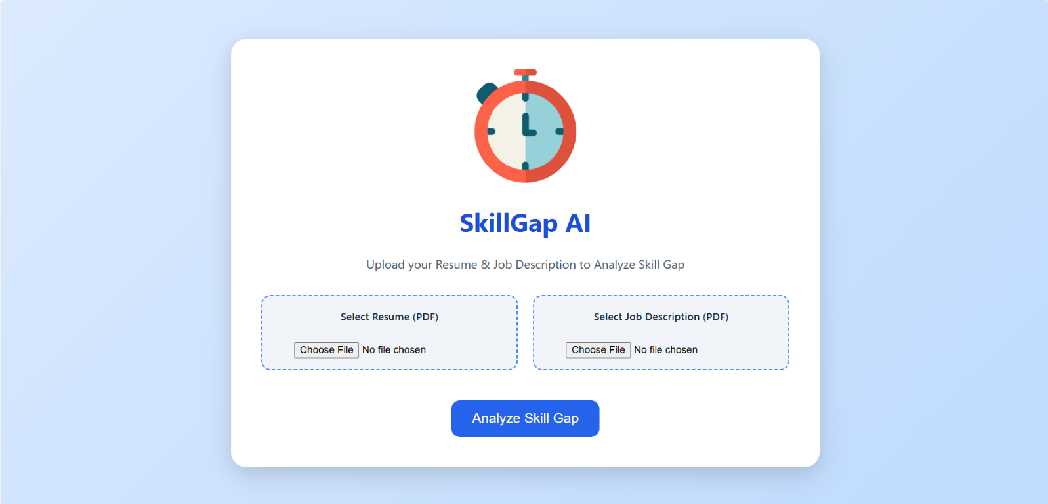
This is the UI:

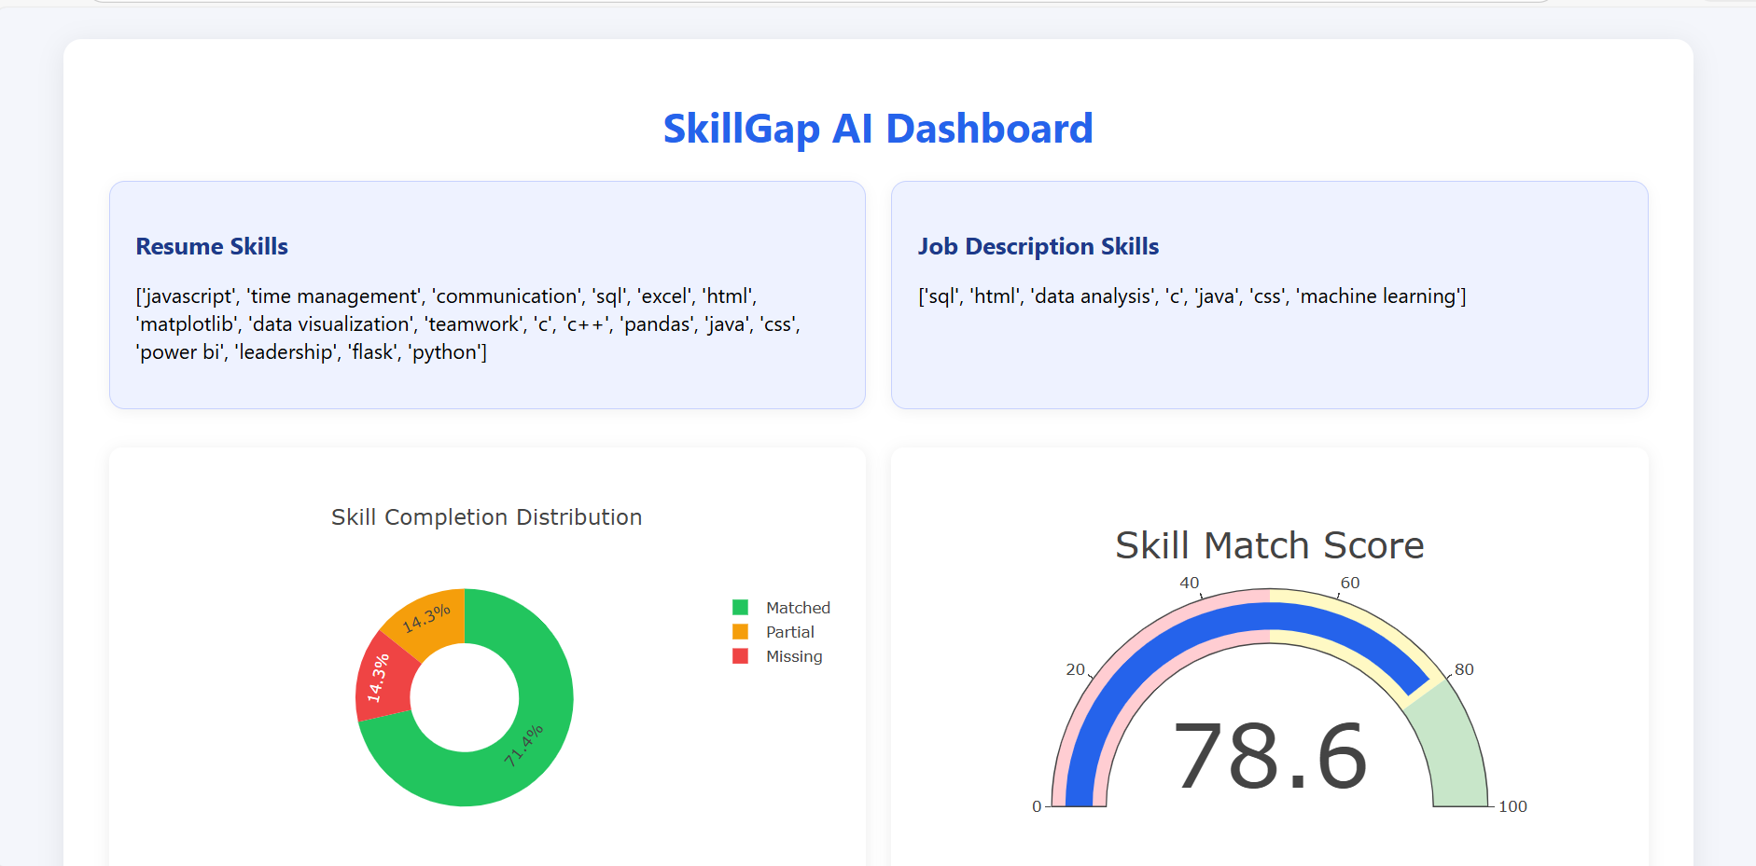
After user uploading their resume and jd , This is how SkillGap AI Dashboard looks like:
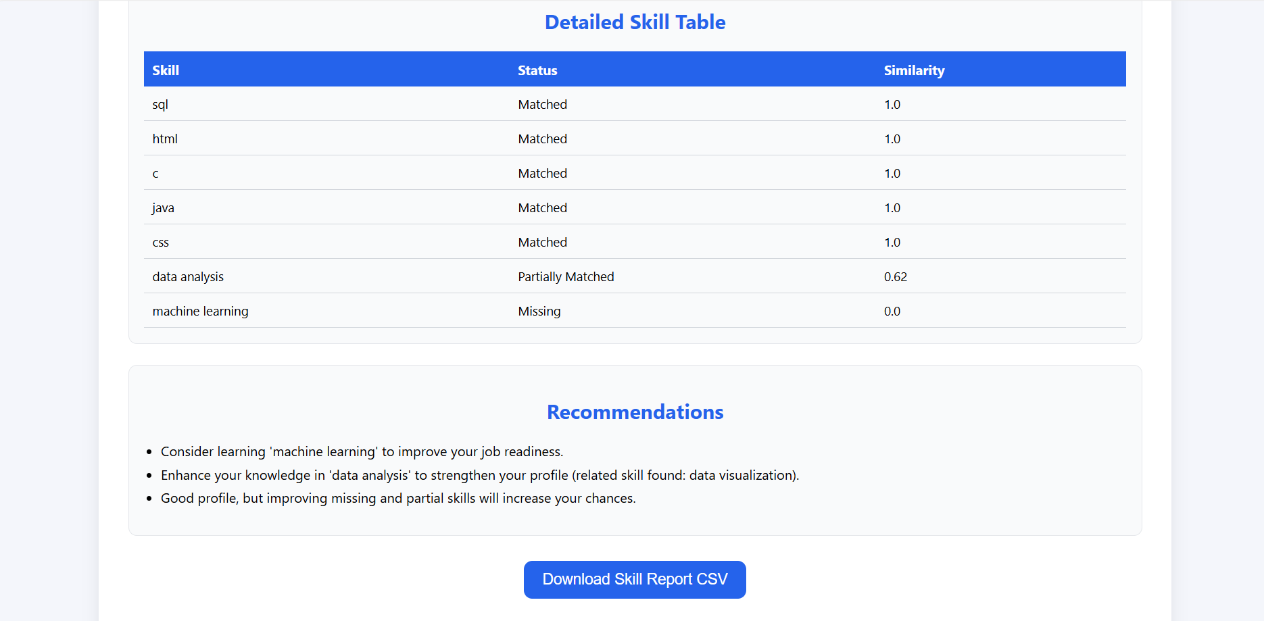
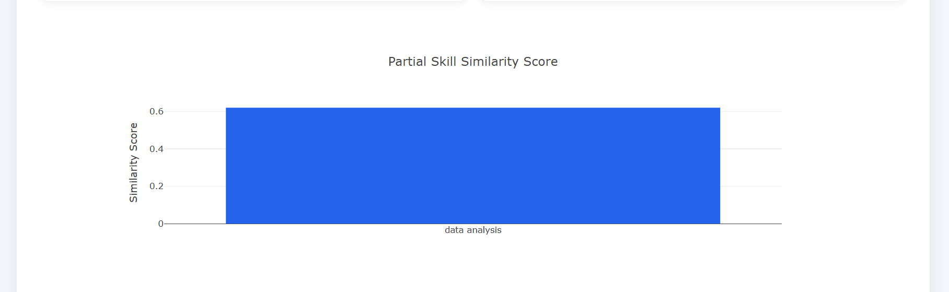
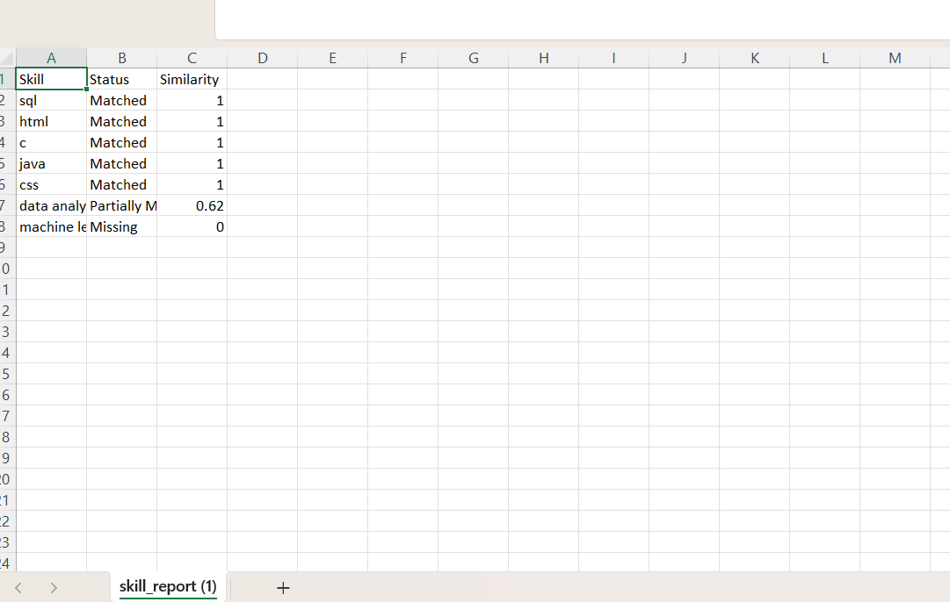

CONCLUSION

The project SkillGapAI successfully automates the process of comparing a resume with a job description to identify the skill gap between a candidate and a job role. The system extracts skills from both documents using Natural Language Processing and uses Sentence-BERT semantic similarity to detect exact, partial, and missing skills. It also calculates a skill match score to measure job readiness and visualizes the results using an interactive dashboard with charts and tables.
This solution helps job seekers clearly understand how suitable they are for a particular role and which skills they need to develop in order

FUTURE ENHANCEMENTS
- Add real-time job listing integration through APIs
- Implement automatic resume scoring using ML classification models
- Include support for multiple resume formats (image/scanned PDF/Word)
- Integrate career recommendation system based on profile
- Multi-language skill extraction
- Export full report as automated PDF

REFERENCES
- https://spacy.io
- https://huggingface.co/sentence-transformers
- https://plotly.com
- Infosys Springboard Learning Resources
- Research papers on NLP & Skill Extraction

