CERTIFICATE

R. D. AND S.H. NATIONAL COLLEGE AND
S. W. A. SCIENCE COLLEGE
BANDRA, MUMBAI - 400 050.

Department of BSC-IT
This is to certify that Mr/Miss Seat No :- of Satisfactory completed :- Practicals, in the subject of
During the academic year 202_- 202_

Term | No of Practicals | Signature

Teacher Incharge Incharge
Department of BSC-IT

Signature of Examiner

INDEX

Sr.No. | Title | Date | Remark
1 | To Perform Arithmetic Operation Using Servlet | 28/06/23
2 | To validate a user by Name and password. | 28/06/23
3 | Display implicit object by JSP. | 05/07/23
4 | To find number times user visited the page. | 05/07/23
5 | To update SQL table by JSP page. | 12/07/23
6 | Currency converter Program | 12/07/23
7 | Use of Request Dispatcher to welcome user | 19/07/23
8 | Working with JSTL. | 19/07/23
9 | To view data from database after submitting.. | 26/07/23
10 | Register user in database(Room booking) | 26/07/23
11 | Validating user by JSP. | 02/08/23
12 | Create a registration and login JSP application to register and authenticate the user | 02/08/23
13 | Create a Servlet Application To Uploading File. | 09/08/23
14 | Create a Servlet Application to download File | 09/08/23
15 | To Create Quiz using Servlet | 23/08/23
16 | Expression language by using JSP | 23/08/23
17 | Use JDBC for data insertion for valid user | 08/09/23

practical 1
AIM: To Perform Arithmetic Operation using Servlet.

HTML Code: index.html
<html>
<head>
<title>Calculator</title>
</head>
<body>
<form action="NewServlet">
Enter First Number <input type="text" name="txtN1"><br> Enter Second Number <input type="text" name="txtN2"><br> Select an Operation<br>
<input type="radio" name="opr" value="+">ADDITION<br>
<input type="radio" name="opr" value="-">SUBTRACTION<br>
<input type="radio" name="opr" value="*">MULTIPLY<br>
<input type="radio" name="opr" value="/">DIVIDE <br>
<input type="reset"><br>
<input type="submit" value="Calculate">
</form>
</body>
</html>

Java Code: NewServlet.java
package com.test;
import java.io.IOException;

import java.io.PrintWriter;
import javax.servlet.ServletException; import javax.servlet.http.HttpServlet;
import javax.servlet.http.HttpServletRequest; import javax.servlet.http.HttpServletResponse; public class NewServlet extends HttpServlet {
public void doGet(HttpServletRequest request, HttpServletResponse response) throws ServletException, IOException { response.setContentType("text/html;charset=UTF-8");
PrintWriter out = response.getWriter();
out.println("<html><head><title>Servlet CalculatorServlet</title></head><body>");
double n1 = Double.parseDouble(request.getParameter("txtN1")); double n2 = Double.parseDouble(request.getParameter("txtN2")); double result =0;
String opr=request.getParameter("opr"); if(opr.equals("+"))
result=n1+n2; if(opr.equals("-")) result=n1-n2; if(opr.equals("*")) result=n1*n2; if(opr.equals("/")) result=n1/n2;
out.println("<h1> Result = "+result); out.println("</body></html>");
}
}

OUTPUT:
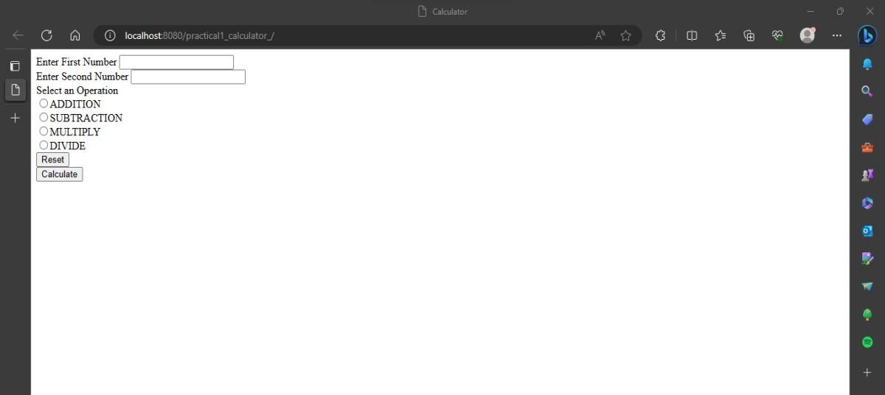
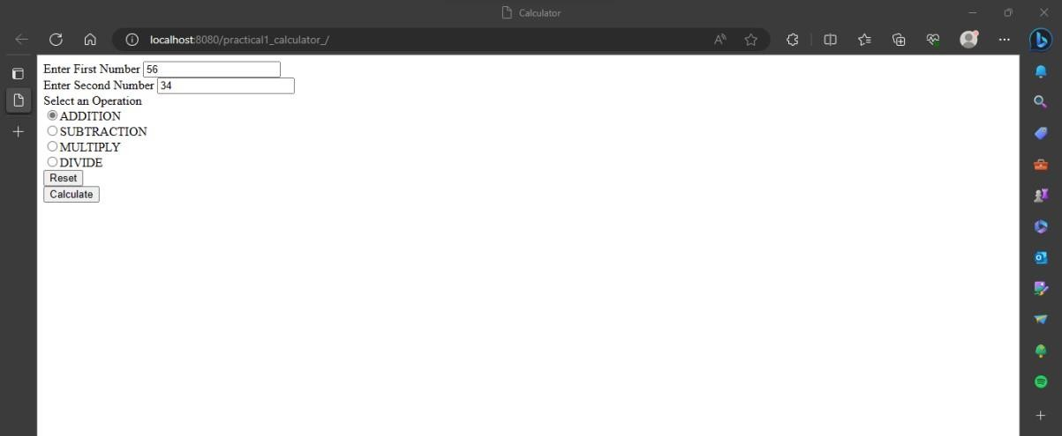
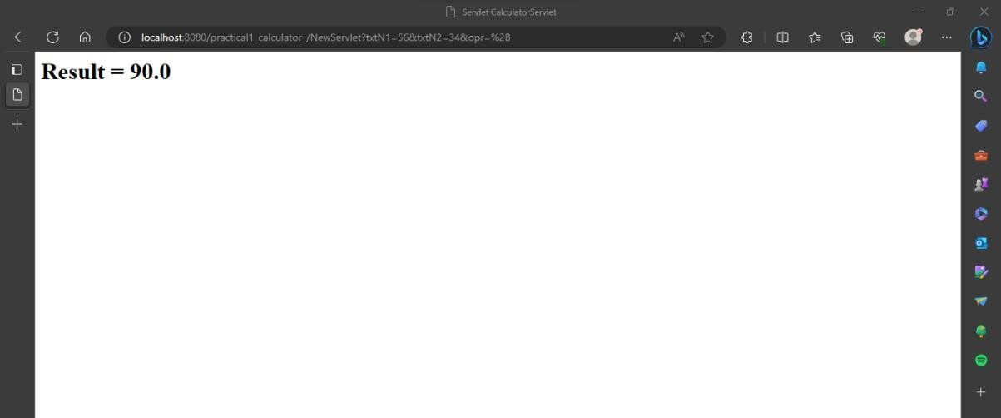

Practical 2
Aim: To validate a user by Name and password. HTML Code: index.html
<html>
<head>
<title>Login Form</title>
</head>
<form action="NewServlet">
Enter User ID<input type="text" name="txtId"><br>
Enter Password<input type="password" name="txtPass"><br>
<input type="reset">
<input type="submit" value=" Click to Login ">
</form>
</html>

Servlet Code: NewSerevlet.java
package mypack; import java.io.*;
import javax.servlet.ServletException; import javax.servlet.http.*;
public class NewServlet extends HttpServlet {
public void doGet(HttpServletRequest request, HttpServletResponse response) throws ServletException, IOException { response.setContentType("text/html;charset=UTF-8");
PrintWriter out = response.getWriter(); out.println("<html><head><title>Servlet LoginServlet</title></head>");

String uname = request.getParameter("txtId"); String upass = request.getParameter("txtPass");
if(uname.equals("admin") &&upass.equals("12345")){ out.println("<body bgcolor=blue >"); out.println("<h1> Welcome !!! "+uname+"</h1>");
}
else{
out.println("<body bgcolor=red >");out.println("<h1> Login Fail !!! </h1>");
}
out.println("</body></html>");}}

Output:

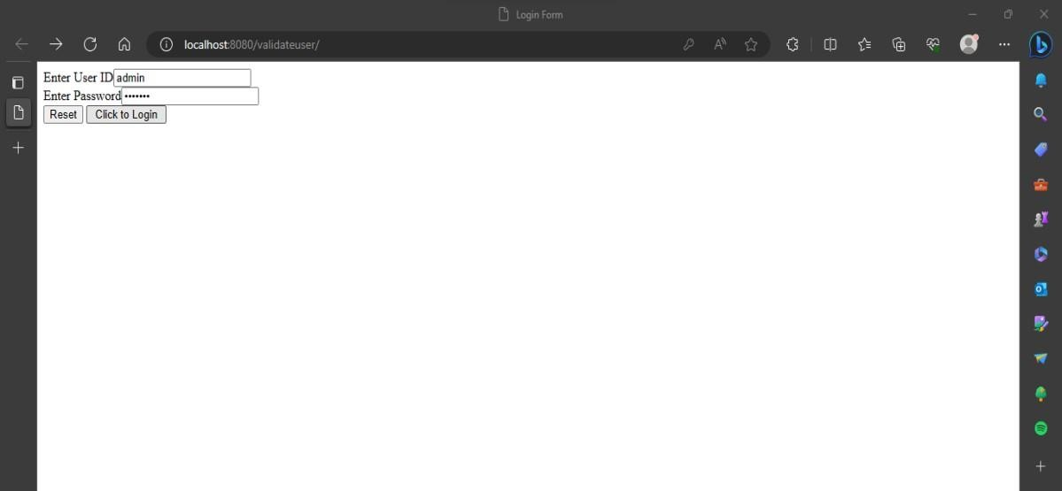

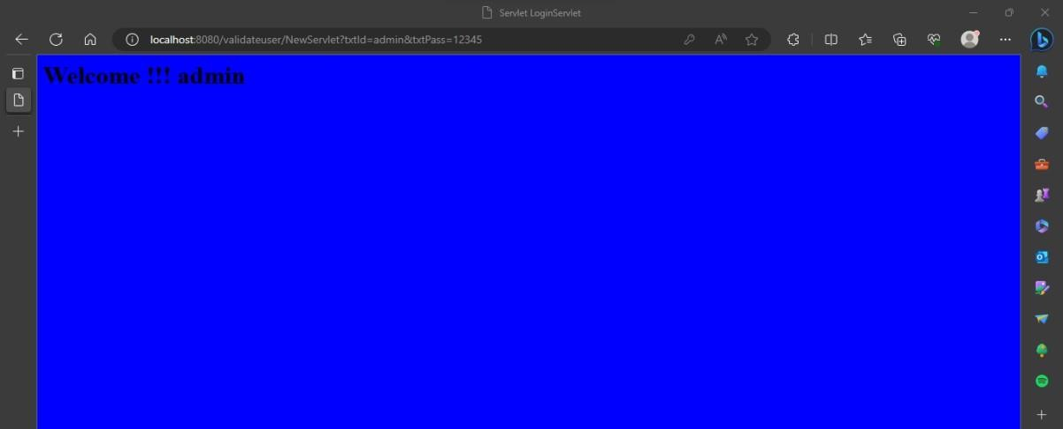

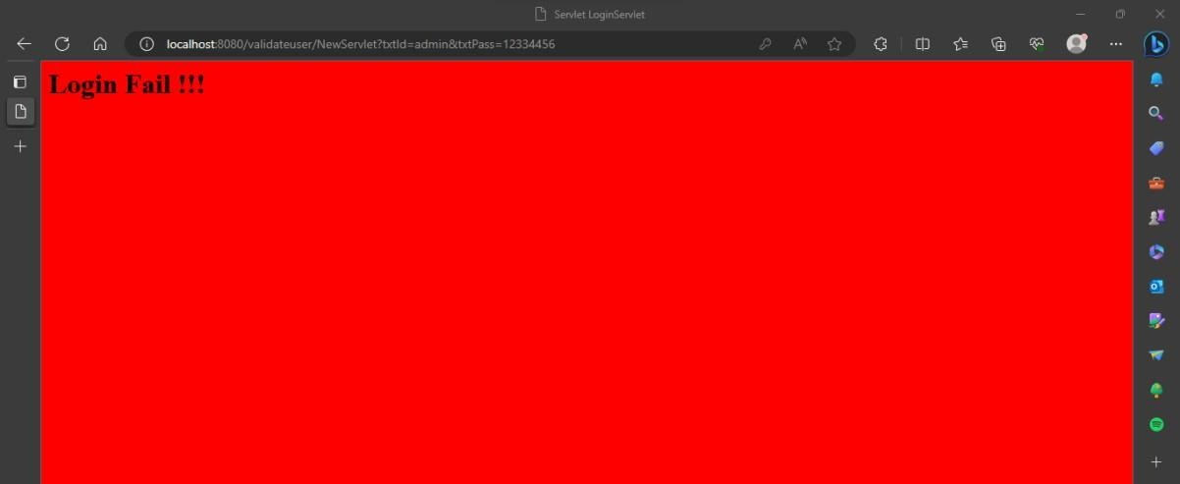

Practical 3 AIM: Display implicit object by JSP.
JSP Code:
<%@page contentType="text/html" pageEncoding="UTF-8"%>
<!DOCTYPE html>
<html>
<head>
<meta http-equiv="Content-Type" content="text/html; charset=UTF-8">
<title>JSP Page</title>
</head>
<body>
<h1>Use of Intrinsic object in JSP</h1>
<h1>Request Object</h1>
Query String <%=request.getQueryString() %><br> Context Path <%=request.getContextPath() %><br> Remote Host <%=request.getRemoteHost() %><br>
<h1>Response Object</h1>
Character Encoding Type <%=request.getCharacterEncoding() %><br> Content Type <%=request.getContentType() %><br>
Locale <%=request.getLocale() %><br>

<h1>Session Object </h1>
ID <%=session.getId() %><br>
Creation Time <%= new java.util.Date(session.getCreationTime()) %><br> Last Access Time <%= new java.util.Date(session.getLastAccessedTime())
%>

</body>
</html>

Output:
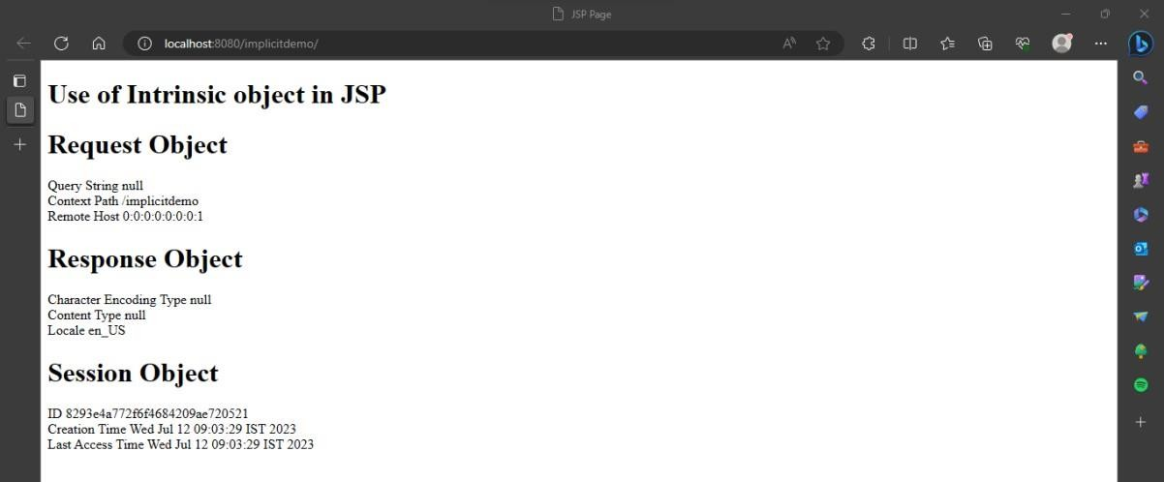

Practical 4

Aim: To find number times user visited the page. Html Code: index.html
<html>
<head>
<title>Login Form</title><meta charset="UTF-8">
<meta name="viewport" content="width=device-width, initial-scale=1.0">
</head>
<body>
<form action="NewServlet">
<center><h1>Login Cookie For Demo</h1></center> Enter User ID <input type="text" name="txtId"><br><br>
Enter Password<input type="password" name="txtPass"><br><br><input type="reset">
<input type="submit" value=" click to Login ">
</form>
</body>
</html>

Java Code:NewServlet.java
import java.io.*; import javax.servlet.*;
import javax.servlet.http.*;
public class NewServlet extends HttpServlet
{
static int i=1;

public void doGet (HttpServletRequest request, HttpServletResponse response) throws IOException, ServletException
{
response.setContentType ("text/html"); PrintWriter out = response.getWriter(); String k=String.valueOf(i);
Cookie c = new Cookie ("visit", k); response.addCookie(c) ;
int j=Integer.parseInt (c.getValue ()) ; if (j==1)
out.println("Welcome"); else
out.println("<font color=blue> oho genious</font›<br>");
out.println("You visited "+i+" times"); i++;}}

Output:
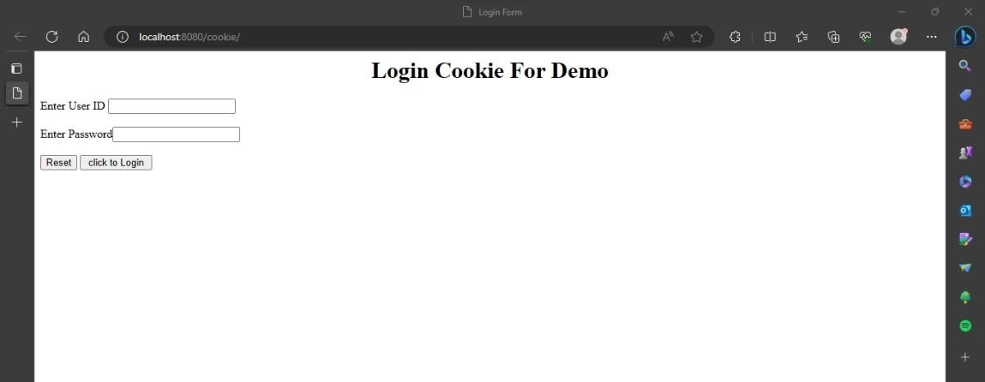
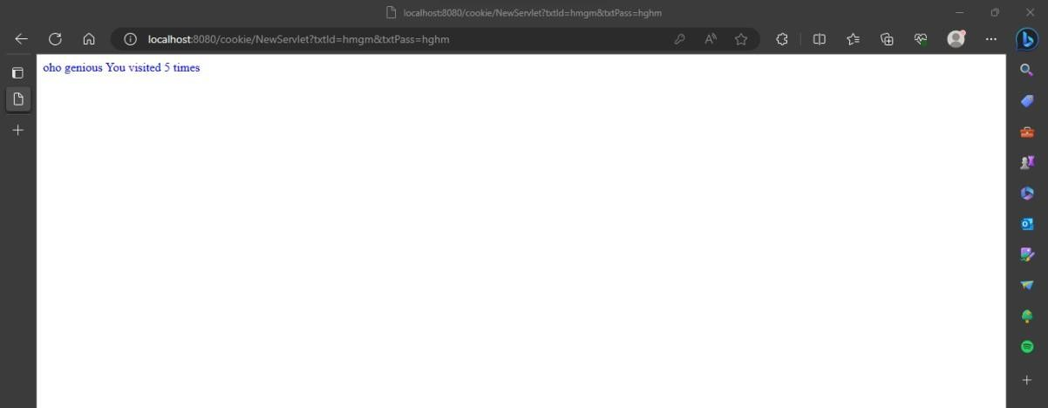

Practical 5 Aim: To update sql table by JSPb page. HTML Code: index.html
<html>

<body>

<form action="UpdateEmp.jsp">

Enter Employee Number<input type="text" name="txtEno"><br> Enter Name<input type="text" name="txtName"><br>
Enter age<input type="text" name="txtAge"><br> Enter Salary<input type="text" name="txtSal"><br>
<input type="reset"><input type="submit">

</form>

</body>

</html>

JSP Code:UpdateEmp.jsp
<%@page contentType="text/html" import="java.sql.*" %>

<html><body>

<h1>Employee Record Update</h1>

<%

String eno=request.getParameter("txtEno"); String name=request.getParameter("txtName"); String age = request.getParameter("txtAge"); String sal = request.getParameter("txtSal");
try{ Class.forName("com.mysql.jdbc.Driver");

Connection con = DriverManager.getConnection("jdbc:mysql://localhost:3306/test","root","hr");
PreparedStatementstmt = con.prepareStatement("select * from emp where empid=?"); stmt.setString(1, eno);
ResultSetrs = stmt.executeQuery(); if(rs.next()){
out.println("<h1>~~~ Employee "+name+" Exist ~~~ </h1>");

PreparedStatement pst1= con.prepareStatement("update emp set salary=? where empid=?");
PreparedStatement pst2= con.prepareStatement("update emp set age=? where empid=?"); pst1.setString(1, sal); pst1.setString(2, eno);
pst2.setString(1, age); pst2.setString(2, eno); pst1.executeUpdate(); pst2.executeUpdate();
}

else{

out.println("<h1>Employee Record not exist !!!!!</h1>");

}

}catch(Exception e){out.println(e);}

%></body></html>

Output:
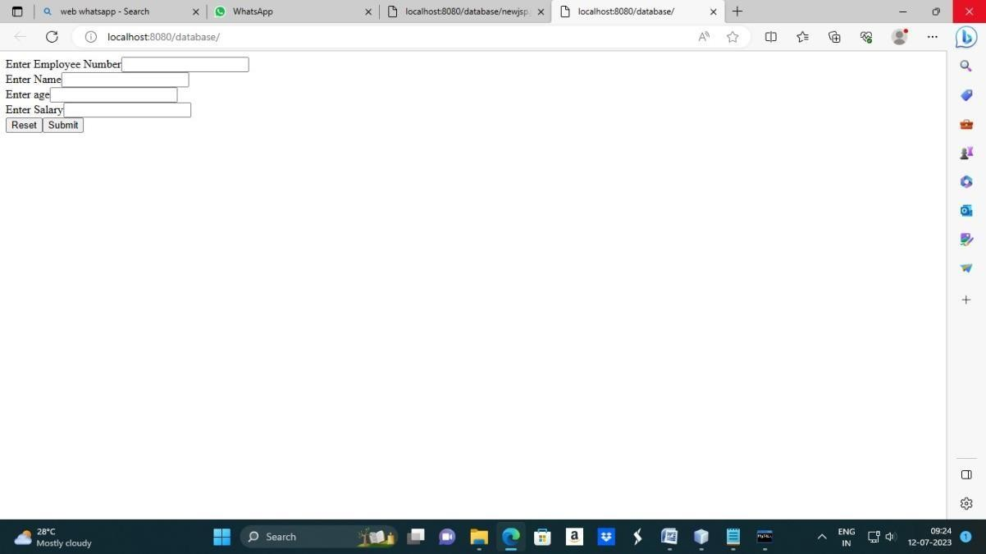
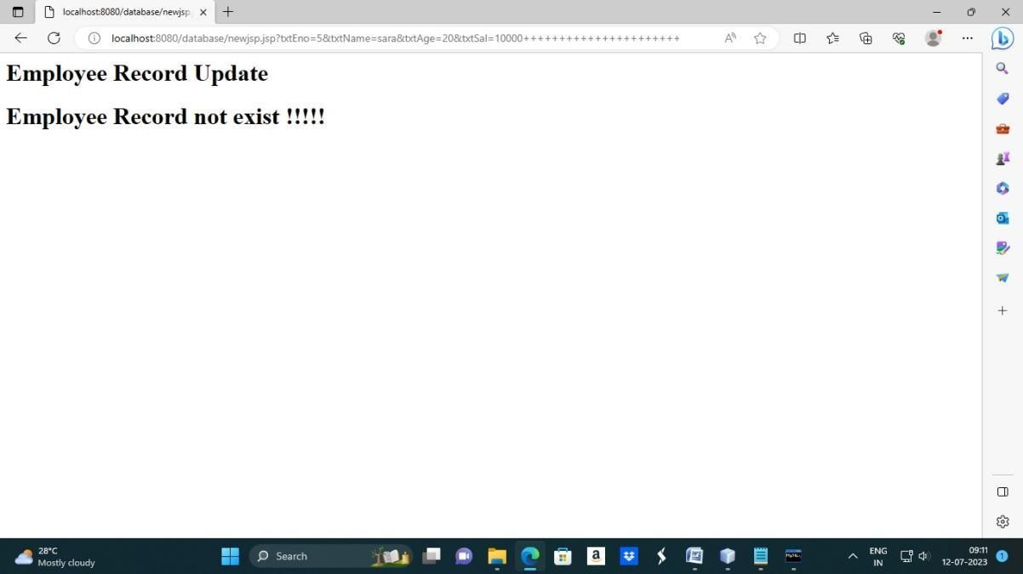

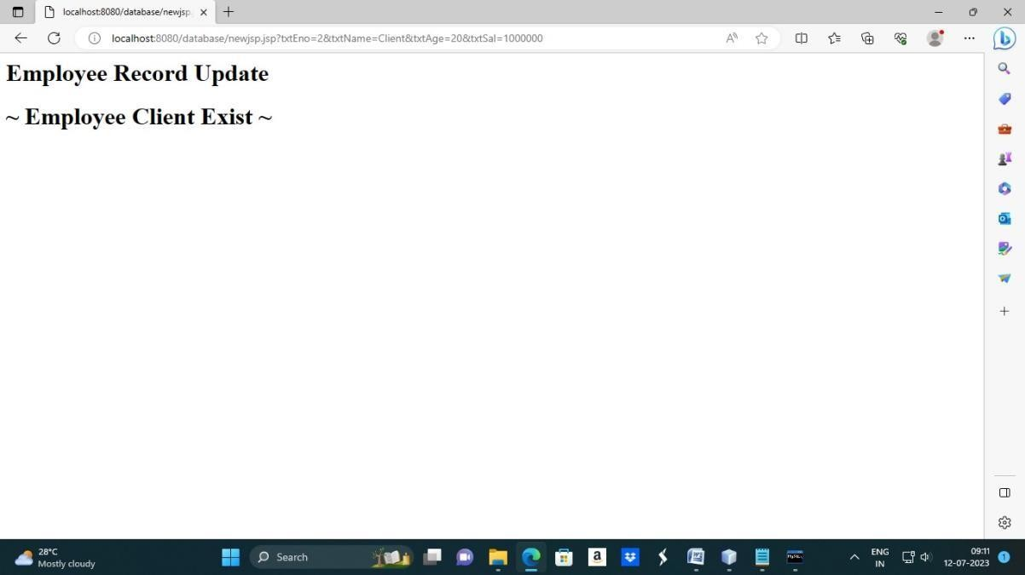

>>create database practical;
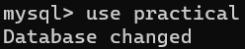
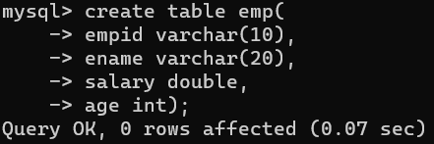
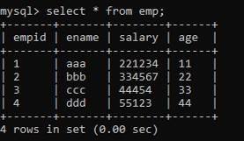

Practical 6 Aim: Currency converter Program.
HTML Code:index.html
<html>
<head>
<title>Currency Converter</title>
</head>
<body>
<form action="NewServlet">
Enter Amount <input type="text" name="amt"><br> Select Conversion Type
<input type="radio" name="type" value="r2d" checked>Rupees to Dollar
<input type="radio" name="type" value="d2r">Dollar to Rupees<br>
<input type="reset"><input type="submit" value="CONVERT">
</form>
</body>
</html>

Servlet 1 code: NewServlet.java
package mypack; import java.io.*; import javax.servlet.*;
import javax.servlet.http.*; import javax.ejb.EJB; import mybeans.ccbeans;
public class NewServlet extends HttpServlet {

@EJB ccbeans obj;
public void doGet(HttpServletRequest request, HttpServletResponse response) throws ServletException, IOException { response.setContentType("text/html;charset=UTF-8");
PrintWriter out = response.getWriter();
double amt = Double.parseDouble(request.getParameter("amt")); if(request.getParameter("type").equals("r2d"))
{
out.println("<h1>"+amt+ " Rupees = "+obj.r2Dollor(amt)+" Dollors</h1>");
}
if(request.getParameter("type").equals("d2r"))
{
out.println("<h1>"+amt+ " Dollors = "+obj.d2Rupees(amt)+" Rupees</h1>");
}
}}

Servlet 2 Code: ccbeans.java
package mybeans;
import javax.ejb.Stateless; @Stateless
public class ccbeans { public ccbeans(){}
public double r2Dollor(double r){ return r/82.04; } public double d2Rupees(double d) {return d*82.04;}
}

Output:
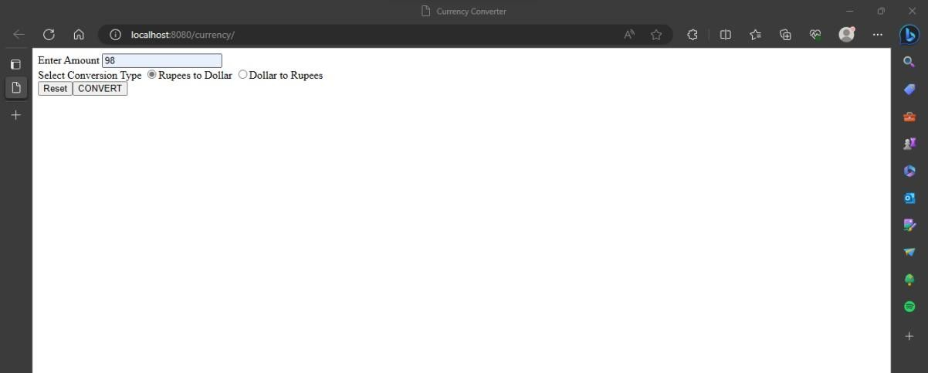
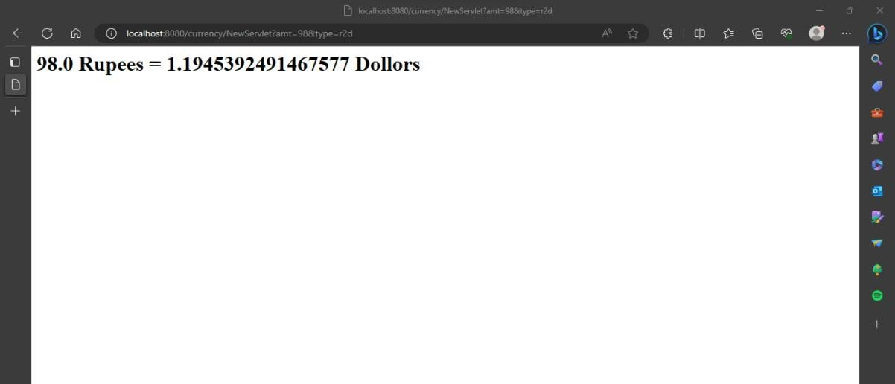
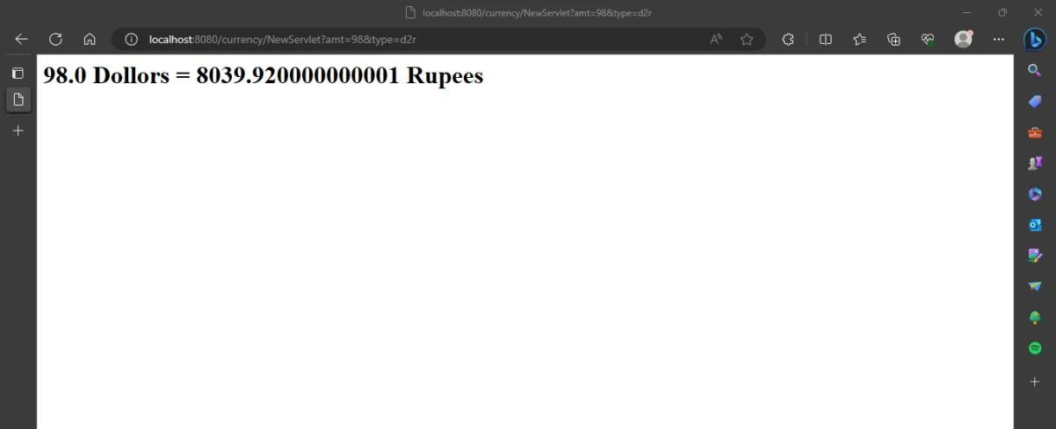

Practical7

Aim::Use of Request Dispatcher to welcome user

HTML Code: index.html
<html>
<head>
<title>prat 1c</title>
<meta charset="UTF-8">
<meta name="viewport" content="width=device-width, initial-scale=1.0">
</head>
<body bgcolor="lightblue">
<center>
<form method="post" action="NewServlet">
User name<input type="text" name="t1"><br> Password<input type="password" name="p1"><br>
<input type="submit">
</form>
</center>
</body>
</html>

Servlet 1 Code:NewServlet
package mypack;
import java.io.IOException; import java.io.PrintWriter;
import javax.servlet.RequestDispatcher; import javax.servlet.ServletException;

import javax.servlet.annotation.WebServlet; import javax.servlet.http.HttpServlet;
import javax.servlet.http.HttpServletRequest; import javax.servlet.http.HttpServletResponse;
@WebServlet(name = "Checklogin", urlPatterns = {"/Checklogin"}) public class NewServlet extends HttpServlet {
protected void processRequest(HttpServletRequest request, HttpServletResponse response)
throws ServletException, IOException { response.setContentType("text/html;charset=UTF-8"); PrintWriter out = response.getWriter(); out.println("<!DOCTYPE html>"); out.println("<html>");
out.println("<head>"); out.println("<title>Servlet Checklogin</title>"); out.println("</head>");
out.println("<body>");
String p=request.getParameter("p1"); if(p.equals("root"))
{
RequestDispatcherrd=request.getRequestDispatcher("Welcome"); rd.forward(request, response);
}
else
{
RequestDispatcherrd=request.getRequestDispatcher("index.html"); out.println("Invalid Login");

rd.include(request, response);
}
out.println("</body>"); out.println("</html>");
}

}

Servlet 2 Code: welcome.java
package mypack;
import java.io.IOException; import java.io.PrintWriter;
import javax.servlet.ServletException; import javax.servlet.annotation.WebServlet; import javax.servlet.http.HttpServlet;
import javax.servlet.http.HttpServletRequest; import javax.servlet.http.HttpServletResponse;
@WebServlet(name = "Welcome", urlPatterns = {"/Welcome"}) public class welcome extends HttpServlet {
protected void processRequest(HttpServletRequest request, HttpServletResponse response)
throws ServletException, IOException { response.setContentType("text/html;charset=UTF-8"); PrintWriter out = response.getWriter();

out.println("<!DOCTYPE html>"); out.println("<html>");

out.println("<head>"); out.println("<title>Servlet Welcome</title>"); out.println("</head>"); out.println("<body>");
out.println("Welcome!! "+ request.getParameter("t1")); out.println("</body>");
out.println("</html>");
}

}

Output:
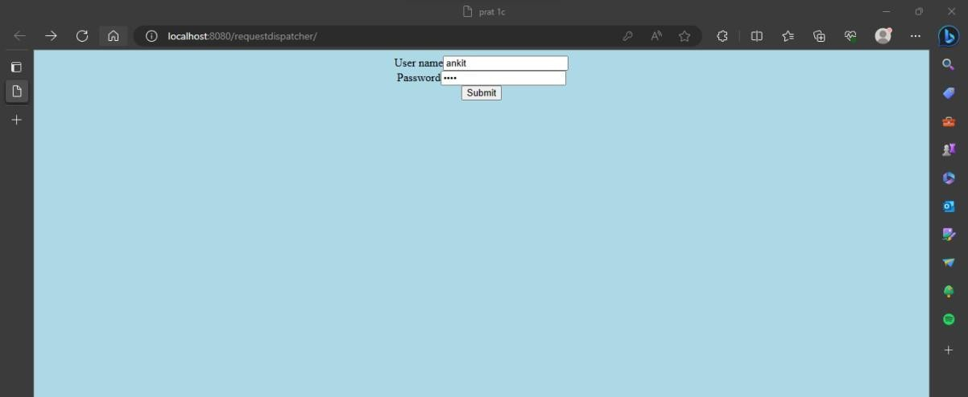
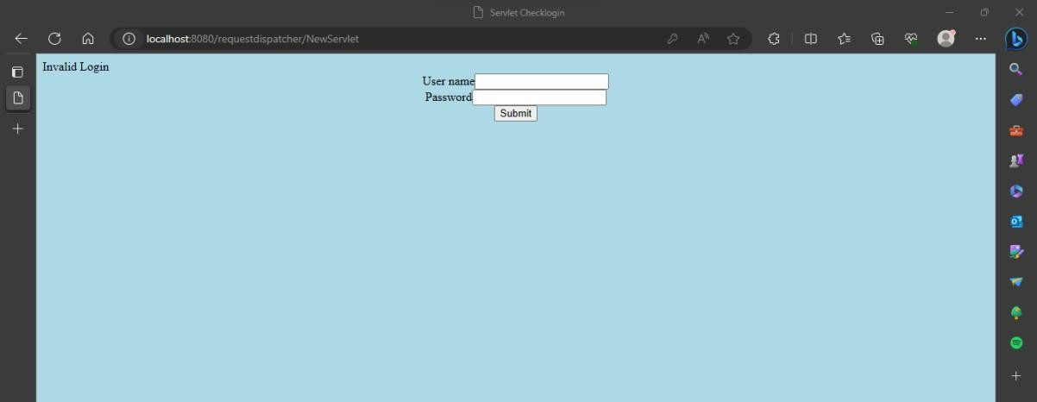

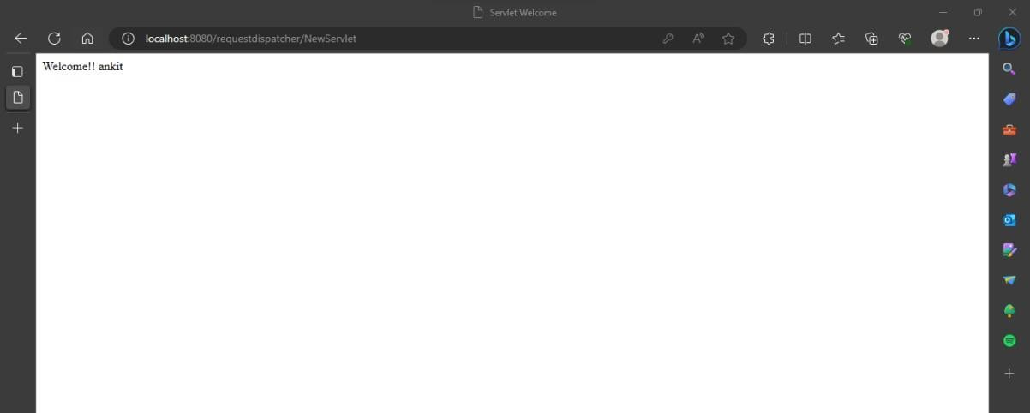

Practical 8

Aim: Working with JSTL. HTML Code: index.html
<html>
<head>
<title>JSP Page</title>
</head>
<body>
<h1>hello world!</h1>
<form action="newjsp.jsp">

fname:<input type="text" name="ufname"/><br> lname:<input type="text" name="ulname"/><br>
<input type="submit" value="click"/>
</form>
</body>
</html>

JSP Code:newjsp.java
<html>
<head>
<meta http-equiv="Content-Type" content="text/html; charset=UTF-8">
<title>JSP Page</title>
</head>
<body>
<b>Welcome ${param.ulname} ${param.ufname}</b><br>
<h1>Hello World! hihihii m jsp</h1><br>

<h1>get sum maths here</h1><br>
<p>is 5 less than 10? ${5<10}<br> 8*5=${8*5}<br></p>

</body>
</html>

Output:
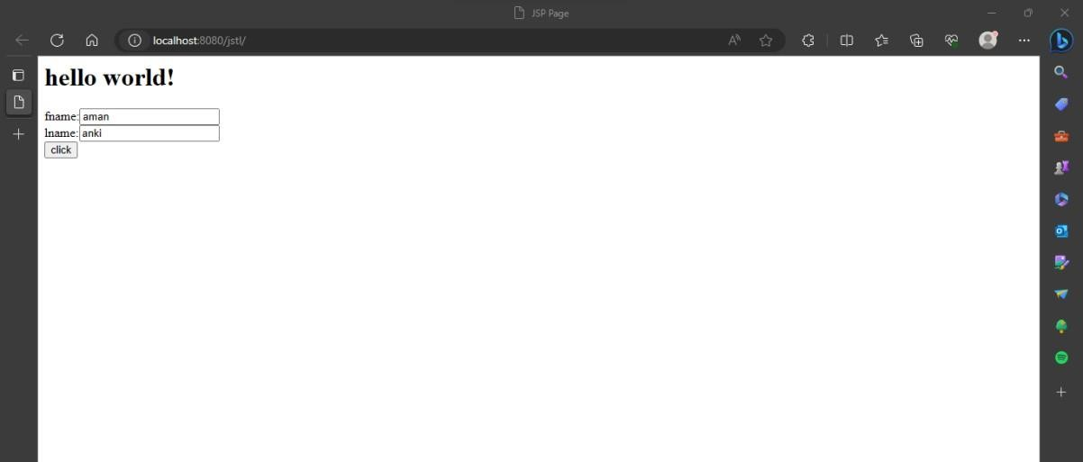
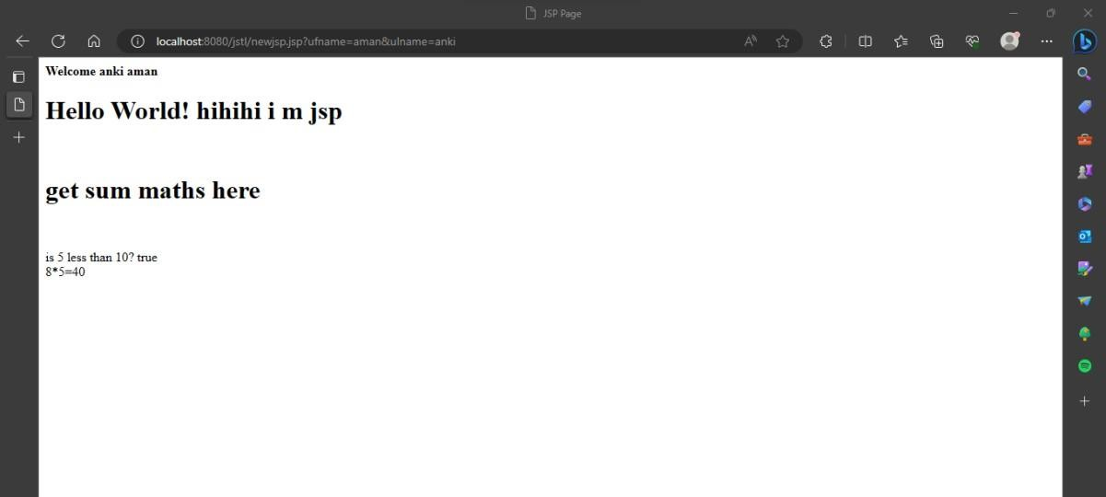

Practical 9

Aim: To view data from database after submitting.. HTML Code: index.html
<html>
<body>
<form action="Newservlet" method="post">
User name :<input type="text" name="uname"><br> Password :<input type="password" name="pw"><br> Email Id :<input type="text" name="email"><br> Country :<select name="coun">
<option>select...
<option> India
<option> Bangladesh
<option> Bhutan
<option> Canada
<option>russia
</select><br>
<input type="submit" value=" Register">
</form>
</body>
</html>

Servlet Code:NewServlet.java
package com.test; import java.io.*; import java.sql.*; import javax.servlet.*;
import javax.servlet.http.*;
public class Newservlet extends HttpServlet
{ public void doPost(HttpServletRequest request, HttpServletResponse response) throws
IOException, ServletException
{ Connection con=null; PreparedStatementps=null; response.setContentType("text/html"); PrintWriter out = response.getWriter();
String uname=request.getParameter("uname"); String pw=request.getParameter("pw");
String email=request.getParameter("email"); String country=request.getParameter("coun"); try
{ Class.forName("com.mysql.jdbc.Driver");

con=DriverManager.getConnection("jdbc:mysql://localhost:3306/test","root"," root");
out.println("connection done successfully..."); ps=con.prepareStatement("insert into user values (?,?,?,?)"); ps.setString(1,uname);
ps.setString(2,pw);

ps.setString(3,email); ps.setString(4,country); ps.execute();
out.print("Data insserted successfully!!!!");
}
catch(Exception e) { out.println(e); } out.println("<b>"+"<b>");
}
}

Output:
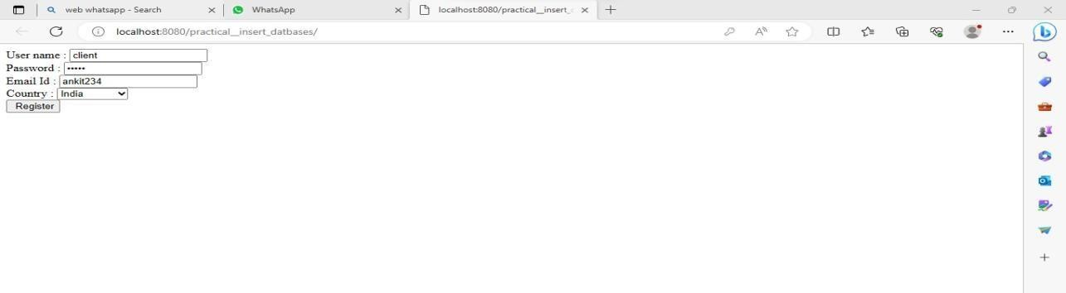
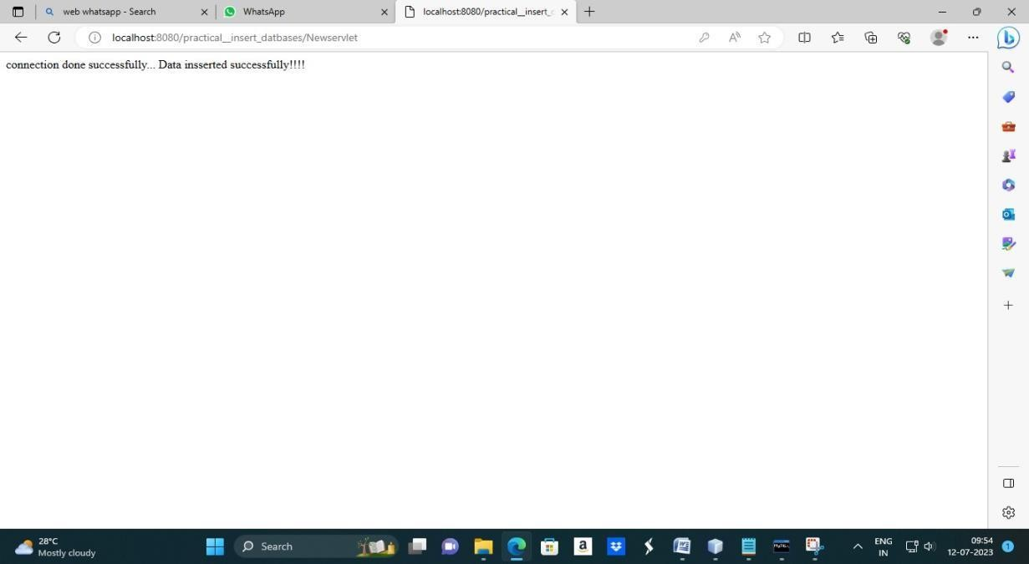

>>create database practical;
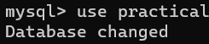
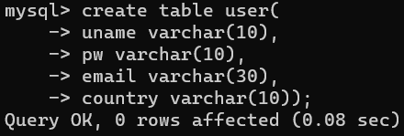
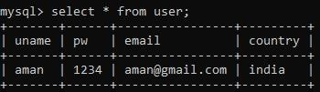

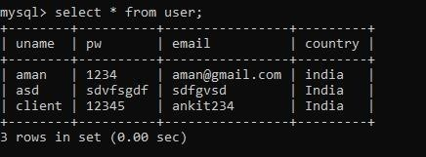

Practical 10
Aim: Register user in database(Room booking). HTML CODE: index.html
<html>
<head>
<title></title>
</head>
<body>
<form action="pack" method="get"> Select A room Type
<br>
<input type="radio" id="delux" name="txtType" value="Delux">
<label for="delux">Delux</label>
<br>
<input type="radio" id="superdelux" name="txtType" value="SuperDelux">
<label for="superdelux">Super Delux</label>
<br>
<input type="radio" id="suit" name="txtType" value="Suit">
<label for="suit">Suit</label>
<br>
Enter Your Name<input type="text" name="txtCust"><br> Enter Mobile No.<input type="tel" name="txtMob"><br>
<button type="reset">Reset</button><br><button type="submit">Submit</button>
</form>
</body></html>

Servlet 1 Code: pack.java
package mypack; import java.io.*; import javax.servlet.*;
import javax.servlet.http.*; import javax.ejb.EJB; import myBeans.RRbeans;
public class pack extends HttpServlet { @EJB RRbeans obj;
public void doGet(HttpServletRequest request, HttpServletResponse response) throws ServletException, IOException{
PrintWriter out=response.getWriter(); String rt=request.getParameter("txtType"); String cn=request.getParameter("txtCust"); String cm=request.getParameter("txtMob"); String msg = obj.roomBook(rt, cn, cm); out.println(msg);
}}

Servlet 2 Code: RRbeans.java
package myBeans;
import javax.ejb.Stateless; import java.sql.*; @Stateless
public class RRbeans { public RRbeans(){}
public String roomBook(String rt, String cn, String cm){

String msg=""; try{
Class.forName("com.mysql.jdbc.Driver"); Connection con =
DriverManager.getConnection("jdbc:mysql://localhost:3306/info","root","hr");
String query="select * from roombook where RoomType=? and status='NotBooked'";
PreparedStatementpst = con.prepareStatement(query); pst.setString(1,rt);
ResultSetrs= pst.executeQuery(); if(rs.next()){
String rno=rs.getString(1);
PreparedStatement stm1 = con.prepareStatement("update roombook set cust=? where RoomId=? ");
PreparedStatement stm2 = con.prepareStatement("update roombook set mob=? where RoomId=? ");
PreparedStatement stm3 = con.prepareStatement("update roombook set status=? where RoomId=? ");
stm1.setString(1,cn); stm1.setString(2,rno); stm2.setString(1,cm); stm2.setString(2,rno); stm3.setString(1, "Booked"); stm3.setString(2,rno); stm1.executeUpdate();
stm2.executeUpdate(); stm3.executeUpdate();
msg = "Room "+rno+ " Booked <br> Charges = "+rs.getString(3);
}

else
{
msg = "Room "+rt+ " currently Not available";
}
}catch(Exception e){msg=""+e;} return msg;}}

Output:
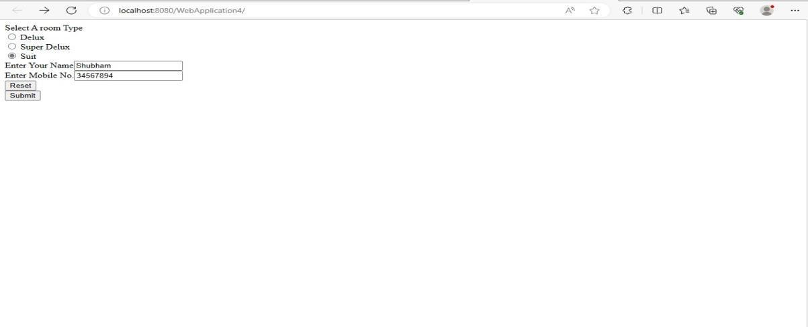

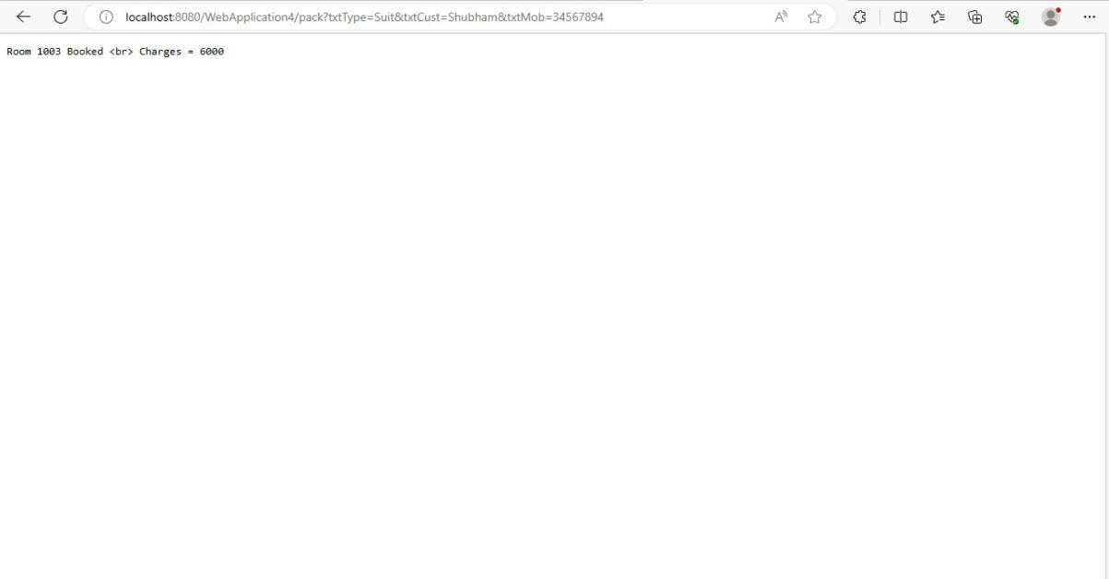

- Create database info;
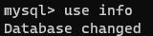
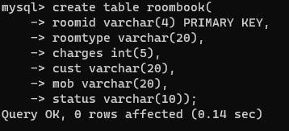
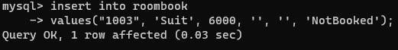
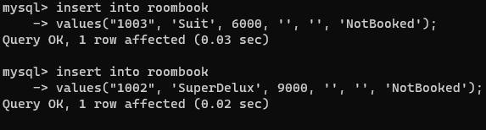
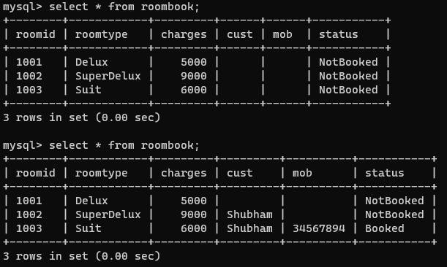

Practical 11
Aim: Validating user by JSP. Html code: index.html
<html>
<head>
<title>User Information Page</title>
</head>
<body>
<form action="validate.jsp">
Enter Your Name<input type="text" name="name" ><br> Enter Your Age<input type="text" name="age" ><br> Select Hobbies
<input type="checkbox" name="hob" value="Singing">Singing
<input type="checkbox" name="hob" value="Reading">Reading Books
<input type="checkbox" name="hob" value="Football">Playing Football<br> Enter E-mail<input type="text" name="email" ><br>
Select Gender
<input type="radio" name="gender" value="male">Male
<input type="radio" name="gender" value="female">Female
<input type="radio" name="gender" value="other">Other<br>
<input type="hidden" name="error" value="">
<input type="submit" value="Submit Form">
</form>
</body>
</html>

JSP code: Validate.jsp
<%@page contentType="text/html" pageEncoding="UTF-8" import="mypack.*" %>
<html><head><title>JSP Page</title></head>
<body>
<h1>Validation Page</h1>
<jsp:useBean id="obj" scope="request" class="mypack.CheckerBean" >
<jsp:setProperty name="obj" property="*"/>
</jsp:useBean>
<%if (obj.validate())
{ %>
<jsp:forward page="successful.jsp"/>
<% }
else {%>
<jsp:include page="index.html"/>
<%}%>
<%=obj.getError() %>
</body>
</html>

Servlet code: CheckerBean.java
package mypack;
public class CheckerBean {
private String name, age, hob, email, gender, error; public CheckerBean(){error="";}
public void setName(String n){name=n;} public void setAge(String a){age=a;} public void setHob(String h){hob=h;} public void setEmail(String e){
email=e;

}
public void setGender(String g){gender=g;} public void setError(String e){error=e;} public String getName(){return name;} public String getAge(){return age;}
public String getHob(){return hob;} public String getEmail(){return email;} public String getGender(){return gender;} public String getError(){return error;} public booleanvalidate(){
boolean res=true;
if(name.trim().equals("")) {error+="<br>Enter First Name";res=false;} if(age.length() > 2 )
{error+="<br>Age Invalid";res=false;} return res; } }

JSP2 Code: successful.jsp
<%@page contentType="text/html" pageEncoding="UTF-8"%>
<!DOCTYPE html>
<html>
<head>
<meta http-equiv="Content-Type" content="text/html; charset=UTF-8">
<title> JSP Page</title>
</head>
<body>
<h1>Data Validated Successfully!!</h1>
</body>
</html>

Output:
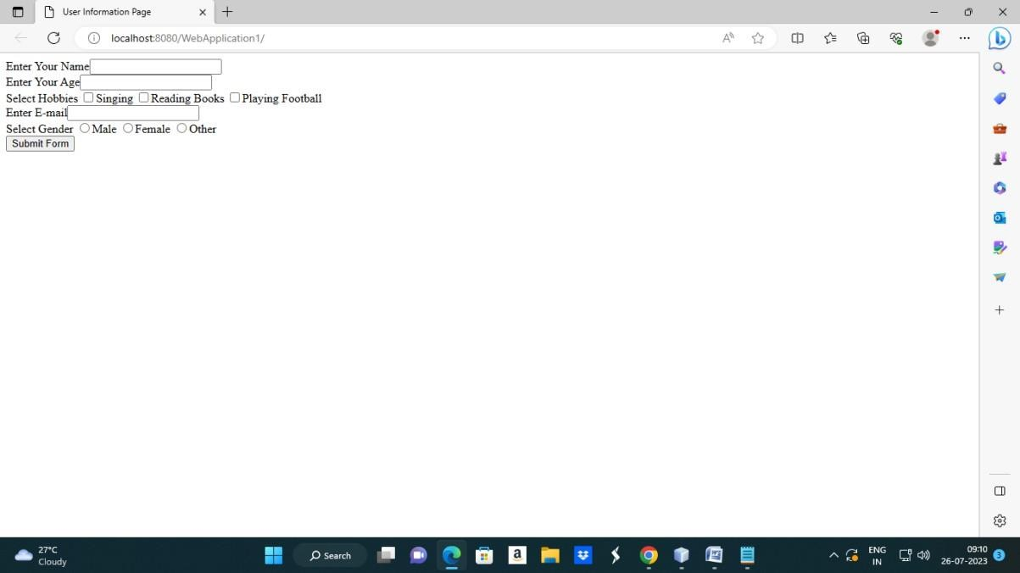

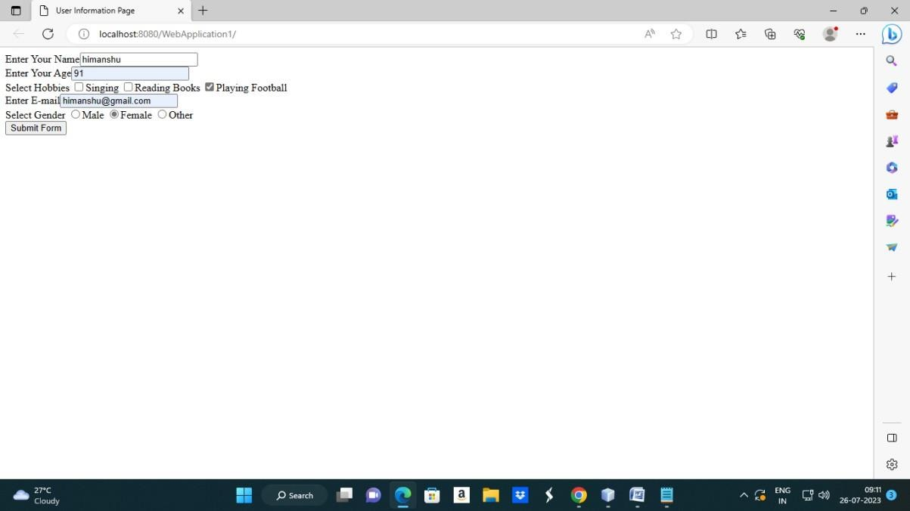

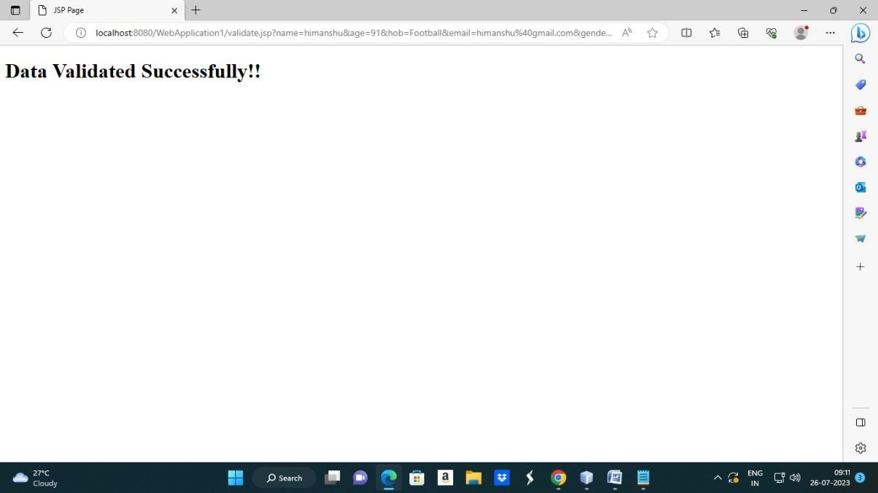

Practical 12
Aim: Create a registration and login JSP application to register and authenticate the user based on username and password using JDBC.

Html code: index.html
<html><head><title>New User Registration Page</title></head>
<body>
<form action="register.jsp" >
<h1> New User Registration Page</h1>
Enter User Name <input type="text" name="txtName" ><br> Enter Password <input type="password" name="txtPass1" ><br>
Re-Enter Password<input type="password" name="txtPass2" ><br> Enter Email<input type="text" name="txtEmail" ><br>
Enter Country Name <input type="text" name="txtCon" ><br>
<input type="reset" ><input type="submit" value="REGISTER" >
</form>
</body>
</html>

JSP code: register.jsp
<%@page contentType="text/html" import="java.sql.*"%>
<html><body>
<h1>Registration JSP Page</h1>
<%
String uname=request.getParameter("txtName"); String pass1 = request.getParameter("txtPass1"); String pass2 = request.getParameter("txtPass2"); String email = request.getParameter("txtEmail"); String ctry = request.getParameter("txtCon"); if(pass1.equals(pass2)){
try{ Class.forName("com.mysql.jdbc.Driver");
Connection con = DriverManager.getConnection("jdbc:mysql://localhost:3306/test","r oot","hr");
PreparedStatementstmt = con.prepareStatement("insert into register values (?,?,?,?,?)");
stmt.setString(1, uname); stmt.setString(2, pass1);
stmt.setString(3, pass2);stmt.setString(4, email); stmt.setString(5, ctry);
int row = stmt.executeUpdate();
if(row==1) { out.println("Registration Successful"); } else {
out.println("Registration FFFFFAAAIIILLLL !!!!");

%><jsp:include page="index.html" ></jsp:include>
<%
}
}catch(Exception e){out.println(e);}
}
else
{
out.println("<h1>Password Mismatch</h1>");
%>
<jsp:include page="index.html" ></jsp:include>
<% }
%>
</body>
</html>

Output:
- create database test;
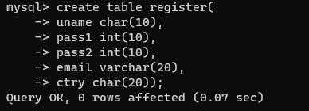
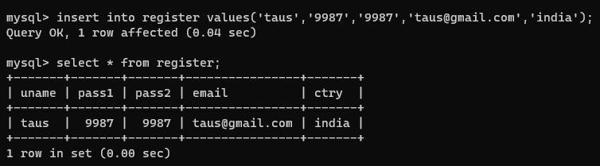
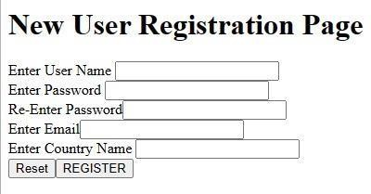
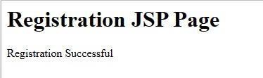

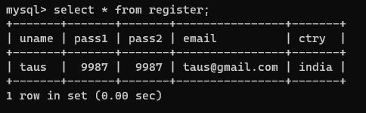

Practical 13
Aim: Create a servlet application to Uploading File.

Code:
HTML CODE: index.html
<html>
<body>
<form action="fileservletapp" method="post" enctype="multipart/form-data">
Select File to Upload:<input type="file" name="file" id="file">
<br>
Destination <input type="text" value="/tmp" name="destination">

<input type="submit" value="Upload file" name="upload" id="upload">
</form>
</body>
</html>

Servlet code: NewServlet.java
package test; import java.io.*;
import javax.servlet.*;
import javax.servlet.annotation.MultipartConfig; import javax.servlet.http.*;
@MultipartConfig
public class NewServlet extends HttpServlet { @Override
public void doPost(HttpServletRequestreq,HttpServletResponse res) throws ServletException,
IOException
{
res.setContentType("text/html"); PrintWriter out = res.getWriter();
String path=req.getParameter("destination"); Part filePart=req.getPart("file");
String filename=filePart.getSubmittedFileName(); out.print("<br><br><hr> file name: "+filename); OutputStreamos=null;
InputStream is=null;

try {
os=new FileOutputStream(new File(path+File.separator+filename));
is=filePart.getInputStream(); int read=0;

while ((read = is.read()) != -1) { os.write(read);
}
out.println("<br>file uploaded sucessfully...!!!");
}
catch(FileNotFoundException e){out.print(e);}
} }

Output:
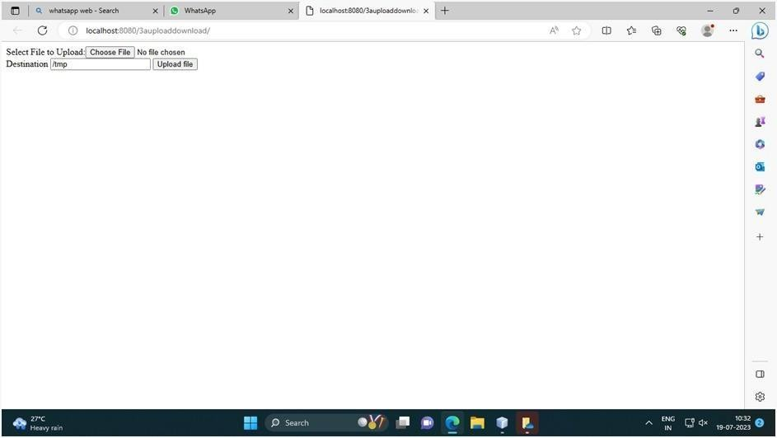

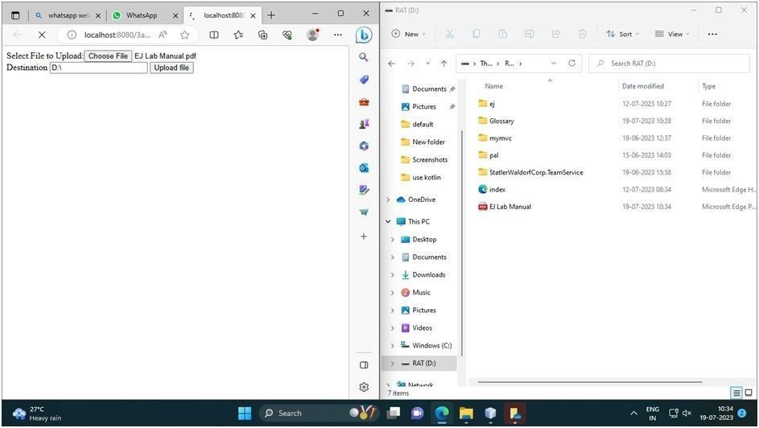

Practical 14 Aim: To download a file:

HTML CODE: index.html
<html>
<head>
<title>File Download Page</title>
</head>
<body>
<h1>File Download Application</h1>
Click <a href="DownloadServlet?filename=ejm.pdf.pdf">Sample Chapter</a>
<br/><br/>
Click <a href="DownloadServlet?filename=index.html">Table Of Contents</a>
</body>
</html>
Servlet CODE:DownloadServlet.java package filedownloadapp;
import java.io.IOException; import java.io.InputStream; import java.io.PrintWriter;

import javax.servlet.ServletContext; import javax.servlet.ServletException; import javax.servlet.http.HttpServlet;
import javax.servlet.http.HttpServletRequest; import javax.servlet.http.HttpServletResponse; public class DownloadServlet extends HttpServlet { @Override
public void doGet(HttpServletRequest request, HttpServletResponse response)
throws ServletException, IOException { response.setContentType("APPLICATION/OCTET-STREAM"); String filename = request.getParameter("filename"); ServletContext context = getServletContext();
PrintWriter out;
//ServletOutputStream out = response.getOutputStream();
// any of the two works
try (InputStream is = context.getResourceAsStream("/" + filename)) {
//ServletOutputStream out = response.getOutputStream(); // any of the two works
out = response.getWriter();
response.setHeader("Content-Disposition","attachment; filename=\"" + filename + "\""); //

//if comment this statement then it wl ask you about the editor with which you want to open the file
int i;
while ((i=is.read()) != -1) { out.write(i);
} }
out.close();
}
}

Output:
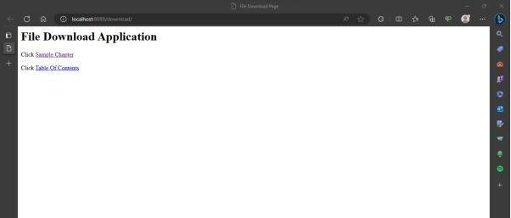

Practical 15 Aim: To Create Quiz using Servlet.
Html code: index.html Code:
<html>
<head>
<title>Quiz Application</title>
</head>
<body>
<h1>Welcome to Quiz Servlet </h1>
<h1><a href="NewServlet" >CLICK TO START QUIZ</a></h1>
</body>
</html>

Servlet1 Code:NewServlet.java Code:
package test; import java.io.*; import java.sql.*;
import javax.servlet.*; import javax.servlet.http.*;
public class NewServlet extends HttpServlet {
public void doGet(HttpServletRequest request, HttpServletResponse response)

throws ServletException, IOException { response.setContentType("text/html;charset=UTF-8"); PrintWriter out = response.getWriter(); out.println("<form action=showresult>");
try { Class.forName("com.mysql.jdbc.Driver"); Connection con =
DriverManager.getConnection("jdbc:mysql://localhost:3306/qadb"," root","hr");
Statement stmt = con.createStatement();
ResultSet res = stmt.executeQuery("select * from quiz"); out.println("<table border=1 >");
int qno=0; while(res.next()){ qno++;
out.println("<tr><td>"+res.getString(1)+"</td>"); out.println("<td>"+res.getString(2)+"</td></tr>");
out.println("<tr><td><input type=radio name="+qno+"value="+res.getString(3)+"></td><td>"+res.getString( 3)+"</td></tr>");
out.println("<tr><td><input type=radio name="+qno+"value="+res.getString(4)+"></td><td>"+res.getString( 4)+"</td></tr>");
out.println("<tr><td><input type=radio name="+qno+"value="+res.getString(5)+"></td><td>"+res.getString( 5)+"</td></tr>");

out.println("<tr><td><input type=radio name="+qno+"value="+res.getString(6)+"></td><td>"+res.getString( 6)+"</td></tr>");
}
}
catch(Exception e)
{out.println(e);} out.println("</table>"); out.println("<input type=reset >");
out.println("<input type=submit value=SUBMIT >"); out.println("</form>");
}
}

Servlet2 code:showresult.java Code:
package test; import java.io.*; import java.sql.*;
import javax.servlet.*; import javax.servlet.http.*;
public class showresult extends HttpServlet {
public void doGet(HttpServletRequest request, HttpServletResponse response)
throws ServletException, IOException {

response.setContentType("text/html;charset=UTF-8"); PrintWriter out = response.getWriter();
try { Class.forName("com.mysql.jdbc.Driver");
Connection con = DriverManager.getConnection("jdbc:mysql://localhost:3306/qadb"," root","hr");
Statement stmt = con.createStatement();
ResultSet res = stmt.executeQuery("select ans from quiz"); int count =0, qno=0;
while(res.next()){ if(res.getString(1).equals(request.getParameter(""+(++qno))))
{ count++; out.println("<h1>Correct </h1>");
}
else {
out.println("<h1>Incorrect </h1>");
}
}
out.println("<h1>Your Score is "+count+" </h1>");
}
catch(Exception e) { out.println(e);
}}}

SQL commands
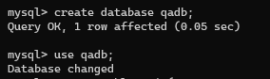
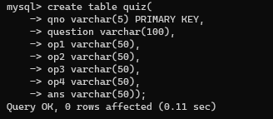
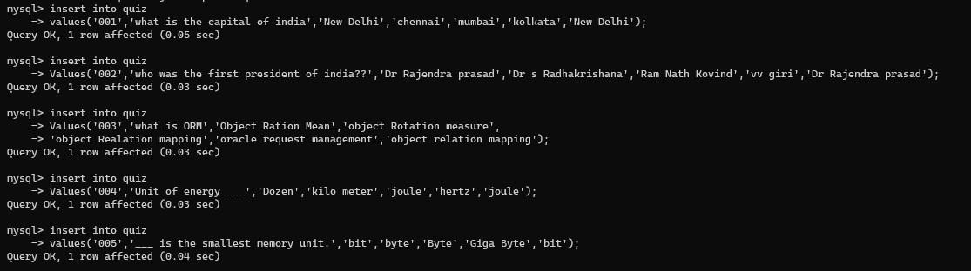
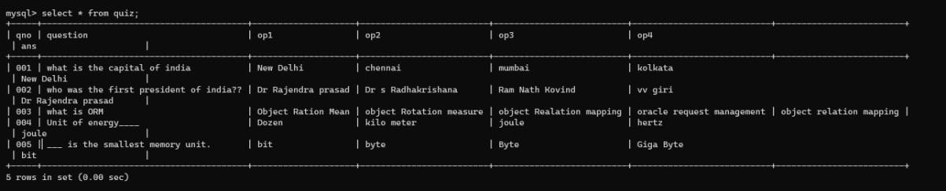

Output:
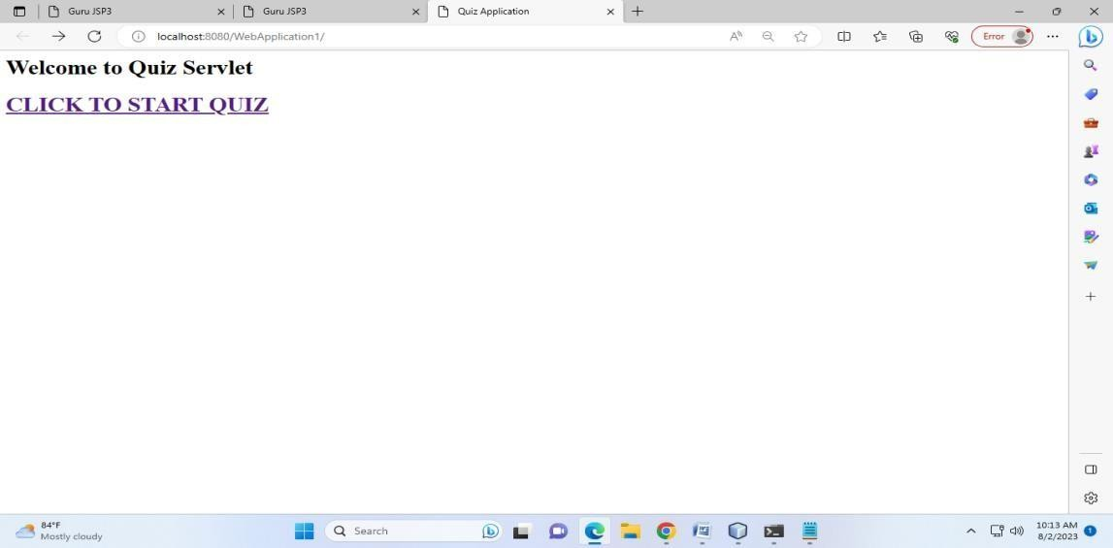

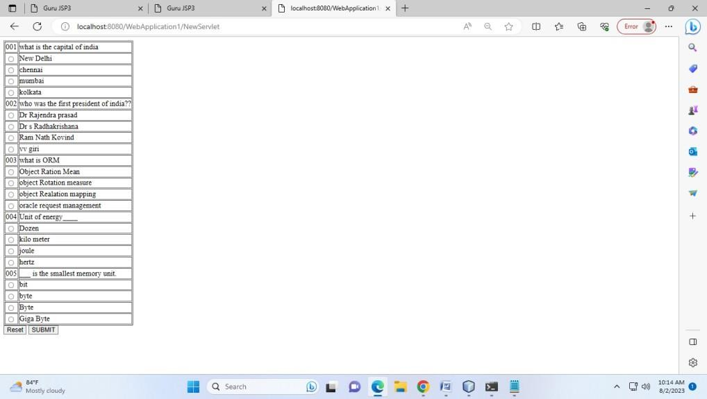

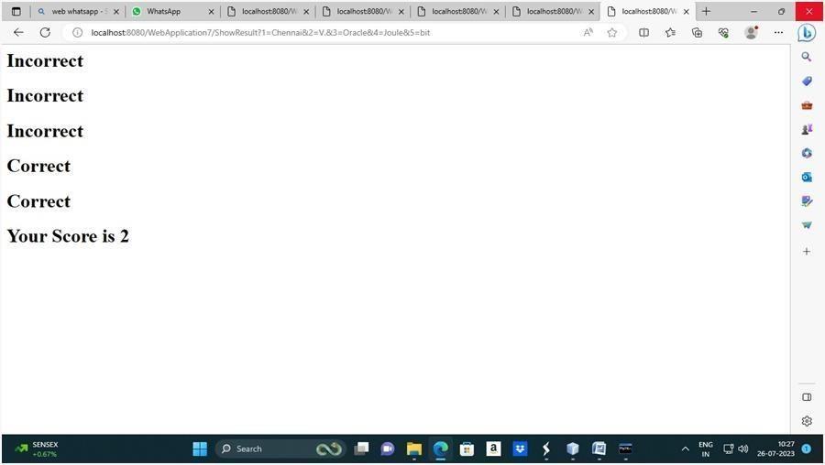

Practical 16 Aim: Expression language by using JSP. JSP code: newjsp.jsp
Code:
<%@ page language="java" contentType="text/html; charset=ISO-8859-1"
pageEncoding="ISO-8859-1"%>
<!DOCTYPE html PUBLIC "-//W3C//DTD HTML 4.01
Transitional//EN" "http://www.w3.org/TR/html4/loose.dtd">
<html>
<head>
<meta http-equiv="Content-Type" content="text/html; charset=ISO-8859-1">
<title>Guru JSP3</title>
</head>
<body>
<%! int week=8; %>
<% switch(week){ case 1: out.println("Sunday");
break; case 2:
out.println("Monday");

break; case 3:
out.println("Tuesday"); break;
case 4: out.println("wednesday");
break; case 5:
out.println("Thursday"); break;
case 6: out.println("Friday");
break; case 7:
out.println("Saturday"); break;
default: out.println("Invalid Input"); break;}
%>
</body>
</html>

Output:
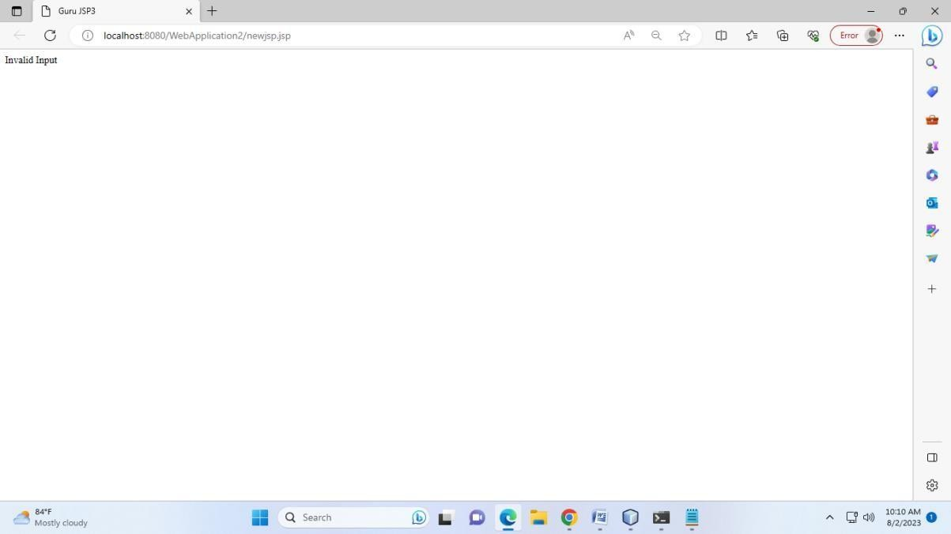

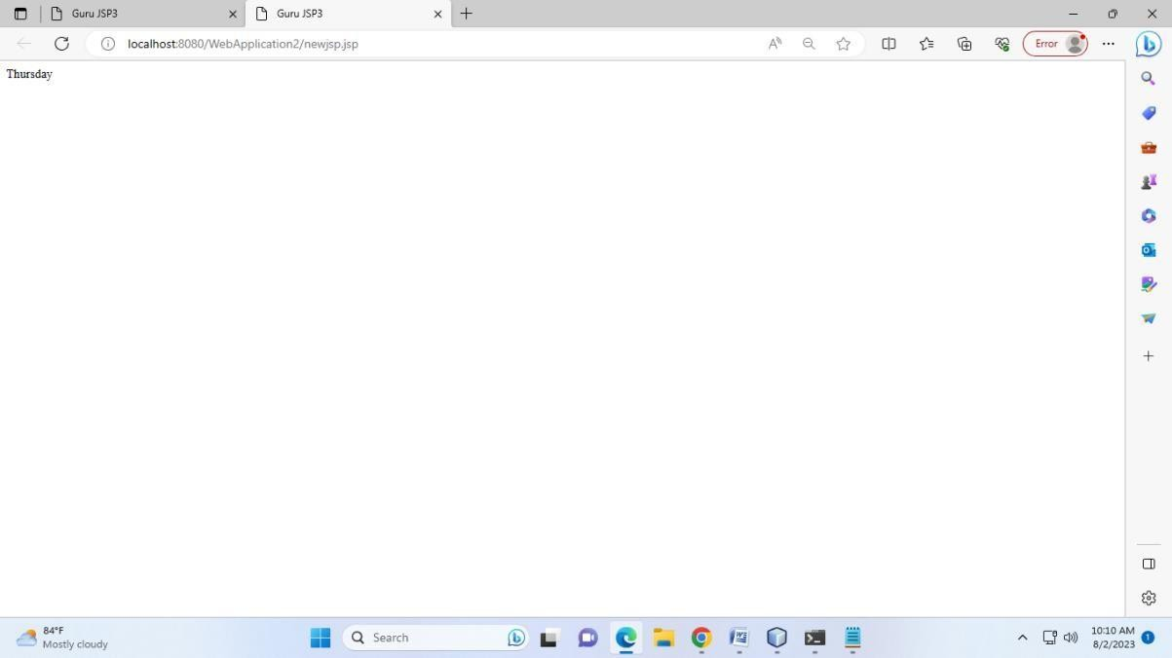

Practical 17
Aim: Use JDBC for data insertion for valid user HTML Code: index.html
<html>
<body bgcolor="lightgreen" >
<center>
<form action="NewServlet" method="post">
User name : <input type="text" name="uname"> <br><br> Password : <input type="password" name="pw"><br><br> Email Id : <input type="text" name="email"> <br><br>
<input type="submit" value=" Register">
</form>
</center>
</body>
</html>

Servlet Code: NewServlet.java

package mypack; import java.io.*; import java.sql.*; import javax.servlet.*;
import javax.servlet.http.*;
public class NewServlet extends HttpServlet
{ public void doPost(HttpServletRequest request, HttpServletResponse response) throws
IOException, ServletException
{ Connection con=null; PreparedStatement ps=null; response.setContentType("text/html");

PrintWriter out = response.getWriter();
String uname=request.getParameter("uname");

String pw=request.getParameter("pw"); String email=request.getParameter("email");
If (uname.equals("admin") && pw.equals("12345")){{ out.println("<body bgcolor= lightblue >");
out.println("<h1><center> Welcome !!! "+uname+"</center></h1>");
}
try
{ Class.forName("com.mysql.jdbc.Driver"); con=DriverManager.getConnection("jdbc:mysql://localhost:3306/office", "root","root");
ps=con.prepareStatement("insert into emp values (?,?,?)"); ps.setString(1,uname);
ps.setString(2,pw); ps.setString(3,email); ps.execute();
out.print("<h1><center>Data inserted successfully!!!!</center></h1>");
}
catch(Exception e) { out.println(e); } out.println("<b>"+"<b>");
}

else{
out.println("<body bgcolor= red >"); out.println("<h1><center> Login Fail !!! </center></h1>");
}}
}

SQL Commands:
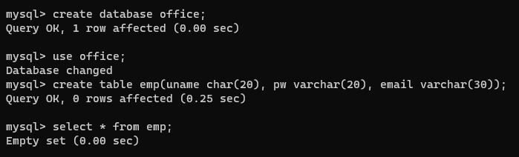

Output:
