Contents

Contents 2

1. Create a XML document for student database and apply the style sheet effects and display onwebpage 5
2. Create a simple web page containing the student details (Roll No, Name, Class, Phone, Email).WriteaprogramtostorethedatainthedatabaseandretrieveitusingDatareaderintabularformat 7
3. Create a simple web page with various sever controls to demonstrate setting and use of theirproperties.(Example:AutoPostBack) 11
   1. On click of a button control display the selected items from the listbox in a textbox. Also in thesame webpage display the name of the selected item from the DropDownList1 in a label. AlsochangethefontsizeofthesamelabelaccordingtothefontsizeselectedfromtheDropdownlist2.

.................................................................................................................................................... 112.DisplayImagecontrolforphoto............................................................................................... 13

1. Check Boxes provides special formatting (viz. underline, bold, italic) and Radio Buttons providescolorforlabel.4.UseofAutoPostBackproperty 14
2. Create a simple web page to count the number of times the current webpage is submitted to theserveronclickeventofaButton 17
3. Createsimpleapplicationtoperformfollowingoperations 19
   1. FindingfactorialValue 19
   2. MoneyConversion 19
   3. Cubeofgivennumber 19
   4. GenerateFibonacciseries 19
4. DemonstratetheuseofCalendarcontroltoperformfollowingoperations. 23
5. Displaymessagesinacalendarcontrol 23
6. Displayvacationinacalendarcontrol 23
7. Selecteddayinacalendarcontrolusingstyle 23
8. Differencebetweentwocalendardates 23
9. Create Web Form to demonstrate use of User Control. Create footer named user control havingcopyrightreserved(ex. “©companyname”)anduseit inawebpage. 26
10. Create Web Form to demonstrate use of Ad rotator Control with five advertisements. Alsodemonstratehowkeywordfilterworks. 28
11. Create XML file employees with nodes (eid, ename, edept, salary). Bind the eid and ename to adropdownlistandtheenameshouldbeintheascendingorder. 30
12. Create simple web page that takes a number as input and display it four times in a row(separatedbyblankspaces),andthenfourtimesinthenextrow,withnoseparation.Like 32

Enteradigit:22 32

ExpectedOutput 32

22222222..................................................................................................................................32

22222222....................................................................................................................................32

22222222..................................................................................................................................32

22222222....................................................................................................................................32

1. CreateasimplewebpagetodisplaytheDateproperties(year,month, day,hour,minute,second, millisecond etc.) as well as to display the number of days of the year between two specifiedyears. 34
2. Create a web page containing the student details (RollNo, Name, Class, Phone, Email) and showresultusingDatabindinganddropdownlistcontrol 35
3. Createasimplewebpagetodemonstrateall stringoperations. 37
4. Design an asp.net webpage with 2 groups of Radio Buttons, DropDownList, label and TextBox toperform the following operations:-On click of Radio Buttons each at the same time from twodifferent groups, change the font- size and font-face of the label’s Text. Also on the same webpageshow that, on selecting a country name from the dropdown list, its respective country code getsdisplayedinatextbox 40
5. Create a delegate del1. Create display1() and display2() static methods. Create a simpleapplicationtocallthesetwomethodsbythethroughthedelegate. 43
6. Createasimplewebpagetoshowhowtowriteandreadacookiefromaclient'scomputer. 45
7. CreateawebapplicationtodemonstrateuseofHtmlEditorExtenderAjaxcontrol 47
8. CreateawebapplicationtodemonstrateuseofMasterPagewithapplyingStylesandThemesforpagebeautification 47
9. Create a web application to demonstrate Form Security and Windows Security with properAuthenticationandAuthorizationproperties. 54
10. Create a web application to demonstrate Grid View paging and Creating own table format usingGrid View 58
11. Createawebapplicationtobinddatainamultilinetextboxbyqueryinginanothertextbox. 60
12. WriteaprogramtocreateaDLLtoprintafactorialofanumber. 62
13. WriteanApplicationto 64
    1. GenerateFibonacciseries 64
    2. Testforprimenumbers 64
    3. Testforvowels 64
    4. Reverse anumber 64
14. Create a simple web page to demonstrate use of built in DivideByZeroException andIndexOutOfRangeExceptionexceptionsusingtextboxandlabelcontrol 66
15. Create a simple web page to show data in Tree view control and datalist using web. Sitemap filecontainingnavigationinformation 68
16. Displaytheno.ofvisitorsonagivenwebpage. 70
17. Create a registration form having text fields for accepting, Name, Age, Email, Address and Mobilenumber.Performthefollowingvalidationsforthesame: 72
    1. Allfieldsneedtobefilledcompulsorily 72
    2. Nameshouldcontainonlyalphabetsandshouldnotbemorethan 25 characterslong 72
    3. Validateemailandmobilenumberappropriately 72
    4. Ageshouldbebetween18and32only 72

Include submit and cancel buttons. On click of submit button, open a new page and display all theinformationenteredbytheuserandonclickofcancelbutton,alltextfieldsshouldbecleared. 72

1. Create a webpage with multiline textbox and two buttons, viz. saveContents and loadContents.On click of saveContents button, contents from the textbox should be retained and on click ofloadContentsbutton,thepreviouslysavedcontentsshouldbedisplayedbackonthetextbox. 77

Codes: 77

1. Store 3 objects of the furniture class having 3 data members (name, manufacturer, and cost) in 3session objects. Display a panel to include a listbox displaying the names of all three furnitureobjects, and a button named “MoreInformation”. On click of the button retrieve the selected object(fromlistbox)informationanddisplayitinalabel 79
2. WriteaprograminC#todemonstratemultipleinheritanceusinginterfaces. 82
3. CreateaXMLdocumentforstudentdatabaseandapplythestylesheeteffectsand displayon webpage

**Student.xml:**

<?xmlversion="1.0"encoding="UTF-8"?>

<?xml-stylesheettype="text/css"href="StyleSheet.css"?>

<students>

<heading>Studentdatabase</heading>

<student>

<id>RollNo:00009</id>

<name>Name:SatyamGupta</name>

<Class>TY-Bsc</Class>

<division>A</division>

<Subject>InformationTechnology</Subject>

<Phone>8433508332</Phone>

<Address>JuhuKoliwada,HbGawdeMarg,SantacruzWestMum-49</Address>

</student>

<student>

<id>RollNo:00015</id>

<name>Name:NumanKhan</name>

<Class>TY-Bsc</Class>

<division>A</division>

<Subject>InformationTechnology</Subject>

<Phone>9667845120</Phone>

<Address>KharDanda,KharWest,Mum-52</Address>

</student>

<student>

<id>RollNo:00025</id>

<name>Name:SalmanKhan</name>

<Class>TY-Bsc</Class>

<division>A</division>

<Subject>ComputerScience</Subject>

<Phone>8433508332</Phone>

<Address>3, Galaxy Apartments, BJ Road Band Stand, Bandra West, Mumbai, Maharashtra –400050,India</Address>

</student>

<student>

<id>RollNo:00901</id>

<name>Name:SangamYadav</name>

<Class>SY-Bsc</Class>

<division>A</division>

<Subject>InformationTechnology</Subject>

<Phone>841623832</Phone>

<Address>JuhuKoliwada,HbGawdeMarg,SantacruzWestMum-49</Address>

</student>

<student>

<id>RollNo:001450</id>

<name>Name:RajuRastogi</name>

<Class>TY-Bsc</Class>

<division>A</division>

<Subject>InformationTechnology</Subject>

<Phone>8433508332</Phone>

<Address>MumbaiMaharashtra</Address></student></students>

**StyleSheet.css**

students

{

font-size:80%;

margin:0.5em;

font-family: Verdana;display:block;

}

student{display:block;

border: 1px solid silver;margin: 0.5em;padding:0.5em;

background-color:whitesmoke;

}

heading{display:block;

font-weight: bolder;text-align: center;font-size:30px;

background-color: green;color:white;

}

id {

font-family: 'Cascadia Code';font-size:30px;

font-weight:bold;

}

name, Class, division, Subject,Phone,Address {display:block

**}**

1. Create a simple web page containing the student details (Roll No, Name,Class,Phone,Email).WriteaprogramtostorethedatainthedatabaseandretrieveitusingData readerintabularformat.

**Codes:**

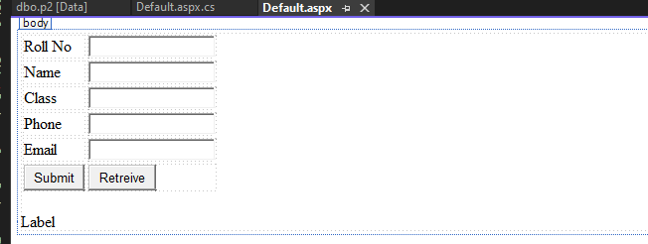

**Deafult.aspx**

<%@PageLanguage="C#"AutoEventWireup="true"CodeFile="Default.aspx.cs"Inherits="_Default"%>

<!DOCTYPEhtml>

<htmlxmlns="<http://www.w3.org/1999/xhtml>">

<headrunat="server">

<title></title>

</head>

<body>

<formid="form1"runat="server">

<div>

<table>

<tr><td>RollNo</td><td>

<asp:TextBoxID="TextBox1"runat="server"></asp:TextBox>

</td></tr>

<tr><td>Name</td><td>

<asp:TextBoxID="TextBox2"runat="server"></asp:TextBox>

</td></tr>

<tr><td>Class</td><td>

<asp:TextBoxID="TextBox3"runat="server"></asp:TextBox>

</td></tr>

<tr><td>Phone</td><td>

<asp:TextBoxID="TextBox4"runat="server"></asp:TextBox>

</td></tr>

<tr><td>Email</td><td>

<asp:TextBoxID="TextBox5"runat="server"></asp:TextBox>

</td></tr>

<tr><td>

<asp:ButtonID="Button1"runat="server"Text="Submit"OnClick="Button1_Click"/>

</td><td>

<asp:ButtonID="Button2"runat="server"Text="Retreive"OnClick="Button2_Click"/>

</td></tr>

</table>

</div>

<p><asp:LabelID="Label1"runat="server"Text="Label"></asp:Label></p>

</form>

</body>

</html>**Default.aspx.cs**using System;

usingSystem.Collections.Generic;

using System.Linq;using System.Web;usingSystem.Web.UI;

using System.Web.UI.WebControls;using System.Data.SqlClient;

usingSystem.Linq.Expressions;

publicpartialclass_Default:System.Web.UI.Page

{

SqlConnectioncon =newSqlConnection("DataSource=(LocalDB)\\MSSQLLocalDB;AttachDbFilename=C:\\Users\\Admin\\OneDrive\\Documents\\"+

"Practical2.mdf;Integrated Security=True;Connect Timeout=30");protected voidPage_Load(objectsender, EventArgse)

{

}

protectedvoidButton1_Click(objectsender,EventArgse)

{

try{

stringInsertQuery= "insertintop2values("+TextBox1.Text+",'"+ TextBox2.Text+"','"+TextBox3.Text

+ "','" + TextBox4.Text + "','" + TextBox5.Text + "') ";SqlCommandcmd=newSqlCommand(InsertQuery, con);con.Open();

cmd.ExecuteNonQuery();//UseforinsertupdateanddeleteOnly(*Required)

}

catch(ExceptionE)

{

Response.Write(E.Message);

}

finally

{

if(con.State==System.Data.ConnectionState.Closed)

{

}

else

{

con.Close();

}

}

}

protectedvoidButton2_Click(objectsender,EventArgse)

{

try

{

stringSELECTQuery="Select*fromp2";

SqlCommandcmd=newSqlCommand(SELECTQuery,con);con.Open();

SqlDataReadersdr=cmd.ExecuteReader();stringtbl="<table>";

if(sdr.HasRows)

{

while(sdr.Read())

{

tbl+="<tr><td>"+sdr[0]+"</td><td>"+sdr[1]+"</td><td>"+sdr[2]+"</td><td>"+sdr[4]

+"</td></tr>";

}

}

tbl+="</table>";

Label1.Text=tbl;

}

catch(ExceptionE)

{

Response.Write(E.Message);

}

finally

{

if(con.State==System.Data.ConnectionState.Closed)

{

}

else

{

con.Close();

}

}

}

**}**

1. Createasimplewebpagewithvarioussevercontrolstodemonstratesettinganduseoftheir properties.(Example:AutoPostBack)
2. Onclick of a button control display the selected items from the listbox in atextbox. Also in the same webpage display the name of the selected item from theDropDownList1 in a label. Also change the font size of the same label accordingtothefontsizeselectedfromtheDropdownlist2.

**Design:**

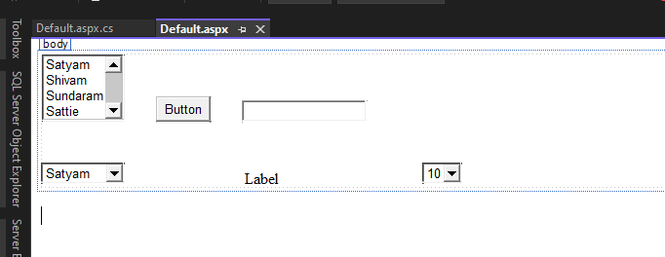

**Default.aspx**

<%@PageLanguage="C#"AutoEventWireup="true"CodeFile="Default.aspx.cs"Inherits="_Default"%>

<!DOCTYPEhtml>

<htmlxmlns="<http://www.w3.org/1999/xhtml>">

<headrunat="server">

<title></title>

</head>

<body>

<formid="form1"runat="server">

<div>

<asp:ListBoxID="ListBox1"runat="server">

<asp:ListItem>Satyam</asp:ListItem>

<asp:ListItem>Shivam</asp:ListItem>

<asp:ListItem>Sundaram</asp:ListItem>

<asp:ListItem>Sattie</asp:ListItem>

<asp:ListItem>Sattu</asp:ListItem>

</asp:ListBox>

<asp:Button ID="Button1" runat="server" OnClick="Button1_Click" Text="Button" />&nbsp;&nbsp;&nbsp;&nbsp;&nbsp;&nbsp;&nbsp;

<asp:TextBoxID="TextBox1"runat="server"></asp:TextBox>

<br/>

<br/>

<br/>

<asp:DropDownList ID="DropDownList1" runat="server" AutoPostBack="True"OnSelectedIndexChanged="DropDownList1_SelectedIndexChanged">

<asp:ListItem>Satyam</asp:ListItem>

<asp:ListItem>Shivam</asp:ListItem>

<asp:ListItem>Sundaram</asp:ListItem>

<asp:ListItem>Sattie</asp:ListItem>

<asp:ListItem>Sattu</asp:ListItem>

</asp:DropDownList>

<asp:LabelID="Label1"runat="server"Text="Label"></asp:Label>

<asp:DropDownList ID="DropDownList2" runat="server" AutoPostBack="True"OnSelectedIndexChanged="DropDownList2_SelectedIndexChanged">

<asp:ListItem>10</asp:ListItem>

<asp:ListItem>20</asp:ListItem>

<asp:ListItem>30</asp:ListItem>

<asp:ListItem>40</asp:ListItem>

<asp:ListItem>45</asp:ListItem>

</asp:DropDownList>

</div>

</form>

</body>

</html>Default.aspx.cs

usingSystem;

using System.Collections.Generic;using System.Linq;

using System.Web;usingSystem.Web.UI;

usingSystem.Web.UI.WebControls;

publicpartialclass_Default:System.Web.UI.Page

{

protectedvoidPage_Load(objectsender,EventArgse)

{

}

protectedvoidButton1_Click(objectsender,EventArgse)

{

TextBox1.Text=ListBox1.SelectedValue.ToString();

}

protectedvoidDropDownList1_SelectedIndexChanged(objectsender,EventArgse)

{

Label1.Text=DropDownList1.SelectedValue.ToString();

}

protectedvoidDropDownList2_SelectedIndexChanged(objectsender,EventArgse)

{

Label1.Font.Size=Convert.ToInt32(DropDownList2.SelectedValue);

}

}

1. playImagecontrolforphoto.

**Design:**

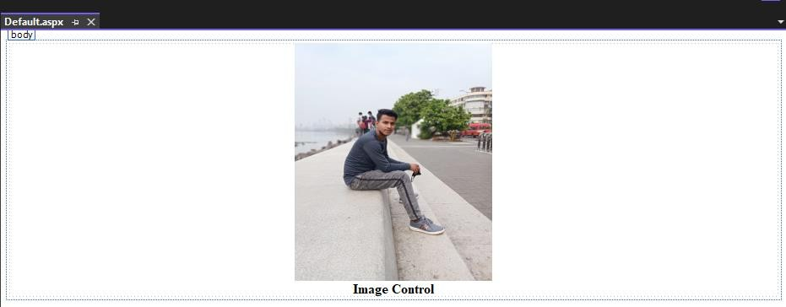

**Deafault.aspx**

<%@PageLanguage="C#"AutoEventWireup="true"CodeFile="Default.aspx.cs"Inherits="_Default"%>

<!DOCTYPEhtml>

<htmlxmlns="<http://www.w3.org/1999/xhtml>">

<headrunat="server">

<title></title>

<styletype="text/css">

.auto-style1{

text-align:center;

}

</style>

</head>

<body>

<formid="form1"runat="server">

<divclass="auto-style1">

<asp:Image ID="Image1" runat="server" Height="282px" ImageUrl="~/IMG-20220324-WA0008.jpg"Width="234px"/>

<br/>

<strong>ImageControl</strong></div>

</form>

</body>

</html>

1. CheckBoxesprovidesspecialformatting(viz.underline, bold,italic)andRadio Buttons provides color for label. 4. Use of AutoPostBack property.Design:

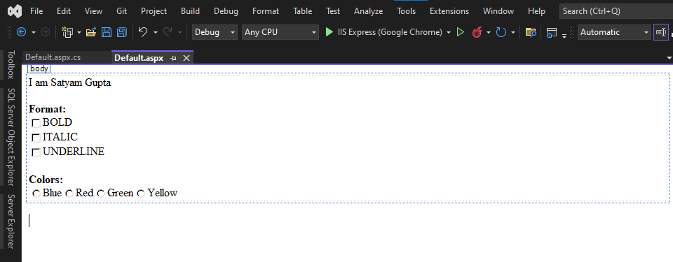

**Defualt.aspx**

<%@ Page Language="C#" MaintainScrollPositionOnPostback ="true" AutoEventWireup="true"CodeFile="Default.aspx.cs"Inherits="_Default"%>

<!DOCTYPEhtml>

<htmlxmlns="<http://www.w3.org/1999/xhtml>">

<headrunat="server">

<title></title>

</head>

<body>

<formid="form1"runat="server">

<asp:LabelID="Label1"runat="server"Text="IamSatyamGupta"></asp:Label>

<br/>

<br/>

<strong>Format:</strong><br/>

<asp:CheckBox ID="CheckBox1" runat="server" AutoPostBack="True"OnCheckedChanged="CheckBox1_CheckedChanged"Text="BOLD"/>

<br />

<asp:CheckBox ID="CheckBox3" runat="server" AutoPostBack="True"OnCheckedChanged="CheckBox3_CheckedChanged"Text="ITALIC"/>

<br />

<asp:CheckBox ID="CheckBox2" runat="server" AutoPostBack="True"OnCheckedChanged="CheckBox2_CheckedChanged"Text="UNDERLINE"/>

<strong>

<br/>

<br/>

Colors:</strong>

<br />

<asp:RadioButton ID="RadioButton1" runat="server" AutoPostBack="True" GroupName="Color"OnCheckedChanged="RadioButton1_CheckedChanged"Text="Blue"/>

<asp:RadioButton ID="RadioButton2" runat="server" AutoPostBack="True" GroupName="Color"OnCheckedChanged="RadioButton2_CheckedChanged"Text="Red"/>

<asp:RadioButton ID="RadioButton3" runat="server" AutoPostBack="True" GroupName="Color"OnCheckedChanged="RadioButton3_CheckedChanged"Text="Green"/>

<asp:RadioButton ID="RadioButton4" runat="server" AutoPostBack="True" GroupName="Color"OnCheckedChanged="RadioButton4_CheckedChanged"Text="Yellow"/>

</form>

</body>

</html>

**Default.aspx.cs**using System;

Using System.Collections.Generic;using System.Linq;

using System.Web;usingSystem.Web.UI;

usingSystem.Web.UI.WebControls;

publicpartialclass_Default:System.Web.UI.Page

{

protectedvoidPage_Load(objectsender,EventArgse)

{

}

protectedvoidCheckBox1_CheckedChanged(objectsender,EventArgse)

{

if(CheckBox1.Checked)

{

Label1.Font.Bold=true;

}

else

{

Label1.Font.Bold=false;

}

}

protectedvoidCheckBox3_CheckedChanged(objectsender,EventArgse)

{

if(CheckBox3.Checked)

{

Label1.Font.Italic=true;

}

else

{

Label1.Font.Italic=false;

}

}

protectedvoidCheckBox2_CheckedChanged(objectsender,EventArgse)

{

if(CheckBox2.Checked)

{

Label1.Font.Underline=true;

}

else

{Label1.Font.Underline= false;}

}

protectedvoidRadioButton1_CheckedChanged(objectsender,EventArgse)

{

Label1.ForeColor=System.Drawing.Color.Blue;

}

protectedvoidRadioButton2_CheckedChanged(objectsender,EventArgse)

{

Label1.ForeColor=System.Drawing.Color.Red;

}

protectedvoidRadioButton3_CheckedChanged(objectsender,EventArgse)

{

Label1.ForeColor=System.Drawing.Color.Green;

}

protectedvoidRadioButton4_CheckedChanged(objectsender,EventArgse)

{

Label1.ForeColor=System.Drawing.Color.Yellow;

}}

1. Createasimplewebpagetocountthenumberoftimesthecurrentwebpage issubmittedtotheserver onclickeventofaButton.

**Design:**

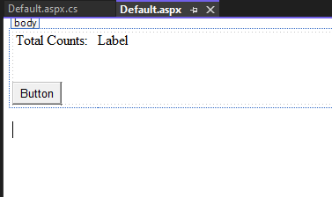

**Default.aspx**

<%@PageLanguage="C#"AutoEventWireup="true"CodeFile="Default.aspx.cs"Inherits="_Default"%>

<!DOCTYPEhtml>

<htmlxmlns="<http://www.w3.org/1999/xhtml>">

<headrunat="server">

<title></title>

</head>

<body>

<formid="form1"runat="server">

<div>

&nbsp;TotalCounts:&nbsp;&nbsp;

<asp:LabelID="Label1"runat="server"Text="Label"></asp:Label>

<br/>

<br/>

<br/>

<asp:ButtonID="Button1"runat="server"OnClick="Button1_Click"Text="Button"/>

</div>

</form>

</body>

</html>**Default.aspx.cs**using System;

publicpartialclass_Default:System.Web.UI.Page

{

protectedvoidPage_Load(objectsender,EventArgse)

{

}

protectedvoidButton1_Click(objectsender,EventArgse)

{

//In thismethod onlythecountwillbedifferentin differenttabsofthesamewebpage

//ViewState["a"]=Convert.ToInt32(ViewState["a"])+1;

//Label1.Text=ViewState["a"].ToString();

Application["a"] = Convert.ToInt32(Application["a"]) + 1;Label1.Text=Application["a"].ToString();

}}

1. Createsimpleapplicationtoperformfollowingoperations
   1. FindingfactorialValue
   2. MoneyConversion
   3. Cubeofgivennumber
   4. GenerateFibonacciseries

**Codes:**

<%@PageLanguage="C#"AutoEventWireup="true"CodeFile="Default.aspx.cs"Inherits="_Default"%>

<!DOCTYPEhtml>

<htmlxmlns="<http://www.w3.org/1999/xhtml>">

<headrunat="server">

<title></title>

<styletype="text/css">

.auto-style1{

text-align:center;

}

.auto-style2 {color:#0099CC;

}

</style>

</head>

<body>

<formid="form1"runat="server">

<divclass="auto-style1">

<h1><spanclass="auto-style2"><strong>CodeBySatyam09</strong></span></h1>

<br/>

<asp:TextBoxID="TextBox1"runat="server"Width="164px"></asp:TextBox>

<asp:DropDownList ID="DropDownList1" runat="server" AutoPostBack="True"OnSelectedIndexChanged="DropDownList1_SelectedIndexChanged">

<asp:ListItemValue="1">Factorial</asp:ListItem>

<asp:ListItemValue="2">RStoUSD</asp:ListItem>

<asp:ListItemValue="3">Cube</asp:ListItem>

<asp:ListItemValue="4">Fibonacci</asp:ListItem>

</asp:DropDownList>

<br/>

<br/>

<br/>

<h2>

<asp:LabelID="Label1"runat="server"Text="Result"></asp:Label>

</h2>

</div>

</form>

</body>

</html>

**C# Code:**

usingSystem;

using System.Collections.Generic;usingSystem.Drawing;

using System.Linq;using System.Web;usingSystem.Web.UI;

usingSystem.Web.UI.WebControls;

publicpartialclass_Default:System.Web.UI.Page

{

protectedvoidPage_Load(objectsender,EventArgse)

{

}

protectedvoidDropDownList1_SelectedIndexChanged(objectsender,EventArgse)

{

if(DropDownList1.SelectedValue=="1")

{

Label1.Text=Factorail(Convert.ToInt32(TextBox1.Text));

}

elseif(DropDownList1.SelectedValue=="2")

{

Label1.Text=Money(Convert.ToDouble(TextBox1.Text));

}

elseif(DropDownList1.SelectedValue=="3")

{

Label1.Text=Cube(Convert.ToInt32(TextBox1.Text));

}

elseif(DropDownList1.SelectedValue=="4")

{

Label1.Text=Fibonacci(Convert.ToInt32(TextBox1.Text));

}

}

publicstringFactorail(intnum)

{

intfact=1;

for(inti= 1;i< num;i++)

{

fact*=i;

}

returnfact.ToString();

}

publicstringMoney(doublen)

{

double d = n / 82.31;returnd.ToString();

}

publicstringCube(doublen)

{

return(n*n*n).ToString();

}

publicstringFibonacci(intn)

{

int n1 = 0, n2 = 1;intn3;

stringfs ="";

fs=n1 +""+n2+"";

for(inti=2;i<n;++i)

{

n3 = n1 + n2;fs+=n3+"";n1 =n2;

n2 =n3;

}

returnfs;

}

}

1. DemonstratetheuseofCalendarcontroltoperformfollowingoperations.
2. Displaymessagesinacalendarcontrol
3. Displayvacationina calendar control
4. Selecteddayinacalendarcontrolusingstyle
5. Differencebetweentwocalendardates

**Codes:**

<%@PageLanguage="C#"AutoEventWireup="true"CodeFile="Default.aspx.cs"Inherits="_Default"%>

<!DOCTYPEhtml>

<htmlxmlns="<http://www.w3.org/1999/xhtml>">

<headrunat="server">

<title></title>

<styletype="text/css">

.auto-style1{

text-align:center;

}

.auto-style2{

text-align:center;

}

.auto-style3 {color:#339933;

text-decoration:underline;

}

</style>

</head>

<body>

<formid="form1"runat="server">

<divclass="auto-style2">

<asp:Calendar ID="Calendar1" runat="server" BackColor="White" BorderColor="Black" Font-Names="Verdana" Font-Size="9pt" ForeColor="Black" Height="250px" OnDayRender="Calendar1_DayRender"OnSelectionChanged="Calendar1_SelectionChanged" Width="330px" BorderStyle="Solid" CellSpacing="1"CssClass="auto-style1"NextPrevFormat="ShortMonth">

<DayHeaderStyleFont-Bold="True"Height="8pt"Font-Size="8pt"ForeColor="#333333"/>

<DayStyleBackColor="#CCCCCC"/>

<NextPrevStyleFont-Size="8pt"ForeColor="White"Font-Bold="True"/>

<OtherMonthDayStyleForeColor="#999999"/>

<SelectedDayStyleBackColor="#333399"ForeColor="White"/>

<TitleStyle BackColor="#333399" Font-Bold="True" Font-Size="12pt" ForeColor="White"BorderStyle="Solid"Height="12pt"/>

<TodayDayStyleBackColor="#999999"ForeColor="White"/>

</asp:Calendar>

<asp:Calendar ID="Calendar2" runat="server" BackColor="White" BorderColor="White"BorderWidth="1px" Font-Names="Verdana" Font-Size="9pt" ForeColor="Black" Height="190px" Width="350px"NextPrevFormat="FullMonth">

<DayHeaderStyleFont-Bold="True"Font-Size="8pt"/>

<NextPrevStyleFont-Size="8pt"ForeColor="#333333"Font-Bold="True"VerticalAlign="Bottom"/>

<OtherMonthDayStyleForeColor="#999999"/>

<SelectedDayStyleBackColor="#333399"ForeColor="White"/>

<TitleStyle BackColor="White" BorderColor="Black" BorderWidth="4px" Font-Bold="True" Font-Size="12pt"ForeColor="#333399"/>

<TodayDayStyleBackColor="#CCCCCC"/>

</asp:Calendar>

<asp:Label ID="Label1" runat="server" Text="Label"></asp:Label>&nbsp;&nbsp;&nbsp;&nbsp;&nbsp;&nbsp;&nbsp;

<asp:ButtonID="Button1"runat="server"OnClick="Button1_Click"Text="Button"/>

<strong>

<brclass="auto-style3"/>

<h1><spanclass="auto-style3">Satyam09</span></h1>

</strong>

<br/>

<br/>

&nbsp;

</div>

</form>

</body>

</html>

**C# Code:**

usingSystem;

using System.Collections.Generic;using System.Linq;

using System.Web;usingSystem.Web.UI;

usingSystem.Web.UI.WebControls;

publicpartialclass_Default:System.Web.UI.Page

{

protectedvoidPage_Load(objectsender,EventArgse)

{

}

protectedvoidCalendar1_DayRender(objectsender,DayRenderEventArgse)

{

if(e.Day.Date.Year==2022&&e.Day.Date.Month ==10&&e.Day.Date.Day==5)

{

Label l1 = new Label();l1.Text="<br>ganpati";e.Cell.Controls.Add(l1);

}

if(e.Day.Date.Year==2022&&e.Day.Date.Month==10&& e.Day.Date.Day==15)

{

Labell1=newLabel();l1.Text="<br>TYITPrelims";e.Cell.Controls.Add(l1);

}

}

protectedvoidCalendar1_SelectionChanged(objectsender,EventArgse)

{

Calendar1.SelectedDayStyle.BackColor =System.Drawing.Color.Red;

Calendar1.SelectedDayStyle.ForeColor=System.Drawing.Color.Yellow;

}

protectedvoidButton1_Click(objectsender,EventArgse)

{

TimeSpan ts = Calendar1.SelectedDate - Calendar2.SelectedDate;Label1.Text=ts.TotalDays.ToString();

}

}

1. Create Web Form to demonstrate use of User Control. Create footernamed user control having copyright reserved (ex. “©company name”) anduseitinawebpage.

**footer.ascx**

<%@ControlLanguage="C#"AutoEventWireup="true"CodeFile="Footer.ascx.cs"Inherits="Footer"%>

<div style="font-family: 'Arial Black'; font-size: xx-large; font-weight: 200; font-style: normal; font-variant: small-caps; text-transform: uppercase; color: #FF0000; line-height: inherit; vertical-align: middle; text-align: justify; text-indent: inherit; white-space: pre; word-spacing: inherit; letter-spacing: inherit; background-color: #00FFFF;background-image: inherit; background-repeat: repeat-x; background-attachment: scroll; background-position: centercenter; border: thick double #008000; padding: inherit; margin: inherit; position: fixed; z-index: inherit; width: inherit;height: inherit; visibility: visible; display: table-column; float: none; clear: both; cursor: move; table-layout: fixed">@CopyrightSatyam.com

</div>

**Default.aspx:**

<%@PageLanguage="C#"AutoEventWireup="true"CodeFile="Default.aspx.cs"Inherits="_Default"%>

<%@Registersrc="Footer.ascx"tagname="Footer"tagprefix="uc1"%>

<!DOCTYPEhtml>

<htmlxmlns="<http://www.w3.org/1999/xhtml>">

<headrunat="server">

<title></title>

<styletype="text/css">

.auto-style1{

text-align: center;color:#3366FF;

}

</style>

</head>

<body>

<formid="form1"runat="server">

<divclass="auto-style1">

<h1><strong>SatyamGupta</strong></h1>

</div>

<uc1:FooterID="Footer1"runat="server"/>

</form>

</body>

</html>

1. CreateWebFormtodemonstrateuseofAdrotatorControlwithfiveadvertisements.Alsodemonstratehowkeywordfilter works.

**Design:**

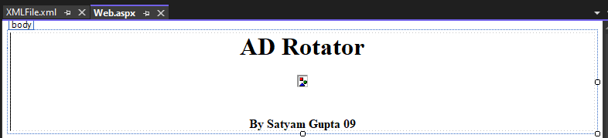

**Code:**

<body>

<formid="form1"runat="server">

<divclass="auto-style1">

<h1style="text-align:center">ADRotator</h1>

<h4>

<asp:AdRotatorAdvertisementFile="~/XMLFile.xml"ID="AdRotator1"runat="server"Target="_blank"/>

<br/>

<br/>

<br/>

BySatyamGupta09</h4>

</div>

</form>

</body>

**Web.xml**

<?xmlversion="1.0"encoding="utf-8"?>

<Advertisements>

<Ad>

</Ad>

<Ad>

</Ad>

<ImageUrl>~/Pic/TMKOC.jpg</ImageUrl>

<Height>300px</Height>

<Width>550px</Width>

<NavigateUrl>https://[www.youtube.com/c/TaarakMehtaKaOoltahChashmah<](http://www.youtube.com/c/TaarakMehtaKaOoltahChashmah)/NavigateUrl>

<AlternateText>

TarakMehta kaOolta Chashma

</AlternateText>

<Impressions>20</Impressions>

<Keyword>FamilyShow</Keyword>

<ImageUrl>~/Pic/the-kapil-sharma-show.jpg</ImageUrl>

<Height>300px</Height>

<Width>550px</Width>

<NavigateUrl>https://[www.youtube.com/c/KapilSharmaK9](http://www.youtube.com/c/KapilSharmaK9)</NavigateUrl>

<AlternateText>Watchtheshow</AlternateText>

<Impressions>15</Impressions>

<Keyword>ComedyShow</Keyword>

</Advertisements>

1. Create XML file employees with nodes (eid, ename, edept, salary). Bindtheeidandenametoadropdownlistandtheenameshouldbein theascendingorder.

**SourceCode:**

<%@PageLanguage="C#"AutoEventWireup="true"CodeFile="Default.aspx.cs"Inherits="_Default"%>

<!DOCTYPEhtml>

<htmlxmlns="<http://www.w3.org/1999/xhtml>">

<headrunat="server">

<title></title>

<styletype="text/css">

.auto-style1{

text-align:center;

}

</style>

</head>

<body>

<formid="form1"runat="server">

<divclass="auto-style1">

<asp:DropDownListID="DropDownList1"runat="server">

</asp:DropDownList>

<br/>

<br/>

RollNo:09

</div>

</form>

</body>

</html>

**CsCode:**

usingSystem;

using System.Collections.Generic;using System.Linq;

using System.Web;usingSystem.Web.UI;

using System.Web.UI.WebControls;using System.Data;

publicpartialclass_Default:System.Web.UI.Page

{

protectedvoidPage_Load(objectsender,EventArgse)

{

DataSet ds = new DataSet();ds.ReadXml("C:\\Users\\Admin\\source\\repos\\P9\\P9\\XMLFile.xml");ds.Tables[0].DefaultView.Sort = "ename";// For Ascending OrderDropDownList1.DataSource=ds.Tables[0];DropDownList1.DataTextField = "ename";DropDownList1.DataValueField = "eid";DropDownList1.DataBind();

}

**}**

**Output:**

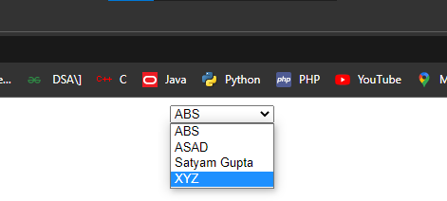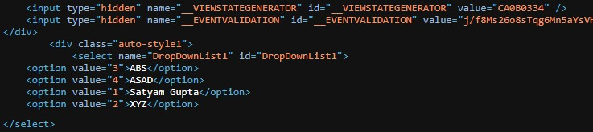

1. Createsimplewebpagethattakesanumberasinputanddisplayitfourtimes in a row (separated by blank spaces), and then four times in the nextrow,with noseparation.Like-

Enteradigit:22ExpectedOutput:

**2222 22 22**

22222222

**2222 22 22**

22222222

**Codes:**

<%@PageLanguage="C#"AutoEventWireup="true"CodeFile="Default2.aspx.cs"Inherits="Default2"%>

<!DOCTYPEhtml>

<htmlxmlns="<http://www.w3.org/1999/xhtml>">

<headrunat="server">

<title></title>

</head>

<body>

<formid="form1"runat="server">

<div>

Enteradigit:&nbsp;&nbsp;&nbsp;&nbsp;&nbsp;&nbsp;&nbsp;

<asp:TextBox ID="TextBox1" runat="server" AutoPostBack="True"OnTextChanged="TextBox1_TextChanged"></asp:TextBox>

<br/>

<br/>

<br/>

<asp:LabelID="Label1"runat="server"Text="Label"></asp:Label>

</div>

</form>

<p>

@SatyamGupta09</p>

</body>

</html>

**CScodes:**

usingSystem;

using System.Collections.Generic;using System.Linq;

using System.Web;usingSystem.Web.UI;

usingSystem.Web.UI.WebControls;

publicpartialclassDefault2 :System.Web.UI.Page

{

protectedvoidPage_Load(objectsender,EventArgse)

{

}

protectedvoidTextBox1_TextChanged(objectsender,EventArgse)

{

Label1.Text="";

intnumber=Convert.ToInt32(TextBox1.Text);for(inti=0;i<4;++i)

{

if(i%2 ==0)

{

for(intj=0;j<4;++j)

{

Label1.Text+=number.ToString();

}

Label1.Text += "<br>";if(i%2==0)

{

for(intj=0;j<4;++j)

{

Label1.Text+=number.ToString()+"";

}

Label1.Text+="<br>";

}

}

}

}

}

1. Create a simple web page to display the Date properties (year, month,day,hour,minute,second,millisecondetc.)aswellastodisplaythenumberofdaysoftheyearbetweentwospecifiedyears.

<%@PageLanguage="C#"AutoEventWireup="true"CodeFile="Default3.aspx.cs"Inherits="Default3"%>

<!DOCTYPEhtml>

<htmlxmlns="<http://www.w3.org/1999/xhtml>">

<headrunat="server">

<title></title>

<styletype="text/css">

.auto-style1{

font-size:xx-large;

}

</style>

</head>

<body>

<formid="form1"runat="server">

<div class="auto-style1">SatyamGupta09<br/>

<br/>

<br/>

<asp:ButtonID="Button1"runat="server"OnClick="Button1_Click"Text="Button"/>

<br/>

<br/>

NumberofDays:

<asp:LabelID="Label1"runat="server"Text="Label"></asp:Label>

</div>

</form>

</body>

</html>

usingSystem;

using System.Collections.Generic;using System.Linq;

using System.Web;usingSystem.Web.UI;

usingSystem.Web.UI.WebControls;

publicpartialclassDefault3 :System.Web.UI.Page

{

protectedvoidPage_Load(objectsender,EventArgse)

{

}

protectedvoidButton1_Click(objectsender,EventArgse)

{

DateTime date = DateTime.Now;Response.Write(date+"<br>");Response.Write(date.Year+"<br>");Response.Write(date.Month+"<br>");Response.Write(date.Day+"<br>");Response.Write(date.Hour+"<br>");Response.Write(date.Minute+ "<br>");Response.Write(date.Second+ "<br>");Response.Write(date.Millisecond+"<br>");

DateTimedt1=newDateTime(2002,05,02);

DateTimedt2= newDateTime(2022,10,16);

TimeSpants=dt2-dt1;

Label1.Text=ts.TotalDays.ToString();

}

**}**

1. Create a web page containing the student details (RollNo, Name, Class,Phone,Email)andshowresultusingDatabindinganddropdownlistcontrol.

**Codes:**

<%@PageLanguage="C#"AutoEventWireup="true"CodeFile="Default.aspx.cs"Inherits="_Default"%>

<!DOCTYPEhtml>

<htmlxmlns="<http://www.w3.org/1999/xhtml>">

<headrunat="server">

<title></title>

<styletype="text/css">

.auto-style1 {width:100%;

}

.auto-style2{

text-align: justify;color:#660066;

}

.auto-style3{

text-align:center;

}

</style>

</head>

<body>

<formid="form1"runat="server">

<div>

<tableclass="auto-style1">

<tr>

<td>

<h1class="auto-style2">SatyamGupta&nbsp;&nbsp;09</h1>

<pclass="auto-style2">&nbsp;</p>

<pclass="auto-style2">&nbsp;</p>

</td>

</tr>

<tr>

<td>

<asp:DropDownListID="DropDownList1"runat="server"CssClass="auto-style3">

</asp:DropDownList>

</td>

</tr>

</table>

</div>

</form>

</body>

</html>

**CScode:**

usingSystem;

using System.Collections.Generic;using System.Linq;

using System.Web;usingSystem.Web.UI;

using System.Web.UI.WebControls;using System.Data;

usingSystem.Activities.Expressions;

publicpartialclass_Default:System.Web.UI.Page

{

protectedvoidPage_Load(objectsender,EventArgse)

{

if(!this.IsPostBack)

{

List<string> list = new List<string>();list.Add("09");

list.Add("Satyam Gupta");list.Add("TYIT");list.Add("8433508332");

list.Add("[Sg80412111@gmail.com](mailto:Sg80412111@gmail.com)");

DropDownList1.DataSource = list;DropDownList1.DataBind();

}

}

**}**

1. Createasimplewebpagetodemonstrateallstringoperations.

**Codes:**

<%@PageLanguage="C#"AutoEventWireup="true"CodeFile="Default.aspx.cs"Inherits="_Default"%>

<!DOCTYPEhtml>

<htmlxmlns="<http://www.w3.org/1999/xhtml>">

<headrunat="server">

<title></title>

</head>

<body>

<formid="form1"runat="server">

<div>

<asp:TextBoxID="TextBox1"runat="server"></asp:TextBox>

<br/>

<asp:ButtonID="Button1"runat="server"OnClick="Button1_Click"Text="Button"/>

</div>

</form>

</body>

</html>

**CSCode:**

usingSystem;

using System.Collections.Generic;using System.Linq;

using System.Web;usingSystem.Web.UI;

usingSystem.Web.UI.WebControls;

publicpartialclass_Default:System.Web.UI.Page

{

protectedvoidPage_Load(objectsender,EventArgse)

{

}

protectedvoidButton1_Click(objectsender,EventArgse)

{

string st = TextBox1.Text;Response.Write(st.ToUpper() + "<br>");Response.Write(st.ToLower() + "<br>");Response.Write(st.Substring(0, 5) + "<br>");Response.Write(st.StartsWith("Sat") +"<br>");Response.Write(st.IndexOf("yam") + "<br>");Response.Write(st.Insert(1,"x")+"<br>");

}

}

1. Designanasp.netwebpagewith2groupsofRadioButtons,DropDownList,labelandTextBoxtoperformthefollowingoperations:-Onclick of Radio Buttons each at the same time from two different groups,change the font- size and font-face of the label’s Text. Also on the samewebpage show that, on selecting a country name from the dropdown list, itsrespectivecountry codegetsdisplayed in a textbox

**Design:**

**Codes:**

<%@PageLanguage="C#"AutoEventWireup="true"CodeFile="Default.aspx.cs"Inherits="_Default"%>

<!DOCTYPEhtml>

<htmlxmlns="<http://www.w3.org/1999/xhtml>">

<headrunat="server">

<title></title>

<styletype="text/css">

.auto-style1{

text-align:center;

}

.auto-style2{}

</style>

</head>

<body>

<formid="form1"runat="server">

<divclass="auto-style1">

<h1>SatyamGupta09</h1>

<p>

<asp:RadioButton ID="RadioButton1" runat="server" GroupName="Font-Size"OnCheckedChanged="RadioButton1_CheckedChanged"Text="Bahnschrift"/>

&nbsp;<asp:RadioButton ID="RadioButton2" runat="server" GroupName="Font-Size" Text="Cambria Math" />&nbsp;<asp:RadioButtonID="RadioButton3"runat="server"GroupName="Font-Size"Text="Symbol"/>

</p>

<p>

<asp:RadioButton ID="RadioButton4" runat="server" GroupName="Font-Face"OnCheckedChanged="fontchanged"Text="10"/>

<asp:RadioButton ID="RadioButton5" runat="server" GroupName="Font-Face"OnCheckedChanged="fontchanged"Text="20"/>

<asp:RadioButton ID="RadioButton6" runat="server" GroupName="Font-Face"OnCheckedChanged="fontchanged"Text="30"/>

</p>

<p>

<asp:LabelID="Label1"runat="server"Text="SatyamGupta"></asp:Label>

</p>

<p>

<asp:DropDownList ID="DropDownList1" runat="server" CssClass="auto-style2" Height="26px"Width="91px"AutoPostBack="True"OnSelectedIndexChanged="DropDownList1_SelectedIndexChanged">

<asp:ListItem>India</asp:ListItem>

<asp:ListItem>Nepal</asp:ListItem>

<asp:ListItem>Pakistan</asp:ListItem>

<asp:ListItem>SaudiaArbia</asp:ListItem>

</asp:DropDownList>

&nbsp;&nbsp;&nbsp;&nbsp;&nbsp;&nbsp;&nbsp;&nbsp;&nbsp;&nbsp;&nbsp;&nbsp;&nbsp;&nbsp;&nbsp;&nbsp;&nbsp;&nbsp;&nbsp;&nbsp;&nbsp;&nbsp;&nbsp;&nbsp;&nbsp;&nbsp;&nbsp;

<asp:TextBoxID="TextBox1"runat="server"></asp:TextBox>

</p>

<p>

&nbsp;</p>

</div>

</form>

</body>

</html>

**Cscode:**

usingSystem;

using System.Collections.Generic;usingSystem.Drawing;

using System.Linq;using System.Web;usingSystem.Web.UI;

usingSystem.Web.UI.WebControls;

publicpartialclass_Default:System.Web.UI.Page

{

protectedvoidPage_Load(objectsender,EventArgse)

{

}

protected voidRadioButton1_CheckedChanged(objectsender, EventArgse)

{

Label1.Font.Name=((RadioButton)sender).Text;

}

protectedvoid fontchanged(objectsender,EventArgse)

{

Label1.Font.Size=Convert.ToInt32(((RadioButton)sender).Text);

}

protectedvoidDropDownList1_SelectedIndexChanged(objectsender,EventArgse)

{

if(DropDownList1.SelectedValue=="India")

{

TextBox1.Text="+91";

} }}

Create a delegate del1. Create display1() and display2() static methods.Create a simple application to call these two methods by the through thedelegate.

**Codes:**

<%@PageLanguage="C#"AutoEventWireup="true"CodeFile="Default2.aspx.cs"Inherits="Default2"%>

<!DOCTYPEhtml>

<htmlxmlns="<http://www.w3.org/1999/xhtml>">

<headrunat="server">

<title></title>

</head>

<body>

<formid="form1"runat="server">

<div>

</div>

</form>

</body>

</html>

**cscode:**

usingSystem;

using System.Collections.Generic;using System.Linq;

using System.Web;usingSystem.Web.UI;

usingSystem.Web.UI.WebControls;

publicpartialclassDefault2 :System.Web.UI.Page

{

delegatestringdel();

protectedvoidPage_Load(objectsender,EventArgse)

{

deld1=newdel(display1);deld2=newdel(display2);Response.Write(d1());Response.Write(d2());

}

publicstaticstringdisplay1()

{

return"display1";

}

publicstaticstringdisplay2()

{

return"display2";

}

**}**

Createasimplewebpagetoshowhowtowriteandreadacookiefromaclient'scomputer.

**Design:**

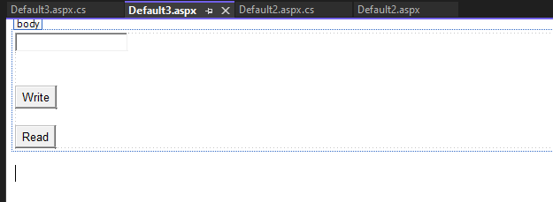

**Codes:**

<%@PageLanguage="C#"AutoEventWireup="true"CodeFile="Default3.aspx.cs"Inherits="Default3"%>

<!DOCTYPEhtml>

<htmlxmlns="<http://www.w3.org/1999/xhtml>">

<headrunat="server">

<title></title>

</head>

<body>

<formid="form1"runat="server">

<div>

<asp:TextBoxID="TextBox1"runat="server"></asp:TextBox>

<br/>

<br/>

<br/>

<asp:ButtonID="Button1"runat="server"OnClick="Button1_Click"Text="Write"/>

<br/>

<br/>

<asp:ButtonID="Button2"runat="server"OnClick="Button2_Click"Text="Read"/>

</div>

</form>

</body>

</html>

**CsCode:**

usingSystem;

using System.Collections.Generic;using System.Linq;

using System.Web;usingSystem.Web.UI;

usingSystem.Web.UI.WebControls;

publicpartialclassDefault3 :System.Web.UI.Page

{

protectedvoidPage_Load(objectsender,EventArgse)

{

}

protectedvoidButton1_Click(objectsender,EventArgse)

{

HttpCookiecook1=newHttpCookie("user1",TextBox1.Text);

Response.Cookies.Add(cook1);

}

protectedvoidButton2_Click(objectsender,EventArgse)

{

TextBox1.Text=Response.Cookies["user1"].Value;

}

**}**

CreateawebapplicationtodemonstrateuseofHtmlEditorExtenderAjaxcontrol.

1. →**RightClickOnToolbox**→**AddNewTab**

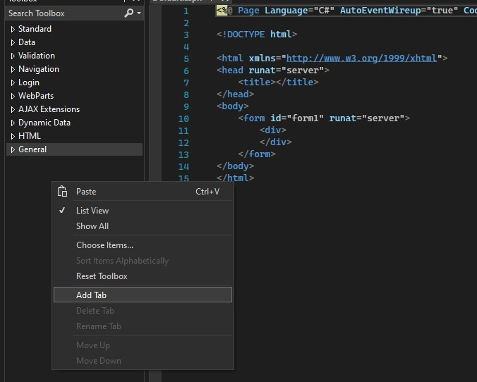

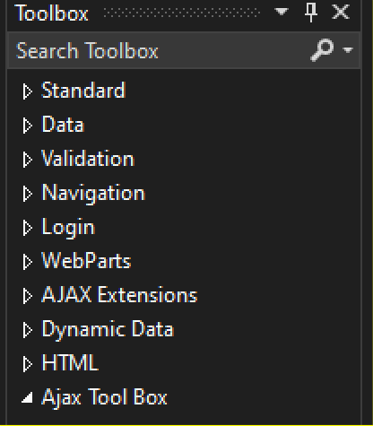

1. →**RightClickonSolutionExplorer**→**ManageNuGetPackages..**

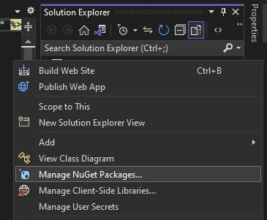

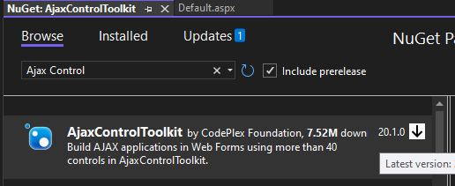

**InstallVersion:16.0.1**

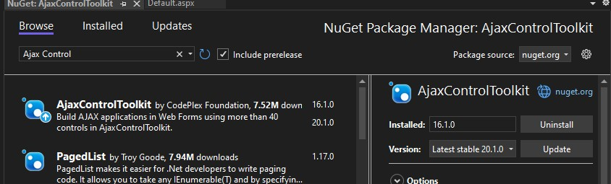

1. 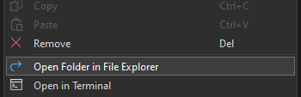→**Right ClickonSolution Explores**→**OpenfolderinFileExplorer**

**CopytheFollowingDirectory:**

**C:\Users\Admin\source\repos\AjaxControlToolkit\packages\AjaxControlToolkit.16.1.0.0\lib\net40**

**4**→**Again RightClickonAjaxControlToolkit**→**ChooseItems**

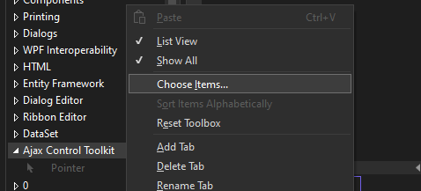

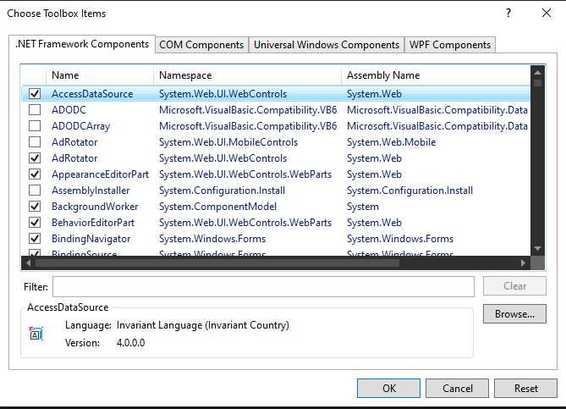

**PastethatDirectory**

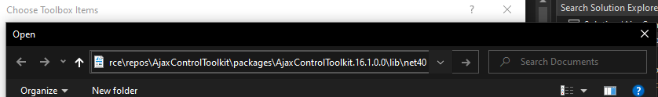

YouWillFind**HtmlEditorExtender**

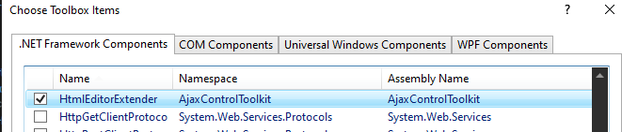

**Codes:**

<%@PageLanguage="C#"AutoEventWireup="true"CodeFile="Default.aspx.cs"Inherits="_Default"%>

<!DOCTYPEhtml>

<htmlxmlns="<http://www.w3.org/1999/xhtml>">

<headrunat="server">

<title></title>

<styletype="text/css">

.auto-style1{

text-align:center;

}

</style>

</head>

<body>

<formid="form1"runat="server">

<div>

<h1class="auto-style1">CodeBySatyam09</h1>

</div>

<asp:TextBox ID="TextBox1" runat="server" Height="228px" TextMode="MultiLine"Width="513px"></asp:TextBox>

<ajaxToolkit:HtmlEditorExtender EnableSanitization="false" ID="TextBox1_HtmlEditorExtender"runat="server"BehaviorID="TextBox1_HtmlEditorExtender"TargetControlID="TextBox1">

</ajaxToolkit:HtmlEditorExtender>

<asp:ScriptManagerID="ScriptManager1"runat="server">

</asp:ScriptManager>

<br/>

</form>

</body>

</html>

CreateawebapplicationtodemonstrateuseofMasterPagewithapplying StylesandThemesforpagebeautification.

MasterPage:

<%@MasterLanguage="C#"AutoEventWireup="true"CodeFile="MasterPage2.master.cs"Inherits="MasterPage2"

%>

<!DOCTYPEhtml>

<html>

<headrunat="server">

<title></title>

<asp:ContentPlaceHolderid="head"runat="server">

</asp:ContentPlaceHolder>

</head>

<body>

<formid="form1"runat="server">

<div class ="head">head

</div>

<asp:ContentPlaceHolderid="ContentPlaceHolder1"runat="server">

</asp:ContentPlaceHolder>

<div class ="foot">foot

</div>

</form>

</body>

</html>

Style:

body{

background-color:green;

}

.head{

border: thick solid #ff6a00;height:200px;

background-color:aqua

}

.foot{

border: thick solid yellow;height:200px;

}

Default.aspx:

<%@PageTitle=""EnableTheming="true"Theme="green"Language="C#"MasterPageFile="~/MasterPage2.master"AutoEventWireup="true"CodeFile="Default2.aspx.cs"Inherits="Default2"

%>

<asp:ContentID="Content1"ContentPlaceHolderID="head"Runat="Server">

</asp:Content>

<asp:Content ID="Content2" ContentPlaceHolderID="ContentPlaceHolder1" Runat="Server">Numan

MufiArfat

FarazSatyamHussainAyaan

</asp:Content>

CreateawebapplicationtodemonstrateFormSecurityandWindowsSecuritywithproperAuthenticationandAuthorizationproperties.

**Code:**

**AdminHome.aspx-**

**<%@Page Language="C#"AutoEventWireup="true"CodeFile="AdminHome.aspx.cs"Inherits="Admin_AdminHome"%>**

**<!DOCTYPEhtmlPUBLIC"-//W3C//DTDXHTML1.0Transitional//EN""**[**http://www.w3.org/TR/xhtml1/DTD/xhtml1-transitional.dtd**](http://www.w3.org/TR/xhtml1/DTD/xhtml1-transitional.dtd)**">**

**<htmlxmlns="**[**http://www.w3.org/1999/xhtml**](http://www.w3.org/1999/xhtml)**">**

**<headrunat="server">**

**<title></title>**

**</head>**

**<body>**

**<formid="form1"runat="server">**

**<div>**

**<h1>ThisisAdminPage</h1>**

**</div>**

**</form>**

**</body>**

**</html>**

**StaffHome.aspx-**

**<%@ Page Language="C#" AutoEventWireup="true" CodeFile="StaffHome.aspx.cs"Inherits="StaffHome"%>**

**<!DOCTYPEhtmlPUBLIC"-//W3C//DTDXHTML1.0Transitional//EN""**[**http://www.w3.org/TR/xhtml1/DTD/xhtml1-transitional.dtd**](http://www.w3.org/TR/xhtml1/DTD/xhtml1-transitional.dtd)**">**

**<htmlxmlns="**[**http://www.w3.org/1999/xhtml**](http://www.w3.org/1999/xhtml)**">**

**<headrunat="server">**

**<title></title>**

**</head>**

**<body>**

**<formid="form1"runat="server">**

**<div>**

**<h1>ThisisStaffPage</h1>**

**</div>**

**</form>**

**</body>**

**</html>**

**StudentHome.aspx-**

**<%@Page Language="C#"AutoEventWireup="true"CodeFile="StudentHome.aspx.cs"Inherits="StudentHome"%>**

**<!DOCTYPEhtmlPUBLIC"-//W3C//DTDXHTML1.0Transitional//EN""**[**http://www.w3.org/TR/xhtml1/DTD/xhtml1-transitional.dtd**](http://www.w3.org/TR/xhtml1/DTD/xhtml1-transitional.dtd)**">**

**<htmlxmlns="**[**http://www.w3.org/1999/xhtml**](http://www.w3.org/1999/xhtml)**">**

**<headrunat="server">**

**<title></title>**

**</head>**

**<body>**

**<formid="form1"runat="server">**

**<div>**

**<h1>Thisisstudetnpage</h1>**

**</div>**

**</form>**

**</body>**

**</html>**

**login.aspx-**

**<%@ Page Language="C#" AutoEventWireup="true" CodeFile="login.aspx.cs"Inherits="login"%>**

**<!DOCTYPEhtmlPUBLIC"-//W3C//DTDXHTML1.0Transitional//EN""**[**http://www.w3.org/TR/xhtml1/DTD/xhtml1-transitional.dtd**](http://www.w3.org/TR/xhtml1/DTD/xhtml1-transitional.dtd)**">**

**<htmlxmlns="**[**http://www.w3.org/1999/xhtml**](http://www.w3.org/1999/xhtml)**">**

**<headrunat="server">**

**<title></title>**

**</head>**

**<body>**

**<formid="form1"runat="server">**

**<div>**

**<asp:LoginID="Login1"runat="server">**

**</asp:Login>**

**</div>**

**</form>**

**</body>**

**</html>**

**Home.aspx-**

**<%@ Page Language="C#" AutoEventWireup="true" CodeFile="Home.aspx.cs"Inherits="Home"%>**

**<!DOCTYPEhtmlPUBLIC"-//W3C//DTDXHTML1.0Transitional//EN""**[**http://www.w3.org/TR/xhtml1/DTD/xhtml1-transitional.dtd**](http://www.w3.org/TR/xhtml1/DTD/xhtml1-transitional.dtd)**">**

**<htmlxmlns="**[**http://www.w3.org/1999/xhtml**](http://www.w3.org/1999/xhtml)**">**

**<headid="Head1"runat="server">**

**<title></title>**

**</head>**

**<body>**

**<formid="form1"runat="server">**

**<div>**

**<asp:HyperLink ID="HyperLink1" runat="server" Font-Size="Large"NavigateUrl="~/Admin/AdminHome.aspx">Admin</asp:HyperLink>**

**<br/>**

**<br/>**

**<asp:HyperLinkID="HyperLink2"runat="server"Font-Size="Large"NavigateUrl="~/Staff/StaffHome.aspx">Staff</asp:HyperLink>**

**<br/>**

**<br/>**

**<asp:HyperLink ID="HyperLink3" runat="server" Font-Size="Large"NavigateUrl="~/Student/StudentHome.aspx">Student</asp:HyperLink>**

**</div>**

**</form>**

**</body>**

**</html>**

CreateawebapplicationtodemonstrateGridViewpagingandCreatingown tableformatusingGrid View.

**Grid View:**

<%@PageLanguage="C#"AutoEventWireup="true"CodeFile="Default.aspx.cs"Inherits="_Default"%>

<!DOCTYPEhtml>

<htmlxmlns="<http://www.w3.org/1999/xhtml>">

<headrunat="server">

<title></title>

</head>

<body>

<formid="form1"runat="server">

<div>

<asp:DetailsViewID="DetailsView1"runat="server"Height="50px"Width="125px">

</asp:DetailsView>

<br/>

<asp:LabelID="Label1"runat="server"Text="Label"></asp:Label>

<br/>

<br/>

<asp:GridView ID="GridView1" runat="server" AllowPaging="True" AllowSorting="True"AutoGenerateColumns="False"DataKeyNames="RollNo"DataSourceID="SqlDataSource1">

<Columns>

<asp:CommandFieldShowDeleteButton="True"ShowEditButton="True"ShowSelectButton="True"/>

<asp:BoundFieldDataField="RollNo"HeaderText="RollNo"ReadOnly="True"SortExpression="Roll

No" />Name"/>

<asp:BoundFieldDataField="StudentName"HeaderText="StudentName"SortExpression="Student

<asp:BoundFieldDataField="Address"HeaderText="Address"SortExpression="Address"/>

</Columns>

</asp:GridView>

<br/>

<asp:SqlDataSource ID="SqlDataSource1" runat="server" ConnectionString="<%$ConnectionStrings:DatabaseConnectionString%>"DeleteCommand="DELETEFROM[Student]WHERE[RollNo]

= @Roll_No" InsertCommand="INSERT INTO [Student] ([Roll No], [Student Name], [Address]) VALUES(@Roll_No, @Student_Name, @Address)" SelectCommand="SELECT * FROM [Student]"UpdateCommand="UPDATE [Student] SET [Student Name] = @Student_Name, [Address] = @Address WHERE[RollNo]=@Roll_No">

<DeleteParameters>

<asp:ParameterName="Roll_No"Type="Int32"/>

</DeleteParameters>

<InsertParameters>

<asp:ParameterName="Roll_No"Type="Int32"/>

<asp:ParameterName="Student_Name"Type="String"/>

<asp:ParameterName="Address"Type="String"/>

</InsertParameters>

<UpdateParameters>

<asp:ParameterName="Student_Name"Type="String"/>

<asp:ParameterName="Address"Type="String"/>

<asp:ParameterName="Roll_No"Type="Int32"/>

</UpdateParameters>

</asp:SqlDataSource>

</div>

</form>

</body></html>

Createawebapplicationtobinddatainamultilinetextboxbyqueryinginanothertextbox.

**Design:**

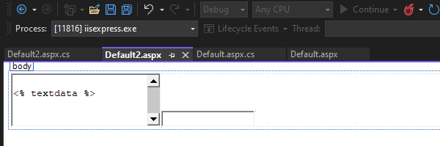

**Code:**

<%@PageLanguage="C#"AutoEventWireup="true"CodeFile="Default2.aspx.cs"Inherits="Default2"%>

<!DOCTYPEhtml>

<htmlxmlns="<http://www.w3.org/1999/xhtml>">

<headrunat="server">

<title></title>

</head>

<body>

<formid="form1"runat="server">

<div>

<asp:TextBox ID="TextBox2" Text="<%textdata %>" runat="server" TextMode="MultiLine"Height="67px"Width="199px">&lt;%textdata %&gt;</asp:TextBox>

<asp:TextBox ID="TextBox3" runat="server" AutoPostBack="True"OnTextChanged="TextBox3_TextChanged"></asp:TextBox>

</div>

</form>

</body>

</html>

**Cscode:**

usingSystem;

using System.Collections.Generic;using System.Linq;

using System.Web;usingSystem.Web.UI;

usingSystem.Web.UI.WebControls;

publicpartialclassDefault2 :System.Web.UI.Page

{

publicstringtextdata;

protectedvoidPage_Load(objectsender,EventArgse)

{

}

protectedvoidTextBox3_TextChanged(objectsender,EventArgse)

{

textdata=TextBox3.Text;this.DataBind();

}

**}**

1. WriteaprogramtocreateaDLLtoprintafactorialofanumber.

**Design:**



**ClassLibrary:**

namespaceClassLibrary1

{

publicclassClass1

{

publicstringfact(intn)

{

int d=1;

for(inti=1;i<=n;i++)

{

d*=i;

}

returnd.ToString();

}

}

**}**

**Source:**

<%@PageLanguage="C#"AutoEventWireup="true"CodeFile="Default.aspx.cs"Inherits="_Default"%>

<!DOCTYPEhtml>

<htmlxmlns="<http://www.w3.org/1999/xhtml>">

<headrunat="server">

<title></title>

<styletype="text/css">

.auto-style1{

text-align:center;

}

.auto-style2 {color:#0099CC;

}

</style>

</head>

<body>

<formid="form1"runat="server">

<divclass="auto-style1">

<h3><spanclass="auto-style2">SatyamGuptaTYIT</span><brclass="auto-style2"/>

</h3>

<p>

&nbsp;</p>

</div>

<asp:TextBox ID="TextBox1" runat="server"></asp:TextBox>&nbsp;&nbsp;&nbsp;&nbsp;&nbsp;&nbsp;&nbsp;

<asp:Button ID="Button1" runat="server" OnClick="Button1_Click" Text="Button" />&nbsp;&nbsp;&nbsp;&nbsp;&nbsp;&nbsp;&nbsp;&nbsp;&nbsp;&nbsp;&nbsp;&nbsp;&nbsp;

<asp:TextBoxID="TextBox2"runat="server"></asp:TextBox>

</form>

</body>

</html>

**CS:**

usingSystem;

usingSystem.Collections.Generic;

using System.Linq;using System.Web;usingSystem.Web.UI;

using System.Web.UI.WebControls;usingClassLibrary1;

publicpartialclass_Default:System.Web.UI.Page

{

protectedvoidPage_Load(objectsender,EventArgse)

{

}

protectedvoidButton1_Click(objectsender,EventArgse)

{

Class1c=new Class1();

TextBox2.Text=c.fact(Convert.ToInt32(TextBox1.Text));

}

**}**

1. WriteanApplicationto:
2. GenerateFibonacciseries
3. **Testforprimenumbers**
4. Testforvowels
5. **Reverseanumber**

**Design:**

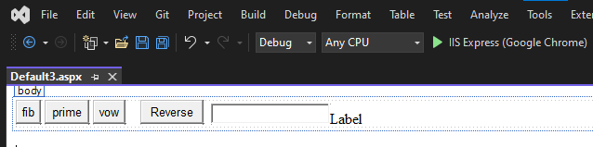

**Code:**

<%@PageLanguage="C#"AutoEventWireup="true"CodeFile="Default3.aspx.cs"Inherits="Default3"%>

<!DOCTYPEhtml>

<htmlxmlns="<http://www.w3.org/1999/xhtml>">

<headrunat="server">

<title></title>

</head>

<body>

<formid="form1"runat="server">

<div>

<asp:ButtonID="Button1"runat="server"OnClick="Button1_Click"Text="fib"/>

&nbsp;<asp:Button ID="Button3" runat="server" OnClick="Button3_Click" style="width: 48px" Text="prime" />&nbsp;<asp:Button ID="Button4" runat="server" OnClick="Button4_Click" style="width: 35px" Text="vow" />&nbsp;&nbsp;&nbsp;

<asp:ButtonID="Button5"runat="server"OnClick="Button5_Click"Text="Reverse"/>

&nbsp;

<asp:TextBoxID="TextBox1"runat="server"></asp:TextBox>

<asp:LabelID="Label1"runat="server"Text="Label"></asp:Label>

</div>

</form>

</body>

</html>

**Code:**

usingSystem;

using System.Collections.Generic;using System.Linq;

using System.Web;usingSystem.Web.UI;

usingSystem.Web.UI.WebControls;

publicpartialclassDefault3 :System.Web.UI.Page

{

protectedvoidPage_Load(objectsender,EventArgse)

{

}

protectedvoidButton1_Click(objectsender,EventArgse)

{

Label1.Text=fib(Convert.ToInt32(TextBox1.Text));

}

publicstringfib(intlimit)

{

int x = 0;int y = 1;intz;

string st=x+","+y+",";for(inti=0;i<10;i++)

{

z=x+y;x=y;

y=z;

if(z> limit)

{

break;

}

st+=z+",";

}

returnst;

}

publicstringprime(int num)

{

for(inti=2;i<num;i++)

{

if(num % i==0)

{

return"Yes";

}

}

return"No";

}

publicstringvow(stringc)

{

if("aeiou".Contains(c))

{

return"vow";

}

else

{

return"Novowel";

}

}

protectedvoidButton3_Click(objectsender,EventArgse)

{

Label1.Text=prime(Convert.ToInt32(TextBox1.Text));

}

protectedvoidButton4_Click(objectsender,EventArgse)

{

Label1.Text=vow(TextBox1.Text);

}

protectedvoidButton5_Click(objectsender,EventArgse)

{

Label1.Text="";

for(inti= TextBox1.Text.Length -1;i>-1;i--)

{

Label1.Text+=TextBox1.Text[i];

}

}

}

1. CreateasimplewebpagetodemonstrateuseofbuiltinDivideByZeroException and IndexOutOfRangeException exceptions usingtextboxand labelcontrol.

Default.aspx:

<%@PageLanguage="C#"AutoEventWireup="true"CodeFile="Default2.aspx.cs"Inherits="Default2"%>

<!DOCTYPEhtml>

<htmlxmlns="<http://www.w3.org/1999/xhtml>">

<headrunat="server">

<title></title>

</head>

<body>

<formid="form1"runat="server">

<div>

<asp:ButtonID="Button1"runat="server"OnClick="Button1_Click"Text="Button"/>

</div>

</form>

</body>

</html>

Code:

usingSystem;

using System.Collections.Generic;using System.Linq;

using System.Web;usingSystem.Web.UI;

usingSystem.Web.UI.WebControls;

publicpartialclassDefault2 :System.Web.UI.Page

{

protectedvoidPage_Load(objectsender,EventArgse)

{

}

protectedvoidButton1_Click(objectsender,EventArgse)

{

try

{

string[] arr = new string[3];arr[0]="a";

arr[1]="b";

arr[2]="c";

int a = 10;int b = 20;intc= a /b;

}

catch(IndexOutOfRangeExceptionior)

{

Response.Write(ior.ToString());

}

catch(DivideByZeroExceptiondbz)

{

Response.Write(dbz.ToString());

}

}

}

1. Create a simple web page to show data in Tree view control and datalistusingweb.Sitemapfile containingnavigationinformation.

**Design:**

<%@PageLanguage="C#"AutoEventWireup="true"CodeFile="Default3.aspx.cs"Inherits="Default3"%>

<!DOCTYPEhtml>

<htmlxmlns="<http://www.w3.org/1999/xhtml>">

<headrunat="server">

<title></title>

</head>

<body>

<formid="form1"runat="server">

<div>

<asp:TreeViewID="TreeView1"runat="server"DataSourceID="SiteMapDataSource1">

</asp:TreeView>

<asp:SiteMapDataSource ID="SiteMapDataSource1" runat="server" />@SatyamGupta

</div>

</form>

</body>

</html>

Sitemap:

<?xmlversion="1.0"encoding="utf-8"?>

<siteMapxmlns="<http://schemas.microsoft.com/AspNet/SiteMap-File-1.0>">

<siteMapNodeurl="Numan.com"title=""description="Numan">

<siteMapNodeurl="yahoomail.com"title="yahoomail"description="mail">

<siteMapNodeurl="sportsnews1.com"title="sports1"description="sports"/>

</siteMapNode>

<siteMapNodeurl="yahoonews.com"title="yahoonews"description="news">

<siteMapNodeurl="sportsnews.com"title="sports"description="sports"/>

<siteMapNodeurl="gloabalnews.com"title="global"description="gloabal"/>

</siteMapNode>

</siteMapNode>

</siteMap>

1. Displaytheno.ofvisitorsonagivenwebpage.

**Default.aspx:**

<%@PageLanguage="C#"AutoEventWireup="true"CodeFile="Default4.aspx.cs"Inherits="Default4"%>

<!DOCTYPEhtml>

<htmlxmlns="<http://www.w3.org/1999/xhtml>">

<headrunat="server">

<title></title>

</head>

<body>

<formid="form1"runat="server">

<div>

</div>

</form>

</body>

</html>

**Code:**

usingSystem;

using System.Collections.Generic;using System.Linq;

using System.Web;usingSystem.Web.UI;

usingSystem.Web.UI.WebControls;

publicpartialclassDefault4 :System.Web.UI.Page

{

protectedvoidPage_Load(objectsender,EventArgse)

{

Response.Write(Application["usercount"].ToString());

}

}

**Global.asax:**

<%@Application Language="C#"%>

<scriptrunat="server">

voidApplication_Start(objectsender,EventArgse)

{

//Codethatrunson applicationstartup

}

voidApplication_End(objectsender,EventArgse)

{

//Codethatrunson applicationshutdown

}

voidApplication_Error(objectsender,EventArgse)

{

//Codethatrunswhenanunhandlederroroccurs

}

voidSession_Start(objectsender,EventArgse)

{

Application.Lock();

Application["usercount"]=Convert.ToInt32(Application["usercount"])+1;

Application.UnLock();

}

voidSession_End(objectsender,EventArgse)

{

}

</scrip>

27. Create a registration form having text fields for accepting, Name, Age,Email, Address and Mobile number. Perform the following validations forthesame:

1. Allfieldsneedtobefilledcompulsorily
2. **Nameshouldcontainonlyalphabetsandshouldnotbemorethan25characterslong**
3. Validateemailandmobilenumberappropriately
4. **Ageshouldbebetween18and32only.**

Include submit and cancel buttons. On click of submit button, open a new pageanddisplayalltheinformationenteredbytheuserandonclickofcancelbutton,all textfieldsshouldbecleared.

**Design:**

**Default.aspx:**

<%@PageLanguage="C#"AutoEventWireup="true"CodeFile="Default.aspx.cs"Inherits="_Default"%>

<!DOCTYPEhtml>

<htmlxmlns="<http://www.w3.org/1999/xhtml>">

<headrunat="server">

<title></title>

<styletype="text/css">

.auto-style1{

text-align: center;color: #006600;font-size:large;

}

.auto-style2 {width:85px;

}

</style>

</head>

<body>

<formid="form1"runat="server">

<div>

<tablestyle="width:100%;">

<tr>

<tdclass="auto-style1"colspan="3"><strong>Registration</strong></td>

</tr>

<tr>

<tdclass="auto-style2">NAME:</td>

<td>

<asp:TextBoxID="TextBox1"runat="server"></asp:TextBox>

<asp:RequiredFieldValidator ID="RequiredFieldValidator1" runat="server"ControlToValidate="TextBox1" Display="Dynamic" ErrorMessage="*"ForeColor="Red"></asp:RequiredFieldValidator>

<asp:RegularExpressionValidator ID="RegularExpressionValidator1" runat="server"ControlToValidate="TextBox1" Display="Dynamic" ErrorMessage="Only Aphabets and not more than 25Characters"ForeColor="Red"ValidationExpression="[a-zA-Z]{5,25}"></asp:RegularExpressionValidator>

</td>

<td>&nbsp;</td>

</tr>

<tr>

<tdclass="auto-style2">AGE:</td>

<td>

<asp:TextBoxID="TextBox2"runat="server"></asp:TextBox>

<asp:RequiredFieldValidator ID="RequiredFieldValidator2" runat="server"ControlToValidate="TextBox2" Display="Dynamic" ErrorMessage="*"ForeColor="Red"></asp:RequiredFieldValidator>

<asp:RangeValidator ID="RangeValidator1" runat="server" ControlToValidate="TextBox2"Display="Dynamic" ErrorMessage="18 to 32 Only" ForeColor="Red" MaximumValue="32" MinimumValue="18"Type="Integer"></asp:RangeValidator>

</td>

<td>&nbsp;</td>

</tr>

<tr>

<tdclass="auto-style2">EMAIL:</td>

<td>

<asp:TextBoxID="TextBox3"runat="server"></asp:TextBox>

<asp:RequiredFieldValidator ID="RequiredFieldValidator3" runat="server"ControlToValidate="TextBox3" Display="Dynamic" ErrorMessage="*"ForeColor="Red"></asp:RequiredFieldValidator>

<asp:RegularExpressionValidator ID="RegularExpressionValidator2" runat="server"ControlToValidate="TextBox3" Display="Dynamic" ErrorMessage="Invalid Email" ForeColor="Red"ValidationExpression="\w+([-+.']\w+)*@\w+([-.]\w+)*\.\w+([-.]\w+)*"></asp:RegularExpressionValidator>

</td>

<td>&nbsp;</td>

</tr>

<tr>

<tdclass="auto-style2">ADDRESS:</td>

<td>

<asp:TextBoxID="TextBox4"runat="server"></asp:TextBox>

<asp:RequiredFieldValidator ID="RequiredFieldValidator4" runat="server"ControlToValidate="TextBox4" Display="Dynamic" ErrorMessage="*"ForeColor="Red"></asp:RequiredFieldValidator>

</td>

<td>&nbsp;</td>

</tr>

<tr>

<tdclass="auto-style2">PHONE:</td>

<td>

<asp:TextBoxID="TextBox5"runat="server"></asp:TextBox>

<asp:RequiredFieldValidator ID="RequiredFieldValidator5" runat="server"ControlToValidate="TextBox5" Display="Dynamic" ErrorMessage="*"ForeColor="Red"></asp:RequiredFieldValidator>

<asp:RegularExpressionValidator ID="RegularExpressionValidator3" runat="server"ControlToValidate="TextBox5" Display="Dynamic" ErrorMessage="Invalid Phone" ForeColor="Red"ValidationExpression="\d{10}"></asp:RegularExpressionValidator>

</td>

<td>&nbsp;</td>

</tr>

<tr>

<tdclass="auto-style2">&nbsp;</td>

<td>

<asp:Button ID="Button1" runat="server" OnClick="Button1_Click" Text="SUBMIT" />&nbsp;&nbsp;&nbsp;

<asp:ButtonID="Button2"runat="server"OnClick="Button2_Click"Text="CLEAR"/>

</td>

<td>&nbsp;</td>

</tr>

</table>

</div>

</form>

</body>

</html>

**Default.aspx.cs:**

usingSystem;

using System.Collections.Generic;using System.Linq;

using System.Web;usingSystem.Web.UI;

usingSystem.Web.UI.WebControls;

publicpartialclass_Default:System.Web.UI.Page

{

protectedvoidPage_Load(objectsender,EventArgse)

{

}

protectedvoidButton1_Click(objectsender,EventArgse)

{

Response.Redirect("Default2.aspx?na="+TextBox1.Text+"&ag="+TextBox2.Text+"&em="+TextBox3.Text+"&ad="

+TextBox4.Text

+"&Ph="+TextBox5.Text+"");

}

protectedvoidButton2_Click(objectsender,EventArgse)

{

TextBox1.Text = "";TextBox2.Text = "";TextBox3.Text = "";TextBox4.Text = "";TextBox5.Text="";

}

**}**

**Default2.aspx:**

<%@PageLanguage="C#"AutoEventWireup="true"CodeFile="Default2.aspx.cs"Inherits="Default2"%>

<!DOCTYPEhtml>

<htmlxmlns="<http://www.w3.org/1999/xhtml>">

<headrunat="server">

<title></title>

</head>

<body>

<formid="form1"runat="server">

<div>

</div>

</form>

</body>

</html>

**Default2.aspx.cs**

usingSystem;

using System.Collections.Generic;using System.Linq;

using System.Web;usingSystem.Web.UI;

usingSystem.Web.UI.WebControls;

publicpartialclassDefault2 :System.Web.UI.Page

{

protectedvoidPage_Load(objectsender,EventArgse)

{

Response.Write(Request.QueryString["na"]+"<br>");Response.Write(Request.QueryString["ag"]+"<br>");Response.Write(Request.QueryString["em"]+"<br>");Response.Write(Request.QueryString["ad"]+"<br>");Response.Write(Request.QueryString["Ph"]+"<br>");

}

}

1. Createawebpagewithmultilinetextboxandtwobuttons,viz.saveContents and loadContents. On click of saveContents button, contentsfromthetextboxshouldberetainedandonclickofloadContentsbutton,thepreviouslysavedcontentsshouldbe displayedbackonthe textbox.

**Design:**

Codes:

<%@PageLanguage="C#"AutoEventWireup="true"CodeFile="Default6.aspx.cs"Inherits="Default6"%>

<!DOCTYPEhtml>

<htmlxmlns="<http://www.w3.org/1999/xhtml>">

<headrunat="server">

<title></title>

<styletype="text/css">

.auto-style1{

text-align:center;

}

</style>

</head>

<body>

<formid="form1"runat="server">

<divclass="auto-style1">

<h1>

<asp:TextBox ID="TextBox2" runat="server" CssClass="auto-style1" Height="129px"TextMode="MultiLine"Width="239px"></asp:TextBox>

<asp:ButtonID="Button1"runat="server"OnClick="Button1_Click"Text="SaveContent"/>

&nbsp;

<asp:ButtonID="Button2"runat="server"OnClick="Button2_Click"Text="LoadContent"/>

<br/>

SatyamGupta</h1>

</div>

</form>

</body>

</html>

**CScode:**

usingSystem;

using System.Collections.Generic;using System.Linq;

using System.Web;usingSystem.Web.UI;

usingSystem.Web.UI.WebControls;

publicpartialclassDefault6 :System.Web.UI.Page

{

stringdata= "";

protectedvoidPage_Load(objectsender,EventArgse)

{

}

protectedvoidButton1_Click(objectsender,EventArgse)

{

ViewState["data"]=TextBox2.Text;TextBox2.Text="";

}

protectedvoidButton2_Click(objectsender,EventArgse)

{

TextBox2.Text=ViewState["data"].ToString();

}

**}**

1. Store 3 objects of the furniture class having 3 data members (name,manufacturer, and cost) in 3 session objects. Display a panel to include alistbox displaying the names of all three furniture objects, and a buttonnamed “MoreInformation”. On click of the button retrieve the selectedobject(fromlistbox) informationand display itina label.

**Codes:**

<%@PageLanguage="C#"AutoEventWireup="true"CodeFile="Default7.aspx.cs"Inherits="Default7"%>

<!DOCTYPEhtml>

<htmlxmlns="<http://www.w3.org/1999/xhtml>">

<headrunat="server">

<title></title>

<style type="text/css">#form1 {

text-align:center;

}

.auto-style1{color:#66FFCC;

}

</style>

</head>

<body>

<formid="form1"runat="server">

<div>

</div>

<asp:ListBoxID="ListBox1"runat="server"></asp:ListBox>

<asp:Button ID="Button1" runat="server" OnClick="Button1_Click" Text="Button" />&nbsp;<asp:LabelID="Label1"runat="server"Text="Label"></asp:Label>

<br/>

<br/>

<br/>

<spanclass="auto-style1">CodeBySatyam</span></form>

</body>

</html>

**CsCode:**

usingSystem;

using System.Collections.Generic;using System.Linq;

using System.Web;usingSystem.Web.UI;

usingSystem.Web.UI.WebControls;

publicpartialclassDefault7 :System.Web.UI.Page

{

protectedvoidPage_Load(objectsender,EventArgse)

{

if(!IsPostBack)

{

Session["s1"] = new Furniture("chair1", "xyz1", "1001");Session["s2"] = new Furniture("chair2", "xyz2", "1002");Session["s3"]=newFurniture("chair3","xyz3", "1003");

ListBox1.Items.Add(((Furniture)Session["s1"]).name);ListBox1.Items.Add(((Furniture)Session["s2"]).name);ListBox1.Items.Add(((Furniture)Session["s3"]).name);

}

}

protectedvoidButton1_Click(objectsender,EventArgse)

{

if(ListBox1.SelectedIndex!= -1)

{

if(ListBox1.SelectedIndex== 0)

{

Label1.Text=((Furniture)Session["s1"]).money;Label1.Text=((Furniture)Session["s1"]).cost;

}

elseif(ListBox1.SelectedIndex==1)

{

Label1.Text=((Furniture)Session["s2"]).money;Label1.Text=((Furniture)Session["s2"]).cost;

}

elseif(ListBox1.SelectedIndex==2)

{

Label1.Text=((Furniture)Session["s3"]).money;Label1.Text=((Furniture)Session["s3"]).cost;

}

}

}

}

class Furniture

{

public string name;public string money;publicstringcost;

publicFurniture(stringname,stringmoney,stringcost)

{

this.name = name;this.money = money;this.cost=cost;

}

1. WriteaprograminC#todemonstratemultipleinheritanceusinginterfaces.

**Code:**

usingSystem;

publicclassProgram

{

publicinterfacecommon

{

voidDisplayed();

}

publicclass A :common

{

publicvoidDisplayed()

{

Console.WriteLine("ThisisthemethodofClassA");

}

}

publicclass B:common

{

publicvoidDisplayed()

{

Console.WriteLine("ThisisthemethodofClassB");

}

}

publicstaticvoidMain()

{

Console.WriteLine("Code by Satyam 09"); Console.WriteLine("Multiple Interface Using Interface"); common c;c=newA();c.Displayed();c=newB();c.Displayed();Console.ReadLine();

}

}