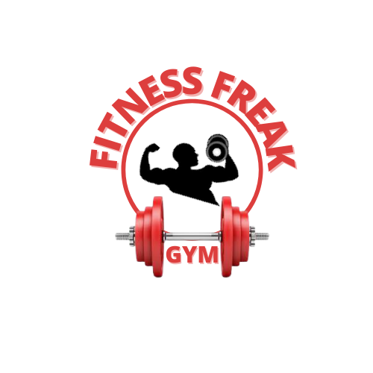

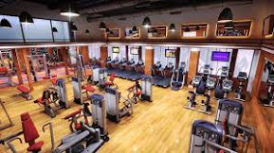
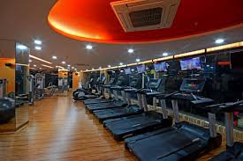

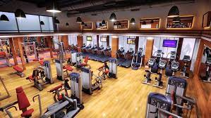

Fitness Freak Gym was established in 2017 with an initial capital of 10 lakhs. Head office at Park Street, Kolkata, West Bengal. We completed 5 years and more than 1000 peoples to achiEve their fitness goal. last year we awarded best the gym in the town award. we started with one branch but now currently we have 5 branches in the city.
Everyone wants to stay fit and healthy. we follow different exercise videos, healthy food videos, dieting, but we cannot succeed in losing our weights, body fats by rigorous efforts because we don't follow the right technique. Don't worry we are with you. join Fitness Freak Gym and reach your target. our gym provides you lots of facilities. our gym's silent features are:
1. We provide different types of exercise machines like Power Rack/ Full Rack, Squat Rack, Cable Crossover machine, Power Tower, Adjustable Weight Bench, Hammer Strength Machine, Chest Press Machine, Pec Deck Machine, Preacher Curl Bench, Lat Pulldown Machine, Roman Chair, Leg press machine, etc.
2. Open Monday to Saturday from 7 am to 10 pm. our package are; 1 month- 2000rs. 3 month-4000rs. 1 year- 6000rs.
3. We provide different types of Diet Plans to our customers according to their health conditions.
4. We provide free trainers to our members.
5. Free monthly BMI (Body Mass Index) Test.
6. Separate changing room for men and women.
7. Fully Airconditioned Gym.
8. We give free Health Supplements like Protein shakes, Protein Bars, Energy drinks after exercise.
9. As we all know about the current covid19 situation so keeping in mind we sanitize our store daily.
10. Locker facility available for your valuable belongings.
11. We provide once in a week free Zumba classes.
12. we five free E-Books of exercises and food receipes.
**Only people who take vaccine of covid19 are allowed to take membership.
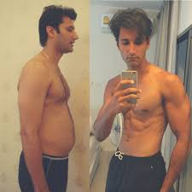
Meet Mr. RAM, he is one of our customers when he joined our gym he was 80 kg but now he is 65 kg and he also builds his muscles.

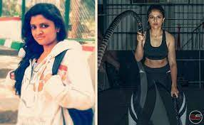

Meet Mrs. Seema, when she joined our gym she was 70 kg but after joining our gym now she is 60 kg. and loss 10 kg weight.
More than 1000 customers attain their target by joining our gym. If you want to also attain your dream of reducing weight and live healthy don't waste your time. Grab our offer and join it now by visiting our nearest stores or call 022-56748.

