Database Design • SQL Queries • Joins • Subqueries • Set Operations

MINI PROJECT

Objective: -
- Use the provided DDLs to create the following tables
(a). Customers
(b). Products
(c). Orders
(d). Order Items
(e). Payments

- Use the Provided DMLs to insert data into the tables created
- Construct SQL queries to answer the given business questions

Table Structures

Customers
Column Name | Data Type | Constraints | Description
Customer_id | Int | PRIMARY KEY, AUTO INCREMENT | Unique id for each customer
name | Varchar(100) | NOT NULL | Full name of customer
Email | Varchar(100) | Unique, not null | Unique email address
Phone | VARCHAR(15) |  | Optional phone number
Created at | DATETIME | Default current timestamp | Account creation timestamp

Products
Column Name | Data Type | Constraints | Description
product_id | INT | PRIMARY KEY, AUTO_INCREMENT | Unique product ID
name | VARCHAR(100) | NOT NULL | Name of the product
category | VARCHAR(50) | NOT NULL | Product category (e.g., Electronics)
price | DECIMAL(10,2) | NOT NULL | CHECK (price > 0) Product price
stock_quantity | INT | NOT NULL | DEFAULT 0 Units available in stock
added_on | DATE | DEFAULT CURRENT_TIMESTAMP | Date product was added

Orders
Column Name | Data Type | Constraints | Description
order_id | INT | PRIMARY KEY, AUTO_INCREMENT | Unique order ID
customer_id | INT | FOREIGN KEY REFERENCES customers(customer_id) | Who placed the order
order_date | DATETIME | DEFAULT CURRENT_TIMESTAMP | When the order was placed
status | VARCHAR(20) | DEFAULT 'Pending' | Order status (Pending, Shipped, etc)
total_amount | DECIMAL(10,2) |  | Calculated total

Order Items
Column Name | Data Type | Constraints | Description
order_item_id | INT | PRIMARY KEY, AUTO_INCREMENT | Unique ID for each line item
order_id | INT | FOREIGN KEY REFERENCES orders(order_id) | Order to which item belongs
product_id | INT | FOREIGN KEY REFERENCES products(product_id) | Which product was bought
quantity | INT | NOT NULL | CHECK (quantity > 0) Quantity ordered
item_price | DECIMAL(10,2) | NOT NULL | Snapshot of product price at order

Payments
Column Name | Data Type | Constraints | Description
payment_id | INT | PRIMARY KEY, AUTO_INCREMENT | Unique ID for payment
order_id | INT | FOREIGN KEY REFERENCES orders(order_id) | Which order was paid for
payment_date | DATETIME | DEFAULT CURRENT_TIMESTAMP | When payment was made
amount_paid | DECIMAL(10,2) | NOT NULL | CHECK (amount_paid > 0) Amount paid
method | VARCHAR(20) | NOT NULL | Method (Credit Card, UPI, etc.)

Product Reviews
Column Name | Data Type | Constraints | Description
review_id | INT | PRIMARY KEY, AUTO_INCREMENT | Unique ID for review
product_id | INT | FOREIGN KEY REFERENCES products(product_id) | Which product is reviewed
customer_id | INT | FOREIGN KEY REFERENCES customers(customer_id) | Who gave the review
rating | INT | NOT NULL CHECK (rating BETWEEN 1 AND 5) | Star rating
review_text | TEXT |  | Review message
review_date | DATE | DEFAULT CURRENT_TIMESTAMP | When the review was posted

DDL Scripts

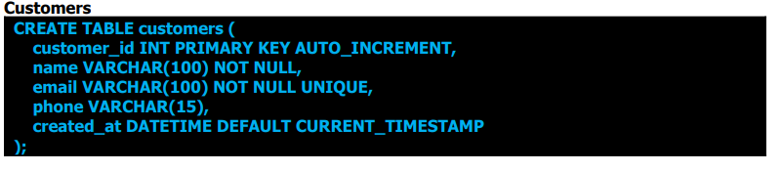
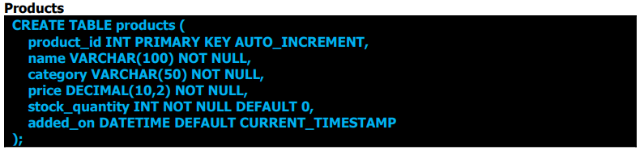
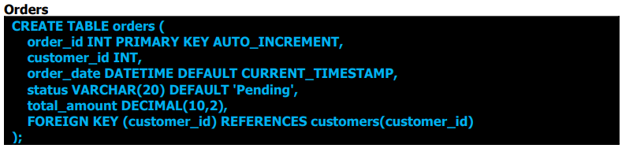
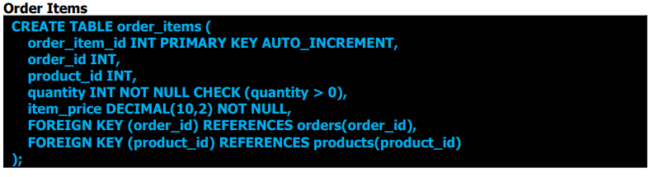
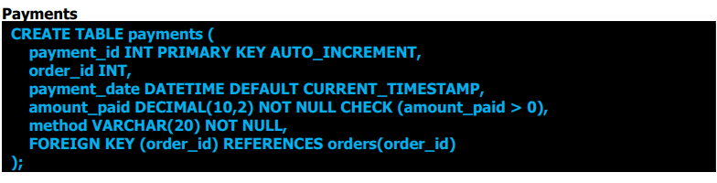
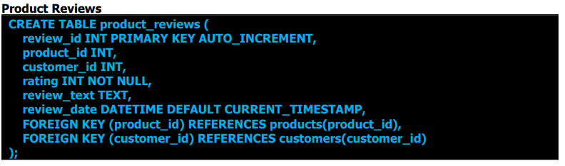

ER Diagram

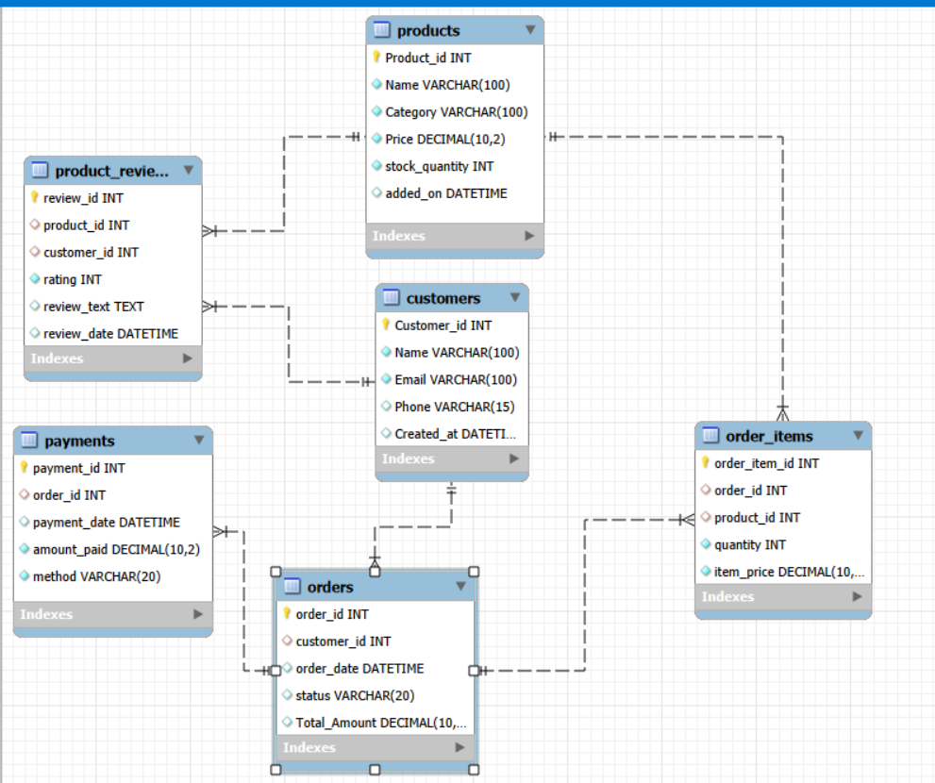

DATA QUERY LANGUAGE

Level 1: Basics
1. SELECT with column names
2. SELECT * (all columns)
3. DISTINCT keyword
4. WHERE clause with: o Comparison operators (=, !=, , <=, >=) o BETWEEN, IN, NOT IN, LIKE
5. Logical operators: AND, OR, NOT
6. Sorting: ORDER BY (ASC/DESC)
7. LIMIT / TOP (based on RDBMS)

Level 2: Filtering and Formatting
8. Using IS NULL / IS NOT NULL
9. Aliases: AS for columns and tables
10. Simple arithmetic operations in SELECT
11. Column concatenation (e.g., first name + last name)
12. Formatting date/time columns (e.g., DATE(order_date))

Level 3: Aggregations
13. Aggregate functions: ● COUNT(), SUM(), AVG(), MIN(), MAX()
14. GROUP BY clause
15. HAVING vs WHERE
16. GROUP BY with multiple columns

Level 4: Multi-Table Queries (JOINS)
17. INNER JOIN
18. LEFT JOIN
19. RIGHT JOIN (optional for MySQL learners)
20. FULL OUTER JOIN (if supported by DB)
21. SELF JOIN (e.g., employee hierarchy)
22. Multiple joins in one query

Level 5: Subqueries (Inner Queries)
23. Scalar subquery in SELECT
24. Subquery in WHERE (e.g., WHERE price > (SELECT AVG(price) ...))
25. Subquery in FROM (inline views)
26. EXISTS / NOT EXISTS usage

Level 6: Set Operations
27. UNION / UNION ALL
28. INTERSECT, EXCEPT (if supported)

QUESTIONS
Basic
- Retrieve customer names and emails for email marketing
This helps the marketing team extract basic customer contact details for campaigns.
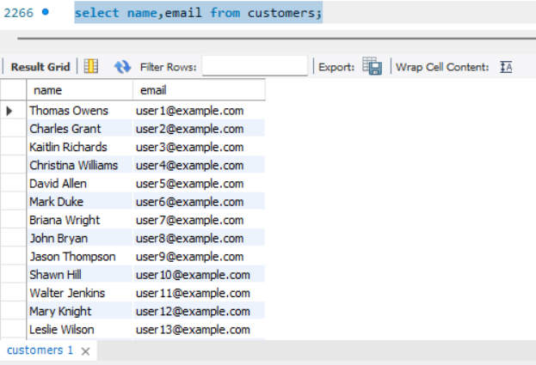

- View complete product catalog with all available details
The product manager may want to review all product listings in one go.
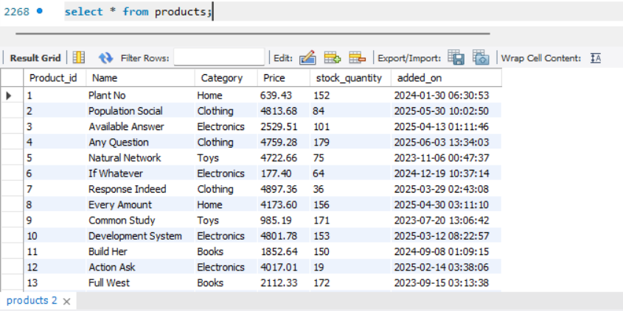
- List all unique product categories
Useful for analyzing the range of departments or for creating filters on the website.
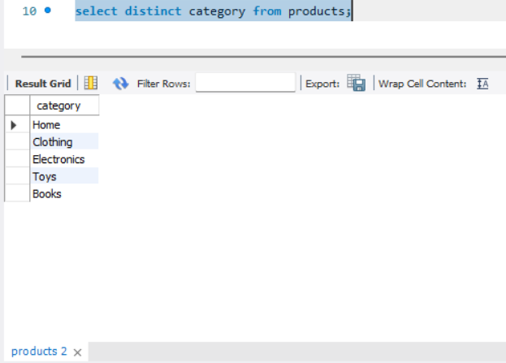

- Show all products priced above ₹1,000
This helps identify high-value items for premium promotions or pricing strategy reviews.

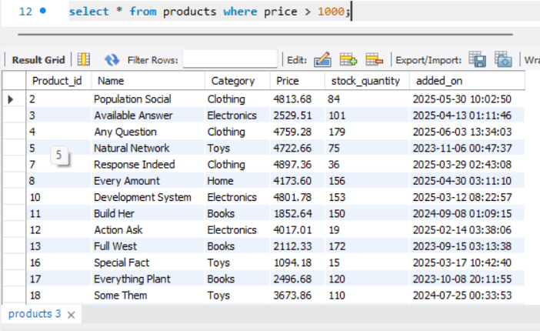
- Display products within a mid-range price bracket (₹2,000 to ₹5,000)
A merchandising team might need this to create a mid-tier pricing campaign.
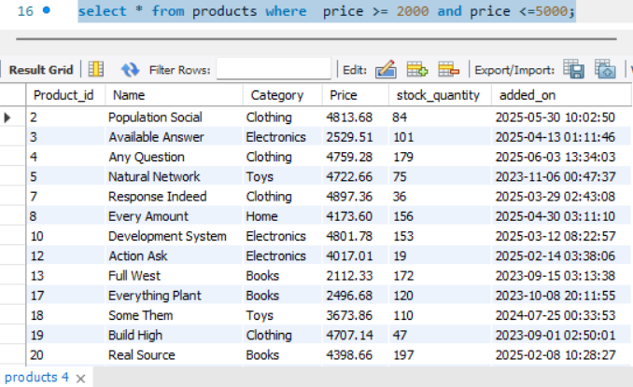
- Fetch data for specific customer IDs (e.g., from loyalty program list)
This is used when customer IDs are pre-selected from another system.
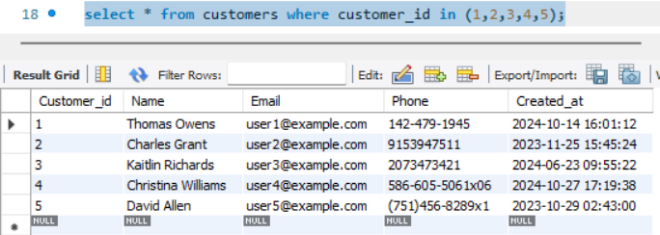
- Identify customers whose names start with the letter ‘A’
Used for alphabetical segmentation in outreach or app display.
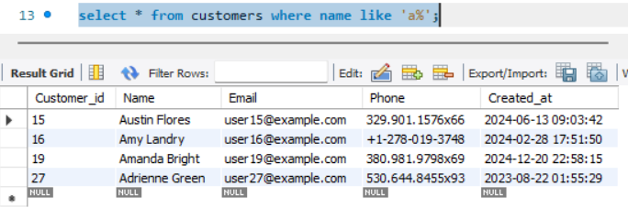
- List electronics products priced under ₹3,000
Used by merchandising or frontend teams to showcase budget electronics.
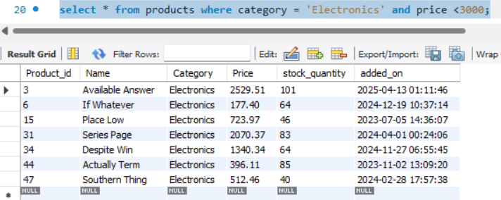

- Display product names and prices in descending order of price
This helps teams easily view and compare top-priced items.
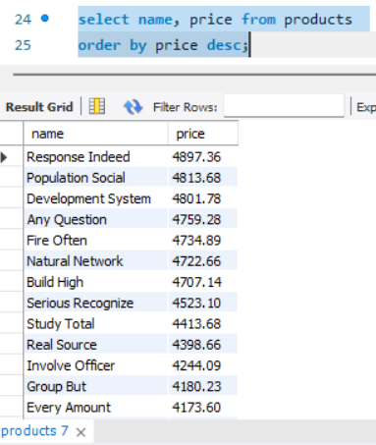

- Display product names and prices, sorted by price and then by name.
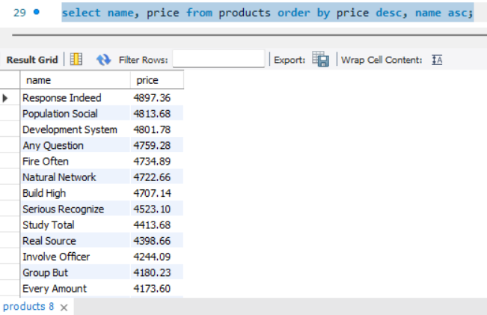

Level 2: Filtering and Formatting

- Retrieve orders where customer information is missing (possibly due to data migration or deletion)
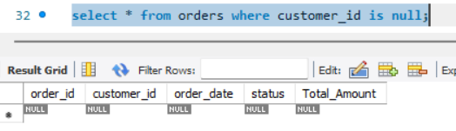

- Display customer names and emails using column aliases for frontend readability. 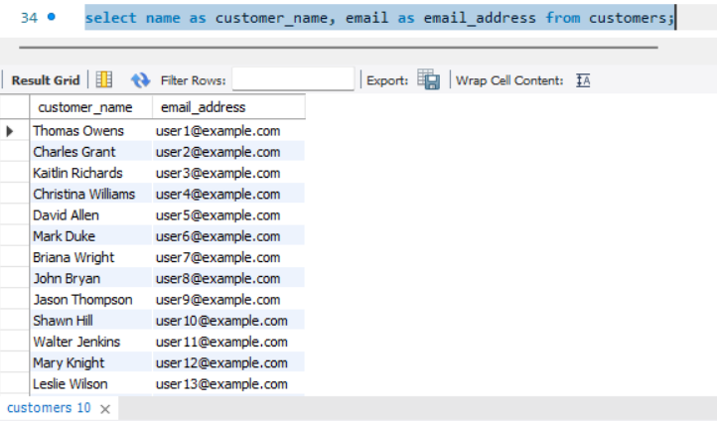

- Calculate total value per item ordered by multiplying quantity and item price

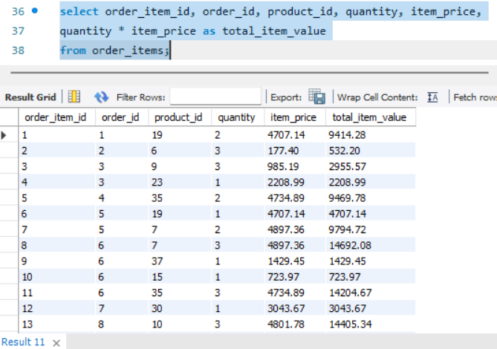

- Combine customer name and phone number in a single column.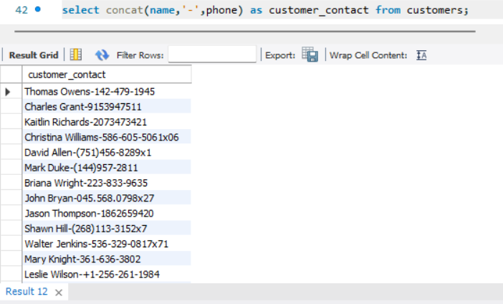
- Extract only the date part from order timestamps for date-wise reporting.
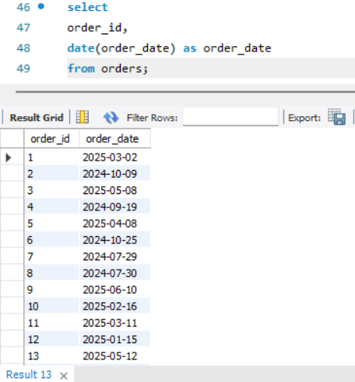
List products that do not have any stock left.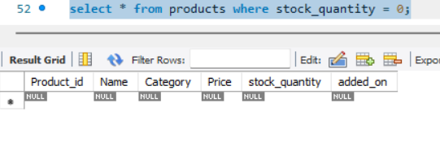

Level 3: Aggregations
- Count the total number of orders placed.
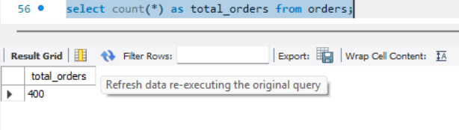
- Calculate the total revenue collected from all orders.
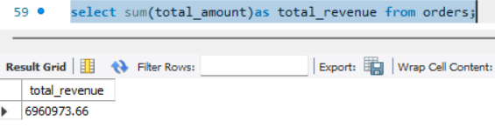

- Calculate the average order value.
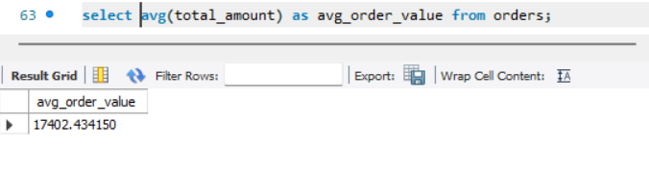
- Count the number of customers who have placed at least one order.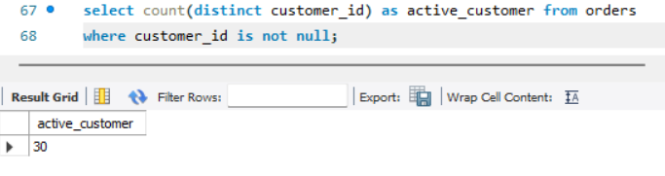
- Find the number of orders placed by each customer.
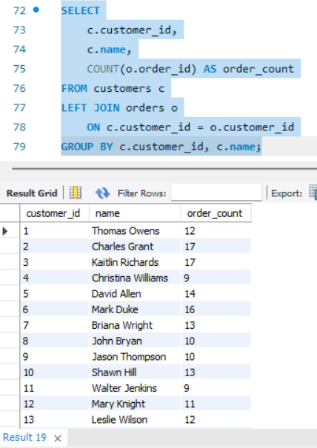
- Find total sales amount made by each customer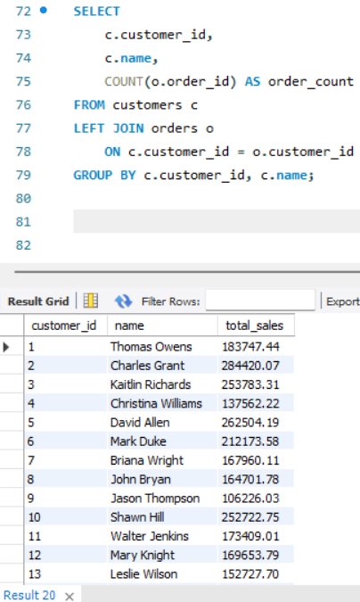

- List the number of products sold per category.

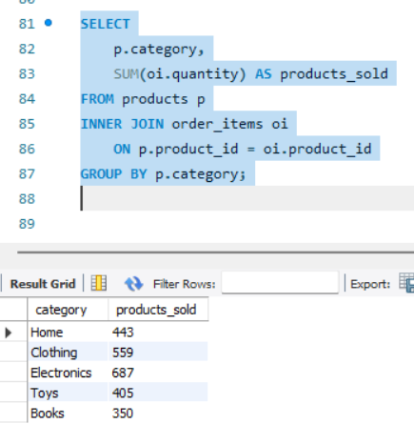
- Find the average item price per category.
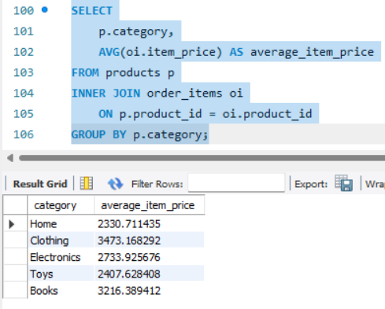

- Show number of orders placed per day.
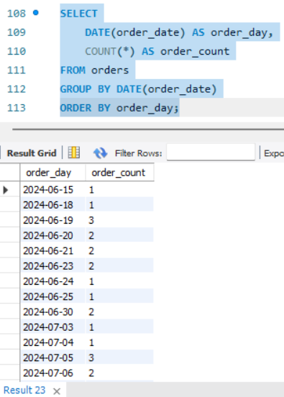
- List total payments received per payment method.

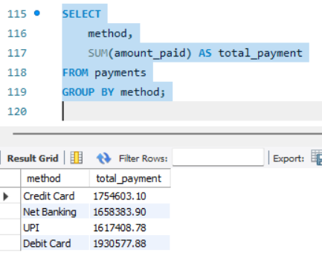

Level 4: Multi-Table Queries (JOINS)
- Retrieve order details along with the customer name (INNER JOIN).
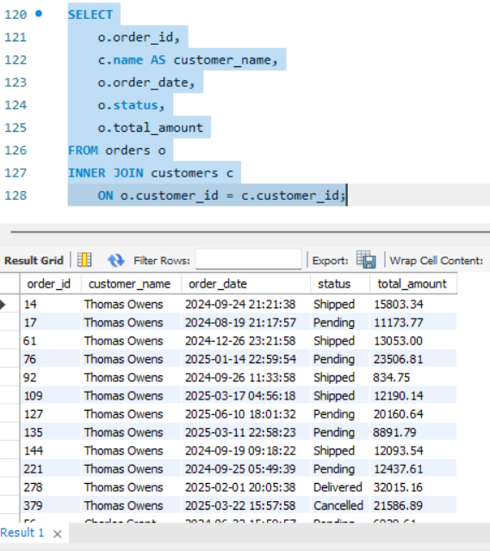

- Get list of products that have been sold (INNER JOIN with order_items).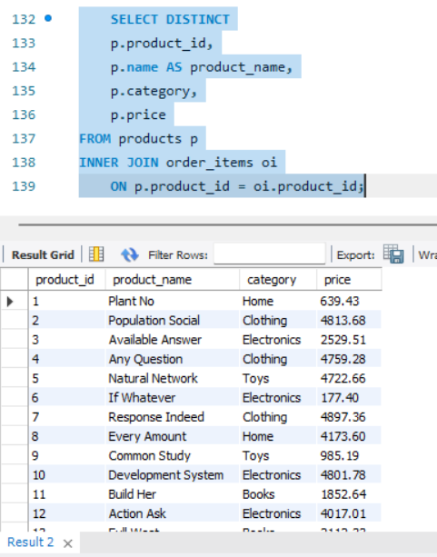

- List all orders with their payment method (INNER JOIN).
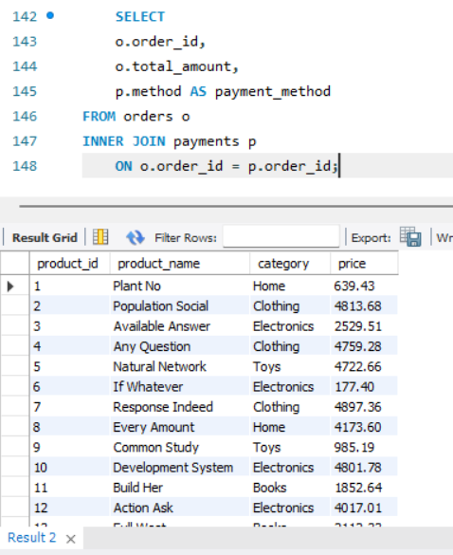

- Get list of customers and their orders (LEFT JOIN).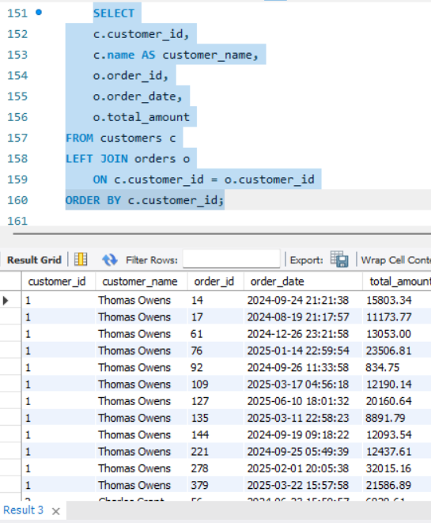
- List all products along with order item quantity (LEFT JOIN).
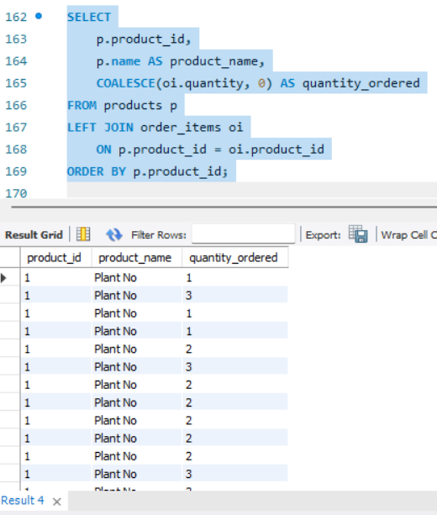
- List all payments including those with no matching orders (RIGHT JOIN).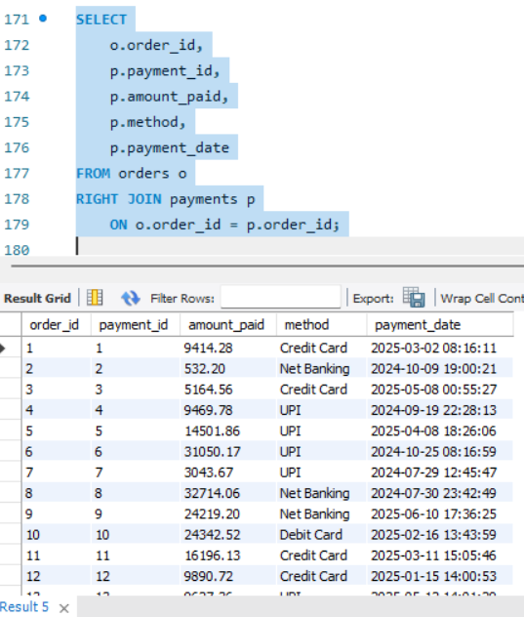
- Combine data from three tables: customer, order, and payment.
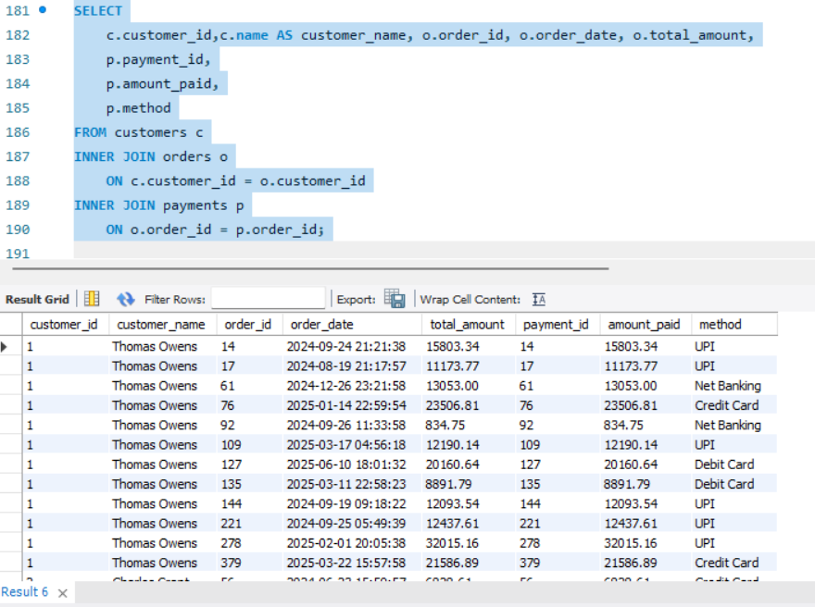

Level 5: Subqueries (Inner Queries)
- List all products priced above the average product price.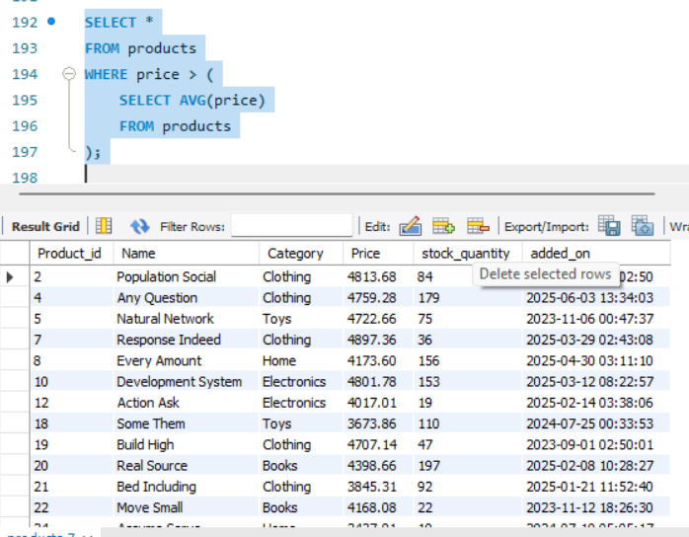
- Find customers who have placed at least one order.
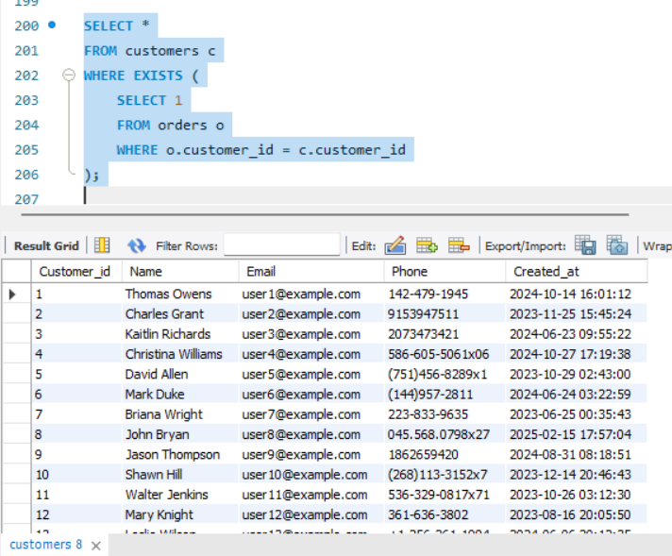

- Show orders whose total amount is above the average for that customer.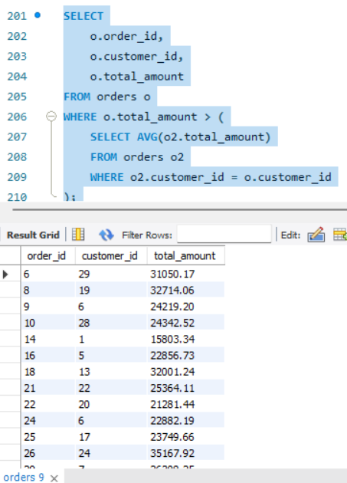
- Display customers who haven’t placed any orders.
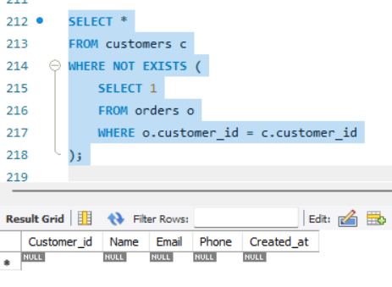

- Show products that were never ordered.
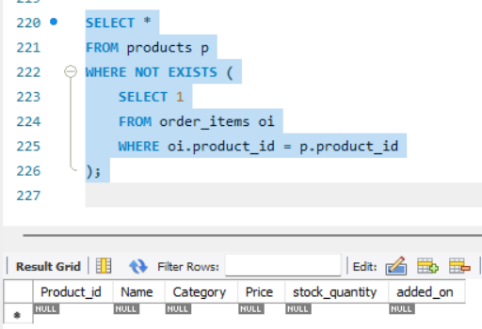
- Show highest value order per customer.
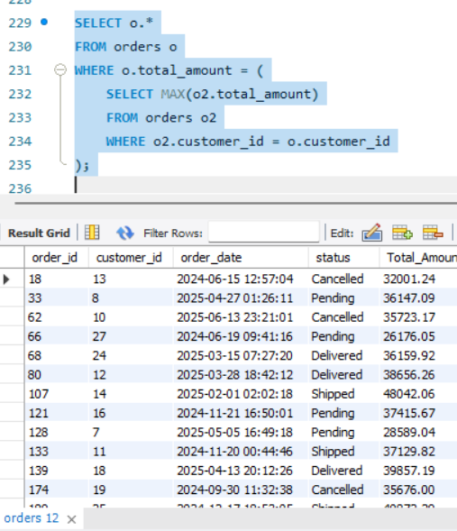

- Highest Order Per Customer (Including Names).
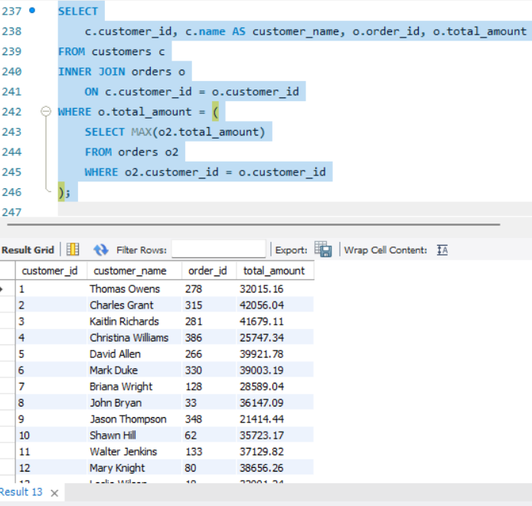

Level 6: Set Operations
- List all customers who have either placed an order or written a product review.
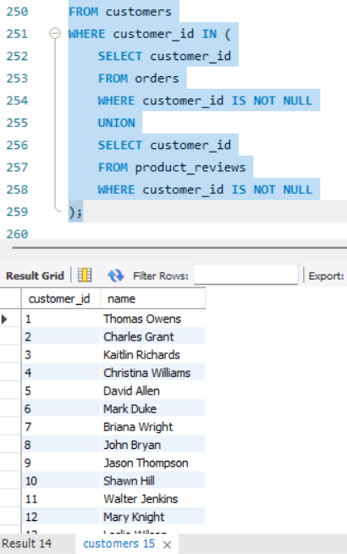
- List all customers who have placed an order as well as reviewed a product.