|  |  |
| --- | --- |
| **Name of company** | **Measure X** |
| Allied Signal | 24.23% |
| Bankers Trust | 25.53% |
| General Mills | 25.41% |
| ITT Industries | 24.14% |
| J.P.Morgan & Co. | 29.62% |
| Lehman Brothers | 28.25% |
| Marriott | 25.81% |
| MCI | 24.39% |
| Merrill Lynch | 40.26% |
| Microsoft | 32.95% |
| Morgan Stanley | 91.36% |
| Sun Microsystems | 25.99% |
| Travelers | 39.42% |
| US Airways | 26.71% |
| Warner-Lambert | 35.00% |

Ans:

MEAN= 33.2713 STD=16.9454 VAR=287.1466

Outlier is Morgan Stanley because it’s the extreme value.

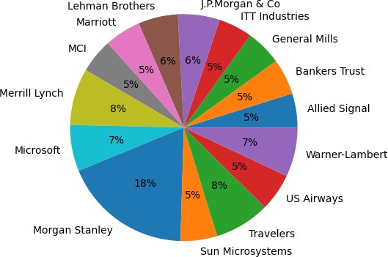

2.

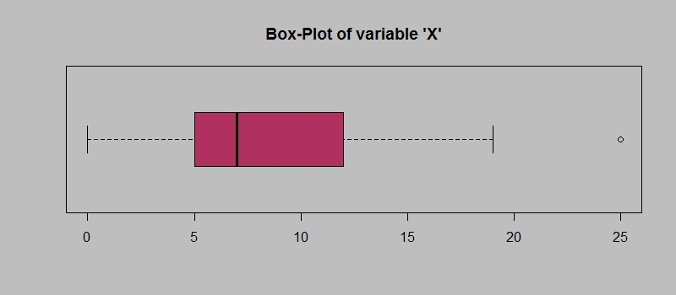

Answer the following three questions based on the box-plot above.

1. What is inter-quartile range of this dataset? (please approximate the numbers) In one line, explain what this value implies.

Ans: IQR= Upper Quartile – Lower Quartile= 13-5= 8

1. What can we say about the skewness of this dataset? Ans: The distribution is positively skewed.
2. If it was found that the data point with the value 25 is actually 2.5, how would the new box-plot be affected?

Ans: There won’t be any outliers and the boxplot will not be affected.

3.

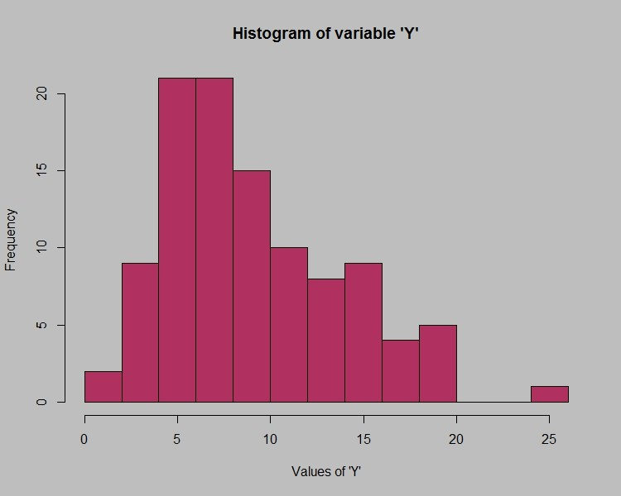

Answer the following three questions based on the histogram above.

1. Where would the mode of this dataset lie? Ans: The mode of this data set is 5 and 7.
2. Comment on the skewness of the dataset. Ans: The distribution is right skewed.
3. Suppose that the above histogram and the box-plot in question 2 are plotted for the same dataset. Explain how these graphs complement each other in providing information about any dataset?

Ans: Boxplot shows the outliers in the dataset whereas histogram shows if the data is symmetric or not. Histogram is frequency distribution so with histogram we can understand the occurrence of data points. We can see median from boxplots and mode from histogram. From both the plots we can understand the distribution is right skewed.

1. AT&T was running commercials in 1990 aimed at luring back customers who had switched to one of the other long-distance phone service providers. One such commercial shows a businessman trying to reach Phoenix and mistakenly getting Fiji, where a half-naked native on a beach responds incomprehensibly in Polynesian. When asked about this advertisement, AT&T admitted that the portrayed incident did not actually take place but added that this was an enactment of something that “could happen.” Suppose that one in 200 long-distance telephone calls is misdirected. What is the probability that at least one in five attempted telephone calls reaches the wrong number? (Assume independence of attempts).

Ans: If one in every 200 Calls are getting misdirected the probability is : 1/200 Probability of calls not misdirected is= 1-1/200= 199

n=5

= 1 - none of the call reaches the wrong number

= 1 - P (0)

= 1 - (1/200) (199/200) ^5

= 1 - (199/200) ^5

= 0.02475.

The probability that at least one in five attempted telephone calls reaches the wrong number 0.02475.

1. Returns on a certain business venture, to the nearest $1,000, are known to follow the following probability distribution

|  |  |
| --- | --- |
| x | P(x) |
| -2,000 | 0.1 |
| -1,000 | 0.1 |
| 0 | 0.2 |
| 1000 | 0.2 |
| 2000 | 0.3 |
| 3000 | 0.1 |

* 1. What is the most likely monetary outcome of the business venture?

Ans: P(x)= 2000. The probability is more so we can conclude that most likely outcome will be 2000

* 1. Is the venture likely to be successful? Explain

Ans: Yes, because the probability of making money is more than loss.

P(x>1000) + P(x>2000) + P(x>3000) = 0.2 + 0.3 + 0.1 =6

So, the probability of being successful is 60%.

* 1. What is the long-term average earning of business ventures of this kind? Explain Ans:800$ is the average earnings.
  2. What is the good measure of the risk involved in a venture of this kind? Compute this measure

Ans: P(Loss)= P(X=1) + (PX=1) = 2. Probability of loss is 20%