

SUMMER INTERNSHIP REPORT

ON

CYBERSECURITY INTERNSHIP AT ALFIDO TECH:
NETWORK RECONNAISSANCE, WEB APPLICATION SECURITY TESTING,
PACKET-LEVEL TRAFFIC ANALYSIS AND INCIDENT RESPONSE SIMULATION

Submitted To
School of Computer Science and Engineering
IILM University, Greater Noida, U.P.

In partial fulfilment of the requirement of degree of
B.Tech CSE (Cybersecurity)

By

Name of Student: NEERAJ UPADHAYAY
Roll Number of Student: CS-2341082
Semester: 7th Semester | Section: 4CSE11
Batch: 2023–2027

2026–27

CANDIDATE'S DECLARATION
I, Neeraj Upadhayay, Roll No. CS-2341082, do hereby declare that the internship report titled "Cybersecurity Internship at Alfido Tech: Network Reconnaissance, Web Application Security Testing, Packet-Level Traffic Analysis and Incident Response Simulation" has been completed by me to fulfil the requirement for the award of the degree of Bachelor of Technology in Computer Science and Engineering. All the references used in the preparation of this report have been duly acknowledged. I affirm that this report is my own original work, based on the internship undertaken by me at Alfido Tech from 10 May 2026 to 10 June 2026, and has not been submitted to any other institute for any degree or diploma requirement. I shall be solely responsible for any kind of copyright violation in this regard, if found otherwise.

Signature: ____________________
Student Name: Neeraj Upadhayay
Roll No.: CS-2341082

ACKNOWLEDGEMENT
I am using this opportunity to express my sincere gratitude to everyone who supported me throughout my internship at Alfido Tech. I am thankful for their aspiring guidance, invaluable constructive criticism, and friendly advice during the course of this Cybersecurity internship program.
I would like to express my special thanks of gratitude to my mentor, Mr. Akash Dubey, at Alfido Tech, for his continuous guidance, encouragement, and technical support throughout the internship. His mentorship played a significant role in helping me understand practical cybersecurity operations and in shaping my technical and professional growth during this period (10 May 2026 – 10 June 2026).
I am equally grateful to IILM University, Greater Noida, and the Department of Computer Science and Engineering for providing this internship opportunity as an integral part of the academic curriculum, and for their continuous support and encouragement throughout the program.
I express my heartfelt gratitude to my parents and family for their constant blessings, support, and motivation.

Signature: ____________________
Student Name: Neeraj Upadhayay
Roll No.: CS-2341082

INTERNSHIP COMPLETION CERTIFICATE
[This page is reserved for the scanned copy of the Internship Completion Certificate issued by Alfido Tech, along with the Internship Offer Letter and the Internship Evaluation / Performance Report issued by the organization. These original documents should be attached here at the time of final submission, as required under Section 4.10 of the university report format.]
As per the internship records, the performance of the candidate during the internship period was evaluated as follows:
Evaluation Parameter | Result
Internship Duration | 10 May 2026 – 10 June 2026 (One Month)
Overall Performance Score | 94%
Internship Grade | A+
Final Evaluation Grade | A
Mentor / Reporting Authority | Mr. Akash Dubey, Alfido Tech

TABLE OF CONTENTS
Cover Page ---
1. Candidate's Declaration i
2. Acknowledgement ii
3. Internship Completion Certificate iii
Table of Contents iv
List of Tables v
List of Figures vi
4. Project Description 1
4.1 Introduction 1
4.2 Organization Profile 2
4.3 Problem Statement 4
4.4 Project Objectives 5
4.5 Scope of the Project 6
4.6 Technologies and Tools Used 7
4.7 System Architecture / Methodology Flow 9
4.8 Methodology (Task-wise Work Done) 10
4.9 Expected Outcomes 16
4.10 Certificates & Communication Proof 17
5. Bibliography / References 18
Appendix – Selected Screenshots 19

LIST OF TABLES
Table 4.1 – Internship Profile Summary 1
Table 4.2 – Objectives Mapped to Internship Tasks 5
Table 4.3 – Tools and Technologies Used 7
Table 4.4 – Task 1: Reconnaissance Findings 11
Table 4.5 – Task 2: Web Vulnerabilities Identified 12
Table 4.6 – Task 3: Protocols Analyzed in Wireshark 13
Table 4.7 – Task 4: Indicators of Compromise (IOCs) 14
Table 4.8 – Overall Internship Evaluation Summary 16

LIST OF FIGURES
Figure 4.1 – Cybersecurity Internship Workflow 9
Figure A.1 – Network Reconnaissance using Nmap and arp-scan 19
Figure A.2 – DVWA Web Application Vulnerability Testing 19
Figure A.3 – Wireshark Packet Capture and Protocol Analysis 20
Figure A.4 – Incident Response Log Analysis 20

4. PROJECT DESCRIPTION

4.1 Introduction
Cybersecurity has become one of the most critical domains in modern information technology, as organizations across every industry face constantly evolving digital threats. As part of the curriculum requirement for the Bachelor of Technology (B.Tech) programme in Computer Science and Engineering (Cybersecurity) at IILM University, Greater Noida, I undertook a one-month Summer Internship in Cybersecurity at Alfido Tech from 10 May 2026 to 10 June 2026.
The internship was designed to provide practical, hands-on exposure to core cybersecurity concepts including network reconnaissance, vulnerability assessment, web application security testing, network traffic analysis, and incident response. Rather than being purely theoretical, the program was structured around real, task-based assignments that required setting up a Linux-based security testing environment (BlackArch Linux) and using industry-standard tools such as Nmap, arp-scan, Nikto, Burp Suite, DVWA, and Wireshark to simulate real-world offensive and defensive security scenarios in a safe, authorized lab environment.
This report documents the objectives, methodology, tools, and outcomes of the internship, along with the four major technical tasks completed during the program: (1) Reconnaissance and Vulnerability Scanning, (2) Web Application Security Testing, (3) Network Packet Analysis using Wireshark, and (4) Incident Response Simulation.
Table 4.1 – Internship Profile Summary
Particular | Details
Student Name | Neeraj Upadhayay
Enrollment / Roll Number | CS-2341082
Programme | B.Tech Computer Science & Engineering (Cybersecurity)
Semester / Section | 7th Semester / 4CSE11
University | IILM University, Greater Noida, U.P.
Organization | Alfido Tech
Internship Domain | Cybersecurity
Duration | 10 May 2026 – 10 June 2026 (One Month)
Mentor | Mr. Akash Dubey
Mode | Remote / Task-based (as per organizational records)

4.2 Organization Profile
Alfido Tech is a technology-driven organization that provides industry-focused internships, real-world project exposure, and IT services aimed at helping students and early-career professionals become skill-ready. The organization offers structured internship programs across multiple technology domains, including Cybersecurity, Web Development, Python, Data Science, and Data Analysis, combining mentorship, hands-on tasks, and verified certification upon successful completion.
Within the Cybersecurity track, Alfido Tech's internship program follows a task-based learning model in which interns are assigned a sequence of practical assignments — covering reconnaissance, web application security, network traffic analysis, and incident response — that are reviewed and evaluated by an assigned mentor. On completion, interns receive an offer letter, a weekly performance report card, a final evaluation, and a certificate of completion.
Note: The organizational description above is based on information published by Alfido Tech and general internship program details; internal/confidential company data has not been used or disclosed in this report.

4.3 Problem Statement
Modern networks and web applications are exposed to a wide range of cyber threats, including unauthorized reconnaissance, exploitation of outdated services, injection-based web attacks (such as Cross-Site Scripting and SQL Injection), interception of unencrypted network traffic, and sophisticated multi-stage intrusions involving credential compromise, malware deployment, and persistence mechanisms.
Many organizations lack sufficient in-house practice in identifying such threats early, analyzing them systematically, and responding to them in a structured manner. The problem addressed during this internship was to gain first-hand, practical experience in identifying, analyzing, and responding to these categories of security issues — using a safe, authorized lab environment — so as to understand how a Security Operations Center (SOC) analyst or penetration tester would approach reconnaissance, vulnerability discovery, traffic analysis, and incident response in a real organizational setting.

4.4 Project Objectives
- To set up and use a dedicated penetration-testing environment (BlackArch Linux) for cybersecurity practice.
- To perform active network reconnaissance and identify live hosts, open ports, and running services using Nmap and arp-scan.
- To assess web applications for common vulnerabilities such as Reflected XSS, Stored XSS, and SQL Injection using DVWA and Burp Suite.
- To capture and analyze live network traffic using Wireshark, and interpret HTTP, DNS, and TCP protocol behavior.
- To simulate a real-world security incident, identify Indicators of Compromise (IOCs), and perform containment actions following SOC-analyst workflows.
- To document all findings professionally in the form of structured technical reports, in line with industry reporting standards.
- To strengthen analytical thinking, problem-solving ability, and professional communication relevant to a career in cybersecurity.

4.5 Scope of the Project
The scope of this internship was limited to a controlled, authorized lab/local-network environment and did not involve testing of any live production system without permission. The work covered four structured modules — reconnaissance and vulnerability scanning, web application security testing, network packet analysis, and incident response simulation — each aligned with foundational SOC and penetration-testing workflows used in the cybersecurity industry.
The scope did not extend to advanced exploitation, real malware development, or engagement with any unauthorized third-party network or system. All activities were strictly educational and ethical in nature, conducted for academic and skill-development purposes only.

4.6 Technologies and Tools Used
Table 4.3 – Tools and Technologies Used
Category | Tools / Technologies
Operating System | BlackArch Linux (Arch-based Penetration Testing Distribution)
Network Reconnaissance | Nmap, arp-scan, Nikto
Web Application Security | DVWA (Damn Vulnerable Web Application), Burp Suite, Apache, MariaDB, PHP
Traffic Analysis | Wireshark, curl, dig, nslookup
Incident Response | grep, netstat, iptables, base64, nano
Reporting & Documentation | Markdown, Pandoc (PDF generation), Microsoft Word
Version Control | Git & GitHub (for maintaining task documentation)

4.7 System Architecture / Methodology Flow
As this internship was task-based and analytical rather than software-development-based, the "system architecture" here refers to the overall security-testing workflow followed across all four tasks: environment setup → target/scope identification → tool-based data collection → analysis → documentation of findings and recommendations. Figure 4.1 illustrates this general workflow, which was applied consistently across the reconnaissance, web security, traffic analysis, and incident response tasks.
Figure 4.1 – Cybersecurity Internship Workflow
Environment Setup (BlackArch Linux) → Target / Scope Identification → Tool-Based Data Collection (Nmap / Burp Suite / Wireshark / Log files) → Analysis of Results (vulnerabilities, packets, IOCs) → Documentation & Reporting → Recommendations / Containment Actions

4.8 Methodology (Task-wise Work Done)

4.8.1 Task 1 – Reconnaissance and Vulnerability Scanning
The first task focused on active reconnaissance and vulnerability scanning on a safe local network using BlackArch Linux. The local network interface was identified using the "ip a" command, following which host discovery was carried out using arp-scan to identify live devices on the network segment 10.99.227.0/24. Two active hosts (10.99.227.122 and 10.99.227.157) were discovered.
Port scanning was then performed on the discovered hosts using Nmap in three stages: a basic scan, a service-version detection scan (-sV), and an aggressive scan (-A) that combined OS detection, version detection, script scanning, and traceroute. The scan identified an open DNS service (port 53/tcp) running "dnsmasq 2.51" on a device fingerprinted as an Android 9–11 mobile device.
Table 4.4 – Task 1: Reconnaissance Findings
Severity | Finding | Description
Medium | Open DNS Service | DNS service (dnsmasq) exposed on the local network
Low | Outdated dnsmasq Version | Older service version may carry known vulnerabilities
Informational | OS Fingerprinting Possible | Device type and OS (Android) could be identified remotely
Based on these findings, recommendations included restricting unnecessary DNS exposure, updating dnsmasq to a patched version, enabling firewall filtering, disabling unused services, and conducting periodic vulnerability assessments.

4.8.2 Task 2 – Web Application Security Testing
The second task involved setting up DVWA (Damn Vulnerable Web Application) on an Apache + MariaDB + PHP stack within BlackArch Linux, and using it to study common web application vulnerabilities in a safe, isolated lab environment. After configuring DVWA at the "Low" security level, three categories of vulnerabilities were tested:
- Reflected XSS – injecting a script payload through a URL parameter and confirming client-side script execution.
- Stored XSS – injecting a persistent script payload that executed every time the affected page was reloaded.
- SQL Injection – using a classic tautology-based payload (1' OR '1'='1) to bypass query logic and retrieve unintended records.
Burp Suite was configured as an intercepting proxy (listening on 127.0.0.1:8080) to capture and inspect the raw HTTP requests generated during each test, providing insight into how such attacks appear at the network/application protocol level.
Table 4.5 – Task 2: Web Vulnerabilities Identified
Vulnerability | Module Tested | Mitigation Studied
Reflected XSS | DVWA - XSS (Reflected) | Input validation, output encoding, CSP
Stored XSS | DVWA - XSS (Stored) | Sanitization libraries, output encoding
SQL Injection | DVWA - SQL Injection | Prepared statements, parameterized queries

4.8.3 Task 3 – Network Packet Analysis using Wireshark
The third task focused on capturing and analyzing live network traffic using Wireshark on BlackArch Linux. HTTP traffic was generated using curl requests and captured using the "http" display filter, allowing inspection of GET requests, response codes, host headers, and user-agent strings. DNS traffic was generated using ping and nslookup and analyzed using the "dns" filter to observe DNS queries, responses, and IP resolution.
The TCP three-way handshake (SYN → SYN-ACK → ACK) was captured and analyzed using SYN-flag filters, and the packet structure was examined layer-by-layer (Ethernet, IP, TCP, and Application layers). Suspicious traffic patterns such as retransmissions ("tcp.analysis.retransmission"), reset packets ("tcp.flags.reset == 1"), and malformed packets were also identified using targeted Wireshark filters.
Table 4.6 – Task 3: Protocols Analyzed in Wireshark
Protocol / Filter | Purpose | Observation
http | HTTP traffic analysis | GET requests, response codes, headers observed
dns | DNS query/response analysis | Domain resolution and query flow captured
tcp.flags.syn == 1 | TCP handshake analysis | 3-way handshake (SYN, SYN-ACK, ACK) verified
tcp.analysis.retransmission | Anomaly detection | Retransmitted packets flagged for review

4.8.4 Task 4 – Incident Response Simulation
The final task simulated a realistic Security Operations Center (SOC) incident response scenario. A sample Windows security log containing suspicious entries was analyzed using command-line log analysis tools (primarily grep) to detect indicators of a brute-force login attack followed by post-exploitation activity.
The simulated timeline showed repeated failed login attempts against the administrator account from a single external IP address, followed by a successful login, execution of a base64-encoded PowerShell command, creation of a malicious file in the Windows Temp directory, an outbound reverse-shell connection on port 4444, creation of an unauthorized user account ("hackeradmin"), and finally, disabling of the antivirus software.
Table 4.7 – Task 4: Indicators of Compromise (IOCs)
IOC Type | Value / Detail
Suspicious Source IP | 185.243.115.84
Reverse-Shell Destination IP : Port | 45.77.88.190 : 4444
Malicious File | C:\Windows\Temp\malware.exe
Unauthorized User Account | hackeradmin
Attack Techniques Observed | Brute-force login, encoded PowerShell execution, AV tampering
Following the analysis, containment actions were simulated, including blocking the malicious IP address using iptables, reviewing active connections with netstat, quarantining the malicious file, and recommending a password reset along with a full antivirus scan. A formal incident response report was prepared documenting the timeline, IOCs, analysis, containment actions, and recommendations (including enabling MFA, restricting PowerShell execution policy, and deploying SIEM/EDR solutions). The overall incident was classified as HIGH severity and marked as "Contained".

4.9 Expected Outcomes
- Ability to perform structured network reconnaissance and interpret Nmap/arp-scan output to identify live hosts and services.
- Practical understanding of common web application vulnerabilities (XSS, SQL Injection) and how to test for them ethically.
- Working knowledge of packet-level traffic analysis using Wireshark, including protocol behavior and anomaly detection.
- Hands-on experience with SOC-style incident response — log analysis, IOC identification, and containment actions.
- Professional documentation skills through the preparation of formal technical and incident response reports.
- Recognition of the internship's Overall Performance Score of 94%, Internship Grade A+, and Final Evaluation Grade A, as per Alfido Tech's evaluation.
Table 4.8 – Overall Internship Evaluation Summary
Parameter | Result
Overall Performance | 94%
Internship Grade | A+
Final Evaluation Grade | A
Supervisor Remarks (summarized) | Strong professionalism, problem-solving ability, communication, and overall excellent performance

4.10 Certificates of Completion and Other Communication / Mail Proof
The following supporting documents, issued by Alfido Tech, are to be physically/digitally attached at the end of this report as proof of internship completion and performance, as required by the university format:
- Internship Offer Letter
- Weekly Internship Report Card(s)
- Final Internship Evaluation / Performance Report
- Internship Completion Certificate
(These original documents are available with the candidate and should be inserted as scanned copies immediately following this section in the final bound/printed submission.)

CHALLENGES FACED, LEARNING OUTCOMES, AND FUTURE SCOPE

Challenges Faced
- Setting up and configuring a BlackArch Linux penetration-testing environment, including Apache, MariaDB, and PHP for DVWA, required careful troubleshooting of service and permission errors.
- Interpreting large volumes of raw Wireshark packet captures and isolating relevant HTTP, DNS, and TCP packets from background network noise was initially challenging.
- Correlating multiple log entries during the incident response simulation to reconstruct an accurate attack timeline required careful, methodical analysis.
- Understanding and safely using tools such as Burp Suite and Nmap required strict adherence to ethical and authorized-testing boundaries at every stage.

Learning Outcomes
- Gained practical, hands-on experience with core offensive and defensive cybersecurity tools used in the industry.
- Developed a working understanding of the vulnerability assessment and penetration testing (VAPT) lifecycle.
- Learned to identify, exploit (ethically), and mitigate common web application vulnerabilities.
- Improved the ability to read and interpret network traffic at the packet level.
- Understood the end-to-end incident response lifecycle followed by SOC analysts, from detection to containment and reporting.
- Strengthened technical documentation and professional reporting skills applicable to real cybersecurity job roles.

Results / Outcome
All four assigned tasks were completed successfully within the internship duration, with each task documented in a dedicated technical report supported by command outputs and screenshots. The internship concluded with an Overall Performance Score of 94%, an Internship Grade of A+, and a Final Evaluation Grade of A, reflecting consistent, high-quality work across all modules.

Future Scope
- Extending the reconnaissance and vulnerability scanning work using automated vulnerability scanners (e.g., OpenVAS, Nessus).
- Integrating a real SIEM platform (such as the ELK Stack or Splunk) for automated log correlation and alerting in incident response scenarios.
- Exploring advanced web application security testing, including authentication bypass and business-logic vulnerabilities.
- Building automated IOC-extraction and YARA-rule-based detection capability for future incident response exercises.

Conclusion
The one-month Cybersecurity internship at Alfido Tech provided valuable, practical exposure to core areas of information security — network reconnaissance, web application security testing, network traffic analysis, and incident response. Working through structured, task-based assignments under the mentorship of Mr. Akash Dubey helped translate classroom concepts into applied, hands-on skills using real industry tools such as Nmap, Burp Suite, DVWA, and Wireshark. The internship strengthened both technical competence and professional skills such as analytical thinking, documentation, and ethical responsibility, and has reinforced a strong foundation for pursuing a career in cybersecurity.

5. BIBLIOGRAPHY / REFERENCES
[1] Nmap Reference Guide, "The Official Nmap Project Guide to Network Discovery and Security Scanning," available at: https://nmap.org/book/
[2] OWASP Foundation, "OWASP Top Ten Web Application Security Risks," available at: https://owasp.org/www-project-top-ten/
[3] Wireshark Foundation, "Wireshark User's Guide," available at: https://www.wireshark.org/docs/
[4] PortSwigger, "Burp Suite Documentation," available at: https://portswigger.net/burp/documentation
[5] Digininja, "DVWA – Damn Vulnerable Web Application," GitHub Repository, available at: https://github.com/digininja/DVWA
[6] BlackArch Linux, "Official Documentation," available at: https://blackarch.org/
[7] Alfido Tech, Official Website, available at: https://www.alfidotech.com/
[8] NIST Special Publication 800-61 Rev. 2, "Computer Security Incident Handling Guide," National Institute of Standards and Technology.
[9] Personal project repository: Neeraj Upadhayay, "2023-2027_Neeraj-upadhayay_CS-2341082_7thsem_4cse11," GitHub, available at: https://github.com/Neerajupadhayay2004/2023-2027_Neeraj-upadhayay_CS-2341082_7thsem_4cse11

APPENDIX – SELECTED SCREENSHOTS
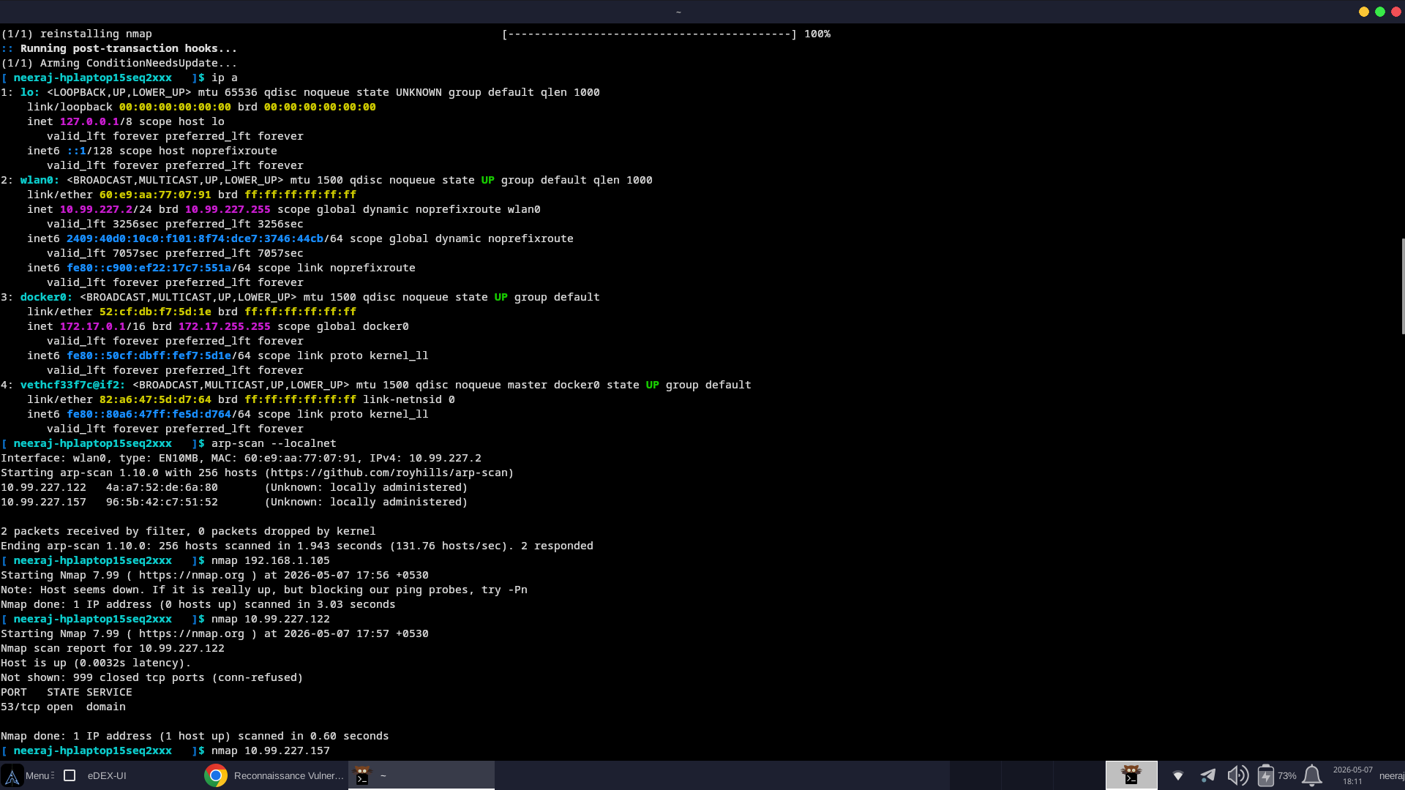
Figure A.1 – Task 1: Host discovery and Nmap scanning on BlackArch Linux
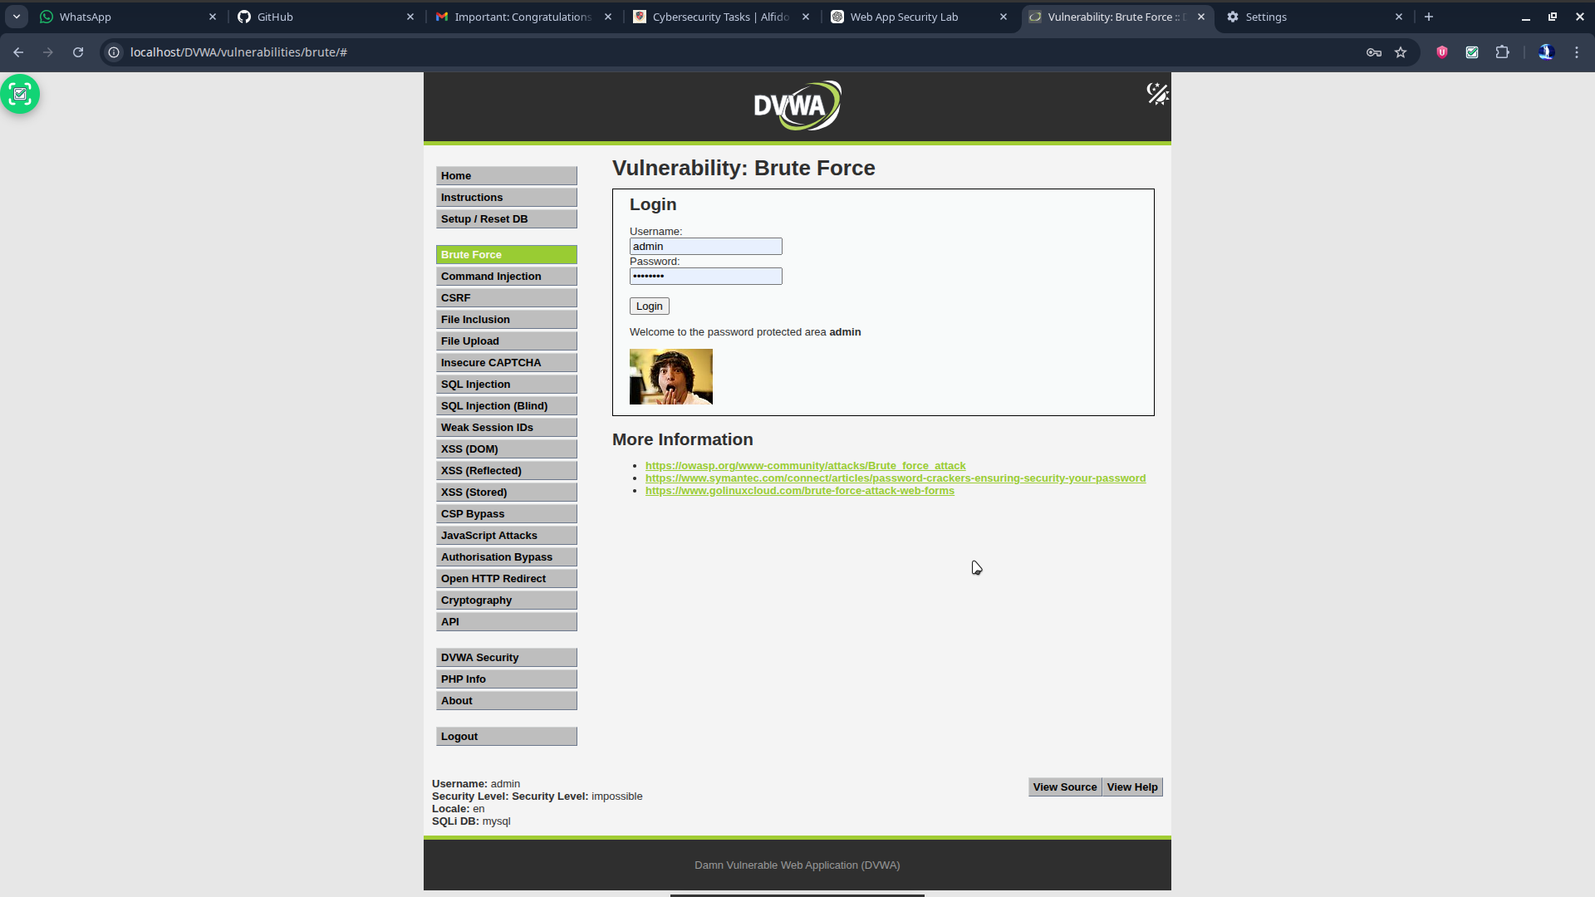
Figure A.2 – Task 2: DVWA setup for web application vulnerability testing
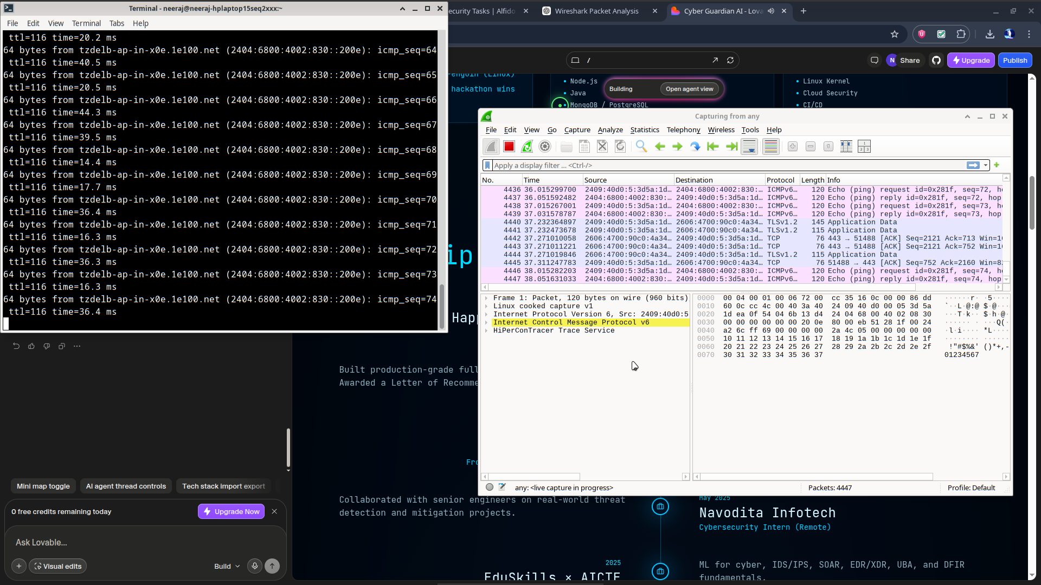
Figure A.3 – Task 3: Wireshark packet capture and protocol analysis
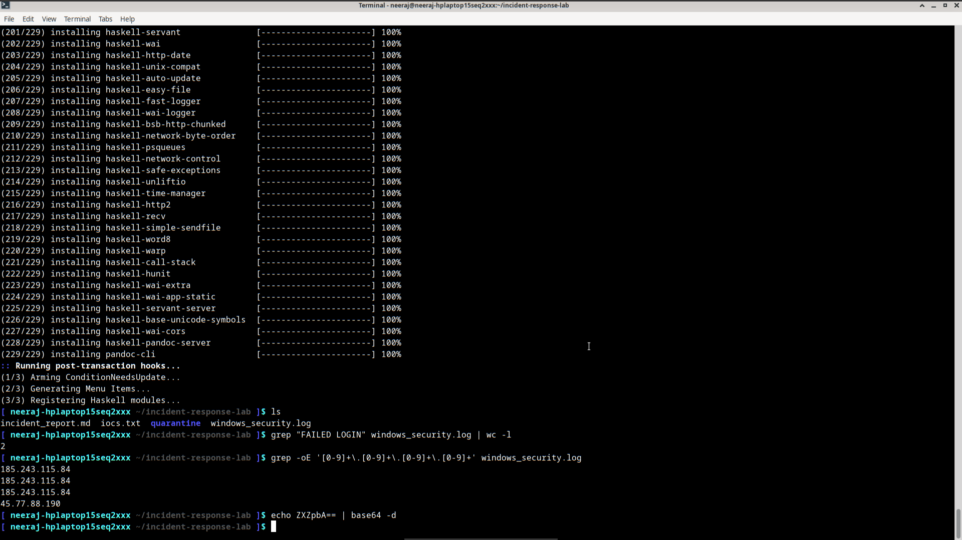
Figure A.4 – Task 4: Windows security log analysis during incident response

