Resilient Kubernetes-Based CI/CD Deployment
Independent Study Progress Report Weeks 5–8

Student | Neeta Misericordia | Instructor | Prof. Fazel Keshtkar
Course | CS Independent Study | Date Submitted | March 13, 2026
Phase | Weeks 5–8: CI/CD Pipeline Integration | University | St. Johns University

1. Summary
Weeks 5 through 8 focused on building out the continuous integration and deployment pipeline for the containerized microservice I completed in the first phase. The main goal was to automate everything that I was doing manually before building the Docker image, running basic checks, and pushing it to Docker Hub so that every commit to the main branch triggers this automatically through GitHub Actions.
By the end of this phase the pipeline is fully operational. It runs linting on the Python code, builds and tests the Docker container, and pushes the final image to my Docker Hub repository. I ran into a few issues along the way, mostly around authentication with Docker Hub, which I’ve documented in the challenges section below.

2. Work Completed

2.1 GitHub Actions Workflow Setup (Weeks 5–6)
I created the CI/CD workflow file at .github/workflows/ci.yml. The workflow is triggered automatically whenever I push to the main branch or open a pull request. It sets up a Python 3.11 environment, installs all dependencies from requirements.txt, and runs flake8 to catch any syntax errors or undefined names in app.py before anything else happens.
I also added a placeholder for pytest so that when I write unit tests in future weeks, they’ll automatically run as part of the same pipeline without any additional setup needed.

2.2 Docker Build, Test, and Push (Weeks 7–8)
After the linting step passes, the pipeline builds the Docker image and tags it with two labels: :latest and the specific commit SHA. Using the commit SHA tag means I can always trace exactly which version of the code is running in any given container, which is useful for debugging.
I added a testing step that starts the container locally on the GitHub Actions runner, waits 10 seconds for it to initialize, then sends a curl request to the /health endpoint. If the response isn’t 200 OK, the pipeline fails and the image is not pushed. This ensures only a working image ever makes it to Docker Hub.
The push step is conditional it only runs on direct pushes to main, not on pull requests. This prevents credentials from being used unnecessarily and keeps the Docker Hub repository clean.

3. Screenshots

3.1 GitHub Repository Pipeline Passing
The screenshot below shows the main repository page. The README badge at the bottom confirms the CI/CD pipeline is currently passing. This badge updates automatically after each workflow run.
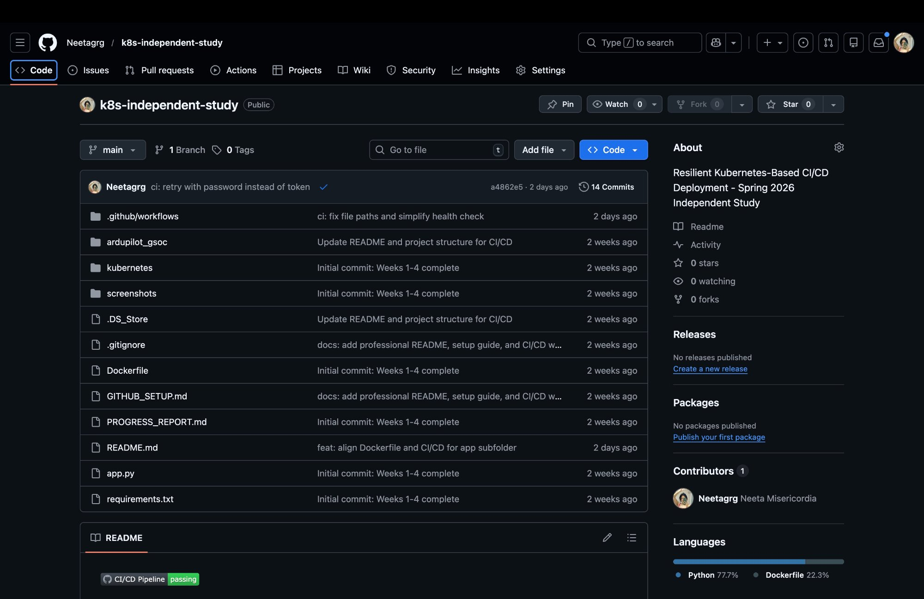
Figure 1: GitHub repository showing CI/CD Pipeline passing badge in the README

3.2 GitHub Actions Workflow Run History
The Actions tab shows all 15 workflow runs. The two most recent runs (marked with blue checkmarks) are successful. Earlier runs show red X marks from when I was troubleshooting the Docker Hub authentication issue.
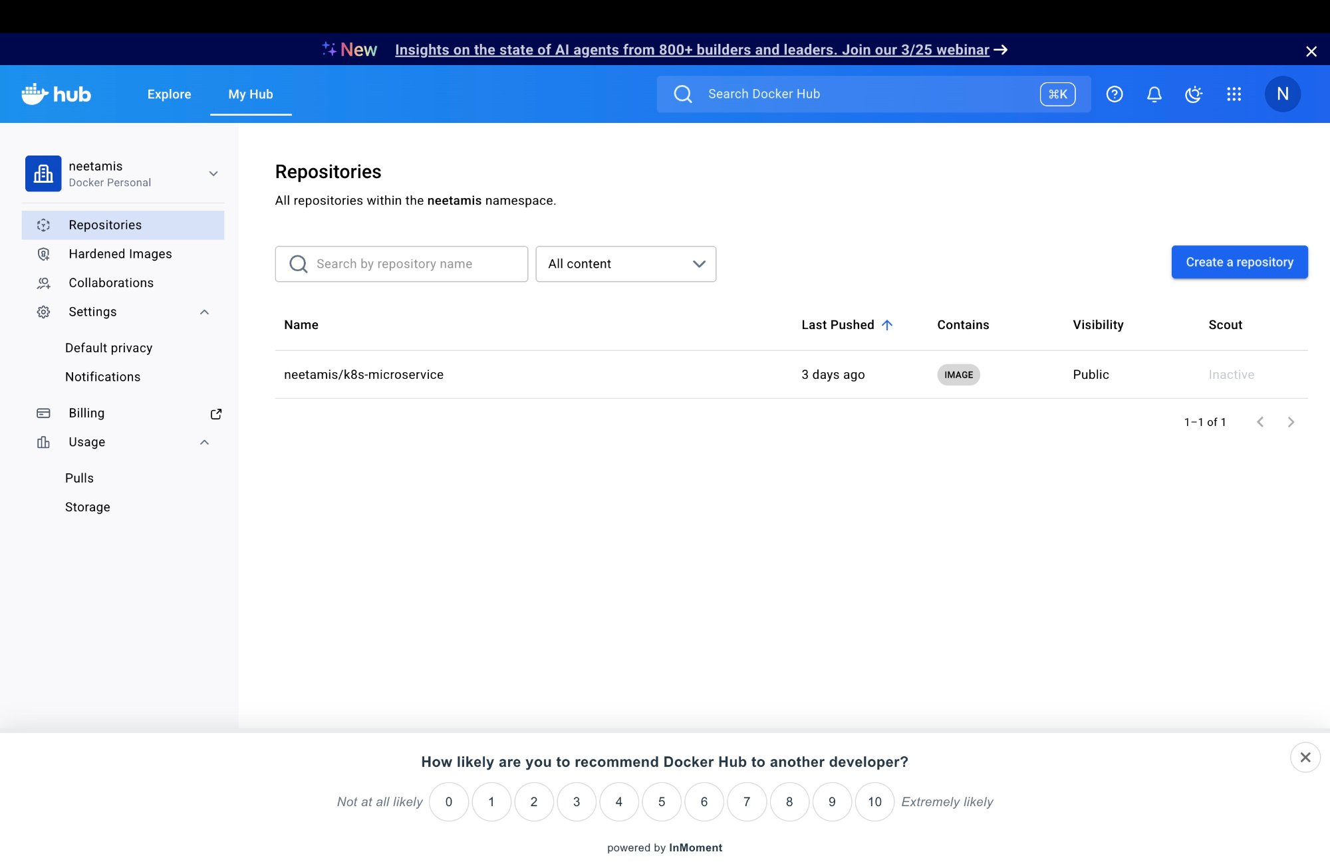
Figure 2: GitHub Actions tab showing successful workflow runs at the top of the run history

3.3 Docker Hub Repository List
This screenshot confirms that the neetamis/k8s-microservice repository exists on Docker Hub as a public image, last pushed 3 days ago by the CI pipeline.
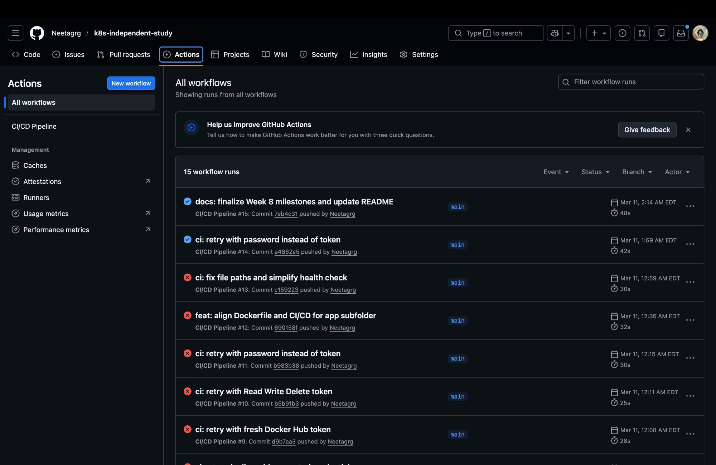
Figure 3: Docker Hub repositories page showing neetamis/k8s-microservice as a public image

3.4 Docker Hub Image Tags
The image details page shows the :latest tag is active, the image is 54.9 MB, and it was most recently pulled less than a day ago. This confirms the pipeline successfully pushed a working image.
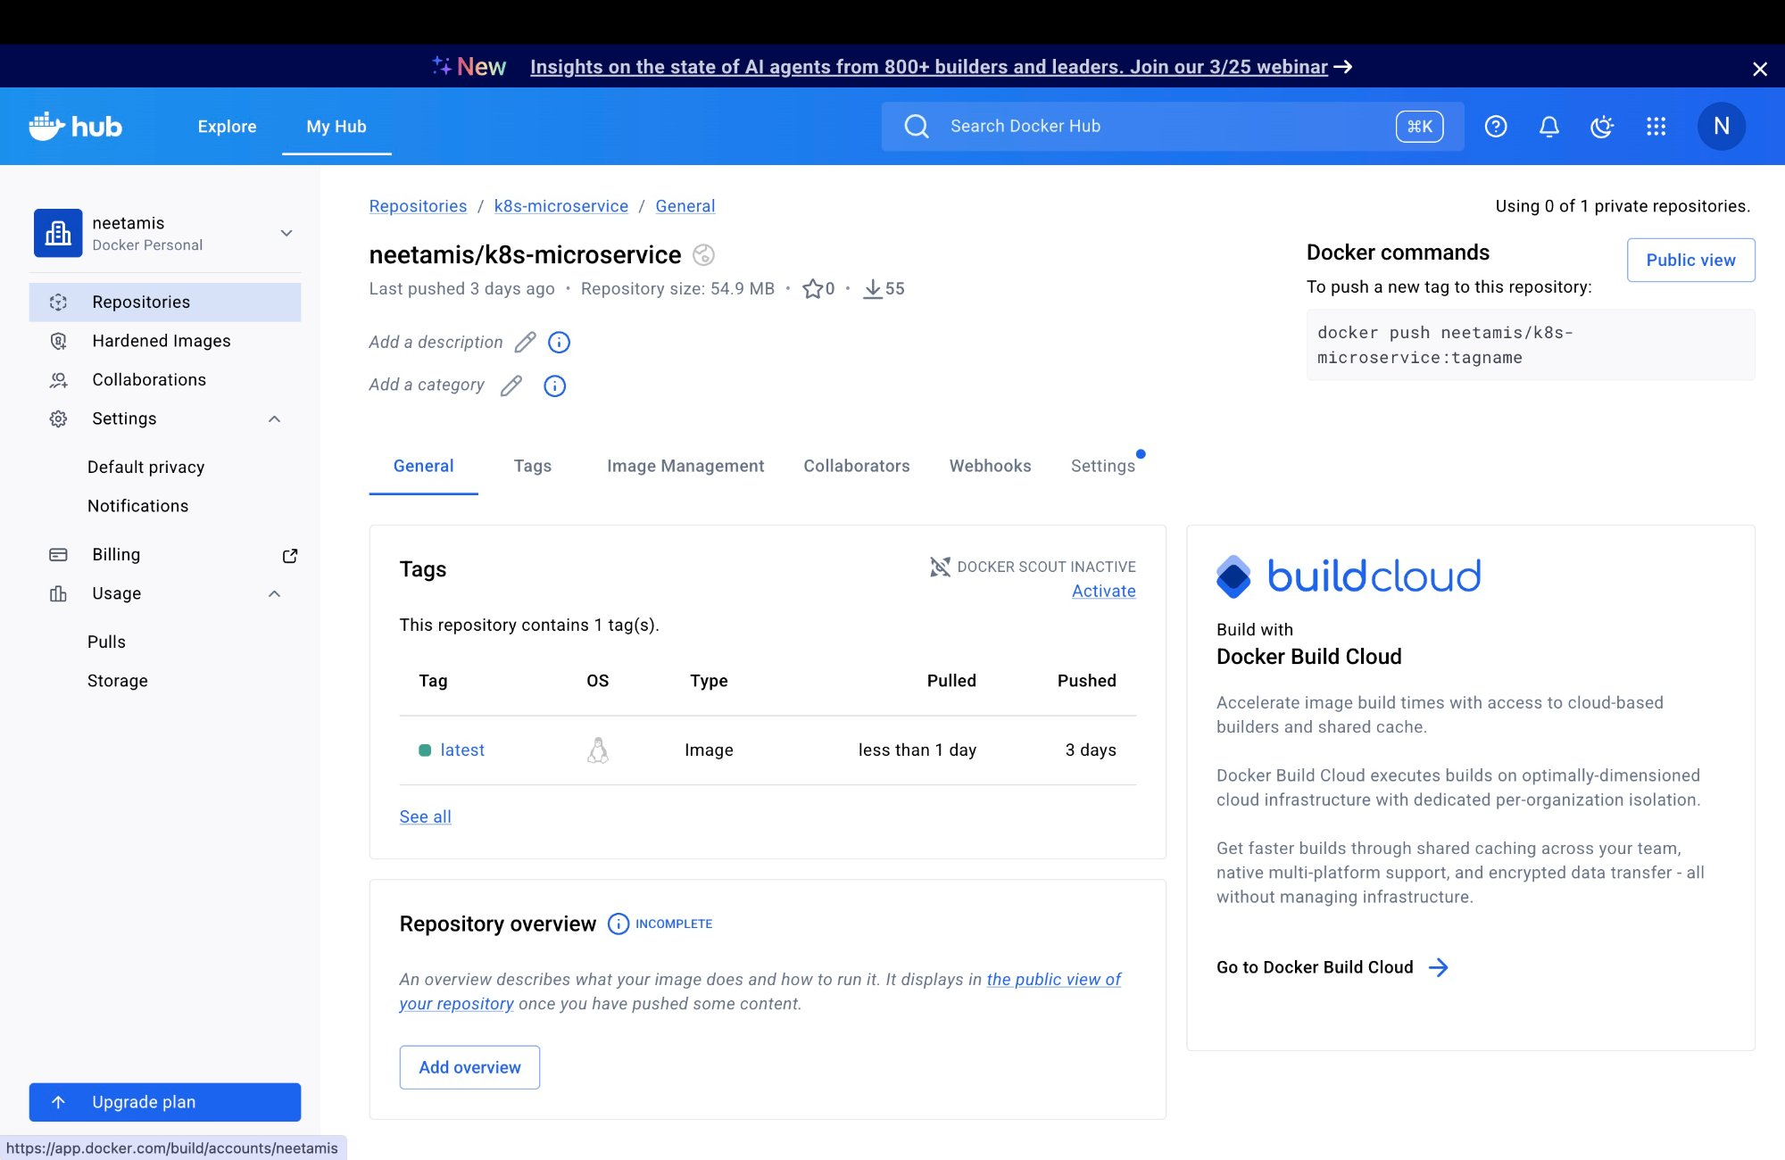
Figure 4: Docker Hub image detail page showing the :latest tag and image metadata

4. Deployment and Setup Instructions (README)
Professor Keshtkar asked in the Week 1–4 feedback to include instructions for how to deploy and run the code. The following section covers the full setup process from cloning the repository to running the application locally and in Kubernetes. This content is also included in the repository’s README.md file.

4.1 Prerequisites
Before getting started, make sure the following tools are installed on your machine:
- Docker Desktop (for building and running containers)
- minikube (for running a local Kubernetes cluster)
- kubectl (Kubernetes command-line tool)
- Python 3.11 or later (for running the app directly without Docker)
- Git (for cloning the repository)

4.2 Clone the Repository
git clone https://github.com/Neetagrg/k8s-independent-study.git
cd k8s-independent-study

4.3 Option A Run Locally with Python
Use this option to quickly test the application without Docker or Kubernetes.
- Install dependencies:
pip install -r requirements.txt
- Start the application:
python app.py
- Open your browser or use curl to test:
curl http://localhost:5000/health
You should see: {"status": "UP", "timestamp": ...}

4.4 Option B Run with Docker
Use this option to test the containerized version of the application.
- Build the Docker image:
docker build -t k8s-microservice:1.0.0 .
- Run the container:
docker run -p 5000:5000 k8s-microservice:1.0.0
- Test the endpoints:
curl http://localhost:5000/
curl http://localhost:5000/health
curl http://localhost:5000/ready
curl http://localhost:5000/info

4.5 Option C Deploy to Kubernetes (minikube)
Use this option to deploy the full Kubernetes setup with probes and auto-healing.
- Start minikube:
minikube start
- Load the Docker image into minikube (so it can use the local image):
minikube image load k8s-microservice:1.0.0
- Apply the Kubernetes manifests:
kubectl apply -f kubernetes/
- Verify the pods are running:
kubectl get pods
You should see 2 pods with status Running.
- Access the service:
minikube service k8s-microservice
This opens the service in your browser automatically, or you can get the URL with:
minikube service k8s-microservice --url
- Check pod health and probe status:
kubectl describe pod <pod-name>

4.6 Available API Endpoints
Endpoint | Method | Description | Expected Response
/ | GET | Basic service info | 200 OK service name and status
/health | GET | Liveness probe endpoint | 200 OK {"status": "UP"}
/ready | GET | Readiness probe endpoint | 200 OK {"status": "READY"}
/info | GET | Service metadata (hostname, uptime) | 200 OK JSON with version and uptime
/metrics | GET | Prometheus-format metrics | 200 OK plain text metrics

4.7 CI/CD Pipeline Overview
The GitHub Actions pipeline at .github/workflows/ci.yml runs automatically on every push to main. It performs the following steps in order:
- Checks out the code from the repository
- Sets up Python 3.11 and installs all dependencies
- Runs flake8 to check for syntax errors
- Runs pytest (unit tests placeholder for future tests)
- Builds the Docker image
- Starts the container and verifies the /health endpoint returns 200 OK
- Pushes the image to Docker Hub (only on pushes to main)
The Docker Hub repository is publicly accessible at: https://hub.docker.com/r/neetamis/k8s-microservice

5. Challenges and How I Resolved Them

5.1 Secret Name Mismatch in ci.yml
The original ci.yml file referenced a secret called DOCKER_HUB_TOKEN, but when I set up the GitHub repository secrets I named it DOCKER_HUB_ACCESS_TOKEN. This caused the Docker login step to fail immediately. I fixed it by running a sed command to find and replace the wrong name in the file, then pushed the fix. Going forward I’ll make sure the secret names in the YAML match exactly what’s configured in GitHub Settings before running the pipeline the first time.

5.2 Docker Hub Personal Access Token Permissions
Even after fixing the secret name, the Docker login step kept failing with an ‘unauthorized’ error. After troubleshooting I found the issue was that my Docker Hub Personal Access Token had been created with Read-only permissions, which doesn’t allow pushing images. I generated a new token with Read, Write & Delete permissions and that resolved it. The lesson here is that PATs for CI/CD need write access to actually push images read-only tokens are only useful for pulling.

5.3 Local Repository Not Available
At the start of this phase I realized the repository wasn’t cloned to my local machine, which made editing files more complicated. I worked around this initially by using the GitHub CLI to update files directly through the API. Eventually I ran git clone to have a proper local copy, which made everything much easier. I’ll make sure to always clone the repo locally at the start of any new phase.

6. Verification Checklist
Item | Status | Evidence
GitHub Actions workflow triggers on push to main | ✅ Pass | 15 runs logged in Actions tab
Python 3.11 environment configured | ✅ Pass | Workflow logs
flake8 linting passes on app.py | ✅ Pass | No syntax errors found
Docker image builds successfully | ✅ Pass | Image size: 54.9 MB
Container /health endpoint returns 200 OK | ✅ Pass | curl test in pipeline
Image pushed to Docker Hub | ✅ Pass | Figure 3 & 4 screenshots
CI/CD badge shows passing in README | ✅ Pass | Figure 1 screenshot
README includes deployment instructions | ✅ Pass | Section 4 of this report

7. Plan for Weeks 9–11
The next phase focuses on auto-scaling and observability. Specifically I plan to:
- Set up Horizontal Pod Autoscaling (HPA) using CPU utilization as the trigger metric
- Run a synthetic load test using a tool like hey or Apache Bench to trigger scaling
- Record recovery time after pod deletion and compare to Phase 1 baseline measurements
- Install Prometheus and configure it to scrape the /metrics endpoint already built into the app

8. References
- GitHub Actions. "Workflow syntax for GitHub Actions." https://docs.github.com/en/actions/using-workflows/workflow-syntax-for-github-actions
- Docker. "GitHub Actions Introduction." https://docs.docker.com/build/ci/github-actions/
- Docker Hub. "Docker Hub Access Tokens." https://docs.docker.com/security/for-developers/access-tokens/
- Kubernetes. "Liveness, Readiness and Startup Probes." https://kubernetes.io/docs/tasks/configure-pod-container/configure-liveness-readiness-startup-probes/
- minikube. "Getting Started with minikube." https://minikube.sigs.k8s.io/docs/start/

