DATA SCIENCE PROJECT PLAN
Forecasting Hourly Bike-Share Demand to Guide Station Rebalancing
Week 1 Deliverable: Project Planning and Strategy (Python-based, hypothetical project)
Item | Summary
Project type | Supervised learning on time series and spatial-temporal count data
Client (hypothetical) | "MetroBike", a city bike-share operator with roughly 300 docking stations
Estimated effort | 33 hours over approximately six weeks
Primary language | Python 3.11 (pandas, scikit-learn, XGBoost, matplotlib, and related libraries)
Data note | No dataset is used this week. All data volumes and figures below are planning assumptions.

1. Project Background

1.1 The problem
MetroBike operates a city-wide network of docking stations and bicycles. Riders pick up a bike at one station and drop it at another, so bikes drift through the network according to commuting patterns, weather, and events. Some stations empty out (no bikes to rent) while others fill up (no free docks to return to). Both situations frustrate riders and cost the operator revenue.
Today, a small operations team rebalances bikes with trucks using fixed daily routes and experience-based judgement. Routes are not linked to expected demand, so trucks often visit stations that did not need help and miss stations that ran empty an hour later.

1.2 Motivation and justification
A demand forecast at the level of "how many bikes will leave and arrive at each station in each hour" converts rebalancing from a reactive routine into a proactive plan. The problem is a good fit for a Python-based data science approach for four reasons:
- Data is naturally logged. Every trip creates a timestamped record, so a long, granular history is available without new instrumentation.
- Demand is structured but not trivial. Strong daily and weekly cycles are modulated by weather, holidays, and local events, which is exactly where machine learning can beat simple rules.
- The business value is measurable. Forecast error and the number of predicted stock-outs can be evaluated against history before anything is deployed.
- The scope is contained. The project can deliver a useful result with tabular models and open-source libraries, with no specialised infrastructure.
The project is also a strong vehicle for demonstrating the full data science lifecycle: framing, data engineering, exploration, feature design, modelling, honest evaluation, and communication of results.

2. Project Objectives
The overall goal is to build and validate a reproducible Python pipeline that predicts hourly departures and arrivals for each station, and turns those forecasts into a ranked list of stations at risk of running empty or full. Specific objectives are stated so they can be checked at the end of the project:
# | Objective | Success measure
O1 | Assemble a clean, documented, analysis-ready dataset joining trips, weather, and calendar information | Data-quality report produced; less than 1% unresolved missing values in modelling features
O2 | Characterise demand patterns by hour, weekday, season, weather, and station type | At least five documented findings supported by charts and summary statistics
O3 | Establish baseline forecasts that any model must beat | Naive and seasonal-naive baselines scored on a held-out period
O4 | Train and compare at least three model families for hourly station demand | Best model reduces MAE by at least 20% relative to the seasonal-naive baseline
O5 | Convert forecasts into a station risk ranking for rebalancing | Recall of at least 70% on historical empty/full events in the test period
O6 | Deliver a reproducible codebase and a clear final report | Pipeline runs end to end from a single command; report reviewed against this plan

3. Project Scope
In scope | Out of scope
Historical trip data for the most recent three years (assumed about 4 million trips) | Real-time streaming and live model serving
Hourly demand (departures and arrivals) for every active station | Optimising truck routes, vehicle capacity, or staffing schedules
Joining weather, public-holiday, and event-calendar data | Dynamic pricing or rider-incentive programmes
Baseline, linear, tree-ensemble, and (stretch goal) neural models | Long-range (multi-month) network expansion planning
Forecast horizons of 1 to 24 hours ahead | Forecasts for stations opened less than 60 days before the test period
Error analysis, feature importance, and a static results dashboard | Building a production web application or mobile interface

Key assumptions. (1) Trip records include start and end timestamps and station identifiers. (2) Historical station availability snapshots exist or can be approximated from trip flows. (3) Weather and holiday data can be obtained from free public sources. (4) Personal rider information is not needed and will not be collected, so privacy risk stays low.

4. Methodology and Strategy
The project follows an iterative version of the standard data science lifecycle, shown in Figure 1. The stages are sequential on a first pass, but findings in evaluation or exploration are expected to send work back to earlier stages (dashed arrow). Figure 2 shows how data moves through the technical components.
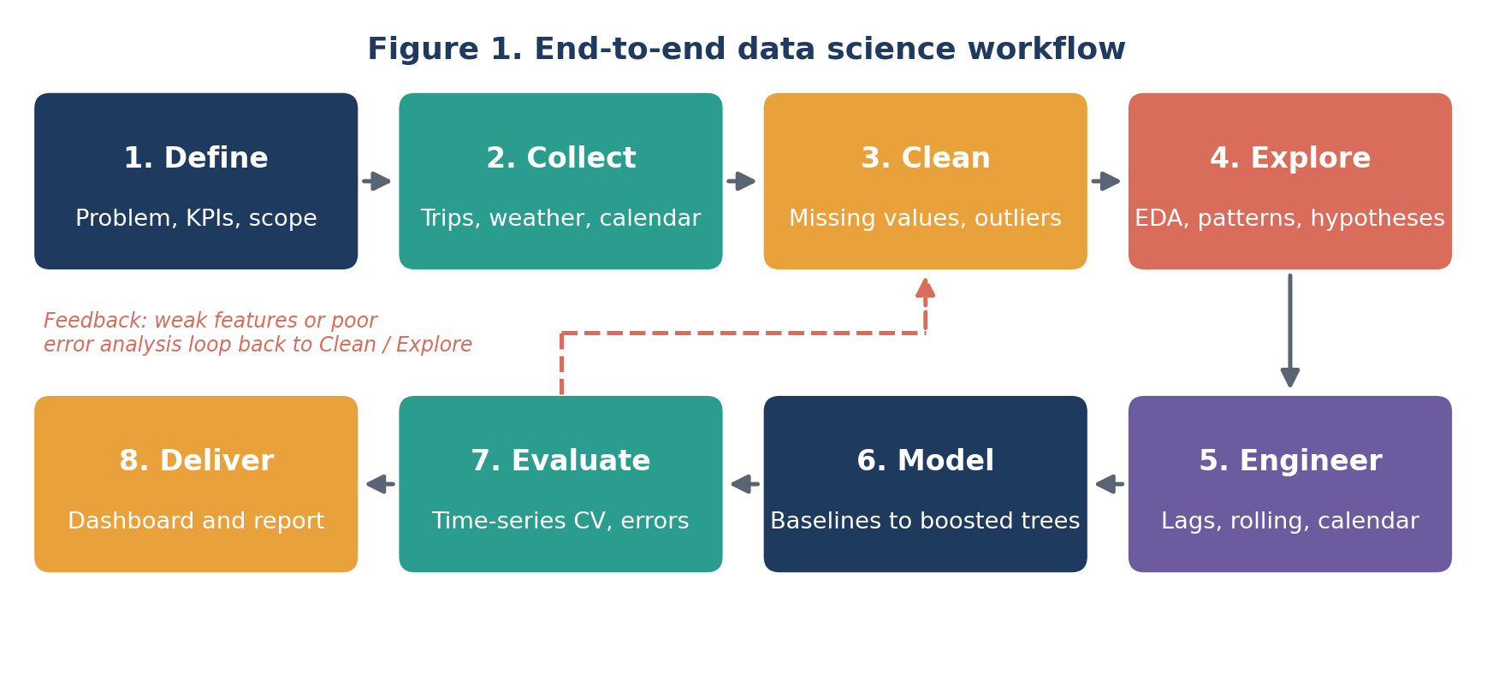
Figure 1: Iterative workflow with a feedback loop from evaluation back to cleaning and exploration.
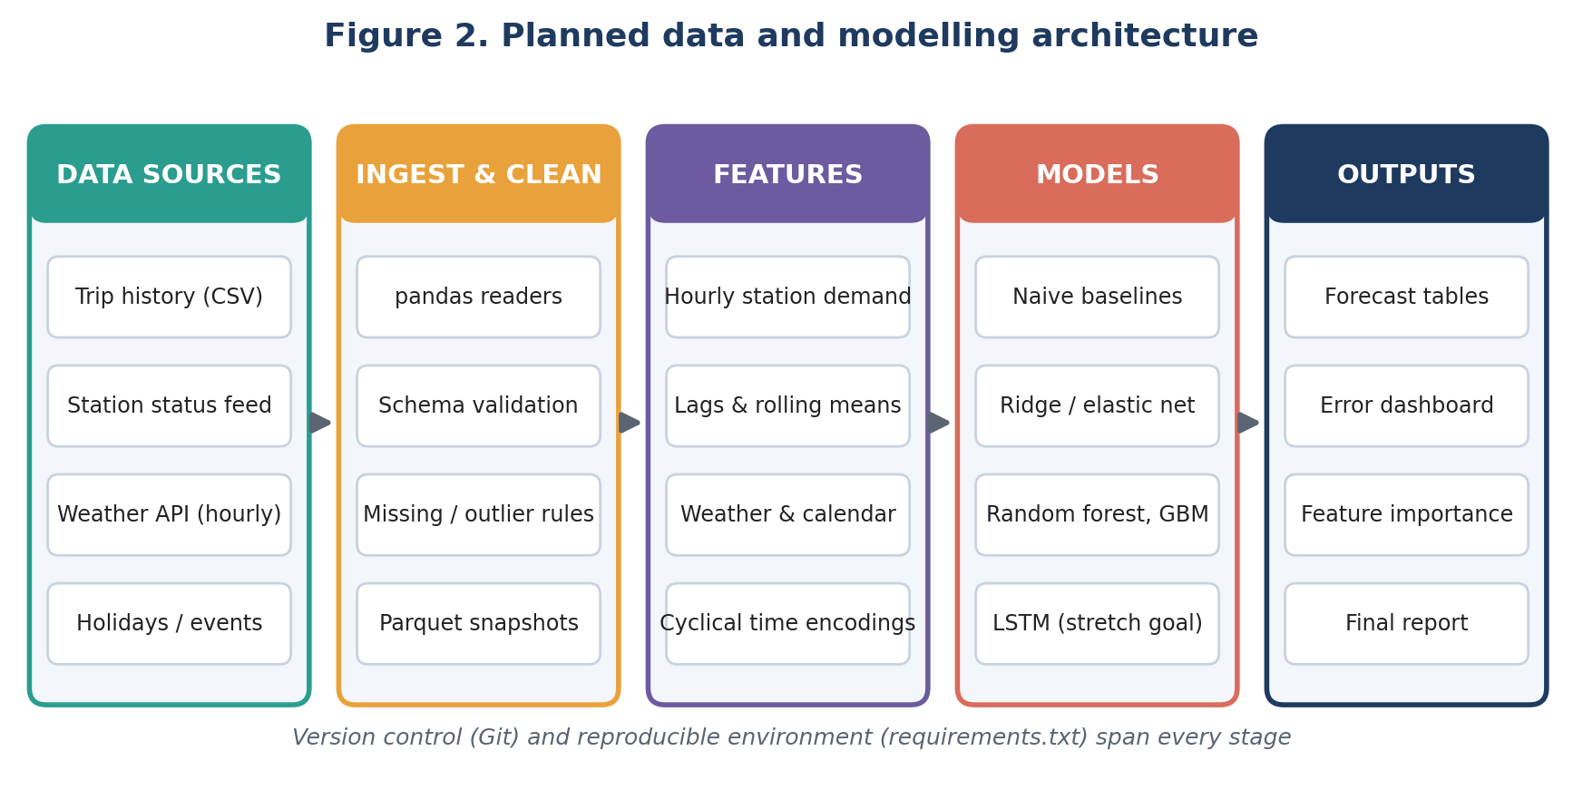
Figure 2: Planned data flow from sources to outputs.

4.1 Data collection
- Trip history: monthly CSV exports with trip start/end time and station IDs, read with pandas in chunks and stored as Parquet for speed.
- Station metadata: station ID, name, latitude/longitude, dock capacity, and install date.
- Weather: hourly temperature, precipitation, wind, and humidity from a free public weather API or historical archive, cached locally so the pipeline does not depend on a live connection.
- Calendar: public holidays, school terms, and major city events assembled into a single lookup table.
Every source is recorded in a data dictionary with its origin, refresh date, licence, and known limitations.

4.2 Data cleaning and preprocessing
- Validate schemas and convert timestamps to a single time zone, handling daylight-saving transitions explicitly.
- Remove or flag impossible records: negative durations, trips shorter than a minute that start and end at the same station, and duplicate trip IDs.
- Handle missing weather values by short-gap interpolation (up to three hours) and a documented fallback beyond that.
- Aggregate trips to a complete station-by-hour grid, filling hours with no trips with zero rather than leaving them absent, so that quiet periods are represented correctly.
- Flag known disruption periods (system outages, station closures) so they can be excluded from training or treated separately.

4.3 Exploratory data analysis
Exploration aims to understand demand before modelling and to generate hypotheses for feature design:
- Daily, weekly, and seasonal profiles, split by weekday versus weekend and by member versus casual rider if available.
- Relationship between demand and temperature, rain, and wind (scatter plots, binned averages, correlation heatmaps).
- Clustering of stations by demand profile (for example, commuter, leisure, and mixed stations) using k-means on normalised hourly profiles.
- Autocorrelation and seasonal decomposition to confirm which lags matter (1 hour, 24 hours, 168 hours).
- Map-based views of net flow (arrivals minus departures) to see where bikes accumulate and drain.

4.4 Feature engineering
Feature group | Examples
Temporal | Hour, weekday, month, and week of year, encoded cyclically with sine/cosine so 23:00 and 00:00 are close
Lag and rolling | Demand 1, 24, and 168 hours ago; rolling 3-hour and 24-hour means; rolling standard deviation
Weather | Temperature, rain flag, wind speed, and a "feels-like" index; forecasted weather for the prediction hour
Calendar | Public holiday, day before/after holiday, school-term flag, event-day flag
Station | Capacity, cluster label from EDA, distance to city centre, nearby transit stop count

All lag features use only information available at prediction time. This rule is enforced in code with automated tests to prevent data leakage.

4.5 Modelling strategy
Models are introduced in order of complexity so that each one must justify its added cost:
- Baselines: naive (same as last hour) and seasonal naive (same hour last week).
- Regularised linear model (ridge / elastic net) for an interpretable reference.
- Tree ensembles: random forest, then gradient boosting (XGBoost or LightGBM) with count-appropriate objectives such as Poisson.
- Stretch goal: a small LSTM or temporal convolutional network in PyTorch, attempted only if time remains and boosted trees leave clear residual structure.
Hyperparameters are tuned with randomised search inside the training folds only. A single global model with a station feature is trained first, then compared with per-cluster models.

4.6 Evaluation
- Validation design: rolling-origin (expanding window) cross-validation with scikit-learn's TimeSeriesSplit, so the model is always tested on data later than its training data. The final eight weeks are held out and touched only once.
- Metrics: MAE and RMSE for accuracy, WAPE (weighted absolute percentage error) to compare busy and quiet stations fairly, and bias to detect systematic over- or under-forecasting.
- Decision metrics: precision and recall for "station will run empty/full within the next 3 hours" alerts.
- Error analysis: errors sliced by hour, weather condition, station cluster, and holiday status to show where the model is weak, plus SHAP or permutation importance for explanation.

5. Timeline and Effort
The plan allocates 33 hours across eight phases, spread over roughly six weeks at five to six hours per week. Figure 3 shows the schedule and Figure 4 the effort split. Modelling receives the largest share because it includes tuning and comparison of several model families.
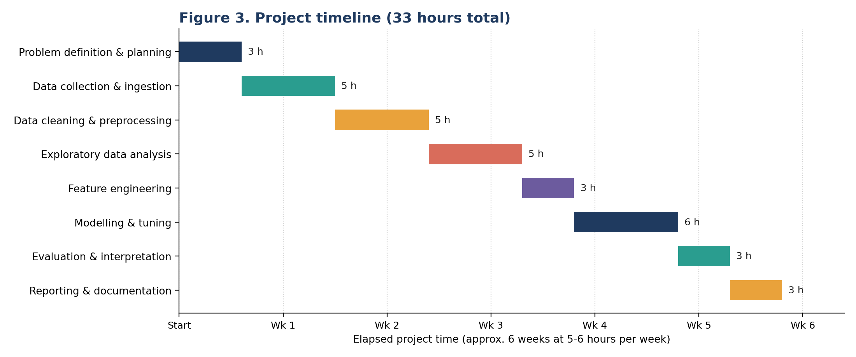
Figure 3: Gantt-style project timeline with hours per phase.
# | Phase | Hours | Main activities and deliverable
1 | Problem definition and planning | 3 | Refine objectives and metrics; set up repository and environment; approved project plan
2 | Data collection and ingestion | 5 | Acquire trips, weather, and calendar data; build loaders; data dictionary
3 | Data cleaning and preprocessing | 5 | Validation rules, outlier handling, station-hour grid; data-quality report
4 | Exploratory data analysis | 5 | Pattern analysis, station clustering, hypotheses; EDA notebook and key charts
5 | Feature engineering | 3 | Lag, rolling, weather, and calendar features; leakage tests; feature table
6 | Modelling and tuning | 6 | Baselines, linear, and tree models; tuning; model comparison table
7 | Evaluation and interpretation | 3 | Held-out test scoring, error slices, feature importance, risk-alert recall
8 | Reporting and documentation | 3 | Final report, results dashboard, README, and reproducible run script
 | Total | 33 | Includes about 10% contingency inside each phase

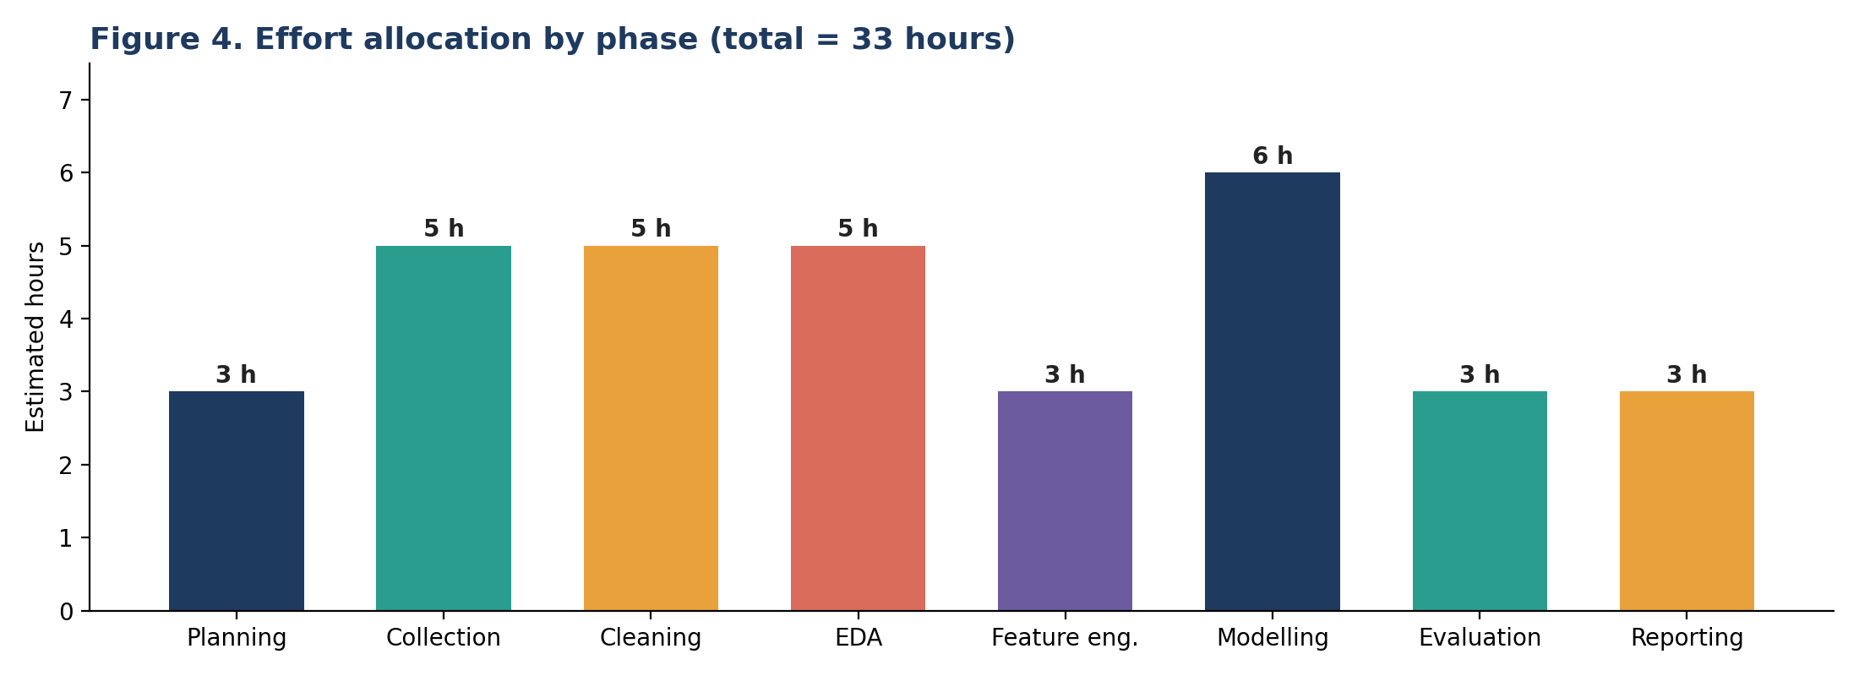
Figure 4: Estimated hours by phase.

6. Tools and Python Libraries
Purpose | Tools / libraries | How they will be used
Environment | Python 3.11, Jupyter, VS Code, venv | Interactive exploration plus scripts for the repeatable pipeline
Version control | Git and GitHub | Track code and experiments; small, descriptive commits
Data handling | pandas, NumPy, PyArrow | Load, clean, aggregate, and store Parquet snapshots
Data acquisition | requests, pathlib | Fetch weather data and manage cached files
Visualisation | matplotlib, seaborn, Plotly, folium | Static charts, interactive plots, and station maps
Statistics | SciPy, statsmodels | Correlation tests, seasonal decomposition, autocorrelation
Machine learning | scikit-learn, XGBoost / LightGBM | Pipelines, cross-validation, tuning, and boosted trees
Deep learning (stretch) | PyTorch | Sequence model if justified by residual analysis
Interpretability | SHAP | Explain predictions and rank drivers of demand
Quality and reproducibility | pytest, black, requirements.txt | Leakage and data tests; consistent formatting; pinned dependencies

7. Expected Outcomes and Benefits

7.1 Deliverables
- A documented, versioned Python repository that reproduces every result from raw data.
- A cleaned station-hour dataset with a data dictionary and quality report.
- An EDA notebook summarising demand patterns and station clusters.
- A model comparison table, with the best model's forecasts, error analysis, and feature importances.
- A station risk ranking and a short final report with recommendations for the operations team.

7.2 Anticipated results
Seasonal-naive forecasts are typically strong for bike-share data because of the weekly rhythm, so the improvement from machine learning is expected to come mainly from weather sensitivity and holiday effects. A realistic target is a 20% to 30% MAE reduction over the baseline, with the largest gains on rainy days and around holidays.

7.3 Benefits
- Operational: trucks can be directed to stations with the highest predicted risk instead of fixed routes.
- Customer: fewer empty and full stations, leading to better service and higher trust.
- Analytical: transparent, reusable methods and a clear understanding of demand drivers that can inform future planning.

8. Anticipated Challenges and Mitigation
Challenge | Why it matters | Mitigation
Data leakage | Using future information inflates scores and fails in practice | Time-based splits only; lag features built from past data; automated leakage tests
Censored demand | An empty station shows zero departures even when riders wanted a bike | Flag stock-out hours; exclude or model them separately; note as a limitation
Sparse, zero-heavy counts | Quiet stations have many zeros, which breaks squared-error assumptions | Poisson-type objectives; WAPE and per-cluster evaluation; aggregate to clusters if needed
Missing or inconsistent data | Sensor gaps and schema changes can bias results | Validation rules, documented imputation limits, and a data-quality report
Non-stationarity | Demand shifts with expansion, pricing, or disruptions | Rolling-origin validation; recency features; retraining schedule recommended
Overfitting and complexity | Complex models may not generalise | Start simple, compare against baselines, regularise, and keep the test set untouched
Time overrun | Only 33 hours are available | Prioritise objectives O1 to O5; treat LSTM as optional; time-box each phase
Privacy and ethics | Trip data can reveal individual movements | Use station-level aggregates only; no rider identifiers; note limitations in the report

9. Conclusion
This plan frames a concrete, realistic data science problem and describes how each stage, from data acquisition to communication of results, will be carried out in Python. The project is contained enough to complete in 33 hours, yet rich enough to exercise data engineering, exploratory analysis, feature design, model comparison, and careful evaluation. The workflow, architecture, and schedule are designed so that later technical tasks can build directly on this foundation.

