SCS2211 – Lab II – Practical 3

Index No - 20000634

1. Load the dataset

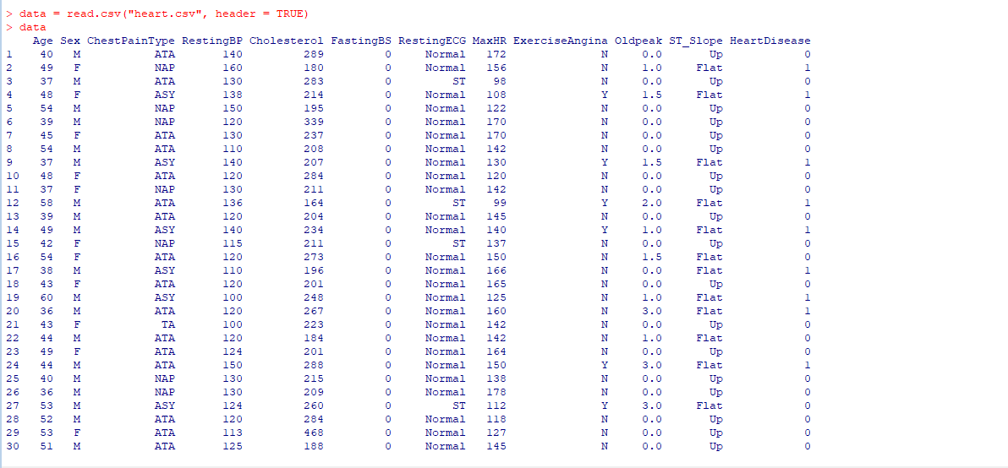

1. Find the number of records

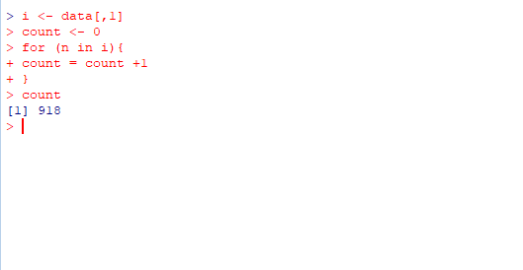

1. Print the summary of RestingBP

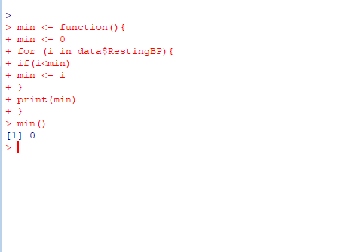

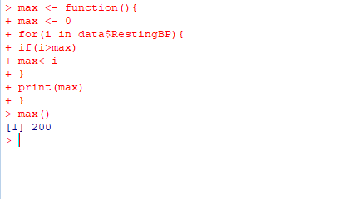

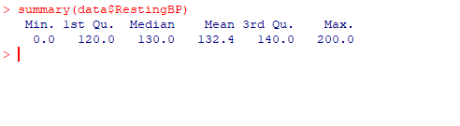

1. Find the number of patients with “higher than mean” RestingBP.

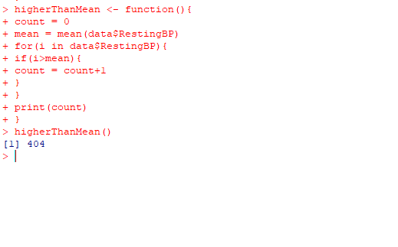

1. Find unique chest pain types.

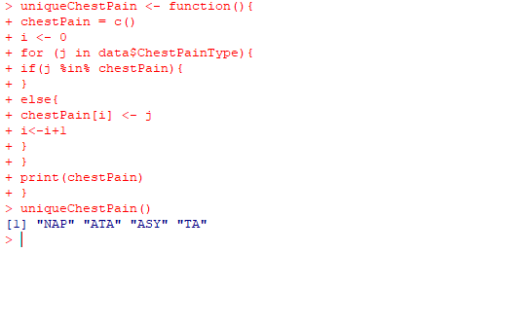

1. Print the ages of the first 10 Females whose resting BP is greater than 140.

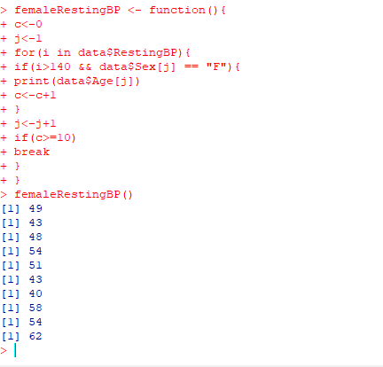

1. Write a function which takes a row of data as input and outputs the attribute information in a structured manner. If cholesterol level is less than 200 then print low else high. Example output is given below

