FINAL PROJECT REPORT
EMERGENCY RESOURCE MATCHING SYSTEM

Project Domain: Design and Analysis of Algorithms (DAA)
Student Names & Roll Numbers:
P. Neethu Priya (25MVCSMR0336)
K. Varshitha (25MVCSMR0313)
G. Lakshmi Srija (25MVCSMR0307)
T. Therishma Reddy (25MVCSMR0361)
Department & College: Mallareddy Vishwavidyapeeth Technical Campus [CSE AIML (sec-D)]
Guide Name: [Guide Name]
Academic Year: 2026-27

Table of Contents
S.No. | Chapter / Section
1 | Abstract & Introduction
2 | Problem Statement, Objectives & Scope
3 | Features & Functional Requirements
4 | Algorithms & Methodology
5 | Technologies & Implementation
6 | Results, Testing & Performance
7 | Conclusion, Future Scope & References

List of Figures
- Figure 1: Overall System Workflow
- Figure 2: Priority Queue Processing Flow
- Figure 3: Matching and Feasibility Flow
- Figure 4: Greedy Resource Selection Flow
- Figure 5: Frontend Dashboard
- Figure 6: Emergency List
- Figure 7: Resource List
- Figure 8: Algorithm Execution Log
- Figure 9: Final Assignment Output

List of Tables
- Table 1: Project Objectives
- Table 2: Functional Requirements
- Table 3: Algorithm Summary
- Table 4: API Endpoints
- Table 5: Sample Emergency Data
- Table 6: Sample Resource Data
- Table 7: Test Cases
- Table 8: Complexity Analysis

1. ABSTRACT & INTRODUCTION

1.1 Abstract
Emergency situations often involve multiple requests arriving while the number of available response resources is limited. The Emergency Resource Matching System is an algorithm-centric prototype designed to demonstrate how emergency requests can be prioritized and matched with suitable resources such as ambulances and fire trucks.
The system considers emergency urgency, resource availability, resource type, resource capacity, and distance. A Priority Queue is used to decide the order in which emergencies are processed. A Matching step identifies feasible resources. A Greedy selection step then chooses the best currently feasible resource according to a defined scoring rule. After assignment, the selected resource is marked unavailable and the next emergency is processed.
The project focuses on making algorithmic decisions visible and understandable. Instead of only presenting a final assignment, the prototype displays execution steps and final assignments so that users can see how the result was obtained. The current prototype uses sample data stored in Python files and does not implement authentication or a PostgreSQL database.

1.2 Introduction
Emergency resource allocation is a decision-making problem in which limited resources must be assigned to requests that may have different priorities and requirements. A simple first-come-first-served approach may not reflect the urgency of each situation. A system therefore needs a clear rule for prioritizing requests and a method for identifying suitable resources.
This project demonstrates a structured approach using three Design and Analysis of Algorithms concepts: Priority Queue, Matching, and Greedy Algorithm. The combination provides a clear sequence: decide which emergency comes first, identify feasible resources, and select one suitable resource.

1.3 Project Overview
- The prototype accepts predefined emergency requests and available resources.
- Emergencies contain information such as type, urgency, location, required resource, and number of patients.
- Resources contain type, location, capacity, distance, and availability information.
- The system processes emergencies through a Priority Queue.
- Feasible resources are identified through matching conditions.
- A Greedy score is used to select one feasible resource.
- Assignments and algorithm execution steps are returned through Flask API endpoints and displayed by the React frontend.

1.4 Problem Background
Emergency response can involve more requests than immediately available resources. Different emergencies may require different resource types, and resources may have different capacities and distances. Therefore, resource allocation needs explicit decision rules. This project uses algorithmic techniques to model those decisions in a small, understandable prototype.

1.5 Proposed Solution
The proposed solution processes emergency requests in priority order. For each emergency, the matching stage removes resources that are unavailable, have the wrong resource type, or have insufficient capacity. The remaining feasible resources are evaluated by the Greedy selection function. The selected resource is assigned and its availability is updated.

1.6 Purpose of the Project
The main purpose is to demonstrate how DAA concepts can be applied to a real-world resource allocation problem. The project emphasizes transparent decision-making, appropriate data structures, algorithmic reasoning, and a simple working web prototype.

2. PROBLEM STATEMENT, OBJECTIVES & SCOPE

2.1 Problem Statement
The problem is to match emergency requests with available resources based on urgency, distance, resource suitability, capacity, and availability. Since resources are limited, the system must determine which emergency should be processed first and which feasible resource should be assigned.

2.2 Objectives
Objective | Description
Prioritize emergencies | Process emergencies according to their urgency.
Identify feasible resources | Filter resources by availability, type, and capacity.
Select a resource | Use a Greedy scoring rule to choose a suitable resource.
Show decisions | Display assignments and execution steps clearly.
Demonstrate DAA | Apply Priority Queue, Matching, and Greedy concepts in one workflow.

2.3 Project Scope
The scope of the current prototype is limited to algorithmic matching using sample data. It demonstrates emergency prioritization, resource feasibility checking, resource selection, availability updates, and result display through a web interface.
- Included: ambulance and fire-truck resource examples.
- Included: urgency-based priority processing.
- Included: availability, resource-type, and capacity checks.
- Included: distance and capacity contribution to the Greedy score.
- Not currently included: live GPS, real-time external emergency feeds, user authentication, PostgreSQL persistence, and production deployment.

2.4 Target Users
- Emergency-response planning demonstrators.
- Students and instructors studying Design and Analysis of Algorithms.
- Developers exploring resource allocation prototypes.
- Emergency management stakeholders as a conceptual prototype audience.

3. FEATURES & FUNCTIONAL REQUIREMENTS

3.1 Main Features
- Emergency request listing.
- Resource listing.
- Urgency-based Priority Queue processing.
- Feasible-resource Matching.
- Greedy resource selection.
- Resource availability updates after assignment.
- Final assignment display.
- Algorithm execution log.
- Responsive React dashboard.

3.2 User Functionalities
- View emergency requests.
- View available resources.
- Run the matching algorithm.
- View algorithm execution steps.
- View final assignments and unmatched emergencies.

3.3 CRUD Operations
The current prototype does not provide a complete CRUD interface. Emergency and resource data are defined in the sample_data.py module and exposed through read-oriented API endpoints. The matching operation processes the data in memory and changes availability in the temporary working copy used for the matching run.
Operation | Current Prototype Status
Create | Not implemented through the UI/API.
Read | Supported through /api/emergencies and /api/resources.
Update | Availability is updated in the in-memory matching process.
Delete | Not implemented.

3.4 Authentication & Validation
Authentication and login functionality are not implemented in the current prototype. Validation is performed through matching conditions: a resource must be available, its type must match the required resource type, and its capacity must be sufficient for the emergency.

3.5 System Requirements
Category | Requirement
Operating System | Windows, Linux, or macOS with Python and Node.js support.
Editor | Visual Studio Code.
Backend | Python with Flask and Flask-CORS.
Frontend | React and Vite.
Browser | Modern web browser such as Chrome, Edge, or Firefox.
Network | Localhost connectivity between frontend and backend during development.

4. ALGORITHMS & METHODOLOGY

4.1 System Workflow
The system follows a sequential algorithmic workflow:
- Receive emergency requests and resource information.
- Insert emergencies into a Priority Queue using urgency priority.
- Remove the highest-priority emergency from the queue.
- Find feasible resources through Matching.
- Calculate a score for each feasible resource.
- Select the highest-scoring feasible resource using the Greedy rule.
- Assign the resource and mark it unavailable.
- Record the execution step and continue with the next emergency.
- Return final assignments and execution steps.

4.2 Overall Workflow
Emergency Requests → Priority Queue → Highest Priority Emergency → Find Feasible Resources → Matching → Calculate Scores → Greedy Selection → Assign Resource → Update Availability → Next Emergency

4.3 Priority Queue
A Priority Queue is a data structure in which elements are removed according to priority rather than ordinary insertion order. In this project, Critical emergencies receive the highest priority, followed by High, Medium, and Low.
Python's heapq module is used to implement the queue. The priority is stored so that the most urgent emergency is retrieved first.

4.4 Matching
Matching identifies resources that can feasibly serve the selected emergency. A resource is considered feasible when it is available, has the required resource type, and has sufficient capacity.
This stage prevents an unsuitable resource from reaching the Greedy selection stage.

4.5 Greedy Algorithm
The Greedy stage evaluates feasible resources and chooses the one with the highest score at that point. The current scoring function combines an urgency component, a distance component, and a capacity component.
The Greedy approach does not claim global optimality. It makes the best locally feasible choice according to the scoring rule defined for this prototype.

4.6 Scoring Rule
The implemented score uses an urgency bonus, a distance score that decreases as distance increases, and a capacity contribution. The score is used only to compare feasible resources for the current emergency.

4.7 Development Methodology
The prototype follows an iterative development approach. The algorithmic components are separated into modules, the Flask backend exposes the processing through API endpoints, and the React frontend presents the data and results. Each major algorithm can be tested independently and then integrated into the complete workflow.

4.8 Data Flow
Emergency and resource data are loaded from sample_data.py. The Flask application sends emergency and resource data to the frontend through API endpoints. When the matching endpoint is called, the backend creates an in-memory working copy of the resources, processes emergencies, and returns assignments and execution steps as JSON.

4.9 Complexity Analysis
Component | Operation | Typical Complexity
Priority Queue | Insert one emergency | O(log n)
Priority Queue | Remove highest-priority emergency | O(log n)
Priority Queue | Read top element | O(1)
Matching | Scan resources for one emergency | O(m)
Greedy | Score and compare feasible resources | O(m) in a scan
Overall processing | For n emergencies and m resources, simple scan-based implementation | O(n log n + n·m)

The overall expression is a theoretical analysis of the current simple implementation. Actual runtime depends on input size, hardware, Python execution, and the number of resources and emergencies.

5. TECHNOLOGIES & IMPLEMENTATION

5.1 Frontend Technologies
- React: used to create the interactive dashboard.
- React DOM: used to render the application.
- Vite: used as the frontend development and build tool.
- CSS: used for dashboard layout, tables, cards, badges, and responsive presentation.

5.2 Backend Technologies
- Python: implementation language for the algorithmic modules.
- Flask: backend web framework and API server.
- Flask-CORS: allows the React development frontend to communicate with the Flask backend.
- heapq: Python standard-library module used for the Priority Queue.

5.3 Database
The current prototype does not use a database. Sample emergencies and resources are stored in sample_data.py. PostgreSQL can be integrated in a future version for persistent storage.

5.4 Tools & APIs
Endpoint | Purpose
/ | Checks that the Flask API is running.
/api/emergencies | Returns emergency request data.
/api/resources | Returns resource data.
/api/match | Runs the matching workflow and returns assignments and execution steps.

5.5 Implementation Details
Module | Responsibility
app.py | Creates the Flask application, routes, matching workflow, and JSON responses.
sample_data.py | Stores sample emergency and resource data.
priority_queue.py | Creates and processes the urgency-based heap.
matching.py | Filters resources using feasibility conditions.
greedy.py | Calculates scores and selects the best feasible resource.
App.jsx | Displays the React dashboard and calls backend endpoints.
App.css | Provides the frontend styling.

5.6 Sample Data Model
Emergency ID | Type | Urgency | Location | Required Resource | Patients
E001 | Accident | Critical | Kompally | Ambulance | 2
E002 | Fire | High | Suchitra | Fire Truck | 0
E003 | Medical | Critical | Medchal | Ambulance | 1
E004 | Accident | Medium | Bowenpally | Ambulance | 1

Resource ID | Type | Location | Capacity | Distance | Available
A001 | Ambulance | Kompally | 4 | 2.0 | Yes
A002 | Ambulance | Medchal | 2 | 3.5 | Yes
A003 | Ambulance | Secunderabad | 4 | 8.0 | Yes
F001 | Fire Truck | Suchitra | 10 | 2.5 | Yes
F002 | Fire Truck | Jeedimetla | 10 | 6.0 | Yes

6. RESULTS, TESTING & PERFORMANCE

6.1 Project Results
The prototype produces a prioritized processing sequence, identifies feasible resources, selects a resource using the Greedy score, updates resource availability within the matching run, and returns final assignment records. The frontend displays these results through a dashboard and execution log.

6.2 Testing Method
Testing is based on functional test cases derived from the implemented rules. The main focus is verifying priority ordering, feasibility filtering, score-based selection, availability updates, and handling of unmatched emergencies.

6.3 Test Cases
ID | Test Case | Expected Result
TC01 | Critical emergency and lower-priority emergency are present. | Critical emergency is processed first.
TC02 | A resource is unavailable. | Unavailable resource is ignored.
TC03 | Resource type does not match the emergency. | Resource is excluded.
TC04 | Resource capacity is below required patient count. | Resource is excluded.
TC05 | Multiple feasible resources exist. | Their scores are compared and the highest-scoring resource is selected.
TC06 | A resource is assigned. | It is marked unavailable in the matching run.
TC07 | No feasible resource exists. | Emergency is recorded as Unmatched.

6.4 Expected Output Structure
The /api/match endpoint returns two main result groups: assignments and execution_steps. Assignments contain emergency ID, emergency type, selected resource ID, distance, score, and status. Execution steps explain which algorithmic stage was performed and what happened during processing.

6.5 Screenshots / Output
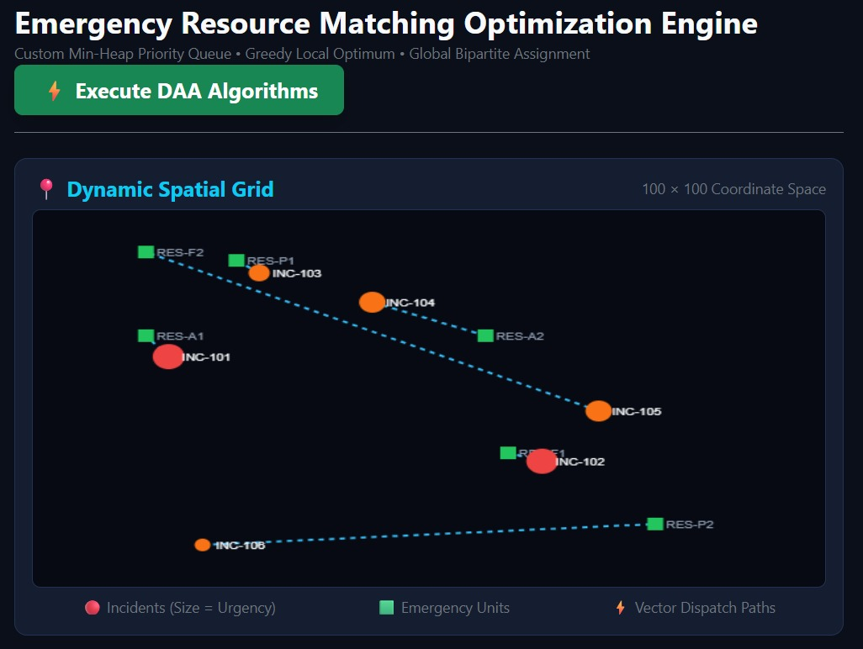

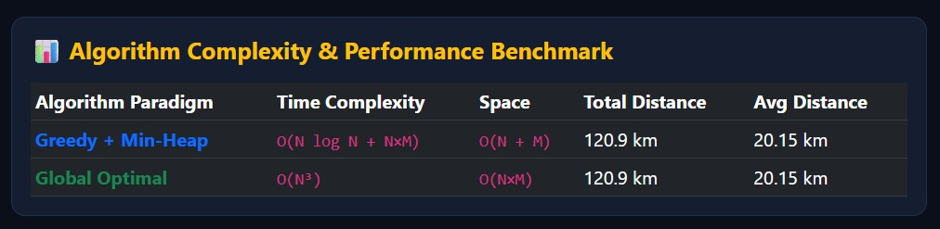

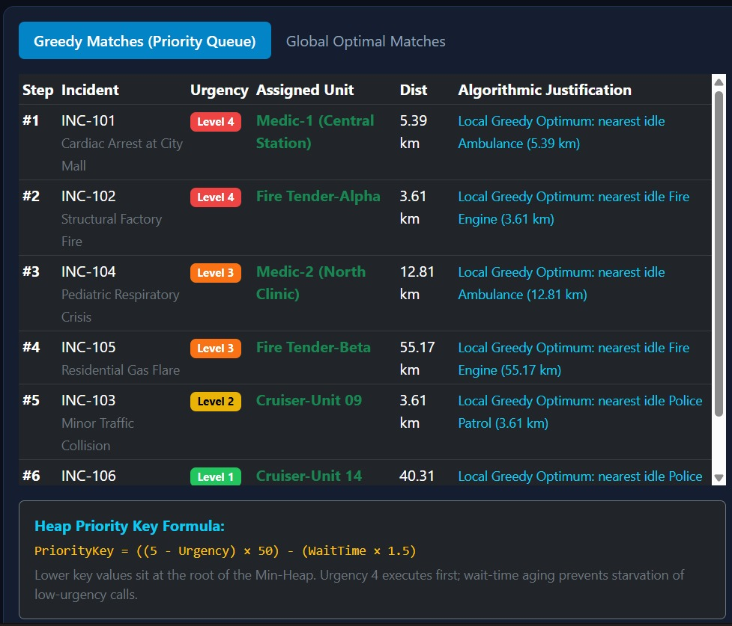

6.6 Performance Analysis
The project uses a simple scan-based implementation suitable for demonstrating the algorithms. Priority Queue operations use a heap and therefore require logarithmic time for insertion and removal. Matching scans the resource list for each emergency. Greedy selection also scans the feasible resources to identify the highest score.
No execution-time benchmark, accuracy percentage, or production-scale performance claim is made because the current project is a prototype using sample data. Performance should be benchmarked with larger datasets in a future version.

6.7 Limitations
- The prototype uses sample data rather than persistent database storage.
- Distance values are predefined rather than calculated from live GPS coordinates.
- There is no authentication or role-based access control.
- The current Greedy score is a demonstration rule and is not a universal emergency-response policy.
- The prototype does not connect to live emergency services or external dispatch systems.

7. CONCLUSION, FUTURE SCOPE & REFERENCES

7.1 Conclusion
The Emergency Resource Matching System demonstrates how Design and Analysis of Algorithms concepts can be applied to a practical emergency resource allocation problem. The system uses a Priority Queue to determine processing order, Matching to identify feasible resources, and a Greedy approach to select the best currently feasible resource according to a defined score.
The project emphasizes transparency by showing intermediate execution steps and final assignments rather than hiding the algorithmic decisions. The current prototype provides a simple foundation for extending the system with persistent data, real-time information, and more advanced optimization techniques.

7.2 Future Scope
- PostgreSQL database integration for persistent emergency and resource records.
- Real-time GPS distance calculation and live location tracking.
- Authentication and role-based access control.
- Real-time emergency request updates.
- Support for additional resource types and specialized capabilities.
- Advanced optimization algorithms for larger and more complex allocation problems.
- Live maps for visualizing emergencies and resource locations.
- Historical data storage and analytics.
- Integration with external emergency-response systems, subject to appropriate APIs and operational requirements.

7.3 References / Documentation
- Python Documentation — Python Standard Library and language documentation.
- Python heapq Documentation — Heap queue algorithm documentation.
- Flask Documentation — Flask web application framework documentation.
- React Documentation — React library documentation.
- Vite Documentation — Frontend development and build tooling documentation.

Appendix A: Sample Algorithm Logic
Priority Queue: emergencies are inserted with a priority value derived from urgency. The heap removes the emergency with the highest urgency first.
Matching: each resource is checked for availability, required resource type, and sufficient capacity. Resources satisfying all conditions become feasible candidates.
Greedy Selection: each feasible resource receives a score. The resource with the highest current score is selected and assigned.

Appendix B: Viva Summary
Question | Short Answer
What is Priority Queue? | It decides which emergency comes first based on urgency.
What is Matching? | It finds which resources are suitable and available.
What is Greedy? | It chooses the best available resource from the feasible resources.
What factors are considered? | Urgency, availability, resource type, capacity, and distance.
Does Greedy guarantee global optimum? | No. It makes the best locally feasible choice according to the defined score.
What is the main goal? | To match emergency requests with suitable available resources using DAA concepts.

