**Create an array of 10 elements and print them using the for each loop.**

Source code: ForEachLoopDisplayArr.java

**package** com.ust.test;

**import** java.util.Scanner;

**public** **class** ForEachLoopDisplayArr {

**public** **static** **void** main(String[] args) {

Scanner sc=**new** Scanner(System.***in***);

System.***out***.println("Enter the elements : ");

//Initializing the array

**int**[] arr=**new** **int**[10];

**for**(**int** i=0;i<10;i++)

{

arr[i]=sc.nextInt();

}

System.***out***.println("Display Array :");

//Display array using For each

**for**(**int** value : arr)

{

System.***out***.print("\t"+value);

}

sc.close();

}

}

Output:

**Take the number input from the console and add all the positive numbers. (not to consider the negative number if entered)**

Source code: SumOfPositive.java

**package** com.ust.test;

**import** java.util.Scanner;

**public** **class** SumOfPositive {

**public** **static** **void** main(String[] args) {

**int** sum=0,value;

Scanner sc=**new** Scanner(System.***in***);

System.***out***.println("Enter the limit of number :");

**int** n=sc.nextInt();

System.***out***.println("Enter the numbers:");

**for**(**int** i=0;i<n;i++)

{

value=sc.nextInt();

//condition for check the number is positive

**if**(value>0) {

sum+=value;

}

}

System.***out***.println("Sum :"+sum);

sc.close();

}

}

Output:

Create a labeled break and write a simple logic and execute the program.

Source code : BreakStatement.java

package com.ust.test;

public class BreakStatement {

public static void main(String[] args) {

//label names as label 1

label1:

for(int i=1;i<5;i++) {

//label name as label2

label2:

for(int j=1;j<3;j++) {

if(i==3) {

System.*out*.println("label1 Break");

//labeled break

break label1;

}

System.*out*.println("i:\t"+i+" j:\t"+j);

if(j==2) {

System.*out*.println("label2 Break");

//labeled break

break label2;

}

}

}

}

}

Output :

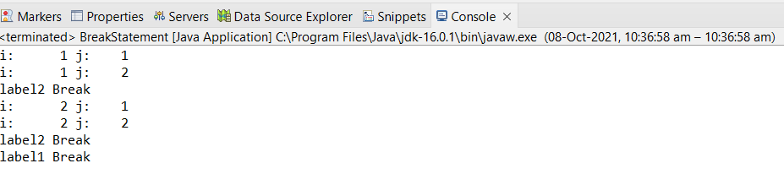

**Do the addition of around 10 even numbers, but use the continue statement in the logic.**

Source code: ContinueStatement.java

package com.ust.test;

public class ContinueStatement {

public static void main(String[] args) {

int sum=0;

System.*out*.println("Numbers :");

for(int i=1;i<=20;i++) {

//continue if the number is odd

if(i%2!=0) {

continue;//skip next iteration

}

System.*out*.print("\t"+i);

//sum of even number

sum=sum+i;

}

System.*out*.println("\nSum : "+sum);

}

}

Output:

