**MongoDB**

Install MongoDB

Syntax:

>mongo.exe

Database

* Database is a physical container for collections.
* Each database gets its own set of files on the file system.
* A single MongoDB server typically has multiple databases.
* Create Database

Syntax

>use DATABASE_NAME



* DROP database

Syntax:

>db.dropDatabase()

Collection

* Collection is a group of MongoDB documents.
* CREATE COLLECTION

Syntax:

db.createCollection(name, options)

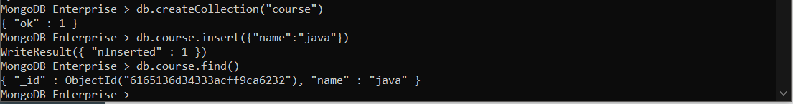

* DROP COLLECTION

Syntax:

db.COLLECTION_NAME.drop()



Document

* A document is a set of key-value pairs.
* Documents have dynamic schema.
* Dynamic schema means that documents in the same collection do not need to have the same set of fields or structure, and common fields in a collection's documents may hold different types of data.
* INSERT data into MongoDB collection:

Syntax:

>db.COLLECTION_NAME.insert(document)

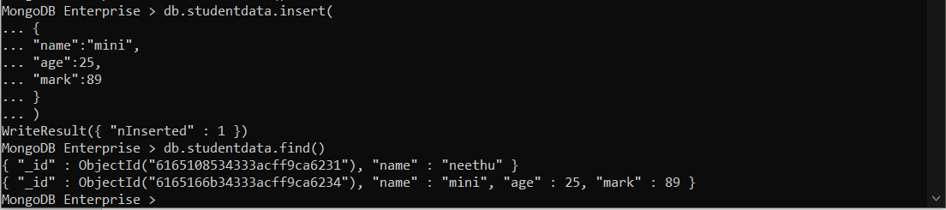

>db.COLLECTION_NAME.insertOne(document)

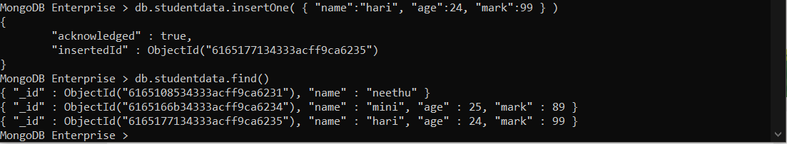

>db.COLLECTION_NAME.insertMany(document)

* find() Method:To query data from MongoDB collection

syntax :

>db.COLLECTION_NAME.find()

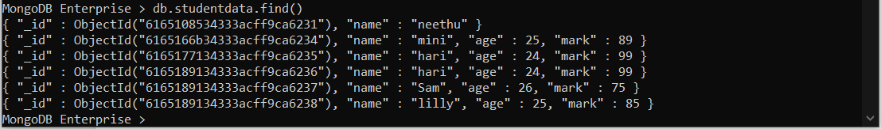

* The update() method updates the values in the existing document.

Syntax:

>db.COLLECTION_NAME.update(SELECTION_CRITERIA, UPDATED_DATA)

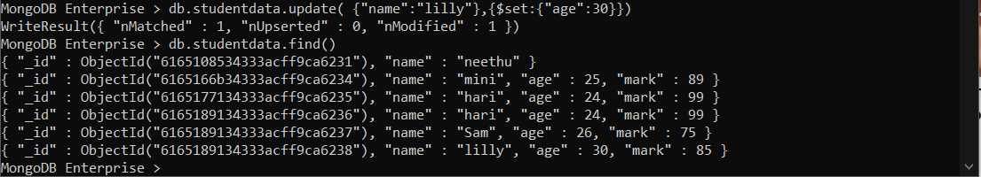

>db.COLLECTION_NAME.findOneAndUpdate(SELECTIOIN_CRITERIA, UPDATED_DATA)

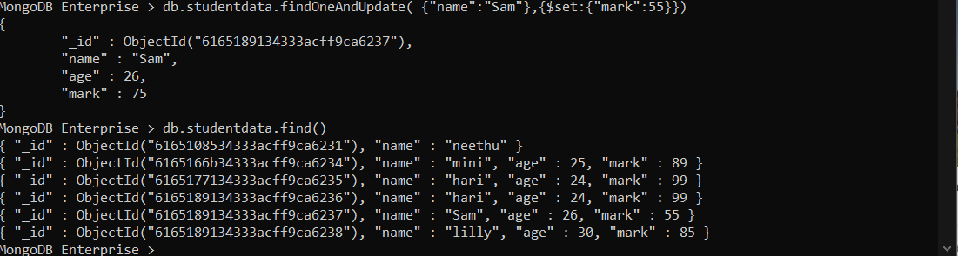

>db.COLLECTION_NAME.updateOne(<filter>, <update>)

>db.COLLECTION_NAME.updateMany(<filter>, <update>)

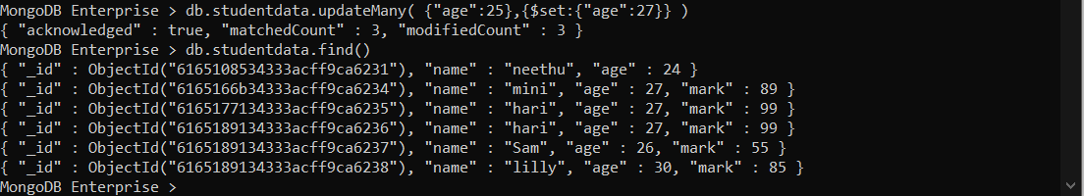

* REMOVE: used to remove a document from the collection.

>db.COLLECTION_NAME.remove(DELLETION_CRITTERIA)

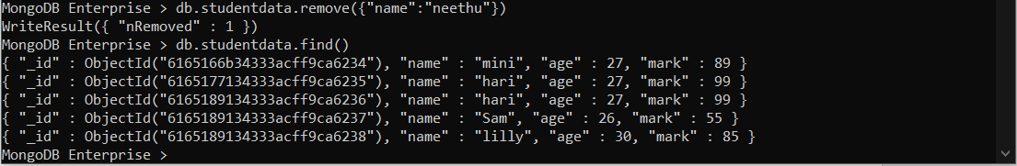

Remove one

>db.COLLECTION_NAME.remove(DELETION_CRITERIA,1)

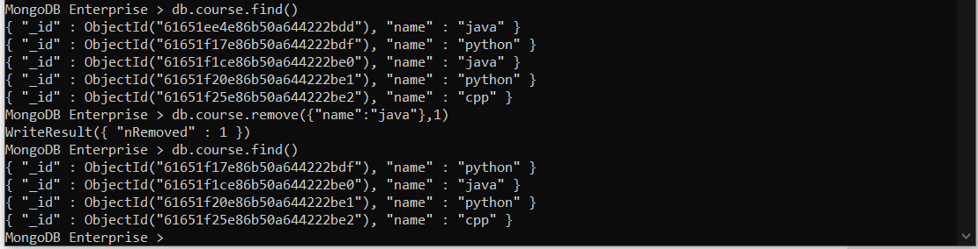

Remove All Documents

>db.COLLECTION_NAME.remove({})

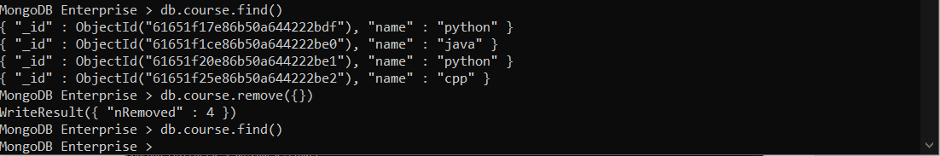

* find() Method

syntax:

>db.COLLECTION_NAME.find({},{KEY:1})