APImeMCP Agent Web Capability Runtime

System Design Proposal

STATUS  Proposed |  | OWNER  APImeMCP maintainers |  | LAST UPDATED  July 16, 2026

Authors | APImeMCP maintainers
Reviewers | Coding-agent platform, security, and developer-experience reviewers
Related docs | README.md; registry and recorder documentation
Scope | Agent-facing compilation, lifecycle governance, browser execution, and reproducible fixtures

1. Abstract
APImeMCP becomes an agent-facing compiler and runtime for stable, typed web capabilities. A coding agent can request a capability such as checking Amazon product availability; the system generates a draft extraction template, output schema, validation rules, replay fixtures, and a callable MCP tool. Capabilities move through a controlled lifecycle from draft to trusted, while every run produces evidence that can be replayed without repeatedly hitting the live site.
The design supports coding agents that need dependable access to changing websites without embedding brittle browser logic in every agent. It keeps the MCP contract stable, isolates browser execution, treats page content as untrusted data, and makes failures diagnosable through captured fixtures. It does not attempt to provide a general-purpose web crawler, autonomous credential acquisition, unrestricted side effects, or a guarantee that any website remains compatible forever.

2. Goals and Non-Goals
Goals | Non-goals
Give coding agents stable, typed MCP capabilities backed by changing websites. | General-purpose crawling at internet scale.
Make capability creation, verification, repair, and promotion auditable. | Autonomous acquisition or sharing of credentials.
Make failures reproducible through HTML, network, DOM, screenshot, and output fixtures. | Treating live website responses as permanent truth.
Default to safe, read-only, domain-scoped execution with explicit permissions. | Unapproved destructive browser actions or unrestricted egress.

3. Background and Problem Statement
Today, an agent can author a one-off Playwright extraction script, but the result is difficult to validate, share, replay, or repair. A website change can silently return empty or malformed data; a failed run usually requires another live browser session; and community templates need stronger provenance and promotion controls. The result is duplicated agent effort and low confidence in data used by code-generation workflows.
The proposed boundary separates intent compilation from execution. The MCP gateway owns the agent contract and policy; the capability compiler creates draft artifacts; the lifecycle registry owns versions and approvals; the browser runtime executes a pinned artifact; and the fixture/evidence layer makes behavior reproducible. The key invariant is: a trusted capability is executable only with a pinned version, declared permissions, a known output contract, and verification evidence.

4. Proposed Architecture

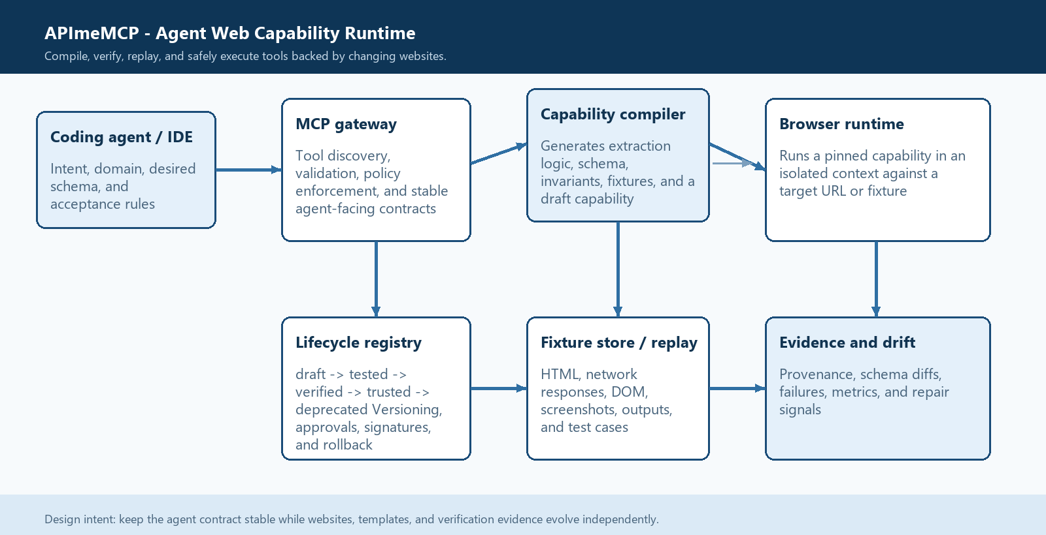
Figure 1. APImeMCP Agent Web Capability Runtime architecture.

Core components

Component | Responsibility | Primary storage | Failure behavior
MCP gateway | Exposes compile, verify, promote, execute, and inspect tools; validates inputs and returns typed envelopes. | MCP tool definitions and capability manifests | Rejects invalid requests; never executes an unvalidated draft.
Capability compiler | Turns agent intent into extraction logic, schemas, invariants, and a draft capability. | Draft source, schema, policy, and generated artifacts | Preserves the draft and returns structured compilation errors.
Lifecycle registry | Tracks versions and transitions: draft, tested, verified, trusted, deprecated. | Manifest, append-only promotion events, signatures | Fails closed for missing or conflicting versions.
Browser runtime | Runs a pinned capability in isolated live or fixture mode with timeouts and permissions. | Ephemeral browser contexts and run records | Captures evidence, returns a typed failure, and leaves trusted state unchanged.
Fixture and evidence layer | Stores replay inputs, outputs, screenshots, DOM/network artifacts, diffs, and drift signals. | Content-addressed fixture and evidence store | Degrades to live-only operation only for explicitly allowed verification; reports missing evidence.

5. Request Lifecycle
- 1. Intent entry: the coding agent calls compile_web_capability with a goal, target domain, example URLs or selectors, desired output schema, and acceptance rules.
- 2. Boundary validation: the gateway validates the request, normalizes domains, rejects unsupported schemes, assigns a capability ID, and applies the default policy of read-only browsing with no credential or off-domain egress.
- 3. Artifact loading: the compiler loads the selected template version, registry metadata, policy manifest, existing fixtures, and any prior successful contract for the same capability.
- 4. Compilation and verification: the system generates or updates extraction logic, schema checks, and invariants, then runs the draft against a controlled live target and captured fixtures. The output is a candidate capability plus structured evidence.
- 5. Durable promotion state: the registry records the draft, source inputs, generated artifacts, fixture hashes, policy, and verification results before any capability is exposed as trusted to other agents.
- 6. Execution: execute_web_capability runs a pinned version in an isolated browser context. It enforces timeouts, network permissions, cookie policy, concurrency limits, and fixture/live mode. Side effects are disabled by default and require explicit capability permissions.
- 7. Evidence and response: the gateway returns typed data, provenance, capability version, fixture/live status, and validation results. It also records metrics, screenshots, DOM/network artifacts, and drift signals for later repair or deprecation.

6. API and Data Contracts

Primary data contract

Field | Type | Required | Description
capabilityId | string | Yes | Stable kebab-case identity for the agent-facing capability.
version | semver | Yes | Immutable version of source, schema, policy, and verification evidence.
inputSchema | JSON Schema | Yes | Validated inputs such as URL, product identifier, or query.
outputSchema | JSON Schema | Yes | Typed result contract returned to the coding agent.
invariants | array | No | Rules such as non-empty SKU, valid price, or minimum result count.
permissions | object | Yes | Domain, network, cookie, browser-action, and data-sensitivity policy.
lifecycle | enum | Yes | draft, tested, verified, trusted, or deprecated with transition evidence.

Contract guarantees

- A run is accepted only when the declared output schema and invariants pass. A capability version is immutable after promotion; a new script or policy creates a new version. Verification evidence is linked to the exact template hash, fixture hashes, target URL, browser profile, and policy version.
- Every capability has a stable capabilityId and monotonically versioned artifact. Run IDs and fixture IDs are unique, and promotion transitions are append-only events. Repeated execution of the same version against the same fixture must produce the same normalized result or an explicitly classified nondeterminism signal.
- The system captures the request intent, generated source, schema, invariants, lifecycle transition, reviewer/agent identity, browser/runtime version, network policy, credentials mode, target URL, and all evidence references required to reconstruct the decision.
- The registry is the source of truth for capability identity, version, lifecycle state, policy, and provenance. Fixtures are the source of truth for reproducible test inputs. Live website output is an observation, not a durable contract, until it passes the capability's validation rules.
The versioned agent contract is published as an MCP tool definition plus a capability manifest containing:
capabilityId, version, input schema, output schema, invariants, permissions, lifecycle state, fixture references, provenance, and verification status. Every contract change requires a new version and a new promotion decision.

7. Consistency, Idempotency, and Replay

The runtime is deterministic for fixture mode and best-effort deterministic for live mode. Live runs never mutate a trusted version. A failed repair proposal remains a draft until it passes the same verification gates as the original. Concurrent promotion requests use optimistic version checks so two agents cannot silently overwrite each other.
Scenario | Expected behavior | Reasoning
Duplicate execute request | Same pinned version and fixture produce the same normalized result and run provenance. | Stable agent behavior and safe retries.
Required verification write fails | Do not promote; preserve the draft and return retryable evidence-storage failure. | A capability cannot become trusted without durable evidence.
Live target changes | Return schema/invariant drift with DOM and screenshot evidence; do not silently accept empty data. | Agents need a repair signal, not plausible-looking corruption.
Concurrent repair proposals | Reject stale promotion attempts and require rebase against the current capability version. | Prevents one agent from overwriting another agent's verified work.

8. Security and Privacy Considerations

- The MCP server is local-first by default and binds administrative surfaces to localhost. Trusted capabilities are explicitly scoped by domain, network egress, credential use, browser actions, and data sensitivity. A capability cannot broaden its own permissions through extracted page content or generated script.
- Page text, DOM, network responses, screenshots, and extracted fields are untrusted web data. They are returned as data with provenance and must never be interpreted as MCP instructions. Sensitive values are redacted from logs where possible; cookies and authenticated fixtures are encrypted or excluded from shared registry artifacts.
- Credentials are supplied by the operator or an approved local agent policy, never learned autonomously from a page. Session cookies are scoped to the registered domain and capability version. Registry capabilities default to no credentials and own-domain network access only.
- Replay and debugging are read-only by default. Actions such as form submission, purchase, deletion, email sending, or code execution require a separate declared permission and an approval gate. A capability can be disabled or rolled back without deleting its evidence.
- Fixture retention is configurable by capability and data class. Trusted public fixtures may be shared; authenticated or private fixtures remain local unless explicitly exported. Lifecycle events, policy changes, approvals, and deprecations are auditable.

9. Operational Readiness
Signal | SLO or alert | Owner | Launch gate
Capability verification success | >= 95% for stable fixture suites; page on repeated invariant failures. | Runtime owner | Required
Live execution latency | P95 under the capability budget; alert on timeout regressions. | Runtime owner | Required
Drift and empty-output rate | No unexplained empty outputs for trusted capabilities; alert after one trusted failure. | Capability owner | Required
Promotion integrity | All trusted versions have source, schema, policy, fixture, and reviewer evidence. | Registry owner | Required
Fixture replay integrity | Scheduled replay detects missing or mutated fixture parts. | Evidence owner | Recommended
Required

10. Alternatives Considered

Alternative | Why it was considered | Why it was not selected
One-off agent Playwright scripts | Fastest path for a single task. | No shared contract, lifecycle, replay, or repair evidence.
Hosted scraping platform | Could provide scale and managed browsers. | Adds third-party data custody and hides the agent's capability lifecycle.
Raw browser-control MCP only | Flexible for arbitrary tasks. | Leaves every agent to rediscover selectors and makes outcomes difficult to test.
Static template registry only | Simple distribution model similar to npm. | Distribution without compilation, verification, or fixture replay does not solve reliability.

11. Open Questions
- Should compile_web_capability generate code from natural-language intent automatically, or require the agent to provide an initial schema and examples before compilation begins?
- What is the minimum approval required for a capability that uses authenticated browsing or performs a browser side effect?
- Should trusted capabilities be distributed through a signed public registry, a private organization registry, or both with the same manifest format?
- Which agent identity and workspace controls are needed when several coding agents share a capability registry and propose concurrent repairs?

12. Decision and Next Steps
Adopt the capability compiler, lifecycle registry, and fixture replay layer as the next major APImeMCP direction. First implement the capability manifest and draft lifecycle, then add fixture capture/replay and schema validation, and finally expose compile_web_capability and execute_web_capability through MCP. Begin with read-only extraction capabilities, require explicit approval for credentials or side effects, and promote only after deterministic fixture tests plus a live verification pass.
Milestone | Deliverable | Exit criteria
M1 | Capability manifest, lifecycle state machine, and compile_web_capability draft tool. | A draft capability can be generated with schema, invariants, policy, and provenance.
M2 | Content-addressed fixtures, replay runner, and execute_web_capability typed envelope. | A capability can be tested offline and failures include actionable evidence.
M3 | Verification and promotion gates with trusted/deprecated versions. | A second agent or human can approve a version and rollback is demonstrated.
M4 | Signed registry distribution, drift alerts, and agent repair workflow. | Community or organization capabilities install safely and repair proposals remain auditable.

Use footnotes for definitions, assumptions, or terms that need precision without interrupting the main narrative.

