Adaptive Neural Control of Quadcopter with Unknown Nonlinearities

Neetish Patel, Student Member IEEE

Motilal Nehru National Institute of Technology Allahabad, Prayagraj India 211204 email: neetish@mnnit.ac.in

Shubhi Purwar, Member IEEE

Motilal Nehru National Institute of Technology Allahabad, Prayagraj India 211204

email: shubhi@mnnit.ac.in

*Abstract*—This paper presents a robust control technique that uses adaptive neural control to stabilize and track the path of the quadcopter when the aerodynamic drag coefficient is assumed to be unknown. The proposed controller is designed for unknown nonlinearities associated with translational and rotational motion. The unknown nonlinearities are approximated using a Chebyshev neural network which is used for designing the controller by feedback linearization technique. The weights of the neural network are tuned by adaptive laws that utilize the Lyapunov analysis such that the closed loop stability convergence of the system using the adaptive controller is established. The proposed controller confirms asymptotic tracking and robustness under parameter uncertainties and external disturbances. The outcomes of numerical simulation demonstrate the efficacy of the proposed control approach.

Keywords— Quadcopter, Adaptive Neural Control, Tracking Control, Feedback Linearization Technique, Chebyshev Neural Network (CNN).

# Introduction

In the past two decades, quadcopter attracted the interest of researchers due to wide variety of applications in both outdoor and indoor environments. The quadcopter has multiple capabilities like vertical take-off and landing, hovering, high maneuverability etc. Moreover, in-spite of its compact structure the quadcopter delivers satisfactory performance. Significant advances in the embedded systems and control theory has opened up new horizons for the quadcopters. Quadcopter are mostly used in defence services, for surveillance, rescue operations (Disaster management), remote inspections, video shooting, photography etc. [1]-[4].

One of the most important techniques for the quadcopter's autonomous flight is effective attitude control and stabilization. Due to the high nonlinearity along with the existence of multivariable and closely coupled dynamics, quadcopter control is quite complicated. The quadcopter is also an underactuated system, since a quadcopter's dynamics has six output $\left(x,y,z,ϕ,θ,ψ\right)$ and only four inputs ($U_{1},U_{2},U_{3},U_{4})$. The techniques developed for fully actuated robotic systems doesn’t apply directly in case of nonlinear systems that are underactuated [5]. To develop a control law, few factors must be taken into account like high nonlinearity and aerodynamic disturbances that affect the time varying behavior of the system. Additionally, UAVs are usually modeled subjected to some parametric uncertainties and unmodeled dynamics [6].

In the last few years, researchers developed various classical linear control techniques like PID and LQR, but are not effective for nonlinear systems with coupling characteristics [7][8]. This type of control works better during the hovering state of the quadcopter. The backstepping control technique [9] and sliding mode technique [10] are developed to control the translational and rotational dynamics of quadcopter thar are interconnected to each other. Both the techniques are combined to make control more efficient in [11]. The robustness and stability in control algorithm of quadcopter is still a challenge under uncertainties and nonlinearities present in the dynamic model.

Recent advancements in the robust and adaptive control literature, along with some mild assumptions are applied to several type of control schemes. Parallel to the rapid growth of the control techniques like robust and adaptive control, NN’s are utilized for the purpose of system identification. [12] and offline tuning of neural weights [13] for designing controller for nonlinear systems. Several control applications with NN controller are proposed [14]-[16]. Adaptive control by online neural control is proposed in [17]. Several researchers proposed the control approach using different neural networks for the quadcopter in recent times [6]. The main focus in these works was to develop robust control algorithms for satisfactory quadcopter performance in the presence of uncertainty, parameter changes un-modeled system dynamics.

The direct adaptive neural control technique is adopted in this paper. The closed loop system is made lyapunov stable while deriving the weight update laws for unknown nonlinearities of the system. One of the major benefits of direct adaptive control approach is that the controller is configured to preserve the closed loop stability while monitoring the error in tracking of the quadrotor system.

Rest of the paper is structured as follows. Section II, presents the dynamic model of the quadcopter. Then Section III demonstrates the stability of system using direct adaptive neural control approach. Finally, Section IV consists of the simulations results illustrating the accuracy of the proposed controller and Section V concludes this research article.

# Modeling of quadcopter

This Section defines the dynamic model of the quadcopter. The quadcopter consists of six degrees of freedom (6-DOF) with only four outputs. i.e. the system is underactuated. The 6-DOF corresponds to the position $x,y,z$ and euler angles $ϕ,θ,ψ i.e.$ roll angle, pitch angle and yaw angle respectively.

These assumptions are considered for deriving the model [18][19]-

1. The structure of quadcopter must be rigid and symmetrical.
2. The center of gravity and origin of Body fixed frame must coincide.
3. Mass of the quadcopter and moment of inertia is taken constant.

The four inputs of the quadcopter are basically the four fixed-pitch rotors. The thrust provided by each propeller of quadcopter is shown in figure 1.

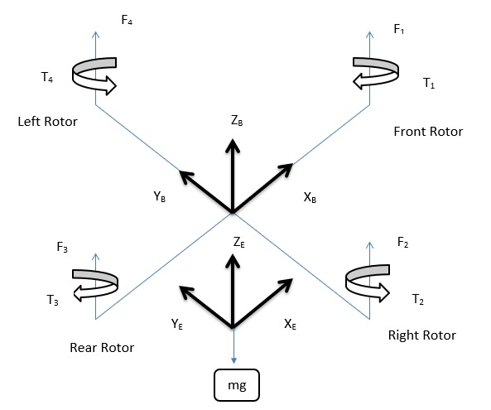

1. Configuration of quadcopter from earth to body fixed frame

Here considering a body frame as B and Earth frame as E. Using parameterization of Euler angles, the orientation of airframe in space is given by RT from body to earth. The Newton-Euler formalism is used in deriving the dynamic model of the quadcopter as shown in [18]-[20].

The relation between the generated thrust and the propeller’s angular velocity is defined by equation (1) and between thrust and torque of the propeller by equation (2)-

|  |  |  |
| --- | --- | --- |
|  |  | () |
|  |  | () |

Where $F_{n}$ represents the thrust generated and $τ_{n}$ represent torque generated by the *n*th propeller respectively and $ω_{n}$ represents the angular velocity of *n*th propeller. $k_{t},k_{p}$ are constants. Now by using equation (1) and (2), the four control inputs can be expressed as-

|  |  |  |
| --- | --- | --- |
|  |  | () |
|  |  | () |
|  |  | () |
|  |  | () |

The position vector and the orientation vector of the quadcopter in context of earth surface are defined as-

|  |  |  |
| --- | --- | --- |
|  |  | () |
|  |  | () |

Here are roll, pitch and yaw angle respectively. The relation of translational velocity of the quadcopter to the B (body fixed frame) and E (earth fixed frame) is given by transformation matrix as-

$$R_{T}=\left[\begin{matrix}c\left(θ\right)c\left(ψ\right) & c\left(θ\right)s\left(ψ\right) & -s\left(θ\right) \\ s\left(ϕ\right)s\left(θ\right)c\left(ψ\right)-c\left(ϕ\right)s\left(ψ\right) & s\left(ϕ\right)s\left(θ\right)s\left(ψ\right)+c\left(ϕ\right)c\left(ψ\right) & s\left(ϕ\right)c\left(θ\right) \\ c\left(ϕ\right)s\left(θ\right)c\left(ψ\right)+s\left(ϕ\right)s\left(ψ\right) & c\left(ϕ\right)s\left(θ\right)s\left(ψ\right)-s\left(ϕ\right)c\left(ψ\right) & c\left(ϕ\right)c\left(θ\right)\end{matrix}\right]$$

Here s(.) and c(.) represents sine and cosine terms respectively. The matrix $R_{T}$ is an orthogonal matrix and can be used to calculate the transformation matrix for earth fixed frame to body fixed frame by using orthogonal properties of the matrices.

Rotational and translational motion written in reference frame FB according to Newton’s law are as-

|  |  |  |
| --- | --- | --- |
|  | $$\sum{F_{ext}=m{\dot{V}}_{B}+ω×\left(mV_{B}\right)}$$ | (9) |
|  | $$\sum{M_{ext}=J\dot{ω}+ω×\left(Jω\right)}$$ | (10) |

Where, *J* = diag ($I_{x},I_{y},I_{z}$) is body inertia matrix, mass of quadcopter is m, translational velocity vector $V_{B}$ and rotational velocity vector is $ω$. Equation (9) and (10) represents the total force and moment acting on the quadcopter body expressed in body-fixed frame, respectively.

From here the simplified nonlinear dynamical model of the quadcopter is described as [19]-

|  |  |  |
| --- | --- | --- |
|  | $$\ddot{ϕ}=\dot{θ}\dot{ψ}\left(\frac{I_{y}-I_{z}}{I_{x}}\right)+\frac{d}{I_{x}}U_{2}$$ $$\ddot{θ}=\dot{ϕ}\dot{ψ}\left(\frac{I_{z}-I_{x}}{I_{y}}\right)+\frac{d}{I_{y}}U_{3}$$ $$\ddot{ψ}=\dot{ϕ}\dot{θ}\left(\frac{I_{x}-I_{y}}{I_{z}}\right)+\frac{1}{I_{z}}U_{4}$$ $$\ddot{x}=-\frac{k_{x}\dot{x}}{m}+\frac{u_{x}U_{1}}{m}$$ $$\ddot{y}=-\frac{k_{y}\dot{y}}{m}+\frac{u_{y}U_{1}}{m}$$ $$\ddot{z}=-g-\frac{k_{z}\dot{z}}{m}+\frac{\cos\left(ϕ\right)\cos\left(θ\right)U_{1}}{m}$$ | (11) |

Where, *d* is moment arm, K = diag ($k_{x},k_{y},k_{z}$) are aerodynamic drag coefficient.

|  |  |  |
| --- | --- | --- |
|  | $$u_{x}= cosϕ cosψ sinθ +sinϕ sinψ$$ | (12) |
|  | $$u_{y}=-\left(cosϕ sinψ sinθ -sinϕ cosψ\right)$$ | (13) |

The Euler angle of quadcopter are bounded as-

$$-\frac{π}{2}<ϕ<\frac{π}{2}; -\frac{π}{2}<θ<\frac{π}{2}; -\frac{π}{2}<ψ<\frac{π}{2}$$

Hence the complete dynamical model of the quadcopter is given in equation (11). The euler angles are bounded to avoid any singularity condition in the system. The next task is to design a controller for the system, assuming that the nonlinear function $f\left(x\right)$ of the mathematical model is completely unknown and is to estimated using the adaptive neural network.

# Design of Controller

The quadcopter has six outputs as $ϕ,θ,ψ,x,y,z$ and four inputs as $U_{1},U_{2},U_{3},U_{4}$ which clearly indicates that system is underactuated. The essential function of the controller is to track the system over a predefined trajectory along with ensuring the stability of the system. A good controller must be able to achieve the final position by ensuring the stability of the system.

The model of the quadcopter is in the form of-

|  |  |  |
| --- | --- | --- |
|  | $$\dot{X}=f\left(x\right)+g\left(x\right)u$$ | (14) |

Where $f\left(x\right)$ is completely unknown nonlinear function and $g(x)$ is known function of the system.

The state vector $x$ is taken as,

$X={[x_{11},x_{21},x_{12},x_{22},x_{13},x_{23},x_{14},x_{24},x_{15},x_{25},x_{16},x_{26}]}^{T}$

here $Xϵ R$ and also the input vector $u={[U_{1},U_{2},U_{3},U_{4}]}^{T}$

$$\left[\begin{aligned}{\dot{x}}_{11} \\ {\dot{x}}_{21} \\ {\dot{x}}_{12} \\ {\dot{x}}_{22} \\ {\dot{x}}_{13} \\ {\dot{x}}_{23} \\ {\dot{x}}_{14} \\ {\dot{x}}_{24} \\ {\dot{x}}_{15} \\ {\dot{x}}_{25} \\ {\dot{x}}_{16} \\ {\dot{x}}_{26}\end{aligned}\right]=\left[\begin{aligned}\dot{ϕ} \\ \ddot{\begin{aligned}ϕ \\ \begin{aligned}\dot{θ} \\ \ddot{θ} \\ \begin{aligned}\dot{ψ} \\ \ddot{ψ} \\ \begin{aligned}\dot{x} \\ \ddot{x}\end{aligned} \\ \begin{aligned}\dot{y} \\ \ddot{y}\end{aligned} \\ \begin{aligned}\dot{z} \\ \ddot{z}\end{aligned}\end{aligned}\end{aligned}\end{aligned}}\end{aligned}\right]=\left[\begin{aligned}x_{21} \\ x_{22}x_{23}\left(\frac{I_{y}-I_{z}}{I_{x}}\right)+\frac{d}{I_{x}}U_{2} \\ x_{22} \\ x_{21}x_{23}\left(\frac{I_{z}-I_{x}}{I_{y}}\right)+\frac{d}{I_{y}}U_{3} \\ x_{23} \\ x_{21}x_{22}\left(\frac{I_{x}-I_{y}}{I_{z}}\right)+\frac{1}{I_{z}}U_{4} \\ x_{24} \\ -\frac{k_{x}x_{24}}{m}+\frac{u_{x}U_{1}}{m} \\ x_{25} \\ -\frac{k_{y}x_{25}}{m}+\frac{u_{y}U_{1}}{m} \\ x_{26} \\ -g-\frac{k_{z}x_{26}}{m}+\frac{\left(\cos\left(x_{11}\right)\cos\left(x_{12}\right)\right)U_{1}}{m}\end{aligned}\right]$$

## Problem Statement

The primary objective of the control issue is to develop an output feedback controller as well as to develop the adaptive laws in such a way that all the signals engaged there in the closed loop system remains bounded and the tracking error should be as minimum as possible.

The complete dynamic model has been divided into six second order subsystems where the first three systems ( $x_{11}to x_{16})$ contribute to rotational dynamics i.e. roll, pitch and yaw angle and the next three ( $x_{17}to x_{22)}$ relates to the translational dynamics of the system.

Then state-space model explained above can be arranged as follows [21]:

|  |  |  |
| --- | --- | --- |
|  | $${\dot{x}}_{1i}=x_{2i}$$ | (15) |
|  | $${\dot{x}}_{2i}=f_{i}\left(x\right)+g_{i}\left(x\right)U_{i}\left(t\right)$$ | (16) |
|  | $$y_{i}=x_{1i}$$ | (17) |

Where $f_{i}\left(x\right) and g_{i}\left(x\right),$ (*i*=1,2,3,4,5,6) for all the six sub-system are nonlinear smooth functions.

Now control law for the dynamical system is designed by assuming that $f_{i}\left(x\right)$ for all the six subsystems are unknown.

## Adaptive Neural Control

Let us suppose a second order system as follows:

|  |  |
| --- | --- |
| $${\dot{x}}_{1}=x_{2}$$ | (18) |
| $${\dot{x}}_{2}=f\left(x\right)+g\left(x\right)u$$ | (19) |
| $$y=x_{1}$$ | (20) |

Now $u$ have to be found in such manner that $x(t)$ follow the desired trajectory $x_{d}(t)$. The control input $u$ is chosen as [22],

|  |  |  |
| --- | --- | --- |
|  | $$u=\frac{1}{g\left(x\right)}(-f\left(x\right)+P_{a}L+δ\dot{e}+{\dot{x}}_{2d})$$ | (21) |

Where *e* is the tracking error and $L=\dot{e}+δe$. The closed-loop error dynamics $\dot{L}=-P_{a}L$, which is linear and stable. The design parameter terms $P_{a} and δ$ are chosen as positive integers. Such design technique is known as feedback linearization technique.

Theorem [22]: Let us assume that the $f(x)$ of the subsystem (19) is unknown nonlinear function while $g(x)$ of the system (19) is completely known. The nonlinear function $f(x)$ can be approximated using Chebyshev neural network (CNN) as $\hat{f}\left(x\right)={\hat{W}}^{T}ϕ(x)$.

The control law designed in (21) is capable in stabilizing the provided system according to the lyapunov theory, provided that the weights will be updated by the law $\dot{\hat{W}}=-GϕL.$

The main advantage of using CNN is efficient computations due to the less complexity in the modelling of the structure. It also provides fast convergence rate and very easy for electrical circuit implementations compared to other multilayer feed forward neural networks [24]. Each subsystem of the dynamical model consists of single input and single output. The hidden layer is designed as taking the input of numerically transformable Chebyshev polynomial expansion of the input.

## Control Law for rotational subsystem

Now the control law for the subsystem 1 i.e. for euler angle $ϕ (Roll Angle)$ is derived as:

|  |  |  |
| --- | --- | --- |
|  | $${\dot{x}}_{11}=x_{21}$$ | (22) |
|  | $${\dot{x}}_{21}=x_{22}x_{23}\left(\frac{I_{y}-I_{z}}{I_{x}}\right)+\frac{d}{I_{x}}U_{2}$$ | (23) |
|  | $$y_{1}=x_{11}$$ | (24) |

Where $f_{1}\left(x\right)=x_{22}x_{23}\left(\frac{I_{y}-I_{z}}{I_{x}}\right)$ and $g_{1}\left(x\right)=\frac{d}{I_{x}}$

The control law $U_{2}$ can be derived as,

|  |  |  |
| --- | --- | --- |
|  | $$U_{2}=\frac{1}{g_{1}\left(x\right)}(-f_{1}\left(x\right)+P_{a}L_{1}+δ{\dot{e}}_{1}+{\dot{x}}_{21d})$$ | (25) |

Where, $f_{1}\left(x\right)={\hat{W}}_{1}^{T}ϕ(x)$

|  |  |  |
| --- | --- | --- |
|  | $$e_{1}=x_{11d}-x_{11}$$ | (26) |
|  | $$L_{1}={\dot{e}}_{1}+ δe_{1}$$ | (27) |

Now let us suppose a lyapunov function for the above system as:

|  |  |  |
| --- | --- | --- |
|  | $$V_{1}={\frac{1}{2}e}_{1}^{2}$$ | (28) |

Differentiating equation (28), we get

|  |  |  |
| --- | --- | --- |
|  | $${\dot{V}}_{1}=e_{1}{\dot{e}}_{1}=e_{1}\left({\dot{x}}_{11d}-x_{21}\right)$$ | (28) |

So for the system to be stable in the sense of Lyapunov , the $x_{21}$ will be $x_{21d}={\dot{x}}_{11d}+A_{1}e_{1}$, where $A_{1}$ is a design parameter which is always greater than $0$.

By using the same steps, input for pitch and yaw angle respectively are obtained as follow:

|  |  |  |
| --- | --- | --- |
|  | $$U_{3}=\frac{1}{g_{2}\left(x\right)}(-f_{2}\left(x\right)+P_{a}L_{2}+δ{\dot{e}}_{2}+{\dot{x}}_{22d})$$ | (29) |
|  | $$U_{4}=\frac{1}{g_{3}\left(x\right)}(-f_{3}\left(x\right)+P_{a}L_{3}+δ{\dot{e}}_{3}+{\dot{x}}_{23d})$$ | (30) |

Where,

$f_{2}\left(x\right)={\hat{W}}_{2}^{T}ϕ(x)$

|  |  |  |
| --- | --- | --- |
|  | $$e_{2}=x_{12d}-x_{12}$$ | (31) |
|  | $$L_{2}={\dot{e}}_{2}+ δe_{2}$$ | (32) |

|  |  |  |
| --- | --- | --- |
|  |  | (33) |
|  | $$L_{3}={\dot{e}}_{3}+ δe_{3}$$ | (34) |

## Control Law for Translational Subsystem

Here let us take the subsystem that tracks the desired trajectory along the z-axis. The subsystem is as follows:

|  |  |  |
| --- | --- | --- |
|  | $${\dot{x}}_{16}=x_{26}$$ | (35) |
|  | $${\dot{x}}_{26}=-g-\frac{k_{z}x_{26}}{m}+\frac{\left(\cos\left(x_{11}\right)\cos\left(x_{12}\right)\right)U_{1}}{m}$$ | (36) |
|  | $$y_{6}=x_{16}$$ | (37) |

Where $f_{6}\left(x\right)=-g-\frac{k_{z}x_{26}}{m}$ and $g_{6}\left(x\right)=\frac{\left(\cos\left(x_{11}\right)\cos\left(x_{12}\right)\right)}{m}$

Using the theorem in [22] the control input $U_{1}$ is derived by assuming that the f(x) of the subsystem is unknown as:

|  |  |  |
| --- | --- | --- |
|  | $$U_{1}=\frac{1}{g_{6}\left(x\right)}(-f_{6}\left(x\right)+P_{a}L_{6}+δ{\dot{e}}_{6}+{\dot{x}}_{26d})$$ | (38) |

Where, $f_{6}\left(x\right)={\hat{W}}_{6}^{T}ϕ(x)$

|  |  |  |
| --- | --- | --- |
|  | $$e_{6}=x_{16d}-x_{16}$$ | (39) |
|  | $$L_{6}={\dot{e}}_{6}+ δe_{6}$$ | (40) |

## Motion Control for x axis and y axis

From the model of the quadcopter, it can be observed that the motion along x axis and y axis depends upon $U_{1}$. Whereas $U_{1}$ is the thrust vector oriented to attain the desired motion along x axis and y axis. The desired roll angle and pitch angle can be deduced from (11) to compute $u_{x}$ and $u_{y}$ which are the orientation of $U_{1}$. Both control efforts are derived using the theorem [22].

# Simulation Results

Test simulations are performed to verify the performance achieved for the trajectory tracking problem to validate the proposed control strategy. The parameters used for quadcopter are as follows:

Mass (m)=1.5 Kg, d=1.5 m, $I_{x}=I_{y}=$ 0.0082 ${Kg-m}^{2}$, $I_{x}=0.0014 {Kg-m}^{2}$, g=9.81 $m/{s^{2}}$, $P_{a}=30$, $L_{i}=20$ (for i=1,2,3…,6).

Now to check robustness of the proposed controller, simulation test is conducted close to the [23], here $x_{d}=-2+2\cos\left(\frac{2π}{20}t\right), y_{d}=2\sin\left(\frac{2π}{20}t\right)$, $z_{d}=\sin{t}$ are desired trajectory and the desired yaw angle is chosen as $ψ_{d}=\frac{π}{3}$. Next for adaptive neural law, $P_{a}=30$ and $δ=20$.

For the weight updates of rotational motion G = 0.01 and for translational motion G = 0.0025.

The 3D plot trajectory tracking is presented in Fig 2.

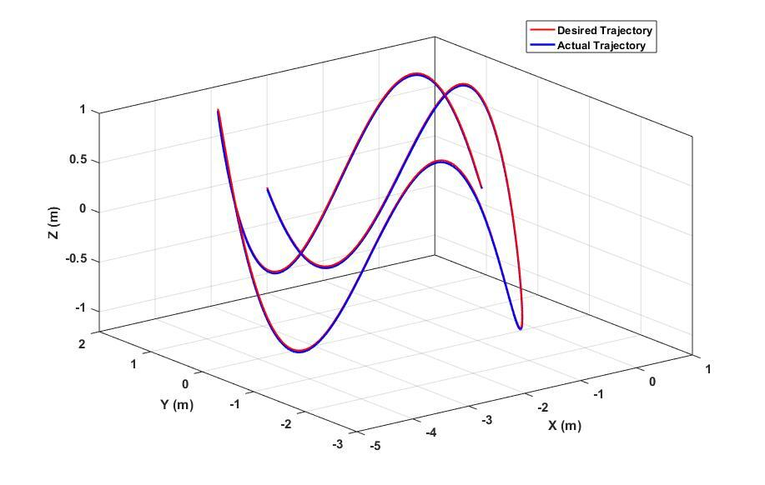

1. 3D plot of trajectory tracking

The position tracking and velocity tracking is presented in Fig 3. The maximum peak in position error of the quadcopter is close to 2 cm for z axis, less than 2 cm for x and less than one cm for y axis which shows the effectiveness of the designed controller from [23] where the error peaks for x and y axis are greater than 6 cm.

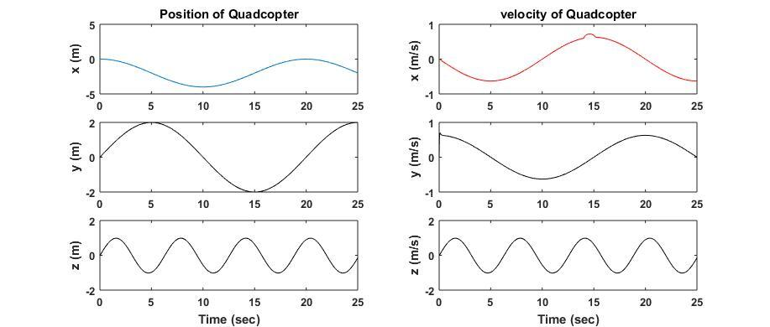

1. Position and Velocity tracking of Quadcopter

Here it is taken that the desired trajectory along z axis as time unbounded. Results shows the effective tracking performance of the quadcopter even with sharp maneuver and also in the presence of disturbance. The position tracking error is presented in Fig 4.

A disturbance of $τ_{d}=2\sin\left(2t+1\right)$ is introduced for duration of 1 sec at time t=14 sec along x axis and controller compensates the disturbance quickly as is evident from Fig.4.

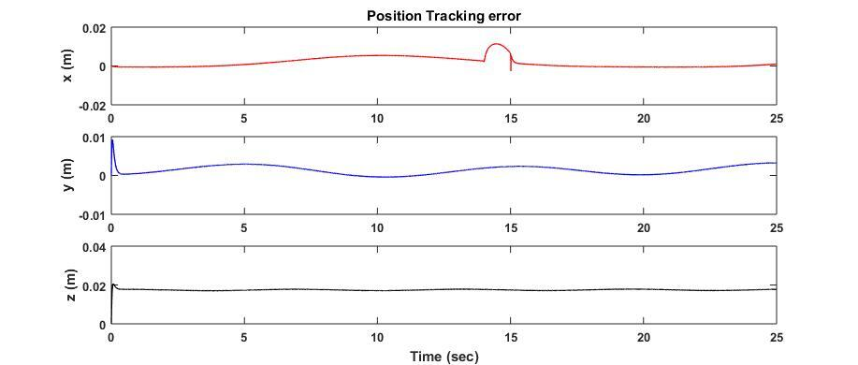

1. Position tracking error

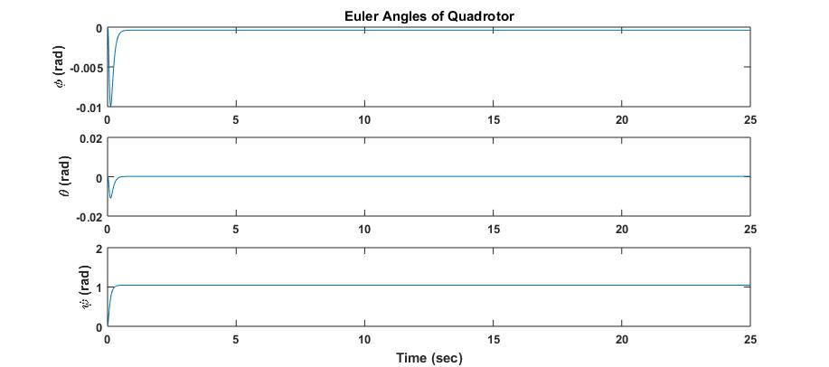

1. Plot of Euler angles

The tracking of euler angles in Fig 5 shows the stability of the system as the $ϕ,θ$ are closed to zero. The yaw angles kept high as $ψ_{d}=\frac{π}{3}$ and is achieved by controller effectively. The error in the yaw angle is represented in Fig 6 of the simulation results.

Here all the results prove the robustness of the proposed controller in the presence of disturbances.

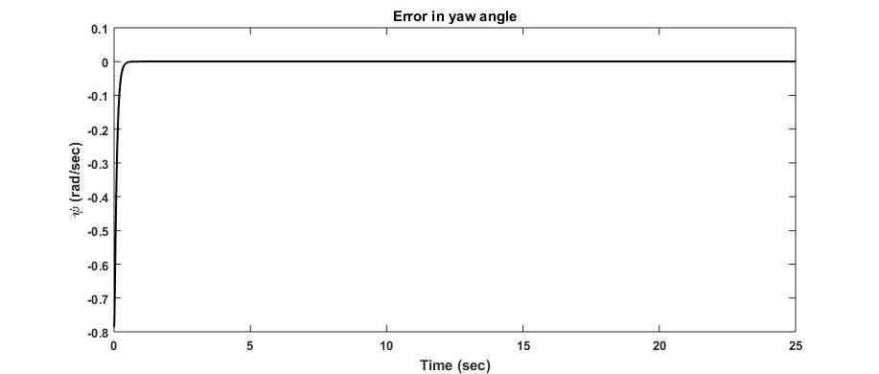

1. Error in yaw angle

# Conclusion and future scope

In this paper, a novel adaptive neural control of quadcopter is proposed. The results prove the efficiency of the proposed controller. In future it is proposed to take $f(x)$ as well as $g(x)$ both unknown to design a controller for a completely unknown system.

# References

1. A. Tayebi, S. McGilvray, "Attitude stabilization of a vtol quadrotor aircraft", *IEEE Trans. Control Syst. Technol.*, vol. 14, no. 3, pp. 562-571, May 2006.
2. B. Erginer, E. Altug, "Modeling and pd control of a quadrotor vtol vehicle", *Proc. IEEE Intell. Vehicles Symp.*, pp. 894-899, 2007.
3. S. Bouabdallah, R. Siegwart, "Full control of a quadrotor", *Proc. IEEE/RSJ Int. Intell. Robots Syst. Conf.*, pp. 153-158, 2007.
4. S. Bouabdallah, P. Murrieri, R. Siegwart, "Design and control of an indoor micro quadrotor", *Proc. IEEE Int. Conf. Robot. Autom. Conf.*, vol. 5, pp. 4393-4398, 2004.
5. I. Fantoni,R. Lozano, “Non-linear control for underactuated mechanical systems”, *Springer Science & Business Media,* 2002*.*
6. F. Yacef, O. Bouhali, and H. Mustapha, "Adaptive fuzzy backstepping control for trajectory tracking of unmanned aerial quadrotor", *International Conference on Unmanned Aircraft Systems (ICUAS)*, pp. 920-927. IEEE, 2014.
7. T. Bresciani, "Modelling, identification and control of a quadrotor helicopter" *MSc Theses*, 2008.
8. S. Bouabdallah, R. Siegwart, "Design and control of a miniature quadrotor", In *Advances in unmanned aerial vehicles*, pp. 171-210. Springer, Dordrecht, 2007.
9. T. Madani, A. Benallegue, "Control of a quadrotor mini-helicopter via full state backstepping technique", In *Proceedings of the 45th IEEE Conference on Decision and Control*, pp. 1515-1520. IEEE, 2006.
10. P. Li, "Research of Four-motor Helicopter control", *Harbin Institute of Technology, Harbin*,2008.
11. S. Bouabdallah, R. Siegwart, "Backstepping and sliding-mode techniques applied to an indoor micro quadrotor", In *Proceedings of the 2005 IEEE international conference on robotics and automation*, pp. 2247-2252. IEEE, 2005.
12. B. Horn, D. Hush, C. Abdallah, "The state space recurrent neural network for robot identification", Advanced Control Issues for Robot Manipulators ASME Winter Annu. Meet., vol. DSC-39, 1992
13. F. C. Chen, H. K. Khalil, "Adaptive control of nonlinear systems using neural networks", Int. J. Control, vol. 55, no. 6, pp. 1299-1317, 1992.
14. C. Kwan, F.L. Lewis, D.M. Dawson, "Robust neural-network control of rigid-link electrically driven robots", *IEEE Transactions on Neural Networks* 9, no. 4, pp. 581-588, 1998.
15. C.M. Kwan, F.L. Lewis, "Robust backstepping control of induction motors using neural networks", *IEEE Transactions on Neural Networks* 11, no. 5, pp. 1178-1187, 2000.
16. C. M. Kwan, F. L. Lewis, Y. H. Kim, "Robust neural network control of rigid link flexible-joint robots", Asian J. Control, vol. 1, no. 3, pp. 188-197, 1999.
17. BY. Lee, HI. Lee, and MJ. Tahk, "Analysis of adaptive control using on-line neural networks for a quadrotor UAV", In *13th International Conference on Control, Automation and Systems (ICCAS)*, pp. 1840-1844. IEEE, 2013.
18. S. Bouabdallah, "Design and Control of Quadrotors with Application to Autonomous Flying", PhD. Thesis, 3727, 2007.
19. Emre Can SUIÇMEZ, “Trajectory Tracking of a Quadrotor Unmanned Aerial Vehicle (UAV) VIA Attitude and position control”, *A MSc Thesis in Midle East Technical University*, July 2014.
20. A. Chriette, "Contribution à la commande et à la modélisation des hélicoptères: Asservissement visuel et commande adaptative." PhD diss., Evry-Val d'Essonne, 2001.
21. F. Yacef, O. Bouhali, M. Hamerlain, "Adaptive fuzzy backstepping control for trajectory tracking of unmanned aerial quadrotor." In *International Conference on Unmanned Aircraft Systems (ICUAS)*, pp. 920-927. IEEE, 2014.
22. I. Kar, L. Behera. "Direct adaptive neural control for affine nonlinear systems." *Applied Soft Computing* 9, no. 2, pp. 756-764, 2009.
23. E.G. Hernandez Martinez, G. Fernandez Anaya, E. D. Ferreira, J. J. Flores Godoy, A. Lopez-Gonzalez, "Trajectory tracking of a quadcopter UAV with optimal translational control", *IFAC-PapersOnLine* 48, no. 19, pp. 226-231, 2015.
24. M. Sornam, and V. Vanitha. "Application of chebyshev neural network for function approximation", *International Journal of Computer Sciences and Engineering.”* , no. 4, pp. 201-204, 2018.